Government of Nepal
Ministry of Energy, Water Resource and Irrigation
Department of Water Resource and Irrigation

Rani Jamara Kulariya Irrigation Project
Phase II

Annexes for Land Donation Report

Command Area Protection (CAP) works along the Pathariya River

Pathraya (Lamki Chuwa 09 & 10, Janaki 02, 04 & 07, Joshipur 04 & 05, Tikapur 06 and Bhajani 08) River Training Works

Submitted by

Rani Jamara Kulariya Irrigation Project
Tikapur, Kailali

December, 2019

The report comprises only the annexes for Land Donation Report of CAP works along with Pathariya River. There are eight annexes. Annex 1 is about land donation process. Annex 2 provides chainagewise PAHs and landloss details. Other annexes include social screening, meeting minutes and land donation consents. The report also comprises google maps of the CAP area and some photographs captured during the course of consultation meetings.

Abbreviations
ACIU Agriculture Component Implementation Unit
ADB Asian Development Bank
AoI Area of Influence
CAP Command Area Protection
CBOs Community Based organization
CDO Chief District Officer
CFG Community Forest Group
DAG DisAdvantaged Group
DAO District Agriculture Office
DFO District Forest Office
DLRO District Land Revenue Office
DLSO District Land Survey Office
DoWRI Department of Water Resourses and Irrigation
EIA Environment Impact Assessment
EMP Environmental Management Plan
FGD Focus Group Discussion
GESI Gender Equality and Social Inclusion
GoN Government of Nepal
GRC Grievance Redress Committee
GRM Grievance Redress Mechanism
HH/s Household/s
IP Indigenous People
IR Involuntary Resettlement
IRP Involuntary Resettlement Plan
KII Key Informant Interview
LB Bank
LCM Lamki Chuwa Municipality
NGO Non-Governmental Organizations
PAHs Project Affected Households
PWDA Person with Different Ability
RB Right Bank
RJKIP Rani Jamara Kulariya Irrigation Project
RM Rural Municipality
RPF Resttlement Policy Framework
VCDP Vulnerable Community Development Plan
WB World Bank
WUA Water Users Association
WUGs Water Users Group

Table of Annexes
Annexes 1
Annex I: Land donation process/mechanism: 1
Annex 2: Chainage wise PAHs and land loss details of all CAP sites 2
Left Bank 9:Chainage 7+750 to 7+900 2
Left Bank 10: Chainage 8+050 to 8+300 3
Left Bank 11: Chainage 8+450 to 8+750 4
Left Bank 12, 13, 14: Chainage 9+200 to 9+300, 9+350 to 9+500, 9+750 to 9+900 5
Left Bank 15: Chainage 10+1500 to 10+400 6
Left Bank 16: Chainage11+100 to 11+300 7
Left Bank 17: Chainage 12+000 to 12+200 8
Left Bank 18: Chainage 15+500 to 16+100 9
Left Bank 19: Chainage 16+300 to 17+000 10
Left Bank 20: Chainage 17+400 to 18+000 11
Left Bank 21: Chainage 18+900 to 19+200 12
Left Bank 22: Chainage 19+650 to 19+800 13
Left Bank 23: Chainage 19+800 to 20+300 (500 Meter) 14
Left Bank 24: Chainage 23+150 to 23+250 15
Left Bank 25: Chainage 23+850 to 24+350 (500 Meter) 15
Left Bank 26: Chainage 28+150 to 28+650 (500 Meter) 16
Left Bank 27: Chainage 28+850 to 29+350 (500 Meter) 17
Left Bank 28: Chainage 30+500 to 31+250 (750 Meter) 18
Left Bank 29: Chainage 35+000 to 35+700 (700 Meter) 19
Right Bank 10: Chainage 18+600 to 19 + 900 (1300 Meter) 20
Right Bank 10: Chainage 22+500 to 24 +800 (2300 Meter) 21
Right Bank 11 Chainage 25+300 to 25 +800 (500 Meter) 23
Right Bank 12 Chainage 29+200 to 29 +900 (700 Meter) 24
Right Bank 13 Chainage 30+800 to 31+000 (200 Meter) 25
Right Bank 14 Chainage 32+850 to 33 +150 (300 Meter) 26
Right Bank 15 Chainage 34+700 to 35 +300 (600 Meter) 27
Right Bank 16 Chainage 35+650 to 36 +000 (350 Meter) 28
Right Bank 17 Chainage 36+600 to 36 +950 (350 Meter) 29
Annex 3: Chainage Wise Details of Construction Site 30
Annex 4: Social Screening 33
Annex 5: Meeting Schedule for Land Donation 93
Annex 6: Meeting Minutes 95
Annex 7: Land Donation Forms 121
Annex 8: Demographic Infromation-Age Distribution and Literacy Rate 276
Annex 9: Google Maps and Photographs 278

Annexes
Annex I: Land donation process/mechanism:

RJKIP has established land denotation mechanism system. The objective of this mechanism is to recognize the farmer's voice against land loss and formalize land donation process for smooth implementation of construction works. The proposed Land Denotation process is given based on discussion with concerned stakeholders. RJKIP has completed the voluntary land donation process. All the Project Affected Households (PAHs) have given their written consent for constructing embankment. The RJKIP safeguard team has prepared special written document for the households having land loss of any volume.

Proposed Land Donation Process for Rani Jamara Kularia Irrigation Project
Step 1 | Identification of the Potential Land Donors based on RJKIP Technical Engineering Design and field verification at the exact filed sites.
Step 2 | Find out demand based history, technical design status.
Step 3 | Consultation meeting with Municipality (M)/Rural Municipality (RM) or ward representatives CBOs/NGOs, WUA, Badghar etc. about the project and land donation process and their official role in land donation transfer process and establish “ Land Donation and Transfer Coordination Committee (LDTCC)”. Prepare written consent of land donation and strong documentation if transfer is not possible.
Step 4 | Conduct census, , KII and field observation of PAP ( Directly affected people by project)
Step 5 | Together with RJKIP Engineers and Land Surveyor, Social safeguards Consultant, calculate the “Land Loss, Land Damages, Agricultural products loss due to land transfer to the project (Direct Affected)”.
Step 6 | Develop/formulate “Incentive Plan” for Project Affected People (PAP)” to be involved in the project and some incentives (i.e. Land donation recognition certificate, employment opportunities, support activities or other good practices done by other similar projects in Nepal i.e. road projects.
Step 7 | Through WUA and local government official representatives, prepare all official individual household land donation documents, explain them, get full consent and get their signatures in all land donation documents.
Step 8 | RJKIP shall prepare the names of PAP households and land loss. The PAP households will request concerned wards for waiving tax of land loss taken by embankment. This shall support to land ownership transfer in future.
Step 9 | RJKIP will establish “Grievances Redress Mechanism (GRM)” through Municipality and ward (Bhajani Municipality, Lamki Chuwa Municipality and Joshipur Rural Municipality. The existing GRM has not covered these locations). The GRM including RJKIP will address complaints/grievances/suggestions received by PAP.
Step10 | Supply the PAP name list to the ACIU for agriculture support program.

Annex 2: Chainage wise PAHs and land loss details of all CAP sites

Left Bank 9:Chainage 7+750 to 7+900
Sub-project implementation place: Lamki Chuha-10, Tighadi, downstream of E/W highway Bridge

S.N. | Name of Land Owner | Length (Meter) | Area of total Registered land |  |  | Area of total non Registered land (Allani) |  |  | Total Land Area |  |  | Total land (Sq. mtr.) | Land use area |  |  | Flood affected/damaged land of total land |  |  | Land covered by embankment |  |  | Total land covered by embankment (Sq. mtr.) | % of land covered by embankment | Remarks
S.N. | Name of Land Owner | Length (Meter) | B | K | D | B | K | D | B | K | D | Total land (Sq. mtr.) | B | K | D | B | K | D | B | K | D | Total land covered by embankment (Sq. mtr.) | % of land covered by embankment | Remarks
1 | Nar Bahadur Khadka | 10 | 3 | 2 | 0 | 0 | 0 | 0 | 3 | 2 | 0 | 20995.06 |  |  |  |  |  |  | 0 | 0 | 12 | 203.16 | 0.97 | 9848429463
2 | Nirpa B. Khadka | 64 | 2 | 10 | 0 | 0 | 0 | 0 | 2 | 10 | 0 | 16931.50 |  |  |  |  |  |  | 0 | 3 | 15.5 | 1278.31 | 7.55 | 9848491885
3 | Gulram D. Tharu | 76 | 2 | 5 | 0 | 0 | 0 | 0 | 2 | 5 | 0 | 15238.35 |  |  |  |  |  |  | 0 | 4 | 10 | 1523.82 | 10.00 | 9868787600
 | Total | 150 | 7 | 17 | 0 | 0 | 0 | 0 | 7 | 17 | 0 | 53164.91 | 0 | 0 | 0 | 0 | 0 | 0 | 0 | 7 | 37.5 | 3005.29 | 18.52

Left Bank 10: Chainage 8+050 to 8+300
Sub-project implementation place: Lamki Chuaiha-10 , Tighadi, near to Padma Devi Bohara's Khet (top)

S.N. | Name of Land Owner | Length (Meter) | Area of total Registered land |  |  | Area of total non Registered land (Allani) |  |  | Total Land Area |  |  | Total land (Sq. mtr.) | Land use area |  |  | Flood affected/damaged land of total land |  |  | Land covered by embankment |  |  | Total land covered by embankment (Sq. mtr.) | % of land covered by embankment | Remarks
S.N. | Name of Land Owner | Length (Meter) | B | K | D | B | K | D | B | K | D | Total land (Sq. mtr.) | B | K | D | B | K | D | B | K | D | Total land covered by embankment (Sq. mtr.) | % of land covered by embankment | Remarks
1 | Padma Devi Bohara | 44 | 2 | 0 | 0 | 1 | 0 | 0 | 3 | 0 | 0 | 20317.8 |  |  |  |  |  |  | 0 | 2 | 12 | 880.42 | 4.33 | 9865839538
2 | Bhagiram Chaudhary | 10 | 0 | 9 | 10 | 0 | 0 | 0 | 0 | 9 | 10 | 3216.97 |  |  |  |  |  |  | 0 | 0 | 12 | 203.16 | 6.32 | 9848023147
3 | Thaggu Chaudhary | 10 | 0 | 10 | 10 | 0 | 0 | 0 | 0 | 10 | 10 | 3555.6 |  |  |  |  |  |  | 0 | 0 | 12 | 203.16 | 5.71
4 | Kalesu Chaudhary | 20 | 5 | 10 | 0 | 0 | 0 | 0 | 5 | 10 | 0 | 37249.3 |  |  |  |  |  |  | 0 | 1 | 3.5 | 397.89 | 1.07
5 | Faguram Chaudhary | 15 | 1 | 1 | 0 | 0 | 0 | 0 | 1 | 1 | 0 | 7111.23 |  |  |  |  |  |  | 0 | 0 | 18 | 304.74 | 4.29 | 9821629291
6 | Panchiram Chauidhary | 15 | 1 | 2 | 0 | 0 | 0 | 0 | 1 | 2 | 0 | 7449.86 |  |  |  |  |  |  | 0 | 0 | 18 | 304.74 | 4.09 | 9824643865
7 | Patiram Chaudhary | 84 | 0 | 9 | 0 | 0 | 0 | 0 | 0 | 9 | 0 | 3047.67 |  |  |  |  |  |  | 0 | 4 | 19 | 1676.19 | 55.00 | 9811657450
8 | Laxman Dangaura C. | 14.5 | 0 | 1 | 6 | 0 | 3 | 6 | 0 | 4 | 12 | 1557.68 |  |  |  |  |  |  | 0 | 0 | 17 | 287.81 | 18.48
9 | Sitaram Dangaura C. | 24 | 0 | 0 | 0 | 0 | 4 | 0 | 0 | 4 | 0 | 1354.52 |  |  |  |  |  |  | 0 | 1 | 8 | 474.07 | 35.00
10 | Rambharosh Chaudhary | 32 | 0 | 1 | 7 | 0 | 3 | 6 | 0 | 4 | 13 | 1574.61 |  |  |  |  |  |  | 0 | 1 | 18 | 643.37 | 40.86
 | Total | 268.5 | 9 | 43 | 33 | 1 | 10 | 12 | 10 | 53 | 45 | 86435.24 | 0 | 0 | 0 | 0 | 0 | 0 | 0 | 9 | 138 | 5375.55 | 175.14

Left Bank 11: Chainage 8+450 to 8+750
Sub-project implementation place: Lamki Chuha-10, Tighadi, near to Khushiram Chauidhary (top)

S.N. | Name of Land Owner | Length (Meter) | Area of total Registered land |  |  | Area of total non-Registered land (Allani) |  |  | Total Land Area |  |  | Total land (Sq. mtr.) | Land use area |  |  | Flood affected/damaged land of total land |  |  | Land covered by embankment |  |  | Total land covered by embankment (Sq. mtr.) | % of land covered by embankment | Remarks
S.N. | Name of Land Owner | Length (Meter) | B | K | D | B | K | D | B | K | D | Total land (Sq. mtr.) | B | K | D | B | K | D | B | K | D | Total land covered by embankment (Sq. mtr.) | % of land covered by embankment | Remarks
1 | Ram Kishan D. Tharu | 14 | 0 | 0 | 0 | 0 | 4 | 0 | 0 | 4 | 0 | 1354.52 |  |  |  |  |  |  | 0 | 0 | 16.5 | 279.35 | 20.62 | 9815638515
2 | Likhram D. Tharu | 12 | 0 | 0 | 0 | 0 | 3 | 10 | 0 | 3 | 10 | 1185.19 |  |  |  |  |  |  | 0 | 0 | 14 | 237.02 | 20.00 | 9812683586
3 | Tetram D. Tharu | 15 | 0 | 0 | 0 | 0 | 3 | 0 | 0 | 3 | 0 | 1015.89 |  |  |  |  |  |  | 0 | 0 | 18 | 304.74 | 30.00 | 9804639558
4 | Khushuiram D. Tharu | 68 | 0 | 0 | 0 | 0 | 6 | 0 | 0 | 6 | 0 | 2031.78 |  |  |  |  |  |  | 0 | 4 | 0 | 1354.52 | 66.67 | 9800647389
5 | Antram D. Tharu | 5 | 0 |  | 0 | 0 | 2 | 0 | 0 | 2 | 0 | 677.26 |  |  |  |  |  |  | 0 | 0 | 6 | 101.58 | 15.00 | Antram D.(son)
6 | Gangaram D. Tharu | 5 | 0 | 1 | 0 | 0 | 2 | 0 | 0 | 3 | 0 | 1015.89 |  |  |  |  |  |  | 0 | 0 | 6 | 101.58 | 10.00 | 9800611731
7 | Tularam D. Tharu | 12 | 0 | 1 | 10 | 0 | 1 | 0 | 0 | 2 | 10 | 846.56 |  |  |  |  |  |  | 0 | 0 | 14 | 237.02 | 28.00 | 9812635978
8 | Chhoturam D. Tharu | 12 | 0 | 0 | 0 | 0 | 1 | 10 | 0 | 1 | 10 | 507.93 |  |  |  |  |  |  | 0 | 0 | 14 | 237.02 | 46.66
9 | Rastriya Nawajaran ma. Bi. | 123 | 14 | 16 | 0 | 0 | 5 |  | 15 | 1 | 0 | 101927.63 |  |  |  |  |  |  | 0 | 7 | 5 | 2455.06 | 2.41
10 | BhojuwaD. Tharu | 50 | 0 | 15 | 0 | 0 | 3 | 0 | 0 | 18 | 0 | 6095.34 |  |  |  |  |  |  | 0 | 2 | 19 | 998.93 | 16.39 | 9814610941
 | Total | 316 | 14 | 33 | 10 | 0 | 30 | 20 | 15 | 43 | 30 | 116657.99 | 0 | 0 | 0 | 0 | 0 | 0 | 0 | 13 | 113 | 6306.82 | 255.74

Left Bank 12, 13, 14: Chainage 9+200 to 9+300, 9+350 to 9+500, 9+750 to 9+900
Sub-project implementation place: Lamki Chuha -10 Tighadi, near Goleram's khet (top) to Jung Bahadur

S.N. | Name of Land Owner | Length (Meter) | Area of total Registered land |  |  | Area of total non-Registered land (Allani) |  |  | Total Land Area |  |  | Total land (Sq. mtr.) | Land use area |  |  | Flood affected/damaged land of total land |  |  | Land covered by embankment |  |  | Total land covered by embankment (Sq. mtr.) | % of land covered by embankment | Remarks
S.N. | Name of Land Owner | Length (Meter) | B | K | D | B | K | D | B | K | D | Total land (Sq. mtr.) | B | K | D | B | K | D | B | K | D | Total land covered by embankment (Sq. mtr.) | % of land covered by embankment | Remarks
1 | Goluwa D. Tharu | 114 | 2 | 13 | 0 | 0 | 0 | 0 | 2 | 13 | 0 | 17947.39 |  |  |  |  |  |  | 0 | 6 | 14.5 | 2277.27 | 12.69 | 9804668286
2 | Gidari D. Tharu | 9 | 0 | 4 | 0 | 0 | 0 | 0 | 0 | 4 | 0 | 1354.52 |  |  |  |  |  |  | 0 | 0 | 10.5 | 177.77 | 13.12
3 | Bandhuram Chaudhary | 5 | 0 | 5 | 0 | 0 | 0 | 0 | 0 | 5 | 0 | 1693.15 |  |  |  |  |  |  | 0 | 0 | 6 | 101.58 | 6.00 | 9808428706
4 | Baliram Chaudhary | 12 | 0 | 4 | 0 | 0 | 7 | 0 | 0 | 11 | 0 | 3724.93 |  |  |  |  |  |  | 0 | 0 | 14 | 237.02 | 6.36 | 9804640946
5 | Mohan Lal Chaudhary | 5 | 0 | 14 | 0 | 0 | 0 | 0 | 0 | 14 | 0 | 4740.82 |  |  |  |  |  |  | 0 | 0 | 6 | 101.58 | 2.14 | 9825660581
6 | Pirame Bahun | 64 | 0 | 8 | 0 | 0 | 0 | 0 | 0 | 8 | 0 | 2709.04 |  |  |  |  |  |  | 0 | 3 | 15.5 | 1278.31 | 47.19
7 | Mahendra Bam | 60 | 0 | 0 | 0 | 0 | 0 | 0 | 0 | 0 | 0 | 0 |  |  |  |  |  |  | 0 | 3 | 10 | 1185.19 | 0.00 | A
8 | Dilip Swor | 72 | 2 | 6 | 0 | 0 | 0 | 0 | 2 | 6 | 0 | 15576.98 |  |  |  |  |  |  | 0 | 4 | 5 | 1439.17 | 9.24 | 9848486666
9 | Bishram D. Tharu | 28 | 0 | 15 | 0 | 0 | 0 | 0 | 0 | 15 | 0 | 5079.45 |  |  |  |  |  |  | 0 | 1 | 13 | 558.72 | 11.00
10 | Raj Kumar Chaudhary | 7 | 0 | 15 | 0 | 0 | 0 | 0 | 0 | 15 | 0 | 5079.45 |  |  |  |  |  |  | 0 | 0 | 8 | 135.44 | 2.67 | 9814660249
11 | Ashok Chaudhary | 7 | 0 | 15 | 0 | 0 | 0 | 0 | 0 | 15 | 0 | 5079.45 |  |  |  |  |  |  | 0 | 0 | 8 | 135.44 | 2.67 | 9811718344
12 | Dhaniram Chaudhary | 7 | 0 | 15 | 0 | 0 | 0 | 0 | 0 | 15 | 0 | 5079.45 |  |  |  |  |  |  | 0 | 0 | 8 | 135.44 | 2.67 | 9810752394
13 | Jung Bahadur Chaudhary | 10 | 1 | 15 | 0 | 0 | 1 | 0 | 1 | 16 | 0 | 12190.68 |  |  |  |  |  |  | 0 | 0 | 12 | 203.16 | 1.67 | 9821654580
 | Total | 400 | 5 | 129 | 0 | 0 | 8 | 0 | 5 | 137 | 0 | 80255.31 | 0 | 0 | 0 | 0 | 0 | 0 | 0 | 17 | 131 | 7966.08 | 117.41

Left Bank 15: Chainage 10+1500 to 10+400
Sub-project implementation place: Lamki Chuaih -10 Tighadi, Muslim Tole
S.N. | Name of Land Owner | Length (Meter) | Area of total Registered land |  |  | Area of total non-Registered land (Allani) |  |  | Total Land Area |  |  | Total land (Sq. mtr.) | Land use area |  |  | Flood affected/damaged land of total land |  |  | Land covered by embankment |  |  | Total land covered by embankment (Sq. mtr.) | % of land covered by embankment | Remarks
S.N. | Name of Land Owner | Length (Meter) | B | K | D | B | K | D | B | K | D | Total land (Sq. mtr.) | B | K | D | B | K | D | B | K | D | Total land covered by embankment (Sq. mtr.) | % of land covered by embankment | Remarks
1 | Nur Mohmad | 12 | 0 | 0 | 0 | 0 | 1 | 10 | 0 | 1 | 10 | 507.93 |  |  |  |  |  |  | 0 | 0 | 14 | 237.02 | 46.66 | 9800648879
2 | Road | 3 | 0 | 0 | 0 | 0 | 0 | 3 | 0 | 0 | 3 | 50.79 |  |  |  |  |  |  | 0 | 0 | 3.5 | 59.255 | 116.67 | Road
3 | Faijali Husen | 10 | 0 | 0 | 0 | 0 | 3 | 10 | 0 | 3 | 10 | 1185.19 |  |  |  |  |  |  | 0 | 0 | 12 | 203.16 | 17.14 | 9824662547
4 | Nabi husen | 61 | 0 | 3 | 17.5 | 0 | 3 | 0 | 0 | 6 | 17.5 | 2328.055 |  |  |  |  |  |  | 0 | 0 | 12 | 203.16 | 8.73 | 9821619792
5 | Ebrahim Khan | 14 | 0 | 0 | 0 | 0 | 2 | 0 | 0 | 2 | 0 | 677.26 |  |  |  |  |  |  | 0 | 0 | 16.5 | 279.345 | 41.25 | 9814627566
6 | Mohmad Hanik | 169 | 0 | 0 | 0 | 0 | 15 | 0 | 0 | 15 | 0 | 5079.45 |  |  |  |  |  |  | 0 | 9 | 19.5 | 3377.805 | 66.50 | 9804603928
 | Total | 269 | 0 | 3 | 17.5 | 0 | 24 | 23 | 0 | 27 | 40.5 | 9828.675 | 0 | 0 | 0 | 0 | 0 | 0 | 0 | 9 | 77.5 | 4359.745 | 296.94

Left Bank 16: Chainage11+100 to 11+300
Sub-project implementation place: Lamki Chuaha-10, Tighadi, Mahesh Chaudhary's House

S.N. | Name of Land Owner | Length (Meter) | Area of total Registered land |  |  | Area of total non-Registered land (Allani) |  |  | Total Land Area |  |  | Total land (Sq. mtr.) | Land use area |  |  | Flood affected/damaged land of total land |  |  | Land covered by embankment |  |  | Total land covered by embankment (Sq. mtr.) | % of land covered by embankment | Remarks
S.N. | Name of Land Owner | Length (Meter) | B | K | D | B | K | D | B | K | D | Total land (Sq. mtr.) | B | K | D | B | K | D | B | K | D | Total land covered by embankment (Sq. mtr.) | % of land covered by embankment | Remarks
1 | Naresh Chaudhary | 33 | 0 | 6 | 13 | 0 | 5 | 0 | 0 | 11 | 13 | 3945.02 |  |  |  |  |  |  | 0 | 1 | 19 | 660.30 | 16.74 | 9814692497
2 | Mahesh Chaudhary | 34 | 0 | 6 | 13 | 0 | 5 | 0 | 0 | 11 | 13 | 3945.02 |  |  |  |  |  |  | 0 | 2 | 0 | 677.26 | 17.17 | 9824626828
3 | Gagan Singh C. | 7 | 2 | 7 | 0 | 0 | 2 | 0 | 2 | 9 | 0 | 16592.87 |  |  |  |  |  |  | 0 | 0 | 8 | 135.44 | 0.82 | 9804627321
4 | Ram Singh C. | 13 | 0 | 6 | 13 | 0 | 4 | 0 | 0 | 10 | 13 | 3606.39 |  |  |  |  |  |  | 0 | 0 | 15 | 253.95 | 7.04 | 9814667182
5 | Sukdev Chaudhry | 16 | 0 | 6 | 13 | 0 | 3 | 0 | 0 | 9 | 13 | 3267.76 |  |  |  |  |  |  | 0 | 0 | 19 | 321.67 | 9.84 | 9812689886
6 | Bishram Chaudhary | 30 | 0 | 0 | 0 | 0 | 5 | 0 | 0 | 5 | 0 | 1693.15 |  |  |  |  |  |  | 0 | 1 | 15.5 | 601.05 | 35.50
7 | Mahadev Chaudhary | 27 | 0 | 7 | 0 | 0 | 1 | 10 | 0 | 8 | 10 | 2878.34 |  |  |  |  |  |  | 0 | 1 | 12 | 541.79 | 18.82 | 9814685113
8 | Santram Chaudhary | 15 | 0 | 0 | 0 | 0 | 1 | 10 | 0 | 1 | 10 | 507.93 |  |  |  |  |  |  | 0 | 0 | 17 | 287.81 | 56.66
9 | Janak Chaudhary | 25 | 0 | 5 | 0 | 0 | 2 | 0 | 0 | 7 | 0 | 2370.41 |  |  |  |  |  |  | 0 | 1 | 9.5 | 499.47 | 21.07 | 9804625519
 | Total | 200 | 2 | 43 | 52 | 0 | 28 | 20 | 2 | 71 | 72 | 38806.89 | 0 | 0 | 0 | 0 | 0 | 0 | 0 | 6 | 115 | 3978.73 | 183.66

Left Bank 17: Chainage 12+000 to 12+200
Sub-project implementation place: Lamki Chuwa 9, confluence point of Charela & Pathariya (Bangalipur, Sonpur)

S.N. | Name of Land Owner | Length (Meter) | Area of total Registered land |  |  | Area of total non-Registered land (Allani) |  |  | Total Land Area |  |  | Total land (Sq. mtr.) | Land use area |  |  | Flood affected/damaged land of total land |  |  | Land covered by embankment |  |  | Total land covered by embankment (Sq. mtr.) | % of land covered by embankment | Remarks
S.N. | Name of Land Owner | Length (Meter) | B | K | D | B | K | D | B | K | D | Total land (Sq. mtr.) | B | K | D | B | K | D | B | K | D | Total land covered by embankment (Sq. mtr.) | % of land covered by embankment | Remarks
1 | Gopal Payar | 65 | 4 | 0 | 0 | 0 | 0 | 0 | 4 | 0 | 0 | 27090.4 |  |  |  |  |  |  | 0 | 3 | 16.5 | 1295.24 | 4.78
2 | Tilu pariyar | 93 | 5 | 0 | 0 | 0 | 0 | 0 | 5 | 0 | 0 | 33863 |  |  |  |  |  |  | 0 | 5 | 10 | 1862.45 | 5.50
3 | Chakra Kumal | 21 | 1 | 10 | 0 | 0 | 0 | 0 | 1 | 10 | 0 | 10158.9 |  |  |  |  |  |  | 0 | 1 | 5 | 423.28 | 4.17
4 | Bhupendra Kumal | 26 | 3 | 15 | 0 | 0 | 0 | 0 | 3 | 15 | 0 | 25397.25 |  |  |  |  |  |  | 0 | 1 | 10.5 | 516.40 | 2.03
 | Total | 205 | 13 | 25 | 0 | 0 | 0 | 0 | 13 | 25 | 0 | 96509.55 | 0 | 0 | 0 | 0 | 0 | 0 | 0 | 10 | 42 | 4097.36 | 16.48

Left Bank 18: Chainage 15+500 to 16+100
Sub-project implementation place: Lamki Chuwa 9, (Sabik Partapur -9, Banbarsa, beside Nawajagran school, Sonpur)

S.N. | Name of Land Owner | Length (Meter) | Area of total Registered land |  |  | Area of total non-Registered land (Allani) |  |  | Total Land Area |  |  | Total land (Sq. mtr.) | Land use area |  |  | Flood affected/damaged land of total land |  |  | Land covered by embankment |  |  | Total land covered by embankment (Sq. mtr.) | % of land covered by embankment | Remarks
S.N. | Name of Land Owner | Length (Meter) | B | K | D | B | K | D | B | K | D | Total land (Sq. mtr.) | B | K | D | B | K | D | B | K | D | Total land covered by embankment (Sq. mtr.) | % of land covered by embankment | Remarks
1 | Motiram Chaudhary | 20 | 1 | 5 | 10 | 0 | 0 | 0 | 1 | 5 | 10 | 8635.05 | 0 | 0 | 0 |  |  |  | 0 | 1 | 3 | 389.42 | 4.51 | 9821694551
2 | Lal B. Chaudhary | 24 | 0 | 7 | 0 | 0 | 1 | 0 | 0 | 8 | 0 | 2709.04 | 0 | 0 | 0 |  |  |  | 0 | 1 | 8 | 474.07 | 17.50 | 9814659907
3 | Kishan Chaudhary | 36.5 | 0 | 7 | 0 | 0 | 1 | 0 | 0 | 8 | 0 | 2709.04 | 0 | 0 | 0 |  |  |  | 0 | 2 | 3 | 728.05 | 26.87 | 9824633424
4 | Khushiram Chaudhary | 99.5 | 3 | 16 | 0 | 0 | 0 | 0 | 3 | 16 | 0 | 25735.88 | 0 | 0 | 0 |  |  |  | 0 | 2 | 3 | 728.05 | 2.83
5 | Bintiram Chaudhary | 12 | 1 | 2 | 0 | 0 | 7 | 0 | 1 | 9 | 0 | 9820.27 | 0 | 0 | 0 |  |  |  | 0 | 0 | 14 | 237.02 | 2.41
6 | Hari Narayan Chaudhary | 12 | 1 | 2 | 0 | 0 | 2 | 10 | 1 | 4 | 10 | 8296.42 | 0 | 0 | 0 |  |  |  | 0 | 0 | 14 | 237.02 | 2.86 | 9811666939
7 | Siv Narayan Chaudhary | 12 | 1 | 2 | 6 | 0 | 7 | 0 | 1 | 9 | 6 | 9921.85 | 0 | 0 | 0 |  |  |  | 0 | 0 | 14 | 237.02 | 2.39
8 | Hari singh chaudhary | 12 | 1 | 3 | 6 | 0 | 7 | 0 | 1 | 10 | 6 | 10260.48 | 0 | 0 | 0 |  |  |  | 0 | 0 | 14 | 237.02 | 2.31
9 | Harak Ram Chaudhary | 12 | 0 | 16 | 0 | 0 | 0 | 0 | 0 | 16 | 0 | 5418.08 | 0 | 0 | 0 |  |  |  | 0 | 0 | 14 | 237.02 | 4.37 | 9821600673
10 | Atwari Chaudhary | 170 | 0 | 0 | 0 | 0 | 12 | 0 | 0 | 12 | 0 | 4063.56 | 0 | 0 | 0 |  |  |  | 0 | 10 | 0 | 3386.30 | 83.33
11 | Bhudhram Chaudhary | 73 | 6 | 0 | 0 | 0 | 0 | 0 | 6 | 0 | 0 | 40635.6 | 0 | 0 | 0 |  |  |  | 0 | 4 | 6 | 1456.10 | 3.58 | 9804607480
12 | Khadak Chaudhary | 28 | 0 | 6 | 2 | 0 | 0 | 0 | 0 | 6 | 2 | 2065.64 | 0 | 6 | 2 |  |  |  | 0 | 1 | 13 | 558.72 | 27.05
13 | Prem Lal Chaudhary | 102 | 3 | 15 | 0 | 0 | 0 | 0 | 3 | 15 | 0 | 25397.25 | 0 | 0 | 0 |  |  |  | 0 | 6 | 0 | 2031.78 | 8.00 | 9848466940
 | Total | 613 | 17 | 81 | 24 | 0 | 37 | 10 | 17 | 118 | 34 | 155668.16 | 0 | 6 | 2 | 0 | 0 | 0 | 0 | 27 | 106 | 10937.59 | 188.02

Left Bank 19: Chainage 16+300 to 17+000
Sub-project implementation place: Lamki Chuwa 9, Sonpur, (Sabik Partapur)/HHs-19/Pop

S.N. | Name of Land Owner | Length (Meter) | Area of total Registered land |  |  | Area of total non-Registered land (Allani) |  |  | Total Land Area |  |  | Total land (Sq. mtr.) | Land use area |  |  | Flood affected/damaged land of total land |  |  | Land covered by embankment |  |  | Total land covered by embankment (Sq. mtr.) | % of land covered by embankment | Remarks
S.N. | Name of Land Owner | Length (Meter) | B | K | D | B | K | D | B | K | D | Total land (Sq. mtr.) | B | K | D | B | K | D | B | K | D | Total land covered by embankment (Sq. mtr.) | % of land covered by embankment | Remarks
1 | Parkash Chandra Mahto | 93 | 5 | 0 | 0 | 0 | 0 | 0 | 5 | 0 | 0 | 33863.00 |  |  |  |  |  |  | 0 | 6 | 0 | 2031.78 | 6.00 | 9806651215
2 | Ramdin Chaudhay | 32 | 0 | 18 | 0 | 0 | 0 | 0 | 0 | 18 | 0 | 6095.34 |  |  |  |  |  |  | 0 | 5 | 9.5 | 1853.99 | 30.42
3 | Atwari Chaudhary | 185 | 0 | 18 | 0 | 0 | 0 | 0 | 0 | 18 | 0 | 6095.34 |  |  |  |  |  |  | 0 | 1 | 17.5 | 634.91 | 10.42
4 | Patiram Chaudhary | 13 | 0 | 14 | 0 | 0 | 6 | 0 | 0 | 20 | 0 | 6772.60 |  |  |  |  |  |  | 0 | 10 | 18.5 | 3699.51 | 54.62 | 9800649798
5 | Gyanu Chaudhary | 180 | 1 | 3 | 0 | 0 | 0 | 0 | 1 | 3 | 0 | 7788.49 |  |  |  |  |  |  | 0 | 10 | 12.5 | 3597.93 | 46.20
6 | Kalchu Dangaura tharu | 9 | 1 | 11 | 0 | 0 | 1 | 0 | 1 | 12 | 0 | 10836.16 |  |  |  |  |  |  | 0 | 0 | 10.5 | 177.77 | 1.64
7 | Vede lal Tahru | 37 | 0 | 12 | 0 | 0 | 0 | 0 | 0 | 12 | 0 | 4063.56 |  |  |  |  |  |  | 0 | 2 | 3 | 728.05 | 17.92 | 9814609439
8 | Sitaram Tharu | 15 | 0 | 13 | 0 | 0 | 0 | 0 | 0 | 13 | 0 | 4402.19 |  |  |  |  |  |  | 0 | 0 | 17.5 | 296.28 | 6.73 | 9814610957
9 | Ram Dayal Tharu | 10 | 0 | 10 | 0 | 0 | 0 | 0 | 0 | 10 | 0 | 3386.30 |  |  |  |  |  |  | 0 | 0 | 11.5 | 194.70 | 5.75 | 9824660996
10 | Singhu Tharu | 9 | 0 | 11 | 0 | 0 | 0 | 0 | 0 | 11 | 0 | 3724.93 |  |  |  |  |  |  | 0 | 0 | 10.5 | 177.77 | 4.77 | 9804677422
11 | Ram janam Chaudhary | 9 | 0 | 4 | 0 | 0 | 0 | 0 | 0 | 4 | 0 | 1354.52 |  |  |  |  |  |  | 0 | 0 | 10.5 | 177.77 | 13.12 | 9824688575
12 | Sant Lal Chaudhary | 9 | 2 | 9 | 0 | 0 | 0 | 0 | 2 | 9 | 0 | 16592.87 |  |  |  |  |  |  | 0 | 0 | 10.5 | 177.77 | 1.07
13 | Bhura Chaudhary | 9 | 2 | 9 | 0 | 0 | 0 | 0 | 2 | 9 | 0 | 16592.87 |  |  |  |  |  |  | 0 | 0 | 10.5 | 177.77 | 1.07
14 | Jumlu Chaudhary | 9 | 2 | 9 | 0 | 0 | 0 | 0 | 2 | 9 | 0 | 16592.87 |  |  |  |  |  |  | 0 | 0 | 10.5 | 177.77 | 1.07
15 | Jokhmal Tharu | 12 | 0 | 15 | 0 | 0 | 0 | 0 | 0 | 15 | 0 | 5079.45 |  |  |  |  |  |  | 0 | 0 | 14 | 237.02 | 4.67
16 | Kanshiram Tharu | 12 | 1 | 0 | 0 | 0 | 0 | 0 | 1 | 0 | 0 | 6772.60 |  |  |  |  |  |  | 0 | 0 | 14 | 237.02 | 3.50 | 9848537876
17 | Sujjla Tharu | 48 | 0 | 11 | 7 | 0 | 0 | 0 | 0 | 11 | 7 | 3843.44 |  |  |  |  |  |  | 0 | 2 | 16.5 | 956.61 | 24.89
18 | Farhari Tharu | 34 | 3 | 10 | 0 | 0 | 0 | 0 | 3 | 10 | 0 | 23704.10 |  |  |  |  |  |  | 0 | 2 | 0 | 677.26 | 2.86
19 | Kallu Jaga | 14 | 0 | 0 | 0 | 0 | 4 | 0 | 0 | 4 | 0 | 1354.52 |  |  |  |  |  |  | 0 | 0 | 16.5 | 279.35 | 20.62 | 9814641137
 | Total | 739 | 17 | 177 | 7 | 0 | 11 | 0 | 17 | 188 | 7 | 178915.15 | 0 | 0 | 0 | 0 | 0 | 0 | 0 | 38 | 214 | 16490.96 | 257.34

Left Bank 20: Chainage 17+400 to 18+000
Implementation place: Lamki Chuwa 9, Sonpur, from Badla Chaudhary's house, Sonpur Ghat
S.N. | Name of Land Owner | Length (Meter) | Area of total Registered land |  |  | Area of total non-Registered land (Allani) |  |  | Total Land Area |  |  | Total land (Sq. mtr.) | Land use area |  |  | Flood affected/damaged land of total land |  |  | Land covered by embankment |  |  | Total land covered by embankment (Sq. mtr.) | % of land covered by embankment | Remarks
S.N. | Name of Land Owner | Length (Meter) | B | K | D | B | K | D | B | K | D | Total land (Sq. mtr.) | B | K | D | B | K | D | B | K | D | Total land covered by embankment (Sq. mtr.) | % of land covered by embankment | Remarks
1 | Radheshyam Chaudhary | 63.5 | 0 | 11 | 3 | 0 | 0 | 0 | 0 | 11 | 3 | 3775.72 |  |  |  |  |  |  | 0 | 3 | 15 | 1269.84 | 33.63
2 | Puran Chaudhary | 26.5 | 0 | 5 | 0 | 0 | 0 | 0 | 0 | 5 | 0 | 1693.15 |  |  |  |  |  |  | 0 | 1 | 11 | 524.86 | 31.00 | 9812725953
3 | Ram Din Tharu | 73 | 1 | 5 | 0 | 0 | 0 | 0 | 1 | 5 | 0 | 8465.75 |  |  |  |  |  |  | 0 | 4 | 6 | 1456.10 | 17.20 | 9824647459
4 | Bal Bahadur Chaudhary | 61 | 1 | 15 | 0 | 0 | 0 | 0 | 1 | 15 | 0 | 11852.05 |  |  |  |  |  |  | 0 | 3 | 12 | 1219.05 | 10.29 | 9811669350
5 | Nathuram Tharu | 102 | 1 | 19 | 0 | 0 | 0 | 0 | 1 | 19 | 0 | 13206.57 |  |  |  |  |  |  | 0 | 6 | 0 | 2031.78 | 15.38
6 | Chhedu Lal Tharu C. | 114 | 2 | 0 | 0 | 0 | 0 | 0 | 2 | 0 | 0 | 13545.2 |  |  |  |  |  |  | 0 | 6 | 14.5 | 2277.27 | 16.81 | 9863303507
7 | Teshan Lal Tharu | 105 | 1 | 16 | 0 | 0 | 0 | 0 | 1 | 16 | 0 | 12190.68 |  |  |  |  |  |  | 0 | 6 | 4 | 2099.50 | 17.22
8 | Khadak Chaudhary | 13.5 | 0 | 5 | 10 | 0 | 0 | 0 | 0 | 5 | 10 | 1862.45 |  |  |  |  |  |  | 0 | 0 | 16 | 270.88 | 14.54
9 | Atwari Chaudhary | 13.5 | 0 | 5 | 10 | 0 | 0 | 0 | 0 | 5 | 10 | 1862.45 |  |  |  |  |  |  | 0 | 0 | 16 | 270.88 | 14.54
10 | Devi Lal Damai | 13.5 | 0 | 10 | 0 | 0 | 0 | 0 | 0 | 10 | 0 | 3386.3 |  |  |  |  |  |  | 0 | 0 | 16 | 270.88 | 8.00
 | Total | 585.5 | 6 | 91 | 23 | 0 | 0 | 0 | 6 | 91 | 23 | 71840.32 | 0 | 0 | 0 | 0 | 0 | 0 | 0 | 29 | 111 | 11691.04 | 178.62

Left Bank 21: Chainage 18+900 to 19+200
Implementation place: Lamki Chuwa 9, Sonpur, near Nathuram Chaudhary's khet, Simal tree

S.N. | Name of Land Owner | Length (Meter) | Area of total Registered land |  |  | Area of total non-Registered land (Allani) |  |  | Total Land Area |  |  | Total land (Sq. mtr.) | Land use area |  |  | Flood affected/damaged land of total land |  |  | Land covered by embankment |  |  | Total land covered by embankment (Sq. mtr.) | % of land covered by embankment | Remarks
S.N. | Name of Land Owner | Length (Meter) | B | K | D | B | K | D | B | K | D | Total land (Sq. mtr.) | B | K | D | B | K | D | B | K | D | Total land covered by embankment (Sq. mtr.) | % of land covered by embankment | Remarks
1 | Chhedu Lal Thari C. | 53 | 2 | 0 | 0 | 0 | 0 | 0 | 2 | 0 | 0 | 13545.2 |  |  |  |  |  |  | 0 | 3 | 2.5 | 1058.22 | 7.81
2 | Pardeshi Chaudhary | 76 | 0 | 0 | 0 | 0 | 0 | 0 | 0 | 0 | 0 | 0 |  |  |  |  |  |  | 0 | 4 | 9 | 1506.89 | 0.00 | A
3 | Bhagiram Dangaura | 28 | 0 | 0 | 0 | 0 | 5 | 0 | 0 | 5 | 0 | 1693.15 |  |  |  |  |  |  | 0 | 1 | 13 | 558.72 | 33.00
4 | Dayaram Dangaura | 85 | 0 | 2 | 0 | 0 | 12 | 0 | 0 | 14 | 0 | 4740.82 |  |  |  |  |  |  | 0 | 5 | 0 | 1693.15 | 35.71 | 9848517290
 | Total | 242 | 2 | 2 | 0 | 0 | 17 | 0 | 2 | 19 | 0 | 19979.17 | 0 | 0 | 0 | 0 | 0 | 0 | 0 | 13 | 24.5 | 4816.98 | 76.53

Left Bank 22: Chainage 19+650 to 19+800
Implementation place: Lamki Chuwa 9, Sonpur, including Chori tributary right bank protection

S.N. | Name of Land Owner | Length (Meter) | Area of total Registered land |  |  | Area of total non-Registered land (Allani) |  |  | Total Land Area |  |  | Total land (Sq. mtr.) | Land use area |  |  | Flood affected/damaged land of total land |  |  | Land covered by embankment |  |  | Total land covered by embankment (Sq. mtr.) | % of land covered by embankment | Remarks
S.N. | Name of Land Owner | Length (Meter) | B | K | D | B | K | D | B | K | D | Total land (Sq. mtr.) | B | K | D | B | K | D | B | K | D | Total land covered by embankment (Sq. mtr.) | % of land covered by embankment | Remarks
1 | Dayaram Chaudhary | 9 | 0 | 0 | 0 | 0 | 11 | 10 | 0 | 11 | 10 | 3894.23 | 0 | 0 | 0 | 0 | 0 | 0 | 0 | 0 | 10.5 | 177.77 | 4.56 | 9848517290
2 | Nathuram Chaudhary | 39 | 1 | 13 | 0 | 0 | 0 | 0 | 1 | 13 | 0 | 11174.79 | 0 | 0 | 0 | 0 | 0 | 0 | 0 | 2 | 6 | 778.84 | 6.97 | 9811669350
3 | Ramdin Chaudhary | 40 | 1 | 8 | 5 | 0 | 0 | 0 | 1 | 8 | 5 | 9566.29 | 0 | 0 | 0 | 0 | 0 | 0 | 0 | 2 | 7 | 795.77 | 8.32 | 9814691473
4 | Chedulal Tharu Chaudhary | 30 | 3 | 0 | 0 | 0 | 0 | 0 | 3 | 0 | 0 | 20317.8 | 0 | 0 | 0 | 0 | 0 | 0 | 0 | 1 | 15.5 | 601.05 | 2.96 | 9804670753
5 | Subash Chaudhary Tharu | 12 | 1 | 0 | 0 | 0 | 0 | 0 | 1 | 0 | 0 | 6772.6 | 0 | 0 | 0 | 0 | 0 | 0 | 0 | 0 | 14 | 237.02 | 3.50
6 | Budhram Chaudhary | 52 | 5 | 0 | 0 | 0 | 0 | 0 | 5 | 0 | 0 | 33863 | 0 | 0 | 0 | 0 | 0 | 0 | 0 | 3 | 0 | 1015.89 | 3.00 | 9814639811
7 | Bal Kishan Chaudhary | 32 | 0 | 0 | 0 | 0 | 2 | 0 | 0 | 2 | 0 | 677.26 | 0 | 0 | 0 | 0 | 0 | 0 | 0 | 1 | 18 | 643.37 | 95.00 | 9804648054
8 | Santram Chaudhary | 16 | 0 | 0 | 0 | 0 | 10 | 0 | 0 | 10 | 0 | 3386.3 | 0 | 0 | 0 | 0 | 0 | 0 | 0 | 0 | 19 | 321.67 | 9.50 | 9814699016
9 | Rup Lal Chaudhary | 19 | 0 | 6 | 0 | 0 | 12 | 0 | 0 | 18 | 0 | 6095.34 | 0 | 0 | 0 | 0 | 0 | 0 | 0 | 1 | 2 | 372.49 | 6.11 | 9800612260
 | Total | 249 | 11 | 27 | 5 | 0 | 35 | 10 | 11 | 62 | 15 | 95747.61 | 0 | 0 | 0 | 0 | 0 | 0 | 0 | 10 | 92 | 4943.86 | 139.92

Left Bank 23: Chainage 19+800 to 20+300 (500 Meter)
Implementation place: Janaki RM-2, starting from Suklal Chaudhary's khet

S.N. | Name of Land Owner | Length (Meter) | Area of total Registered land |  |  | Area of total non-Registered land (Allani) |  |  | Total Land Area |  |  | Total land (Sq. mtr.) | Land use area |  |  | Flood affected/damaged land of total land |  |  | Land covered by embankment |  |  | Total land covered by embankment (Sq. mtr.) | % of land covered by embankment | Remarks
S.N. | Name of Land Owner | Length (Meter) | B | K | D | B | K | D | B | K | D | Total land (Sq. mtr.) | B | K | D | B | K | D | B | K | D | Total land covered by embankment (Sq. mtr.) | % of land covered by embankment | Remarks
1 | Suklal Chaudhary | 275 | 8 | 3 | 0 | 0 | 0 | 0 | 8 | 3 | 0 | 55196.69 | 0 | 0 | 0 |  |  |  | 0 | 16 | 4.5 | 5494.27 | 9.95 | 9815636741
2 | Sivram Chaulagai | 26 | 1 | 0 | 0 | 0 | 0 | 0 | 1 | 0 | 0 | 6772.60 | 0 | 0 | 0 |  |  |  | 0 | 1 | 10.5 | 516.40 | 7.62
3 | Narayan Chaulagai | 27 | 1 | 0 | 0 | 0 | 0 | 0 | 1 | 0 | 0 | 6772.60 | 0 | 0 | 0 |  |  |  | 0 | 1 | 12 | 541.79 | 8.00 | 9848464811
4 | Puran Bhul | 32 | 1 | 0 | 0 | 0 | 10 | 0 | 1 | 10 | 0 | 10158.90 | 0 | 0 | 0 |  |  |  | 0 | 1 | 18 | 643.37 | 6.33 | 9814633627
5 | Rabi Chand | 15 | 0 | 2 | 0 | 0 | 0 | 0 | 0 | 2 | 0 | 677.26 | 0 | 0 | 0 |  |  |  | 0 | 0 | 17.5 | 296.28 | 43.75 | 9865716601
6 | Prince Chand | 29 | 1 | 5 | 0 | 0 | 0 | 0 | 1 | 5 | 0 | 8465.75 | 0 | 0 | 0 |  |  |  | 0 | 1 | 14 | 575.65 | 6.80
7 | Mahendra Chand | 56 | 1 | 10 | 0 | 0 | 0 | 0 | 1 | 10 | 0 | 10158.90 | 0 | 0 | 0 |  |  |  | 0 | 3 | 6 | 1117.47 | 11.00 | 9865816601
 | Total | 460 | 13 | 20 | 0 | 0 | 10 | 0 | 13 | 30 | 0 | 98202.7 | 0 | 0 | 0 | 0 | 0 | 0 | 0 | 23 | 82.5 | 9185.22 | 93.46

Left Bank 24: Chainage 23+150 to 23+250
Janaki RM 2, Janaki Nagar
(Not included in the screening since the Chainage needs only maintenance of the existing structures)

Left Bank 25: Chainage 23+850 to 24+350 (500 Meter)
Implementation place: Janaki RM 4, Belpur, Munuwan Bridge (upstream)

S.N. | S.N. | Length (Meter) | Area of total Registered land |  |  | Area of total non-Registered land (Allani) |  |  | Total Land Area |  |  | Total land (Sq. mtr.) | Land use area |  |  | Flood affected/damaged land of total land |  |  | Land covered by embankment |  |  | Total land covered by embankment (Sq. mtr.) | % of land covered by embankment | Remarks
S.N. | S.N. | Length (Meter) | B | K | D | B | K | D | B | K | D | Total land (Sq. mtr.) | B | K | D | B | K | D | B | K | D | Total land covered by embankment (Sq. mtr.) | % of land covered by embankment | Remarks
1 | Basu Dev Kathariya | 54 | 0 | 19 | 0 | 0 | 5 | 0 | 1 | 4 | 0 | 8127.12 | 0 | 0 | 0 |  |  |  | 0 | 3 | 3.5 | 1075.15 | 13.23
2 | Sivlal Dangaura Tharu | 36 | 0 | 19 | 0 | 0 | 5 | 0 | 1 | 4 | 0 | 8127.12 | 0 | 0 | 0 |  |  |  | 0 | 2 | 2.5 | 719.59 | 8.85
3 | Jugram Chaudhary | 9 | 0 | 2 | 0 | 0 | 7 | 0 | 0 | 9 | 0 | 3047.67 | 0 | 0 | 0 |  |  |  | 0 | 0 | 10.5 | 177.77 | 5.83
4 | Tulshiram Chaudhary | 9 | 0 | 5 | 0 | 0 | 2 | 10 | 0 | 7 | 10 | 2539.71 | 0 | 0 | 0 |  |  |  | 0 | 0 | 10.5 | 177.77 | 7.00 | 9804686391
5 | Thaguram Chaudhary | 9 | 0 | 6 | 0 | 0 | 0 | 0 | 0 | 6 | 0 | 2031.78 | 0 | 0 | 0 |  |  |  | 0 | 0 | 10.5 | 177.77 | 8.75
6 | Raju Dangaura Tharu | 9 | 0 | 5 | 0 | 0 | 2 | 10 | 0 | 7 | 10 | 2539.71 | 0 | 0 | 0 |  |  |  | 0 | 0 | 10.5 | 177.77 | 7.00
7 | Kishanlal Chauhary | 23 | 0 | 16 | 0 | 0 | 3 | 0 | 0 | 19 | 0 | 6433.97 | 0 | 0 | 0 |  |  |  | 0 | 1 | 2 | 372.49 | 5.79
8 | Kanshiram Chaudhary | 11 | 5 | 0 | 0 | 0 | 0 | 0 | 5 | 0 | 0 | 1693.15 | 0 | 0 | 0 |  |  |  | 0 | 0 | 13 | 220.00 | 12.99 | 9800649313
9 | Dhan B. Chaudhary | 33 | 0 | 15 | 0 | 0 | 6 | 0 | 1 | 1 | 0 | 355.56 | 0 | 0 | 0 |  |  |  | 0 | 1 | 19 | 338.60 | 95.23 | 9814697158
10 | Atwari Chaudhary | 37 | 0 | 16 | 10 | 0 | 0 | 15 | 0 | 17 | 5 | 2101.86 | 0 | 0 | 0 |  |  |  | 0 | 2 | 3.5 | 152.37 | 7.25 | 9800659677
11 | Khushiram Chaudhary | 36 | 5 | 0 | 0 | 0 | 0 | 0 | 5 | 0 | 0 | 1693.15 | 0 | 0 | 0 |  |  |  | 0 | 2 | 2.5 | 118.51 | 7.00
12 | Road | 14 | 0 | 0 | 0 | 0 | 0 | 0 | 0 | 0 | 0 | 0.00 | 0 | 0 | 0 |  |  |  | 0 | 0 | 0 | 0.00 | 0.00
13 | Chetra Bdr. Hamal | 70 | 0 | 10 | 0 | 1 | 0 | 0 | 1 | 10 | 0 | 10158.90 | 0 | 0 | 0 |  |  |  | 0 | 4 | 2.5 | 1396.85 | 13.75 | 9825615480
14 | Devi Krishna Pyakurel | 67 | 0 | 10 | 0 | 1 | 0 | 0 | 1 | 10 | 0 | 10158.90 | 0 | 0 | 0 |  |  |  | 0 | 3 | 19 | 1337.56 | 13.17
15 | Parshuram Tharu | 80 | 0 | 5 | 0 | 0 | 0 | 0 | 0 | 5 | 0 | 1693.15 | 0 | 0 | 0 |  |  |  | 0 | 4 | 4.5 | 1430.71 | 0.00
16 | Sivlal Tharu | 17 | 5 | 0 | 0 | 0 | 3 | 0 | 5 | 3 | 0 | 34878.89 | 0 | 0 | 0 |  |  |  | 0 | 1 | 0 | 338.63 | 0.97 | 9810786927
 | Total | 514 | 15 | 128 | 10 | 2 | 33 | 35 | 20 | 102 | 25 | 95580.64 | 0 | 0 | 0 | 0 | 0 | 0 | 0 | 23 | 114 | 8211.5 | 206.81

Left Bank 26: Chainage 28+150 to 28+650 (500 Meter)
Implementation place: Janaki RM 4, Girdharpur confluence point of Pathariya & Kulariya

S.N. | Name of Land Owner | Length (Meter) | Area of total Registered land |  |  | Area of total non-Registered land (Allani) |  |  | Total Land Area |  |  | Total land (Sq. mtr.) | Land use area |  |  | Flood affected/damaged land of total land |  |  | Land covered by embankment |  |  | Total land covered by embankment (Sq. mtr.) | % of land covered by embankment | Remarks
S.N. | Name of Land Owner | Length (Meter) | B | K | D | B | K | D | B | K | D |  | B | K | D | B | K | D | B | K | D
1 | Tulshiram Chaudhary | 150 | 0 | 2 | 0 | 7 | 0 | 0 | 7 | 2 | 0 | 48085.46 | 0 | 0 | 0 |  |  |  | 0 | 8 | 17 | 2996.85 | 6.23 | 9811649682
2 | Kalp singh Rawat | 50 | 2 | 0 | 0 | 0 | 0 | 0 | 2 | 0 | 0 | 13545.20 | 0 | 0 | 0 |  |  |  | 0 | 2 | 19 | 998.93 | 7.37
3 | Nandaram Tharu | 130 | 8 | 10 | 0 | 0 | 0 | 0 | 8 | 10 | 0 | 57567.10 | 0 | 0 | 0 |  |  |  | 0 | 7 | 13.5 | 2598.97 | 4.51 | 9812652747
4 | Hira Lal Tharu | 25 | 1 | 10 | 0 | 0 | 0 | 0 | 1 | 10 | 0 | 10158.90 | 0 | 0 | 0 |  |  |  | 0 | 1 | 9.5 | 499.47 | 4.92
5 | Ghurahi Tharu | 25 | 1 | 10 | 0 | 0 | 0 | 0 | 1 | 10 | 0 | 10158.90 | 0 | 0 | 0 |  |  |  | 0 | 1 | 9.5 | 499.47 | 4.92
6 | Deshi Lal Tharu | 25 | 1 | 10 | 0 | 0 | 0 | 0 | 1 | 10 | 0 | 10158.90 | 0 | 0 | 0 |  |  |  | 0 | 1 | 9.5 | 499.47 | 4.92
7 | Brij Lal Tharu | 25 | 1 | 10 | 0 | 0 | 0 | 0 | 1 | 10 | 0 | 10158.90 | 0 | 0 | 0 |  |  |  | 0 | 1 | 9.5 | 499.47 | 4.92 | 9824610654
8 | Satya Narayan Tharu | 12 | 1 | 0 | 0 | 0 | 0 | 0 | 1 | 0 | 0 | 6772.60 | 0 | 0 | 0 |  |  |  | 0 | 0 | 14 | 237.02 | 3.50
9 | Sagram Tharu | 12 | 1 | 15 | 0 | 0 | 0 | 0 | 1 | 15 | 0 | 11852.05 | 0 | 0 | 0 |  |  |  | 0 | 0 | 14 | 237.02 | 2.00 | 9815647853
10 | Hira Lal Tharu | 11 | 1 | 3 | 0 | 0 | 0 | 0 | 1 | 3 | 0 | 7788.49 | 0 | 0 | 0 |  |  |  | 0 | 0 | 13 | 220.09 | 2.83 | 984865400
11 | Panchuram D.Tharu | 11 | 1 | 3 | 0 | 0 | 0 | 0 | 1 | 3 | 0 | 7788.49 | 0 | 0 | 0 |  |  |  | 0 | 0 | 13 | 220.09 | 2.83 | 9814675464
12 | Bintiram Chaudhary | 27 | 2 | 10 | 0 | 0 | 0 | 0 | 2 | 10 | 0 | 16931.50 | 0 | 0 | 0 |  |  |  | 0 | 1 | 12 | 541.79 | 3.20
13 | Baburam D. Tharu | 27 | 2 | 10 | 0 | 0 | 0 | 0 | 2 | 10 | 0 | 16931.50 | 0 | 0 | 0 |  |  |  | 0 | 1 | 12 | 541.79 | 3.20 | 9804637369
 | Total | 530 | 22 | 93 | 0 | 7 | 0 | 0 | 29 | 93 | 0 | 227897.99 | 0 | 0 | 0 | 0 | 0 | 0 | 0 | 23 | 166 | 10590.41 | 55.34

Left Bank 27: Chainage 28+850 to 29+350 (500 Meter)
Implementation place: Janki RM-7, Jawalpur/Shankarpur

S.N. | Name of Land Owner | Length (Meter) | Area of total Registered land |  |  | Area of total non-Registered land (Allani) |  |  | Total Land Area |  |  | Total land (Sq. mtr.) | Land use area |  |  | Flood affected/damaged land of total land |  |  | Land covered by embankment |  |  | Total land covered by embankment (Sq. mtr.) | % of land covered by embankment | Remarks
S.N. | Name of Land Owner | Length (Meter) | B | K | D | B | K | D | B | K | D | Total land (Sq. mtr.) | B | K | D | B | K | D | B | K | D | Total land covered by embankment (Sq. mtr.) | % of land covered by embankment | Remarks
1 | Nursery | 33 | 0 | 0 | 0 | 16 | 0 | 0 | 16 | 0 | 0 | 108361.60 | 0 | 0 | 0 |  |  |  | 0 | 1 | 19 | 660.30 | 0.61
2 | Chetram Chaudhary | 180 | 3 | 0 | 0 | 0 | 0 | 0 | 3 | 0 | 0 | 20317.80 | 0 | 0 | 0 |  |  |  | 0 | 10 | 12.5 | 3597.93 | 17.71
3 | Surat Bahadur Bist | 22 | 0 | 0 | 0 | 0 | 0 | 0 | 0 | 0 | 0 | 0.00 | 0 | 0 | 0 |  |  |  | 0 | 1 | 6 | 440.21 | 0.00 | A
4 | Laxmi Narayan Mahto | 129 | 16 | 0 | 0 | 0 | 5 | 0 | 16 | 5 | 0 | 110054.75 | 0 | 0 | 0 |  |  |  | 0 | 7 | 12 | 2573.57 | 2.34 | 9821641737
5 | Bikash Bdr Bist | 45 | 2 | 12 | 0 | 0 | 0 | 0 | 2 | 12 | 0 | 17608.76 | 0 | 0 | 0 |  |  |  | 0 | 2 | 13 | 897.35 | 5.10 | 9858421693
6 | Ratne Sunar | 41 | 0 | 13 | 15 | 0 | 0 | 0 | 0 | 13 | 15 | 4656.14 | 0 | 0 | 0 |  |  |  | 0 | 2 | 8 | 812.7 | 17.45 | 9800621825
7 | Roshan Chaudhary | 13 | 0 | 15 | 0 | 0 | 5 | 0 | 1 | 0 | 0 | 6772.6 | 0 | 0 | 0 |  |  |  | 0 | 0 | 15 | 253.95 | 3.75 | 9848446647
8 | Ram Charan Chaudhary | 67 | 3 | 0 | 0 | 0 | 0 | 0 | 3 | 0 | 0 | 20317.8 | 0 | 0 | 0 |  |  |  | 0 | 3 | 19 | 1337.56 | 6.58 | 9824664243
9 | Dev Bahadur Thapa | 59 | 0 | 0 | 0 | 0 | 6 | 0 | 0 | 6 | 0 | 2031.78 | 0 | 0 | 0 |  |  |  | 0 | 3 | 9.5 | 1176.73 | 57.92 | 9814614887
10 | Sher Bahadur Dhami | 5 | 0 | 5 | 0 | 0 | 3 | 0 | 0 | 8 | 0 | 2709.04 | 0 | 0 | 0 |  |  |  | 0 | 0 | 6 | 101.58 | 3.75 | 9812694527
Total |  | 594 | 24 | 45 | 15 | 16 | 19 | 0 | 41 | 44 | 15 | 292830.27 | 0 | 0 | 0 | 0 | 0 | 0 | 0 | 29 | 120 | 11851.87 | 115.20

Left Bank 28: Chainage 30+500 to 31+250 (750 Meter)
Implementation place: Janaki RM 7, Chori Tributary, Jawalpur/ Shankarpur

S.N. | Name of Land Owner | Length (Meter) | Area of total Registered land |  |  | Area of total non-Registered land (Allani) |  |  | Total Land Area |  |  | Total land (Sq. mtr.) | Land use area |  |  | Flood affected/damaged land of total land |  |  | Land covered by embankment |  |  | Total land covered by embankment (Sq. mtr.) | % of land covered by embankment | Remarks
S.N. | Name of Land Owner | Length (Meter) | B | K | D | B | K | D | B | K | D | Total land (Sq. mtr.) | B | K | D | B | K | D | B | K | D | Total land covered by embankment (Sq. mtr.) | % of land covered by embankment | Remarks
1 | Rama Devi Malla | 26 | 0 | 0 | 0 | 0 | 8 | 0 | 0 | 8 | 0 | 2709.04 | 0 | 0 | 0 |  |  |  | 0 | 1 | 10.5 | 516.40 | 19.06 | 9868533316
2 | Dil Bahadur Gautam | 27 | 0 | 0 | 0 | 0 | 8 | 0 | 0 | 8 | 0 | 2709.04 | 0 | 0 | 0 |  |  |  | 0 | 1 | 11.5 | 533.33 | 19.69 | 9868533316
3 | Lok Bahadur Gautam | 23 | 0 | 0 | 0 | 0 | 8 | 0 | 0 | 8 | 0 | 2709.04 | 0 | 0 | 0 |  |  |  | 0 | 1 | 7 | 457.14 | 16.87
4 | Karan Dhami (parkash Dhami) | 21 | 0 | 0 | 0 | 0 | 8 | 0 | 0 | 8 | 0 | 2709.04 | 0 | 0 | 0 |  |  |  | 0 | 1 | 5 | 423.28 | 15.62 | 9840651660
5 | Chhedu Dhami | 24 | 0 | 0 | 0 | 0 | 7 | 0 | 0 | 7 | 0 | 2370.41 | 0 | 0 | 0 |  |  |  | 0 | 1 | 8 | 474.07 | 20.00 | 9812666332
6 | Ram Dulari Chaudhary | 19 | 0 | 0 | 0 | 0 | 8 | 0 | 0 | 8 | 0 | 2709.04 | 0 | 0 | 0 |  |  |  | 0 | 1 | 2.5 | 380.96 | 14.06
7 | Safty house | 16 | 0 | 0 | 0 | 0 | 2 | 0 | 0 | 2 | 0 | 677.26 | 0 | 0 | 0 |  |  |  | 0 | 0 | 19 | 321.67 | 47.50
8 | Bhagiram Chaudhary | 30 | 0 | 0 | 0 | 0 | 8 | 0 | 0 | 8 | 0 | 2709.04 | 0 | 0 | 0 |  |  |  | 0 | 1 | 15.5 | 601.05 | 22.19
9 | Nand singh Dhakal | 32 | 0 | 0 | 0 | 0 | 12 | 0 | 0 | 12 | 0 | 4063.56 | 0 | 0 | 0 |  |  |  | 0 | 1 | 17.5 | 634.91 | 15.62
10 | Sher Bahadur Pun | 7 | 0 | 0 | 0 | 0 | 5 | 0 | 0 | 5 | 0 | 1693.15 | 0 | 0 | 0 |  |  |  | 0 | 0 | 8 | 135.44 | 8.00
11 | Kalawati Bist | 13 | 1 | 0 | 0 | 0 | 1 | 0 | 1 | 1 | 0 | 7111.23 | 0 | 0 | 0 |  |  |  | 0 | 0 | 15 | 253.95 | 3.57
12 | Madhab Gautam | 20 | 0 | 0 | 0 | 0 | 5 | 0 | 0 | 5 | 0 | 1693.15 | 0 | 0 | 0 |  |  |  | 0 | 1 | 3.5 | 397.89 | 23.50
13 | Dil Bahadur Alemagar | 24 | 0 | 0 | 0 | 0 | 5 | 0 | 0 | 5 | 0 | 1693.15 | 0 | 0 | 0 |  |  |  | 0 | 1 | 8 | 474.07 | 28.00 | 9812664958
14 | Maghu Dangaura | 37 | 0 | 1 | 5 | 0 | 6 | 0 | 0 | 7 | 5 | 2455.06 | 0 | 0 | 0 |  |  |  | 0 | 2 | 3.5 | 736.52 | 30.00 | 9824645216
15 | Had singh Tharu | 13 | 0 | 0 | 0 | 0 | 5 | 0 | 0 | 5 | 0 | 1693.15 | 0 | 0 | 0 |  |  |  | 0 | 0 | 15 | 253.95 | 15.00
16 | Manu Parshad Sharma | 76 | 0 | 0 | 0 | 0 | 11 | 0 | 0 | 11 | 0 | 3724.93 | 0 | 0 | 0 |  |  |  | 0 | 4 | 9.5 | 1515.36 | 40.68
17 | Road | 7 | 0 | 0 | 0 | 0 | 1 | 0 | 0 | 1 | 0 | 338.63 | 0 | 0 | 0 |  |  |  | 0 | 0 | 8 | 135.44 | 40.00
18 | Purna Parshad Gautam | 37 | 0 | 0 | 0 | 0 | 8 | 0 | 0 | 8 | 0 | 2709.04 | 0 | 0 | 0 |  |  |  | 0 | 2 | 3.5 | 736.52 | 27.19
19 | Ganesh Parshad Gautam | 30 | 0 | 0 | 0 | 0 | 8 | 0 | 0 | 8 | 0 | 2709.04 | 0 | 0 | 0 |  |  |  | 0 | 1 | 15.5 | 601.05 | 22.19
20 | Shyam Lal Chaudhary | 106 | 0 | 0 | 0 | 0 | 9 | 0 | 0 | 9 | 0 | 3047.67 | 0 | 0 | 0 |  |  |  | 0 | 6 | 5 | 2116.43 | 69.44 | 9811669250
21 | Janki Chaudhary | 20 | 0 | 0 | 0 | 0 | 5 | 0 | 0 | 5 | 0 | 1693.15 | 0 | 0 | 0 |  |  |  | 0 | 1 | 3.5 | 397.89 | 23.50
22 | Khushman Chaudhary | 40 | 0 | 0 | 0 | 1 | 5 | 0 | 1 | 5 | 0 | 8465.75 | 0 | 0 | 0 |  |  |  | 0 | 2 | 7 | 795.77 | 9.40 | 9804667887
23 | Imran Miya | 38 | 0 | 0 | 0 | 0 | 5 | 0 | 0 | 5 | 0 | 1693.15 | 0 | 0 | 0 |  |  |  | 0 | 2 | 5 | 761.91 | 45.00
24 | Irfan Miya | 39 | 0 | 0 | 0 | 0 | 5 | 0 | 0 | 5 | 0 | 1693.15 | 0 | 0 | 0 |  |  |  | 0 | 2 | 6 | 778.84 | 46.00
25 | Vikkhu Chaudhary | 16 | 0 | 8 | 0 | 0 | 0 | 0 | 0 | 8 | 0 | 2709.04 | 0 | 0 | 0 |  |  |  | 0 | 0 | 19 | 321.67 | 11.87 | 9800625050
 | Total | 741 | 1 | 9 | 5 | 1 | 153 | 0 | 2 | 162 | 5 | 68487.91 | 0 | 0 | 0 | 0 | 0 | 0 | 0 | 32 | 232 | 14755.46 | 633.95

Left Bank 29: Chainage 35+000 to 35+700 (700 Meter)
Implementation place: Tikapur 6, Dhailekhi Tole, Bharthapur, near Asha Ram Chaudhary's farm

S.N. | Name of Land Owner | Length (Meter) | Area of total Registered land |  |  | Area of total non-Registered land (Allani) |  |  | Total Land Area |  |  | Total land (Sq. mtr.) | Land use area |  |  | Flood affected/damaged land of total land |  |  | Land covered by embankment |  |  | Total land covered by embankment (Sq. mtr.) | % of land covered by embankment | Remarks
S.N. | Name of Land Owner | Length (Meter) | B | K | D | B | K | D | B | K | D | Total land (Sq. mtr.) | B | K | D | B | K | D | B | K | D | Total land covered by embankment (Sq. mtr.) | % of land covered by embankment | Remarks
1 | Asharam Chaudhary | 61 | 1 | 16 | 0 | 0 | 0 | 0 | 1 | 16 | 0 | 12190.68 | 0 | 0 | 0 |  |  |  | 0 | 3 | 12 | 1219.05 | 10.00
2 | Dhaniram Chaudhary | 27 | 1 | 16 | 0 | 0 | 0 | 0 | 1 | 16 | 0 | 12190.68 | 0 | 0 | 0 |  |  |  | 0 | 1 | 12 | 541.79 | 4.44 | 9800652081
3 | Murali Chaudhary | 28 | 1 | 16 | 0 | 0 | 0 | 0 | 1 | 16 | 0 | 12190.68 | 0 | 0 | 0 |  |  |  | 0 | 1 | 13 | 558.72 | 4.58 | 9824693355
4 | Nala (jharan) | 22 | 0 | 0 | 0 | 0 | 0 | 0 | 0 | 0 | 0 | 0.00 | 0 | 0 | 0 |  |  |  | 0 | 0 | 0 | 0.00 | 0.00
5 | Sitaram B.K. | 55 | 0 | 0 | 0 | 1 | 10 | 0 | 1 | 10 | 0 | 10158.90 | 0 | 0 | 0 |  |  |  | 0 | 3 | 5 | 1100.54 | 10.83
6 | Dubble Saud | 49 | 0 | 14 | 10 | 0 | 0 | 0 | 0 | 14 | 10 | 4910.12 | 0 | 0 | 0 |  |  |  | 0 | 2 | 18 | 982.00 | 20.00 | 9815610935
7 | Chanda Devi Saud | 29 | 1 | 5 | 0 | 0 | 4 | 0 | 1 | 9 | 0 | 9820.27 | 0 | 0 | 0 |  |  |  | 0 | 1 | 14 | 575.65 | 5.86 | 981413548
8 | Gaytri Devi Saud | 17 | 0 | 9 | 0 | 0 | 4 | 0 | 0 | 13 | 0 | 4402.19 | 0 | 0 | 0 |  |  |  | 0 | 1 | 0 | 338.63 | 7.69 | 9815610530
9 | Keshab Bahadur Saud | 21.5 | 1 | 2 | 0 | 0 | 0 | 0 | 1 | 2 | 0 | 7449.86 | 0 | 0 | 0 |  |  |  | 0 | 1 | 5 | 423.28 | 5.68 | 9815610935
10 | Motiram Saud | 22 | 0 | 13 | 0 | 0 | 0 | 0 | 0 | 13 | 0 | 4402.19 | 0 | 0 | 0 |  |  |  | 0 | 1 | 6 | 440.21 | 10.00 | 9814695685
11 | Tularam Saud | 17 | 0 | 7 | 0 | 0 | 4 | 0 | 0 | 11 | 0 | 3724.93 | 0 | 0 | 0 |  |  |  | 0 | 1 | 0 | 338.63 | 9.09 | 9811612495
12 | Karna Budha | 24 | 1 | 4 | 4 | 0 | 0 | 0 | 1 | 4 | 4 | 8194.84 | 0 | 0 | 0 |  |  |  | 0 | 1 | 8 | 474.07 | 5.78 | 9804545245
13 | Sabitri Budha | 19 | 1 | 10 | 10 | 0 | 2 | 0 | 1 | 12 | 10 | 11005.46 | 0 | 0 | 0 |  |  |  | 0 | 1 | 2.5 | 380.96 | 3.46
14 | Durga Devi Budha | 30 | 1 | 4 | 0 | 0 | 0 | 0 | 1 | 4 | 0 | 8127.12 | 0 | 0 | 0 |  |  |  | 0 | 1 | 15.5 | 601.05 | 7.40
15 | Bir B. Budha | 83 | 1 | 10 | 0 | 0 | 0 | 0 | 1 | 10 | 0 | 10158.90 | 0 | 0 | 0 |  |  |  | 0 | 4 | 18 | 1659.26 | 16.33 | 9848520909
16 | Rajesh B. Budha | 8 | 0 | 0 | 0 | 0 | 0 | 0 | 0 | 0 | 0 | 0.00 | 0 | 0 | 0 |  |  |  | 0 | 0 | 9.5 | 160.84 | 0.00 | A
17 | Padam B. Budha | 22 | 1 | 4 | 0 | 0 | 0 | 0 | 1 | 4 | 0 | 8127.12 | 0 | 0 | 0 |  |  |  | 0 | 1 | 6 | 440.21 | 5.42
18 | Obiram B.K. | 20 | 1 | 1 | 10 | 0 | 0 | 0 | 1 | 1 | 10 | 7280.53 | 0 | 0 | 0 |  |  |  | 0 | 1 | 3.5 | 397.89 | 5.47
19 | Nain Budha | 26 | 1 | 10 | 0 | 0 | 0 | 0 | 1 | 10 | 0 | 10158.90 | 0 | 0 | 0 |  |  |  | 0 | 1 | 10.5 | 516.40 | 5.08
20 | Sitaram B.K. | 27 | 0 | 0 | 0 | 1 | 10 | 0 | 1 | 10 | 0 | 10158.90 | 0 | 0 | 0 |  |  |  | 0 | 1 | 12 | 541.79 | 5.33
21 | Karna B. Rawal | 35 | 1 | 2 | 0 | 0 | 0 | 0 | 1 | 2 | 0 | 7449.86 | 0 | 0 | 0 |  |  |  | 0 | 2 | 0 | 677.26 | 9.09 | 9815592934
Total |  | 642.5 | 13 | 143 | 34 | 2 | 34 | 0 | 15 | 177 | 34 | 162102.13 | 0 | 0 | 0 | 0 | 0 | 0 | 0 | 28 | 171 | 12368.21 | 151.55

Right Bank 10: Chainage 18+600 to 19 + 900 (1300 Meter)
Implementation place: Joshipur -5, Rajagaudi , Simrana

S.N. | Name of Land Owner | Length (Meter) | Area of total Registered land |  |  | Area of total non-Registered land (Allani) |  |  | Total Land Area |  |  | Total land (Sq. mtr.) | Land use area |  |  | Flood affected/damaged land of total land |  |  | Land covered by embankment |  |  | Total land covered by embankment (Sq. mtr.) | % of land covered by embankment | Remarks
S.N. | Name of Land Owner | Length (Meter) | B | K | D | B | K | D | B | K | D | Total land (Sq. mtr.) | B | K | D | B | K | D | B | K | D | Total land covered by embankment (Sq. mtr.) | % of land covered by embankment | Remarks
1 | Jaggu Lal Chaudhary | 32.5 | 0 | 2 | 0 | 0 | 7 | 10 | 0 | 9 | 10 | 3216.97 | 0 | 0 | 0 |  |  |  | 0 | 1 | 18 | 643.37 | 20.00
2 | Thaggu Ram Dangua | 122 | 0 | 5 | 0 | 0 | 15 | 0 | 1 | 0 | 0 | 6772.60 | 0 | 0 | 0 |  |  |  | 0 | 7 | 4 | 2438.13 | 36.00 | 9804685557
3 | Chamari D. Tharu | 31 | 0 | 3 | 0 | 0 | 7 | 0 | 0 | 10 | 0 | 3386.30 | 0 | 0 | 0 |  |  |  | 0 | 1 | 16.5 | 617.98 | 18.25 | 9825696611
4 | Hari B. Tharu | 32 | 0 | 0 | 0 | 0 | 5 | 0 | 0 | 5 | 0 | 1693.15 | 0 | 0 | 0 |  |  |  | 0 | 1 | 17.5 | 634.91 | 37.50 | 9821680390
5 | Lautan Pr. Chaudhary | 148 | 0 | 4 | 0 | 2 | 0 | 0 | 2 | 4 | 0 | 14899.72 | 0 | 0 | 0 |  |  |  | 0 | 8 | 15 | 2962.99 | 19.89 | 9814606491
6 | Jabbu Lal Chaudhary | 76.5 | 0 | 0 | 0 | 0 | 13 | 0 | 0 | 13 | 0 | 4402.19 | 0 | 0 | 0 |  |  |  | 0 | 4 | 10 | 1523.82 | 34.62
7 | Dayalu Chaudhary | 20 | 0 | 0 | 0 | 0 | 7 | 0 | 0 | 7 | 0 | 2370.41 | 0 | 0 | 0 |  |  |  | 0 | 1 | 3.5 | 397.89 | 16.79
8 | Mewa Lal Chaudhary | 11 | 0 | 0 | 12 | 0 | 2 | 10 | 0 | 3 | 2 | 1049.75 | 0 | 0 | 0 |  |  |  | 0 | 0 | 13 | 220.09 | 20.97 | 9812688667
9 | Bandhuram Chaudhary | 14 | 1 | 0 | 0 | 0 | 0 | 0 | 1 | 0 | 0 | 6772.60 | 0 | 0 | 0 |  |  |  | 0 | 0 | 16.5 | 279.35 | 4.12 | 9821616763
10 | Ram B. Dangaura | 14 | 0 | 0 | 0 | 0 | 12 | 0 | 0 | 12 | 0 | 4063.56 | 0 | 0 | 0 |  |  |  | 0 | 0 | 16.5 | 279.35 | 6.87
11 | Tej B. Dangaura | 27 | 0 | 1 | 0 | 0 | 12 | 0 | 0 | 13 | 0 | 4402.19 | 0 | 0 | 0 |  |  |  | 0 | 1 | 12 | 541.79 | 12.31 | 9812652680
12 | Mangal Parsad Dangaura | 59 | 0 | 2 | 17 | 1 | 16 | 0 | 1 | 18 | 17 | 13155.75 | 0 | 0 | 0 |  |  |  | 0 | 3 | 9.5 | 1176.73 | 8.94 | 9814620726
13 | Madan Nepali | 17 | 0 | 0 | 10 | 0 | 2 | 0 | 0 | 2 | 10 | 846.56 | 0 | 0 | 0 |  |  |  | 0 | 1 | 12 | 541.79 | 64.00
14 | Aatwari Tharu | 14 | 0 | 1 | 10 | 0 | 2 | 10 | 0 | 4 | 0 | 1354.52 | 0 | 0 | 0 |  |  |  | 0 | 0 | 16.5 | 279.35 | 20.62 | 9800634555
15 | Dhukha Ram Chaudhary | 28 | 0 | 2 | 0 | 0 | 7 | 0 | 0 | 9 | 0 | 3047.67 | 0 | 0 | 0 |  |  |  | 0 | 1 | 13 | 558.72 | 18.33 | 9814648994
16 | Santram Chaudhary | 26 | 0 | 10 | 0 | 0 | 5 | 0 | 0 | 15 | 0 | 5079.45 | 0 | 0 | 0 |  |  |  | 0 | 1 | 10.5 | 516.40 | 10.17 | 9800606659
17 | Masura D. Tharu | 62 | 0 | 0 | 0 | 0 | 18 | 0 | 0 | 18 | 0 | 6095.34 | 0 | 0 | 0 |  |  |  | 0 | 3 | 13 | 1235.98 | 20.28 | 9800643723
18 | Uttim Raj Tharu | 81 | 0 | 2 | 0 | 0 | 10 | 0 | 0 | 12 | 0 | 4063.56 | 0 | 0 | 0 |  |  |  | 0 | 4 | 15.5 | 1616.94 | 39.79 | 9848517390
19 | Chamari D. Tharu | 32 | 0 | 3 | 0 | 0 | 9 | 0 | 0 | 12 | 0 | 4063.56 | 0 | 0 | 0 |  |  |  | 0 | 1 | 18 | 643.37 | 15.83 | 9824694136
20 | Satyaram Chaudhary | 20 | 0 | 0 | 0 | 0 | 12 | 0 | 0 | 12 | 0 | 4063.56 | 0 | 0 | 0 |  |  |  | 0 | 1 | 3.5 | 397.89 | 9.79 | 9800683797
21 | Dayalu Lal Chaudhary | 84 | 0 | 0 | 0 | 0 | 9 | 0 | 0 | 9 | 0 | 3047.67 | 0 | 0 | 0 |  |  |  | 0 | 4 | 19 | 1676.19 | 55.00 | 9809443094
22 | Lal B. Nepali | 105 | 0 | 1 | 0 | 1 | 10 | 0 | 1 | 11 | 0 | 10497.53 | 0 | 0 | 0 |  |  |  | 0 | 6 | 4 | 2099.50 | 20.00 | 9821616620
23 | Raj Kumar Chaudhary | 70 | 3 | 0 | 0 | 0 | 0 | 0 | 3 | 0 | 0 | 20317.80 | 0 | 0 | 0 |  |  |  | 0 | 4 | 2.5 | 1396.85 | 6.87
24 | Jug Lal Chaudhary | 48 | 3 | 0 | 0 | 0 | 0 | 0 | 3 | 0 | 0 | 20317.80 | 0 | 0 | 0 |  |  |  | 0 | 2 | 16.5 | 956.61 | 4.71
25 | Ram B. Chaudhary | 154 | 2 | 10 | 0 | 0 | 0 | 0 | 2 | 10 | 0 | 16931.50 | 0 | 0 | 0 |  |  |  | 0 | 9 | 2 | 3081.53 | 18.20 | 9804654457
26 | Bahadure Bhul | 26 | 1 | 6 | 0 | 0 | 4 | 0 | 1 | 10 | 0 | 10158.90 | 0 | 0 | 0 |  |  |  | 0 | 1 | 10.5 | 516.40 | 5.08 | 9824669709
Total |  | 1354 | 10 | 52 | 49 | 4 | 184 | 30 | 15 | 218 | 39 | 176070.61 | 0 | 0 | 0 | 0 | 0 | 0 | 0 | 65 | 309 | 27233.85 | 544.93

Right Bank 10: Chainage 22+500 to 24 +800 (2300 Meter)
Implementation place: Joshipur -4, Daharbiriya

S.N. | Name of Land Owner | Length (Meter) | Area of total Registered land |  |  | Area of total non-Registered land (Allani) |  |  | Total Land Area |  |  | Total land (Sq. mtr.) | Land use area |  |  | Flood affected/damaged land of total land |  |  | Land covered by embankment |  |  | Total land covered by embankment (Sq. mtr.) | % of land covered by embankment | Remarks
S.N. | Name of Land Owner | Length (Meter) | B | K | D | B | K | D | B | K | D | Total land (Sq. mtr.) | B | K | D | B | K | D | B | K | D | Total land covered by embankment (Sq. mtr.) | % of land covered by embankment | Remarks
1 | Kamlesh Parshad C. | 37 | 0 | 9 | 0 | 0 | 0 | 0 | 0 | 9 | 0 | 3047.67 | 0 | 0 | 0 |  |  |  | 0 | 2 | 3.5 | 736.52 | 24.17
2 | Lohari D.Chaudhary | 75 | 0 | 3 | 13 | 0 | 0 | 0 | 0 | 3 | 13 | 1235.98 | 0 | 0 | 0 |  |  |  | 0 | 4 | 8.5 | 1498.43 | 121.23
3 | Kumar Thapa | 106 | 4 | 10 | 0 | 0 | 0 | 0 | 4 | 10 | 0 | 30476.70 | 0 | 0 | 0 |  |  |  | 0 | 6 | 5 | 2116.43 | 6.94
4 | Rajendra Thapa | 54 | 2 | 0 | 0 | 0 | 0 | 0 | 2 | 0 | 0 | 13545.20 | 0 | 0 | 0 |  |  |  | 0 | 3 | 4 | 1083.61 | 8.00
5 | Binod Thapa | 23 | 0 | 9 | 3 | 0 | 0 | 0 | 0 | 9 | 3 | 3098.46 | 0 | 0 | 0 |  |  |  | 0 | 1 | 7 | 457.14 | 14.75
6 | Tek Bahaur Malla | 90 | 1 | 6 | 0 | 0 | 0 | 0 | 1 | 6 | 0 | 8804.38 | 0 | 0 | 0 |  |  |  | 0 | 1 | 10.5 | 516.40 | 5.87
7 | Akshy Kumar Chaudhary | 173 | 2 | 10 | 0 | 0 | 0 | 0 | 2 | 10 | 0 | 16931.50 | 0 | 0 | 0 |  |  |  | 0 | 10 | 4 | 3454.02 | 20.40 | 9824608632
8 | Vediram Chaudhary | 19 | 0 | 6 | 5 | 0 | 0 | 0 | 0 | 6 | 5 | 2116.43 | 0 | 0 | 0 |  |  |  | 0 | 1 | 2.5 | 380.96 | 18.00 | 9825671064
9 | Krishna Chaudhary | 18 | 0 | 12 | 0 | 0 | 0 | 0 | 0 | 12 | 0 | 4063.56 | 0 | 0 | 0 |  |  |  | 0 | 1 | 0 | 338.63 | 8.33
10 | Motiram Chaudhary | 19 | 0 | 12 | 0 | 0 | 0 | 0 | 0 | 12 | 0 | 4063.56 | 0 | 0 | 0 |  |  |  | 0 | 1 | 2.5 | 380.96 | 9.37
11 | Tularam Chaudhary | 19 | 0 | 12 | 0 | 0 | 0 | 0 | 0 | 12 | 0 | 4063.56 | 0 | 0 | 0 |  |  |  | 0 | 1 | 2.5 | 380.96 | 9.37
12 | Phulram Chaudhary | 20 | 1 | 0 | 0 | 0 | 0 | 0 | 1 | 0 | 0 | 6772.60 | 0 | 0 | 0 |  |  |  | 0 | 1 | 3.5 | 397.89 | 5.87 | 9810538139
13 | Ram Kumar Sunar | 45 | 0 | 0 | 0 | 0 | 0 | 0 | 0 | 0 | 0 | 0.00 | 0 | 0 | 0 |  |  |  | 0 | 2 | 13 | 897.35 | 0.00 | A
14 | Paltu Lal Chaudhary | 22 | 2 | 10 | 0 | 0 | 0 | 0 | 2 | 10 | 0 | 16931.50 | 0 | 0 | 0 |  |  |  | 0 | 1 | 6 | 440.21 | 2.60
15 | Kalpu Chaudhary | 45 | 0 | 11 | 0 | 0 | 0 | 0 | 0 | 11 | 0 | 3724.93 | 0 | 0 | 0 |  |  |  | 0 | 2 | 13 | 897.35 | 24.09 | 9825684979
16 | Man B. Chaudhary | 45 | 1 | 13 | 0 | 0 | 0 | 0 | 1 | 13 | 0 | 11174.79 | 0 | 0 | 0 |  |  |  | 0 | 2 | 13 | 897.35 | 8.03
17 | Birbal Kathariya | 23 | 1 | 0 | 0 | 0 | 0 | 0 | 1 | 0 | 0 | 6772.60 | 0 | 0 | 0 |  |  |  | 0 | 1 | 7 | 457.14 | 6.75 | 9811639708
18 | Ram Bahadur Kathariya | 11 | 1 | 10 | 0 | 0 | 0 | 0 | 1 | 10 | 0 | 10158.90 | 0 | 0 | 0 |  |  |  | 0 | 0 | 13 | 220.09 | 2.17
19 | Parshu Dev Mahto | 52 | 1 | 15 | 0 | 0 | 0 | 0 | 1 | 15 | 0 | 11852.05 | 0 | 0 | 0 |  |  |  | 0 | 3 | 0 | 1015.89 | 8.57 | 9812690900
20 | Balram Kathariya | 10 | 0 | 14 | 0 | 0 | 0 | 0 | 0 | 14 | 0 | 4740.82 | 0 | 0 | 0 |  |  |  | 0 | 0 | 11.5 | 194.70 | 4.11 | 9811646137
21 | Ram Kishan Katariya | 21 | 0 | 19 | 0 | 0 | 0 | 0 | 0 | 19 | 0 | 6433.97 | 0 | 0 | 0 |  |  |  | 0 | 1 | 5 | 423.28 | 6.58 | 9810715418
22 | Ashok Kathariya | 21 | 1 | 0 | 0 | 0 | 0 | 0 | 1 | 0 | 0 | 6772.60 | 0 | 0 | 0 |  |  |  | 0 | 1 | 5 | 423.28 | 6.25
23 | Bhagiram Katahriay | 16 | 0 | 17 | 0 | 0 | 0 | 0 | 0 | 17 | 0 | 5756.71 | 0 | 0 | 0 |  |  |  | 0 | 0 | 19 | 321.67 | 5.59 | 9804684719
24 | Sher Bahadur Saud | 80 | 0 | 0 | 0 | 0 | 0 | 0 | 0 | 0 | 0 | 0.00 | 0 | 0 | 0 |  |  |  | 0 | 4 | 14.5 | 1600.01 | 0.00 | A
25 | Ram Avtar Chaudhary | 71 | 1 | 0 | 0 | 0 | 0 | 0 | 1 | 0 | 0 | 6772.60 | 0 | 0 | 0 |  |  |  | 0 | 4 | 3.5 | 1413.78 | 20.87 | 9804682777
26 | Hari Parshad Chaudhary | 23 | 4 | 0 | 0 | 0 | 0 | 0 | 4 | 0 | 0 | 27090.40 | 0 | 0 | 0 |  |  |  | 0 | 1 | 7 | 457.14 | 1.69 | 9815692207
27 | Chhallu Chaudhary | 29 | 3 | 10 | 0 | 0 | 0 | 0 | 3 | 10 | 0 | 23704.10 | 0 | 0 | 0 |  |  |  | 0 | 1 | 14 | 575.65 | 2.43 | 9811662714
28 | Kant Parshad Mahto | 49 | 3 | 0 | 0 | 0 | 0 | 0 | 3 | 0 | 0 | 20317.80 | 0 | 0 | 0 |  |  |  | 0 | 2 | 18 | 982.00 | 4.83 | 9800651998
29 | Bhajan Lal Katahriya | 90 | 8 | 0 | 0 | 0 | 0 | 0 | 8 | 0 | 0 | 54180.80 | 0 | 0 | 0 |  |  |  | 0 | 5 | 6 | 1794.73 | 3.31
30 | Bhagmal Kathariya | 114 | 8 | 0 | 0 | 0 | 0 | 0 | 8 | 0 | 0 | 54180.80 | 0 | 0 | 0 |  |  |  | 0 | 6 | 14.5 | 2277.27 | 4.20 | 9815670768
31 | Graund land | 91 | 0 | 0 | 0 | 1 | 0 | 0 | 1 | 0 | 0 | 6772.60 | 0 | 0 | 0 |  |  |  | 0 | 5 | 7.5 | 1820.13 | 26.87
32 | Sitaram Kathariya | 21 | 3 | 0 | 0 | 0 | 4 | 0 | 3 | 4 | 0 | 21672.32 | 0 | 0 | 0 |  |  |  | 0 | 1 | 5 | 423.28 | 1.95 | 9814630326
33 | Bishram Katahriya | 21 | 3 | 0 | 0 | 0 | 0 | 0 | 3 | 0 | 0 | 20317.80 | 0 | 0 | 0 |  |  |  | 0 | 1 | 5 | 423.28 | 2.08 | 9824639897
34 | Mathura Kathariya | 32 | 2 | 0 | 0 | 0 | 0 | 0 | 2 | 0 | 0 | 13545.20 | 0 | 0 | 0 |  |  |  | 0 | 1 | 18 | 643.37 | 4.75
35 | Gokarna Kathariya | 80 | 2 | 0 | 0 | 0 | 0 | 0 | 2 | 0 | 0 | 13545.20 | 0 | 0 | 0 |  |  |  | 0 | 4 | 14.5 | 1600.01 | 11.81
36 | Janjira Kathariya | 25 | 8 | 0 | 0 | 0 | 0 | 0 | 8 | 0 | 0 | 54180.80 | 0 | 0 | 0 |  |  |  | 0 | 1 | 9.5 | 499.47 | 0.92 | 9800618283
37 | Ujjala D. Chaudhary | 24 | 4 | 8 | 0 | 0 | 0 | 0 | 4 | 8 | 0 | 29799.44 | 0 | 0 | 0 |  |  |  | 0 | 1 | 8 | 474.07 | 1.59
38 | Ram Bakash Kathariya | 22 | 0 | 5 | 0 | 0 | 0 | 0 | 0 | 5 | 0 | 1693.15 | 0 | 0 | 0 |  |  |  | 0 | 1 | 6 | 440.21 | 26.00
39 | Dittu Parshad C. | 25 | 1 | 10 | 0 | 0 | 0 | 0 | 1 | 10 | 0 | 10158.90 | 0 | 0 | 0 |  |  |  | 0 | 1 | 9.5 | 499.47 | 4.92
40 | Ram Avtar Chaudhary | 12 | 1 | 0 | 0 | 0 | 0 | 0 | 1 | 0 | 0 | 6772.60 | 0 | 0 | 0 |  |  |  | 0 | 0 | 14 | 237.02 | 3.50 | 9804668277
Total |  | 1773 | 68 | 231 | 21 | 1 | 4 | 0 | 69 | 235 | 21 | 547242.98 | 0 | 0 | 0 | 0 | 0 | 0 | 0 | 84 | 334 | 34091.07 | 448.79

Right Bank 11 Chainage 25+300 to 25 +800 (500 Meter)
Sub-project imlementation place: Joshipur 4, Daharbiriya

S.N. | Name of Land Owner | Length (Meter) | Area of total Registered land |  |  | Area of total non-Registered land (Allani) |  |  | Total Land Area |  |  | Total land (Sq. mtr.) | Land use area |  |  | Flood affected/damaged land of total land |  |  | Land covered by embankment |  |  | Total land covered by embankment (Sq. mtr.) | % of land covered by embankment | Remarks
S.N. | Name of Land Owner | Length (Meter) | B | K | D | B | K | D | B | K | D | Total land (Sq. mtr.) | B | K | D | B | K | D | B | K | D | Total land covered by embankment (Sq. mtr.) | % of land covered by embankment | Remarks
1 | Kewal Parshad Chaudhary | 11 | 1 | 5 | 0 | 0 | 0 | 2 | 1 | 5 | 2 | 8499.61 | 0 | 0 | 0 |  |  |  | 0 | 0 | 13 | 220.09 | 2.59 | 9811680098
2 | Baburam Dangaura | 11 | 3 | 0 | 0 | 0 | 10 | 0 | 3 | 10 | 0 | 23704.10 | 0 | 0 | 0 |  |  |  | 0 | 0 | 13 | 220.09 | 0.93 | 9848501594
3 | Lautan Dangaura | 14 | 2 | 10 | 0 | 0 | 0 | 0 | 2 | 10 | 0 | 16931.50 | 0 | 0 | 0 |  |  |  | 0 | 0 | 16.5 | 279.35 | 1.65 | 9824697043
4 | Bagiram Chaudhary | 13 | 0 | 10 | 0 | 0 | 0 | 0 | 0 | 10 | 0 | 3386.30 | 0 | 0 | 0 |  |  |  | 0 | 0 | 15.5 | 262.42 | 7.75 | 9812665867
5 | Ram Narayan Chaudhary | 29 | 4 | 0 | 0 | 0 | 0 | 0 | 4 | 0 | 0 | 27090.40 | 0 | 0 | 0 |  |  |  | 0 | 1 | 14 | 575.65 | 2.12 | 9848465778
6 | Gauri Sankar Chaudhary | 14 | 2 | 16 | 10 | 0 | 0 | 0 | 2 | 16 | 10 | 19132.58 | 0 | 0 | 0 |  |  |  | 0 | 0 | 16.5 | 279.35 | 1.46 | 9812684774
7 | Banghuram Chaudhary | 23 | 0 | 0 | 0 | 0 | 0 | 0 | 0 | 0 | 0 | 0.00 | 0 | 0 | 0 |  |  |  | 0 | 1 | 7 | 457.14 | 0.00 | A
8 | Biru Parshad Chaudhary | 185 | 15 | 0 | 0 | 0 | 0 | 0 | 15 | 0 | 0 | 101589.00 | 0 | 0 | 0 |  |  |  | 0 | 10 | 18.5 | 3699.51 | 3.64
9 | Daya Nand Chaudhary | 184 | 15 | 0 | 0 | 0 | 0 | 0 | 15 | 0 | 0 | 101589.00 | 0 | 0 | 0 |  |  |  | 0 | 10 | 17 | 3674.11 | 3.62 | 9815637745
10 | Pahalman Dangaura | 36 | 0 | 10 | 0 | 0 | 5 | 0 | 0 | 15 | 0 | 5079.45 | 0 | 0 | 0 |  |  |  | 0 | 2 | 2.5 | 719.59 | 14.17 | 9811765613
Total |  | 520 | 42 | 51 | 10 | 0 | 15 | 2 | 42 | 66 | 12 | 307001.94 | 0 | 0 | 0 | 0 | 0 | 0 | 0 | 24 | 134 | 10387.27 | 37.92

Right Bank 12 Chainage 29+200 to 29 +900 (700 Meter)
Implementation place: Joshipur -4 Lalpur ,Bajaraha Bani

S.N. | Name of Land Owner | Length (Meter) | Area of total Registered land |  |  | Area of total non-Registered land (Allani) |  |  | Total Land Area |  |  | Total land (Sq. mtr.) | Land use area |  |  | Flood affected/damaged land of total land |  |  | Land covered by embankment |  |  | Total land covered by embankment (Sq. mtr.) | % of land covered by embankment | Remarks
S.N. | Name of Land Owner | Length (Meter) | B | K | D | B | K | D | B | K | D | Total land (Sq. mtr.) | B | K | D | B | K | D | B | K | D | Total land covered by embankment (Sq. mtr.) | % of land covered by embankment | Remarks
1 | Badlu Dangaura | 47 | 1 | 1 | 0 | 0 | 0 | 0 | 1 | 1 | 0 | 7111.23 | 0 | 0 | 0 |  |  |  | 0 | 2 | 15.5 | 939.68 | 13.21
2 | Maan Bahadur Dangaura | 41 | 1 | 5 | 0 | 0 | 0 | 0 | 1 | 5 | 0 | 8465.75 | 0 | 0 | 0 |  |  |  | 0 | 2 | 8.5 | 821.17 | 9.70 | 9811622074
3 | Sunder Dash Dangaura | 67 | 2 | 0 | 0 | 0 | 0 | 0 | 2 | 0 | 0 | 13545.20 | 0 | 0 | 0 |  |  |  | 0 | 3 | 19 | 1337.56 | 9.87
4 | Dhaniram Chaudhary | 40 | 1 | 8 | 0 | 0 | 0 | 0 | 1 | 8 | 0 | 9481.64 | 0 | 0 | 0 |  |  |  | 0 | 2 | 7 | 795.77 | 8.39 | 9864301685
5 | Ghanshyam Chaudhary | 43 | 2 | 10 | 0 | 0 | 0 | 0 | 2 | 10 | 0 | 16931.50 | 0 | 0 | 0 |  |  |  | 0 | 2 | 10.5 | 855.03 | 5.05
6 | Jung Bahadur Chaudhary | 24 | 0 | 3 | 0 | 0 | 2 | 10 | 0 | 5 | 10 | 1862.45 | 0 | 0 | 0 |  |  |  | 0 | 1 | 8 | 474.07 | 25.45 | 9804618263
7 | Ram Kishan Chaudhary | 25 | 0 | 10 | 0 | 0 | 0 | 0 | 0 | 10 | 0 | 3386.30 | 0 | 0 | 0 |  |  |  | 0 | 1 | 9.5 | 499.47 | 14.75 | 9814506212
8 | Vikhkhu Chaudhary | 62 | 0 | 18 | 0 | 0 | 0 | 0 | 0 | 18 | 0 | 6095.34 | 0 | 0 | 0 |  |  |  | 0 | 3 | 13 | 1235.98 | 20.28
9 | Ram Bilash Chaudhary | 13 | 1 | 15 | 0 | 0 | 0 | 0 | 1 | 15 | 0 | 11852.05 | 0 | 0 | 0 |  |  |  | 0 | 0 | 15 | 253.95 | 2.14
10 | Lahanu Chaudhary | 26 | 1 | 3 | 0 | 0 | 0 | 0 | 1 | 3 | 0 | 7788.49 | 0 | 0 | 0 |  |  |  | 0 | 1 | 10 | 507.93 | 6.52
11 | Mayaram Dangaura | 27 | 0 | 11 | 0 | 0 | 0 | 0 | 0 | 11 | 0 | 3724.93 | 0 | 0 | 0 |  |  |  | 0 | 1 | 12 | 541.79 | 14.54
12 | Nursary | 250 | 0 | 0 | 0 | 1 | 11 | 10 | 1 | 11 | 10 | 10666.83 | 0 | 0 | 0 |  |  |  | 0 | 16 | 5 | 5502.73 | 51.59
13 | Chunnu Lal Chaudhary | 12 | 0 | 0 | 0 | 0 | 2 | 0 | 0 | 2 | 0 | 677.26 | 0 | 0 | 0 |  |  |  | 0 | 0 | 14 | 237.02 | 35.00 | 9811638218
14 | Anaram Chaudhary | 14 | 0 | 0 | 0 | 0 | 2 | 0 | 0 | 2 | 0 | 677.26 | 0 | 0 | 0 |  |  |  | 0 | 0 | 16.5 | 279.35 | 41.25
15 | Bachchu Lal Chaudhary | 20 | 0 | 0 | 0 | 0 | 2 | 0 | 0 | 2 | 0 | 677.26 | 0 | 0 | 0 |  |  |  | 0 | 1 | 3 | 389.42 | 57.50
16 | Road | 9 | 0 | 0 | 0 | 0 | 0 | 0 | 0 | 0 | 0 | 0.00 | 0 | 0 | 0 |  |  |  | 0 | 0 | 0 | 0.00 | 0.00
17 | Rajaram Chaudhary | 19 | 0 | 0 | 0 | 0 | 2 | 0 | 0 | 2 | 0 | 677.26 | 0 | 0 | 0 |  |  |  | 0 | 1 | 2.5 | 380.96 | 56.25
Total |  | 739 | 9 | 84 | 0 | 1 | 21 | 20 | 10 | 105 | 20 | 103620.75 | 0 | 0 | 0 | 0 | 0 | 0 | 0 | 36 | 169 | 15051.85 | 371.50

Right Bank 13 Chainage 30+800 to 31+000 (200 Meter)
Implementation place: Joshipur -4 Lalpur, Bajaraha Bani Near Shiv Mandir

S.N. | Name of Land Owner | Length (Meter) | Area of total Registered land |  |  | Area of total non-Registered land (Allani) |  |  | Total Land Area |  |  | Total land (Sq. mtr.) | Land use area |  |  | Flood affected/damaged land of total land |  |  | Land covered by embankment |  |  | Total land covered by embankment (Sq. mtr.) | % of land covered by embankment | Remarks
S.N. | Name of Land Owner | Length (Meter) | B | K | D | B | K | D | B | K | D | Total land (Sq. mtr.) | B | K | D | B | K | D | B | K | D | Total land covered by embankment (Sq. mtr.) | % of land covered by embankment | Remarks
1 | Shiv Mandir | 58 | 0 | 0 | 0 | 1 | 0 | 0 | 1 | 0 | 0 | 6772.60 | 0 | 0 | 0 |  |  |  | 0 | 3 | 8.5 | 1159.80 | 17.12
2 | Manoj Kumar Chaudhary | 94 | 3 | 4 | 0 | 0 | 0 | 0 | 3 | 4 | 0 | 21672.32 | 0 | 0 | 0 |  |  |  | 0 | 5 | 6 | 1794.73 | 8.28 | 9812662009
3 | Tilak Ram Chaudhary | 35 | 5 | 0 | 0 | 0 | 0 | 0 | 5 | 0 | 0 | 33863.00 | 0 | 0 | 0 |  |  |  | 0 | 2 | 0 | 677.26 | 2.00 | 9812538414
4 | Chinkan Dash Chaudhary | 22 | 1 | 5 | 8 | 0 | 0 | 0 | 1 | 5 | 8 | 8601.19 | 0 | 0 | 0 |  |  |  | 0 | 1 | 6 | 440.21 | 5.12 | 9814686436
Total |  | 209 | 9 | 9 | 8 | 1 | 0 | 0 | 10 | 9 | 8 | 70909.11 | 0 | 0 | 0 | 0 | 0 | 0 | 0 | 11 | 20.5 | 4072.00 | 32.52

Right Bank 14 Chainage 32+850 to 33 +150 (300 Meter)
Implementation place: Bhajni 8, Chhachharwa, near Chhchrawa Ghat

S.N. | Name of Land Owner | Length (Meter) | Area of total Registered land |  |  | Area of total non-Registered land (Allani) |  |  | Total Land Area |  |  | Total land (Sq. mtr.) | Land use area |  |  | Flood affected/damaged land of total land |  |  | Land covered by embankment |  |  | Total land covered by embankment (Sq. mtr.) | % of land covered by embankment | Remarks
S.N. | Name of Land Owner | Length (Meter) | B | K | D | B | K | D | B | K | D | Total land (Sq. mtr.) | B | K | D | B | K | D | B | K | D | Total land covered by embankment (Sq. mtr.) | % of land covered by embankment | Remarks
1 | Lohari Chaudhary | 72 | 3 | 0 | 0 | 0 | 0 | 0 | 3 | 0 | 0 | 20317.80 | 0 | 0 | 0 |  |  |  | 0 | 4 | 5 | 1439.17 | 7.08
2 | Shiv Adharvut School | 228 | 0 | 0 | 0 | 2 | 0 | 0 | 2 | 0 | 0 | 13545.20 | 0 | 0 | 0 |  |  |  | 0 | 13 | 9 | 4554.56 | 33.62
Total |  | 300 | 3 | 0 | 0 | 2 | 0 | 0 | 5 | 0 | 0 | 33863.00 | 0 | 0 | 0 | 0 | 0 | 0 | 0 | 17 | 14 | 5993.73 | 40.71

Right Bank 15 Chainage 34+700 to 35 +300 (600 Meter)
Implementation place: Bhajni 8, Janakpur

S.N. | Name of Land Owner | Length (Meter) | Area of total Registered land |  |  | Area of total non-Registered land (Allani) |  |  | Total Land Area |  |  | Total land (Sq. mtr.) | Land use area |  |  | Flood affected/damaged land of total land |  |  | Land covered by embankment |  |  | Total land covered by embankment (Sq. mtr.) | % of land covered by embankment | Remarks
S.N. | Name of Land Owner | Length (Meter) | B | K | D | B | K | D | B | K | D | Total land (Sq. mtr.) | B | K | D | B | K | D | B | K | D | Total land covered by embankment (Sq. mtr.) | % of land covered by embankment | Remarks
1 | Laxman Chaudhary | 50 | 2 | 0 | 0 | 0 | 0 | 0 | 2 | 0 | 0 | 13545.20 | 0 | 0 | 0 |  |  |  | 0 | 2 | 19 | 998.93 | 7.37
2 | Hira Singh Chaudhary | 35 | 2 | 0 | 0 | 0 | 0 | 0 | 2 | 0 | 0 | 13545.20 | 0 | 0 | 0 |  |  |  | 0 | 2 | 0 | 677.26 | 5.00
3 | Tapendra Rawal | 74 | 3 | 0 | 0 | 0 | 0 | 0 | 3 | 0 | 0 | 20317.80 | 0 | 0 | 0 |  |  |  | 0 | 4 | 7.5 | 1481.50 | 7.29 | 9848536612
4 | Rambharoshan Chaudhary | 108 | 3 | 0 | 0 | 2 | 0 | 0 | 5 | 0 | 0 | 33863.00 | 0 | 0 | 0 |  |  |  | 0 | 6 | 7.5 | 2158.76 | 6.37 | 9804618355
5 | Siv Raj Timilsaina | 86 | 3 | 0 | 0 | 1 | 15 | 0 | 4 | 15 | 0 | 32169.85 | 0 | 0 | 0 |  |  |  | 0 | 5 | 0 | 1693.15 | 5.26
6 | Hira Singh Chaudhary | 56 | 2 | 0 | 0 | 0 | 7 | 0 | 2 | 7 | 0 | 15915.61 | 0 | 0 | 0 |  |  |  | 0 | 3 | 6 | 1117.47 | 7.02 | 9815657093
7 | Pahram Chaudhary | 41 | 3 | 0 | 0 | 0 | 0 | 0 | 3 | 0 | 0 | 20317.80 | 0 | 0 | 0 |  |  |  | 0 | 2 | 8 | 812.70 | 4.00 | 9811602499
8 | Padam Lal Upadhay | 150 | 0 | 0 | 0 | 1 | 6 | 0 | 1 | 6 | 0 | 8804.38 | 0 | 0 | 0 |  |  |  | 0 | 8 | 17 | 2996.85 | 34.04
Total |  | 600 | 18 | 0 | 0 | 4 | 28 | 0 | 22 | 28 | 0 | 158478.84 | 0 | 0 | 0 | 0 | 0 | 0 | 0 | 32 | 65 | 11936.61 | 76.36

Right Bank 16 Chainage 35+650 to 36 +000 (350 Meter)
Implementation place: Bhajni 8, Janakpur, Dailekhitole

S.N. | Name of Land Owner | Length (Meter) | Area of total Registered land |  |  | Area of total non-Registered land (Allani) |  |  | Total Land Area |  |  | Total land (Sq. mtr.) | Land use area |  |  | Flood affected/damaged land of total land |  |  | Land covered by embankment |  |  | Total land covered by embankment (Sq. mtr.) | % of land covered by embankment | Remarks
S.N. | Name of Land Owner | Length (Meter) | B | K | D | B | K | D | B | K | D | Total land (Sq. mtr.) | B | K | D | B | K | D | B | K | D | Total land covered by embankment (Sq. mtr.) | % of land covered by embankment | Remarks
1 | Hast Bahadur Rawat | 11 | 0 | 0 | 0 | 1 | 4 | 0 | 1 | 4 | 0 | 8127.12 | 0 | 0 | 0 |  |  |  | 0 | 0 | 13 | 220.09 | 2.71
2 | Tikaram Bhandari | 40 | 0 | 11 | 5 | 0 | 0 | 0 | 0 | 11 | 5 | 3809.58 | 0 | 0 | 0 |  |  |  | 0 | 2 | 7 | 795.77 | 20.89 | 9848540636
3 | Patiram Dangaura | 39 | 0 | 8 | 0 | 0 | 0 | 0 | 0 | 8 | 0 | 2709.04 | 0 | 0 | 0 |  |  |  | 0 | 2 | 6 | 778.84 | 28.75 | 9804689171
4 | Jung Bahadur Chaudhary | 31 | 1 | 4 | 0 | 1 | 0 | 0 | 2 | 4 | 0 | 14899.72 | 0 | 0 | 0 |  |  |  | 0 | 1 | 16 | 609.51 | 4.09
5 | Tej Bahadur Rawat | 43 | 0 | 0 | 0 | 0 | 15 | 10 | 0 | 15 | 10 | 5248.75 | 0 | 0 | 0 |  |  |  | 0 | 2 | 10.5 | 855.03 | 16.29 | 9810758338
6 | Dev Bahadur Budha | 35 | 0 | 12 | 0 | 1 | 8 | 0 | 2 | 0 | 0 | 13545.20 | 0 | 0 | 0 |  |  |  | 0 | 2 | 0 | 677.26 | 5.00
7 | Uttam Sing Saud | 100 | 0 | 0 | 0 | 1 | 0 | 0 | 1 | 0 | 0 | 6772.60 | 0 | 0 | 0 |  |  |  | 0 | 5 | 18 | 1997.89 | 29.50
8 | Kabi Raj Rawat | 50 | 1 | 10 | 0 | 1 | 0 | 0 | 2 | 10 | 0 | 16931.50 | 0 | 0 | 0 |  |  |  | 0 | 2 | 19 | 998.93 | 5.90
Total |  | 349 | 2 | 45 | 5 | 5 | 27 | 10 | 8 | 52 | 15 | 72043.51 | 0 | 0 | 0 | 0 | 0 | 0 | 0 | 16 | 89.5 | 6933.32 | 113.13

Right Bank 17 Chainage 36+600 to 36 +950 (350 Meter)
Implementation place: Bhajni 8, Janakpur, Bharthanpur

S.N. | Name of Land Owner | Length (Meter) | Area of total Registered land |  |  | Area of total non-Registered land (Allani) |  |  | Total Land Area |  |  | Total land (Sq. mtr.) | Land use area |  |  | Flood affected/damaged land of total land |  |  | Land covered by embankment |  |  | Total land covered by embankment (Sq. mtr.) | % of land covered by embankment | Remarks
S.N. | Name of Land Owner | Length (Meter) | B | K | D | B | K | D | B | K | D | Total land (Sq. mtr.) | B | K | D | B | K | D | B | K | D | Total land covered by embankment (Sq. mtr.) | % of land covered by embankment | Remarks
1 | Lal Bahadur Saud | 14 | 5 | 0 | 0 | 0 | 15 | 0 | 5 | 15 | 0 | 38942.45 | 0 | 0 | 0 |  |  |  | 0 | 0 | 16.5 | 279.35 | 0.72
2 | Budhram Chaudhary | 74 | 0 | 0 | 0 | 0 | 15 | 0 | 0 | 15 | 0 | 5079.45 | 0 | 0 | 0 |  |  |  | 0 | 4 | 7.5 | 1481.50 | 29.17 | 9815623560
3 | Dayaram Chaudhary | 19 | 0 | 3 | 0 | 0 | 15 | 0 | 0 | 18 | 0 | 6095.34 | 0 | 0 | 0 |  |  |  | 0 | 1 | 2.5 | 380.96 | 6.25 | 9804603510
4 | Parshuram Chaudhary | 45 | 0 | 6 | 0 | 0 | 15 | 0 | 1 | 1 | 0 | 7111.23 | 0 | 0 | 0 |  |  |  | 0 | 2 | 13 | 897.35 | 12.62 | 9825637280
5 | Sudhram Chaudhary | 17 | 0 | 0 | 0 | 0 | 16 | 0 | 0 | 16 | 0 | 5418.08 | 0 | 0 | 0 |  |  |  | 0 | 1 | 0 | 338.63 | 6.25
6 | Tikaram Chauhary | 24 | 0 | 5 | 0 | 1 | 10 | 0 | 1 | 15 | 0 | 11852.05 | 0 | 0 | 0 |  |  |  | 0 | 1 | 8 | 474.07 | 4.00
7 | Chheddu Chaudhary | 29 | 0 | 9 | 0 | 1 | 0 | 0 | 1 | 9 | 0 | 9820.27 | 0 | 0 | 0 |  |  |  | 0 | 1 | 14 | 575.65 | 5.86
8 | Sitaram Chaudhary | 38 | 0 | 9 | 0 | 1 | 0 | 0 | 1 | 9 | 0 | 9820.27 | 0 | 0 | 0 |  |  |  | 0 | 2 | 5 | 761.91 | 7.76 | 9848535088
9 | Thakur Chaudhary | 53 | 0 | 0 | 0 | 0 | 16 | 0 | 0 | 16 | 0 | 5418.08 | 0 | 0 | 0 |  |  |  | 0 | 3 | 2.5 | 1058.22 | 19.53
10 | Graund | 50 | 0 | 0 | 0 | 2 | 0 | 0 | 2 | 0 | 0 | 13545.20 | 0 | 0 | 0 |  |  |  | 0 | 2 | 19 | 998.93 | 7.37
Total |  | 363 | 5 | 32 | 0 | 5 | 102 | 0 | 11 | 114 | 0 | 113102.42 | 0 | 0 | 0 | 0 | 0 | 0 | 0 | 17 | 88 | 7246.55 | 99.53

Annex 3: Chainage Wise Details of Construction Site
Lamki Chuwa Municipality Ward No 10
RJKIP's Patharaiya River Training Works (CAP) is planned to protect the river flood by constructing embankment structures which include revetment, toe and lunching at the river bank. RJKIP has taken technical measurement of the left bank of Patharaiya River showing the left bank embankment structure measuring 7850 meters in length. The project site at Lamki Chuwa Municipality ward no 10 has 8 chainages at the left bank of the river which measures 1550 meters. The project sites at ward no 10 are locally known as Tigri, Muslim tole, Banbarsa, and Bankhet.
The site is 23 km far from RJKIP office (1km west to Khadak Chowk from RJKIP, 12 km north to Lamki from Khadak Chowk and 10 km west to Patharaiya River Bridge from Lamki). The first chainage (left bank 9) of ward no 10 is situated at downstream of Patharaiya Bridge. The last chainage (left bank 16) of ward no 10 is situated at the Banbarsa or Bankhet (which is 3.5 km earthen road from Patharaiya Bridge).
Lamki Chuwa Municipality Ward No 9
The project site at Lamki Chuwa Municipality ward no 9 has 6 chainages at the left bank of Patharaiya River with a total of 2650 meters length. The project sites at ward no 9are locally named as Bangalipur (near to Thakurdhara irrigation canal), Belpur, Pratappur, Sonpur and Sonpur Ghat.
The project site is 29 km far from RJKIP office (1 km West to Khadak Chowk from RJKIP, 12 km north to Lamki from Khadak Chowk and 9 km west to Chuwa Chowk from Lamki and 6 km earthen road south to Bangalipur from Chuwa Chowk). The first chainage (left bank 17) of ward no 9is situated at Bangalipur near to Thakurdhara irrigation canal. The last chainage (left bank 22) of Ward No.9 ends at the confluence point of Chori River and Patharaiya River (which is 5 km earthen road fom Bangalipur).
Joshipur Rural Municipality Ward No 05
The project site at Joshipur Rural Municipality Ward No 05 has 1 chainage at the right bank of Patharaiya River measuring 1300 meters. The project sites at Ward No 5 locally are named as Rajagaudi and Simrana.
The project site is around 17 km far from RJKIP office (1km west to Khadak Chowk from RJKIP, 14 km west to Simrana from Khadak Chowk and 2 km North-East earthen road to construction site from Simrana). The construction site (right bank 10) of ward no 5 is situated at Rajagaudi, Simranadownstream of Sonpur Ghat.
Joshipur Rural Municipality Ward No 04
The project site at Joshipur Rural Municipality Ward No 04 has 4 chainages at the right bank of Patharaiya River with a total 3700-meter length. The project sites at Ward No 5 are locally known as Daharbiriya (downstream of Bani Headworks to Munuwa Bridge), Bajaharawa, Bani, Lalpur (near Shiv Mandir).
The project site is around 11 km far from RJKIP office (1 km west to Khadak Chowk from RJKIP, 8 km West to Munuwa from Khadak Chowk and 2 km North-East earthen road to the construction site from Munuwa). The first chainage (right bank 10) of ward no 4 is situated at Daharbiriya downstream of Bani Headworks. The last chainage (right bank 13) of ward no 4 ends at the border point of Joshipur and Bhajani Municipality (near Shiv Mandir which is 7 km earthen road from Daharbiriya).
Janaki Rural Municipality Ward No 02
The project site at Janaki Rural Municipality Ward No 02 has 2 chainages at the left bank of Patharaiya River measuring a length of 700 meters.The project siteis locally named as Janaki Nagar.
The project site is around 17 km far from RJKIP office (1km west to Khadak Chowk from RJKIP, 8 km West to Munuwa from Khadak Chowk and 8 km North-East earthen road to the construction site from Munuwa). The first chainage (left bank 23) of Ward No 2 is situated at Janaki Nagar, Chori tributary (start from Sukhlal Chaudhary's Khet). The second chainage (left bank 24) of ward no 4 ends at the border point of Janaki 02 and Janaki 04 (which is 2.5 km earthen road from first chainage). The latter project site has already existing embankment structure and hence needs only maintenance works for smooth functioning. Therefore, no any land donation forms are adminitered with the residents residing along the bank.
Janaki Rural Municipality Ward No 04
The project site at Janaki Rural Municipality Ward No 04 has 2 chainages at the left bank of Patharaiya River measuring1000 meters. The project sites are locally named as Belpur (upstream of Munuwa bridge), Ghirdharpur (confluence point of Patharaiya and Kulariya branch canal).
The project site is around 11 km far from RJKIP office (1km West to Khadak Chowk from RJKIP, 8 km West to Munuwa from Khadak Chowk and 2 km North-East earthen road to construction site from Munuwa). The first chainage (left bank 25) of Ward No 4 is situated at Belpur (upstream of Munuwa Bridge). The last chainage (left bank 26) of Ward No 4 ends at the border point of Janaki 04 and Janaki 07 (which is 2.5 km earthen road from the first chainage).
Janaki Rural Municipality Ward No 07
The project site at Janaki Rural Municipality Ward No 07 has 2 chainages at the left bank of Patharaiya River with a total of 1250 meters length. The project sites are locally known as Jawalpur and Shankerpur.
The project site is around 13km far from RJKIP office (1 km West to Khadak Chowk from RJKIP, 8 km west to Munuwa from Khadak Chowk and 4 km south earthen road to the construction site from Munuwa). The first chainage (left bank 26) of ward no 7 is situated at Shankerpur (near to Juneli Community Forest User Group). The last chainage (left bank 27) of ward no 7 ends at the border point of Janaki 07 and Tikapur 06 (which is 1.3 km earthen road from the first chainage).
Tikapur Municipality Ward No 06
The project site at Tikapur Municipality Ward No 6 has one chainage at the left bank of Patharaiya River with a total of 700 meters. The project site at Ward No 6is locally named as Bharthapur (downstream of Chheree Ghat).
The project site is around 17 km far from RJKIP office (1 km West to Khadak Chowk from RJKIP and 2 km North-East earthen road to the construction site from Simrana). The construction site (right bank 10) of ward no 6 is situated at Rajagaudi, Simrana downstream of Sonpur Ghat.
Bhajani Municipality Ward No 08
The project site at Bhajani Municipality Ward No 08 has 4 chainages at the right bank of Patharaiya River with a total 1600 meters. The project sites are locally known as Chhachharwa (Chhesree Ghat), Janakpur, Dailekhitole and Bharthanpur.
The project site is around 11 km far from RJKIP office (1 km west to Khadak Chowk from RJKIP, 14 km south to Khakraula from Khadak Chowk and 3 km west to Patharaiya Bridge from Khakraula and 3 km earthen road north to construction site from Patharaiya Bridge). The first chainage (right bank 14) of Ward No 8 is situated at Chhachharwa (near chhshree ghat). The last chainage (right bank 17) of Ward No 8 ends at Janakpur,Bharthanpur (which is 4 km earthen road from first chainage).

Annex 4: Social Screening
(Social screening was done during the assessment in the field)
Lamki Chuwa Municipality Ward No 10
Type of Sub-project: River Training work.
Sub-project: left bank 9 chainage 7+750 to 7+900
Sub-project screening side: Left Bank of Pathariya river
Address: Tigadi-10 Downstream of E/W highway Bridge-Lamkichuwa Miniicipality.
Name of Work: Construction
Reporting date: 2076/2/2
S.N. | Screening Questions | Response (Yes/No) | Remarks (Specify relevant information to supplement the response)
1 | Did project inform and consult about the subproject activity? if yes how many HHs | No
2 | Does the project activity involve, physical/construction works? | Yes | River training work
3 | Will the subproject activity require taking of land for its development?  If yes: Please specify category of land (private/communal/government etc.)  Temporarily or permanently | Yes | Agriculture registered land and river bend land.
4 | Does the subproject pass through private land and settlements? If yes, specify. Also prepare a sketch of the stretch in separate page where the subproject is located.  type of private land where the subproject passes (agri land, barren land, urban/rural) | Yes | Existing agriculture land and river bend land.  This will pass through west side of Pathariya river bank.  Not affected any structure of farmers.
5 | Does the project include private land holding from others where the project construction?. eg. mukta kamaya, haleya, landless of rented, lease, tenants . If yes how many Hhs | No
6 | Is there free from encroachers/squatters in the subproject working area? | Yes
7 | Do they tenants of users (if Yes) how many HHs | No
8 | Will the project result in involuntary resettlement or physical displacement of the individuals of families? | No
9 | Does people happy to contribute the land free of cost (donation) for subproject construction in private land? | Yes | All direct affected land owners were agreed to provide their land voluntarily.
10 | Does the subproject works affect the land value? if Yes  Specify the extent of loss: less than or more than 10% of the total area ( format) | Yes | According to land surveyor consultant, River training work will cover total 3005.29 Sq. meter loss of land of 3 hhs.
11 | Does the subproject work damage any private house/structure/toilet etc.? If yes, specify the details in separate page (owner, type of damage, value of land, house/structure) | No
12 | Does the construction work damage standing crops/ fruit trees/ other trees? If yes, what is the value? | Yes | Farmer has wheat, pulses standing crops. The actual value/loss is……..Quintal and Rs 26625/-  In total 202 private trees will damaged by work
13 | Does the construction work damage public properties/ resources/utilities? If yes, get more information. | No
14 | Will the project cause encroachment on historical/cultural/religious areas? | No
15 | Do they have any expectations in lieu of their lands being used for the subproject? If yes, get more information. | Yes | Support on Goat farming to 3 hhs
16 | Do people ready to co-operate the construction of subproject activity? | Yes | Mr. Narbhadur Khadka was agree to provide his land for the collection of construction material.
17 | What will be the role of contactor during project work construction? specify | No
18 | What types of benefit people will get during project implementation phase | No
19 | What types of people get benefits after complication of river training /construction works? | Yes | The people will get protection of land, increase food sufficiency after construction of River Training work
20 | What types of income and livelihood sources of farmers? specify | Yes | Agriculture is the main livelihood source. The second income source has neen daily wages
Indigenous People/Vulnerable Ethnic Group
1 | Were IPs/Dalits informed and consulted about the subproject activity? if yes | No
2 | Are any vulnerable households ( Janajatis/ dalits/ landless/small and marginal farmers affected directly by subproject works? | No
3 | Does any hh that belongs to highly endangered population? Like former haliya, kamaiya, lohar, sonar? | No
4 | If yes, how many and where? Please get more information separately? Also specify the IP/ethnic groups affected. | No
5 | Are they ready to contribute /donate the land for subproject works? | No
6 | Are they involved in construction work? | No
7 | What types of income and livelihood sources of the IPs/ ethnic groups, landless, small and marginal farmers and Dalits? specify | No
8 | How much get wage daily basis at present? | No
9 | Does the wage be equal for equal amount of work for both women and men? If yes how much?the wage be equal for equal amount of work for both women and men? If yes how much? | No
10 | What Types of skills involved if yes | No
11 | How many people will get first priority to work in sub-project works? | No
12 | Will local women also involved as workers? If yes, how many? | No
13 | What are the major area of working place and types of work. (India, local….) | No
14 | Land use pattern by HHs:  (Battay, rent) If yes, Specify:  How many HHs: | Yes | The use of land by rented
A | Major issues/negative impacts as of date |  | Loss of land, Land erosion, crop damage,
B | Major positive Impacts after completion of sub-project |  | Protection of remaining land,
C | Expectations |  | Their expectations were goat raring trainings, vegetable farming with poly house.
D | Well-being status of HHs  Well  Medium  Poor | HHs  HHs  HHs | According to well-being exercise 3 hhs falls under well category,
E | Monitoring and super vision mechanism |  | Monitoring mechanism should be form including farmer participation
A | Screening result (please summarize the finding of the checklist and specify the key adverse impacts as well as the benefits from the embankment, expectation of peoples from the embankment and their views/perception about the embankment)  Background of River Training work:  Proposed River Training work will be constructed west side of Tigadi tole ward-10 of Lamkichuwa Municipality. The distance of River Training work is 20.5 Km. along Tikapur to Lamki 13 Km. Lamki to Chuha (National Highway 7 Km. and Chhuha to Tigadi south side 0.5 Km. earthen road far from RJKIP office. The river training work will affect to 3 direct hhs. along.. populations whereas …% women population and …% men population are respectively. Caste/ethnicity wise 2 hhs belongs to Chhetari and 1 hh belongs to Janjati caste.  (Note: Population data are not available)  There were 3 Land owner farmers were participated during focus group discussion meeting at Tigadi tole.  Impact:  During the site observation and group meeting following adverse impacts were discussed.  1) Loss of land.  2) Standing crops (Wheat and Pulses).  3) Private Trees (202).  Benefit:  1) Protection of land which was damaged by river flood annually.  Participant suggestion and expectation during focus group discussion:  1) Farmers were agreed to donate land involuntary for river training construction work.  3) All Land owners has proposed Goat farming for livelihood improve.  4) Mr. Nar Bhadur Khadaka will provide his land for collection of construction material without damage their crop. If crop will damage then provide compensation to him.  5) Farmers will cooperate to contactor on local level dispute settled.
B | Recommended Social Plans as revealed by Screening (Simple Social Management Plan, RAP, plan required etc)  1) Safeguard unit support team should organize planning workshop at individual working side.  2) Aware to farmers on river training work construction design estimate.  3) Project supports should be reached to direct affective household population.  4) Provide compensation to farmers who are losing their strictures, standing crop and private fruits trees and other valuable tress.  Detail social plan is given in text repot.
C | Name of Informants (Please list the names of the people met during screening; take some pictures of the affected people/locations) Photo futures are given in text report and participant name list also include in an annex

Type of Sub-project: River Training work.
Sub-project: left bank 10 Chainage 8+050 to 8+300.
Sub-project screening side: Left Bank of Pathariya River .
Address: Tigadi-10 Near to Padama Devi Bohara khet-Lamkichuwa Municipality.
Name of work: Construction.
Reporting date: 2076/2/3
S.N. | Screening Questions | Yes/No | Remarks (Specify relevant information to supplement the response)
1 | Does project inform and consulted about the subproject activity? if yes how many HHs | No
2 | Does the project activity involve, physical/construction works? | Yes | River training work
3 | Will the subproject activity require taking of land for its development?  If yes: Please specify category of land (private/communal/government etc.)  Temporarily or permanently | Yes | Agriculture land and river bend land.
4 | Does the subproject pass through private land and settlements? If yes, specify. Also prepare a sketch of the stretch in separate page where the subproject is located.  type of private land where the subproject passes (agri land, barren land, urban/rural) | Yes | Existing agriculture land and river bend land.  This will pass through west side of Pathariya river bank.  Not affected any structure of farmers.
5 | Does the private land holding from others where the project construction?. eg. mukta kamaya, haleya, landless of rented, lease, tenants . If yes how many Hhs | No
6 | Is there free from encroachers/squatters in the subproject working area? | Yes
7 | Do they tenants of users (if Yes) how many HHs | Yes | 3 hhs
8 | Will the project result in involuntary resettlement or physical displacement of the individuals of families? | No
9 | Does people happy to contribute the land free of cost (donation) for subproject construction in private land? | Yes | All direct River training works affected households owners are agreed to provide their land voluntarily.
10 | Does the subproject works affect the land value? if Yes  Specify the extent of loss: less than or more than 10% of the total area ( format) | Yes | According to land surveyor consultant, River tainting work will cover total 5375.55 Sq. meter loss of land of 10 hhs.
11 | Does the subproject work damage any private house/structure/toilet etc.? If yes, specify the details in separate page (owner, type of damage, value of land, house/structure) | No
12 | Does the construction work damage standing crops/ fruit trees/ other trees? If yes, what is the value? | Yes | Farmer has wheat, pulses standing crops. The actual value/loss is……..Quintal and Rs 47700/-. In total 200 private trees will damaged
13 | Does the construction work damage public properties/ resources/utilities? If yes, get more information. | No
14 | Will the project cause encroachment on historical/cultural/religious areas? | No
15 | Do they have any expectations in lieu of their lands being used for the subproject? If yes, get more information. | Yes | Farmers requested Goat farming to 9 hhs. and section pipe for group vegetable farming (9 hhs)
16 | Do people ready to co-operate the construction of subproject activity? | Yes | Ms.Padama Devi Bohara was agree to provide land for the collection of construction material.
17 | What will be the role of contactor during project work construction? specify | No
18 | What types of benefit people will get during project implementation phase | No
19 | What types of people get benefits after complication of river training /construction works? | Yes | The people will get protection of land, increase food sufficiency after competition of river training work
20 | What types of income and livelihood sources of farmers? specify | Yes | Agriculture is the main livelihood source. The second income source has been daily wages.
Indigenous People/Vulnerable Ethnic Group
1 | Does IPs/Dalits informed and consulted about the subproject activity? if yes | No
2 | Does any vulnerable households (Janajatis/ dalits/ landless/small and marginal farmers affected directly by subproject works? | Yes | 4 hhs have below 5 katta land/less land
3 | Does any hhs that belongs to highly endangered population? Like former haliya, kamaiya, lohar, sonar? | No
4 | If yes, how many and where? Please get more information separately? Also specify the IP/ethnic groups affected. | No
5 | Are they ready to contribute /donate the land for subproject works? | Yes | They were agree to provide land
6 | Are they involved in construction work? | No
7 | What types of income and livelihood sources of the IPs/ ethnic groups, landless, small and marginal farmers and Dalits? specify | Yes | Daily wages Battayia work
8 | How much get wage daily basis at present? | Yes | Women get @ rate of 400/- per day
9 | Does the wage be equal for equal amount of work for both women and men? If yes how much?the wage be equal for equal amount of work for both women and men? If yes how much? | Yes | As per district rate
10 | What Types of skills involved if yes | No
11 | How many people will get first priority to work in sub-project works? | Yes | 10 people from 5 hhs
12 | Will local women also involved as workers? If yes, how many? | Yes | Approximately 15 women
13 | What are the major area of working place and types of work. (India, local….) | No
14 | Land use pattern by HHs:  (Battay, rent) If yes, Specify:  How many HHs: | No
A | Major issues/negative impacts as of date |  | Loss of land, Land erosion, crop damage,
B | Major positive Impacts after completion of sub-project |  | Protection of remaining land,
C | Expectations |  | Focus to less land farmer to Goat raring tool and techniques; provide section pipe for irrigation for vegetable production group with poly house.
D | Well-being status of HHs  Well  Medium  Poor | HHs  HHs  HHs | According to well-being exercise 1 hhs falls under well, 6 hhs falls under medium category and 3 hhs are under poor category
E | Monitoring and super vision mechanism |  | Monitoring mechanism should be form including farmer participation
A | Screening result (please summarize the finding of the checklist and specify the key adverse impacts as well as the benefits from the embankment, expectation of peoples from the embankment and their views/perception about the embankment)  Background of River Training work:  Proposed River Training work will be constructed west side of Tigadi tole ward-10 of Lamkichuwa Municipality. The distance of River Training work is 20.5 Km. along Tikapur to Lamki 13 Km. Lamki to Chuha (National Highway 7 Km. and Chhuha to Tigadi south side 0.5 Km. earthen road far from RJKIP office. The river training work will affect to 10 hhs directly along 79 populations. Sex wise 35 women population and 44 men population respectively. Caste/ethnicity wise 9 hhs belongs to Janjat (Dangaura Tharu) and 1 hhs belong to Chhetari caste.  All focus group participants were direct affected farmers of Tigadi-10. They are listed in anniex.  Impact:  During the site observation and group meeting following adverse impacts were discussed.  1) Loss of land.  2) Standing crops (Wheat and Pulses).  3) Private Trees (193) including Mango trees.  Benefit:  1) Protection of land which was damaged by river flood annually.  Participant suggestion and expectation during focus group discussion:  1) They were felling well for construction of river training work.  2) They were agreed to donate land involuntary for river training construction work.  3) All Land owners has proposed Goat farming for livelihood improve.  4) Ms Padama Devi Bohara will provide hes land for collection of construction material without damage their crop. If crop will damage then provide compensation to them.  5) They will cooperate to contactor on local level dispute settled.
B | Recommended Social Plans as revealed by Screening (Simple Social Management Plan, RAP, plan required etc)  1) Safeguard unit support team should organize planning workshop at individual working side.  2) Aware to farmers on river training work construction design estimate.  3) Project supports should be reached to direct affective household population.  4) Provide compensation to farmers who are losing their strictures, standing crop and private fruits trees and other valuable tress.  Detail social plan is given in text repot.
C | Name of Informants (Please list the names of the people met during screening; take some pictures of the affected people/locations) Photo futures are given in text report and participant name list also include in an annex

Lamki Chuwa Municipality Ward No 09
Type of Sub-project: River Training Work.
Sub-project chainage: Left Bank 17 Chainage 12+000 to 12+200
Sub-project screening side: Left Bank of Patharaiya River
Address: Sabik Pratapur 09- Sonpur -9 Lamkichuwa Municipality.
Name of work: Construction
Reporting date: 2076/2/4
S.N. | Screening Questions | Yes/No | Remarks (Specify relevant information to supplement the response)
1 | Does project inform and consulted about the subproject activity? if yes how many HHs | No
2 | Does the project activity involve, physical/construction works? | Yes | River Training Work.
3 | Will the subproject activity require taking of land for its development?  If yes: Please specify category of landprivate/ communal/government etc.)  Temporarily or permanently | Yes | River Training work will take agriculture land and river bend land of Farmers registered land.
4 | Does the subproject pass through private land and settlements? If yes, specify. Also prepare a sketch of the stretch in separate page where the subproject is located.  type of private land where the subproject passes (agri land, barren land, urban/rural) | Yes | The proposed River Training work will pass through existing agriculture land and river bend land.  This will pass through west side at the left side of pathariya river bank.
5 | Does the private land holding from others where the project construction?. eg. mukta kamaya, haleya, landless of rented, lease, tenants . If yes how many Hhs | No
6 | Is there free from encroachers/squatters in the subproject working area? | Yes
7 | Do they tenants of users (if Yes) how many HHs | No
8 | Will the project result in involuntary resettlement or physical displacement of the individuals of families? | No
9 | Does people happy to contribute the land free of cost (donation) for subproject construction in private land? | Yes | All direct affected Land owners were agreed to provide their land voluntarily.
10 | Does the subproject works affect the land value? if Yes  Specify the extent of loss: less than or more than 10% of the total area ( format) | Yes | According to land surveyor consultant, River training work will cover total 4094.36 Sq. meter land loss.
11 | Does the subproject work damage any private house/structure/toilet etc.? If yes, specify the details in separate page (owner, type of damage, value of land, house/structure) | No
12 | Does the construction work damage standing crops/ fruit trees/ other trees? If yes, what is the value? | Yes | Farmer has wheat, pulses standing crops. The actual value/loss is 12.10 Quintal and Rs. 36300/-  In total 12 private trees will damaged by costruction work
13 | Does the construction work damage public properties/ resources/utilities? If yes, get more information. | No
14 | Will the project cause encroachment on historical/cultural/religious areas? | No
15 | Do they have any expectations in lieu of their lands being used for the subproject? If yes, get more information. | Yes | Goat poultry and agriculture production training. Compensation for use of open space land for material collection
16 | Do people ready to co-operate the construction of subproject activity? | Yes | Mr. Charak Kumal will provide his/her land for material collection. or land can use land of thakurdawara play ground. Local dispute settled, Manpower for construction work.
17 | What will be the role of contactor during project work construction? specify | Yes | Contractor should not use soil of farmer land, No sound pollution, and maintained clean environment, do no use alcohol.
18 | What types of benefit people will get during project implementation phase | Yes | People will get skilled and non skilled employment opportunity at locally.
19 | What types of benefits people will get benefit after complication of river training /construction works? | Yes | Protection of remaining land, increased agriculture production.
20 | What types of income and livelihood sources of farmers? specify | No | First income source: Agriculture prod HHs 4.  Second income source:
Indigenous People/Vulnerable Ethnic Group
1 | Does IPs/Dalits informed and consulted about the subproject activity? if yes | No
2 | Does any vulnerable households ( Janajatis/ dalits/ landless/small and marginal farmers affected directly by subproject works? | Yes | Number of 2 Dali hhs
3 | Does any hhs that belongs to highly endangered population? Like former haliya, kamaiya, lohar, sonar? | No
4 | If yes, how many and where? Please get more information separately? Also specify the IP/ethnic groups affected. | No
5 | Are they ready to contribute /donate the land for subproject works? | Yes | They were agree
6 | Are they involved in construction work? | Yes | Total 25 indirect population will worked as labor.
7 | What types of income and livelihood sources of the IPs/ ethnic groups, landless, small and marginal farmers and Dalits? specify | Yes | Agriculture was main income source of 4 HHs.
8 | How much get wage daily basis at present? | No
9 | Does the wage be equal for equal amount of work for both women and men? If yes how much?the wage be equal for equal amount of work for both women and men? If yes how much? | No
10 | What Types of skills involved if yes | Yes | Skilled and non skilled people will involved
11 | How many people will get first priority to work in sub-project works? | No
12 | Will local women also involved as workers? If yes, how many? | Yes | Approximately 25 women
13 | What are the major area of working place and types of work. (India, local….) | No | Where:  Working Type:
14 | Land use pattern by HHs:  (Battay, rent) If yes, Specify:  How many HHs: |  | 4 land owners used their land themselves.
A | Major issues/negative impacts as of date |  | Loss of land, Land erosion, crop damage,
B | Major positive Impacts after completion of sub-project |  | Protection of remaining land,
C | Expectations |  | They request about vegetable production and agriculture production poultry production trainings.
D | Well-being status of HHs  Well  Medium  Poor | HHs  HHs  HHs | According to well-being ranking exercise 4 hhs falls under well category.
E | Monitoring and super vision mechanism
A | Screening result (please summarize the finding of the checklist and specify the key adverse impacts as well as the benefits from the embankment, expectation of peoples from the embankment and their views/perception about the embankment)  Background of River Training work:  Proposed River Training work will be construct west and south side of near Bangalipur ward-9 of Lamkichuwa Municipality. The distance of River Training work is 28 Km. along Tikapur to Lamki 13 Km. Lamki to Chuha (National Highway 7 Km. and Chhuha to Tigadi south side 8 Km. earthen road far from RJKIP office. The river training work will affect to 4 hhs directly along 49 populations whereas 27 women population and 22 men population are respectively. Caste/ethnicity wise 2 hhs belongs to Dalit caste and 2 hhs belongs to Chhetri caste.  Focus group discussion meeting has been conducted among 7 farmers at house of Gopal Darji in Sonpur-9.  Impact:  Discussion was made following adverse impacts.  1) Loss of land.  2) Standing wheat crops.  3) Private Trees (5).  Benefit:  1) Protection of remaining land.  2) Opportunity of daily wage at local level.  Participant suggestion and expectation during focus group discussion:  1) They were felling well for construction of river training work.  2) They were agreed to donate land involuntary for river training construction work.  3) They request for vegetable farming, goat production and poultry production training.  4) Mr. Chakra Kumal will provide his/her land for material collection without damage their crop. If crop will damage then provide compensation to him. (or Land of play ground)  5) They will cooperate to contactor on local level dispute settled.
B | Recommended Social Plans as revealed by Screening (Simple Social Management Plan, RAP, plan required etc)  1) Safeguard support team of RJKIP should consider the views of farmers about using minimum loss of land.  2) Consultation planning should organize at community level.  3) Aware to farmers on design estimate and land donation process.  4) Project supports should be reached to direct affective household population.  Detail social plan is given in text repot.
C | Name of Informants (Please list the names of the people met during screening; take some pictures of the affected people/locations) Photo futures are given in text report and participant name list also include in an annex

Type of Sub-project: River Training Work.
Sub-project chainage: : Left bank 18 chainage 15+500 to 16+100
Sub-project screening side: Left Bank of Patharaiya River
Address: Sabik Pratapur 09- Lamkichuwa Miniicipality .
Name of Work: Construction
Reporting date: 2076/2/5
S.N. | Screening Questions | Yes/No | Remarks (Specify relevant information to supplement the response)
1 | Does project inform and consulted about the subproject activity? if yes how many HHs | No
2 | Does the project activity involve, physical/construction works? | Yes | River Training Work.
3 | Will the subproject activity require taking of land for its development?  If yes: Please specify category of land (private/communal/government etc.)  Temporarily or permanently | Yes | River training work will take registered and non registered agriculture land and river bend land of farmers.
4 | Does the subproject pass through private land and settlements? If yes, specify. Also prepare a sketch of the stretch in separate page where the subproject is located.  type of private land where the subproject passes (agri land, barren land, urban/rural) | Yes | The proposed river training work will pass through existing agriculture land.  This will pass through west side of affected hh and left side of pathariya river bank.
5 | Does the private land holding from others where the project construction?. eg. mukta kamaya, haleya, landless of rented, lease, tenants . If yes how many Hhs | No
6 | Is there free from encroachers/squatters in the subproject working area? | Yes
7 | Do they tenants of users (if Yes) how many HHs | No
8 | Will the project result in involuntary resettlement or physical displacement of the individuals of families? | No
9 | Does people happy to contribute the land free of cost (donation) for subproject construction in private land? | Yes | All direct affected Land owners were agreed to provide their land voluntarily.
10 | Does the subproject works affect the land value? if Yes  Specify the extent of loss: less than or more than 10% of the total area ( format) | Yes | According to land surveyor consultant, River training work will cover total 2793.63 Sq. meter land loss.
11 | Does the subproject work damage any private house/structure/toilet etc.? If yes, specify the details in separate page (owner, type of damage, value of land, house/structure) | No
12 | Does the construction work damage standing crops/ fruit trees/ other trees? If yes, what is the value? | Yes | Farmer has wheat, pulses standing crops. The actual value/loss is 365 .Quintal and Rs 91950/-.  In total 258 private trees will damaged by costruction work
13 | Does the construction work damage public properties/ resources/utilities? If yes, get more information. | No
14 | Will the project cause encroachment on historical/cultural/religious areas? | No
15 | Do they have any expectations in lieu of their lands being used for the subproject? If yes, get more information. | Yes | Farmers has request of Group vegetable production with section pioe for irrigation,
16 | Do people ready to co-operate the construction of subproject activity? | Yes | Mr. Khusiram will provide his/her land for material collection. Avoid local dispute, skilled and non skilled manpower management.
17 | What will be the role of contactor during project work construction? specify | Yes | Contractor should not use soil of farmer land, No sound pollution, and maintained clean environment, do no use alcohol.
18 | What types of benefit people will get during project implementation phase | Yes | People will get skilled and non skilled employment opportunity at locally.
19 | What types of benefits people will get benefit after complication of river training /construction works? | Yes | Protection of remaining land, use of remaining land in agriculture production or vegetable farming.
20 | What types of income and livelihood sources of farmers? specify | Yes | First income source: Agriculture prod HHs 11.  Second income source: 6 hhs worked daily Wages and business at local leve and 6 hhs worked as seasonal labor in Nepal
Indigenous People/Vulnerable Ethnic Group
1 | Does IPs/Dalits informed and consulted about the subproject activity? if yes | No
2 | Does any vulnerable households ( Janajatis/ dalits/ landless/small and marginal farmers affected directly by subproject works? | Yes
3 | Does any hhs that belongs to highly endangered population? Like former haliya, kamaiya, lohar, sonar? | No
4 | If yes, how many and where? Please get more information separately? Also specify the IP/ethnic groups affected. | No
5 | Are they ready to contribute /donate the land for subproject works? | Yes | All land owners were agree to provide land
6 | Are they involved in construction work? | Yes | Approximately 15 people will work as labor.
7 | What types of income and livelihood sources of the IPs/ ethnic groups, landless, small and marginal farmers and Dalits? specify | Yes | Agriculture is main income source of farmers and second income source of farmers has been daily wage, business, seasonal labor of 12 HHs.
8 | How much get wage daily basis at present? | Yes | The present wage rate for women Rs. 350/- per day and for men Rs. 550/- as unskilled
9 | Does the wage be equal for equal amount of work for both women and men? If yes how much?the wage be equal for equal amount of work for both women and men? If yes how much? | Yes | They request daily wage rate should provide as per government rule or as per district rate.
10 | What Types of skills involved if yes | Yes | Skilled and non skilled
11 | How many people will get first priority to work in sub-project works? | Yes | 2 members of each hhs of 7 = 14 people will involve in construction work
12 | Will local women also involved as workers? If yes, how many? | Yes | Approximately 12 women
13 | What are the major area of working place and types of work. (India, local….) | Yes | Where:  Working Type: temporary job at local level and in other place of Nepal
14 | Land use pattern by HHs:  (Battay, rent) If yes, Specify:  How many HHs: |  | 5 hhs (Mr. Hira, Siv Narayan, Khusiram, Harinarayan and Aitwar chaudhary) working as daily wage and Battayia.
A | Major issues/negative impacts as of date |  | Annually land erosion by river flood. crop damage.
B | Major positive Impacts after completion of sub-project |  | Protection of remaining land.
C | Expectations |  | Direct and indirect affected people will work as a labor in construction work; get group vegetable production with inputs.
D | Well-being status of HHs  Well  Medium  Poor | HHs  HHs  HHs | According to well-being ranking exercise all hhs falls under well category.
E | Monitoring and super vision mechanism
A | Screening result (please summarize the finding of the checklist and specify the key adverse impacts as well as the benefits from the embankment, expectation of peoples from the embankment and their views/perception about the embankment)  Background of River Training work:  Proposed River Training work will be constructed south side of near beside of Nawa Jagarn School ward-9 of Lamkichuwa Municipality. The distance of River Training work is 28.5 Km. along Tikapur to Lamki 13 Km. Lamki to Chuha (National Highway 7 Km. and Chhuha to Tigadi south side 8.5 Km. earthen road far from RJKIP office. The river training work will affect to 11 hhs directly along 85 populations whereas 40 women population and 45 men population are respectively. 2 disable women belongs 1 hhs. Caste/ethnicity wise all 11 hhs belongs to Janjati caste.  There were 15 farmers participated during focus group discussion meeting at Banbarsa tole of Sonpur-9.  Impact:  Discussion was made following adverse impacts.  1) Loss of land.  2) Standing wheat crops.  3) Private Trees (268).  Benefit:  1) Protection of remaining land.  2) Opportunity of daily wage at local level.  3) Use of remaining land in agriculture and vegetable farming.  Participant suggestion and expectation during focus group discussion:  1) All land owners were agreed to donate land involuntary for river training construction work.  2) All Land owners have proposed group Vegetable farming inputs and training for livelihood improve.  3) Mr. Khusiram Chaudhary will provide his/her land for material collection without damage their crop. If crop will damage then provide compensation to him.  4) Farmers will cooperate to contactor on local level dispute settled, manpower management.  5) Farmers has been requested local people should get first priority to work as per daily wage basis.
B | Recommended Social Plans as revealed by Screening (Simple Social Management Plan, RAP, plan required etc)  1) Safeguard team of RJKIP should consider the views of farmers about using minimum loss of land.  2) Consultation planning should organize at community level.  3) Aware to farmers on design estimate and land donation process.  4) Project supports should be reached to direct affective household population.  Detail social plan is given in text repot.
C | Name of Informants (Please list the names of the people met during screening; take some pictures of the affected people/locations) Photo futures are given in text report and participant name list also include in an annex

Janaki Rural Municipality ward no 2
Type of Sub-project: River Training Work.
Sub-project chainage: Left Bank 23 Chainage 19+800 to 20+300
Sub-project screening side: Left Bank of Patharaiya River
Address: Janaki Rural Municipality Ward No. 02.
Name of Work: Construction
Reporting date: 3/3/2076
S.N. | Screening Questions | Yes  /No | Remarks (Specify relevant information to supplement the response)
1 | Does project inform and consulted about the subproject activity? if yes how many HHs | Yes | All Project Affected Households.
2 | Does the project activity involve, physical/construction works? | Yes | River Training Work.
3 | Will the subproject activity require taking of land for its development?  If yes: Please specify category of land (private/communal/government etc.)  Temporarily or permanently | Yes | River Training work will take agriculture land and river bend land of Farmers registered land.
4 | Does the subproject pass through private land and settlements? If yes, specify. Also prepare a sketch of the stretch in separate page where the subproject is located.  type of private land where the subproject passes (agri land, barren land, urban/rural) | Yes | The proposed River Training work will pass through existing agriculture land and river bend land.  This will pass through west side at the left side of pathariya river bank.
5 | Does the private land holding from others where the project construction?. eg. mukta kamaya, haleya, landless of rented, lease, tenants . If yes how many Hhs | No
6 | Is there free from encroachers/squatters in the subproject working area? | Yes
7 | Do they tenants of users (if Yes) how many HHs | No
8 | Will the project result in involuntary resettlement or physical displacement of the individuals of families? | No
9 | Does people happy to contribute the land free of cost (donation) for subproject construction in private land? | Yes | All direct affected Land owners were agreed to provide their land voluntarily.
10 | Does the subproject works affect the land value? if Yes  Specify the extent of loss: less than or more than 10% of the total area ( format) | Yes | (for further details see Annex 6 & 7)
11 | Does the subproject work damage any private house/structure/toilet etc.? If yes, specify the details in separate page (owner, type of damage, value of land, house/structure) | No | Only agricultural land will be taken by embankment.
12 | Does the construction work damage standing crops/ fruit trees/ other trees? If yes, what is the value? | Yes | At Present no standing crops is observed
13 | Does the construction work damage public properties/ resources/utilities? If yes, get more information. | No
14 | Will the project cause encroachment on historical/cultural/religious areas? | No
15 | Do they have any expectations in lieu of their lands being used for the subproject? If yes, get more information. | Yes | Goat poultry and agriculture production training. Compensation for use of open space land for material collection
16 | Do people ready to co-operate the construction of subproject activity? | Yes
17 | What will be the role of contactor during project work construction? specify | Yes | Contractor should not use soil of farmer land, No sound pollution, and maintained clean environment, do no use alcohol.
18 | What types of benefit people will get during project implementation phase | Yes | People will get skilled and non skilled employment opportunity at locally.
19 | What types of benefits people will get benefit after complication of river training /construction works? | Yes | Protection of remaining land, increased agriculture production.
20 | What types of income and livelihood sources of farmers? specify | No | First income source: Agriculture prod HHs 4.  Second income source:
Indigenous People/Vulnerable Ethnic Group
1 | Does IPs/Dalits informed and consulted about the subproject activity? if yes | No
2 | Does any vulnerable households ( Janajatis/ dalits/ landless/small and marginal farmers affected directly by subproject works? | No
3 | Does any hhs that belongs to highly endangered population? Like former haliya, kamaiya, lohar, sonar? | No
4 | If yes, how many and where? Please get more information separately? Also specify the IP/ethnic groups affected. | No
5 | Are they ready to contribute /donate the land for subproject works? | Yes | They were agree
6 | Are they involved in construction work? | Yes | Total 25 indirect population will worked as labor.
7 | What types of income and livelihood sources of the IPs/ ethnic groups, landless, small and marginal farmers and Dalits? specify | Yes | Agriculture was main income source of 7 HHs.
8 | How much get wage daily basis at present? |  | Rs 500 per male and Rs 400 per female
9 | Does the wage be equal for equal amount of work for both women and men? If yes how much?the wage be equal for equal amount of work for both women and men? If yes how much? | No
10 | What Types of skills involved if yes | Yes | Skilled and non skilled people will involved
11 | How many people will get first priority to work in sub-project works? | Local Settlers
12 | Will local women also involved as workers? If yes, how many? | Yes | Approximately 25 women
13 | What are the major area of working place and types of work. (India, local….) | No | Where:  Working Type:
14 | Land use pattern by HHs:  (Battay, rent) If yes, Specify:  How many HHs: |  | 7 land owners used their land themselves.
A | Major issues/negative impacts as of date |  | Loss of land, Land erosion, crop damage,
B | Major positive Impacts after completion of sub-project |  | Protection of remaining land,
C | Expectations |  | They request about vegetable production and agriculture production poultry production trainings.
D | Well-being status of HHs  Well  Medium  Poor | HHs  HHs  HHs | According to well-being ranking exercise all 7 hhs falls under medium category.
E | Monitoring and super vision mechanism
A | Screening result (please summarize the finding of the checklist and specify the key adverse impacts as well as the benefits from the embankment, expectation of peoples from the embankment and their views/perception about the embankment)  Background of River Training work:  There have been number of flooding events which has damaged the agriculture land every year. This has made them vulnerable due to double deprivation ( land loss and agriculture production loss) In consequence they will go to India for their livelihood support. It is said that approximately 10-15 households will be involved in construction works wages. Flooding is one of the main factors of temporary or seasonal migration as part of their livelihood strategy.  People are keen to construct embankment. The embankment would . create no adverse impact to the community though It requires raising and widening of the existing embankment. Preserving agricultural land is their prime objective through preventing their land from the river flooding.  Impact:  Discussion was made following adverse impacts.  1) Loss of land.  2) Standing wheat crops.  3) Private Trees (5).  Benefit:  1) Protection of remaining land.  2) Opportunity of daily wage at local level.  Participant suggestion and expectation during focus group discussion:  1) They were felling well for construction of river training work.  2) They were agreed to donate land involuntary for river training construction work.  3) They request for vegetable farming, goat production and poultry production training.  5) They will cooperate to contactor on local level dispute settled.
B | Recommended Social Plans as revealed by Screening (Simple Social Management Plan, RAP, plan required etc)  1) Safeguard support team of RJKIP should consider the views of farmers about using minimum loss of land.  2) Consultation planning should organize at community level.  3) Aware to farmers on design estimate and land donation process.  4) Project supports should be reached to direct affective household population.  Detail social plan is given in text repot.
C | Name of Informants (Please list the names of the people met during screening; take some pictures of the affected people/locations) Photo futures are given in text report and participant name list also include in an annex
Janaki Rural Municipality 4
Type of Sub-project: River Training Work.
Sub-project chainage: : Left bank 25 chainage 23+850 to 24+350
Sub-project screening side: Left Bank of Patharaiya River
Address: Janaki Rural Municipality Ward No 04 .
Name of Work: Construction
Reporting date: 4/3/2076
S.N. | Screening Questions | Yes/No |  | Remarks (Specify relevant information to supplement the response)
1 | Does project inform and consulted about the subproject activity? if yes how many HHs | yes |  | All project Affected Household.
2 | Does the project activity involve, physical/construction works? | Yes |  | River Training Work.
3 | Will the subproject activity require taking of land for its development?  If yes: Please specify category of land (private/communal/government etc.)  Temporarily or permanently | Yes |  | River training work will take registered and non registered agriculture land and river bend land of farmers.
4 | Does the subproject pass through private land and settlements? If yes, specify. Also prepare a sketch of the stretch in separate page where the subproject is located.  type of private land where the subproject passes (agri land, barren land, urban/rural) | Yes |  | The proposed rivertraining work will pass through existing agriculture land.  This will pass through west side of affected hh and left side of pathariya river bank.
5 | Does the private land holding from others where the project construction?. eg. mukta kamaya, haleya, landless of rented, lease, tenants . If yes how many Hhs | No
6 | Is there free from encroachers/squatters in the subproject working area? | Yes
7 | Do they tenants of users (if Yes) how many HHs | No
8 | Will the project result in involuntary resettlement or physical displacement of the individuals of families? | No
9 | Does people happy to contribute the land free of cost (donation) for subproject construction in private land? | Yes |  | All direct affected Land owners were agreed to provide their land voluntarily.
10 | Does the subproject works affect the land value? if Yes  Specify the extent of loss: less than or more than 10% of the total area ( format) | Yes |  | For details see Annex 6 & 7
11 | Does the subproject work damage any private house/structure/toilet etc.? If yes, specify the details in separate page (owner, type of damage, value of land, house/structure) | No
12 | Does the construction work damage standing crops/ fruit trees/ other trees? If yes, what is the value? | Yes |  | Not any standing crops observed.
13 | Does the construction work damage public properties/ resources/utilities? If yes, get more information. | No
14 | Will the project cause encroachment on historical/cultural/religious areas? | No
15 | Do they have any expectations in lieu of their lands being used for the subproject? If yes, get more information. | Yes |  | Farmers has request of Group vegetable production with section pipe for irrigation,
16 | Do people ready to co-operate the construction of subproject activity? | Yes
17 | What will be the role of contactor during project work construction? specify | Yes |  | Contractor should not use soil of farmer land, No sound pollution, and maintained clean environment.
18 | What types of benefit people will get during project implementation phase | Yes |  | People will get skilled and non skilled employment opportunity at locally.
19 | What types of benefits people will get benefit after complication of river training /construction works? | Yes |  | Protection of remaining land, use of remaining land in agriculture production or vegetable farming.
20 | What types of income and livelihood sources of farmers? specify | Yes |  | First income source: Agriculture prod HHs 11.  Second income source: 4 hhs worked daily Wages and business at local level.
Indigenous People/Vulnerable Ethnic Group
1 | Does IPs/Dalits informed and consulted about the subproject activity? if yes | No
2 | Does any vulnerable households ( Janajatis/ dalits/ landless/small and marginal farmers affected directly by subproject works? | Yes
3 | Does any hhs that belongs to highly endangered population? Like former haliya, kamaiya, lohar, sonar? | No
4 | If yes, how many and where? Please get more information separately? Also specify the IP/ethnic groups affected. | No
5 | Are they ready to contribute /donate the land for subproject works? | Yes | All land owners were agree to provide land
6 | Are they involved in construction work? | Yes | Approximately 15 people will work as labor.
7 | What types of income and livelihood sources of the IPs/ ethnic groups, landless, small and marginal farmers and Dalits? specify | Yes | Agriculture is main income source of farmers and second income source of farmers has been daily wage, business, seasonal labor of 12 HHs.
8 | How much get wage daily basis at present? | Yes | The present wage rate for women Rs. 400/- per day and for men Rs. 500/- as unskilled
9 | Does the wage be equal for equal amount of work for both women and men? If yes how much?the wage be equal for equal amount of work for both women and men? If yes how much? | Yes | They request daily wage rate should provide as per government rule or as per district rate.
10 | What Types of skills involved if yes | Yes | Skilled and non skilled
11 | How many people will get first priority to work in sub-project works? | Yes | 2 members of each hhs of 11 = 22 people will involve in construction work
12 | Will local women also involved as workers? If yes, how many? | Yes | Approximately 12 women
13 | What are the major area of working place and types of work. (India, local….) | Yes | Where:  Working Type: temporary job at local level and in other place of Nepal
14 | Land use pattern by HHs:  (Battay, rent) If yes, Specify:  How many HHs:
A | Major issues/negative impacts as of date |  | Annually land erosion by river flood. Crop damage.
B | Major positive Impacts after completion of sub-project |  | Protection of remaining land.
C | Expectations |  | Direct and indirect affected people will work as a labor in construction work; get group vegetable production with inputs.
D | Well-being status of HHs  Well  Medium  Poor | HHs  HHs  HHs | See details on Well Being Ranking Table
E | Monitoring and super vision mechanism
A | Screening result (please summarize the finding of the checklist and specify the key adverse impacts as well as the benefits from the embankment, expectation of peoples from the embankment and their views/perception about the embankment)  Background of River Training work:  Proposed River Training work will be constructed south side of near upstream of Munuwa Bridge ward-4 of Janaki Rural Municipality. The distance of River Training work is 12.5 Km. along Tikapur to Munuwa 12.5 Km.. The river training work will affect to 15 hhs directly.  Benefit:  1) Protection of remaining land.  2) Opportunity of daily wage at local level.  3) Use of remaining land in agriculture and vegetable farming.  Participant suggestion and expectation during focus group discussion:  1) All land owners were agreed to donate land involuntary for river training construction work.  2) All Land owners have proposed group Vegetable farming inputs and training for livelihood improve.  3) They will provide his/her land for material collection without damage their crop. If crop will damage then provide compensation to him.  4) Farmers will cooperate to contactor on local level dispute settled, manpower management.  5) Farmers has been requested local people should get first priority to work as per daily wage basis.
B | Recommended Social Plans as revealed by Screening (Simple Social Management Plan, RAP, plan required etc)  1) Safeguard team of RJKIP should consider the views of farmers about using minimum loss of land.  2) Consultation planning should organize at community level.  3) Aware to farmers on design estimate and land donation process.  4) Project supports should be reached to direct affective household population.  Detail social plan is given in text repot.
C | Name of Informants (Please list the names of the people met during screening; take some pictures of the affected people/locations) Photo futures are given in text report and participant name list also include in an annex

Type of Sub-project: River Training Work.
Sub-project: Left bank 26 chainage 28+150 to 28+650
Sub-project screening side: Left Bank of Patharaiya River
Address: Janaki Rural Municipality Ward No 04.
Name of Work: Construction
Reporting date: 5/3/2076
S.N. | Screening Questions | Yes/No | Remarks (Specify relevant information to supplement the response)
1 | Does project inform and consulted about the subproject activity? if yes how many HHs | yes | All project Affected Household.
2 | Does the project activity involve, physical/construction works? | Yes | River Training Work.
3 | Will the subproject activity require taking of land for its development?  If yes: Please specify category of land (private/communal/government etc.)  Temporarily or permanently | Yes | River training work will take registered and non registered agriculture land and river bend land of farmers.
4 | Does the subproject pass through private land and settlements? If yes, specify. Also prepare a sketch of the stretch in separate page where the subproject is located.  type of private land where the subproject passes (agri land, barren land, urban/rural) | Yes | The proposed rivertraining work will pass through existing agriculture land.  This will pass through west side of affected hh and left side of pathariya river bank.
5 | Does the private land holding from others where the project construction?. eg. mukta kamaya, haleya, landless of rented, lease, tenants . If yes how many Hhs | No
6 | Is there free from encroachers/squatters in the subproject working area? | Yes
7 | Do they tenants of users (if Yes) how many HHs | No
8 | Will the project result in involuntary resettlement or physical displacement of the individuals of families? | No
9 | Does people happy to contribute the land free of cost (donation) for subproject construction in private land? | Yes | All direct affected Land owners were agreed to provide their land voluntarily.
10 | Does the subproject works affect the land value? if Yes  Specify the extent of loss: less than or more than 10% of the total area ( format) | Yes | For details see Annex 6 & 7
11 | Does the subproject work damage any private house/structure/toilet etc.? If yes, specify the details in separate page (owner, type of damage, value of land, house/structure) | No
12 | Does the construction work damage standing crops/ fruit trees/ other trees? If yes, what is the value? | Yes | Not any standing crops observed.
13 | Does the construction work damage public properties/ resources/utilities? If yes, get more information. | No
14 | Will the project cause encroachment on historical/cultural/religious areas? | No
15 | Do they have any expectations in lieu of their lands being used for the subproject? If yes, get more information. | Yes | Farmers has request of Group vegetable production with section pipe for irrigation,
16 | Do people ready to co-operate the construction of subproject activity? | Yes
17 | What will be the role of contactor during project work construction? specify | Yes | Contractor should not use soil of farmer land, No sound pollution, and maintained clean environment.
18 | What types of benefit people will get during project implementation phase | Yes | People will get skilled and non skilled employment opportunity at locally.
19 | What types of benefits people will get benefit after complication of river training /construction works? | Yes | Protection of remaining land, use of remaining land in agriculture production or vegetable farming.
20 | What types of income and livelihood sources of farmers? specify | Yes | First income source: Agriculture prod HHs 11.  Second income source: 4 hhs worked daily Wages and business at local level.
Indigenous People/Vulnerable Ethnic Group
1 | Does IPs/Dalits informed and consulted about the subproject activity? if yes | No
2 | Does any vulnerable households ( Janajatis/ dalits/ landless/small and marginal farmers affected directly by subproject works? | Yes
3 | Does any hhs that belongs to highly endangered population? Like former haliya, kamaiya, lohar, sonar? | No
4 | If yes, how many and where? Please get more information separately? Also specify the IP/ethnic groups affected. | No
5 | Are they ready to contribute /donate the land for subproject works? | Yes | All land owners were agree to provide land
6 | Are they involved in construction work? | Yes | Approximately 15 people will work as labor.
7 | What types of income and livelihood sources of the IPs/ ethnic groups, landless, small and marginal farmers and Dalits? specify | Yes | Agriculture is main income source of farmers and second income source of farmers has been daily wage, business, seasonal labor of 12 HHs.
8 | How much get wage daily basis at present? | Yes | The present wage rate for women Rs. 400/- per day and for men Rs. 500/- as unskilled
9 | Does the wage be equal for equal amount of work for both women and men? If yes how much?the wage be equal for equal amount of work for both women and men? If yes how much? | Yes | They request daily wage rate should provide as per government rule or as per district rate.
10 | What Types of skills involved if yes | Yes | Skilled and non skilled
11 | How many people will get first priority to work in sub-project works? | Yes | 2 members of each hhs of 11 = 22 people will involve in construction work
12 | Will local women also involved as workers? If yes, how many? | Yes | Approximately 12 women
13 | What are the major area of working place and types of work. (India, local….) | Yes | Where:  Working Type: temporary job at local level and in other place of Nepal
14 | Land use pattern by HHs:  (Battay, rent) If yes, Specify:  How many HHs:
A | Major issues/negative impacts as of date |  | Annually land erosion by river flood. Crop damage.
B | Major positive Impacts after completion of sub-project |  | Protection of remaining land.
C | Expectations |  | Direct and indirect affected people will work as a labor in construction work; get group vegetable production with inputs.
D | Well-being status of HHs  Well  Medium  Poor | HHs  HHs  HHs | See details on Well Being Ranking Table
E | Monitoring and super vision mechanism
A | Screening result (please summarize the finding of the checklist and specify the key adverse impacts as well as the benefits from the embankment, expectation of peoples from the embankment and their views/perception about the embankment)  Background of River Training work:  Proposed River Training work will be constructed south side of near confluence point of Kulariya and Patharaiya ward-4 of Janaki Rural Municipality. The distance of River Training work is 11.5 Km. along Tikapur to Munuwai 11.5 Km.. The river training work will affect to 14 hhs directly along 114 populations whereas 61 women population and 114 men population are respectively.  Benefit:  1) Protection of remaining land.  2) Opportunity of daily wage at local level.  3) Use of remaining land in agriculture and vegetable farming.  4) 4m wide embankment with top road  Participant suggestion and expectation during focus group discussion:  1) All land owners were agreed to donate land involuntary for river training construction work.  2) All Land owners have proposed group Vegetable farming inputs and training for livelihood improve.  3) They were agreed to provide his/her land for material collection without damage their crop. If crop will damage then provide compensation to him.  4) Farmers will cooperate to contactor on local level dispute settled, manpower management.  5) Farmers has been requested local people should get first priority to work as per daily wage basis.
B | Recommended Social Plans as revealed by Screening (Simple Social Management Plan, RAP, plan required etc)  1) Safeguard team of RJKIP should consider the views of farmers about using minimum loss of land.  2) Consultation planning should organize at community level.  3) Aware to farmers on design estimate and land donation process.  4) Project supports should be reached to direct affective household population.  Detail social plan is given in text repot.
C | Name of Informants (Please list the names of the people met during screening; take some pictures of the affected people/locations) Photo futures are given in text report and participant name list also include in an annex

Janaki Rural Municipality ward no 7

Type of Sub-project: River Training Work.
Sub-project: Left bank 27 Chainage 28+850 to 29+350
Sub-project screening side: Left Bank of Patharaiya River
Address: Janaki Rural Municipality Ward No 07, Jawalpur/Shankerpur .
Name of Work: Constrcuction
Reporting date: 9/3/2076
S.No | Screening Questions | Yes/No | Remarks (Please specify relevant information to supplement the response)
1 | Does the project activity involve physical / construction works? | yes | 500 mtr. of river training works
2 | Will the subproject activity require taking of land for its development?  Please specify category of land (private/communal/government etc.)  Temporarily or permanently: Temporarily loss standing crop- | yes | Private land.
3 | Does the subproject pass through private land and settlements? If yes, specify. Also prepare a sketch of the stretch in separate page where the subproject is located . | yes | The construction works take only private land but not agriculture land
4 | Specify the type of private land where the subproject passes (agri land, barren land, urban/rural) |  | Users .
5 | Is the subproject work area free from encroachers/squatters? | yes
6 | Are there users or tenants? | yes | Users
7 | Will the project result in involuntary resettlement or physical displacement of the individuals of families? | No
8 | Does the subproject works affect the land value? | yes | The land value will be increased if the embankment construction develop as service road
9 | Specify the extent of loss: less than or more than 10% of the total area ( format) |  | Only 2 households has more than 10% land
10 | Are people happy to contribute the land free of cost (donation) for subproject construction in private land? | yes
11 | Or do they have any expectations in lieu of their lands being used for the subproject? If yes, get more information. | yes | Employment as paid labour, trainings and agriculture support activities
12 | Does the subproject work damage any private house/structure/toilet etc.? If yes, specify the details in separate page (owner, type of damage, value of land, house/structure) | No
13 | Does the construction work damage standing crops/ fruit trees/ other trees? If yes, what is the value? | No
14 | Does the construction work damage public properties/ resources/utilities? If yes, get more information. | No
15 | Will the project cause encroachment on historical/cultural/religious areas? | No
16 | Are people ready to cooperate the construction of subproject activity? | yes
17 | What other benefits are locals getting from the river training /construction works (employment etc)? | yes | Employment in construction and training on mushroom farming.
18 | Other issues, if any?
 | Indigenous People/Vulnerable Ethnic Group
19 | Are any vulnerable households including Janajatis/ dalits/ landless/small and marginal farmers affected directly by subproject works? Any hhs that belong to highly endangered and endangered population ? like former haliya, kamaiya, lohar, sonar? | yes | Tharu community households are in proposed works
20 | If yes, how many and where? Please get more information separately? Also specify the IP/ethnic groups affected. |  | Attached in land donation sheets
21 | What are the income and livelihood sources of the IPs/ ethnic groups, landless, small and marginal farmers and Dalits? |  | Agriculture, wages
22 | Are the IPs/Dalits informed and consulted about the subproject activity? | yes
23 | Are they ready to contribute /donate the land for subproject works? | yes
24 | Are they involved in construction works? | yes | 10-15 hhs will be involved in construction works.
25 | If yes, how much wage do they get on daily basis? |  | Male-500/-, Female- 400/-
26 | Are these people getting priority in employment from this subproject works? | yes | 10-15 hhs are interested to work.
27 | Will local women also involved as workers? If yes, how many? How much is their wage? | yes | 10 hhs. The wage rate is 470/- as per district rate
28 | Will the wage be equal for equal amount of work for both women and marginalized? | yes | Gender discrimination on wages for male and female
29 | Types of their skills involved  Men  Women |  | All are unskilled labour.
30 | Other informationService road construction, and land safety. PAP HHs have strong demand for embankment construction whatever the land takes by embankment. The proposed embankment will save remaining land.
Screening result (please summarize the finding of the checklist and specify the key adverse impacts as well as the benefits from the embankment, expectation of peoples from the embankment and their views/perception about the embankment)

There have been number of flooding events which has damaged the agriculture land every year. This has made them vulnerable due to double deprivation ( land loss and agriculture production loss) In consequence they will go to India for their livelihood support. It is said that approximately 10-15 households will be involved in construction works wages. Flooding is one of the main factors of temporary or seasonal migration as part of their livelihood strategy.

People are keen to construct embankment. The embankment would . create no adverse impact to the community though It requires raising and widening of the existing embankment. Preserving agricultural land is their prime objective through preventing their land from the river flooding.

Recommended Social Plans as revealed by Screening (Simple Social Management Plan, RAP, plan required etc)
Orientation program for labour, contractors and technicians for health and safety plan, waste management and traffic management plan
Grievance redress mechanism- 3 tiers of GRM- Ward Level, Project Level, R/Municipality Level
Dolphin/environment conservation Awareness program for school children through essay and pictorial competition.

Name of Informants (Please list the names of the people met during screening; take some pictures of the affected people/locations)
Minute attached.

Type of Sub-project: River Training Work.
Sub-project: Left bank 28 chainage 30+500 to 31+250
Sub-project screening side: Left Bank of Patharaiya River
Address: Janaki Rural Municipality Ward No 07, Jawalpur.
Name of Work: Constrcuction
Reporting date: 2076/3/10
S.N | Screening Questions | Yes/No | Remarks (Specify relevant information to supplement the response)
1 | Does project inform and consulted about the subproject activity? if yes how many HHs | yes | All project affected household and other stakeholders.
2 | Does the project activity involve, physical/construction works? | Yes | River Training Work.
3 | Will the subproject activity require taking of land for its development?  If yes: Please specify category of land (private/communal/government etc.)  Temporarily or permanently | Yes | River training work will take registered and non registered agriculture land and river bend land.
4 | Does the subproject pass through private land and settlements? If yes, specify. Also prepare a sketch of the stretch in separate page where the subproject is located.  type of private land where the subproject passes (agri land, barren land, urban/rural) | Yes | The proposed sub-project will pass through existing agriculture land and river bend land.  This will pass through south side of settlements in the left side of pathariya river bank.
5 | Does the private land holding from others where the project construction?. eg. mukta kamaya, haleya, landless of rented, lease, tenants . If yes how many Hhs | No
6 | Is there free from encroachers/squatters in the subproject working area? | Yes
7 | Do they tenants of users (if Yes) how many HHs | No
8 | Will the project result in involuntary resettlement or physical displacement of the individuals of families? | No
9 | Does people happy to contribute the land free of cost (donation) for subproject construction in private land? | Yes | All direct affected Land owners were agreed to provide their land voluntarily.
10 | Does the subproject works affect the land value? if Yes  Specify the extent of loss: less than or more than 10% of the total area ( format) | Yes | See Detail land loss calculation at main body of report.
11 | Does the subproject work damage any private house/structure/toilet etc.? If yes, specify the details in separate page (owner, type of damage, value of land, house/structure) | No
12 | Does the construction work damage standing crops/ fruit trees/ other trees? If yes, what is the value? | Yes | Farmer has wheat, pulses standing crops. The actual value/loss is 877.5 Quintal and Rs 26325/-  In total 12 private trees will damaged by construction work
13 | Does the construction work damage public properties/ resources/utilities? If yes, get more information. | Yes | Two human houses
14 | Will the project cause encroachment on historical/cultural/religious areas? | No
15 | Do they have any expectations in lieu of their lands being used for the subproject? If yes, get more information. | Yes | Farmers request about Culvert construction between Chori river and pathariya, Group vegetable production, Agriculture production training,
16 | Do people ready to co-operate the construction of subproject activity? | Yes | Farmers will manage land for material collection at Sonpur Narsari
17 | What will be the role of contactor during project work construction? specify | Yes | Contractor should not use soil of farmer land, No sound pollution, and maintained clean environment, do no use alcohol.
18 | What types of benefit people will get during project implementation phase | Yes | People will get skilled and non skilled employment opportunity at locally.
19 | What types of benefits people will get benefit after complication of river training /construction works? | Yes | Protection of remaining land, increased agriculture production.
20 | What types of income and livelihood sources of farmers? specify | No | First income source: Agriculture prod HHs 6.  Second income source: Wages and seasonal labor India
Indigenous People/Vulnerable Ethnic Group
1 | Does IPs/Dalits informed and consulted about the subproject activity? if yes | No
2 | Does any vulnerable households ( Janajatis/ dalits/ landless/small and marginal farmers affected directly by subproject works? | Yes | They all are belongs to marginal farmers, they have not their own registered land.
3 | Does any hhs that belongs to highly endangered population? Like former haliya, kamaiya, lohar, sonar? | No
4 | If yes, how many and where? Please get more information separately? Also specify the IP/ethnic groups affected. | No
5 | Are they ready to contribute /donate the land for subproject works? | No
6 | Are they involved in construction work? | Yes | All farmers were interested to work as a skilled and non skilled labor. Total 12 population will worked as labour.
7 | What types of income and livelihood sources of the IPs/ ethnic groups, landless, small and marginal farmers and Dalits? specify | No | Agriculture was main income source and second income source of farmers were seasonal labor, business of 6 HHs.
8 | How much get wage daily basis at present? | Yes | The present wage rate for women Rs. 350/- per day and for men Rs. 550/- as unskilled
9 | Does the wage be equal for equal amount of work for both women and men? If yes how much?the wage be equal for equal amount of work for both women and men? If yes how much? | Yes | Farmers request wage should paid as per government rule or as per district rate.
10 | What Types of skills involved if yes | Yes | Skilled and non skilled people will involved
11 | How many people will get first priority to work in sub-project works? | Yes | 2 members of each hhs of 23 =46 people can work
12 | Will local women also involved as workers? If yes, how many? | Yes | Approximately 12 women
13 | What are the major area of working place and types of work. (India, local….) | Yes | Where:  Working Type: temporary job
14 | Land use pattern by HHs:  (Battay, rent) If yes, Specify:  How many HHs: |  | 6 land owners used their land themselves.
A | Major issues/negative impacts as of date |  | Loss of land, Land erosion, crop damage,
B | Major positive Impacts after completion of sub-project |  | Protection of remaining land,
C | Expectations |  | Project affected people will Involve in construction work, daily wage amount paid weekly basis, provide group vegetable production and agriculture production trainings.
D | Well-being status of HHs  Well  Medium  Poor | HHs  HHs  HHs | They all are belongs to poor well being status.
E | Monitoring and super vision mechanism
A | Screening result (please summarize the finding of the checklist and specify the key adverse impacts as well as the benefits from the embankment, expectation of peoples from the embankment and their views/perception about the embankment)  Background of River Training work:  Proposed River Training work will be constructed west and south side of near jawalpur, Janaki Rural Municipality ward no 07. The distance of River Training work is 10 Km. along Tikapur to munuwa 6.5 Km black topped road, munuwa to jawalpur 3.5km earthen road from RJKIP office. The river training work will affect to 4 hhs directly along 24 populations whereas 13 women population and 11 men population are respectively. Caste/ethnicity wise all 4 hhs belongs to Janjati caste.  There were only 19farmers were participated during focus group discussion meeting at jawalpur 07.  Impact:  Discussion was made following adverse impacts.  1) Loss of land.  2) Standing wheat crops.  3) Private Trees (12).  4) two houses  Benefit:  1) Protection of remaining land.  2) Opportunity of daily wage at local level.  Participant suggestion and expectation during focus group discussion:  1) Farmers were agreed to donate land involuntary for river training construction work.  3) All Land owner's farmers have proposed group Vegetable farming inputs and training for livelihood improves.  4) Farmers will managed land for material collection at safety homes' land)  5) They will cooperate to contactor on local level dispute settled, and local level manpower.  6) Less land population should get first priority to work as per daily wage basis.
B | Recommended Social Plans as revealed by Screening (Simple Social Management Plan, RAP, plan required etc)  1) Safeguard support team of RJKIP should consider the views of farmers about using minimum loss of land.  2) Consultation planning should organize at community level.  3) Aware to farmers on design estimate and land donation process.  4) Project supports should be reached to direct affective household population.  Detail social plan is given in text repot.
C | Name of Informants (Please list the names of the people met during screening; take some pictures of the affected people/locations) Photo futures are given in text report and participant name list also include in an annex

Tikapur Municipality ward no 6
Type of Sub-project: River Training Work.
Sub-project chainage: Left Bank 29 Chainage 35+000 to 35+700
Sub-project screening side: Right Bank of Patharaiya River
Address: Dhailekhi Tole, Bharthanpur, Tikapur Municipality - 06
Name of work: Construction
Reporting date: 2076/3/8
S.N. | Screening Questions | Yes/No | Remarks (Specify relevant information to supplement the response)
1 | Does project inform and consulted about the subproject activity? if yes how many HHs | Yes | All Project Affected Household
2 | Does the project activity involve, physical/construction works? | Yes | River Training Work.
3 | Will the subproject activity require taking of land for its development?  If yes: Please specify category of land (private/communal/government etc.)  Temporarily or permanently | Yes | River Training work will take agriculture land and river bend land of Farmers registered land.
4 | Does the subproject pass through private land and settlements? If yes, specify. Also prepare a sketch of the stretch in separate page where the subproject is located.  type of private land where the subproject passes (agri land, barren land, urban/rural) | Yes | The proposed River Training work will pass through existing agriculture land and river bend land.  This will pass through west side at the left side of pathariya river bank.
5 | Does the private land holding from others where the project construction?. eg. mukta kamaya, haleya, landless of rented, lease, tenants . If yes how many Hhs | No
6 | Is there free from encroachers/squatters in the subproject working area? | Yes
7 | Do they tenants of users (if Yes) how many HHs | No
8 | Will the project result in involuntary resettlement or physical displacement of the individuals of families? | No
9 | Does people happy to contribute the land free of cost (donation) for subproject construction in private land? | Yes | All direct affected Land owners were agreed to provide their land voluntarily.
10 | Does the subproject works affect the land value? if Yes  Specify the extent of loss: less than or more than 10% of the total area ( format) | Yes | See details on land loss calculation sheet
11 | Does the subproject work damage any private house/structure/toilet etc.? If yes, specify the details in separate page (owner, type of damage, value of land, house/structure) | No
12 | Does the construction work damage standing crops/ fruit trees/ other trees? If yes, what is the value? | No | No Standing crops observed
13 | Does the construction work damage public properties/ resources/utilities? If yes, get more information. | No
14 | Will the project cause encroachment on historical/cultural/religious areas? | No
15 | Do they have any expectations in lieu of their lands being used for the subproject? If yes, get more information. | Yes | Goat poultry and agriculture production training. Compensation for use of open space land for material collection
16 | Do people ready to co-operate the construction of subproject activity? | Yes
17 | What will be the role of contactor during project work construction? specify | Yes | Contractor should not use soil of farmer land, No sound pollution, and maintained clean environment, do no use alcohol.
18 | What types of benefit people will get during project implementation phase | Yes | People will get skilled and non skilled employment opportunity at locally.
19 | What types of benefits people will get benefit after complication of river training /construction works? | Yes | Protection of remaining land, increased agriculture production.
20 | What types of income and livelihood sources of farmers? specify |  | Agriculture is the main source of income.
Indigenous People/Vulnerable Ethnic Group
1 | Does IPs/Dalits informed and consulted about the subproject activity? if yes | No
2 | Does any vulnerable households ( Janajatis/ dalits/ landless/small and marginal farmers affected directly by subproject works? | Yes
3 | Does any hhs that belongs to highly endangered population? Like former haliya, kamaiya, lohar, sonar? | No
4 | If yes, how many and where? Please get more information separately? Also specify the IP/ethnic groups affected. | No
5 | Are they ready to contribute /donate the land for subproject works? | Yes | They were agree
6 | Are they involved in construction work? | Yes
7 | What types of income and livelihood sources of the IPs/ ethnic groups, landless, small and marginal farmers and Dalits? specify | Yes
8 | How much get wage daily basis at present? | No
9 | Does the wage be equal for equal amount of work for both women and men? If yes how much?the wage be equal for equal amount of work for both women and men? If yes how much? | No
10 | What Types of skills involved if yes | Yes | Skilled and non skilled people will involved
11 | How many people will get first priority to work in sub-project works? | No
12 | Will local women also involved as workers? If yes, how many? | Yes | Approximately 25 women
13 | What are the major area of working place and types of work. (India, local….) | No | Where:  Working Type:
14 | Land use pattern by HHs:  (Battay, rent) If yes, Specify:  How many HHs: |  | 4 land owners used their land themselves.
A | Major issues/negative impacts as of date |  | Loss of land, Land erosion.
B | Major positive Impacts after completion of sub-project |  | Protection of remaining land,
C | Expectations |  | They request about vegetable production and agriculture production poultry production trainings.
D | Well-being status of HHs  Well  Medium  Poor | HHs  HHs  HHs
E | Monitoring and super vision mechanism
A | Screening result (please summarize the finding of the checklist and specify the key adverse impacts as well as the benefits from the embankment, expectation of peoples from the embankment and their views/perception about the embankment)  Background of River Training work:  Proposed River Training work will be construct west and south side of near Bharthanpur ward-6 of Tikapur Municipality. The distance of River Training work is 15 Km. along Tikapur to Khakraula 12 Km, Khakraula to Bharthanpur 3 km earthen road far from RJKIP office. The river training work will affect to 20 hhs directly with total population 96 .  Focus group discussion meeting has been conducted among 20 farmers at house of Sher Bahadur Saud in Tikapur 06.  Impact:  Discussion was made following adverse impacts.  1) Loss of land.  2) Private Trees (few).  Benefit:  1) Protection of remaining land.  2) Opportunity of daily wage at local level.  Participant suggestion and expectation during focus group discussion:  1) They were felling well for construction of river training work.  2) They were agreed to donate land involuntary for river training construction work.  3) They request for vegetable farming, goat production and poultry production training.  4) Mr. Sher Bahadur Saud will provide his land for material collection without damage their crop. If crop will damage then provide compensation to him. (or Land of play ground)  5) They will cooperate to contactor on local level dispute settled.
B | Recommended Social Plans as revealed by Screening (Simple Social Management Plan, RAP, plan required etc)  1) Safeguard support team of RJKIP should consider the views of farmers about using minimum loss of land.  2) Consultation planning should organize at community level.  3) Aware to farmers on design estimate and land donation process.  4) Project supports should be reached to direct affective household population.  Detail social plan is given in text repot.
C | Name of Informants (Please list the names of the people met during screening; take some pictures of the affected people/locations) Photo futures are given in text report and participant name list also include in an annex

Joshipur Rural Municipality 5
Type of Sub-project: River Training Work.
Sub-project chainage: Right Bank 10 Chainage 18+600 to 19+900
Sub-project screening side: Right Bank of Patharaiya River
Address: Rajagaudi, Simrana Joshipur Rural Municipality - 05.
Name of Woke: Construction
Reporting date: 2076/3/8
S.N | Screening Questions | Yes/No | Remarks (Please specify relevant information to supplement the response)
1 | Does the project activity involve physical / construction works? | yes | 500 mtr. of river training works
2 | Will the subproject activity require taking of land for its development?  Please specify category of land (private/communal/government etc.)  Temporarily or permanently: Temporarily loss standing crop- | yes | Ailani land (Non-registered land)  Agriculture land  Permanently.  ?
3 | Does the subproject pass through private land and settlements? If yes, specify. Also prepare a sketch of the stretch in separate page where the subproject is located . | yes | The construction works take only private land but not agriculture land
4 | Specify the type of private land where the subproject passes (agri land, barren land, urban/rural) |  | Users .
5 | Is the subproject work area free from encroachers/squatters? | yes
6 | Are there users or tenants? | yes | Users
7 | Will the project result in involuntary resettlement or physical displacement of the individuals of families? | No
8 | Does the subproject works affect the land value? | yes | The land value will be increased if the embankment construction develop as s service road
9 | Specify the extent of loss: less than or more than 10% of the total area ( format) |  | Only ………. households has more than 10% land
10 | Are people happy to contribute the land free of cost (donation) for subproject construction in private land? | yes
11 | Or do they have any expectations in lieu of their lands being used for the subproject? If yes, get more information. | yes | Employment as paid labour, trainings and agriculture support activities
12 | Does the subproject work damage any private house/structure/toilet etc.? If yes, specify the details in separate page (owner, type of damage, value of land, house/structure) | No
13 | Does the construction work damage standing crops/ fruit trees/ other trees? If yes, what is the value? | No
14 | Does the construction work damage public properties/ resources/utilities? If yes, get more information. | No
15 | Will the project cause encroachment on historical/cultural/religious areas? | No
16 | Are people ready to cooperate the construction of subproject activity? | yes
17 | What other benefits are locals getting from the river training /construction works (employment etc)? | yes | Employment in construction, saves life, protect land
18 | Other issues, if any?
 | Indigenous People/Vulnerable Ethnic Group
19 | Are any vulnerable households including Janajatis/ dalits/ landless/small and marginal farmers affected directly by subproject works? Any hhs that belong to highly endangered and endangered population ? like former haliya, kamaiya, lohar, sonar? | yes | Dalit-3
20 | If yes, how many and where? Please get more information separately? Also specify the IP/ethnic groups affected. |  | Attached in land donation sheets
21 | What are the income and livelihood sources of the IPs/ ethnic groups, landless, small and marginal farmers and Dalits? |  | Agriculture, daily wages and seasonal migration for employment
22 | Are the IPs/Dalits informed and consulted about the subproject activity? | yes
23 | Are they ready to contribute /donate the land for subproject works? | yes
24 | Are they involved in construction works? | yes | 15 hhs will be involved in construction works.
25 | If yes, how much wage do they get on daily basis? |  | Male-500/-, Female- 300/-
26 | Are these people getting priority in employment from this subproject works? | yes | .
27 | Will local women also involved as workers? If yes, how many? How much is their wage? | yes | M-20 hhs, Female-25 hhs. The wage rate is 470/- as per district rate.
28 | Will the wage be equal for equal amount of work for both women and marginalized? | yes | Existing gender discrimination on wages for male and female. Project advocates equal wages for equal work.
29 | Types of their skills involved  Men  Women |  | All are unskilled labour.
30 | Other information Awareness program, Skill based training on agriculture, Seed money for income generation activities, logistic support for livelihood enhancement.
Screening result (please summarize the finding of the checklist and specify the key adverse impacts as well as the benefits from the embankment, expectation of peoples from the embankment and their views/perception about the embankment)

There have been number of flooding events which has damaged the agriculture land every year. This has made them vulnerable due to double deprivation ( land loss and agriculture production loss) To fulfill their needs they go to India for their livelihood support. It is said that approximately 15 PAP households will be involved in construction works wages. Beside this, 45 more households of adjacent settlements will be involved in construction works as daily wages. Flooding is one of the main factors of temporary or seasonal migration as part of their livelihood strategy. Because

People are keen to construct embankment. The embankment would . create no adverse impact to the community though It requires raising and widening of the existing embankment. Preserving agricultural land is their prime objective through preventing their land from the river flooding.

Recommended Social Plans as revealed by Screening (Simple Social Management Plan, RAP, plan required etc)
Orientation program for labour, contractors and technicians for health and safety plan, waste management and traffic management plan
Grievance redress mechanism- Badghar and WUA
Dolphin/environment conservation Awareness program for school children through essay and pictorial competition.

Name of Informants (Please list the names of the people met during screening; take some pictures of the affected people/locations)
Minute attached.

Joshipur Rural Municipality Ward No 04
Type of Sub-project: River Training Work.
Sub-project chainage: Right Bank 10 Chainage 22+500 to 24+800
Sub-project screening side: Right Bank of Patharaiya River
Address: Daharbiriya, Joshipur Rural Municipality - 04.
Name of Work: Construction
Reporting date: 2076/3/9
S.N | Screening Questions | Yes/No | Remarks (Please specify relevant information to supplement the response)
1 | Does the project activity involve physical / construction works? | yes | 500 mtr. of river training works
2 | Will the subproject activity require taking of land for its development?  Please specify category of land (private/communal/government etc.)  Temporarily or permanently: Temporarily loss standing crop- | yes | Private Agriculture land  Permanently.  ?
3 | Does the subproject pass through private land and settlements? If yes, specify. Also prepare a sketch of the stretch in separate page where the subproject is located . | yes | The construction works take only private land but not agriculture land
4 | Specify the type of private land where the subproject passes (agri land, barren land, urban/rural) |  | Agr land.
5 | Is the subproject work area free from encroachers/squatters? | yes
6 | Are there users or tenants? | yes | Self cultivator-52, SC cum tenant-20
7 | Will the project result in involuntary resettlement or physical displacement of the individuals of families? | No
8 | Does the subproject works affect the land value? | yes | The land value will be increased if the embankment construction develop as s service road
9 | Specify the extent of loss: less than or more than 10% of the total area ( format)
10 | Are people happy to contribute the land free of cost (donation) for subproject construction in private land? | yes
11 | Or do they have any expectations in lieu of their lands being used for the subproject? If yes, get more information. | yes | Employment as paid labour, trainings and agriculture support activities
12 | Does the subproject work damage any private house/structure/toilet etc.? If yes, specify the details in separate page (owner, type of damage, value of land, house/structure) | No
13 | Does the construction work damage standing crops/ fruit trees/ other trees? If yes, what is the value? | No
14 | Does the construction work damage public properties/ resources/utilities? If yes, get more information. | No
15 | Will the project cause encroachment on historical/cultural/religious areas? | No
16 | Are people ready to cooperate the construction of subproject activity? | yes
17 | What other benefits are locals getting from the river training /construction works (employment etc)? | yes | Employment in construction, saves life, protect land, control floods
18 | Other issues, if any?
 | Indigenous People/Vulnerable Ethnic Group
19 | Are any vulnerable households including Janajatis/ dalits/ landless/small and marginal farmers affected directly by subproject works? Any hhs that belong to highly endangered and endangered population ? like former haliya, kamaiya, lohar, sonar? | yes | Tharu
20 | If yes, how many and where? Please get more information separately? Also specify the IP/ethnic groups affected. |  | Attached in land donation sheets
21 | What are the income and livelihood sources of the IPs/ ethnic groups, landless, small and marginal farmers and Dalits? |  | Agriculture, daily wages, share croppers and seasonal migration for employment
22 | Are the IPs/Dalits informed and consulted about the subproject activity? | yes
23 | Are they ready to contribute /donate the land for subproject works? | yes
24 | Are they involved in construction works? | yes | 10 PAP HHs shall involve.
25 | If yes, how much wage do they get on daily basis? |  | Male-500/-, Female- 300/-
26 | Are these people getting priority in employment from this subproject works? | yes | .
27 | Will local women also involved as workers? If yes, how many? How much is their wage? | yes | The surrounding settlement HHs will be involved in construction works  Male-50, Female-50. The wage rate is 470/- as per district rate.
28 | Will the wage be equal for equal amount of work for both women and marginalized? | yes | Existing gender discrimination on wages for male and female. Project advocates equal wages for equal work.
29 | Types of their skills involved  Men  Women |  | All are unskilled labour.
30 | Other informationAwareness program, Skill based training on agriculture, Seed money for income generation activities, logistic support for livelihood enhancement.
Screening result (please summarize the finding of the checklist and specify the key adverse impacts as well as the benefits from the embankment, expectation of peoples from the embankment and their views/perception about the embankment)

There have been number of flooding events which has damaged the agriculture land every year. This has made them vulnerable due to double deprivation ( land loss and agriculture production loss) To fulfill their needs they go to India for their livelihood support. It is said that approximately 10 PAP households will be involved in construction works wages. Beside this, 50 more households of adjacent settlements will be involved in construction works as daily wages. Flooding is one of the main factors of temporary or seasonal migration as part of their livelihood strategy. Because

People are keen to construct embankment. The embankment would . create no adverse impact to the community though It requires raising and widening of the existing embankment. Preserving agricultural land is their prime objective through preventing their land from the river flooding.

Recommended Social Plans as revealed by Screening (Simple Social Management Plan, RAP, plan required etc)
Orientation program for labour, contractors and technicians for health and safety plan, waste management and traffic management plan
Grievance redress mechanism- Badghar and WUA
Dolphin/environment conservation Awareness program for school children through essay and pictorial competition.

Name of Informants (Please list the names of the people met during screening; take some pictures of the affected people/locations)
Minute attached.

Type of Sub-project: River Training Work.
Sub-project chainage: Right Bank 11 Chainage 25+300 to 25+800
Sub-project screening side: Right Bank of Patharaiya River
Address: Daharbiriya, Joshipur Rural Municipality - 04.
Name of Woke: Construction
Total direct affected HHs: 10
Total number of HHs population: 53
Reporting date:

S.N. | Screening Questions | Yes/No | Remarks (Specify relevant information to supplement the response)
1 | Does project inform and consulted about the subproject activity? if yes how many HHs | No
2 | Does the project activity involve, physical/construction works? | Yes | River Training Work.
3 | Will the subproject activity require taking of land for its development?  If yes: Please specify category of land (private/communal/government etc.)  Temporarily or permanently | Yes | River Training work will take registered and non registered agriculture land and river bend land.
4 | Does the subproject pass through private land and settlements? If yes, specify. Also prepare a sketch of the stretch in separate page where the subproject is located.  type of private land where the subproject passes (agri land, barren land, urban/rural) | Yes | The proposed river training work will pass through existing agriculture land and river bend land.  This will pass through left side of sabik pratpurin and Pathariya river bank.
5 | Does the private land holding from others where the project construction?. eg. mukta kamaya, haleya, landless of rented, lease, tenants . If yes how many Hhs | No
6 | Is there free from encroachers/squatters in the subproject working area? | Yes
7 | Do they tenants of users (if Yes) how many HHs | No
8 | Will the project result in involuntary resettlement or physical displacement of the individuals of families? | No
9 | Does people happy to contribute the land free of cost (donation) for subproject construction in private land? | Yes | All direct affected Land owners were agreed to provide their land voluntarily.
10 | Does the subproject works affect the land value? if Yes  Specify the extent of loss: less than or more than 10% of the total area ( format) | Yes | According to land surveyor consultant, River training work will cover total 16490.96 Sq. meter land loss.
11 | Does the subproject work damage any private house/structure/toilet etc.? If yes, specify the details in separate page (owner, type of damage, value of land, house/structure) | No
12 | Does the construction work damage standing crops/ fruit trees/ other trees? If yes, what is the value? | Yes | Farmer has wheat, pulses standing crops. The actual value/loss is 4870 Quintal and Rs 146100/-.  In total 250 private trees will damaged by costruction work
13 | Does the construction work damage public properties/ resources/utilities? If yes, get more information. | No
14 | Will the project cause encroachment on historical/cultural/religious areas? | No
15 | Do they have any expectations in lieu of their lands being used for the subproject? If yes, get more information. | Yes | Group vegetable farming (2 loarings with section pipe, improve seeds, training and poly-house)
16 | Do people ready to co-operate the construction of subproject activity? | Yes | Adarsh youwa club nursery land or land of kalchu chaudhary will provide for material collection space. avoid of local level disputes, local level manpower.
17 | What will be the role of contactor during project work construction? specify | Yes | Contractor should not use soil of farmer land, No sound pollution, and maintained clean environment, do no use alcohol.
18 | What types of benefit people will get during project implementation phase | Yes | People will get skilled and non skilled employment opportunity at locally.
19 | What types of benefits people will get benefit after complication of river training /construction works? | Yes | Protection of remaining land, increased agriculture production.
20 | What types of income and livelihood sources of farmers? specify | No | First income source: Agriculture production  daily wages and seasonal labor to India as leisure period.
Indigenous People/Vulnerable Ethnic Group
1 | Does IPs/Dalits informed and consulted about the subproject activity? if yes | No
2 | Does any vulnerable households ( Janajatis/ dalits/ landless/small and marginal farmers affected directly by subproject works? | Yes | Janjati and Muslim hhs
3 | Does any hhs that belongs to highly endangered population? Like former haliya, kamaiya, lohar, sonar? | No
4 | If yes, how many and where? Please get more information separately? Also specify the IP/ethnic groups affected. | No
5 | Are they ready to contribute /donate the land for subproject works? | Yes | All farmer ready to donate land
6 | Are they involved in construction work? | Yes | All farmers will work as a skilled and non skilled labor. Total 18 hhs populations will worked as labour.
7 | What types of income and livelihood sources of the IPs/ ethnic groups, landless, small and marginal farmers and Dalits? specify | Yes | Agriculture is main income source and farmers were worked as a daily wage in leisure period.
8 | How much get wage daily basis at present? | Yes | The present wage rate for women Rs. 350/- per day and for men Rs. 550/- as unskilled
9 | Does the wage be equal for equal amount of work for both women and men? If yes how much?the wage be equal for equal amount of work for both women and men? If yes how much? | Yes | Their views were equal work of equal wage to provide as per government rule or as per district rate.
10 | What Types of skills involved if yes | Yes | Skilled and non skilled people will involved
11 | How many people will get first priority to work in sub-project works? | Yes | 2 members of each hhs of 18 =36 people will work
12 | Will local women also involved as workers? If yes, how many? | Yes | Approximately 15 women
13 | What are the major area of working place and types of work. (India, local….) | Yes | Where:  Working Type: temporary job
14 | Land use pattern by HHs:  (Battay, rent) If yes, Specify:  How many HHs: |  | All land owners used their land themselves.
A | Major issues/negative impacts as of date |  | Loss of land, Land erosion, damage crop and trees,
B | Major positive Impacts after completion of sub-project |  | Protection of remaining land,
C | Expectations |  | Priority to local people in construction work, daily wage amount paid weekly basis, request of group vegetable production and agriculture production trainings.
D | Well-being status of HHs  Well  Medium  Poor | HHs  HHs  HHs | According to well-being ranking exercise 5 hhs falls under well, 18 hhs falls under medium category and 2 falls under poor category.
E | Monitoring and super vision mechanism
A | Screening result (please summarize the finding of the checklist and specify the key adverse impacts as well as the benefits from the embankment, expectation of peoples from the embankment and their views/perception about the embankment)  Background of River Training work:  There have been number of flooding events which has damaged the agriculture land every year. This has made them vulnerable due to double deprivation ( land loss and agriculture production loss) To fulfill their needs they go to India for their livelihood support. It is said that approximately 10 PAP households will be involved in construction works wages. Beside this, 50 more households of adjacent settlements will be involved in construction works as daily wages. Flooding is one of the main factors of temporary or seasonal migration as part of their livelihood strategy. Because  People are keen to construct embankment. The embankment would . create no adverse impact to the community though It requires raising and widening of the existing embankment. Preserving agricultural land is their prime objective through preventing their land from the river flooding.  Impact:  Discussion was made following adverse impacts.  1) Loss of land.  2) Private Trees (few) .  Benefit:  1) Protection of remaining land.  2) Opportunity of daily wage at local level.  Participant suggestion and expectation during focus group discussion:  1) Farmers were agreed to donate land involuntary for river training construction work.  3) They request group Vegetable farming (with boring, section pipe, seed, poly-house and training) for livelihood improve.  4) Farmers will cooperate to contactor on local level dispute settled, local manpower management.  5) Less land farmers get first priority to work as per daily wage basis.
B | Recommended Social Plans as revealed by Screening (Simple Social Management Plan, RAP, plan required etc)  1) Safeguard team of RJKIP should consider the views of farmers about using minimum loss of land.  2) Consultation planning should organize at community level.  3) Aware to farmers on design estimate and land donation process.  4) Project supports should be reached to direct affective household population.  Detail social plan is given in text repot.
C | Name of Informants (Please list the names of the people met during screening; take some pictures of the affected people/locations) Photo futures are given in text report and participant name list also include in an annex

Type of Sub-project: River Training Work.
Sub-project chainage: Right Bank 12 Chainage 29+200 to 29+900
Sub-project screening side: Right Bank of Patharaiya River
Address: Lalpur (Bajaharawa), Bani, Joshipur Rural Municipality - 04.
Name of Woke: Construction
Total direct affected HHs: 15
Total number of HHs population: 100
Reporting date: :
S.N | Screening Questions | Yes/No | Remarks (Please specify relevant information to supplement the response)
1 | Does the project activity involve physical / construction works? | yes | 500 mtr. of river training works
2 | Will the subproject activity require taking of land for its development?  Please specify category of land (private/communal/government etc.)  Temporarily or permanently: Temporarily loss standing crop- | yes | Private Agriculture land  Permanently.  It is supposed to be constructed after harvesting paddy and other crops in limited land. But much of land has been left fallow.
3 | Does the subproject pass through private land and settlements? If yes, specify. Also prepare a sketch of the stretch in separate page where the subproject is located . | yes | The construction works take only private land but not agriculture land
4 | Specify the type of private land where the subproject passes (agri land, barren land, urban/rural) |  | Agr land.
5 | Is the subproject work area free from encroachers/squatters? | yes
6 | Are there users or tenants? | yes | Self cultivator-52, SC cum tenant-20
7 | Will the project result in involuntary resettlement or physical displacement of the individuals of families? | No
8 | Does the subproject works affect the land value? | yes | The land value will be increased if the embankment construction develop as s service road
9 | Specify the extent of loss: less than or more than 10% of the total area ( format) |  | Only ………. households has more than 10% land
10 | Are people happy to contribute the land free of cost (donation) for subproject construction in private land? | yes
11 | Or do they have any expectations in lieu of their lands being used for the subproject? If yes, get more information. | yes | Employment as paid labour, trainings and agriculture support activities
12 | Does the subproject work damage any private house/structure/toilet etc.? If yes, specify the details in separate page (owner, type of damage, value of land, house/structure) | No
13 | Does the construction work damage standing crops/ fruit trees/ other trees? If yes, what is the value? | No
14 | Does the construction work damage public properties/ resources/utilities? If yes, get more information. | No
15 | Will the project cause encroachment on historical/cultural/religious areas? | No
16 | Are people ready to cooperate the construction of subproject activity? | yes
17 | What other benefits are locals getting from the river training /construction works (employment etc)? | yes | Employment in construction, saves life, protect land, control floods
18 | Other issues, if any?
 | Indigenous People/Vulnerable Ethnic Group
19 | Are any vulnerable households including Janajatis/ dalits/ landless/small and marginal farmers affected directly by subproject works? Any hhs that belong to highly endangered and endangered population ? like former haliya, kamaiya, lohar, sonar? | yes | Tharu
20 | If yes, how many and where? Please get more information separately? Also specify the IP/ethnic groups affected. |  | Attached in land donation sheets
21 | What are the income and livelihood sources of the IPs/ ethnic groups, landless, small and marginal farmers and Dalits? |  | Agriculture, daily wages, share croppers and seasonal migration for employment
22 | Are the IPs/Dalits informed and consulted about the subproject activity? | yes
23 | Are they ready to contribute /donate the land for subproject works? | yes
24 | Are they involved in construction works? | yes | 12 PAP HHs shall involve.
25 | If yes, how much wage do they get on daily basis? |  | Male-400/-, Female- 350/-
26 | Are these people getting priority in employment from this subproject works? | yes | .
27 | Will local women also involved as workers? If yes, how many? How much is their wage? | yes | The surrounding settlement HHs will be involved in construction works  Male-50, Female-100. The wage rate is 470/- as per district rate.
28 | Will the wage be equal for equal amount of work for both women and marginalized? | yes | Existing gender discrimination on wages for male and female. Project advocates equal wages for equal work.
29 | Types of their skills involved  Men  Women |  | All are unskilled labour.
30 | Other information Awareness program, Skill based training on agriculture, Seed money for income generation activities, logistic support for livelihood enhancement.
Screening result (please summarize the finding of the checklist and specify the key adverse impacts as well as the benefits from the embankment, expectation of peoples from the embankment and their views/perception about the embankment)

There have been number of flooding events which has damaged the agriculture land every year. This has made them vulnerable due to double deprivation ( land loss and agriculture production loss) To fulfill their needs they go to India for their livelihood support. It is said that approximately 10 PAP households will be involved in construction works wages. Beside this, 50 more households of adjacent settlements will be involved in construction works as daily wages. Flooding is one of the main factors of temporary or seasonal migration as part of their livelihood strategy. Because

People are keen to construct embankment. The embankment would create no adverse impact to the community though It requires raising and widening of the existing embankment. Preserving agricultural land is their prime objective through preventing their land from the river flooding.

Recommended Social Plans as revealed by Screening (Simple Social Management Plan, RAP, plan required etc)
Orientation program for labor, contractors and technicians for health and safety plan, waste management and traffic management plan
Grievance redress mechanism- Badghar and WUA
Dolphin/environment conservation Awareness program for school children through essay and pictorial competition.

Name of Informants (Please list the names of the people met during screening; take some pictures of the affected people/locations)
Minute attached.

Type of Sub-project: River Training Work.
Sub-project chainage: Right Bank 13 Chainage 30+800 to 31+000
Sub-project screening side: Right Bank of Patharaiya River
Address: Lalpur (Bajaharawa), Bani, Near Shiv Mandir, Joshipur Rural Municipality - 04.
Name of Work: Construction
Reporting date: 2076/3/8
S.N. | Screening Questions | Yes/No | Remarks (Specify relevant information to supplement the response)
1 | Does project inform and consulted about the subproject activity? if yes how many HHs | yes | All project affected household
2 | Does the project activity involve, physical/construction works? | Yes | River Training Work.
3 | Will the subproject activity require taking of land for its development?  If yes: Please specify category of land (private/communal/government etc.)  Temporarily or permanently | Yes | River training work will take registered and non registered agriculture land and river bend land.
4 | Does the subproject pass through private land and settlements? If yes, specify. Also prepare a sketch of the stretch in separate page where the subproject is located.  type of private land where the subproject passes (agri land, barren land, urban/rural) | Yes | The proposed sub-project will pass through existing agriculture land and river bend land.  This will pass through south side of settlements in the left side of pathariya river bank.
5 | Does the private land holding from others where the project construction?. eg. mukta kamaya, haleya, landless of rented, lease, tenants . If yes how many Hhs | No
6 | Is there free from encroachers/squatters in the subproject working area? | Yes
7 | Do they tenants of users (if Yes) how many HHs | No
8 | Will the project result in involuntary resettlement or physical displacement of the individuals of families? | No
9 | Does people happy to contribute the land free of cost (donation) for subproject construction in private land? | Yes | All direct affected Land owners were agreed to provide their land voluntarily.
10 | Does the subproject works affect the land value? if Yes  Specify the extent of loss: less than or more than 10% of the total area ( format) | Yes
11 | Does the subproject work damage any private house/structure/toilet etc.? If yes, specify the details in separate page (owner, type of damage, value of land, house/structure) | No
12 | Does the construction work damage standing crops/ fruit trees/ other trees? If yes, what is the value? | Yes
13 | Does the construction work damage public properties/ resources/utilities? If yes, get more information. | No
14 | Will the project cause encroachment on historical/cultural/religious areas? | No
15 | Do they have any expectations in lieu of their lands being used for the subproject? If yes, get more information. | Yes
16 | Do people ready to co-operate the construction of subproject activity? | Yes
17 | What will be the role of contactor during project work construction? specify | Yes | Contractor should not use soil of farmer land, No sound pollution, and maintained clean environment, do no use alcohol.
18 | What types of benefit people will get during project implementation phase | Yes | People will get skilled and non skilled employment opportunity at locally.
19 | What types of benefits people will get benefit after complication of river training /construction works? | Yes | Protection of remaining land, increased agriculture production.
20 | What types of income and livelihood sources of farmers? specify | No | First income source: Agriculture prod HHs 6.  Second income source: Wages and seasonal labor India
Indigenous People/Vulnerable Ethnic Group
1 | Does IPs/Dalits informed and consulted about the subproject activity? if yes | No
2 | Does any vulnerable households ( Janajatis/ dalits/ landless/small and marginal farmers affected directly by subproject works? | Yes
3 | Does any hhs that belongs to highly endangered population? Like former haliya, kamaiya, lohar, sonar? | No
4 | If yes, how many and where? Please get more information separately? Also specify the IP/ethnic groups affected. | No
5 | Are they ready to contribute /donate the land for subproject works? | No
6 | Are they involved in construction work? | Yes | All farmers were interested to work as a skilled and non skilled labor. Total 12 population will worked as labour.
7 | What types of income and livelihood sources of the IPs/ ethnic groups, landless, small and marginal farmers and Dalits? specify | No | Agriculture is the main income source of all HHs.
8 | How much get wage daily basis at present? | Yes | The present wage rate for women Rs. 350/- per day and for men Rs. 550/- as unskilled
9 | Does the wage be equal for equal amount of work for both women and men? If yes how much?the wage be equal for equal amount of work for both women and men? If yes how much? | Yes | Farmers request wage should paid as per government rule or as per district rate.
10 | What Types of skills involved if yes | Yes | Skilled and non skilled people will involved
11 | How many people will get first priority to work in sub-project works? | Yes
12 | Will local women also involved as workers? If yes, how many? | Yes | Approximately 12 women
13 | What are the major area of working place and types of work. (India, local….) | Yes | Where:  Working Type: temporary job
14 | Land use pattern by HHs:  (Battay, rent) If yes, Specify:  How many HHs:
A | Major issues/negative impacts as of date |  | Loss of land, Land erosion, crop damage,
B | Major positive Impacts after completion of sub-project |  | Protection of remaining land,
C | Expectations |  | Project affected people will Involve in construction work, daily wage amount paid weekly basis, provide group vegetable production and agriculture production trainings.
D | Well-being status of HHs  Well  Medium  Poor | HHs  HHs  HHs | .
E | Monitoring and super vision mechanism
A | Screening result (please summarize the finding of the checklist and specify the key adverse impacts as well as the benefits from the embankment, expectation of peoples from the embankment and their views/perception about the embankment)  Background of River Training work:  There have been number of flooding events which has damaged the agriculture land every year. This has made them vulnerable due to double deprivation (land loss and agriculture production loss) To fulfill their needs they go to India for their livelihood support. It is said that approximately 10 PAP households will be involved in construction works wages. Beside this, 50 more households of adjacent settlements will be involved in construction works as daily wages. Flooding is one of the main factors of temporary or seasonal migration as part of their livelihood strategy. Because  People are keen to construct embankment. The embankment would create no adverse impact to the community though It requires raising and widening of the existing embankment. Preserving agricultural land is their prime objective through preventing their land from the river flooding.  Impact:  Discussion was made following adverse impacts.  1) Loss of land.  3) Private Trees (few).  Benefit:  1) Protection of remaining land.  2) Opportunity of daily wage at local level.  Participant suggestion and expectation during focus group discussion:  1) Farmers were agreed to donate land involuntary for river training construction work.  2) All Land owner's farmers have proposed group Vegetable farming inputs and training for livelihood improves.  4) They will cooperate to contactor on local level dispute settled, and local level manpower.  5) Less land population should get first priority to work as per daily wage basis.
B | Recommended Social Plans as revealed by Screening (Simple Social Management Plan, RAP, plan required etc)  1) Safeguard support team of RJKIP should consider the views of farmers about using minimum loss of land.  2) Consultation planning should organize at community level.  3) Aware to farmers on design estimate and land donation process.  4) Project supports should be reached to direct affective household population.  Detail social plan is given in text repot.
C | Name of Informants (Please list the names of the people met during screening; take some pictures of the affected people/locations) Photo futures are given in text report and participant name list also include in an annex

Bhajani Rural Municipality ward no 8
Type of Sub-project: River Training Work.
Sub-project chainage: Right Bank 14 Chainage 32+800 to 33+150
Sub-project screening side: Right Bank of Patharaiya River
Address: Chhachharwa, Near Chhchree Ghat, Bhajani Municipality - 08.
Name of Work: Construction
Reporting date: 2076/3/13
S.N. | Screening Questions | Yes/No | Remarks (Specify relevant information to supplement the response)
1 | Does project inform and consulted about the subproject activity? if yes how many HHs | Yes | All project affected households and other stakeholders.
2 | Does the project activity involve, physical/construction works? | Yes | River Training Work.
3 | Will the subproject activity require taking of land for its development?  If yes: Please specify category of land (private/communal/government etc.)  Temporarily or permanently | Yes | River Training work will take agriculture land and river bend land of Farmers registered land.
4 | Does the subproject pass through private land and settlements? If yes, specify. Also prepare a sketch of the stretch in separate page where the subproject is located.  type of private land where the subproject passes (agri land, barren land, urban/rural) | Yes | The proposed River Training work will pass through existing agriculture land and river bend land.  This will pass through west side at the left side of pathariya river bank.
5 | Does the private land holding from others where the project construction?. eg. mukta kamaya, haleya, landless of rented, lease, tenants . If yes how many Hhs | No
6 | Is there free from encroachers/squatters in the subproject working area? | Yes
7 | Do they tenants of users (if Yes) how many HHs | No
8 | Will the project result in involuntary resettlement or physical displacement of the individuals of families? | No
9 | Does people happy to contribute the land free of cost (donation) for subproject construction in private land? | Yes | All direct affected Land owners were agreed to provide their land voluntarily.
10 | Does the subproject works affect the land value? if Yes  Specify the extent of loss: less than or more than 10% of the total area ( format) | Yes | According to land surveyor consultant, River training work will cover total 4094.36 Sq. meter land loss.
11 | Does the subproject work damage any private house/structure/toilet etc.? If yes, specify the details in separate page (owner, type of damage, value of land, house/structure) | No
12 | Does the construction work damage standing crops/ fruit trees/ other trees? If yes, what is the value? | No | No Standing Crops Observed.
13 | Does the construction work damage public properties/ resources/utilities? If yes, get more information. | No
14 | Will the project cause encroachment on historical/cultural/religious areas? | No
15 | Do they have any expectations in lieu of their lands being used for the subproject? If yes, get more information. | Yes | Goat poultry and agriculture production training. Compensation for use of open space land for material collection
16 | Do people ready to co-operate the construction of subproject activity? | Yes
17 | What will be the role of contactor during project work construction? specify | Yes | Contractor should not use soil of farmer land, No sound pollution, and maintained clean environment, do no use alcohol.
18 | What types of benefit people will get during project implementation phase | Yes | People will get skilled and non skilled employment opportunity at locally.
19 | What types of benefits people will get benefit after complication of river training /construction works? | Yes | Protection of remaining land, increased agriculture production.
20 | What types of income and livelihood sources of farmers? specify | No | First income source: Agriculture prod. HHs 4.  Second income source:
Indigenous People/Vulnerable Ethnic Group
1 | Does IPs/Dalits informed and consulted about the subproject activity? if yes | No
2 | Does any vulnerable households ( Janajatis/ dalits/ landless/small and marginal farmers affected directly by subproject works? | Yes | Number of 2 Dali hhs
3 | Does any hhs that belongs to highly endangered population? Like former haliya, kamaiya, lohar, sonar? | No
4 | If yes, how many and where? Please get more information separately? Also specify the IP/ethnic groups affected. | No
5 | Are they ready to contribute /donate the land for subproject works? | Yes | They were agree
6 | Are they involved in construction work? | Yes | Total 25 indirect population will worked as labor.
7 | What types of income and livelihood sources of the IPs/ ethnic groups, landless, small and marginal farmers and Dalits? specify | Yes | Agriculture was main income source of all HHs.
8 | How much get wage daily basis at present? | No
9 | Does the wage be equal for equal amount of work for both women and men? If yes how much?the wage be equal for equal amount of work for both women and men? If yes how much? | No
10 | What Types of skills involved if yes | Yes | Skilled and non skilled people will involved
11 | How many people will get first priority to work in sub-project works? | No
12 | Will local women also involved as workers? If yes, how many? | Yes | Approximately 25 women
13 | What are the major area of working place and types of work. (India, local….) | No | Where:  Working Type:
14 | Land use pattern by HHs:  (Battay, rent) If yes, Specify:  How many HHs: |  | 4 land owners used their land themselves.
A | Major issues/negative impacts as of date |  | Loss of land, Land erosion, crop damage,
B | Major positive Impacts after completion of sub-project |  | Protection of remaining land,
C | Expectations |  | They request about vegetable production and agriculture production poultry production trainings.
D | Well-being status of HHs  Well  Medium  Poor | HHs  HHs  HHs | According to well-being ranking exercise 4 hhs falls under well category.
E | Monitoring and super vision mechanism
A | Screening result (please summarize the finding of the checklist and specify the key adverse impacts as well as the benefits from the embankment, expectation of peoples from the embankment and their views/perception about the embankment)  Background of River Training work:  Proposed River Training work will be construct west and south side of near Chesre ghat ward-8 of Bhajani Municipality. The distance of River Training work is 20 Km. along Tikapur to Khakraula 12 Km black topped road, Khakraula to patharaiya bridge 4 km black topped road (Hulaki Highway), and bridge to construction site 4 km earthen road far from RJKIP office.  Focus group discussion meeting has been conducted among 9 pap hhs at ward office of Bhajani municipality  . Impact:  Discussion was made following adverse impacts.  1) Loss of land.  2) Private Trees  Benefit:  1) Protection of remaining land.  2) Opportunity of daily wage at local level.  Participant suggestion and expectation during focus group discussion:  1) They were felling well for construction of river training work.  2) They were agreed to donate land involuntary for river training construction work.  3) They request for vegetable farming, goat production and poultry production training.  4) In order to dump construction material, a wide government land is available.  5) They will cooperate to contactor on local level dispute settled.
B | Recommended Social Plans as revealed by Screening (Simple Social Management Plan, RAP, plan required etc)  1) Safeguard support team of RJKIP should consider the views of farmers about using minimum loss of land.  2) Consultation planning should organize at community level.  3) Aware to farmers on design estimate and land donation process.  4) Project supports should be reached to direct affective household population.  Detail social plan is given in text repot.
C | Name of Informants (Please list the names of the people met during screening; take some pictures of the affected people/locations) Photo futures are given in text report and participant name list also include in an annex

Type of Sub-project: River Training Work.
Sub-project chainage: Right Bank 15 Chainage 34+700 to 35+300
Sub-project screening side: Right Bank of Patharaiya River
Address: Janakpur, Bhajani Municipality - 08.
Name of Work: Construction
Reporting date: 2076/3/13
S.N. | Screening Questions |  | Yes/No | Remarks (Specify relevant information to supplement the response)
1 | Does project inform and consulted about the subproject activity? if yes how many HHs |  | Yes | All project affected households and other stakeholders.
2 | Does the project activity involve, physical/construction works? |  | Yes | River Training Work.
3 | Will the subproject activity require taking of land for its development?  If yes: Please specify category of land (private/communal/government etc.)  Temporarily or permanently |  | Yes | River training work will take registered and non registered agriculture land and river bend land of farmers.
4 | Does the subproject pass through private land and settlements? If yes, specify. Also prepare a sketch of the stretch in separate page where the subproject is located.  type of private land where the subproject passes (agri land, barren land, urban/rural) |  | Yes | The proposed river training work will pass through existing agriculture land.  This will pass through west side of affected hh and left side of pathariya river bank.
5 | Does the private land holding from others where the project construction?. eg. mukta kamaya, haleya, landless of rented, lease, tenants . If yes how many Hhs |  | No
6 | Is there free from encroachers/squatters in the subproject working area? |  | Yes
7 | Do they tenants of users (if Yes) how many HHs |  | No
8 | Will the project result in involuntary resettlement or physical displacement of the individuals of families? |  | No
9 | Does people happy to contribute the land free of cost (donation) for subproject construction in private land? |  | Yes | All direct affected Land owners were agreed to provide their land voluntarily.
10 | Does the subproject works affect the land value? if Yes  Specify the extent of loss: less than or more than 10% of the total area ( format) |  | Yes | See detail on land loss calculation sheet.
11 | Does the subproject work damage any private house/structure/toilet etc.? If yes, specify the details in separate page (owner, type of damage, value of land, house/structure) |  | No
12 | Does the construction work damage standing crops/ fruit trees/ other trees? If yes, what is the value? |  | No | No Standing crops observed.
13 | Does the construction work damage public properties/ resources/utilities? If yes, get more information. |  | No
14 | Will the project cause encroachment on historical/cultural/religious areas? |  | No
15 | Do they have any expectations in lieu of their lands being used for the subproject? If yes, get more information. |  | Yes | Farmers has request of Group vegetable production with section pioe for irrigation,
16 | Do people ready to co-operate the construction of subproject activity? |  | Yes | .
17 | What will be the role of contactor during project work construction? specify |  | Yes | Contractor should not use soil of farmer land, No sound pollution, and maintained clean environment, do no use alcohol.
18 | What types of benefit people will get during project implementation phase |  | Yes | People will get skilled and non skilled employment opportunity at locally.
19 | What types of benefits people will get benefit after complication of river training /construction works? |  | Yes | Protection of remaining land, use of remaining land in agriculture production or vegetable farming.
20 | What types of income and livelihood sources of farmers? specify |  | Yes | Agriculture as a main source of income.
Indigenous People/Vulnerable Ethnic Group
1 | Does IPs/Dalits informed and consulted about the subproject activity? if yes | No
2 | Does any vulnerable households ( Janajatis/ dalits/ landless/small and marginal farmers affected directly by subproject works? | Yes
3 | Does any hhs that belongs to highly endangered population? Like former haliya, kamaiya, lohar, sonar? | No
4 | If yes, how many and where? Please get more information separately? Also specify the IP/ethnic groups affected. | No
5 | Are they ready to contribute /donate the land for subproject works? | Yes |  | All land owners were agree to provide land
6 | Are they involved in construction work? | Yes |  | Approximately 15 people will work as labor.
7 | What types of income and livelihood sources of the IPs/ ethnic groups, landless, small and marginal farmers and Dalits? specify | Yes |  | Agriculture is main income source of farmers and second income source of farmers has been daily wage, business, seasonal labor of 12 HHs.
8 | How much get wage daily basis at present? | Yes |  | The present wage rate for women Rs. 350/- per day and for men Rs. 550/- as unskilled
9 | Does the wage be equal for equal amount of work for both women and men? If yes how much?the wage be equal for equal amount of work for both women and men? If yes how much? | Yes |  | They request daily wage rate should provide as per government rule or as per district rate.
10 | What Types of skills involved if yes | Yes |  | Skilled and non skilled
11 | How many people will get first priority to work in sub-project works? | Yes |  | 2 members of each hhs of 7 = 14 people will involve in construction work
12 | Will local women also involved as workers? If yes, how many? | Yes |  | Approximately 12 women
13 | What are the major area of working place and types of work. (India, local….) | Yes |  | Where:  Working Type: temporary job at local level and in other place of Nepal
14 | Land use pattern by HHs:  (Battay, rent) If yes, Specify:  How many HHs:
A | Major issues/negative impacts as of date |  |  | Annually land erosion by river flood. crop damage.
B | Major positive Impacts after completion of sub-project |  |  | Protection of remaining land.
C | Expectations |  |  | Direct and indirect affected people will work as a labor in construction work; get group vegetable production with inputs.
D | Well-being status of HHs  Well  Medium  Poor | HHs  HHs  HHs |  | According to well-being ranking exercise all hhs falls under well category.
E | Monitoring and super vision mechanism
A | Screening result (please summarize the finding of the checklist and specify the key adverse impacts as well as the benefits from the embankment, expectation of peoples from the embankment and their views/perception about the embankment)  Background of River Training work:  Proposed River Training work will be construct west and south side of near Chesre ghat ward-8 of Bhajani Municipality. The distance of River Training work is 20 Km. along Tikapur to Khakraula 12 Km black topped road, Khakraula to patharaiya bridge 4 km black topped road (Hulaki Highway), and bridge to construction site 4 km earthen road far from RJKIP office.  There were 12 farmers participated during focus group discussion meeting at ward office of bhajani municipality.  Impact:  Discussion was made following adverse impacts.  1) Loss of land.  2) Private Trees (few).  Benefit:  1) Protection of remaining land.  2) Opportunity of daily wage at local level.  3) Use of remaining land in agriculture and vegetable farming.  Participant suggestion and expectation during focus group discussion:  1) All land owners were agreed to donate land involuntary for river training construction work.  2) All Land owners have proposed group Vegetable farming inputs and training for livelihood improve.  3) Farmers will cooperate to contactor on local level dispute settled, manpower management.  4) Farmers has been requested local people should get first priority to work as per daily wage basis.
B | Recommended Social Plans as revealed by Screening (Simple Social Management Plan, RAP, plan required etc)  1) Safeguard team of RJKIP should consider the views of farmers about using minimum loss of land.  2) Consultation planning should organize at community level.  3) Aware to farmers on design estimate and land donation process.  4) Project supports should be reached to direct affective household population.  Detail social plan is given in text repot.
C | Name of Informants (Please list the names of the people met during screening; take some pictures of the affected people/locations) Photo futures are given in text report and participant name list also include in an annex

Type of Sub-project: River Training Work.
Sub-project chainage: Right Bank 16 Chainage 35+650 to 36+000
Sub-project screening side: Right Bank of Patharaiya River
Address: Janakpur, Dailekhitole, Bhajani Municipality - 08.
Name of Work: Construction
Total direct affected HHs: 8
Total number of HHs population: 55
Reporting date: 2076/3/15
S.N. | Screening Questions |  | Yes/No | Remarks (Specify relevant information to supplement the response)
1 | Does project inform and consulted about the subproject activity? if yes how many HHs |  | Yes | All project affected household.
2 | Does the project activity involve, physical/construction works? |  | Yes | River Training Work.
3 | Will the subproject activity require taking of land for its development?  If yes: Please specify category of land (private/communal/government etc.)  Temporarily or permanently |  | Yes | River Training work will take registered and non registered agriculture land and river bend land.
4 | Does the subproject pass through private land and settlements? If yes, specify. Also prepare a sketch of the stretch in separate page where the subproject is located.  type of private land where the subproject passes (agri land, barren land, urban/rural) |  | Yes | The proposed river training work will pass through existing agriculture land and river bend land.
5 | Does the private land holding from others where the project construction?. eg. mukta kamaya, haleya, landless of rented, lease, tenants . If yes how many Hhs |  | No
6 | Is there free from encroachers/squatters in the subproject working area? |  | Yes
7 | Do they tenants of users (if Yes) how many HHs |  | No
8 | Will the project result in involuntary resettlement or physical displacement of the individuals of families? |  | No
9 | Does people happy to contribute the land free of cost (donation) for subproject construction in private land? |  | Yes | All direct affected Land owners were agreed to provide their land voluntarily.
10 | Does the subproject works affect the land value? if Yes  Specify the extent of loss: less than or more than 10% of the total area ( format) |  | Yes | See detailat land loss calculation sheet.
11 | Does the subproject work damage any private house/structure/toilet etc.? If yes, specify the details in separate page (owner, type of damage, value of land, house/structure) |  | No
12 | Does the construction work damage standing crops/ fruit trees/ other trees? If yes, what is the value? |  | No | No standing crops observed.
13 | Does the construction work damage public properties/ resources/utilities? If yes, get more information. |  | No
14 | Will the project cause encroachment on historical/cultural/religious areas? |  | No
15 | Do they have any expectations in lieu of their lands being used for the subproject? If yes, get more information. |  | Yes | Group vegetable farming (2 loarings with section pipe, improve seeds, training and poly-house)
16 | Do people ready to co-operate the construction of subproject activity? |  | Yes | .
17 | What will be the role of contactor during project work construction? specify |  | Yes | Contractor should not use soil of farmer land, No sound pollution, and maintained clean environment, do no use alcohol.
18 | What types of benefit people will get during project implementation phase |  | Yes | People will get skilled and non skilled employment opportunity at locally.
19 | What types of benefits people will get benefit after complication of river training /construction works? |  | Yes | Protection of remaining land, increased agriculture production.
20 | What types of income and livelihood sources of farmers? specify |  | No | First income source: Agriculture production  daily wages and seasonal labor to India as leisure period.
Indigenous People/Vulnerable Ethnic Group
1 | Does IPs/Dalits informed and consulted about the subproject activity? if yes | No
2 | Does any vulnerable households ( Janajatis/ dalits/ landless/small and marginal farmers affected directly by subproject works? | Yes
3 | Does any hhs that belongs to highly endangered population? Like former haliya, kamaiya, lohar, sonar? | No
4 | If yes, how many and where? Please get more information separately? Also specify the IP/ethnic groups affected. | No
5 | Are they ready to contribute /donate the land for subproject works? | Yes |  | All farmer ready to donate land
6 | Are they involved in construction work? | Yes |  | All farmers will work as a skilled and non skilled labor. Total 18 hhs populations will worked as labour.
7 | What types of income and livelihood sources of the IPs/ ethnic groups, landless, small and marginal farmers and Dalits? specify | Yes |  | Agriculture is main income source and farmers were worked as a daily wage in leisure period.
8 | How much get wage daily basis at present? | Yes |  | The present wage rate for women Rs. 350/- per day and for men Rs. 550/- as unskilled
9 | Does the wage be equal for equal amount of work for both women and men? If yes how much?the wage be equal for equal amount of work for both women and men? If yes how much? | Yes |  | Their views were equal work of equal wage to provide as per government rule or as per district rate.
10 | What Types of skills involved if yes | Yes |  | Skilled and non skilled people will involved
11 | How many people will get first priority to work in sub-project works? | Yes |  | 2 members of each hhs of 8 =16 people will work
12 | Will local women also involved as workers? If yes, how many? | Yes |  | Approximately 15 women
13 | What are the major area of working place and types of work. (India, local….) | Yes |  | Where:  Working Type: temporary job
14 | Land use pattern by HHs:  (Battay, rent) If yes, Specify:  How many HHs: |  |  | All land owners used their land themselves.
A | Major issues/negative impacts as of date |  |  | Loss of land, Land erosion, damage crop and trees,
B | Major positive Impacts after completion of sub-project |  |  | Protection of remaining land,
C | Expectations |  |  | Priority to local people in construction work, daily wage amount paid weekly basis, request of group vegetable production and agriculture production trainings.
D | Well-being status of HHs  Well  Medium  Poor | HHs  HHs  HHs
E | Monitoring and super vision mechanism
A | Screening result (please summarize the finding of the checklist and specify the key adverse impacts as well as the benefits from the embankment, expectation of peoples from the embankment and their views/perception about the embankment)  Background of River Training work:  Proposed River Training work will be construct west and south side of near Chesre ghat ward-8 of Bhajani Municipality. The distance of River Training work is 19 Km. along Tikapur to Khakraula 12 Km black topped road, Khakraula to patharaiya bridge 4 km black topped road (Hulaki Highway), and bridge to construction site 3 km earthen road far from RJKIP office.  There were 17 farmers participated during focus group discussion meeting at ward office of bhajani municipality.  Impact:  Discussion was made following adverse impacts.  1) Loss of land.  2) Private Trees (few) .  Benefit:  1) Protection of remaining land.  2) Opportunity of daily wage at local level.  Participant suggestion and expectation during focus group discussion:  1) Farmers were agreed to donate land involuntary for river training construction work.  2) They request group Vegetable farming (with boring, section pipe, seed, poly-house and training) for livelihood improves.  3) Farmers will cooperate to contactor on local level dispute settled, local manpower management.  4) Less land farmers get first priority to work as per daily wage basis.
B | Recommended Social Plans as revealed by Screening (Simple Social Management Plan, RAP, plan required etc)  1) Safeguard team of RJKIP should consider the views of farmers about using minimum loss of land.  2) Consultation planning should organize at community level.  3) Aware to farmers on design estimate and land donation process.  4) Project supports should be reached to direct affective household population.  Detail social plan is given in text repot.
C | Name of Informants (Please list the names of the people met during screening; take some pictures of the affected people/locations) Photo futures are given in text report and participant name list also include in an annex

Type of Sub-project: River Training Work.
Sub-project chainage: Right Bank 17Chainage 36+600 to 36+950
Sub-project screening side: Right Bank of Patharaiya River
Address: Janakpur, Bharthanpur, Bhajani Municipality - 08.
Name of Work: Construction
Total direct affected HHs: 9
Total number of HHs population: 39
Reporting date: 2076/3/15
S.N. | Screening Questions | Yes/No |  | Remarks (Specify relevant information to supplement the response)
1 | Does project inform and consulted about the subproject activity? if yes how many HHs | yes |  | All project affected household
2 | Does the project activity involve, physical/construction works? | Yes |  | River Training Work.
3 | Will the subproject activity require taking of land for its development?  If yes: Please specify category of land (private/communal/government etc.)  Temporarily or permanently | Yes |  | River training work will take registered agriculture land and river bend land.
4 | Does the subproject pass through private land and settlements? If yes, specify. Also prepare a sketch of the stretch in separate page where the subproject is located.  type of private land where the subproject passes (agri land, barren land, urban/rural) | Yes |  | The proposed river training work will pass through existing agriculture land and river bend land.
5 | Does the private land holding from others where the project construction?. eg. mukta kamaya, haleya, landless of rented, lease, tenants . If yes how many Hhs | No
6 | Is there free from encroachers/squatters in the subproject working area? | Yes
7 | Do they tenants of users (if Yes) how many HHs | No
8 | Will the project result in involuntary resettlement or physical displacement of the individuals of families? | No
9 | Does people happy to contribute the land free of cost (donation) for subproject construction in private land? | Yes |  | All direct affected Land owners were agreed to provide their land voluntarily.
10 | Does the subproject works affect the land value? if Yes  Specify the extent of loss: less than or more than 10% of the total area ( format) | Yes |  | See detail at land loss calculation sheet.
11 | Does the subproject work damage any private house/structure/toilet etc.? If yes, specify the details in separate page (owner, type of damage, value of land, house/structure)
12 | Does the construction work damage standing crops/ fruit trees/ other trees? If yes, what is the value? | no
13 | Does the construction work damage public properties/ resources/utilities? If yes, get more information. | No
14 | Will the project cause encroachment on historical/cultural/religious areas? | No
15 | Do they have any expectations in lieu of their lands being used for the subproject? If yes, get more information. | Yes |  | Group vegetable production, Agriculture production training,
16 | Do people ready to co-operate the construction of subproject activity? | Yes
17 | What will be the role of contactor during project work construction? specify | Yes |  | Contractor should not use soil of farmer land, No sound pollution, and maintained clean environment, do no use alcohol.
18 | What types of benefit people will get during project implementation phase | Yes |  | People will get skilled and non skilled employment opportunity at locally.
19 | What types of benefits people will get benefit after complication of river training /construction works? | Yes |  | Protection of remaining land, increased agriculture production.
20 | What types of income and livelihood sources of farmers? specify | No |  | Agriculture as a main source of income.
Indigenous People/Vulnerable Ethnic Group
1 | Does IPs/Dalits informed and consulted about the subproject activity? if yes | yes | During survey.
2 | Does any vulnerable households ( Janajatis/ dalits/ landless/small and marginal farmers affected directly by subproject works? | Yes
3 | Does any hhs that belongs to highly endangered population? Like former haliya, kamaiya, lohar, sonar? | No
4 | If yes, how many and where? Please get more information separately? Also specify the IP/ethnic groups affected. | No
5 | Are they ready to contribute /donate the land for subproject works? | No
6 | Are they involved in construction work? | Yes | All farmers were interested to work as a skilled and non skilled labor. Total 18 population will worked as labour.
7 | What types of income and livelihood sources of the IPs/ ethnic groups, landless, small and marginal farmers and Dalits? specify | No | Agriculture was main income source and second income source of farmers were seasonal labor, business of 9 HHs.
8 | How much get wage daily basis at present? | Yes | The present wage rate for women Rs. 350/- per day and for men Rs. 550/- as unskilled
9 | Does the wage be equal for equal amount of work for both women and men? If yes how much?the wage be equal for equal amount of work for both women and men? If yes how much? | Yes | Farmers requested to daily wage prove as per government rule or as per district rate.
10 | What Types of skills involved if yes | Yes | Skilled and non skilled people will involved
11 | How many people will get first priority to work in sub-project works? | Yes | 2 members of each hhs of 11 hhs=22 people can work
12 | Will local women also involved as workers? If yes, how many? | Yes | Approximately 25 women
13 | What are the major area of working place and types of work. (India, local….) | Yes | Where:  Working Type: temporary job
14 | Land use pattern by HHs:  (Battay, rent) If yes, Specify:  How many HHs:
A | Major issues/negative impacts as of date |  | Loss of land, Land erosion, crop damage,
B | Major positive Impacts after completion of sub-project |  | Production increase, protection of remaining land,
C | Expectations |  | Project affected people should Involve in construction work, daily wage amount paid weekly basis, provide group vegetable production and agriculture production trainings.
D | Well-being status of HHs  Well  Medium  Poor | HHs  HHs  HHs
E | Monitoring and super vision mechanism
A | Screening result (please summarize the finding of the checklist and specify the key adverse impacts as well as the benefits from the embankment, expectation of peoples from the embankment and their views/perception about the embankment)  Background of River Training work:  Proposed River Training work will be construct west and south side of near Chesre ghat ward-8 of Bhajani Municipality. The distance of River Training work is 19 Km. along Tikapur to Khakraula 12 Km black topped road, Khakraula to patharaiya bridge 4 km black topped road (Hulaki Highway), and bridge to construction site 3 km earthen road far from RJKIP office.  There were 17 farmers participated during focus group discussion meeting at ward office of bhajani municipality.  Impact:  Discussion was made following adverse impacts.  1) Loss of land.  2) Private Trees (few).  Benefit:  1) Protection of remaining land.  2) Opportunity of daily wage at local level.  Participant suggestion and expectation during focus group discussion:  1) All farmers were agreed to donate land involuntary for river training construction work.  3) All Land owners have proposed group Vegetable farming inputs and training for livelihood improve.  4) Farmers will manage land of sonpur nursery for material collection.  5) Farmers will cooperate to contactor on local level dispute settled.  6) Less land farmers should get first priority to work as per daily wage basis.
B | Recommended Social Plans as revealed by Screening (Simple Social Management Plan, RAP, plan required etc)  1) Safeguard support team of RJKIP should consider the views of farmers about using minimum loss of land.  2) Consultation planning should organize at community level.  3) Aware to farmers on design estimate and land donation process.  4) Project supports should be reached to direct affective household population.  Detail social plan is given in text repot.
C | Name of Informants (Please list the names of the people met during screening; take some pictures of the affected people/locations) Photo futures are given in text report and participant name list also include in an annex
D | Prepared by: Signature and Date:  Screened by:  Approved by:

Annex 5: Meeting Schedule for Land Donation

SN | Minute's Date | Location | Participants | No. of PAHs | Decisions
1 | 2076/02/02 | Lamki Chuwa 09 | 25 | 3 | Voluntary land donation, GRC formation
2 | 2076/02/03 | Lamki Chuwa 09 | 29 | 10 | Voluntary land donation, GRC formation
3 | 2076/02/04 | Lamki Chuwa 09 | 27 | 10 | Voluntary land donation, GRC formation
4 | 2076/02/05 | Lamki Chuwa 09 | 34 | 13 | Voluntary land donation, GRC formation
5 | 2076/02/09 | Lamki Chuwa 09 | 11 | 6 | Voluntary land donation, GRC  formation
6 | 2076/02/10 | Lamki Chuwa 09 | 15 | 9 | Voluntary land donation, GRC formation
7 | 2076/02/11 | Lamki Chuwa 10 | 9 | 4 | Voluntary land donation, GRC formation
8 | 2076/02/12 | Lamki Chuwa 10 | 15 | 13 | Voluntary land donation, GRC formation
9 | 2076/02/13 | Lamki Chuwa 10 | 15 | 19 | Voluntary land donation, GRC formation
10 | 2076/02/15 | Lamki Chuwa 10 | 57 | 10 | Voluntary land donation, GRC formation
11 | 2076/02/18 | Lamki Chuwa 10 | 42 | 4 | Voluntary land donation, GRC formation
12 | 2076/02/19 | Lamki Chuwa 10 | 16 | 9 | Voluntary land donation, GRC formation
13 | 2076/02/30 | Janaki Rural Municipality 02 | 13 | 7 | Social Screening, Well-being Ranking, Voluntary land donation, GRC formation
14 | 2076/02/31 | Janaki Rural Municipality 04 | 21 | 15 | Social Screening, Well-being Ranking, Voluntary land donation, GRC formation
15 | 2076/02/32 | Janaki Rural Municipality 04 | 20 | 14 | Social Screening, Well-being Ranking, Voluntary land donation, GRC formation
16 | 2076/03/02 | Janaki Rural Municipality 07 | 31 | 9 | Social Screening, Well-being Ranking, Voluntary land donation, GRC formation
17 | 2076/03/03 | Janaki Rural Municipality 07 | 15 | 23 | Social Screening, Well-being Ranking, Voluntary land donation, GRC formation
18 | 2076/03/04 | Joshipur 04, Daharbiriya | 48 | 39 | Social Screening, Well-being Ranking, Voluntary land donation, GRC formation
19 | 2076/03/5 | Joshipur 04, Daharbiriya | 25 | 10 | Social Screening, Well-being Ranking, Voluntary land donation, GRC formation
20 | 2076/03/5 | Joshipur 04, Lalpur | 17 | 15 | Social Screening, Well-being Ranking, Voluntary land donation, GRC formation
21 | 2076/03/08 | Joshipur 04, Lalpur | 12 | 3 | Social Screening, Well-being Ranking, Voluntary land donation, GRC formation
22 | 2076/03/11 | Joshipur 05, Rajagaudi | 33 | 26 | Social Screening, Well-being Ranking, Voluntary land donation, GRC formation
23 | 2076/03/01 | Tikapur 06, Bharthapur | 31 | 20 | Social Screening, Well-being Ranking, Voluntary land donation, GRC formation
24 | 2076/03/09 | Bhajani 08, Chhachharwa | 48 | 39 | Social Screening, Well-being Ranking, Voluntary land donation, GRC formation
25 | 2076/03/09 | Bhajani 08,  Janakpur | 25 | 10 | Social Screening, Well-being Ranking, Voluntary land donation, GRC formation
26 | 2076/03/10 | Bhajani 08, Dailekhitole | 17 | 15 | Social Screening, Well-being Ranking, Voluntary land donation, GRC formation
27 | 2076/03/10 | Bhajani 08, Bharthanpur | 13 | 3 | Social Screening, Well-being Ranking, Voluntary land donation, GRC formation

Sources: Minutes 2076/02/02 to 2076/02/05, 2076/02/09 to 2076/02/13, 2076/02/15, 18 &19, Minutes 2076/02/30 to 2076/02/32 and 2076/03/02 &03, : Minutes 2076/03/4 to 2076/03/5 and 2076/03/08 &11, Minutes 2076/03/08, Minutes 2076/03/09 to 2076/03/10

Annex 6: Meeting Minutes
1: Lamki Chuwa Municipality 10 (LB)
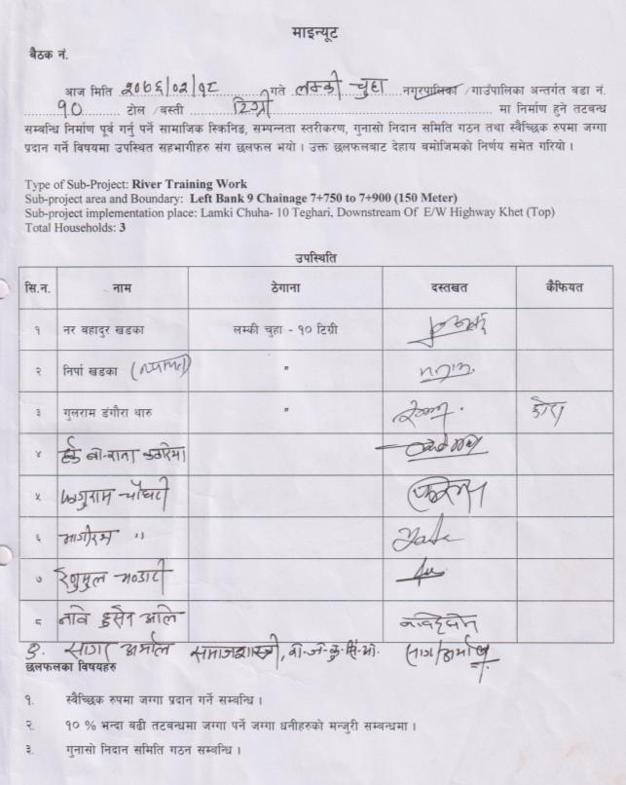
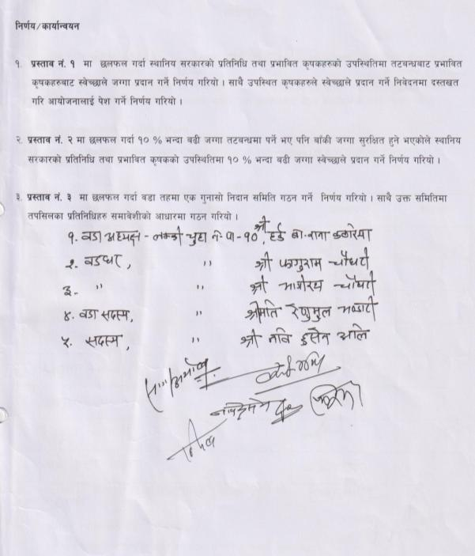

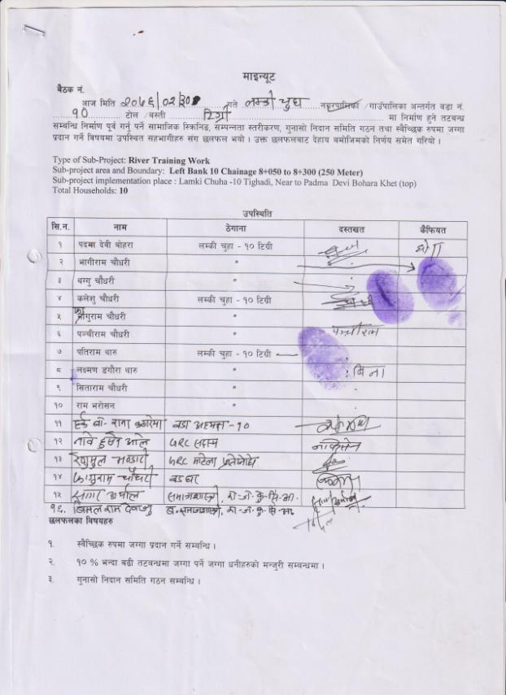
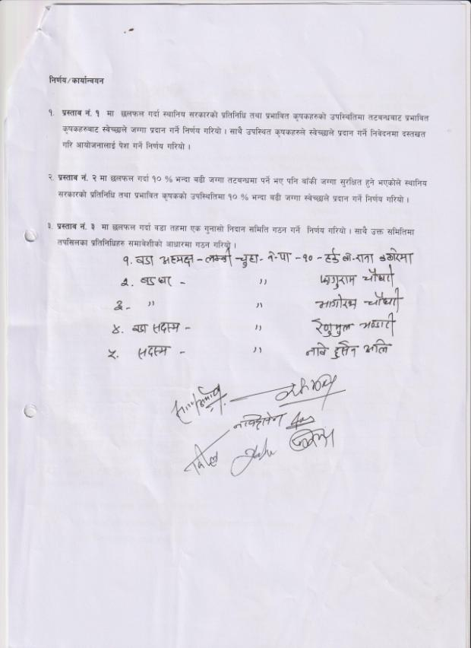

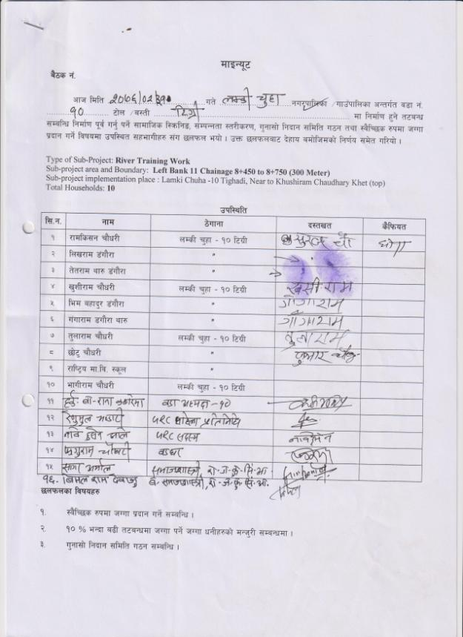
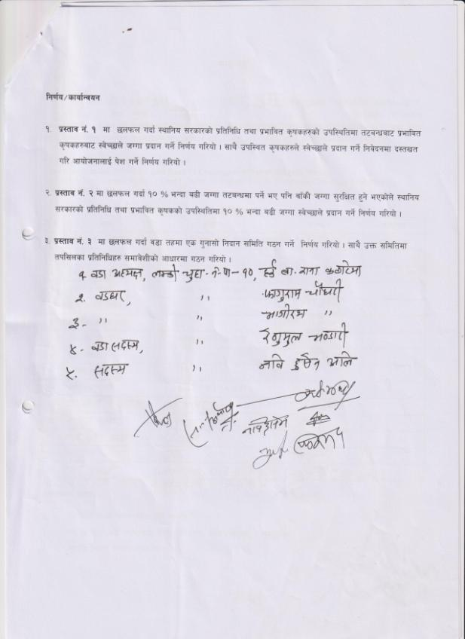

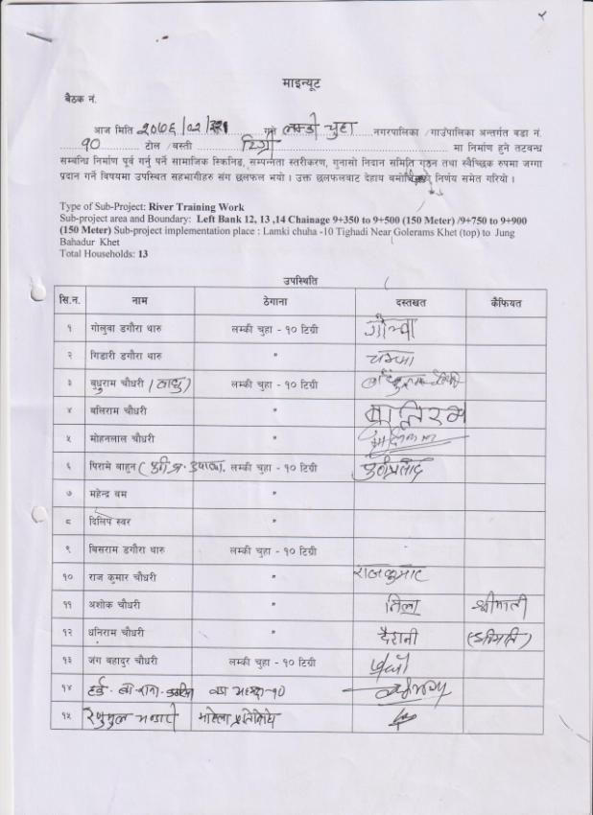
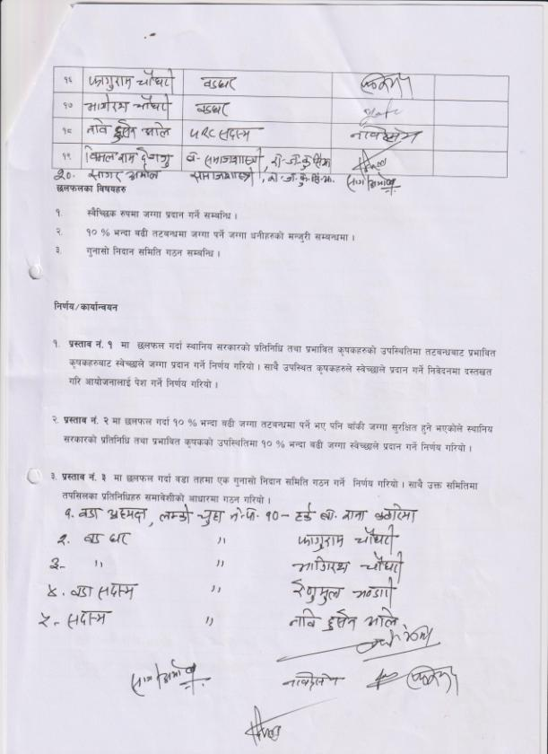

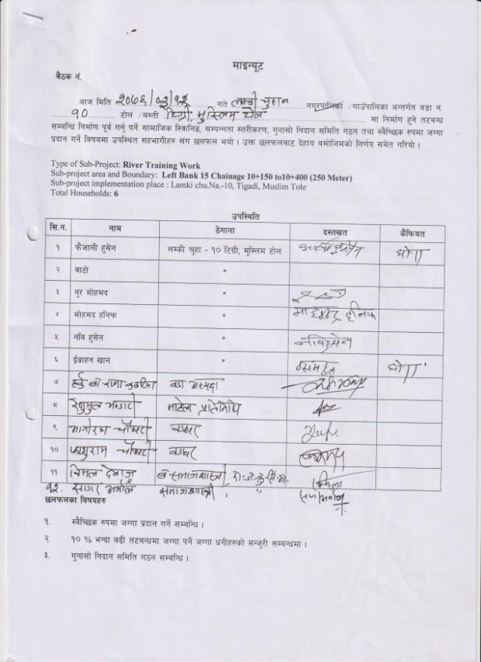
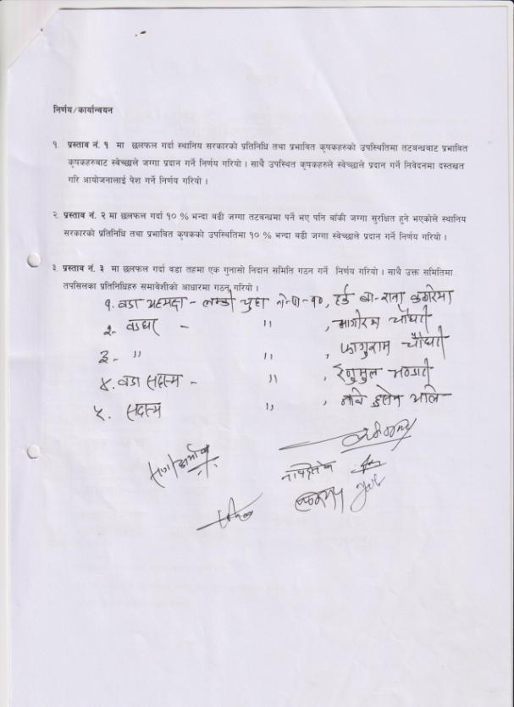

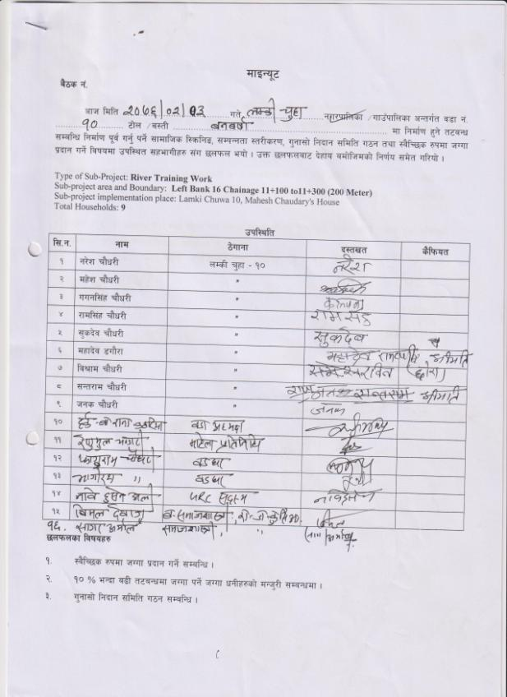
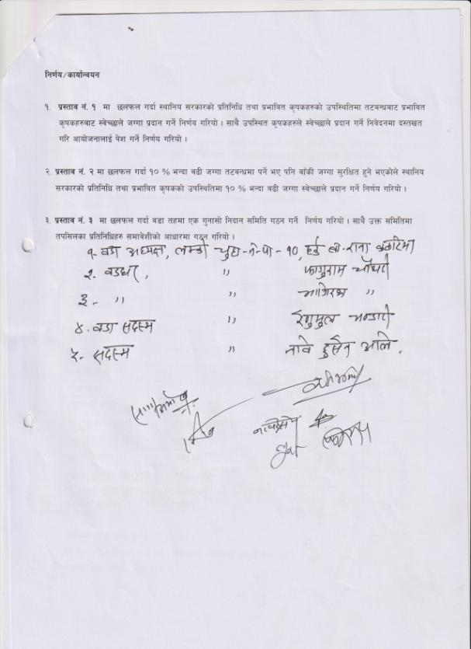

2: Lamki Chuwa Municipality 9 (LB)
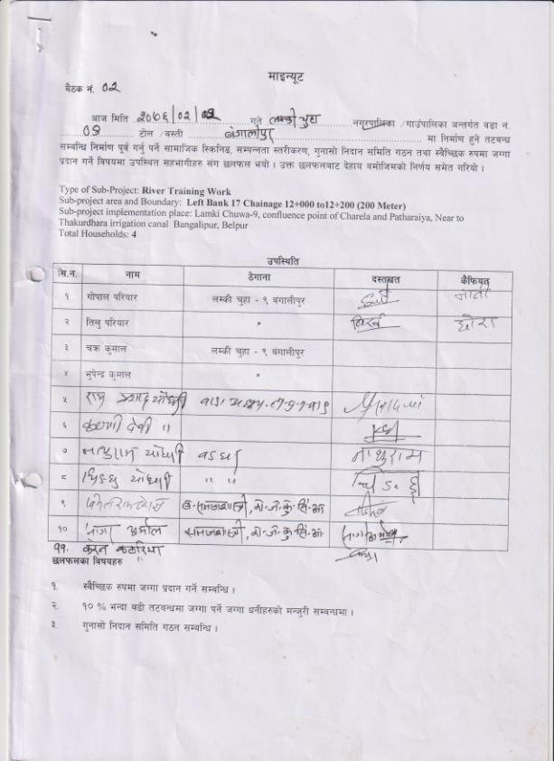
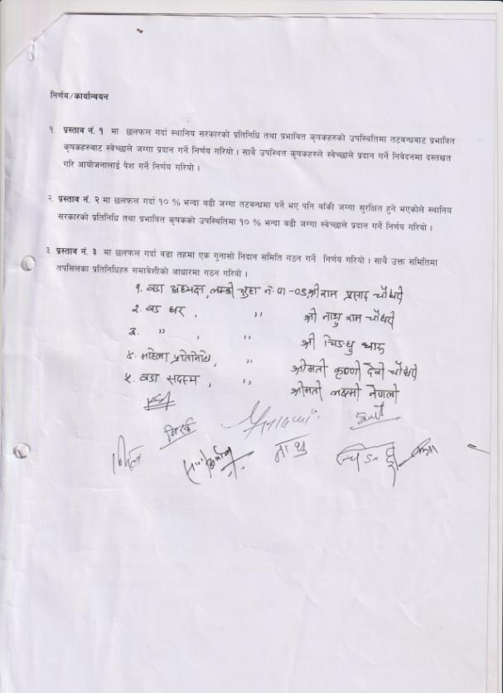

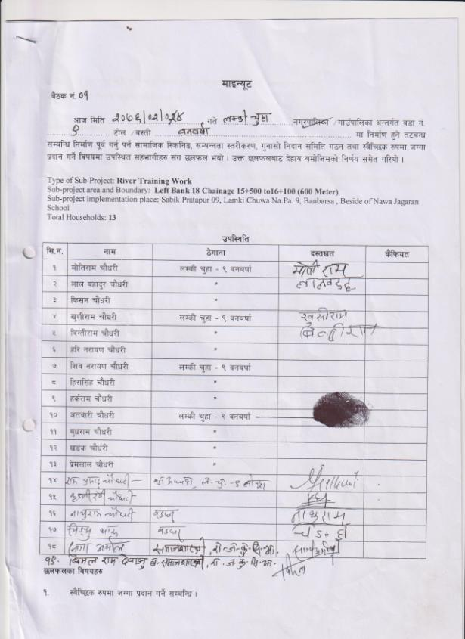
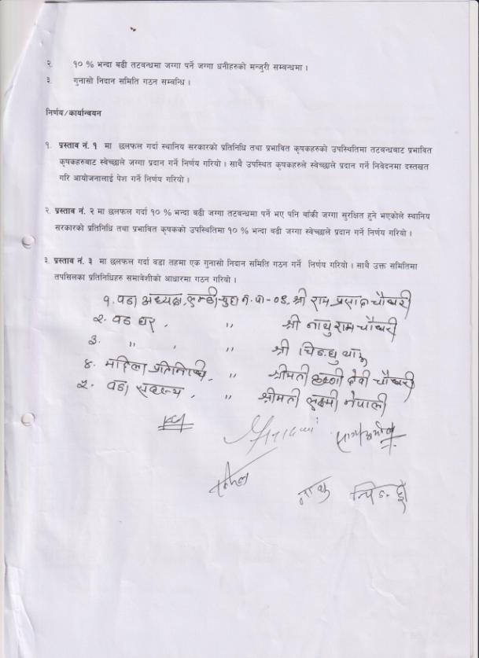

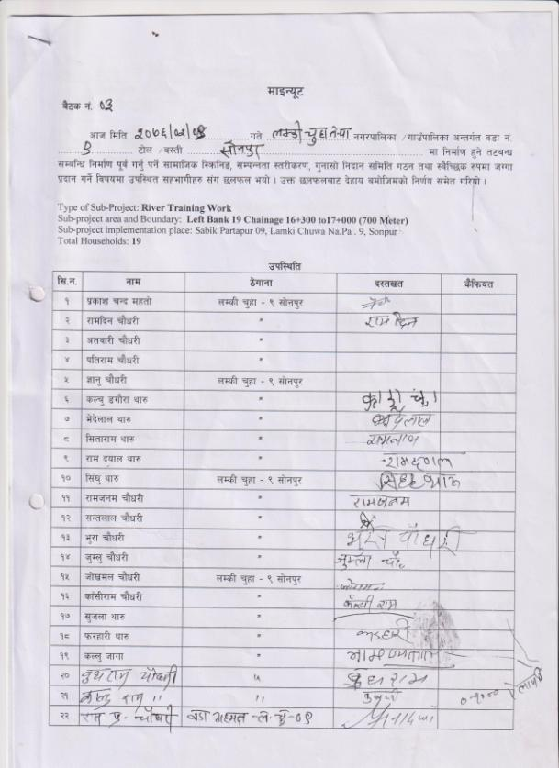
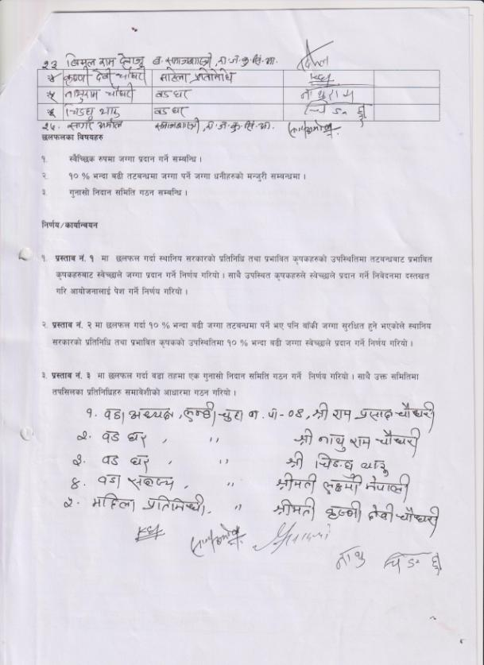

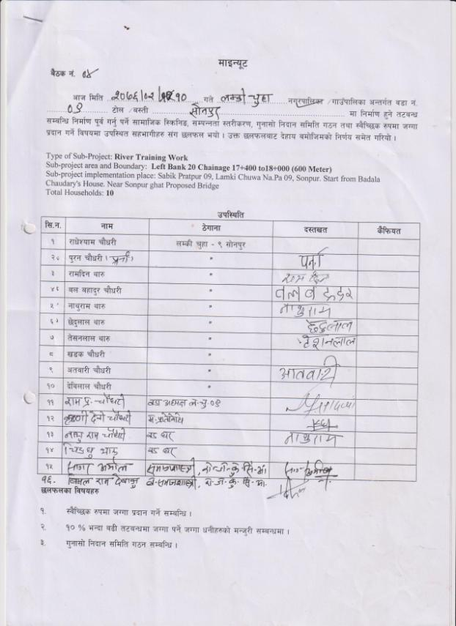
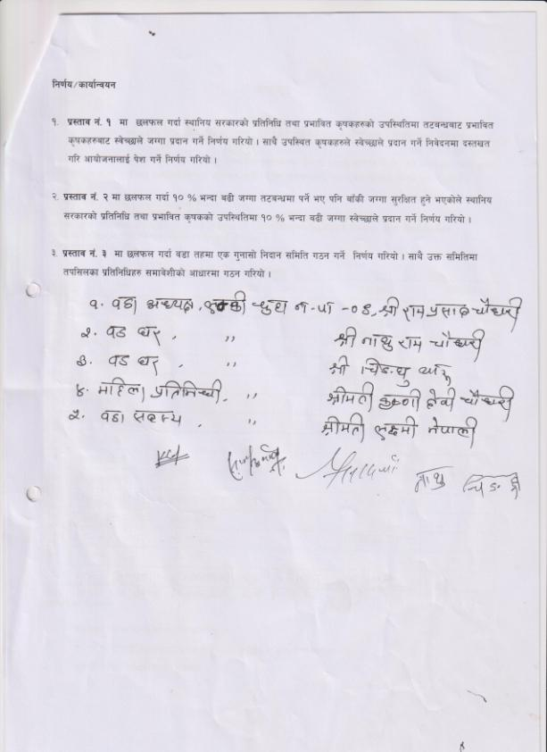

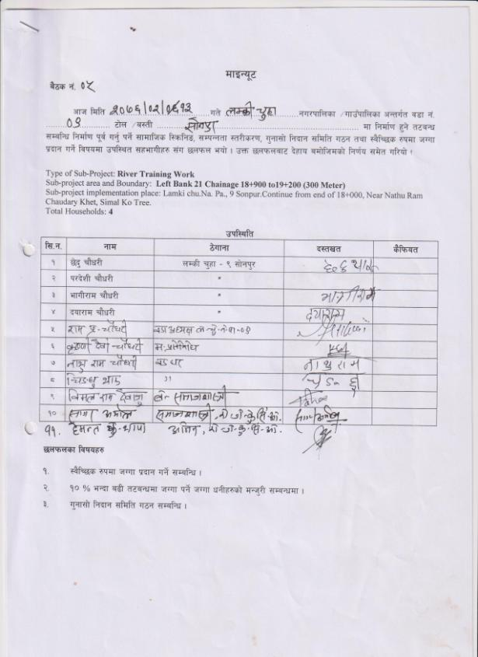
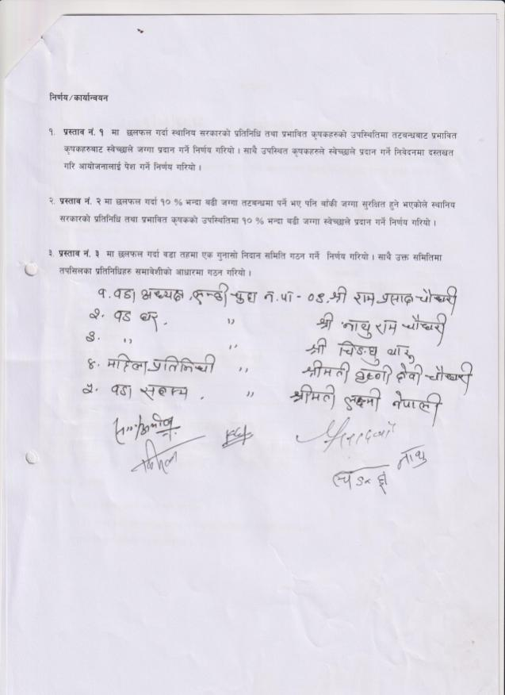

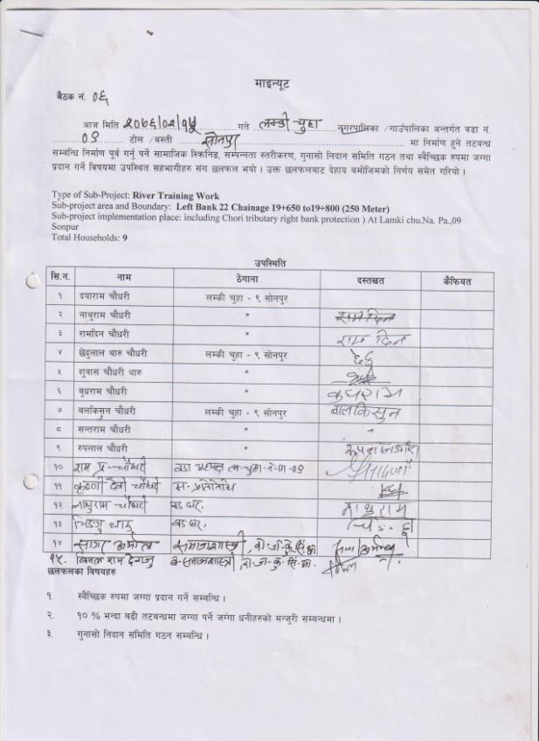
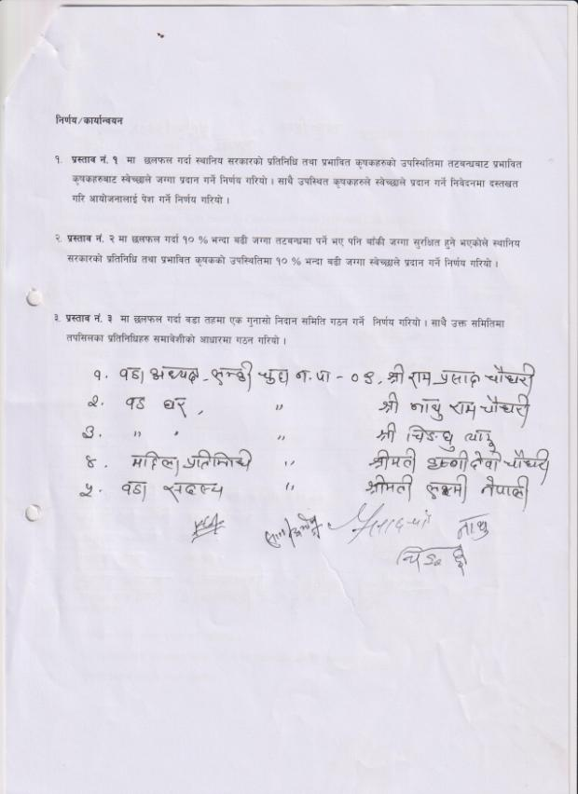

3: Janaki RM 02 (LB)
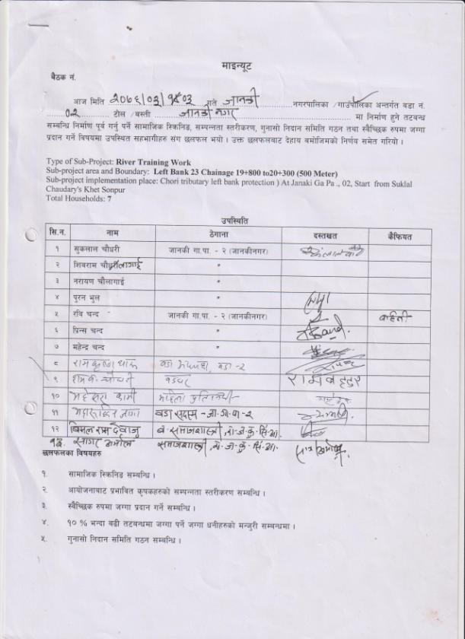
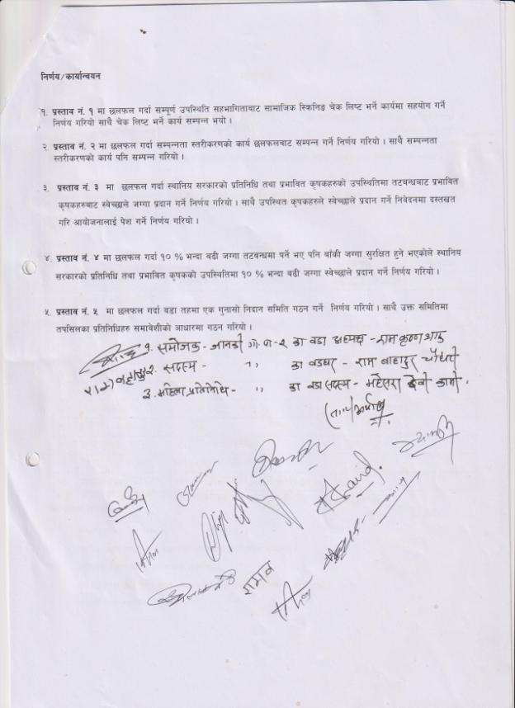

4: Janaki RM 04 (LB)

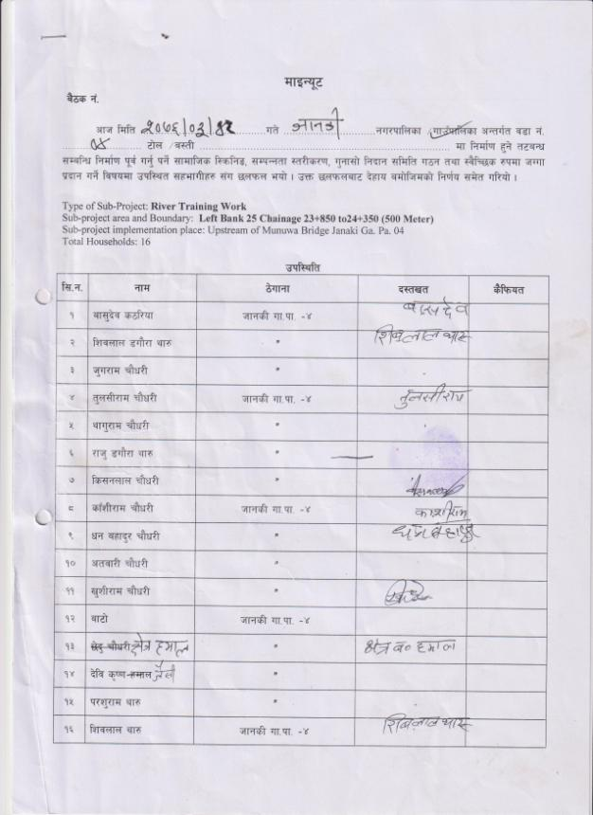
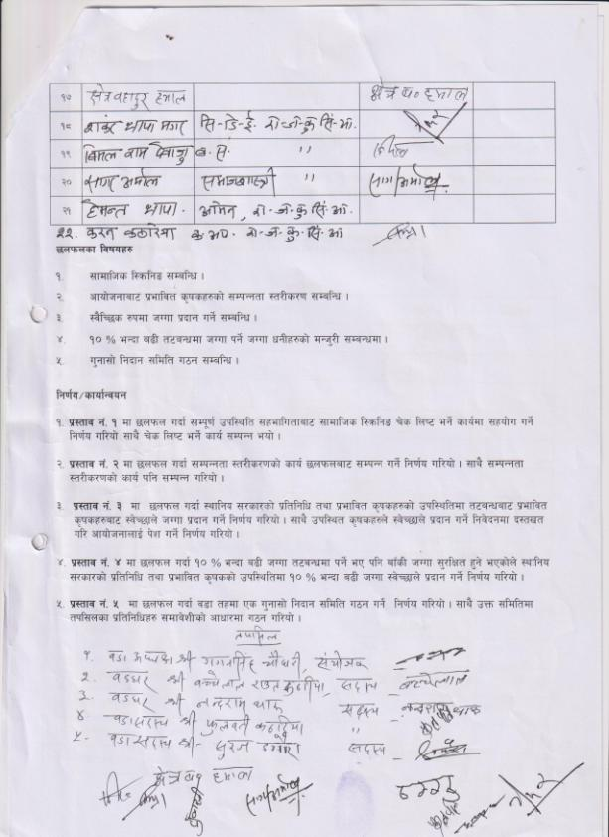

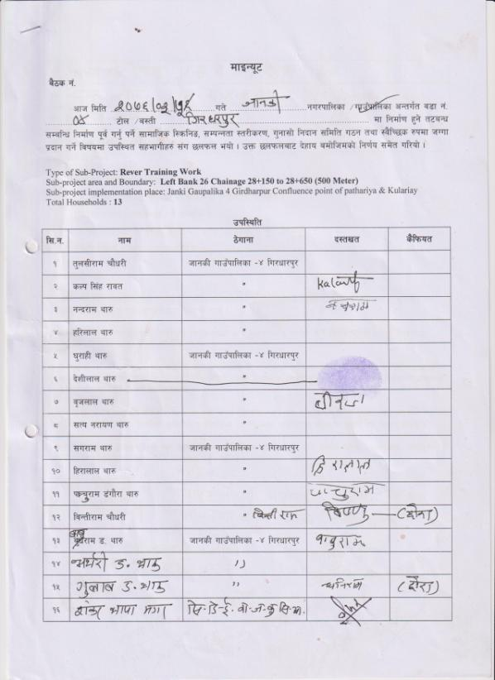
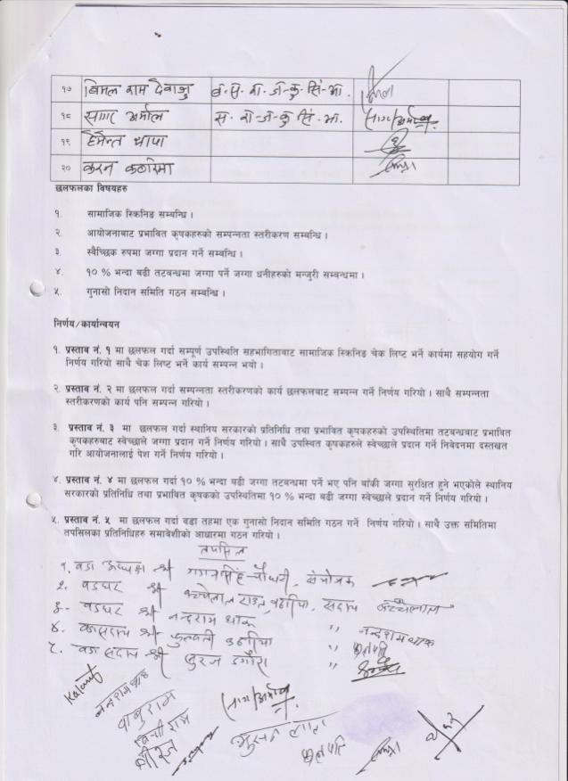

5: Janaki RM 07 (LB)
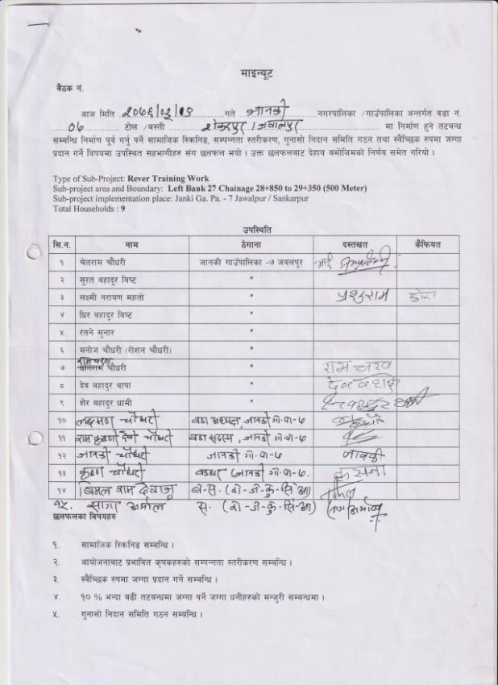
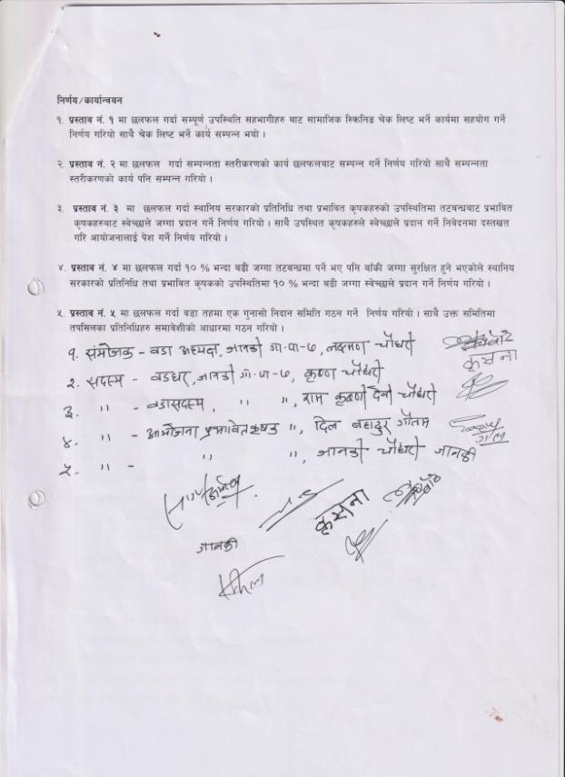

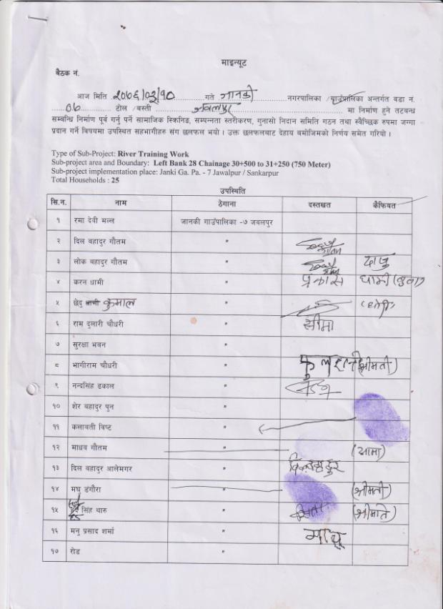
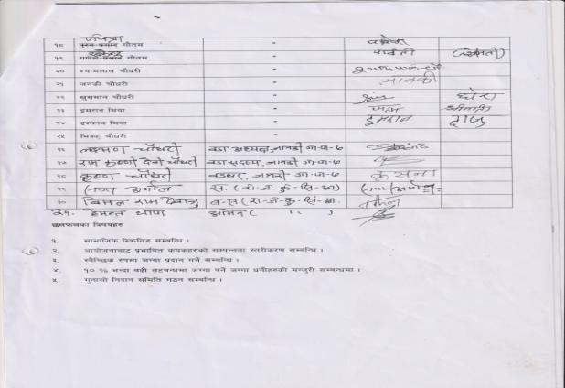
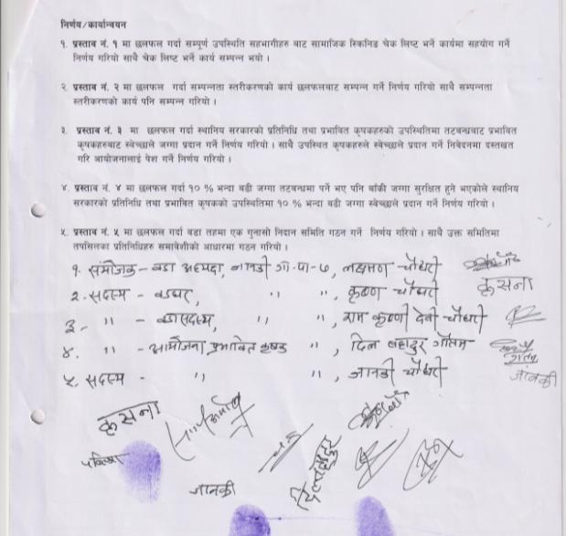

6: Tikapur Municipality 06 (LB)
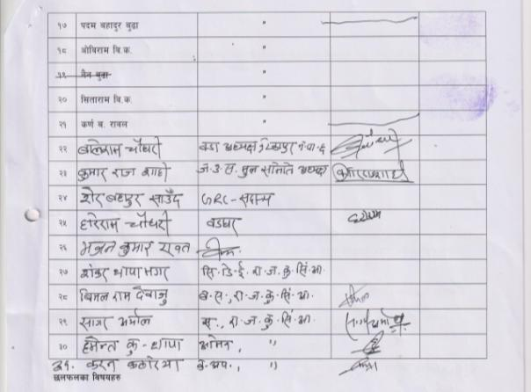
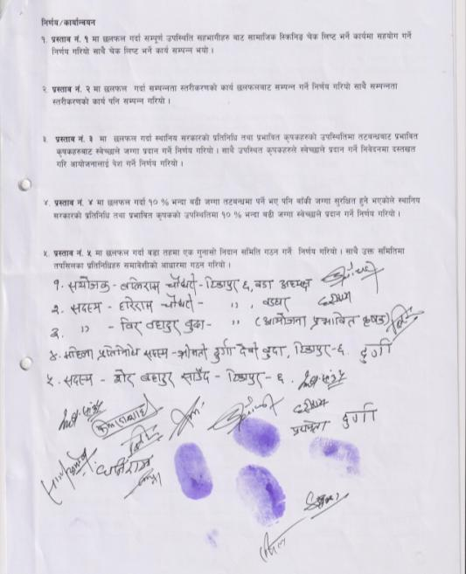

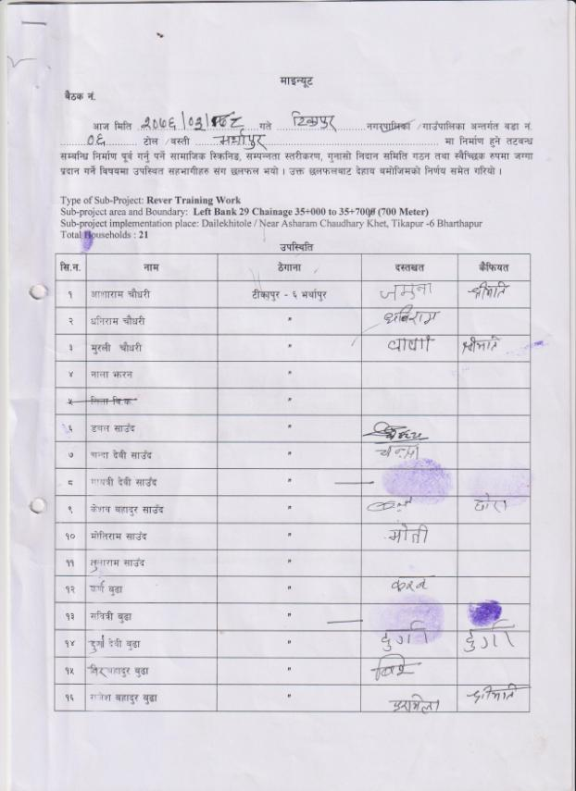

7: Joshipur RM 05 (RB)
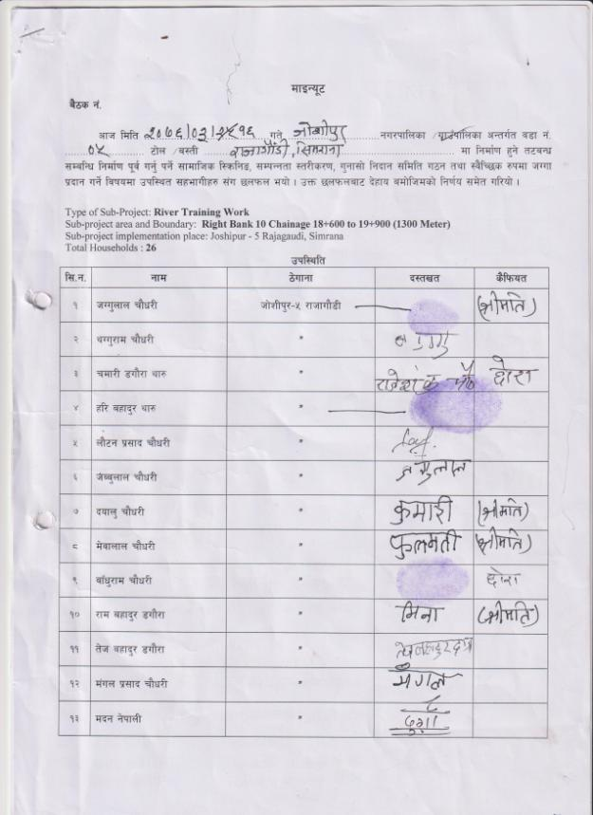
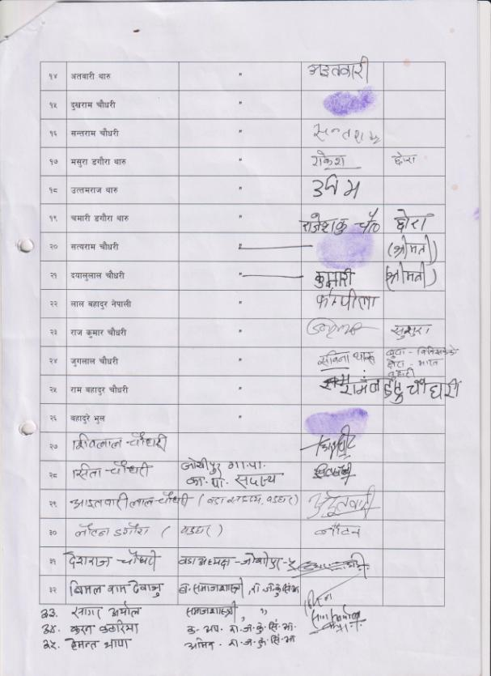
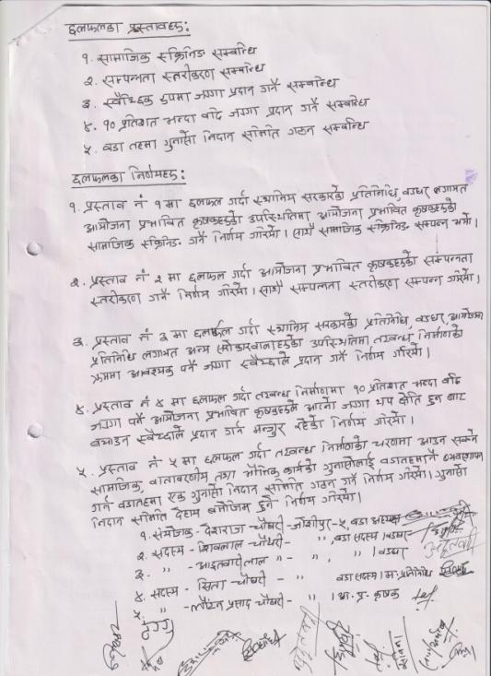

8: Joshipur RM 04 (RB)
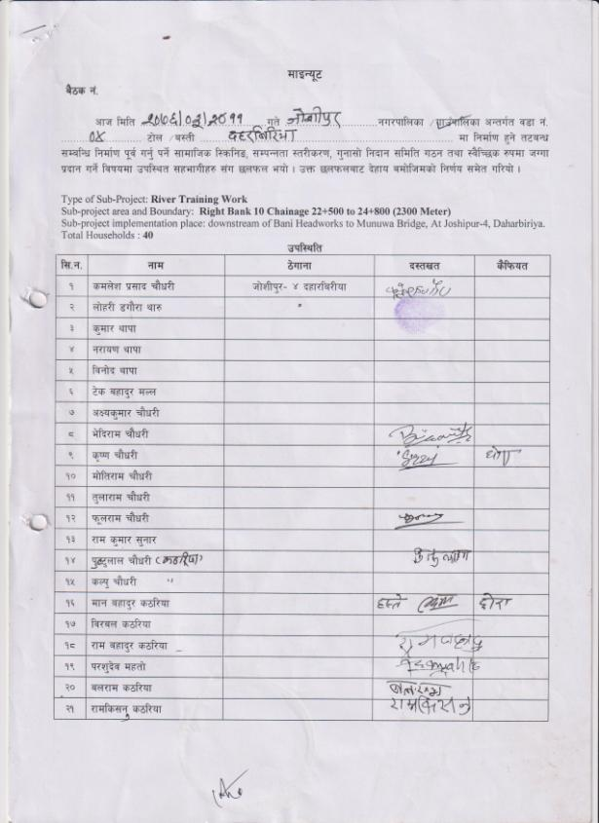
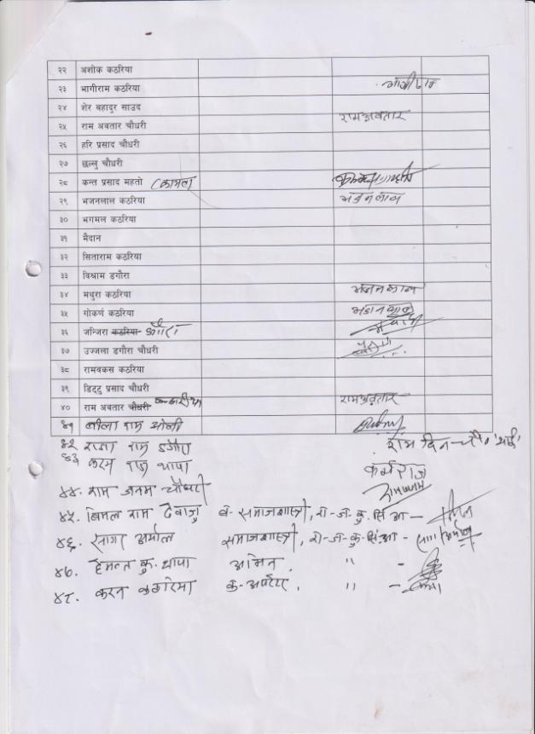
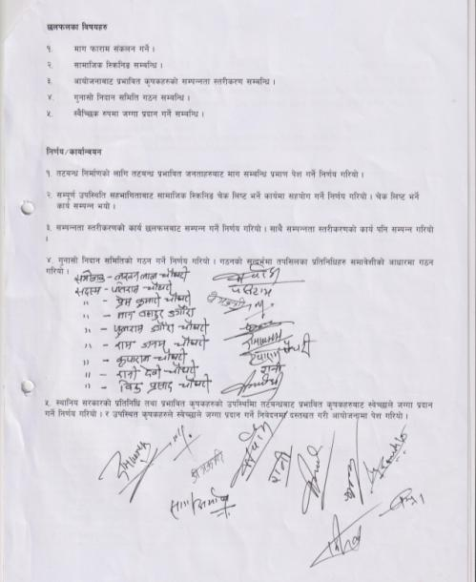

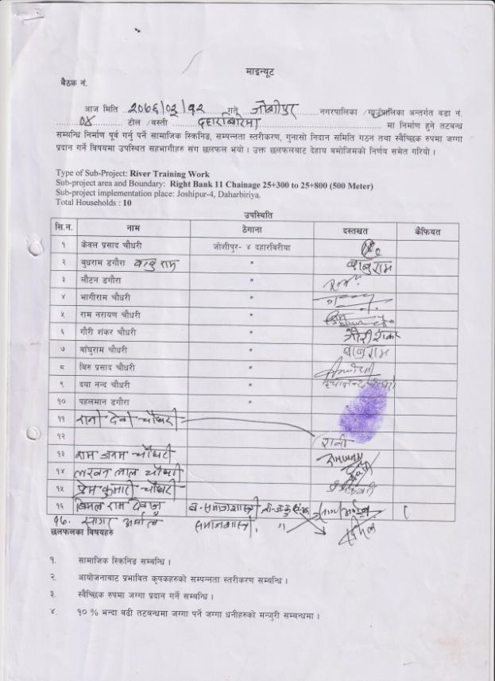
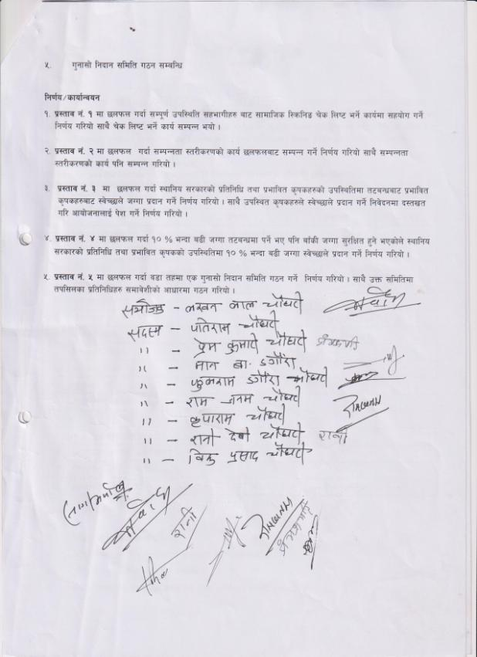

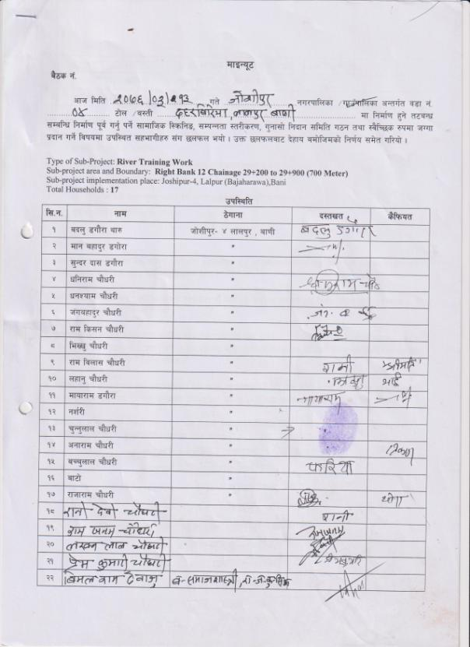
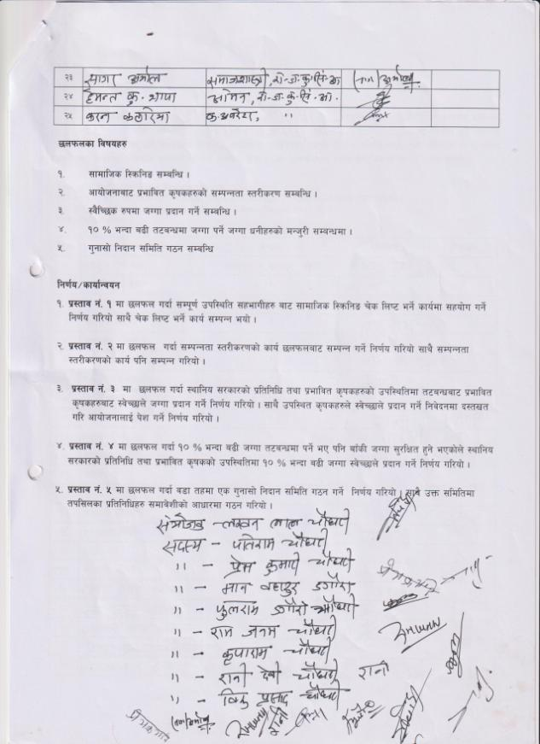

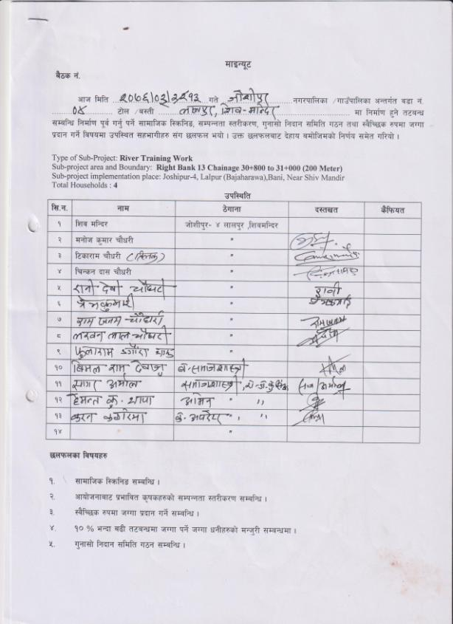
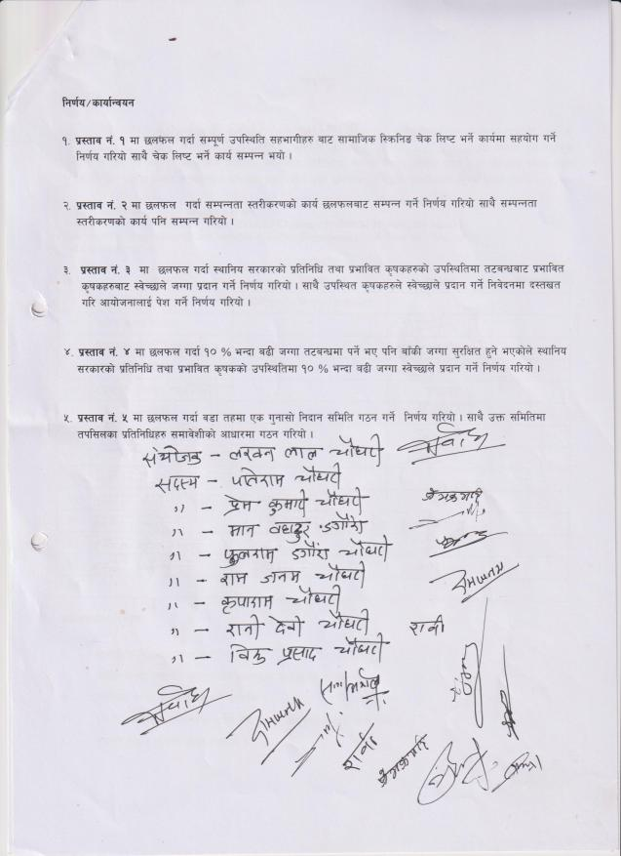

9: Bhajani RM 08 (RB)

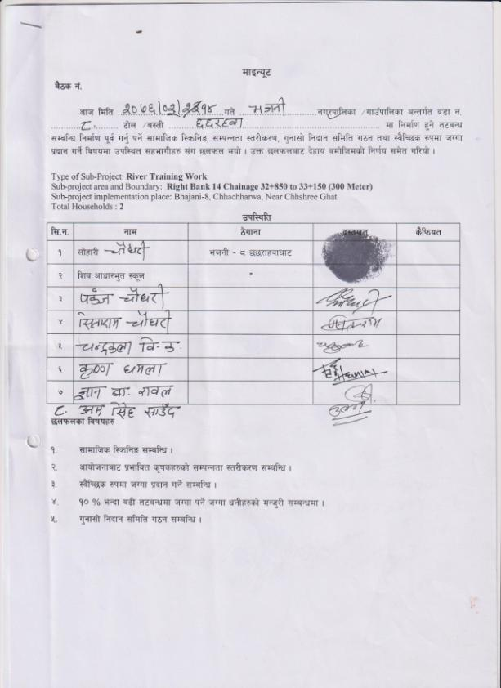
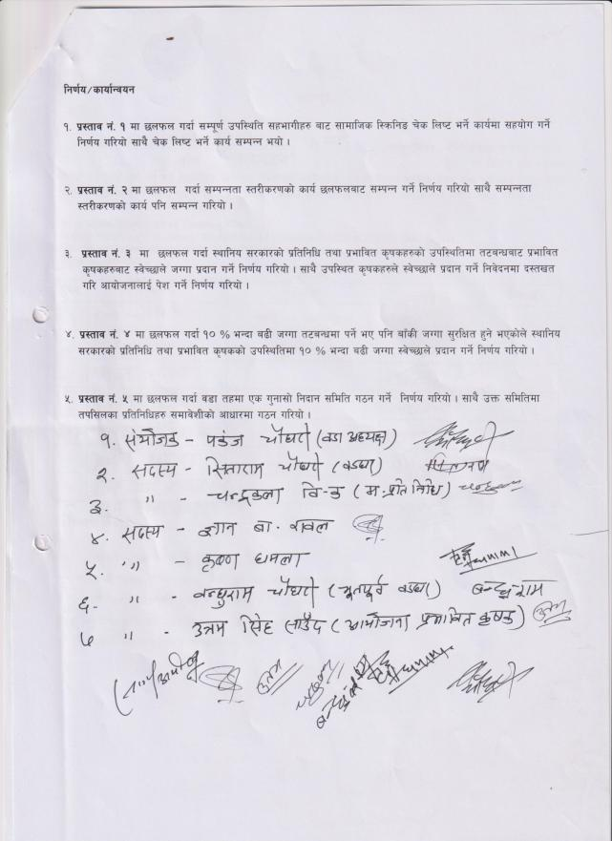

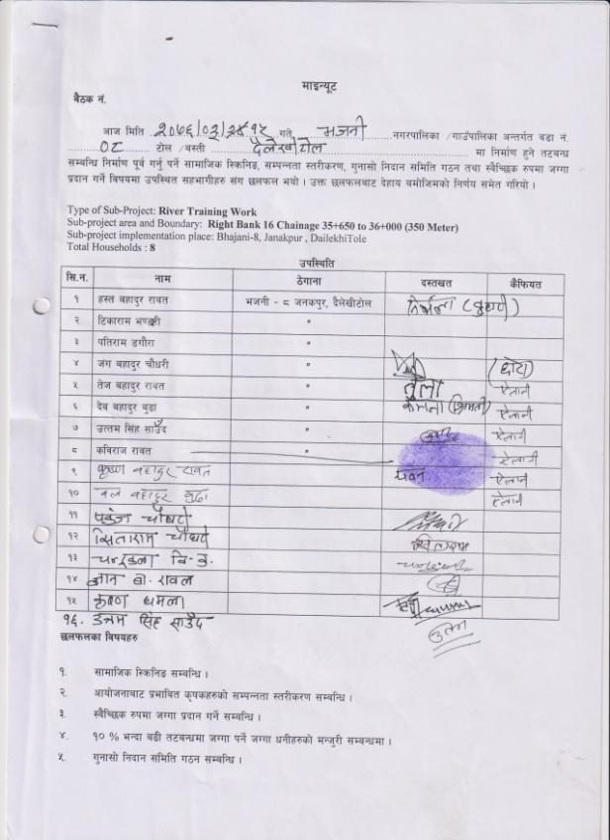
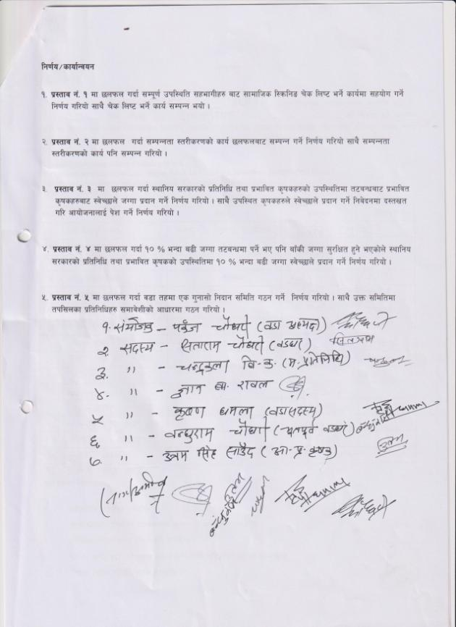

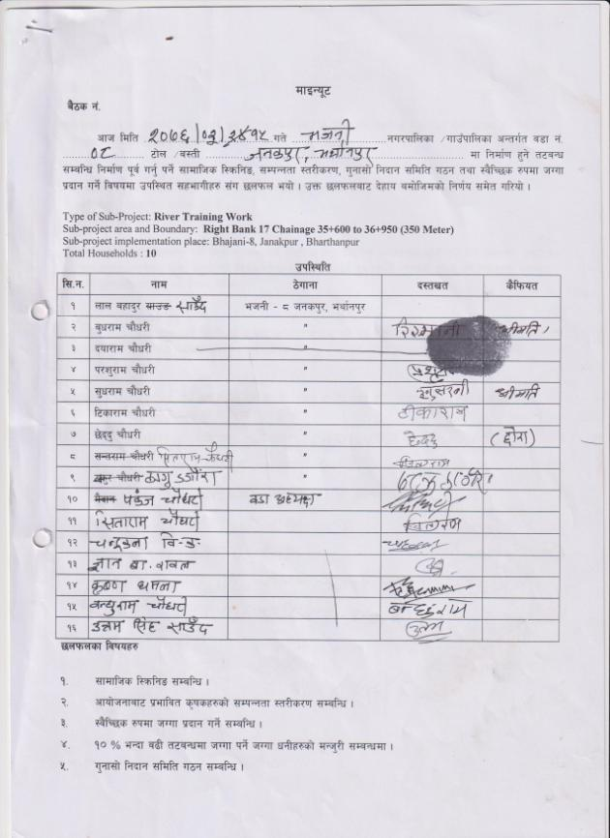
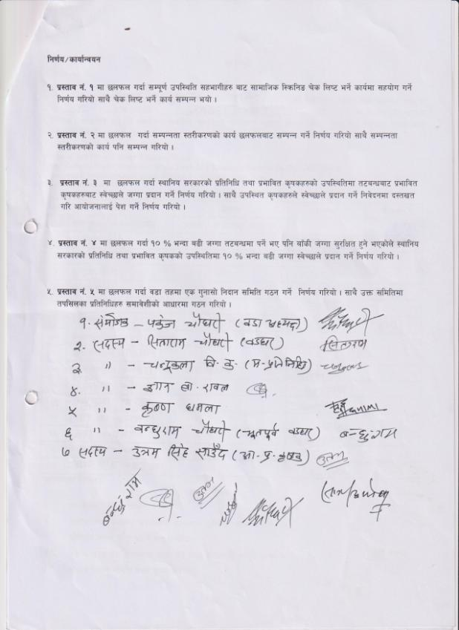

Annex 7: Land Donation Forms
1: Lamki Chuwa Municipality Ward No. 10(LB)
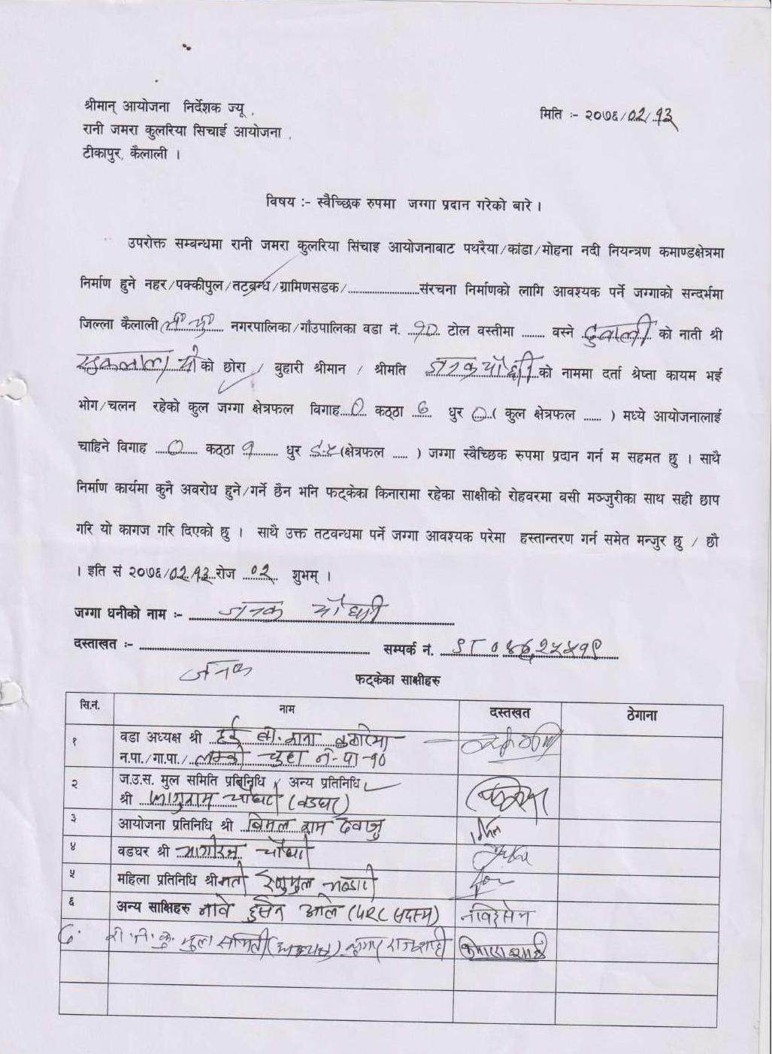
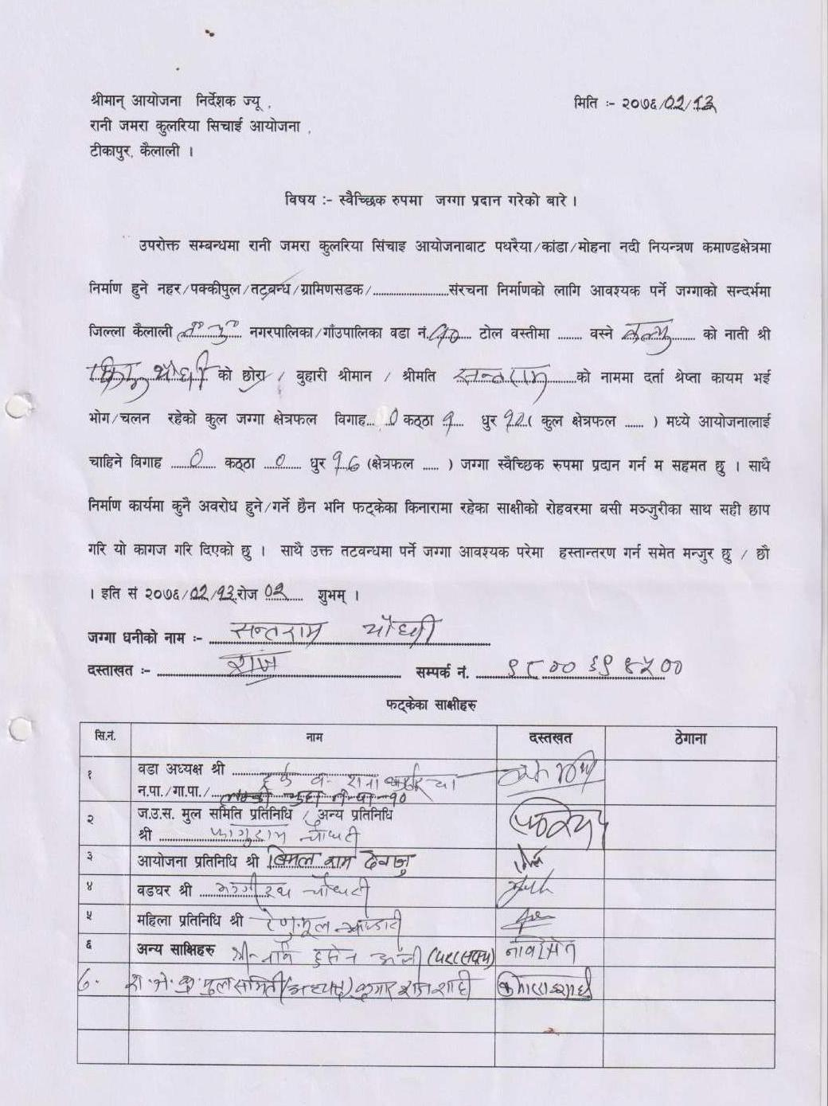

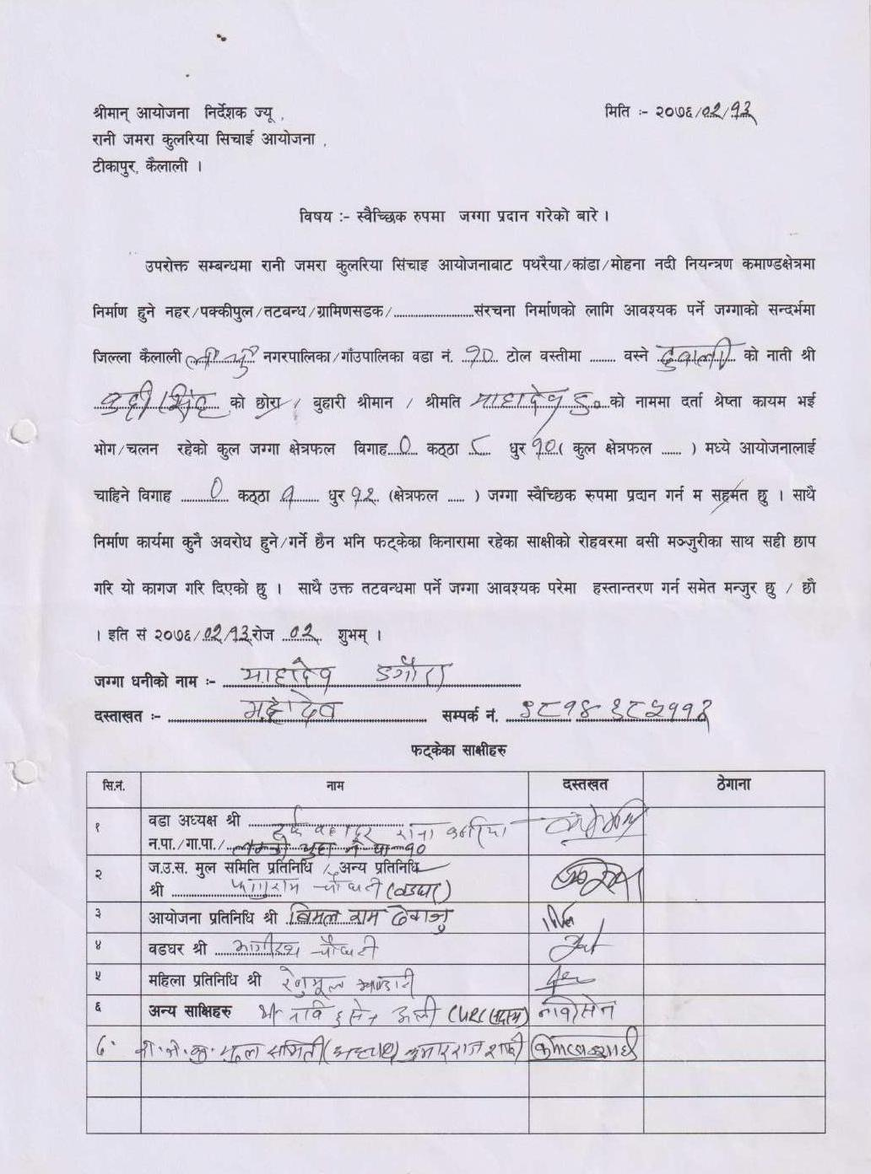
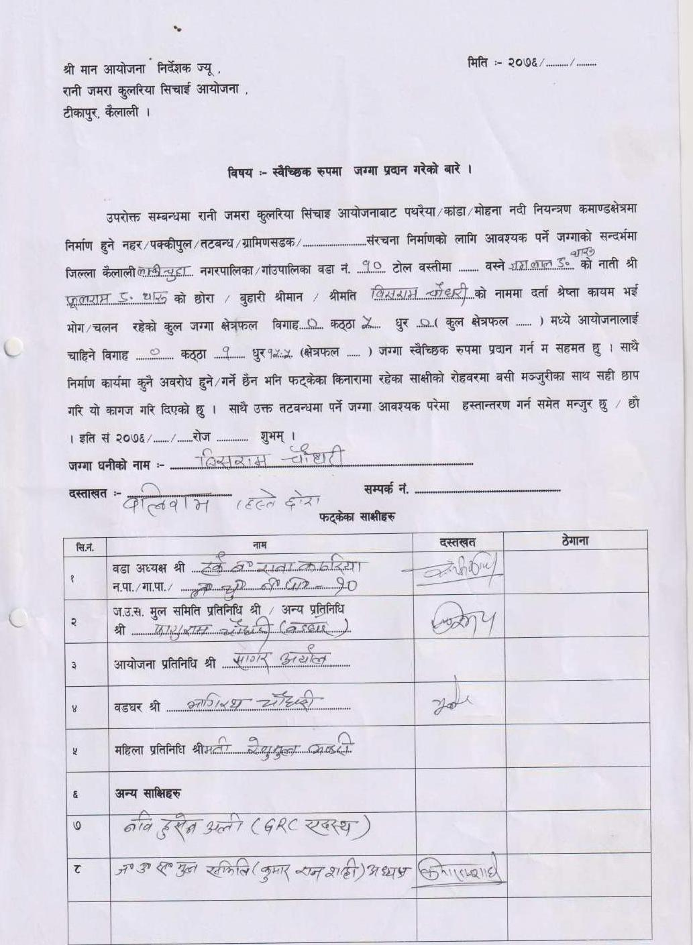

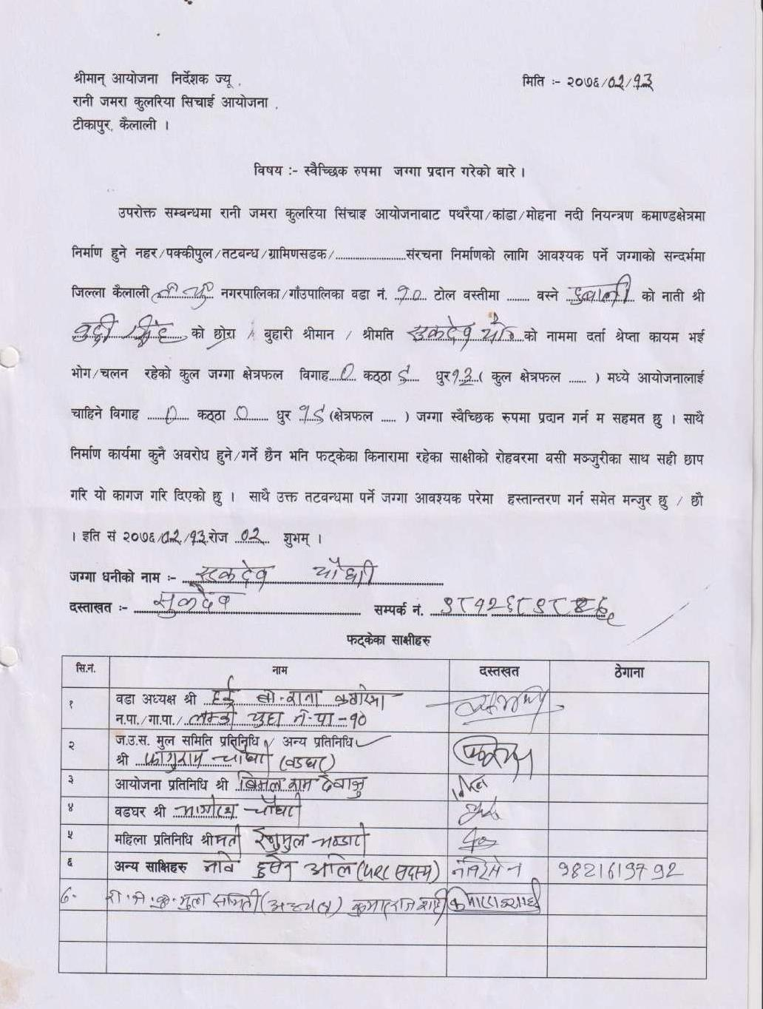
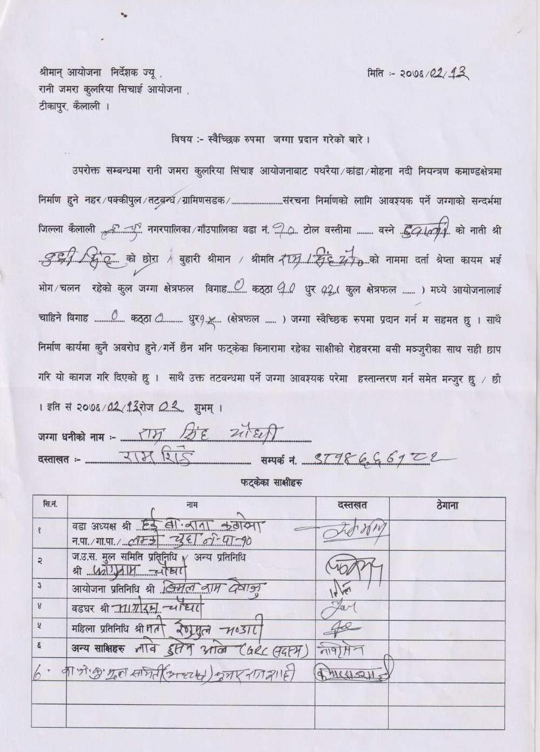

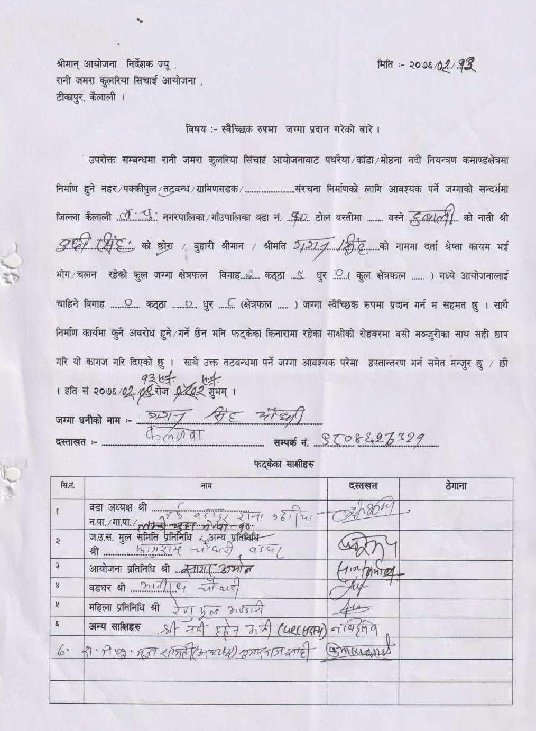
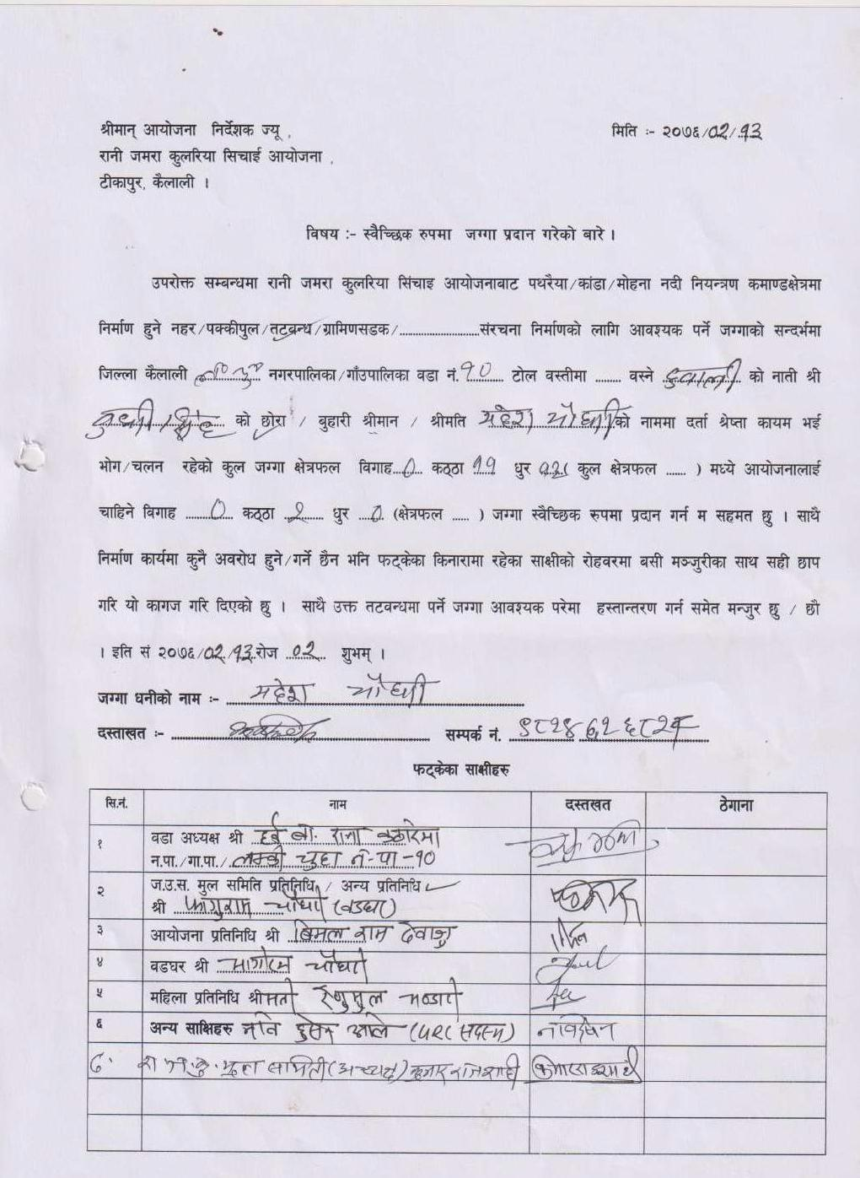

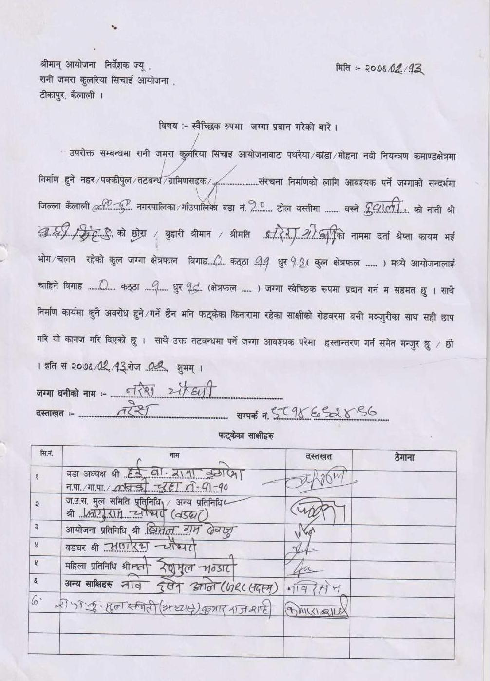
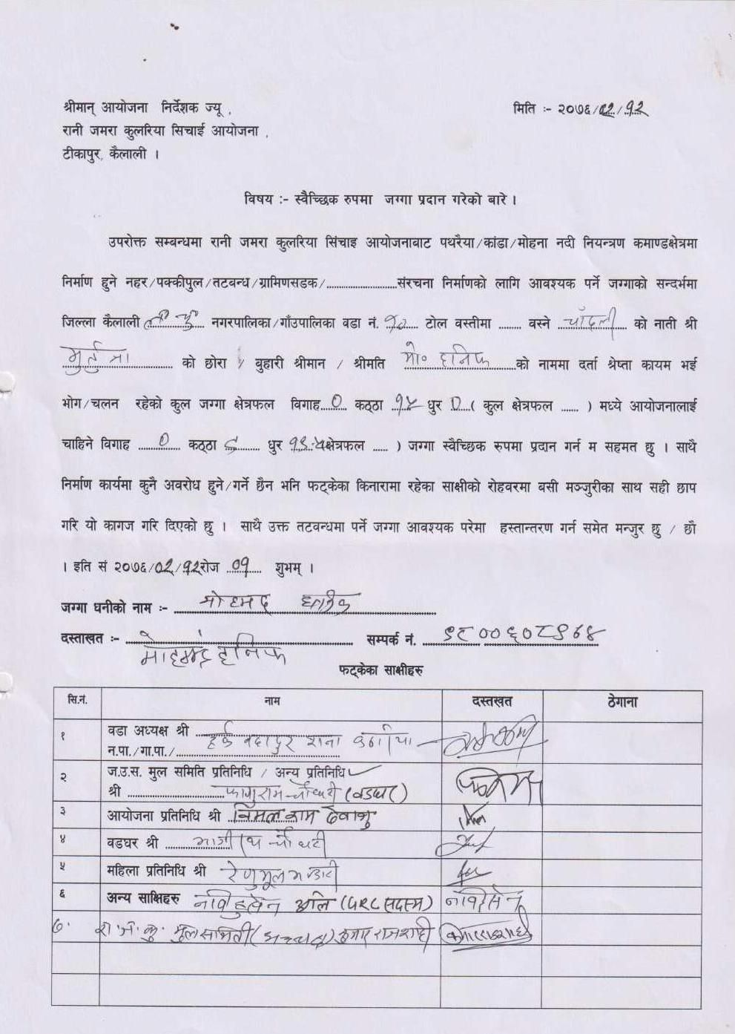

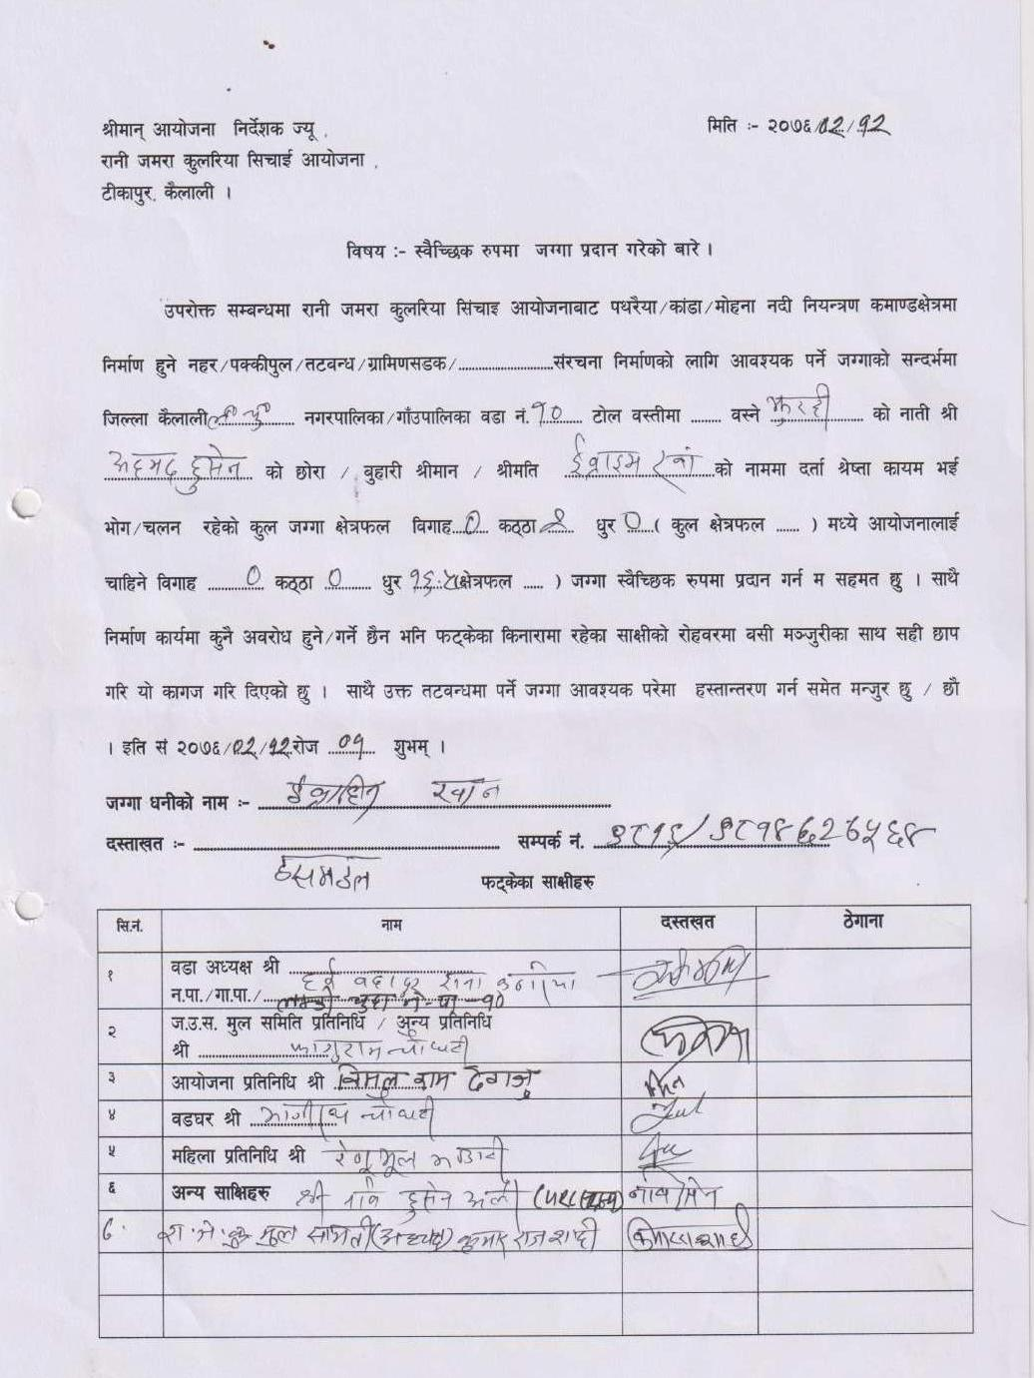
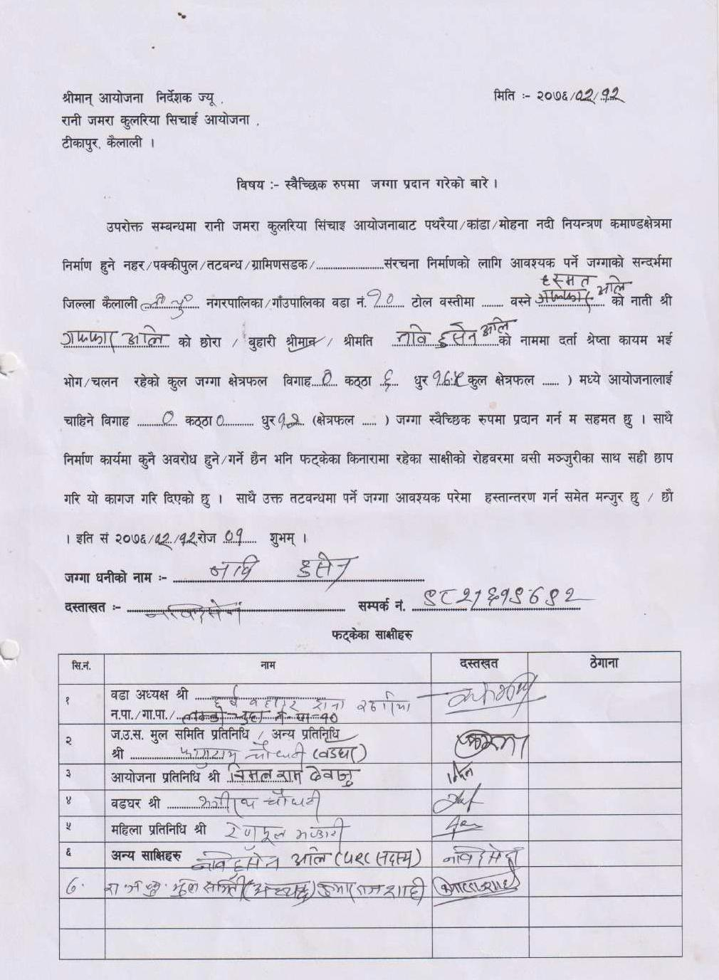

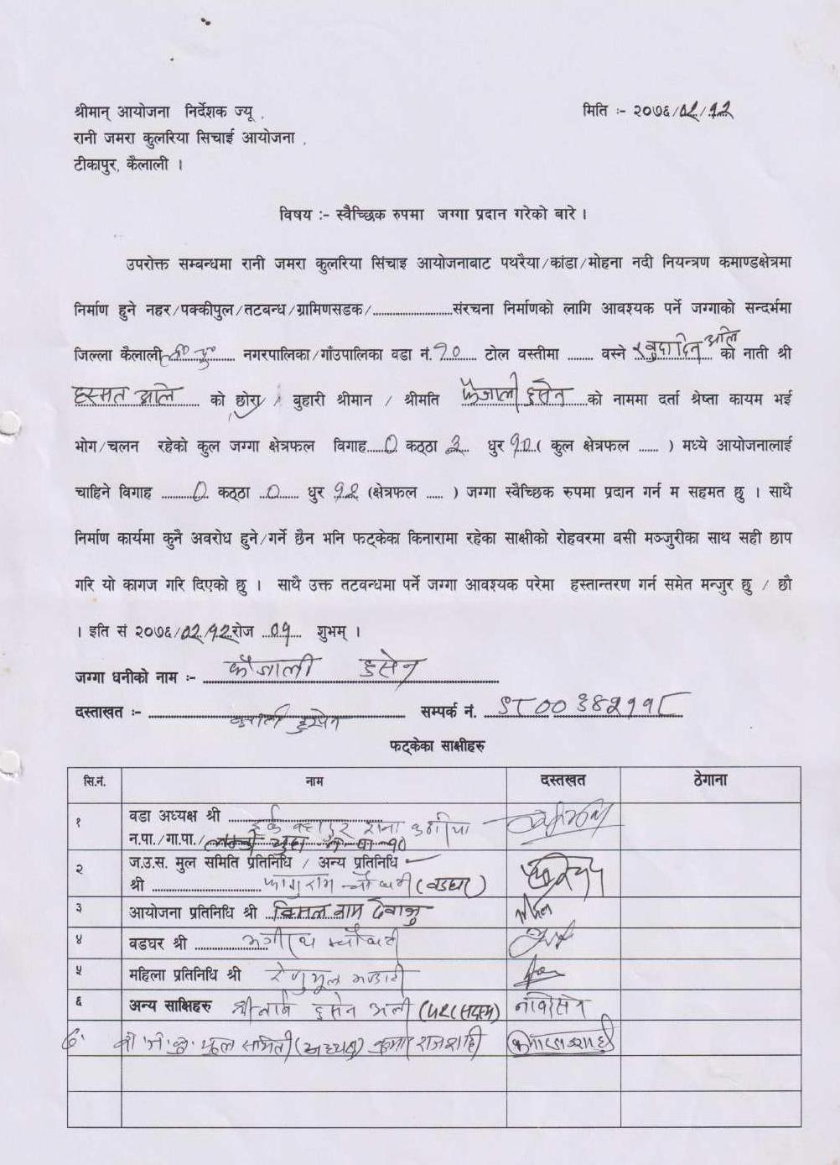
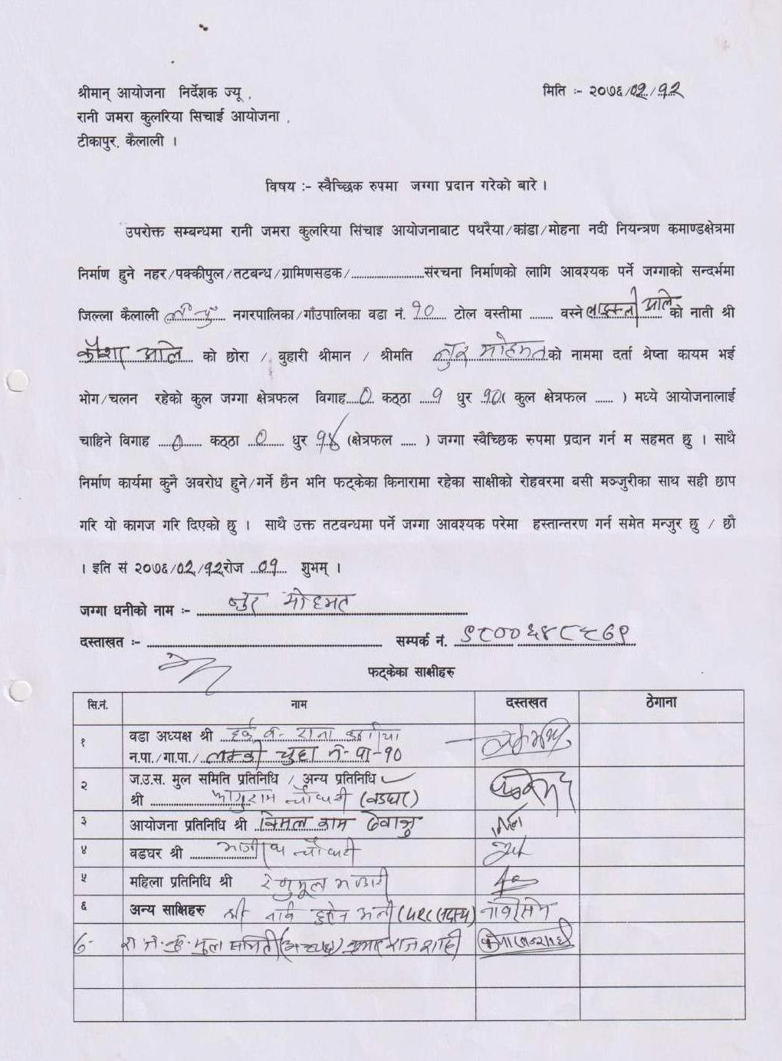

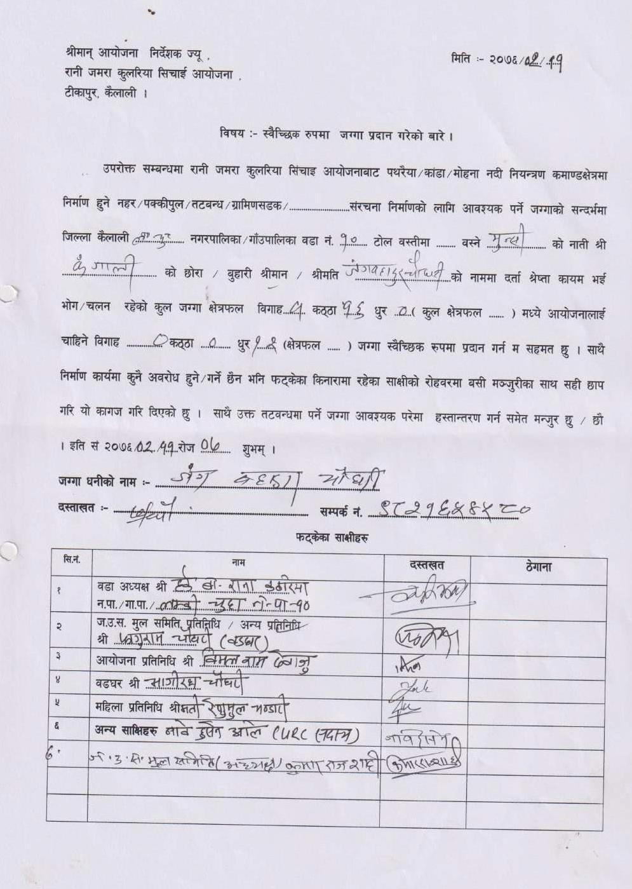
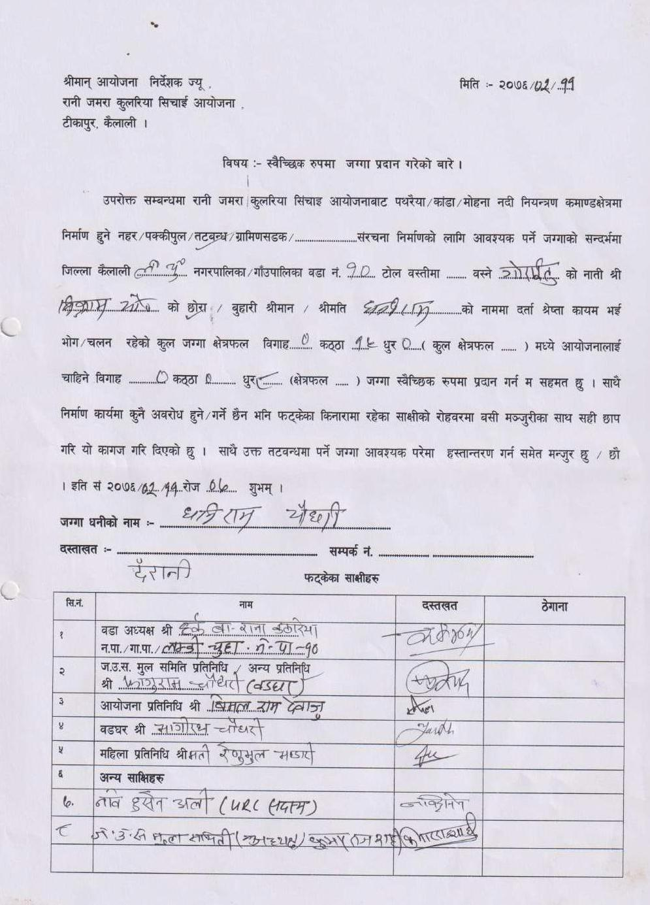

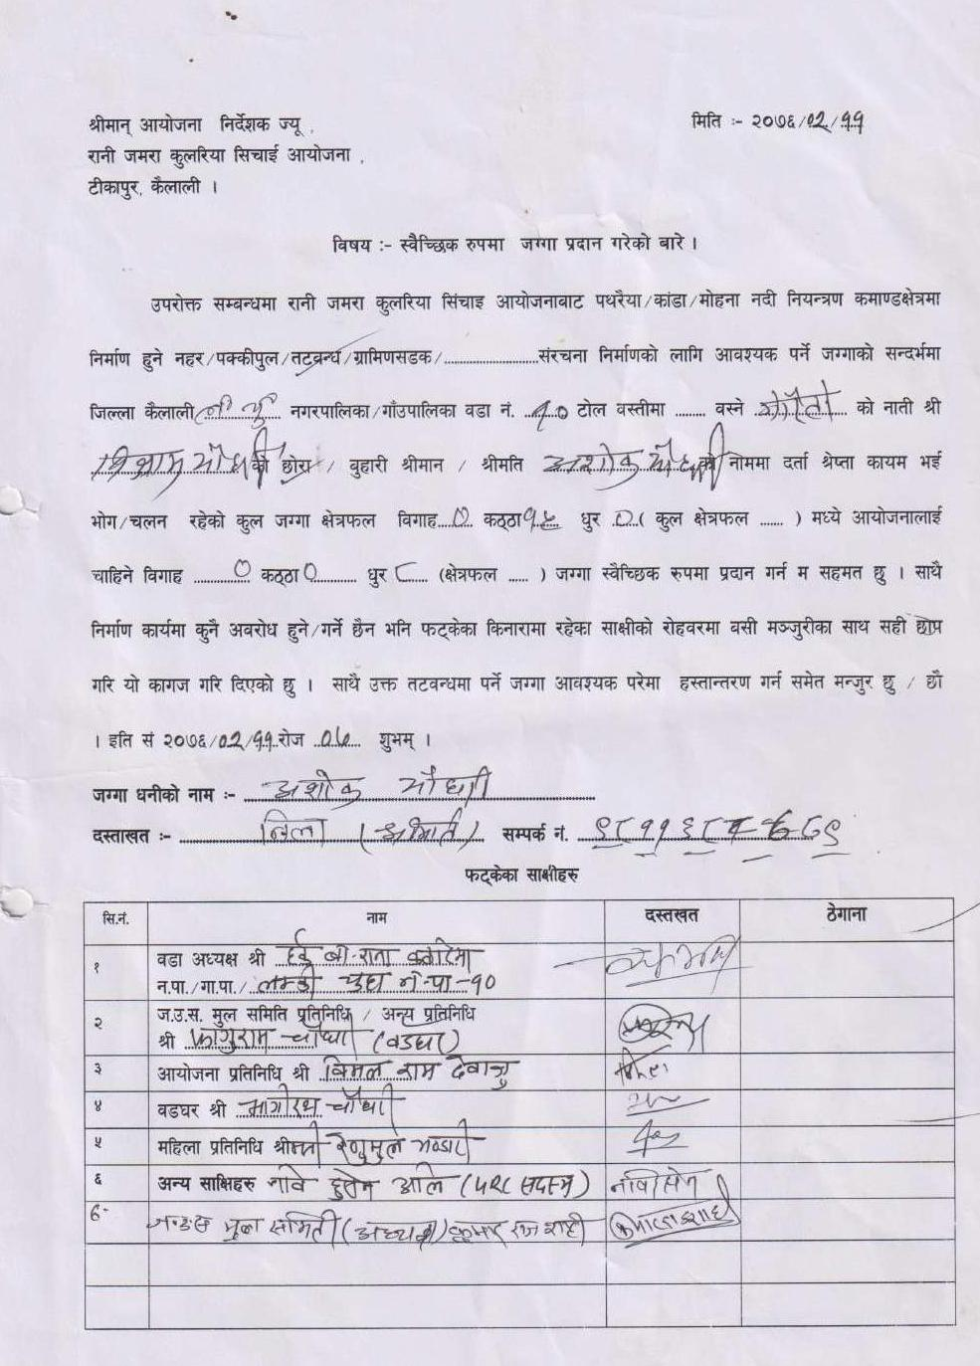
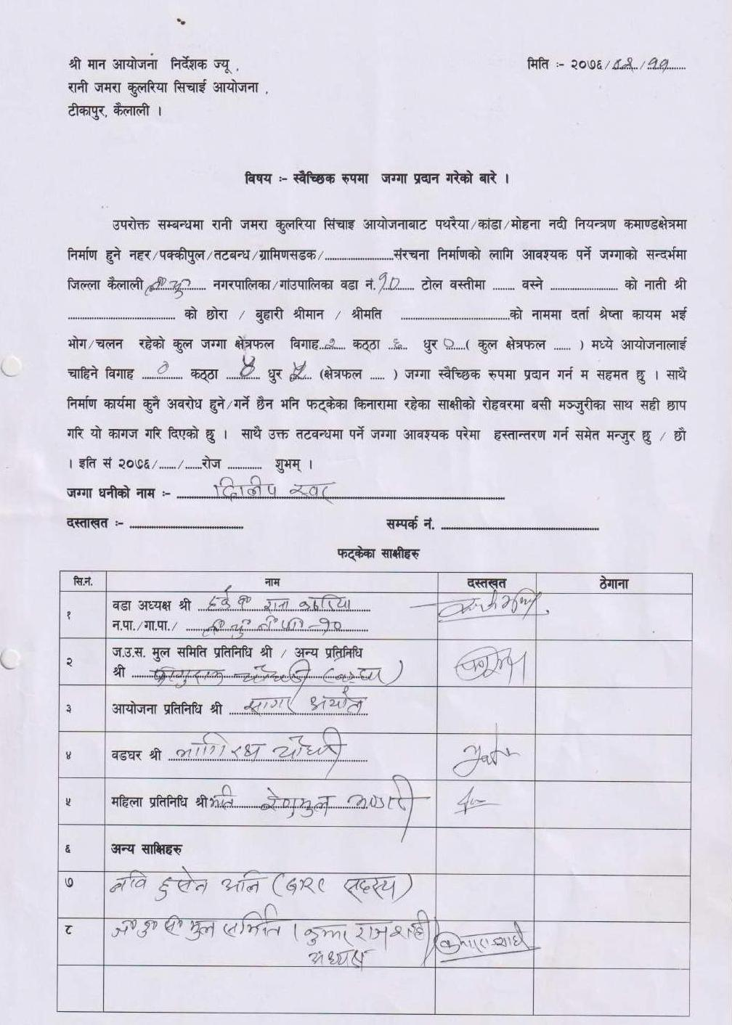

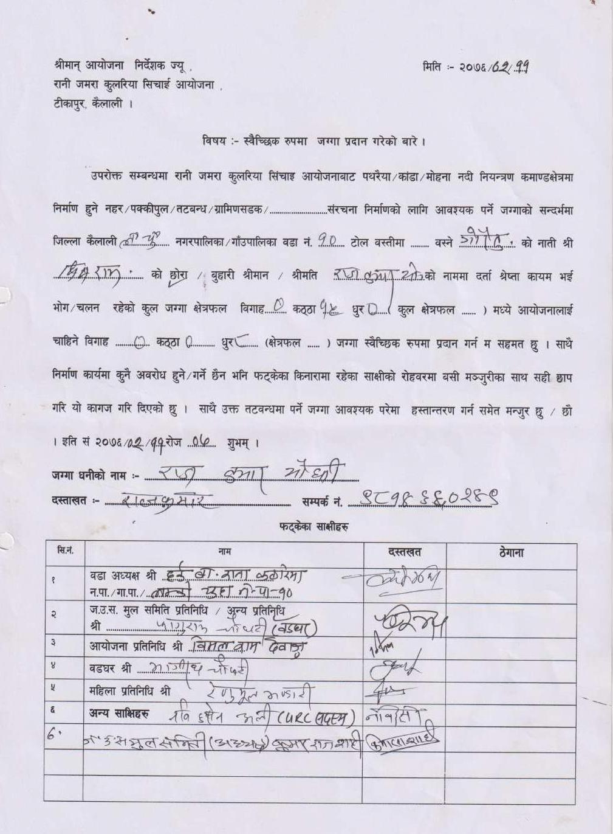
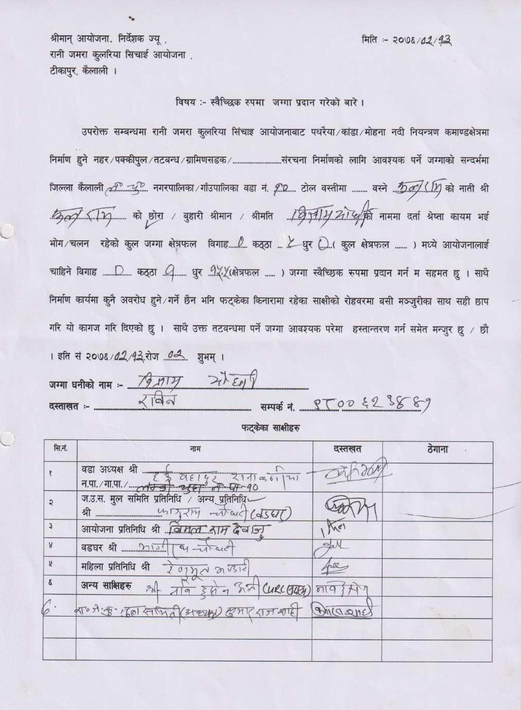

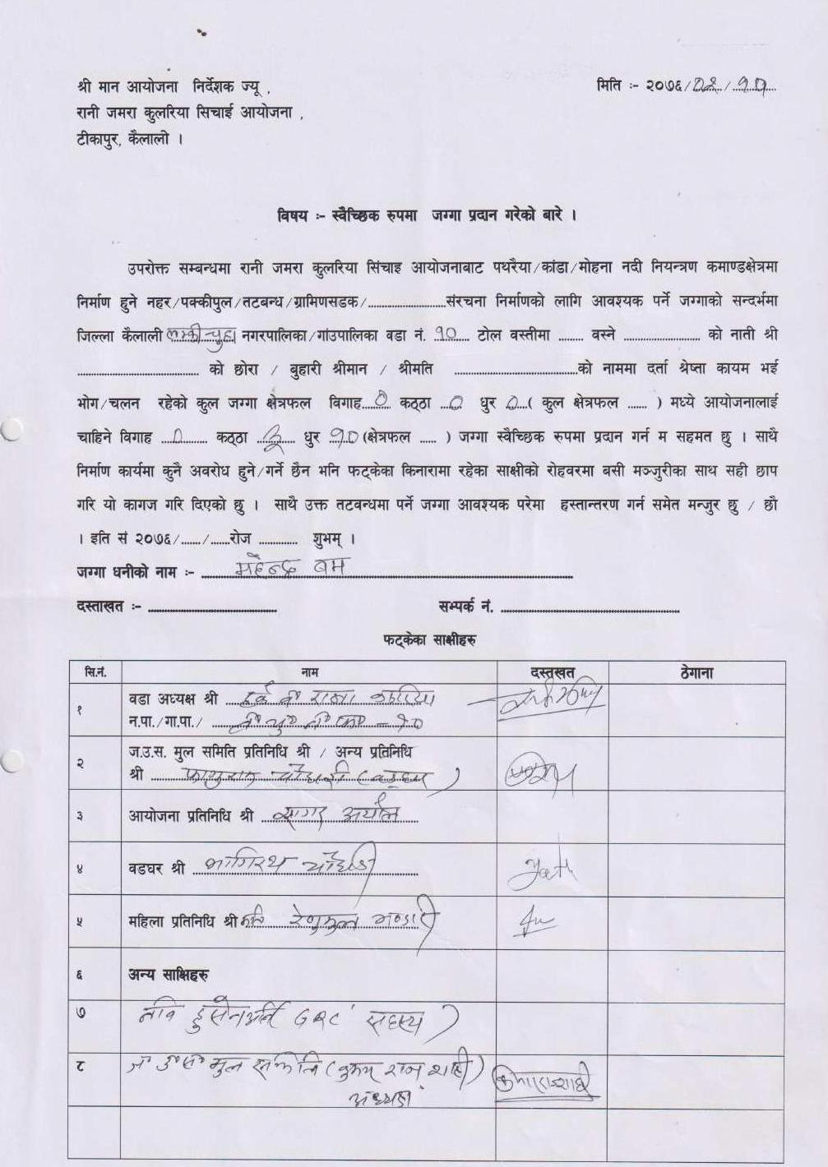
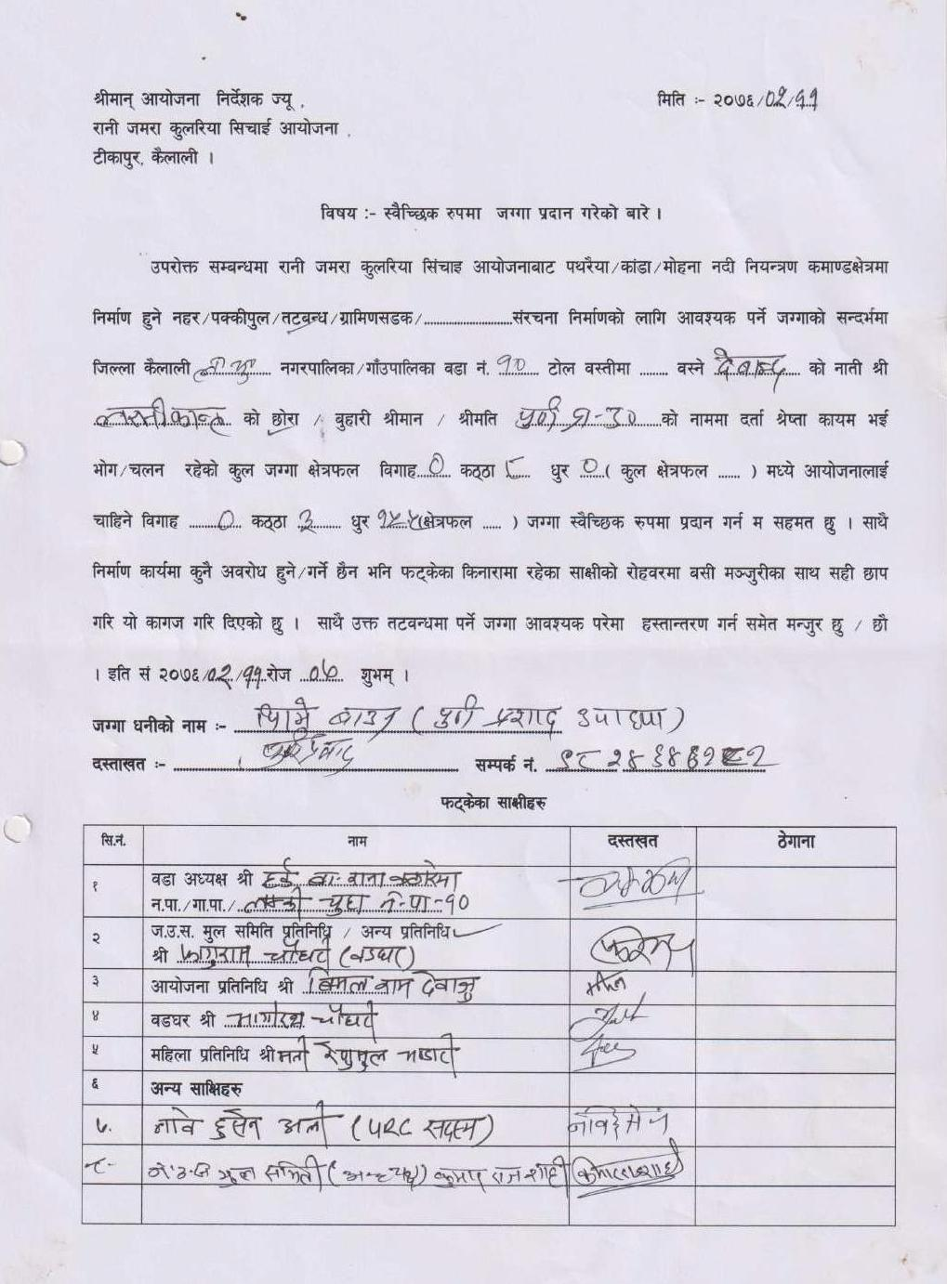

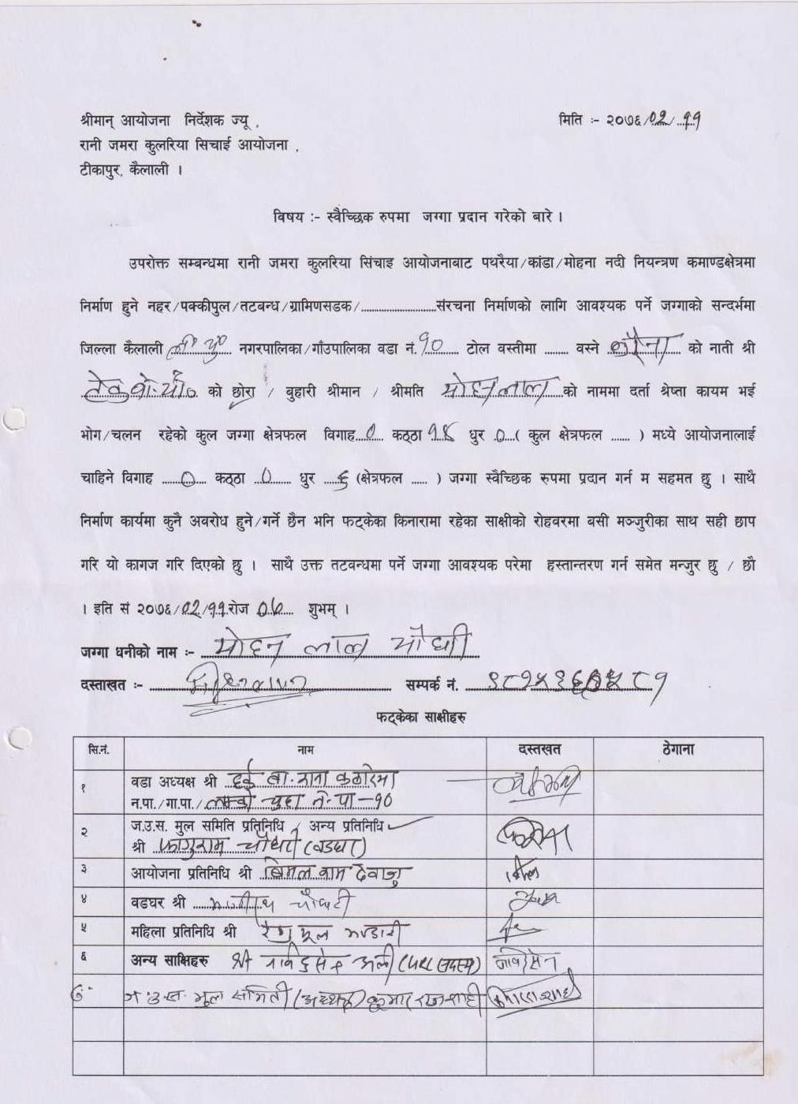
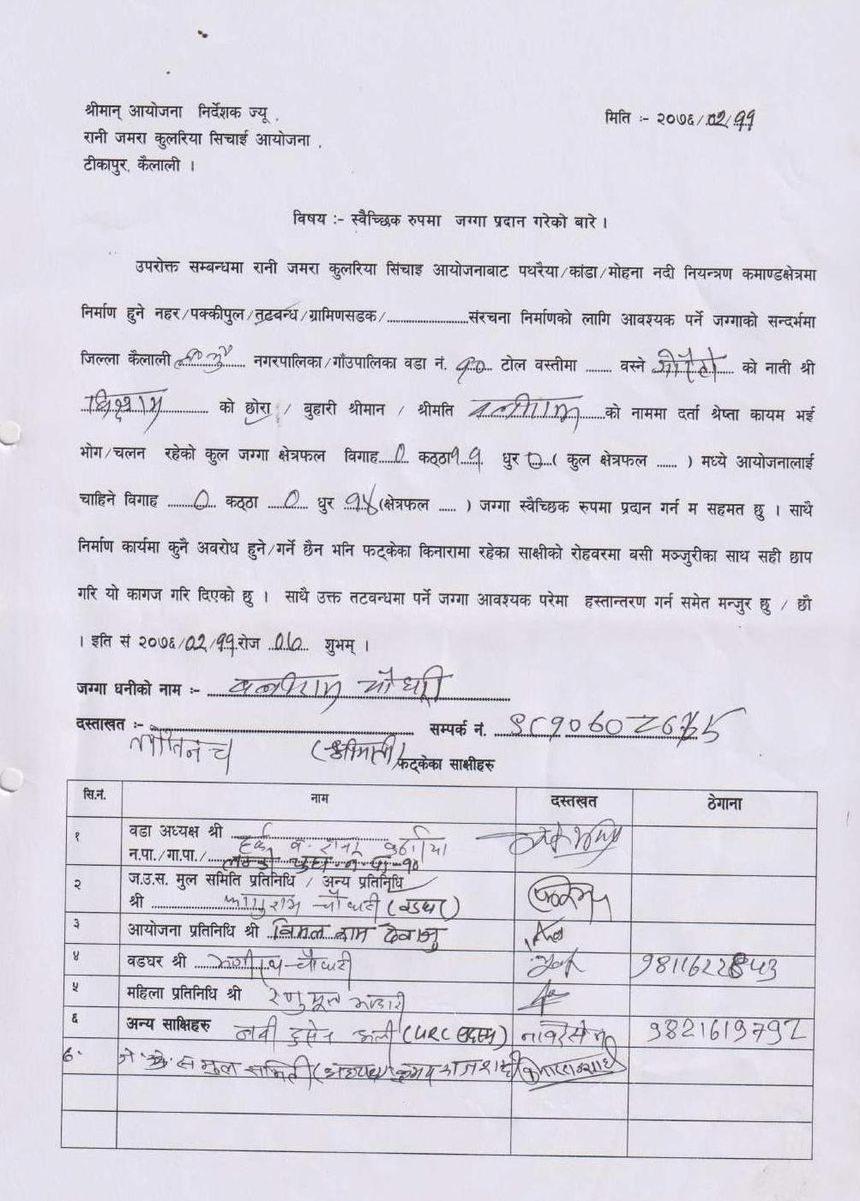

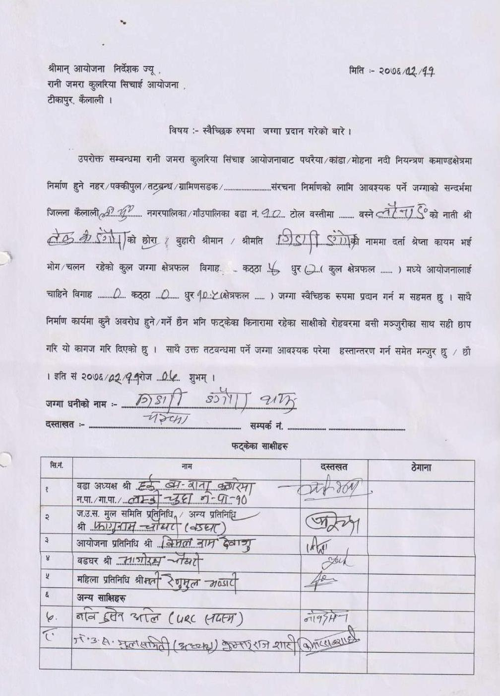
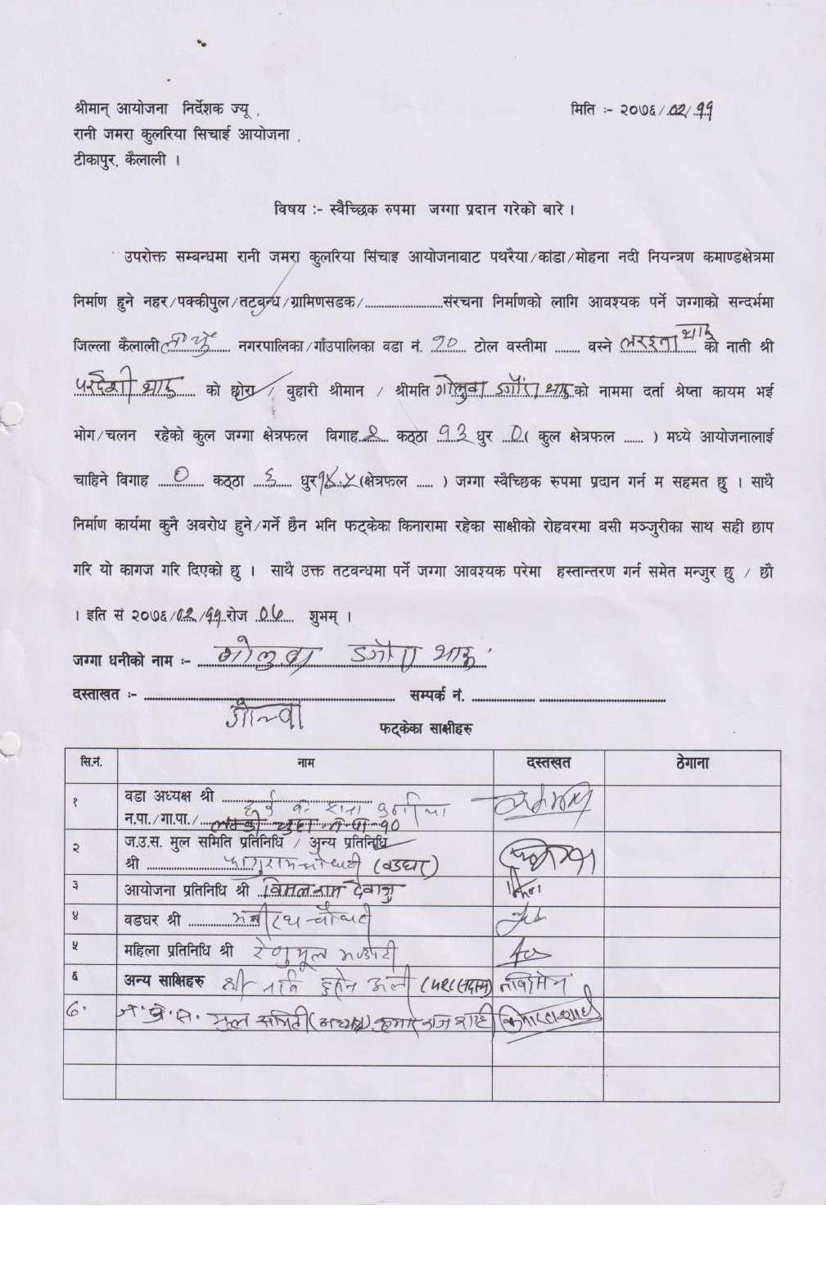

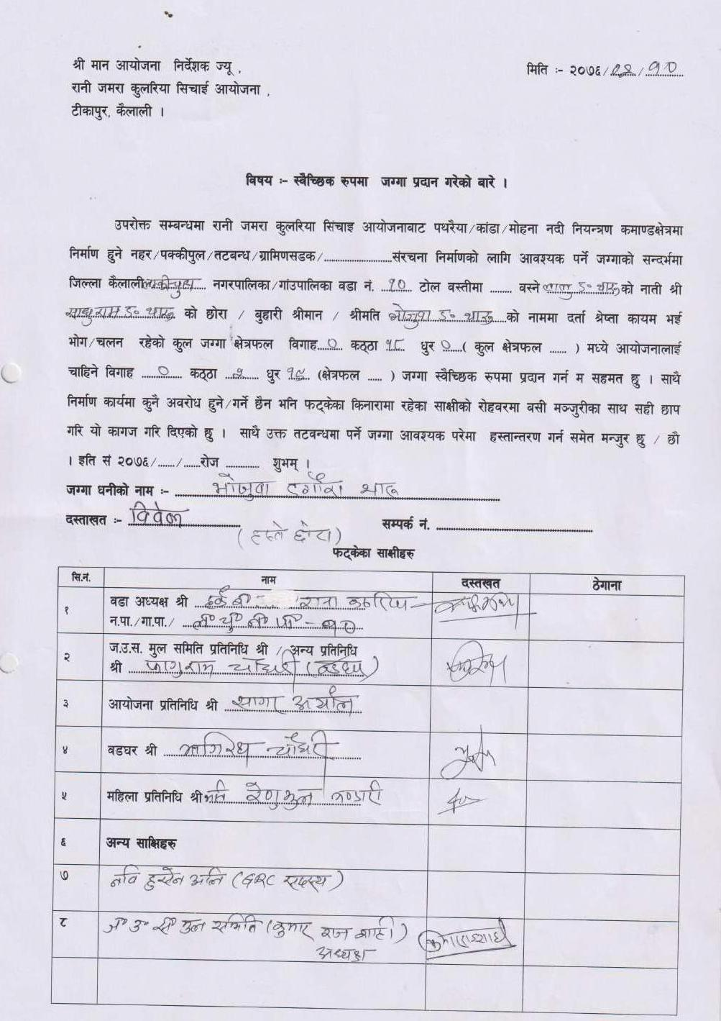
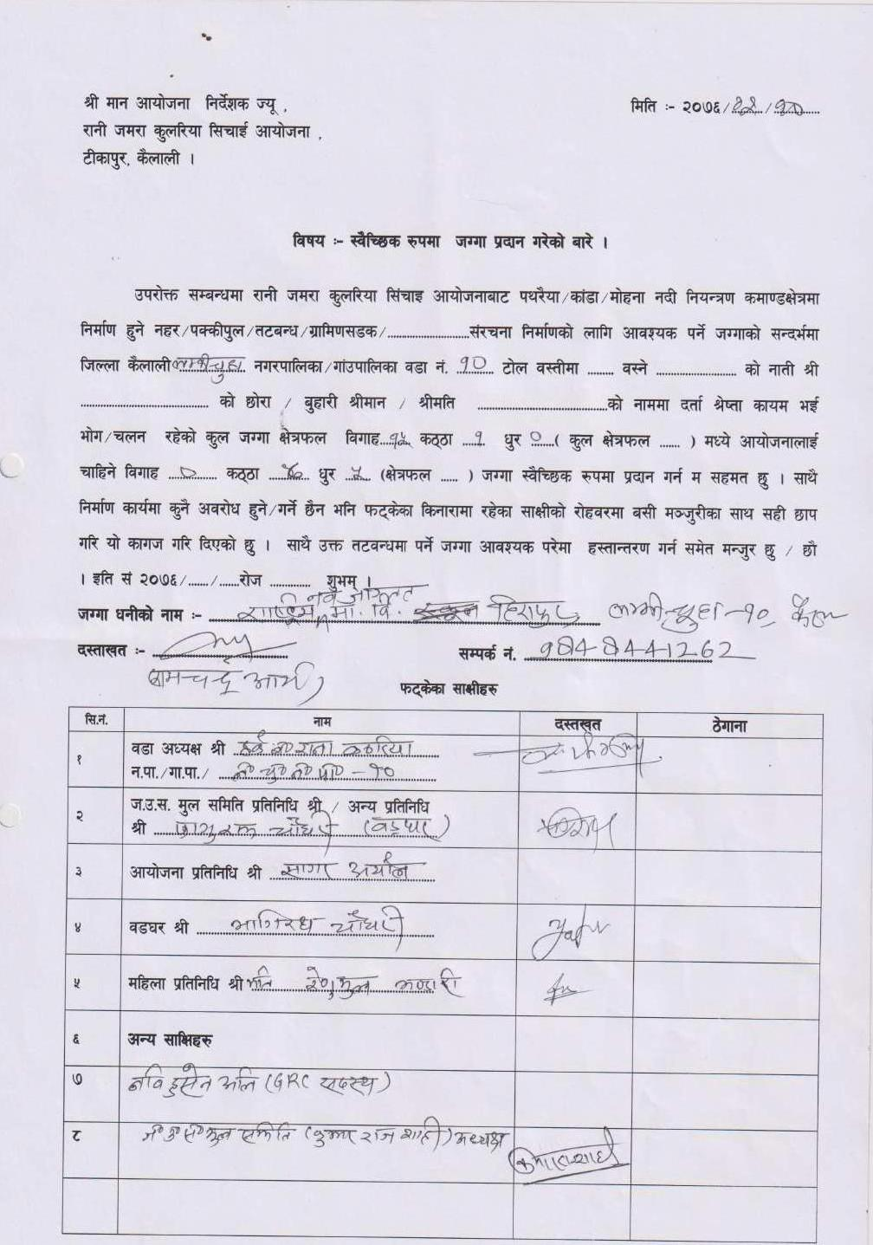

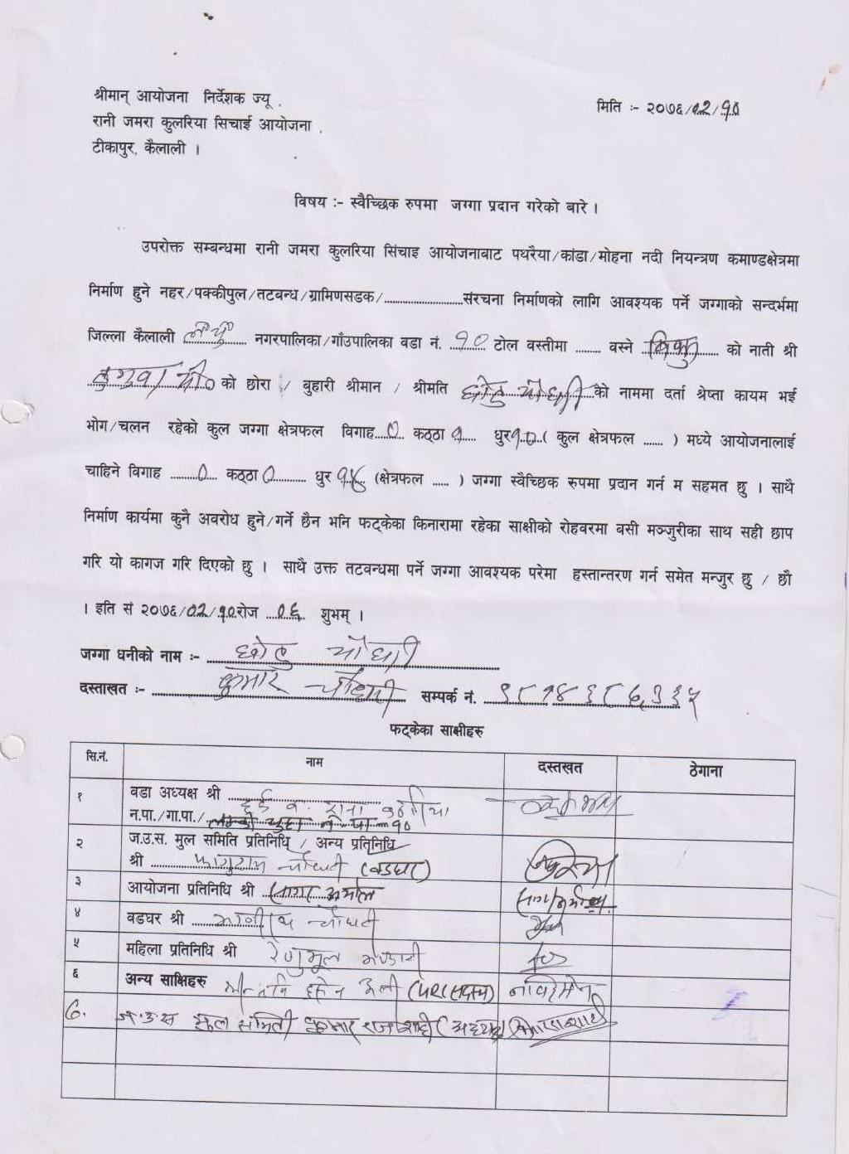
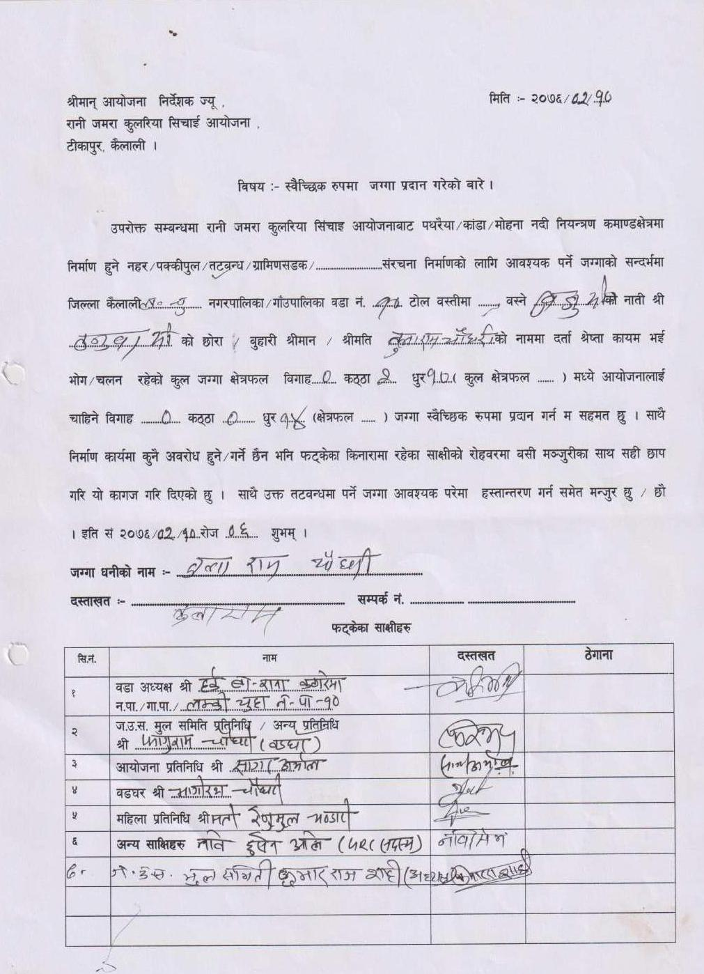

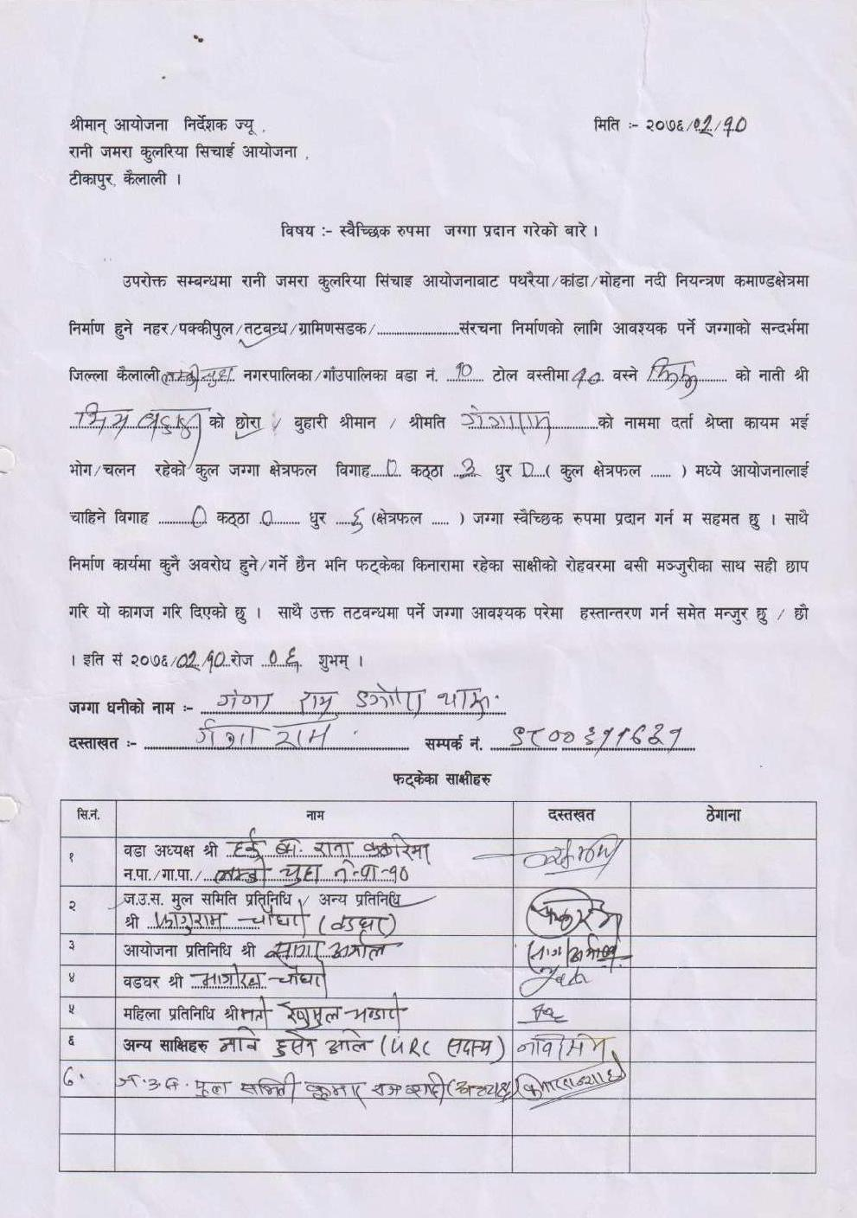
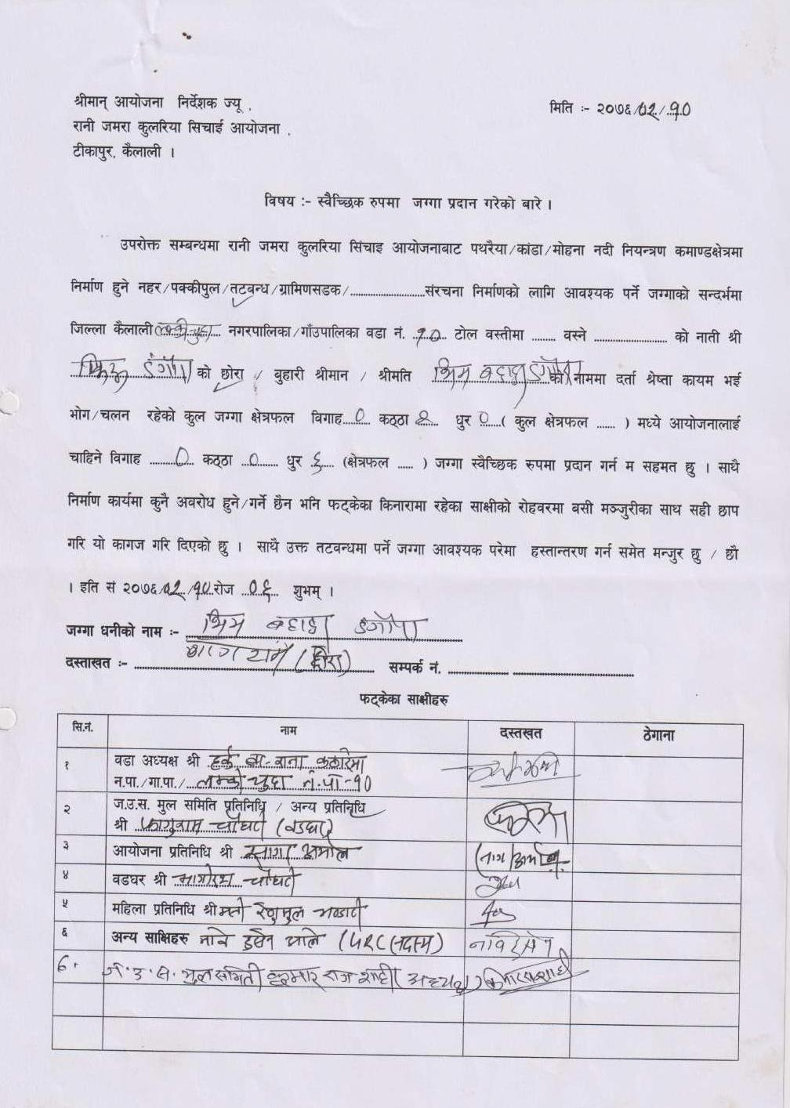

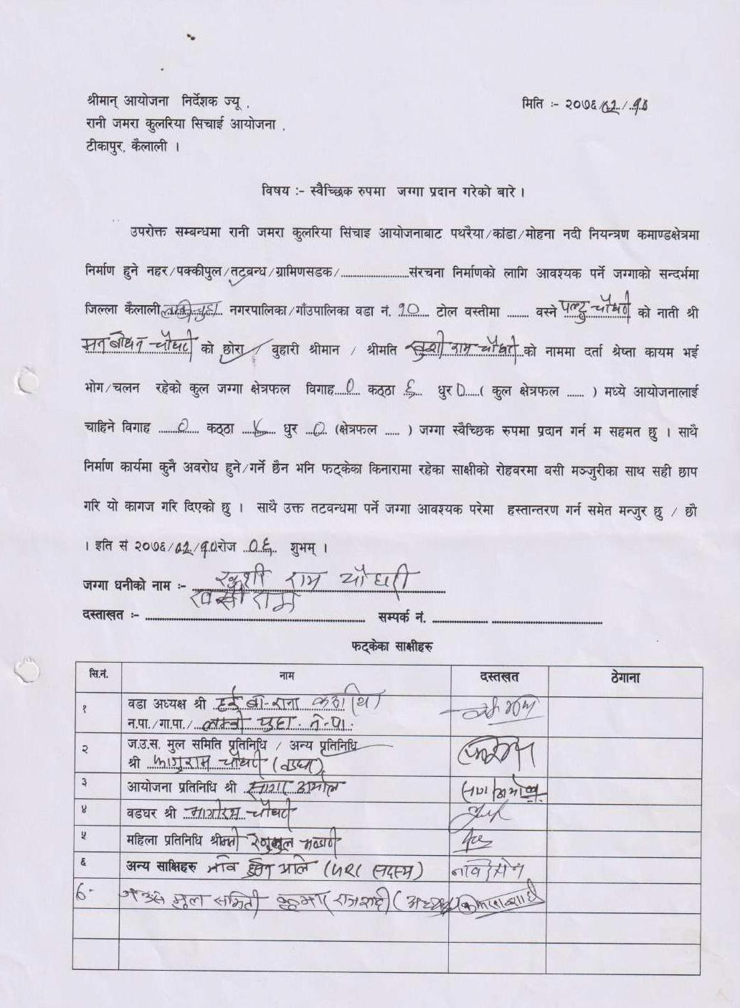
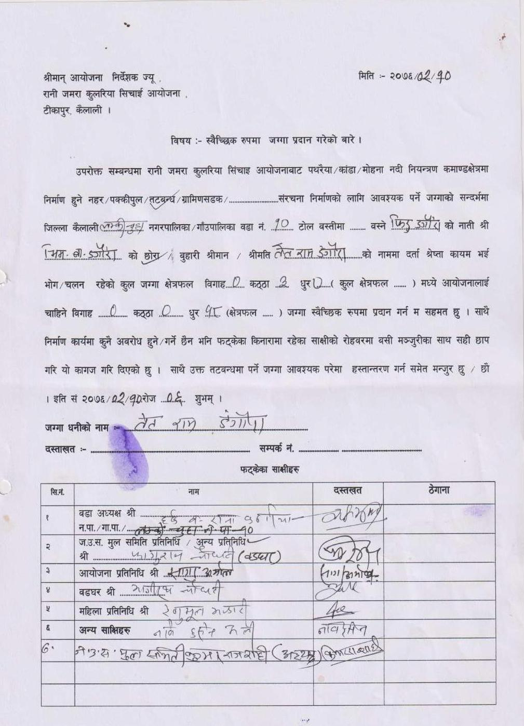

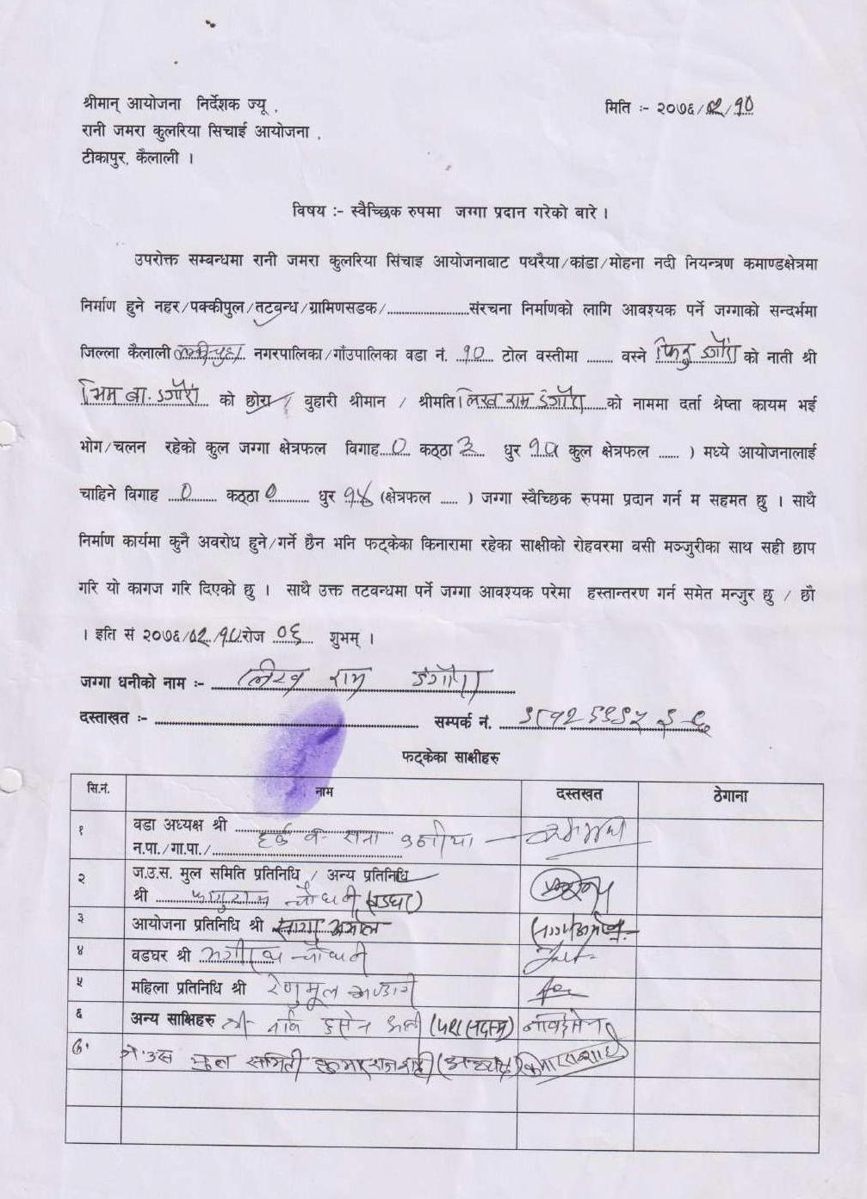
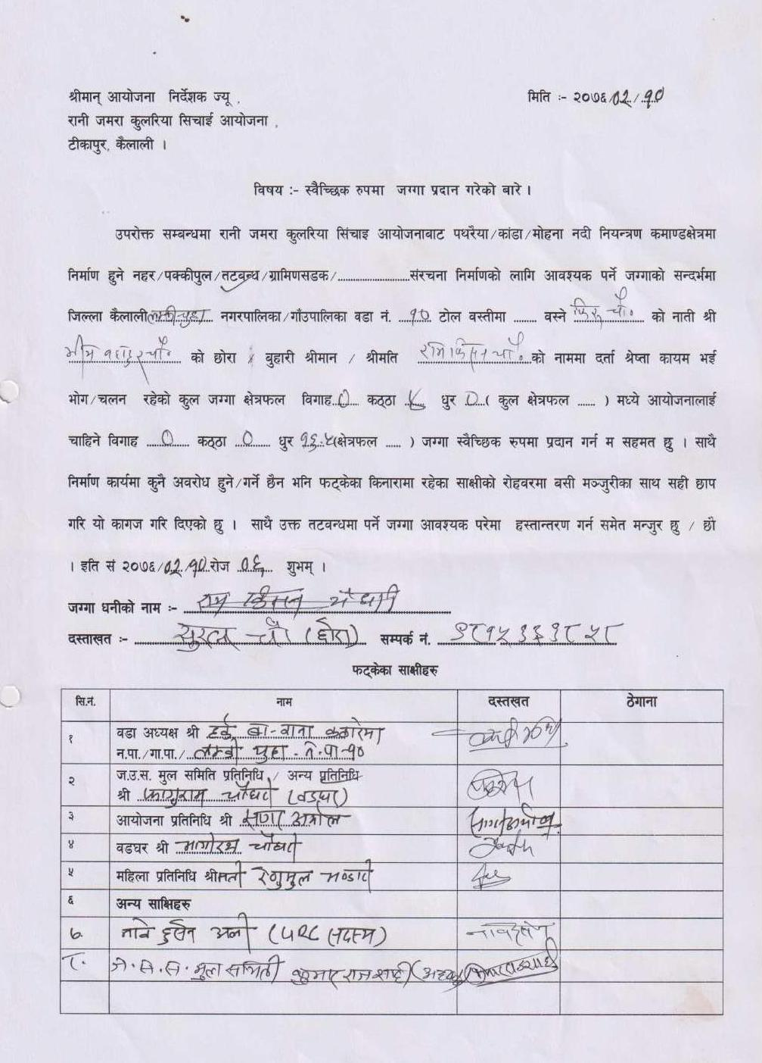

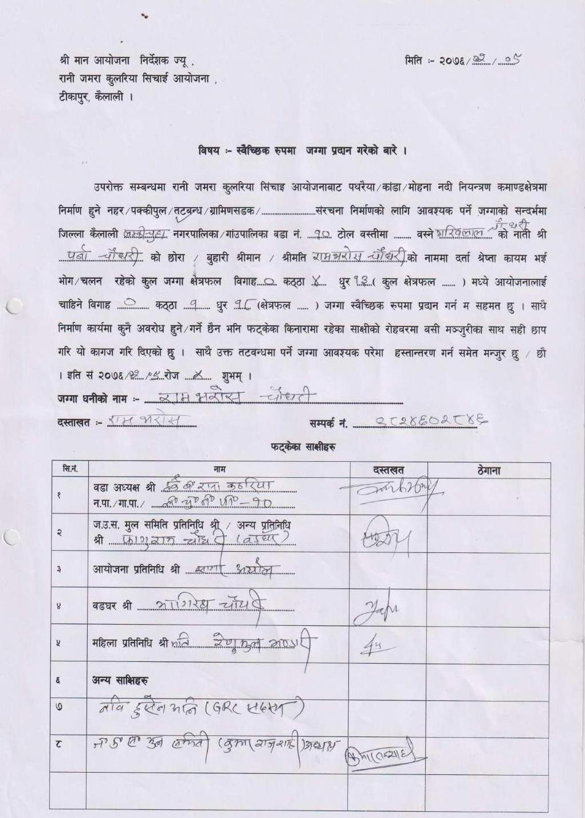
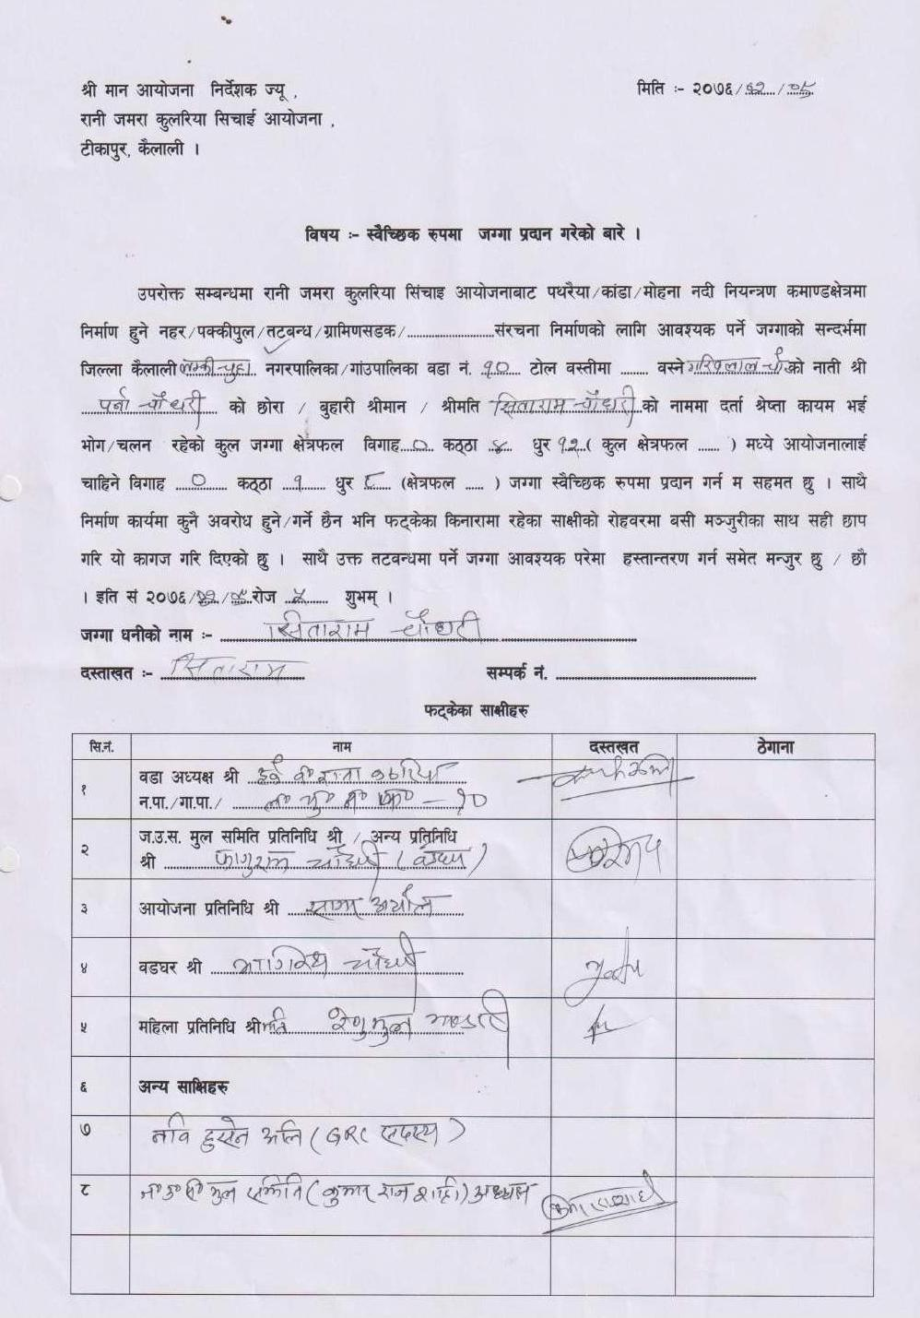

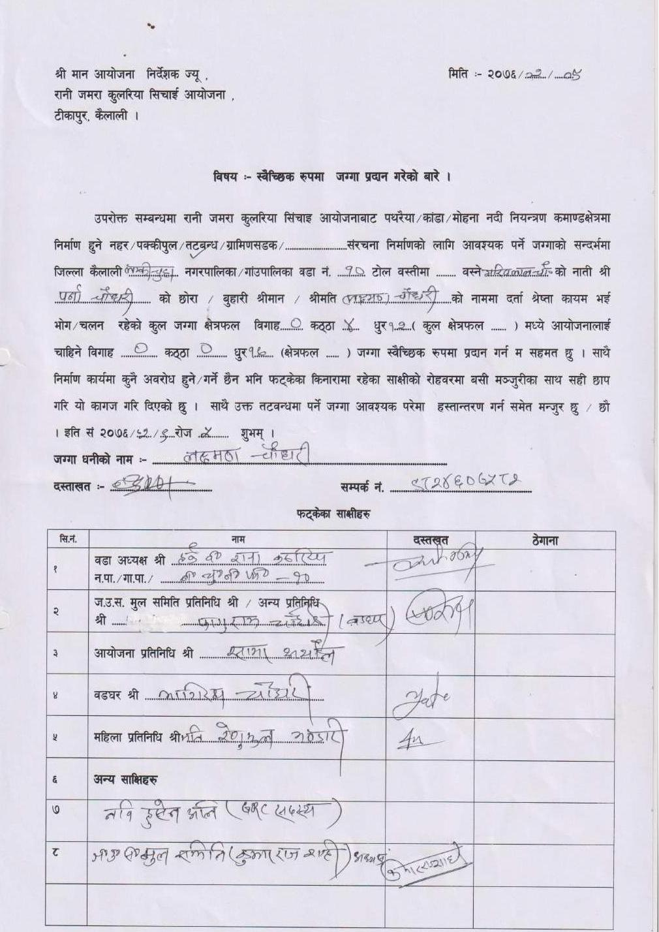
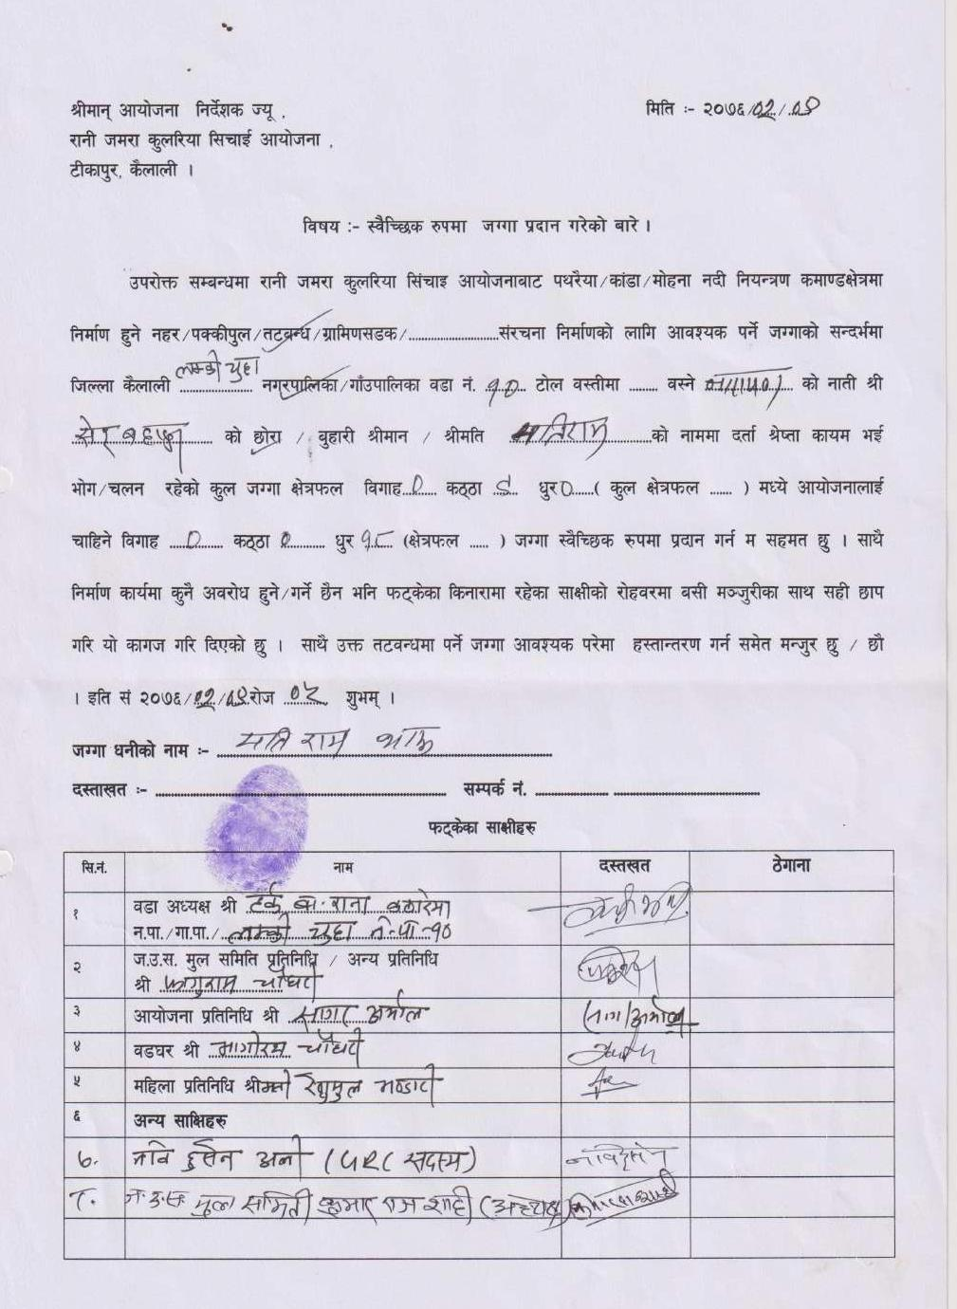

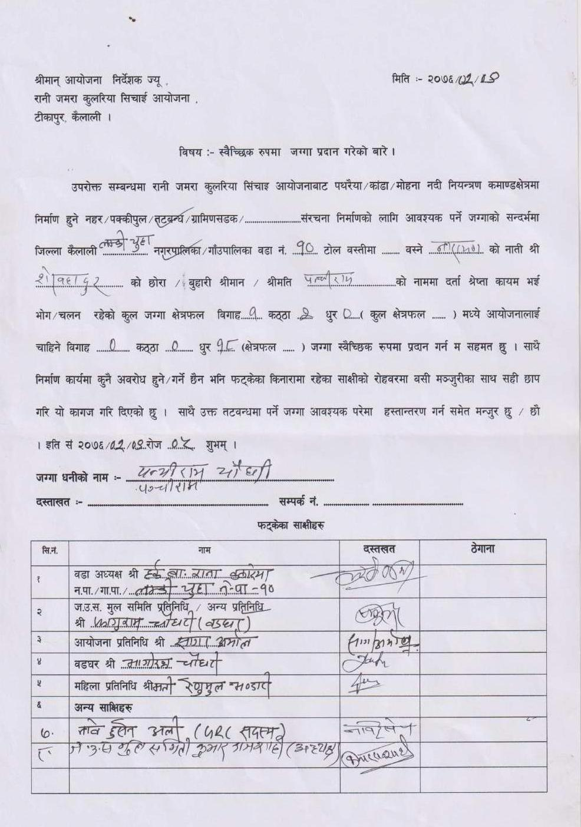
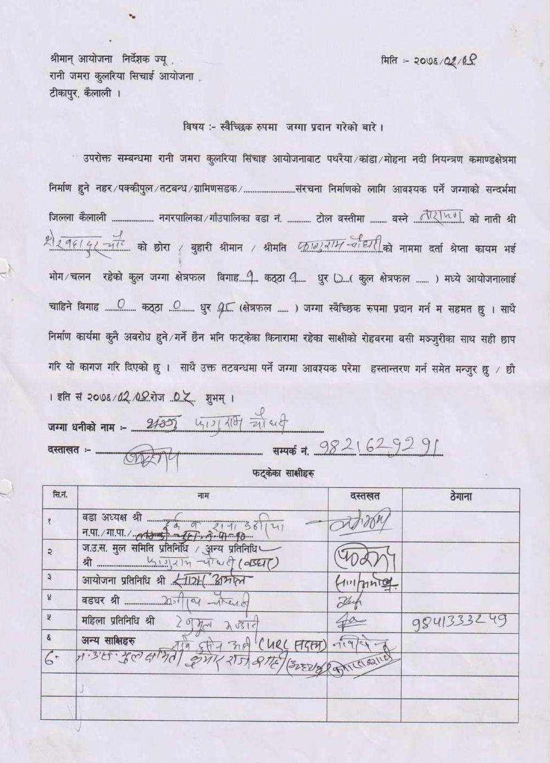

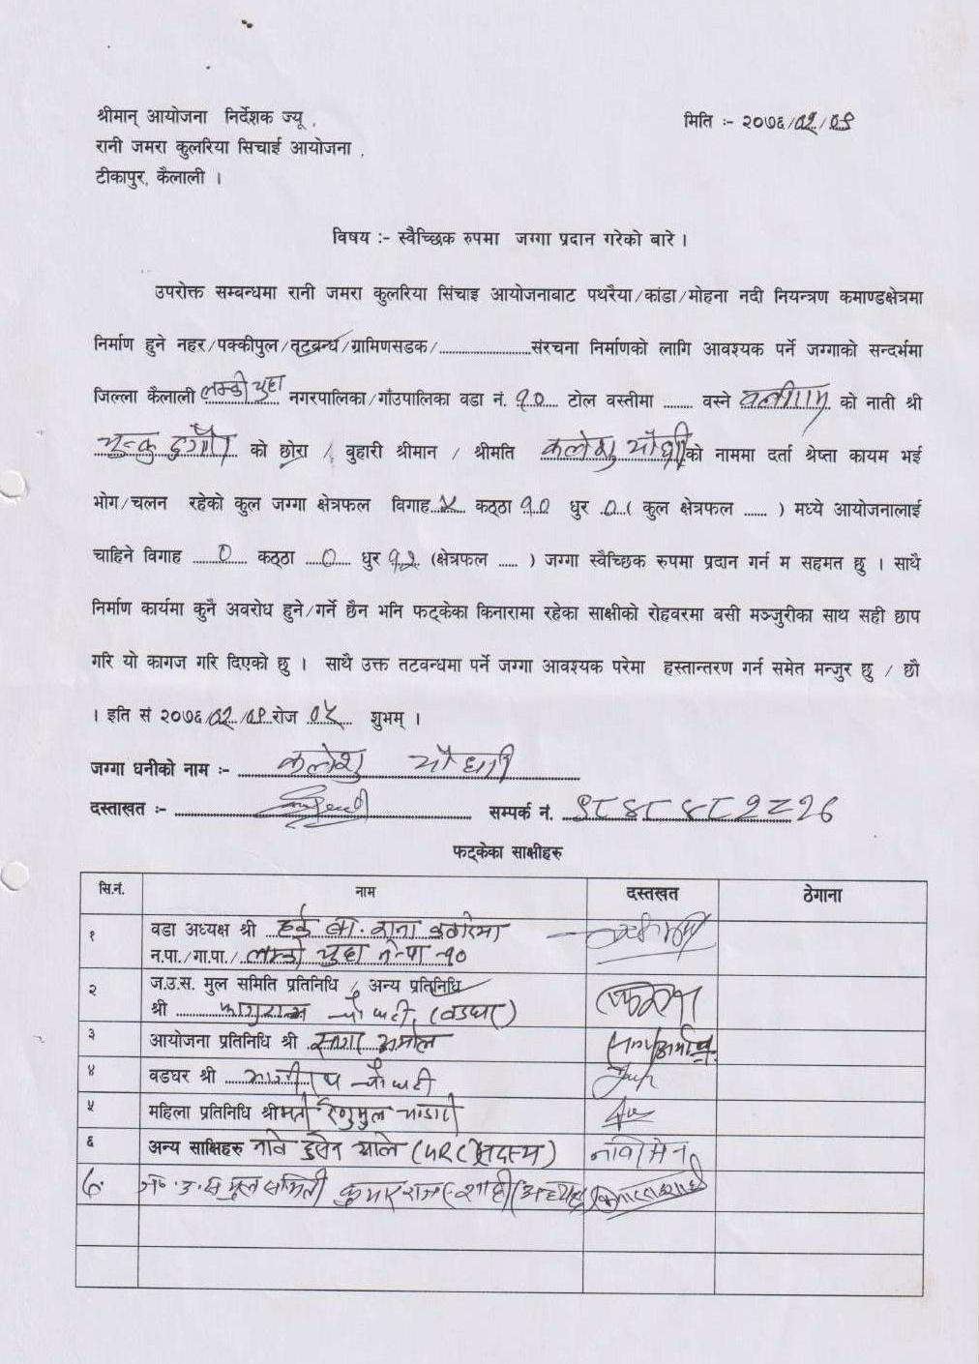

2: Lamki Chuwa Municipality Ward no. 9
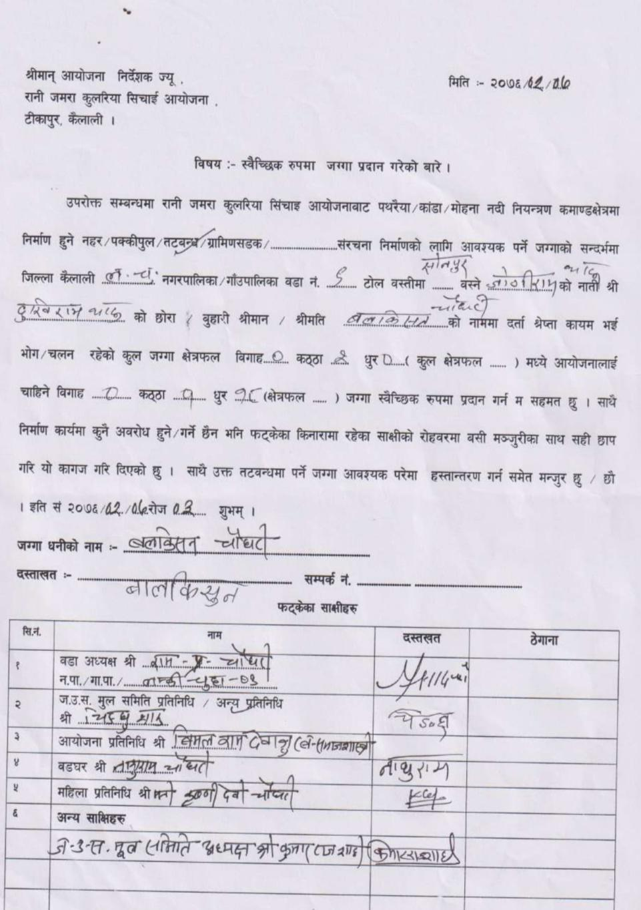
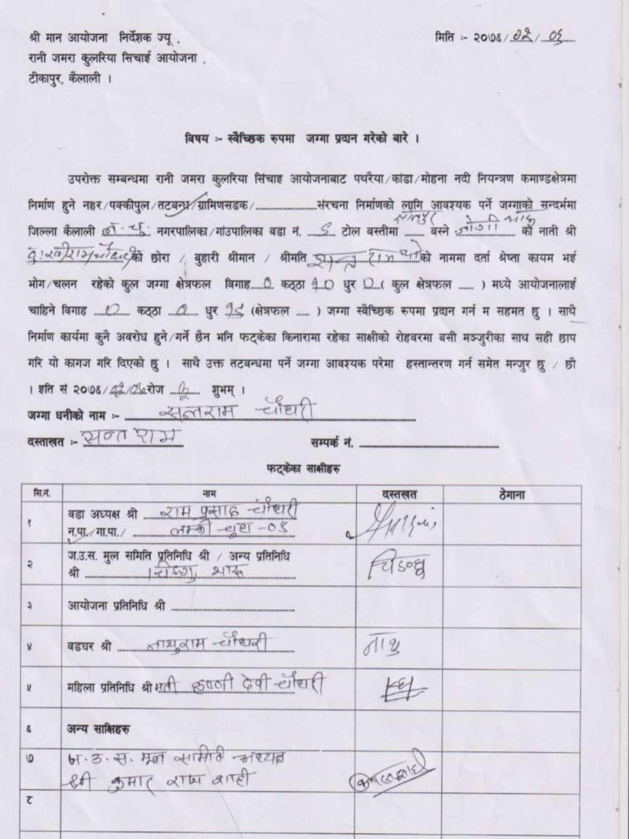

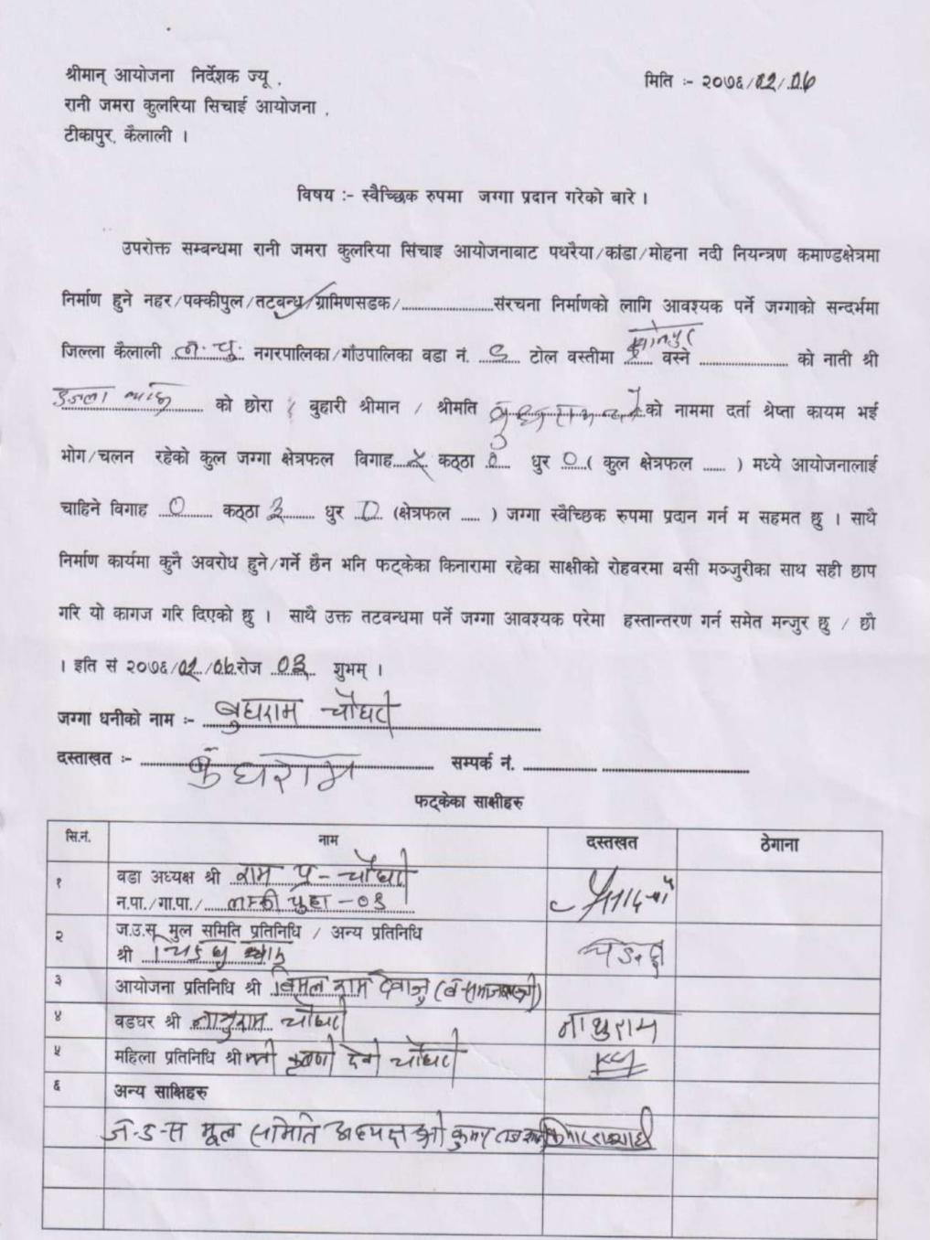
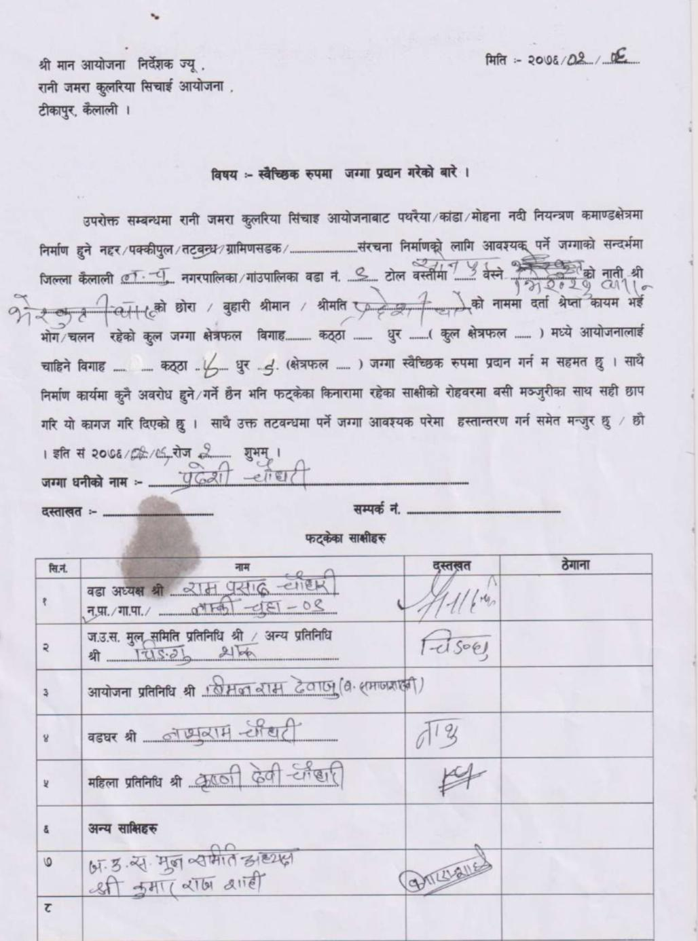

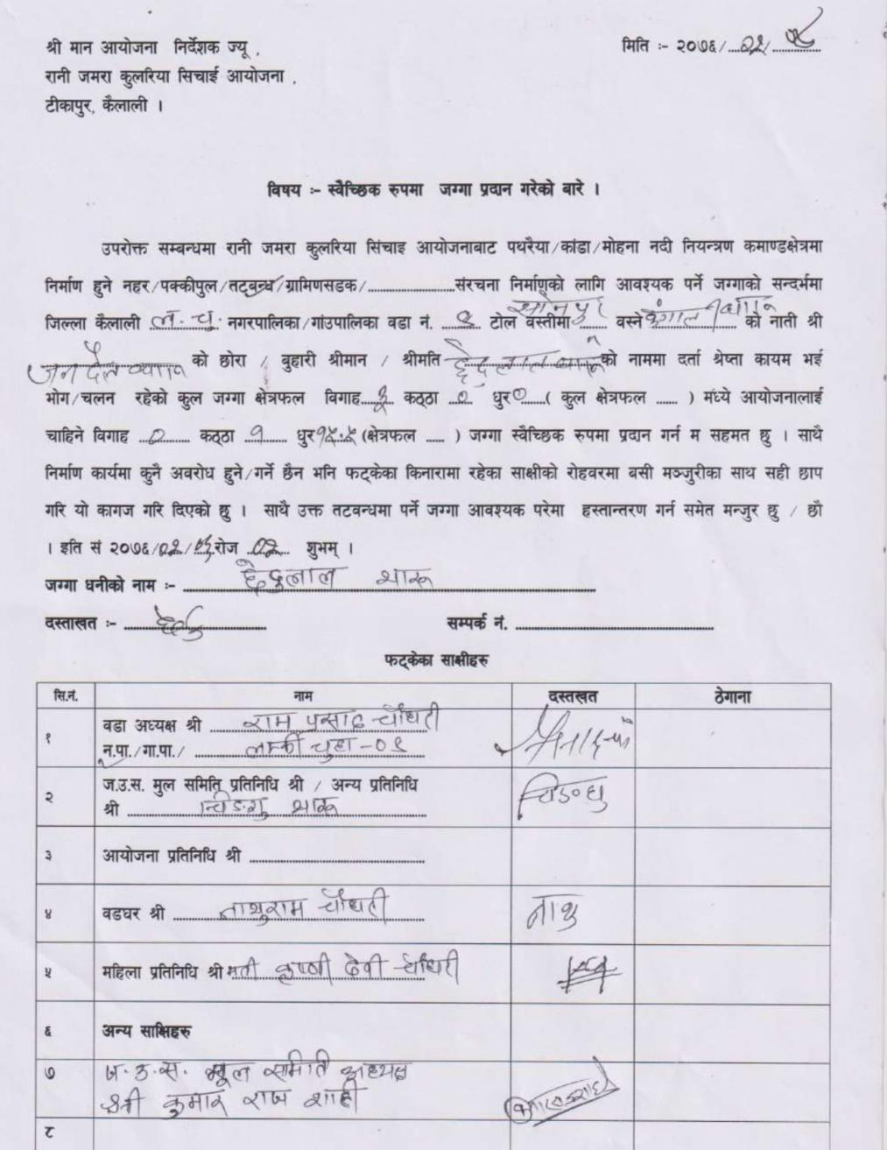
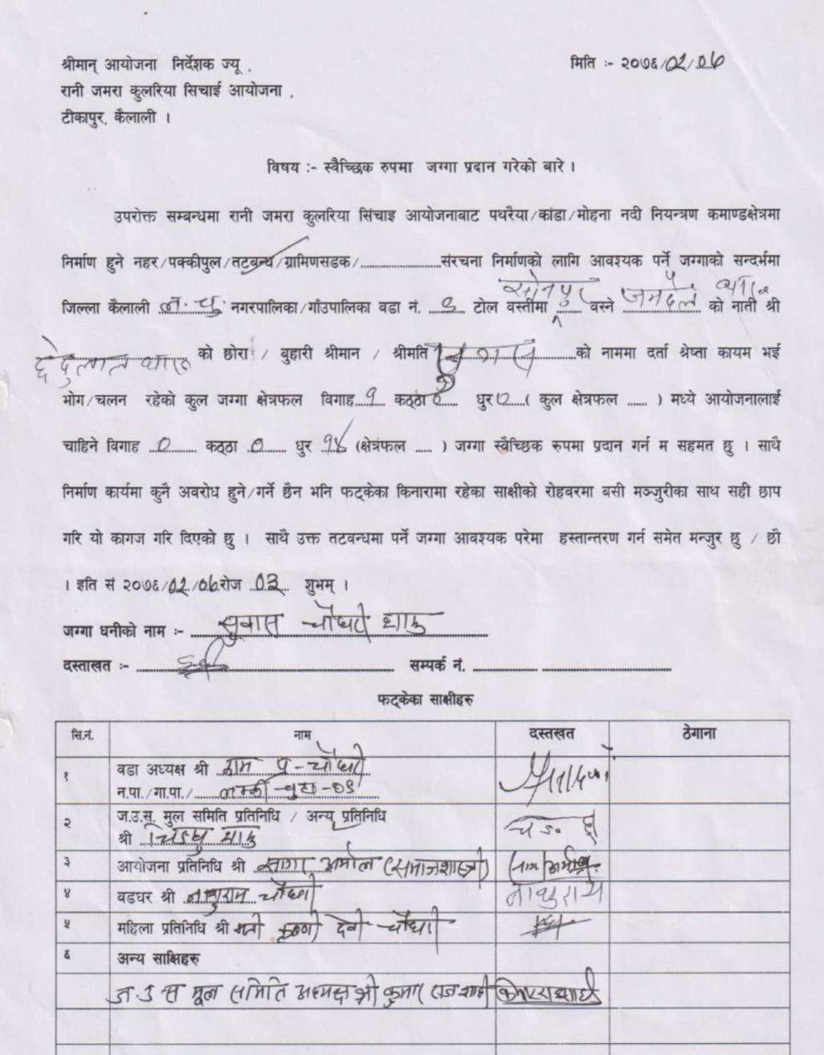

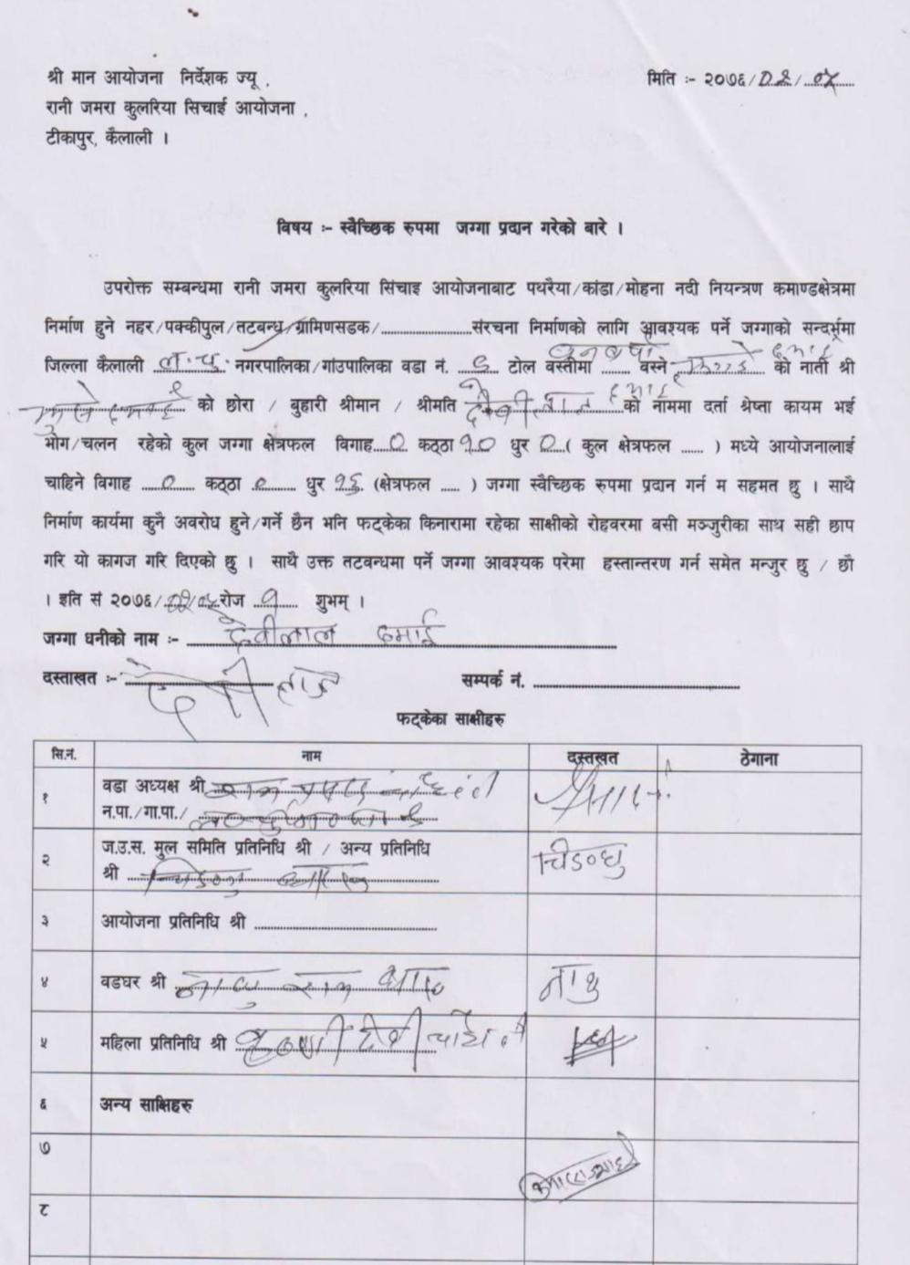

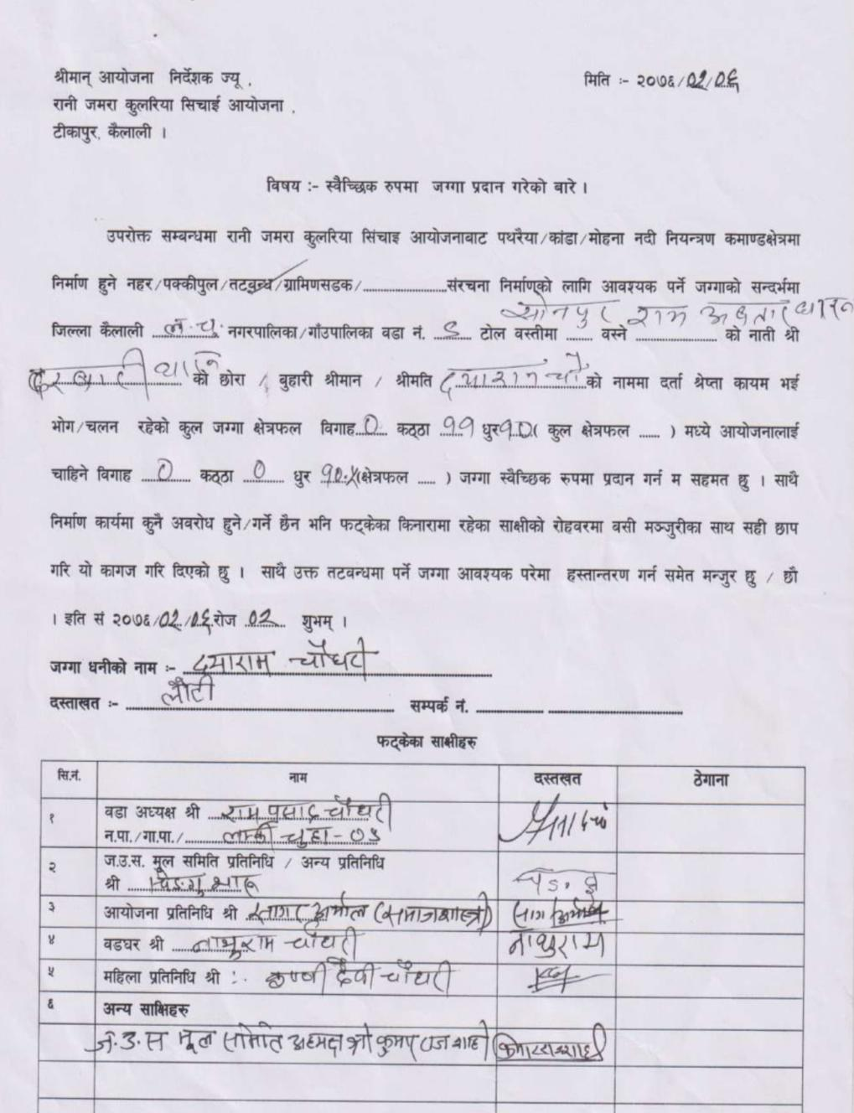
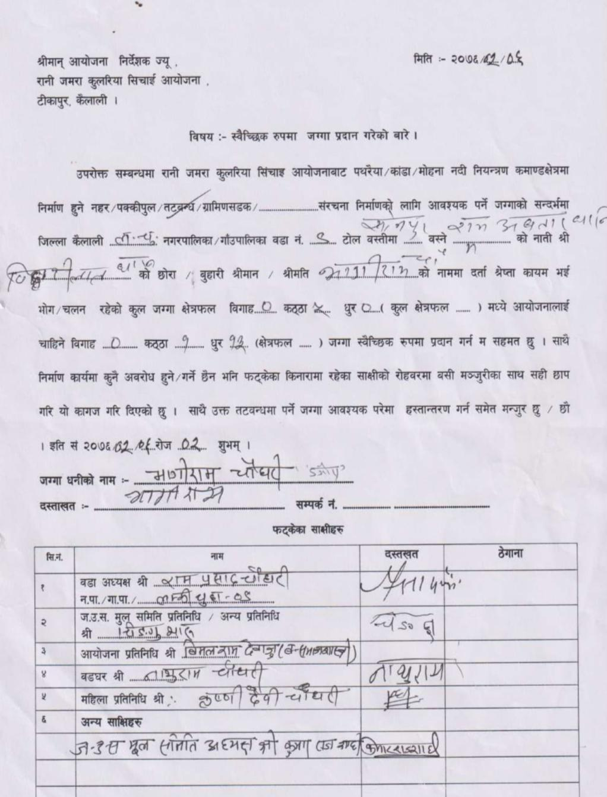

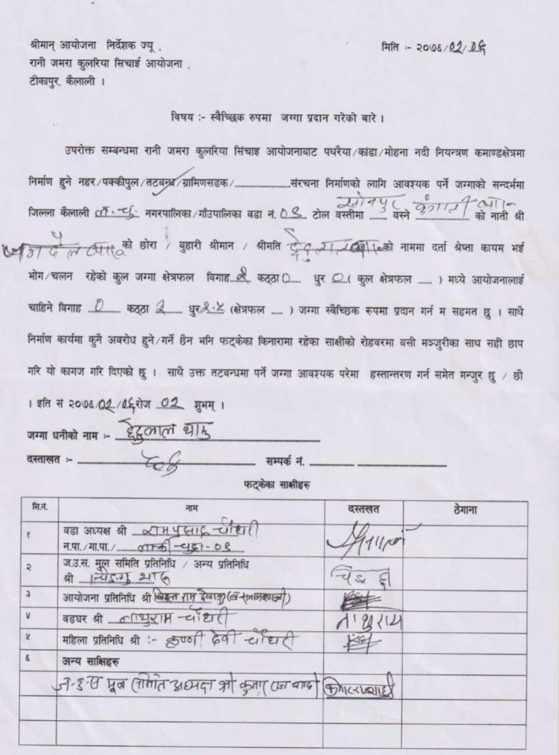

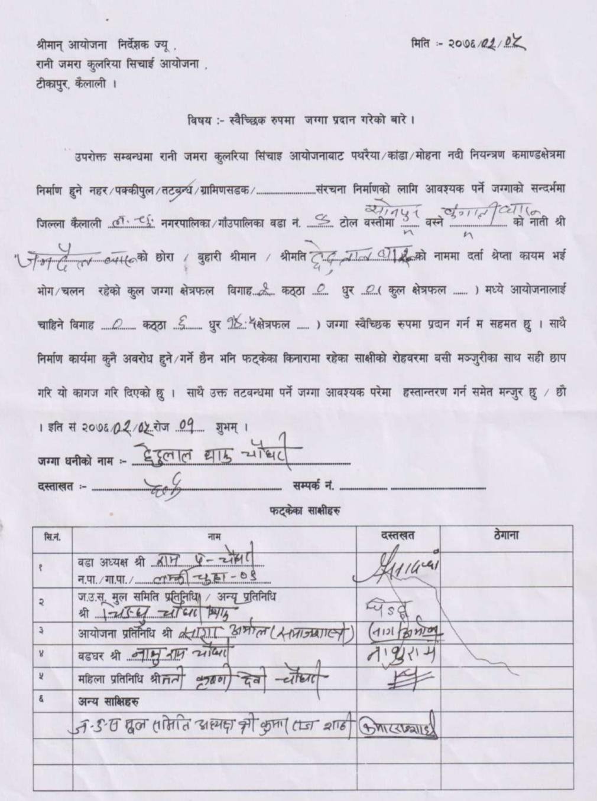

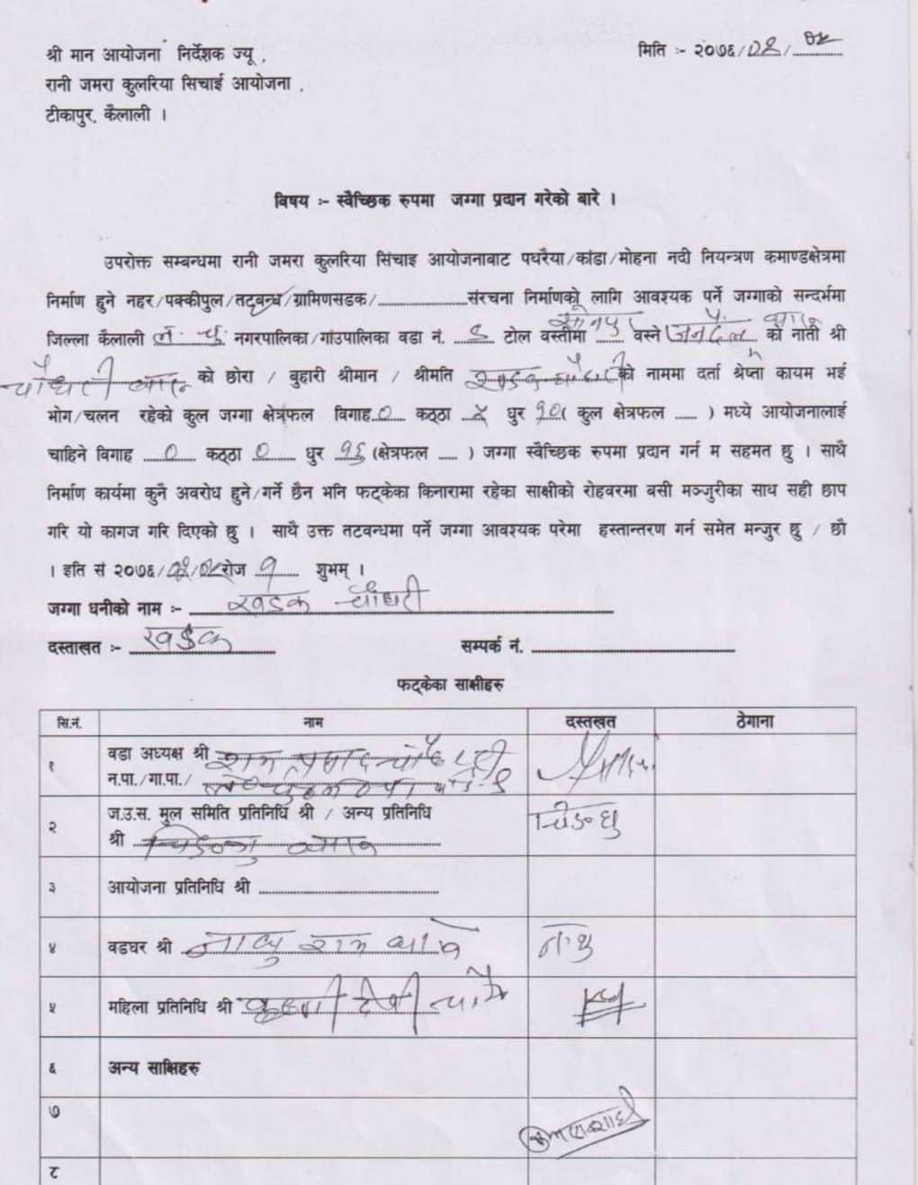
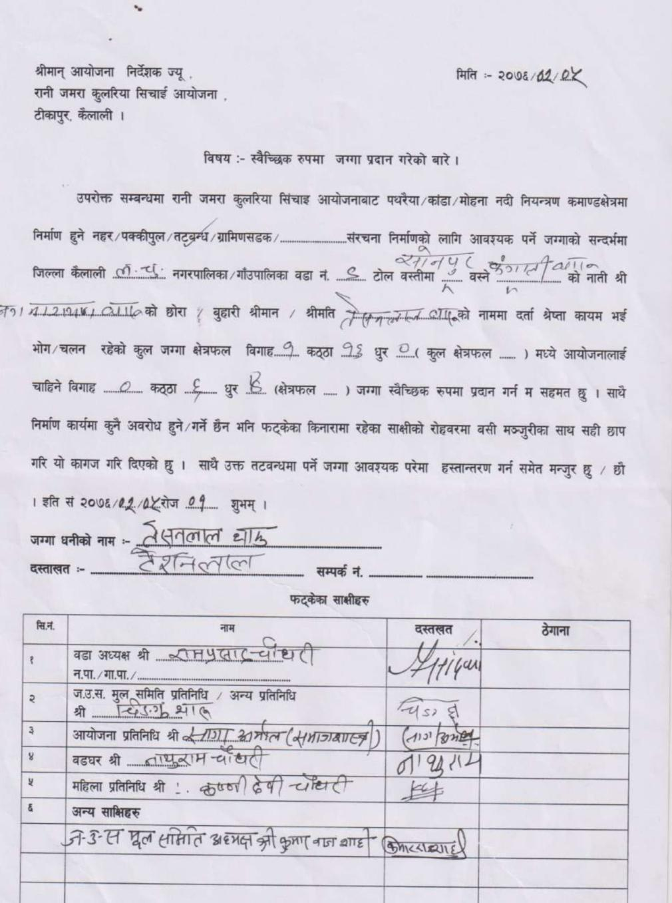

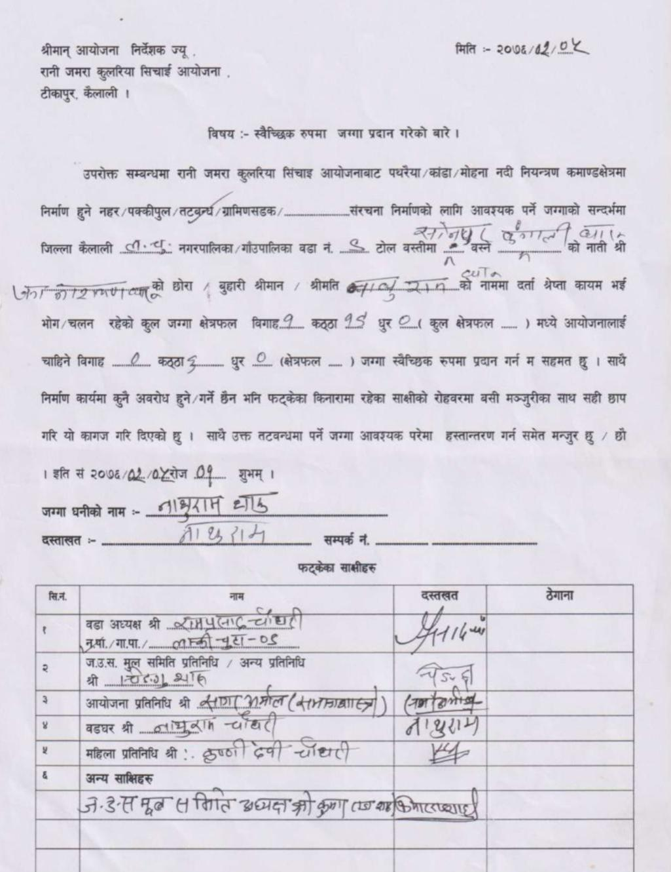

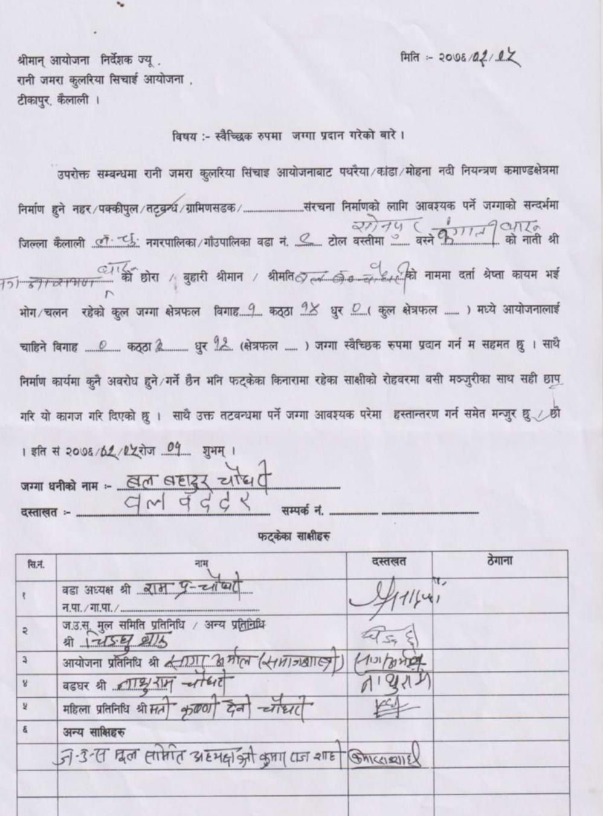
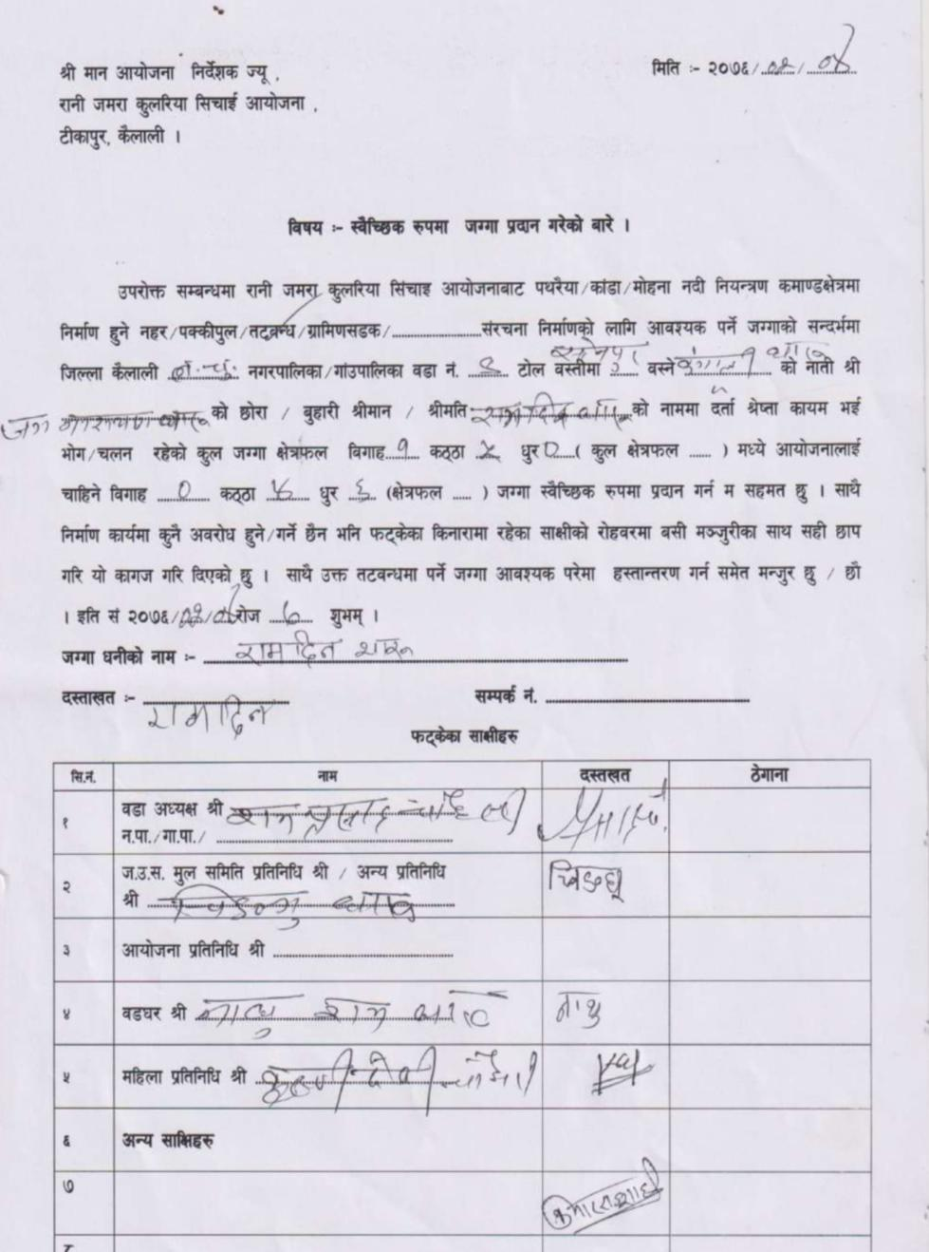

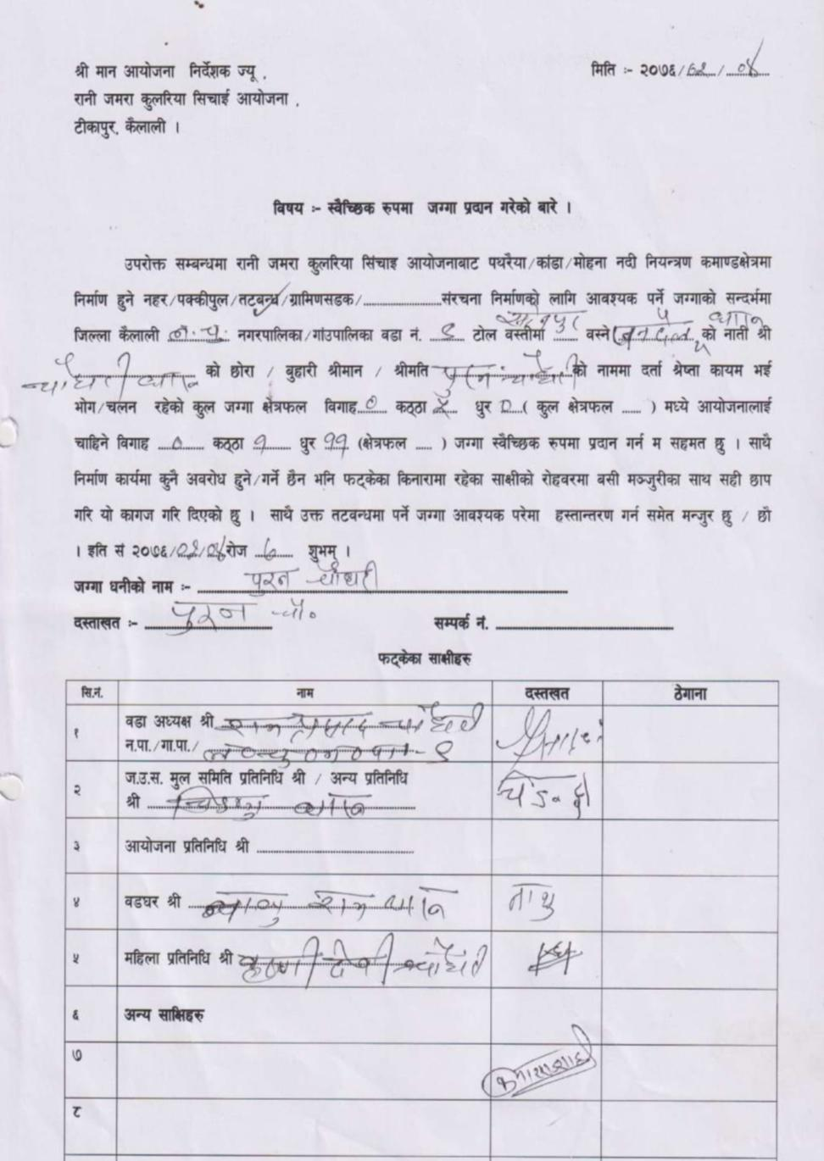
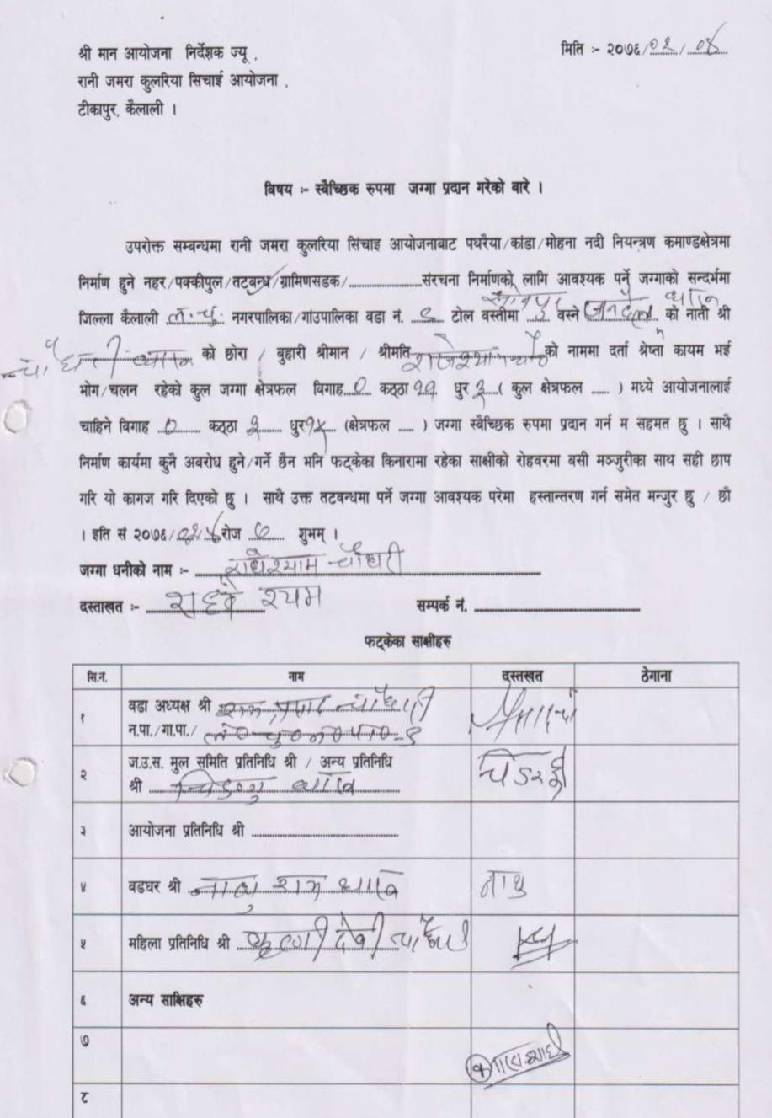

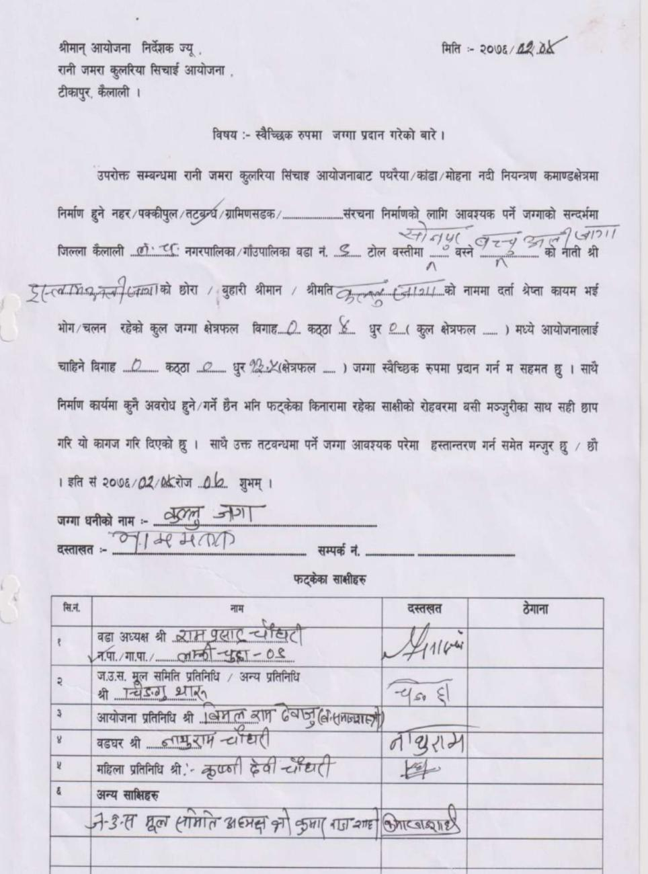
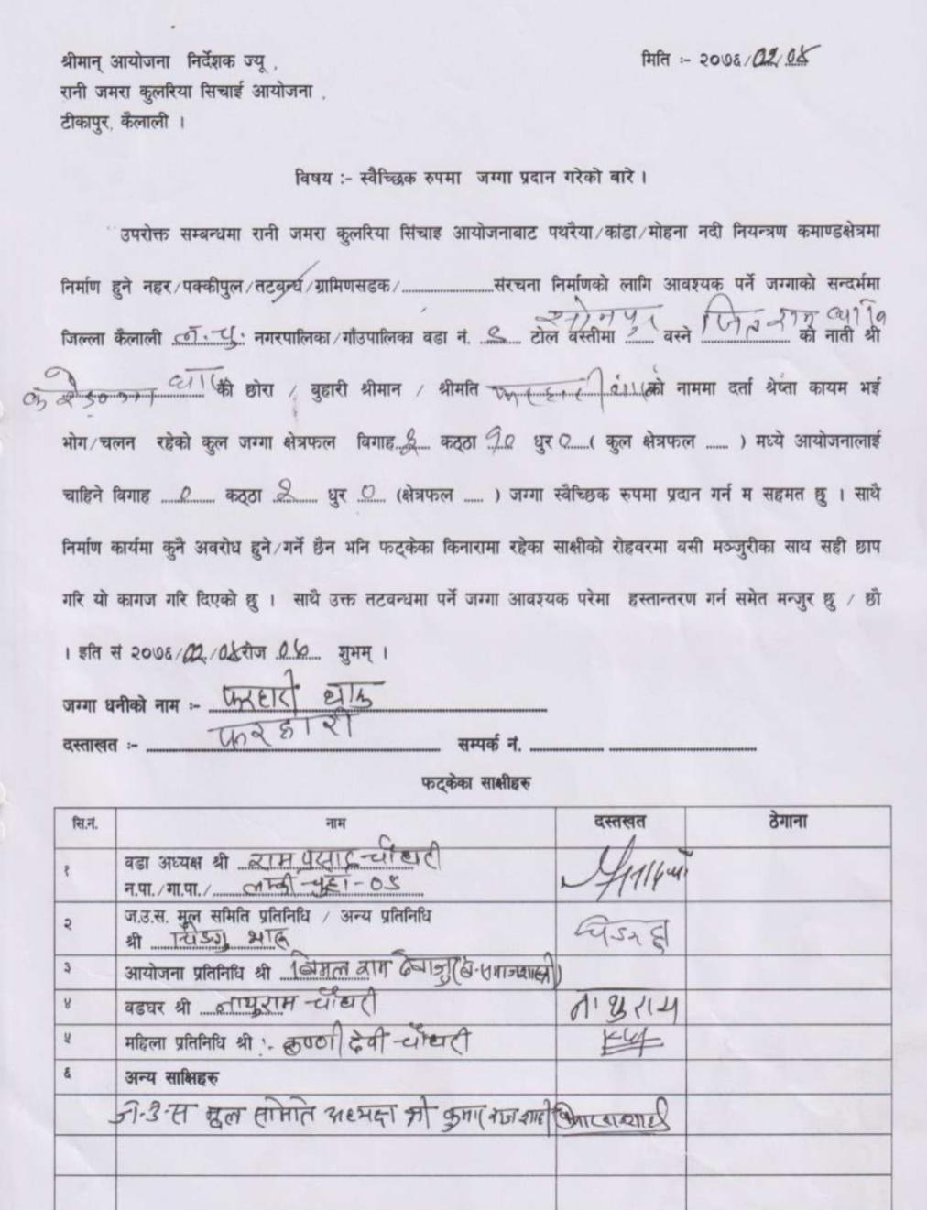

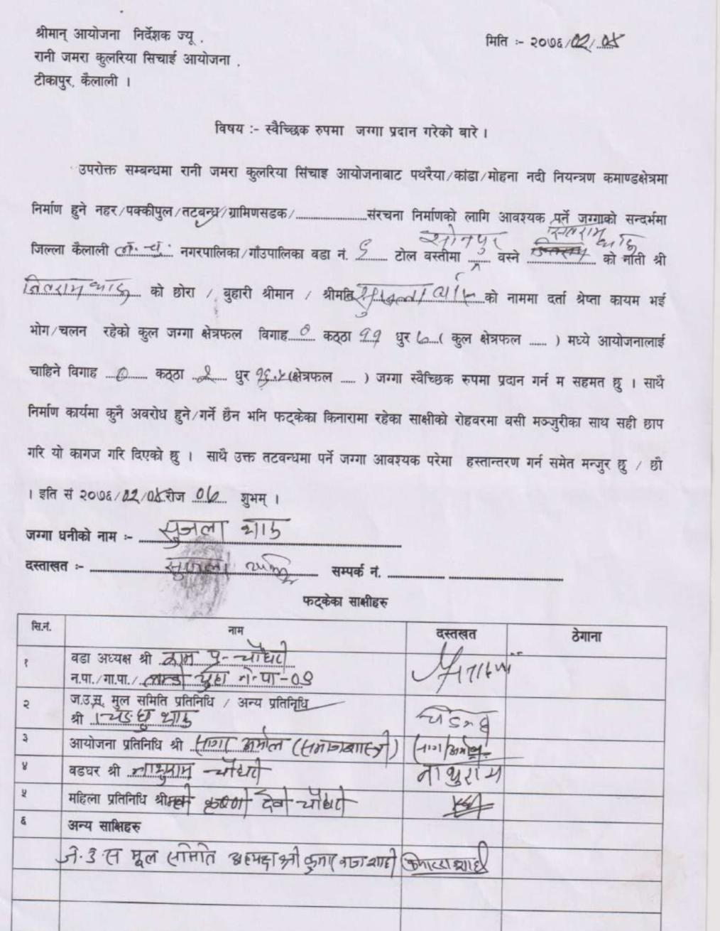
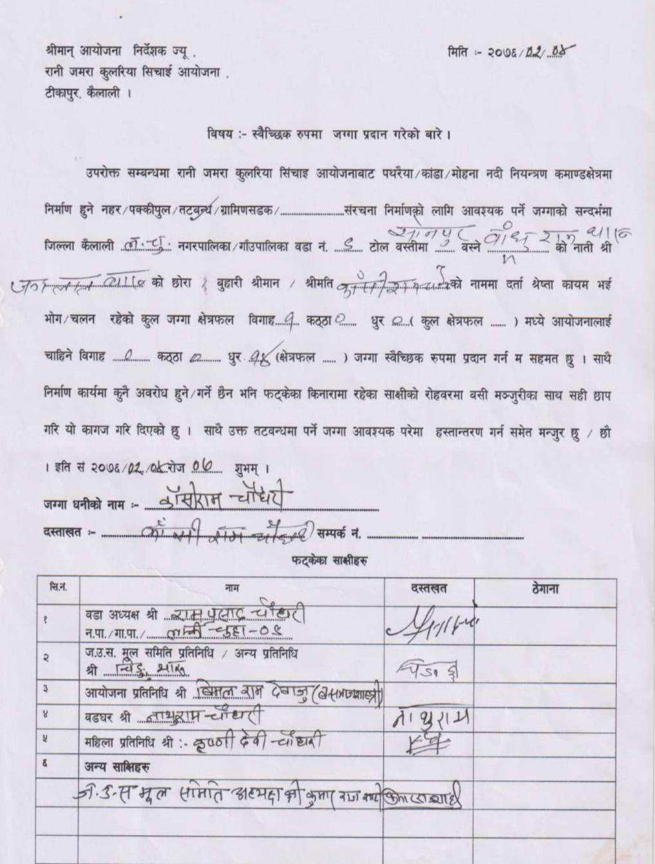

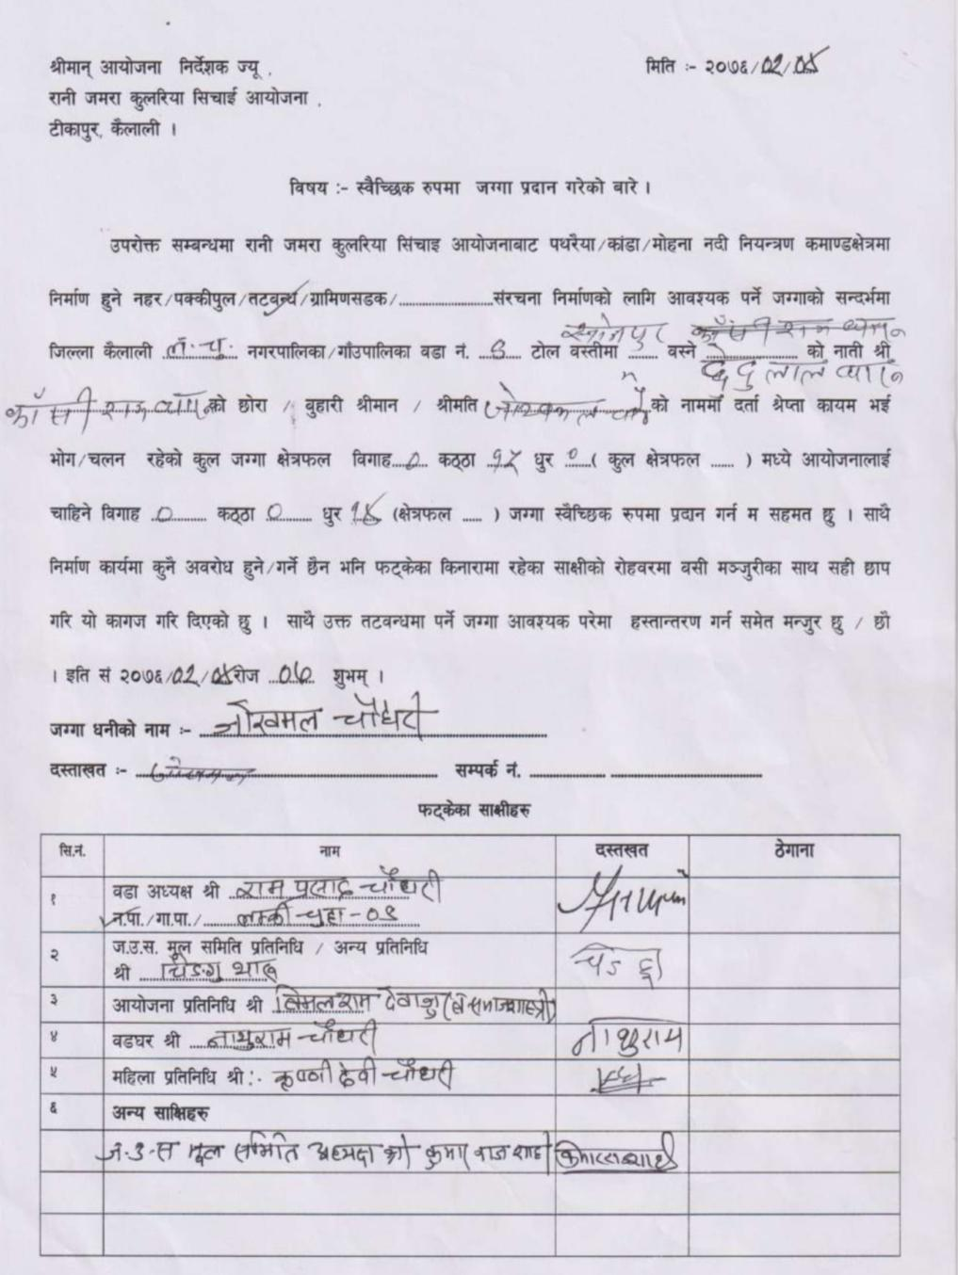
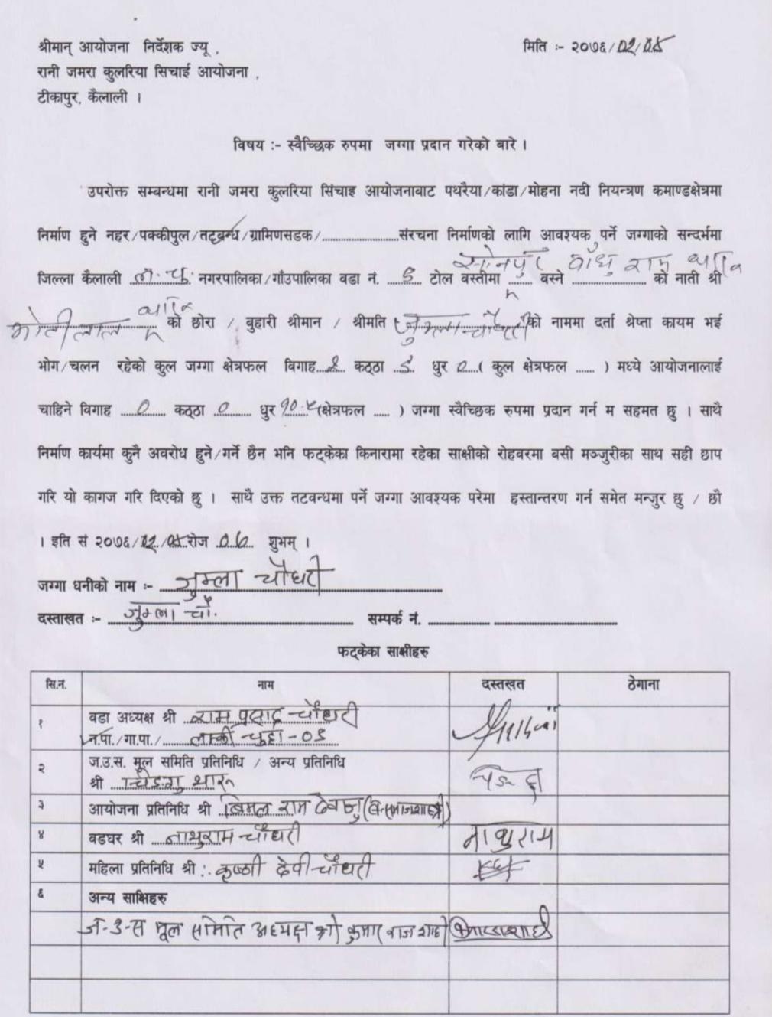

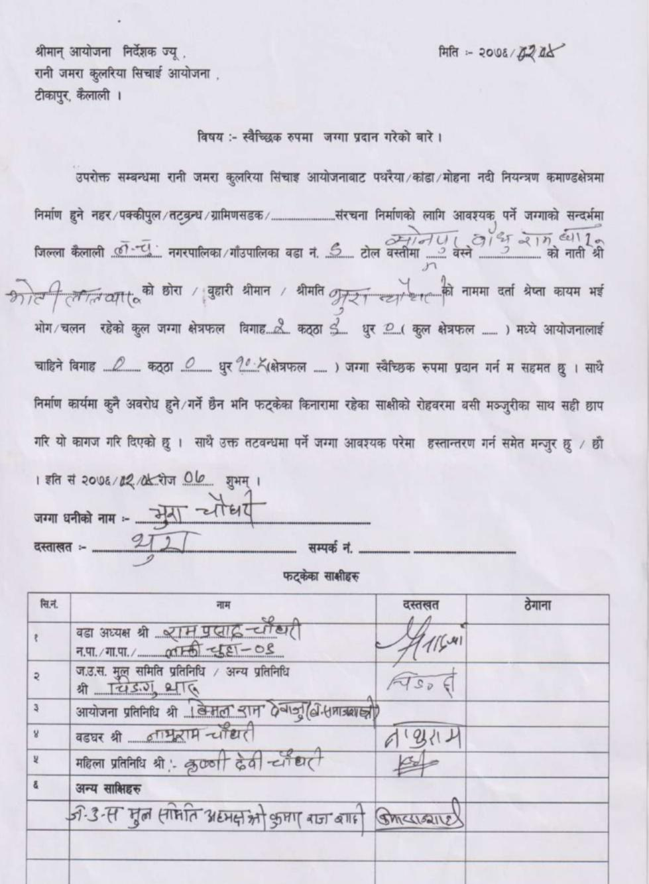
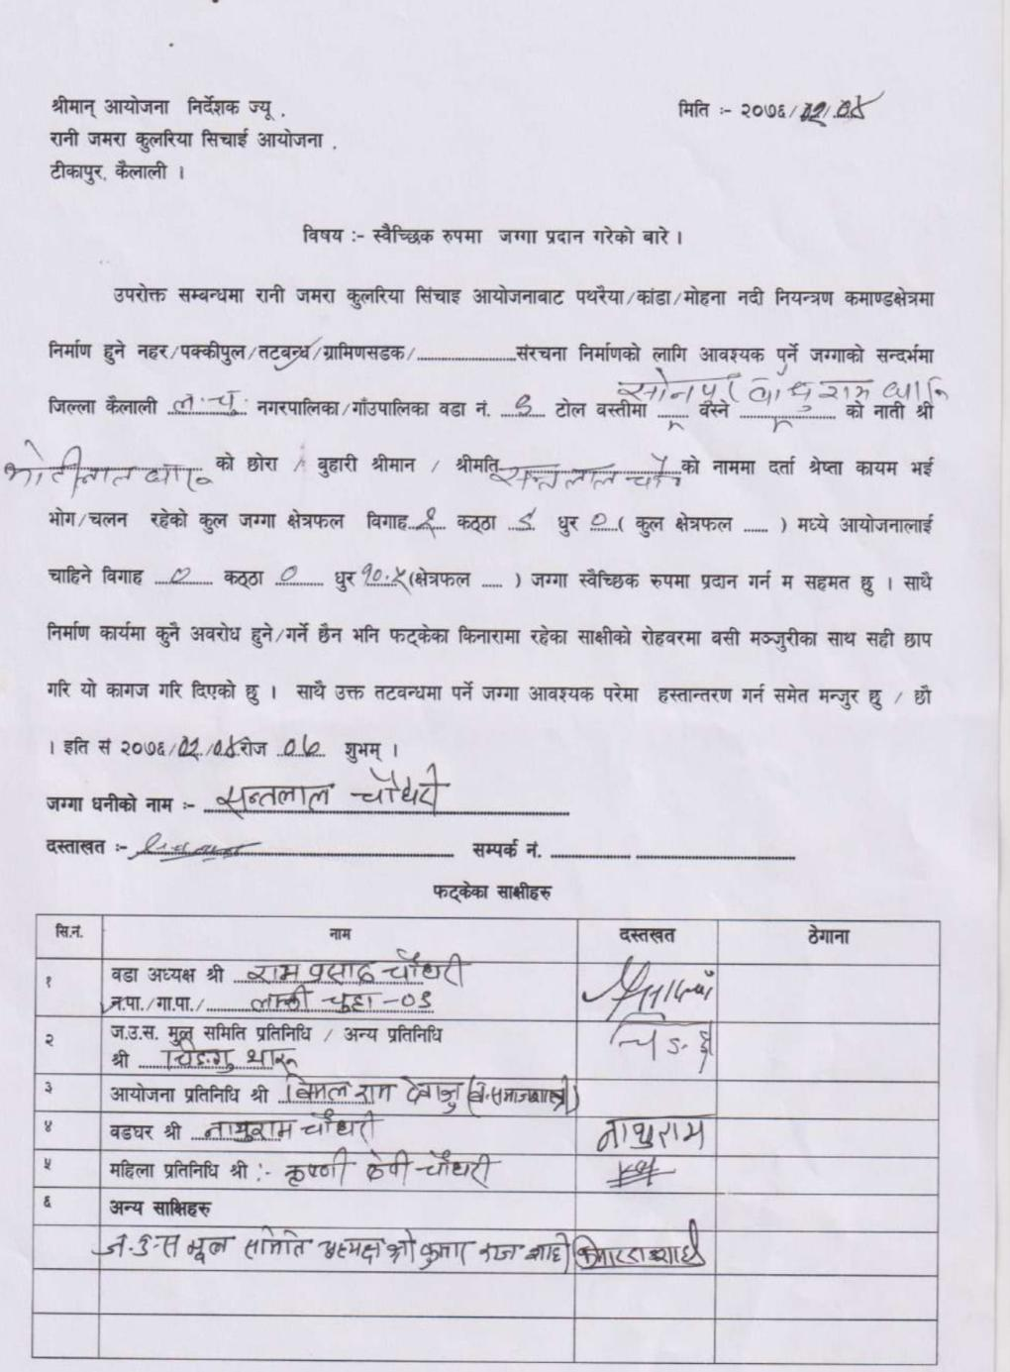

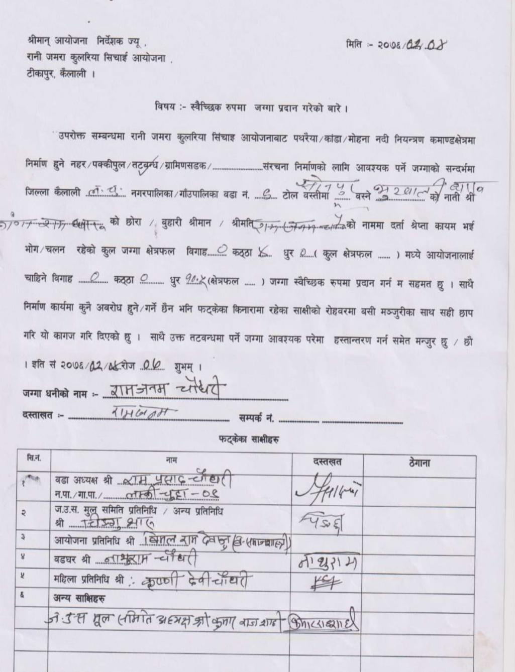
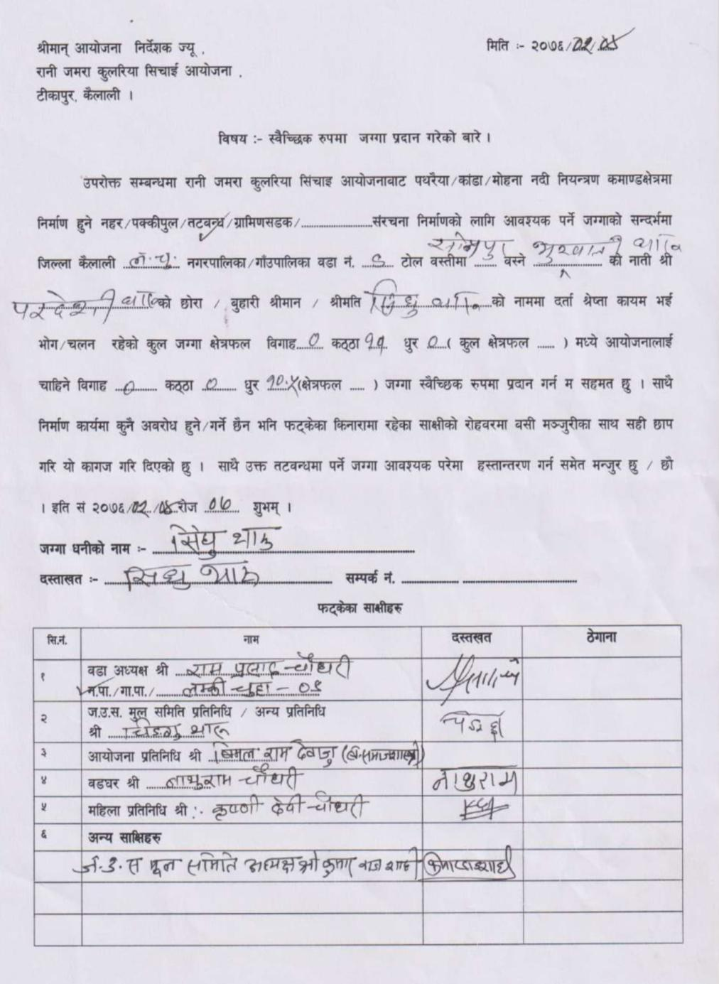

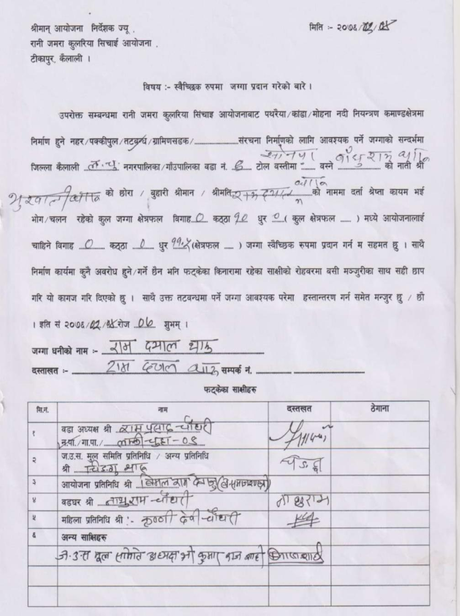
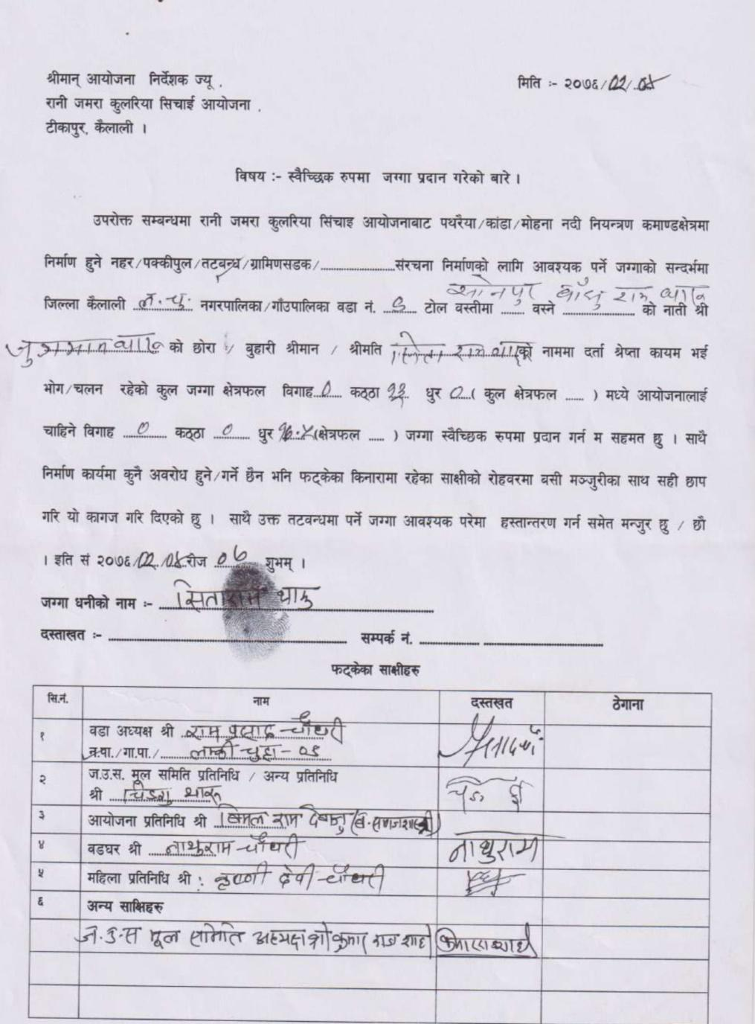

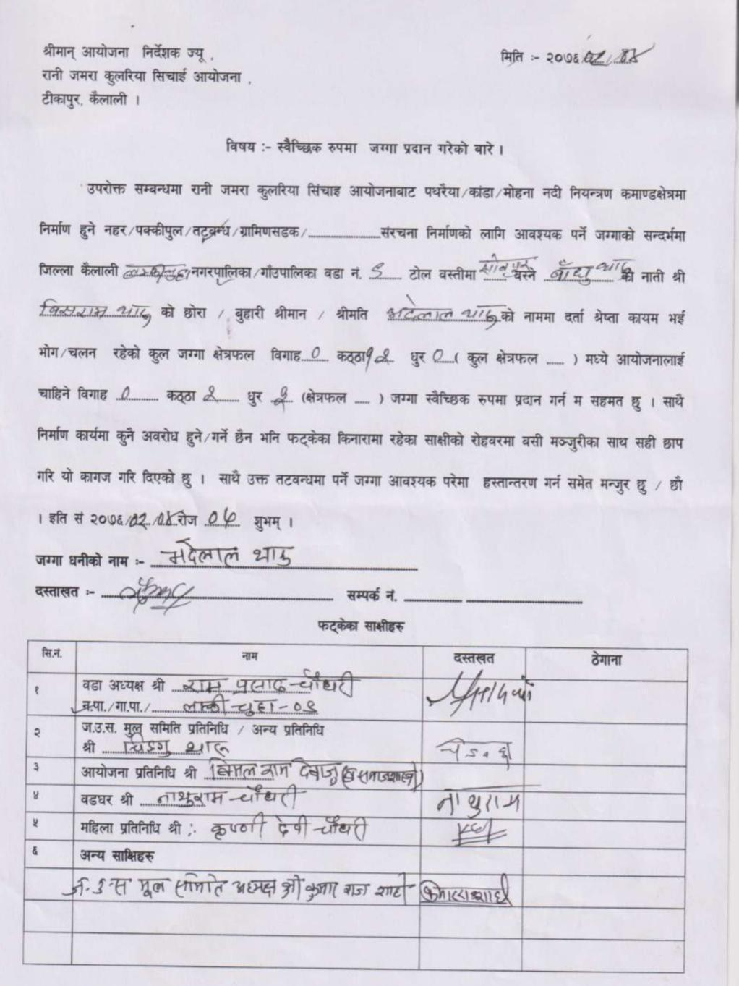
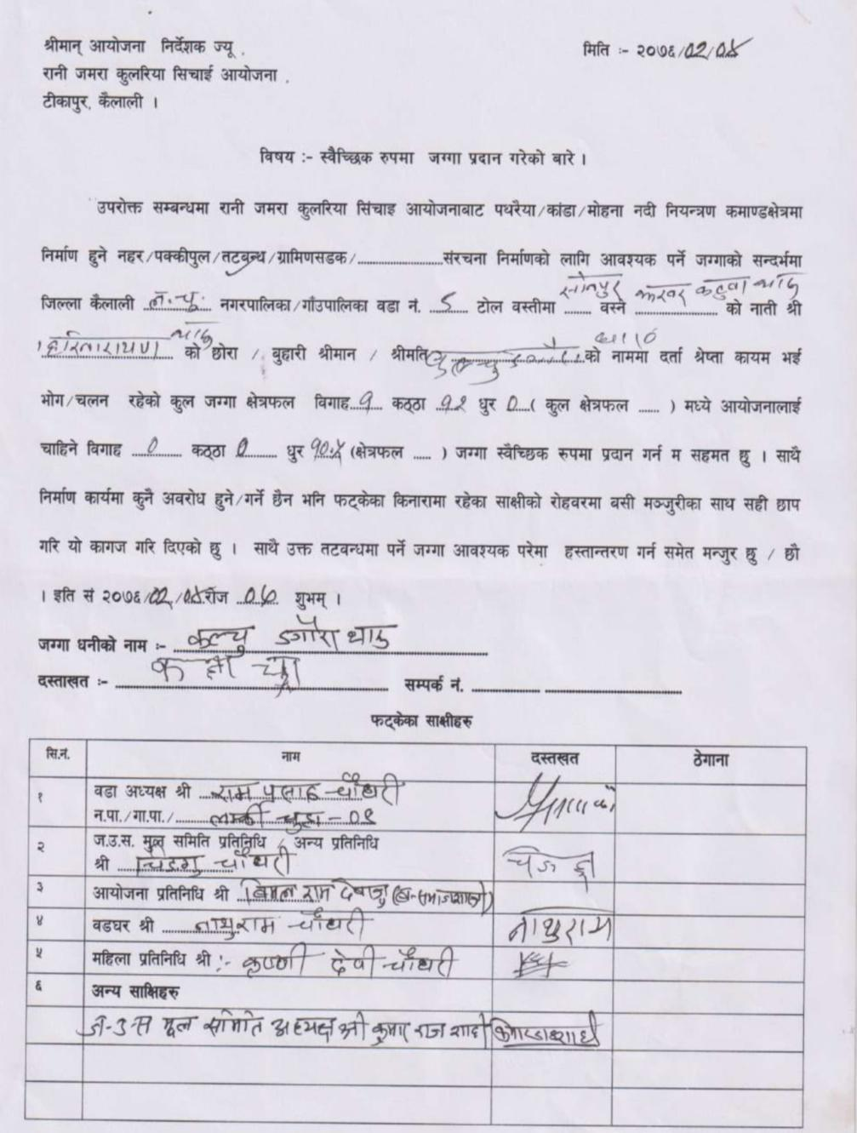

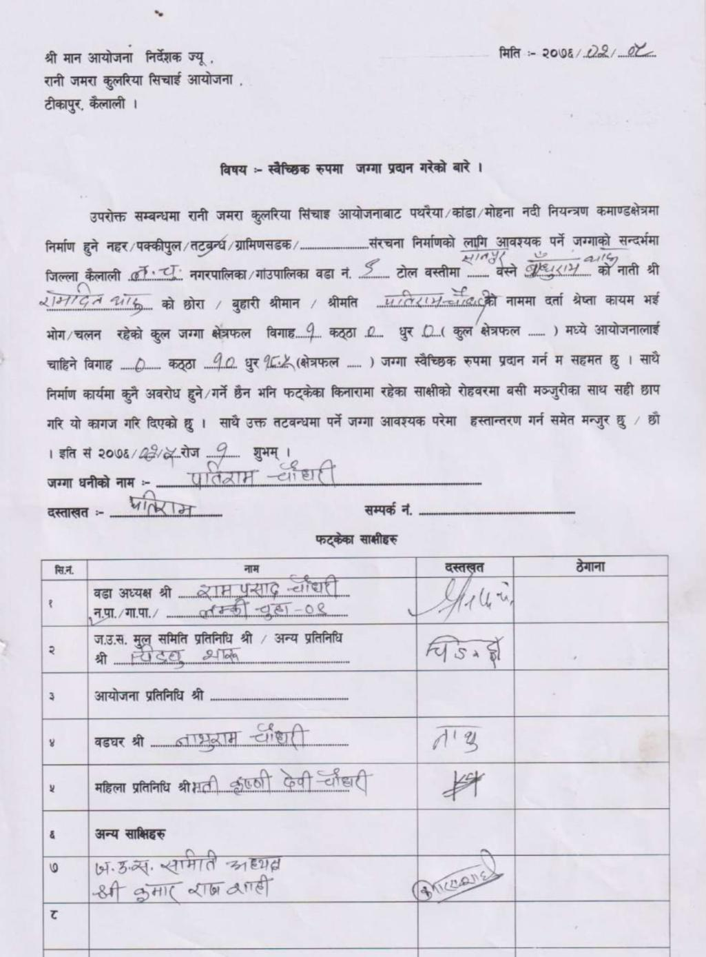
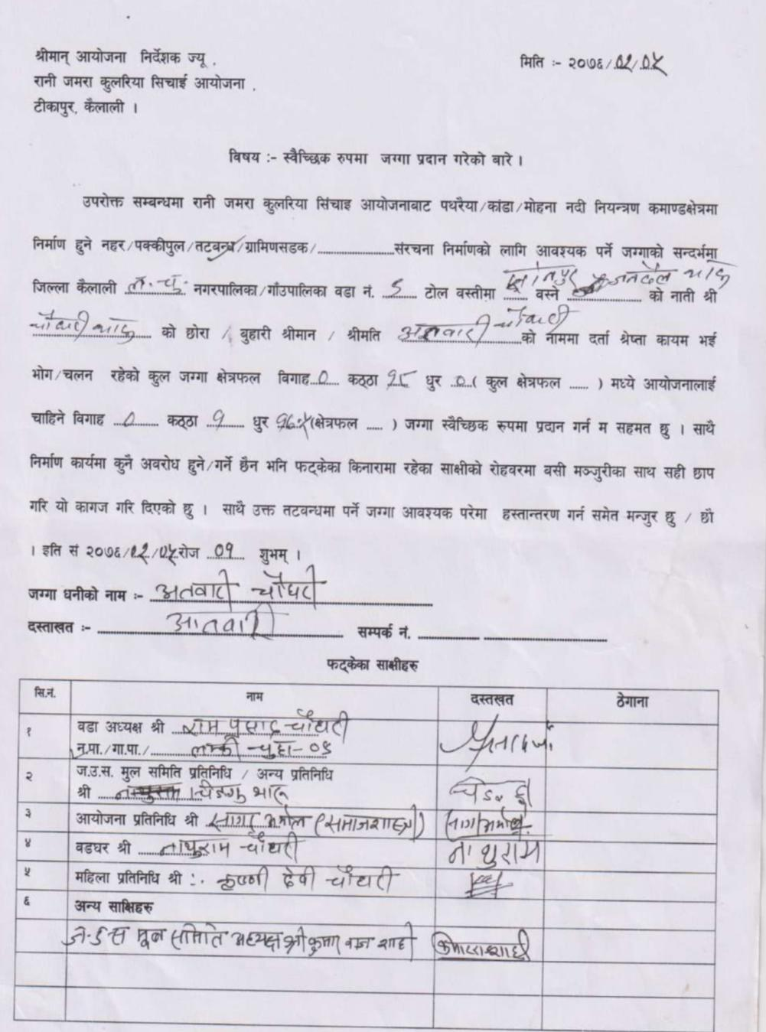

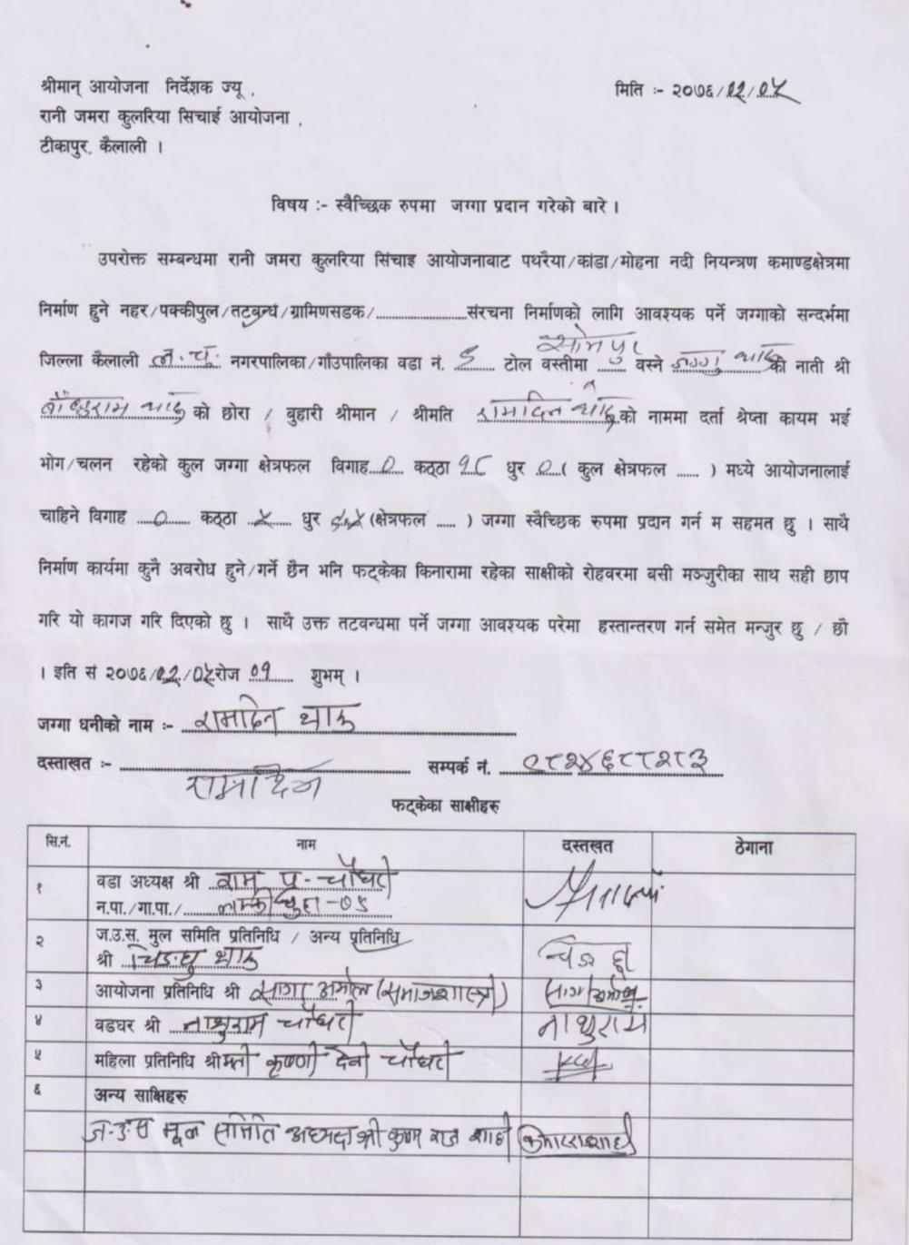
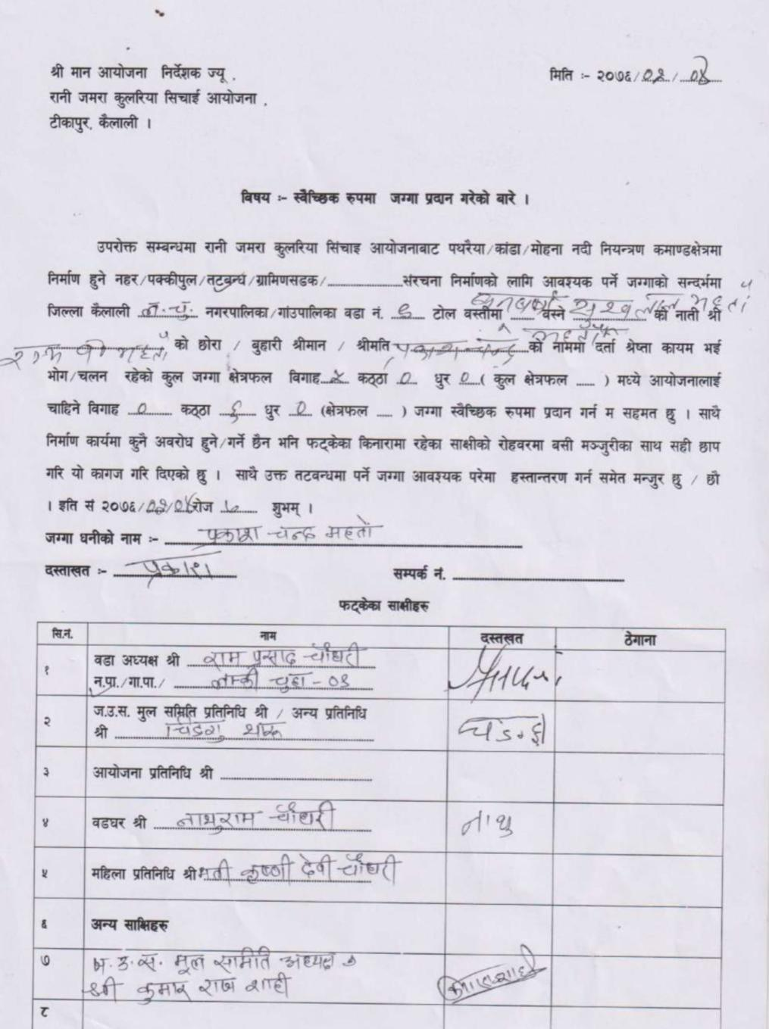

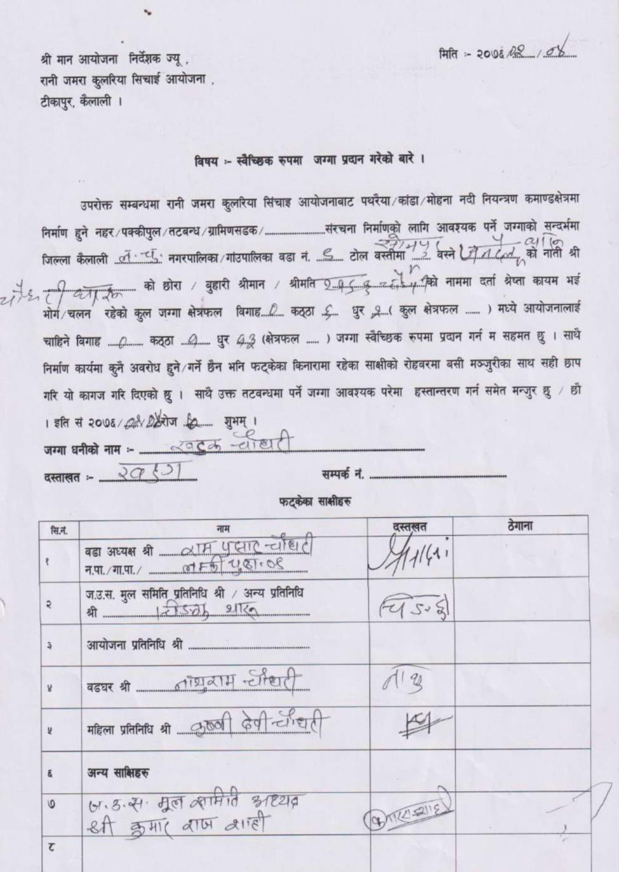
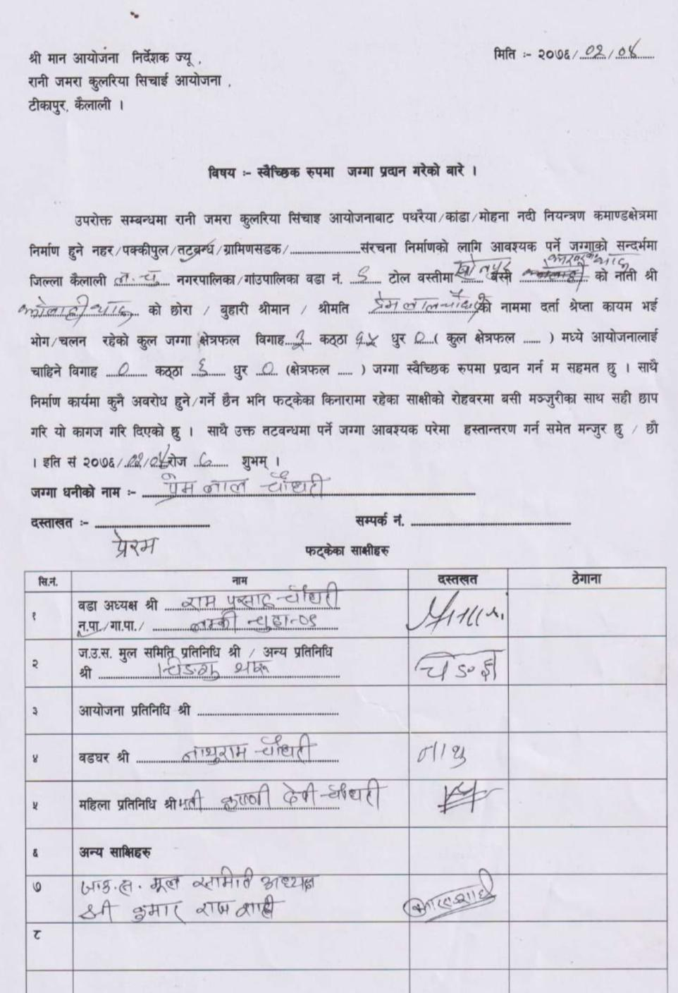

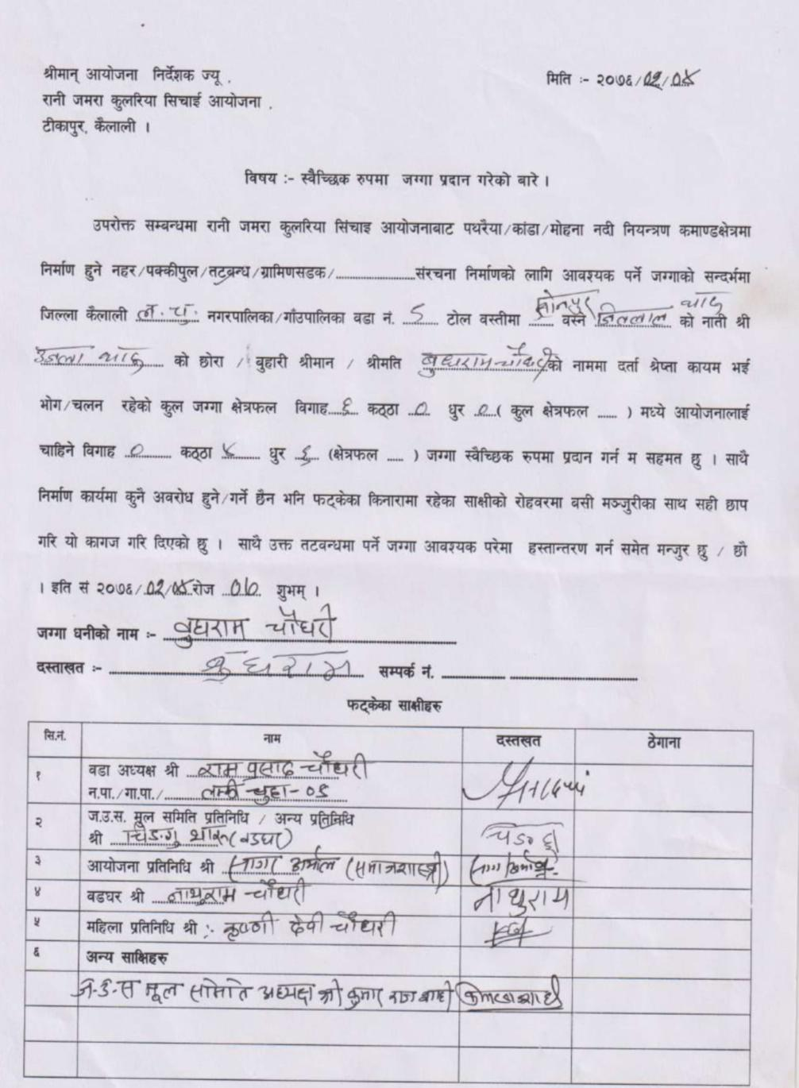
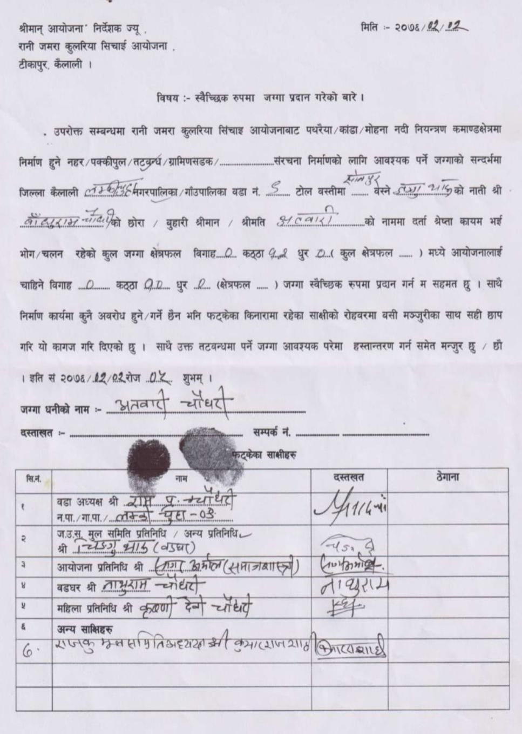

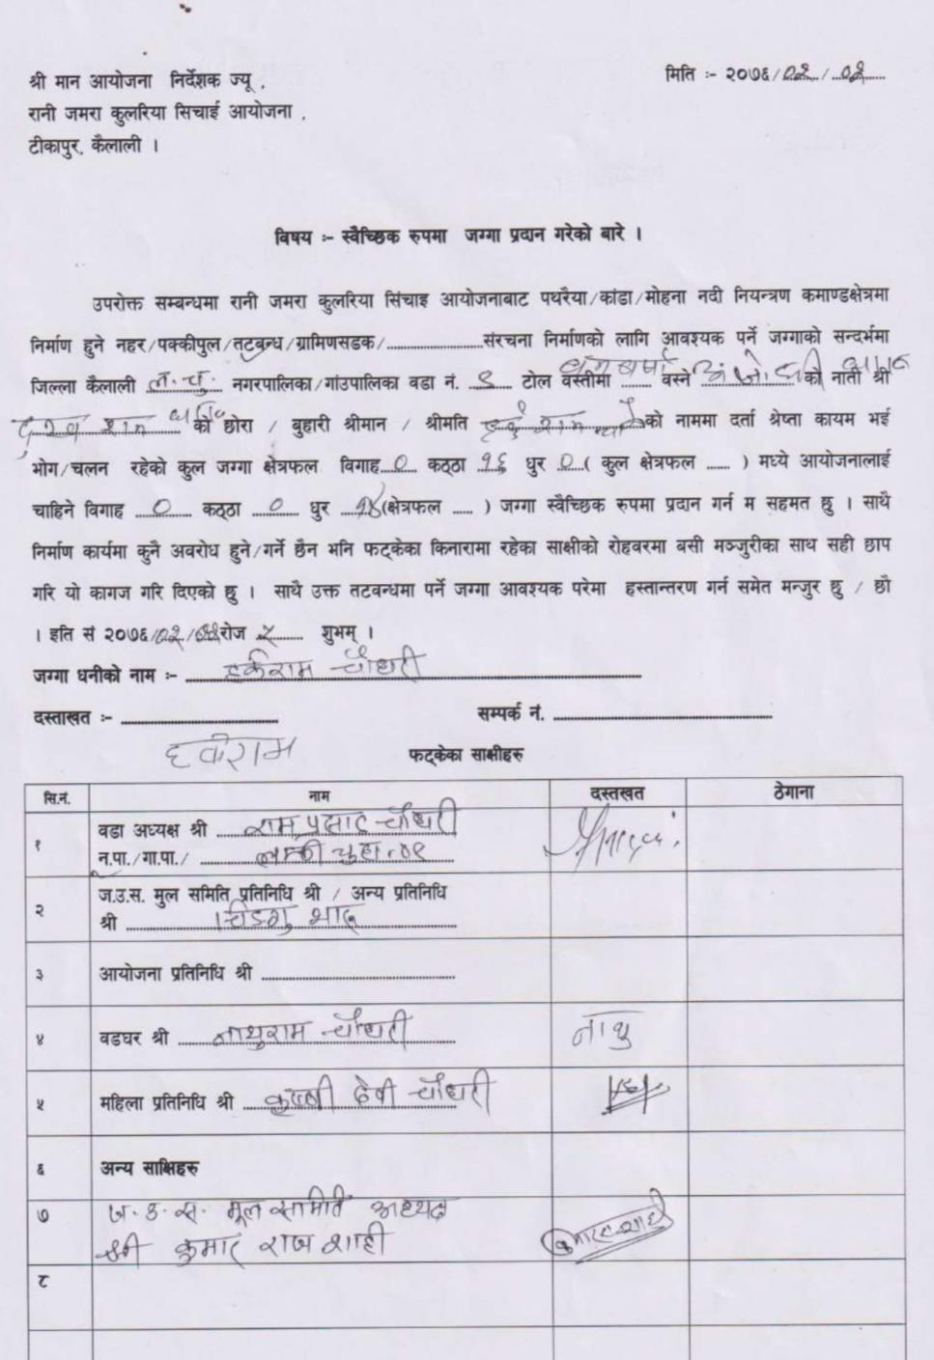
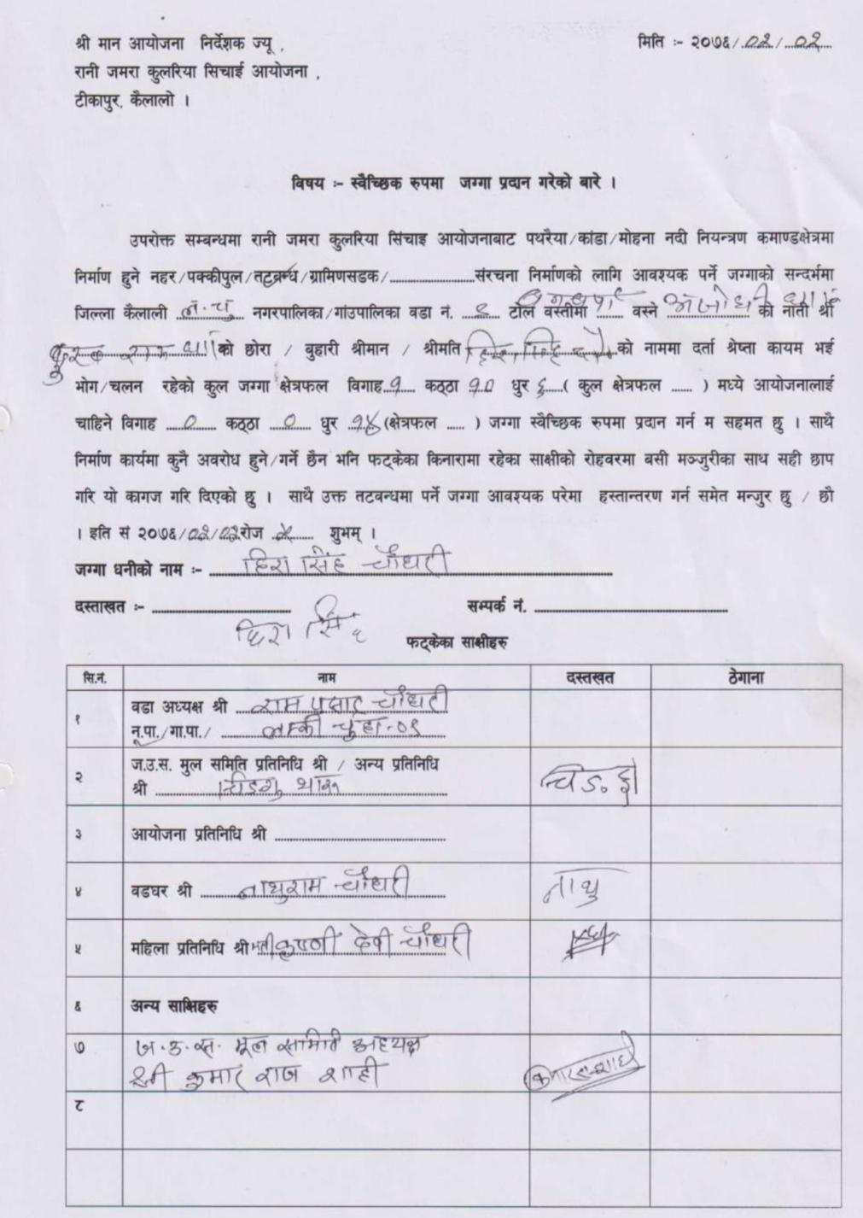

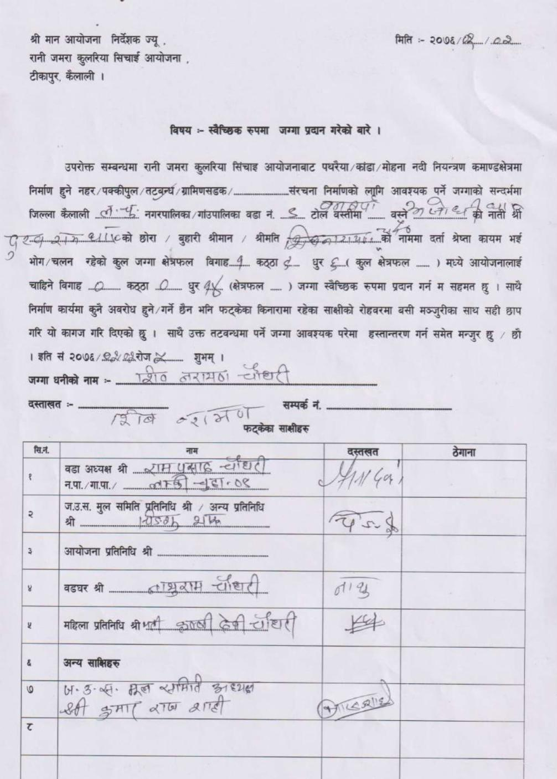
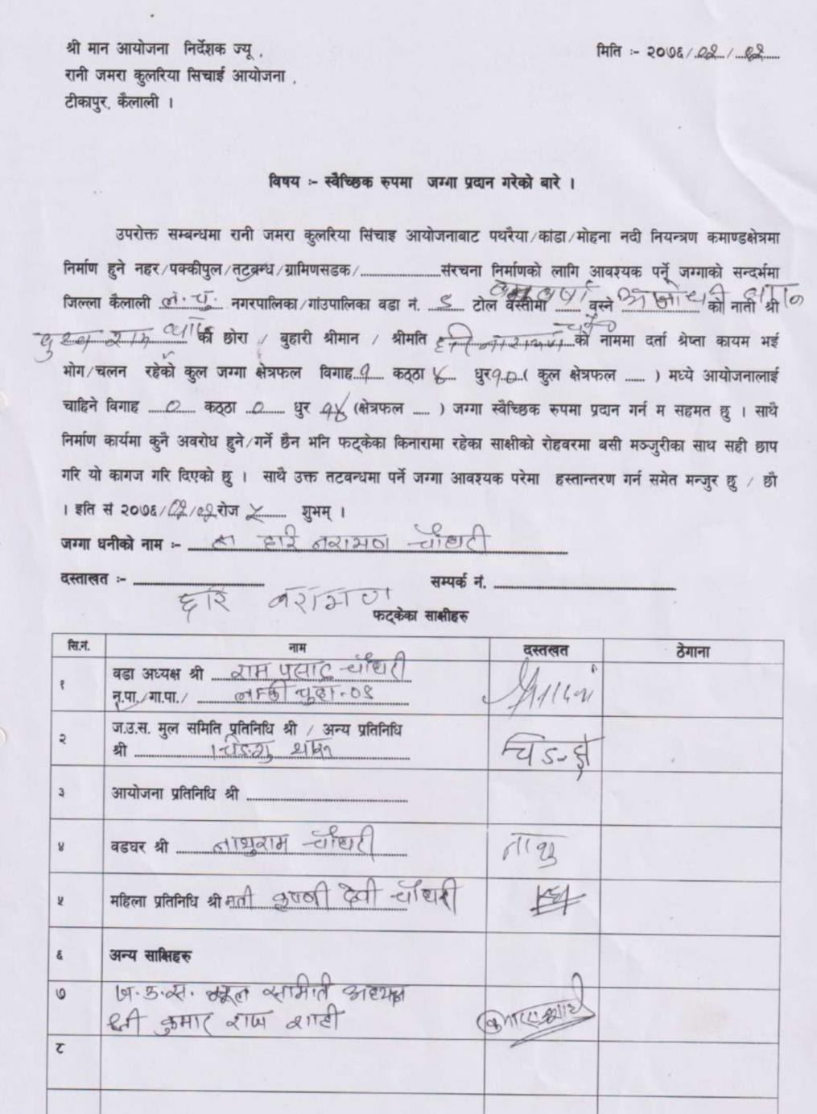

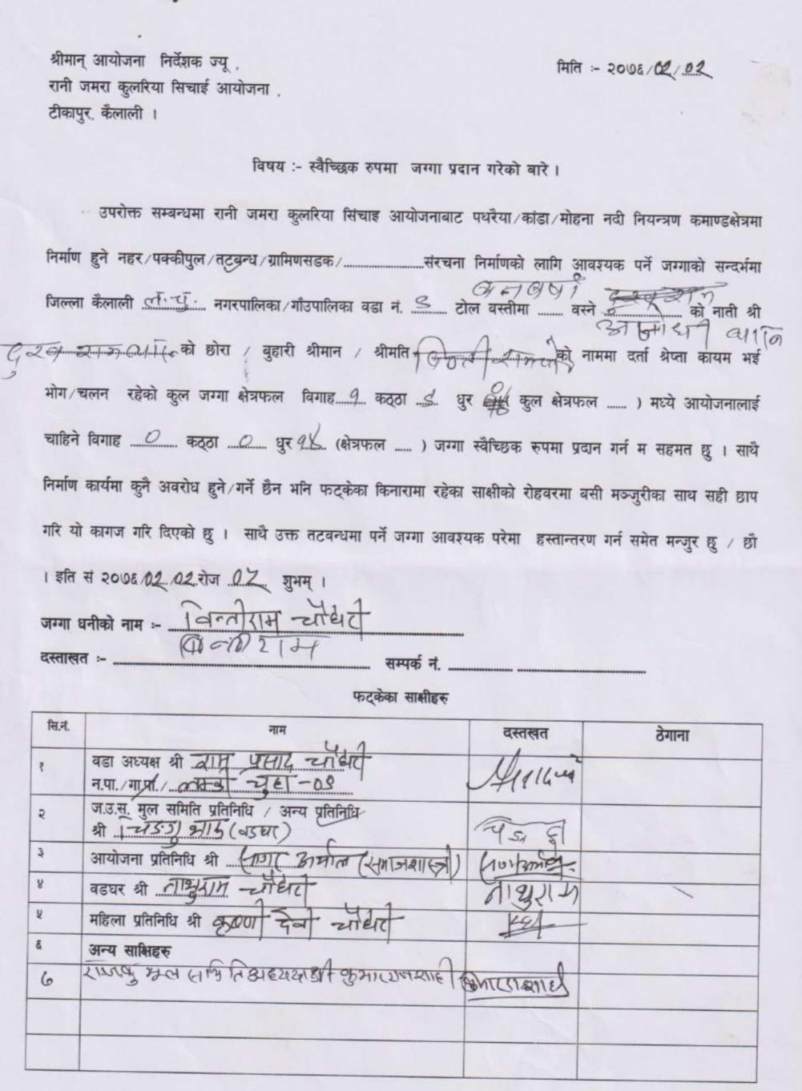
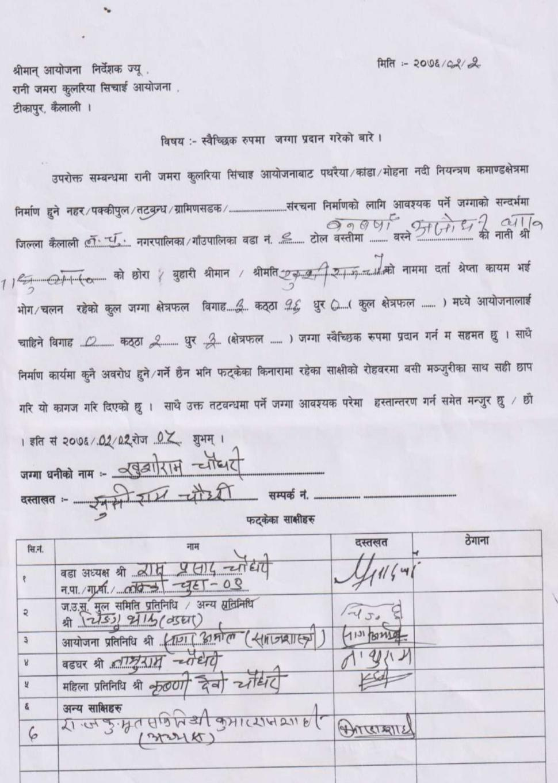

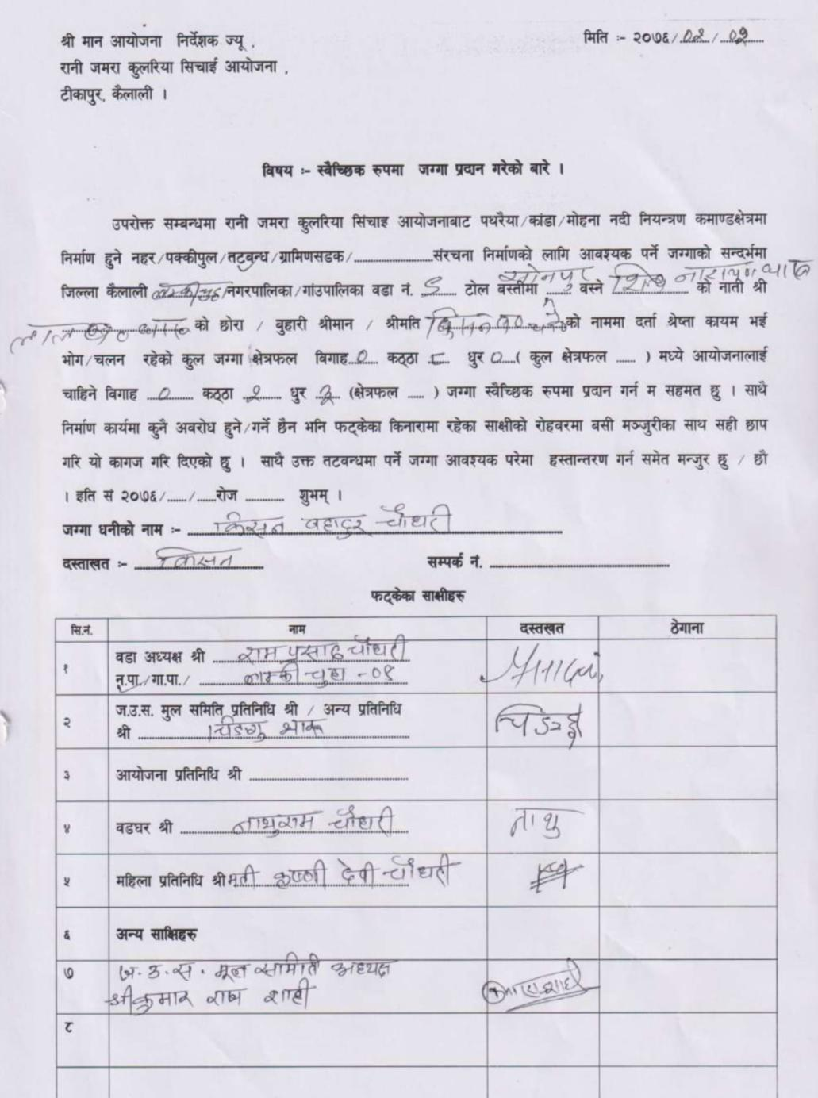
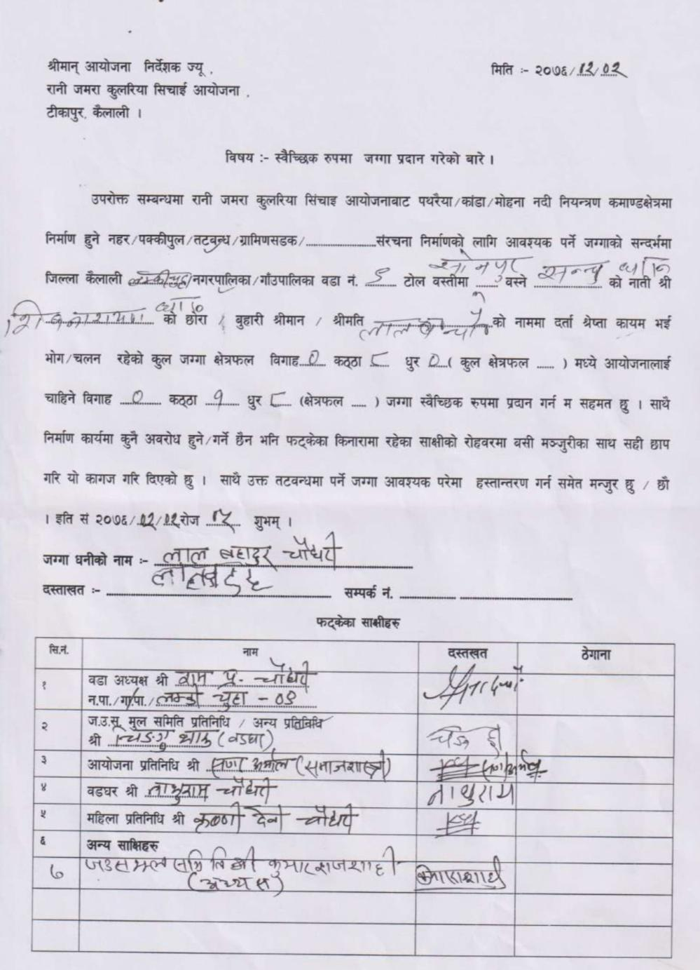

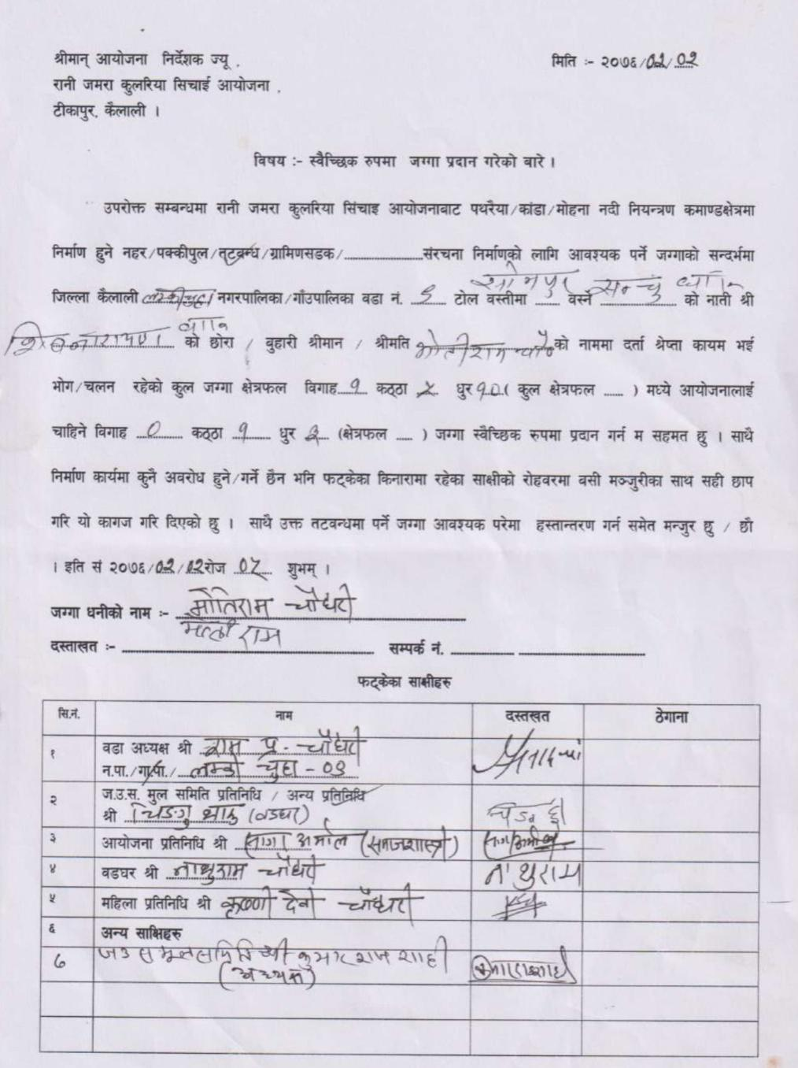
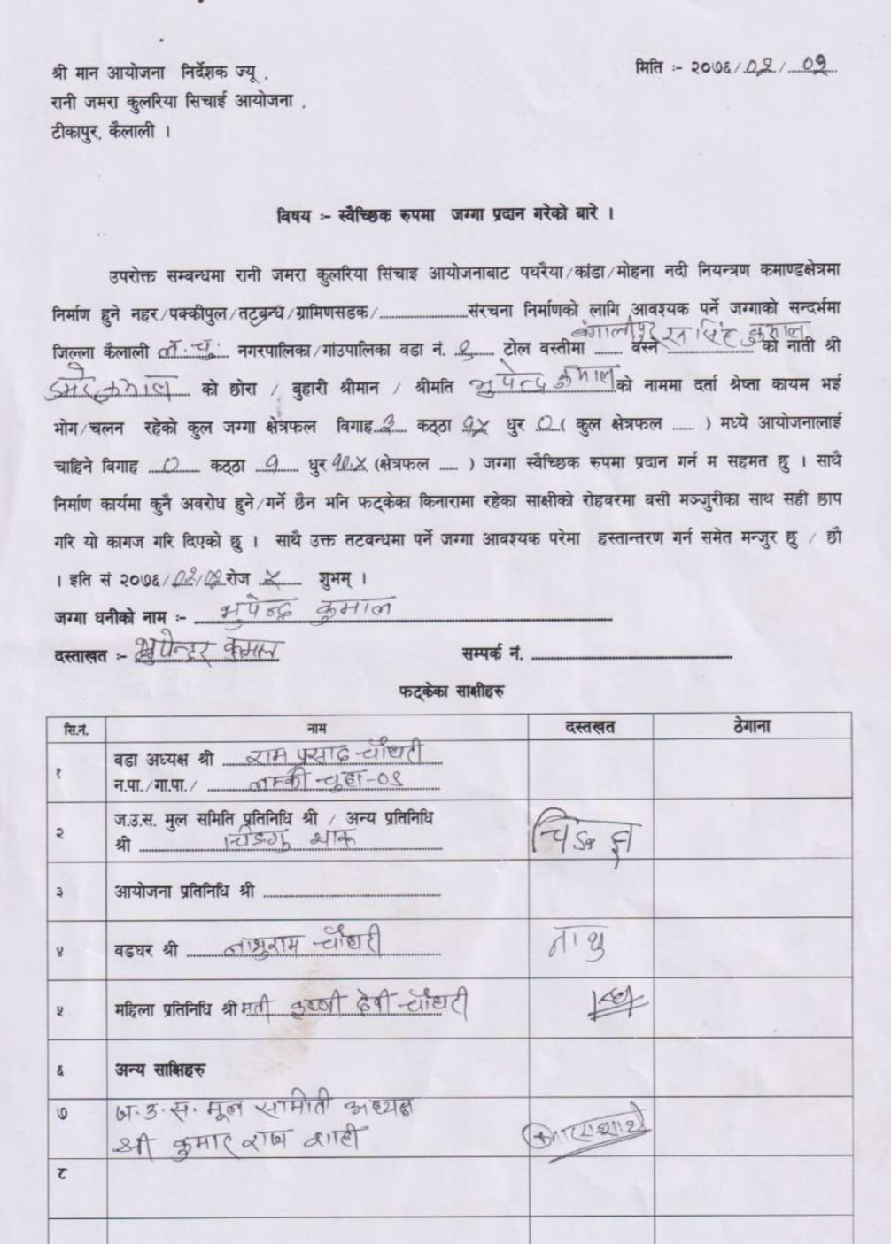

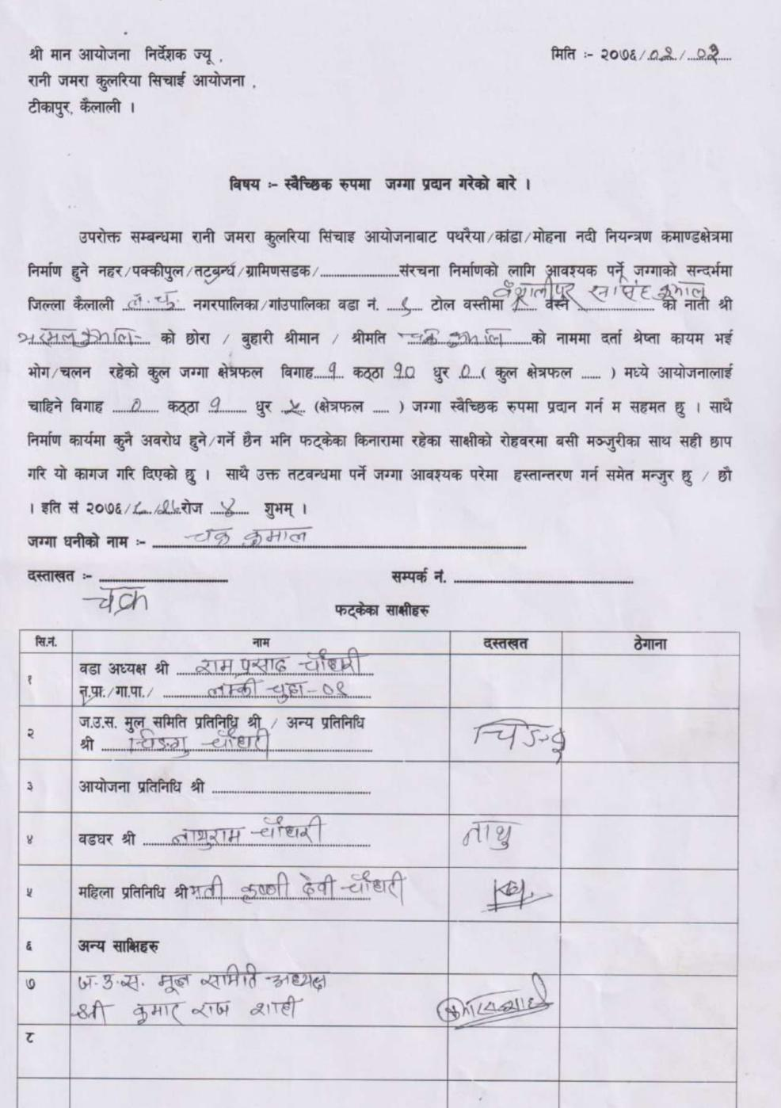
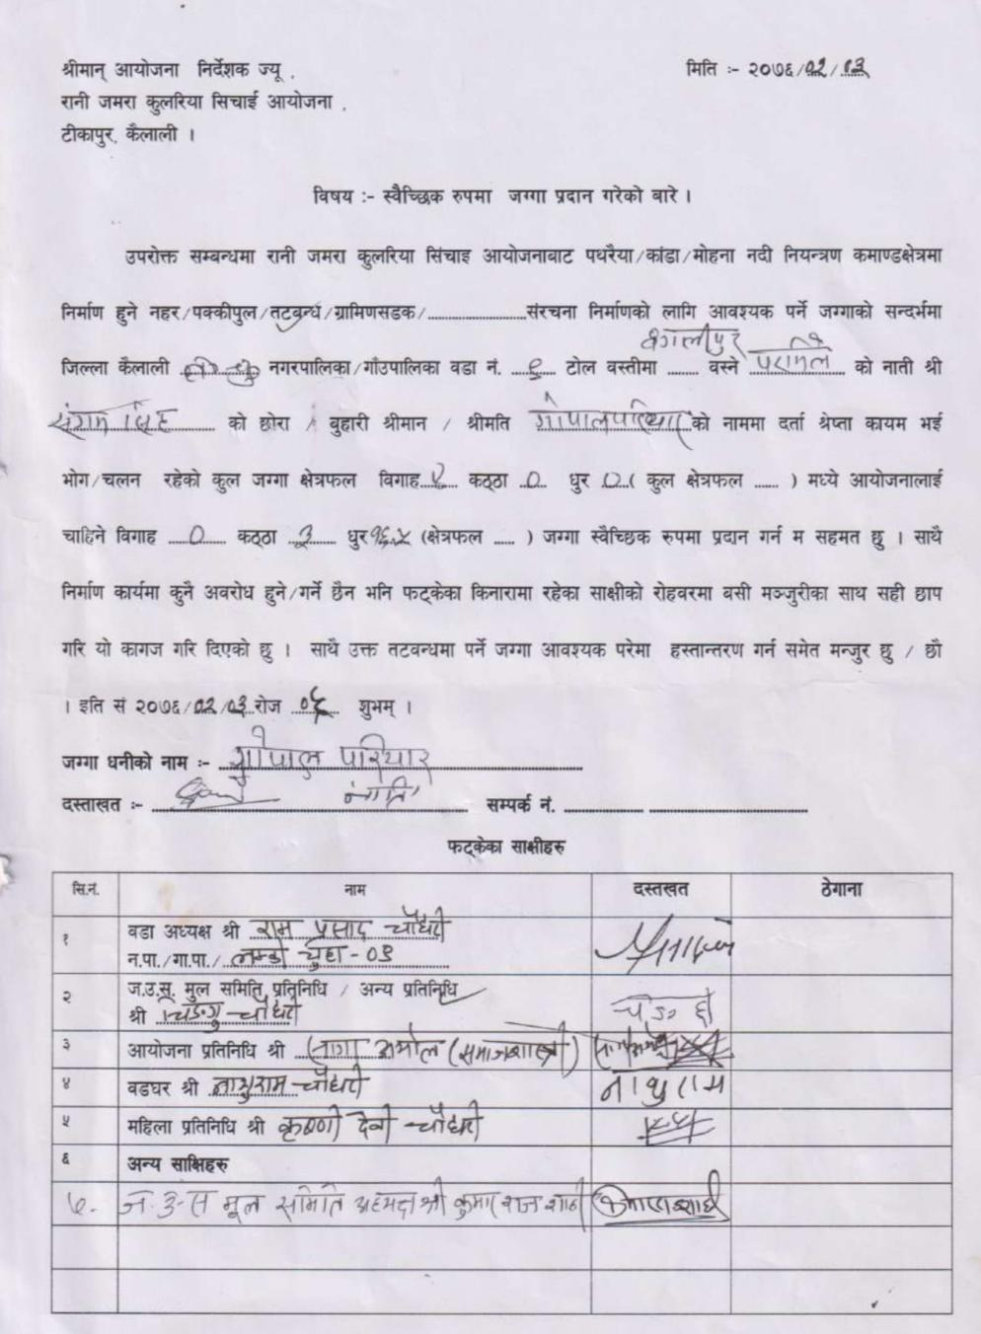

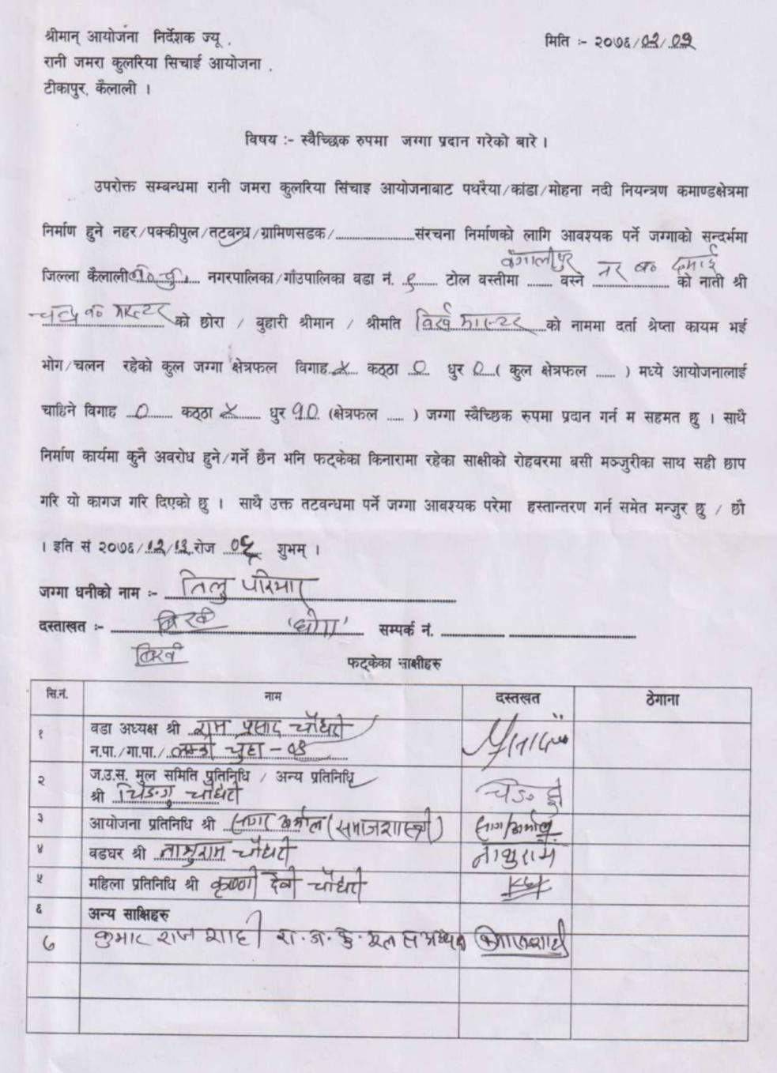

3: Janaki RM 2 (LB)
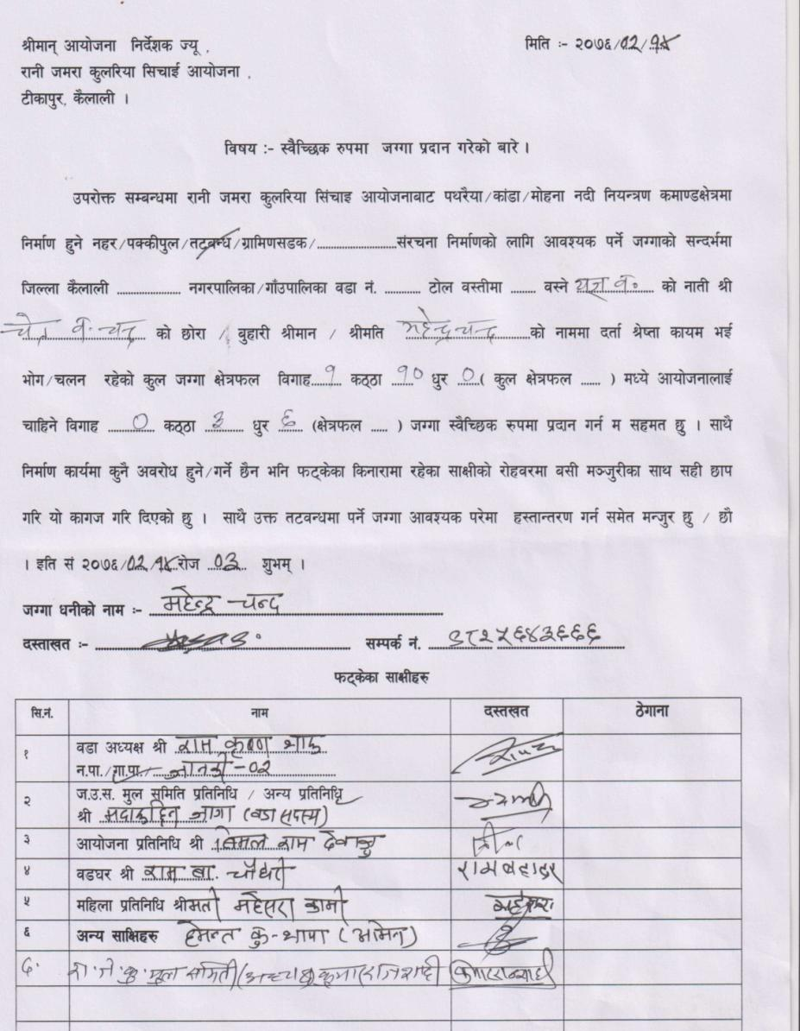
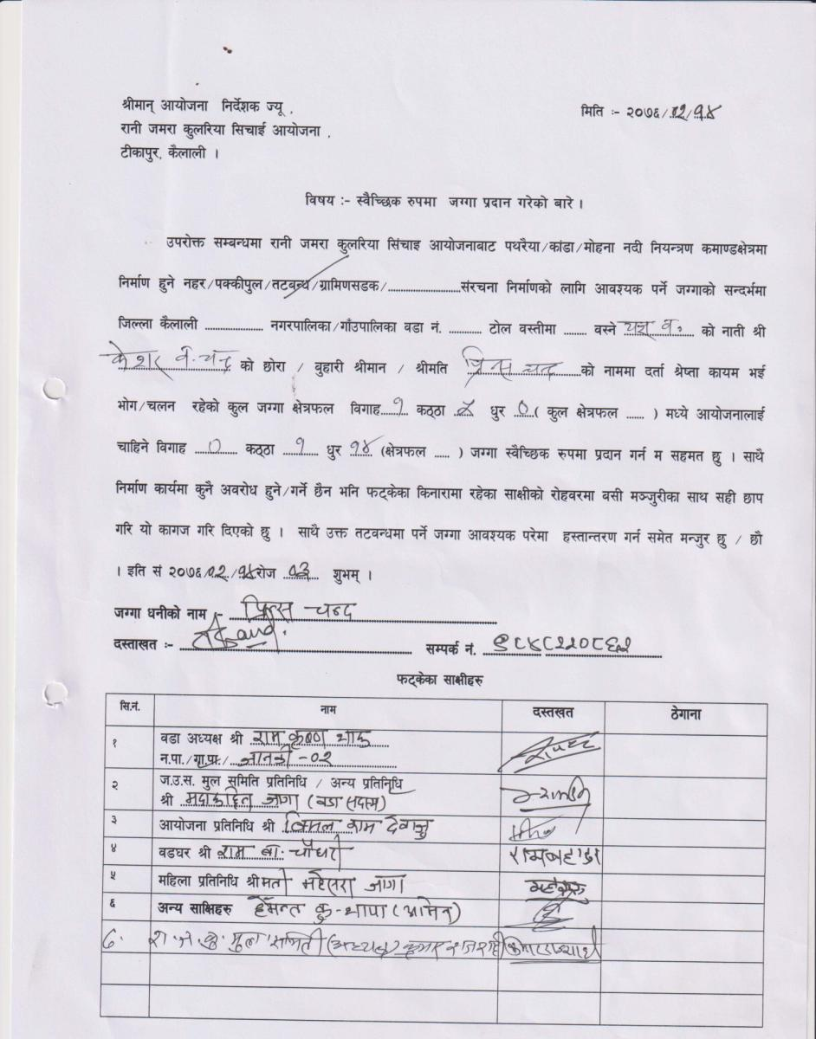

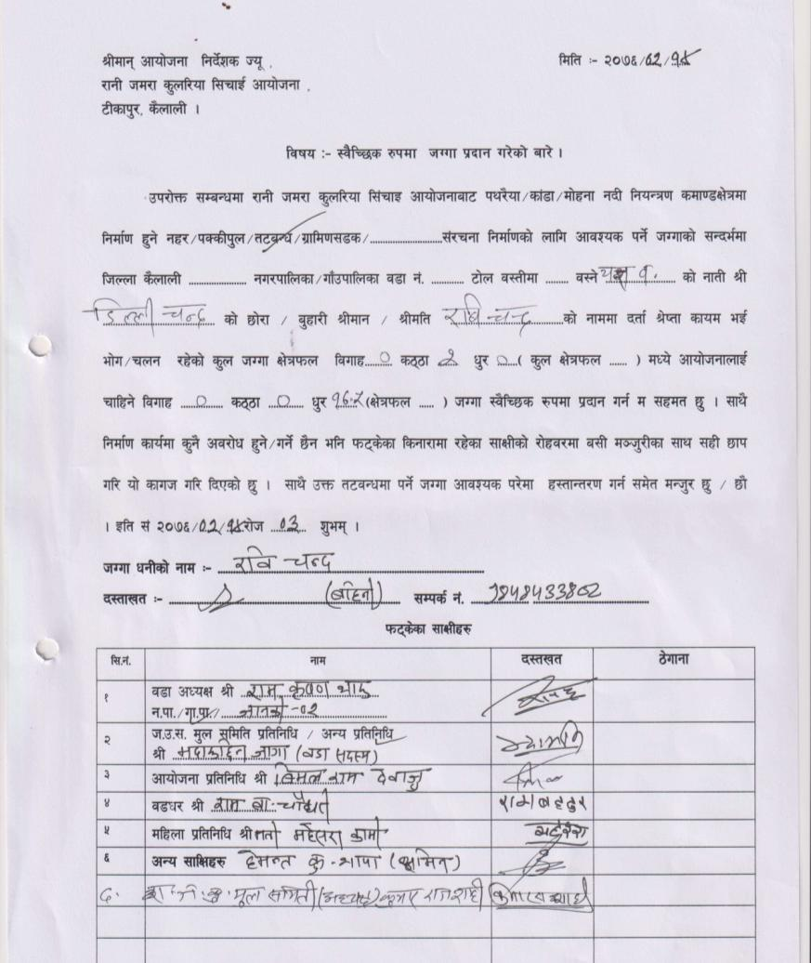
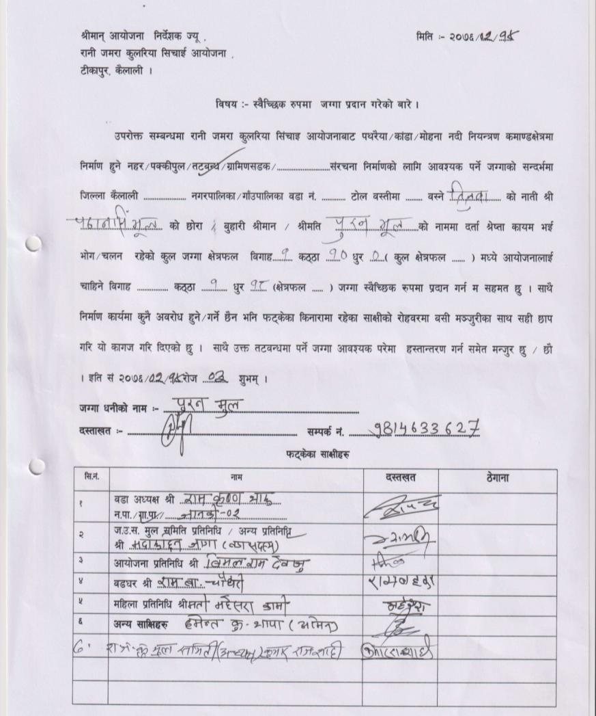

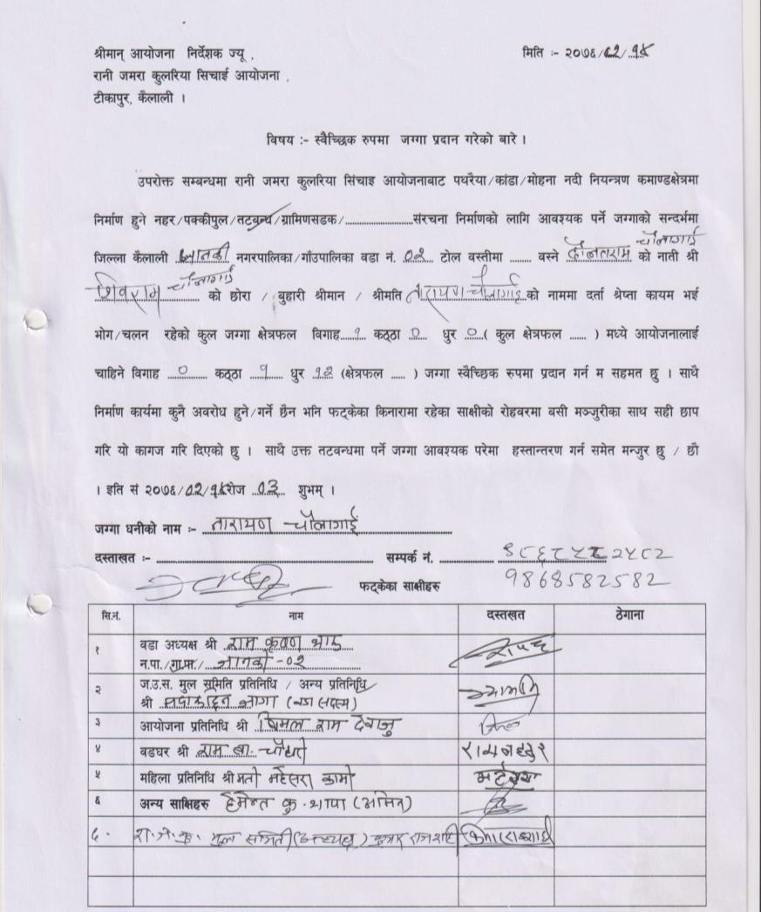
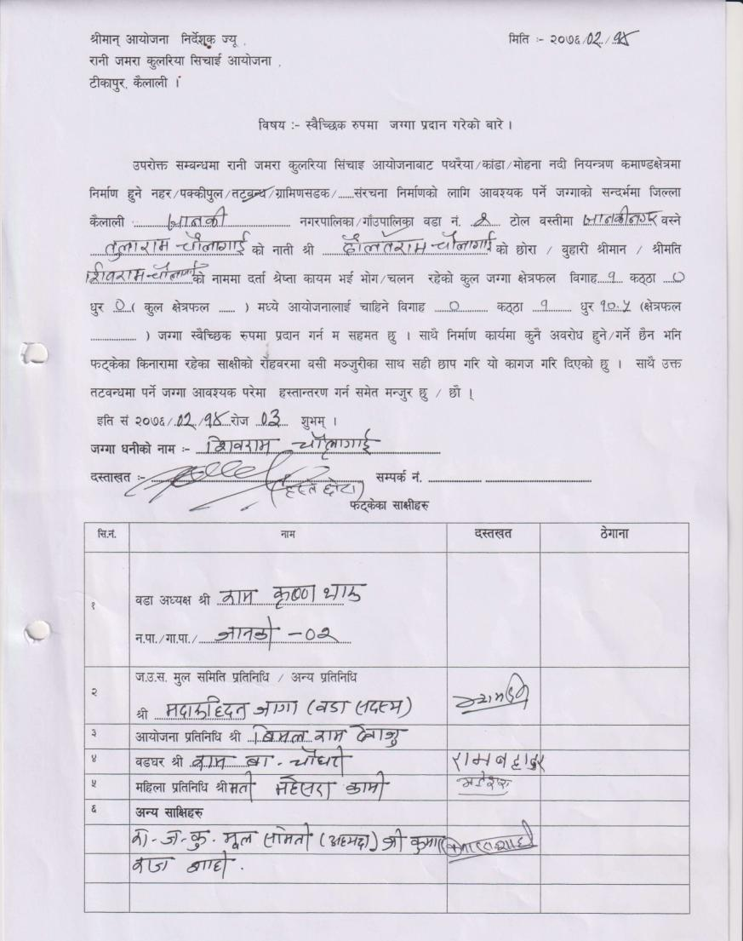

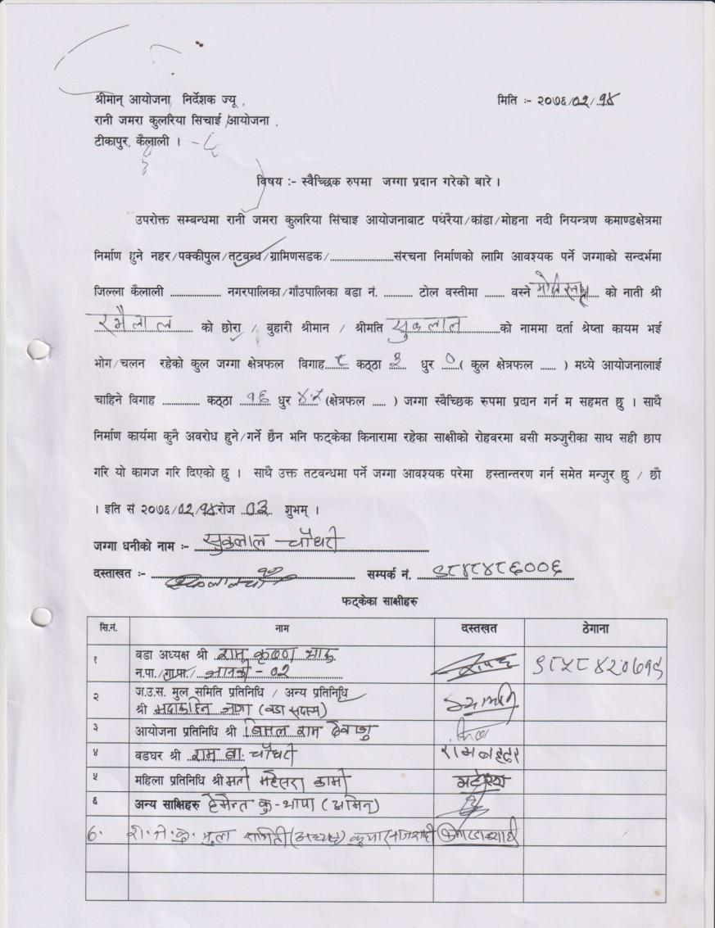

4: Janaki RM 4 (LB)
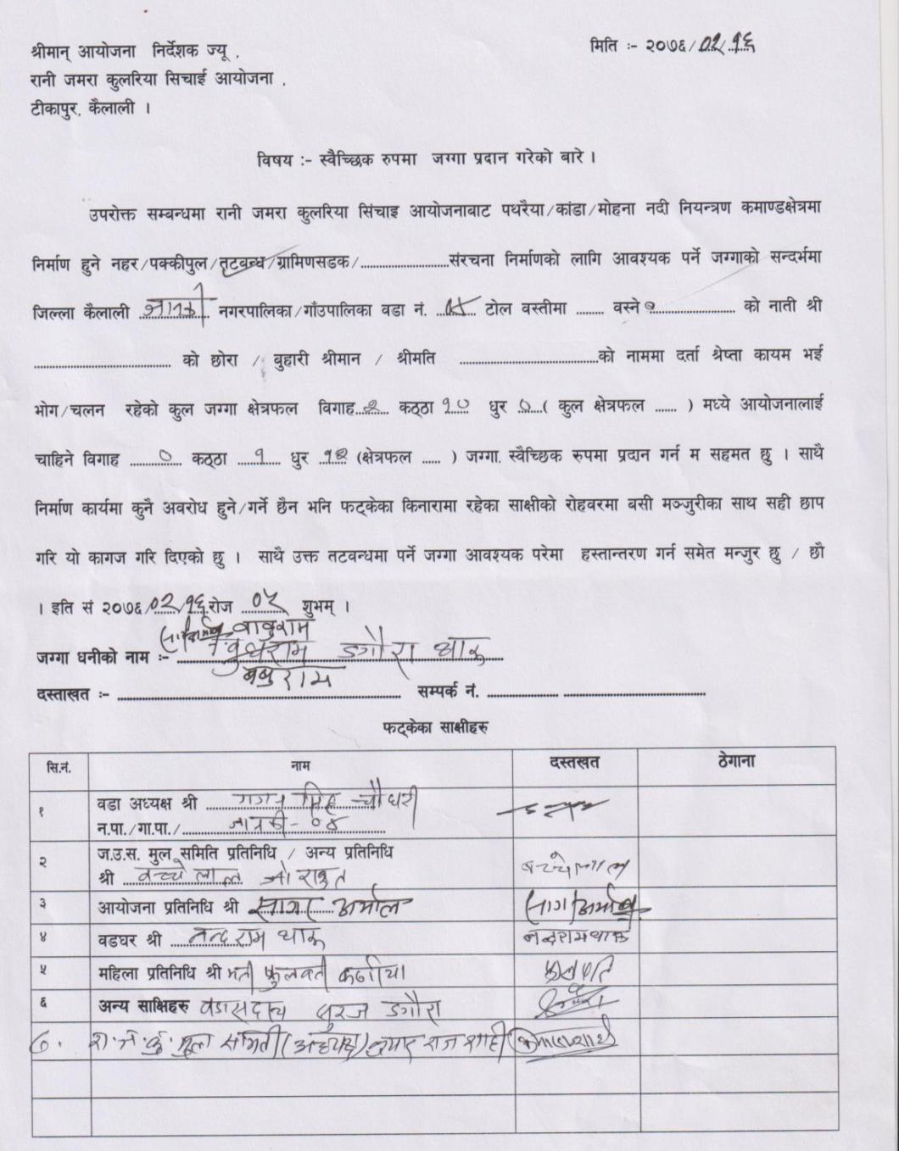
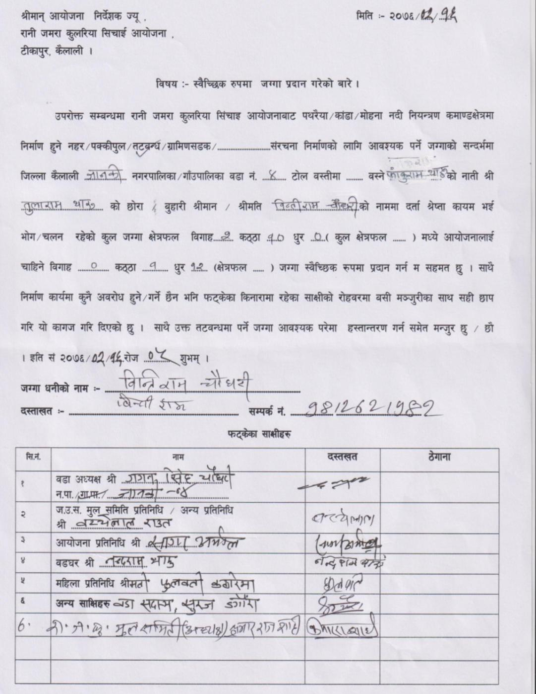

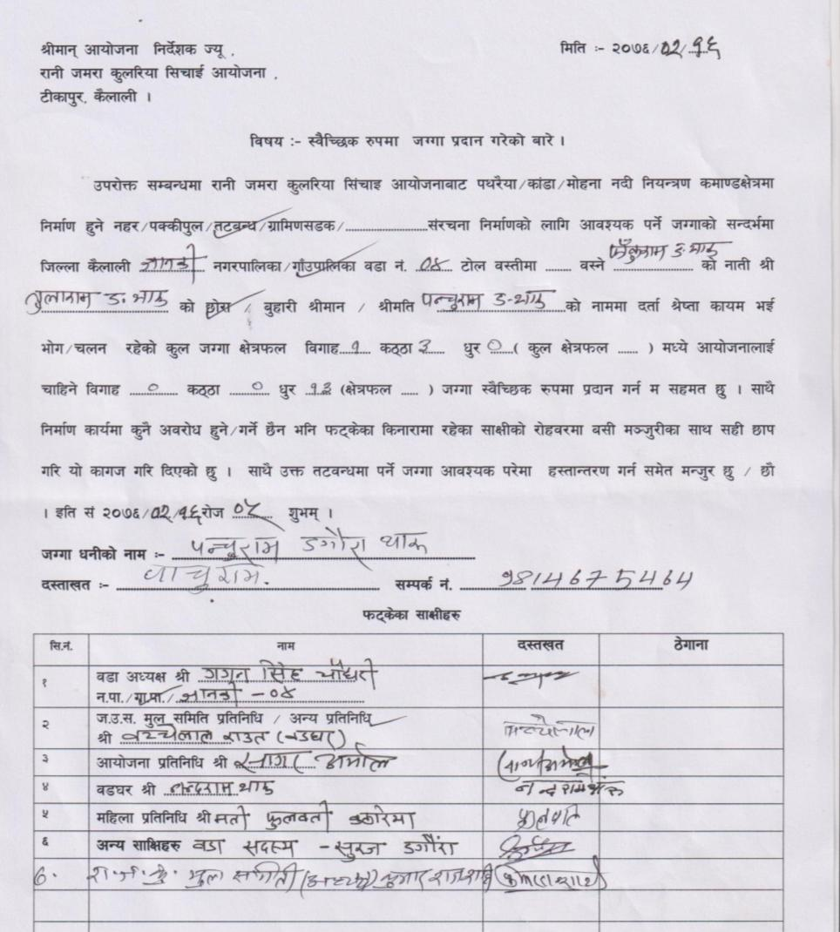
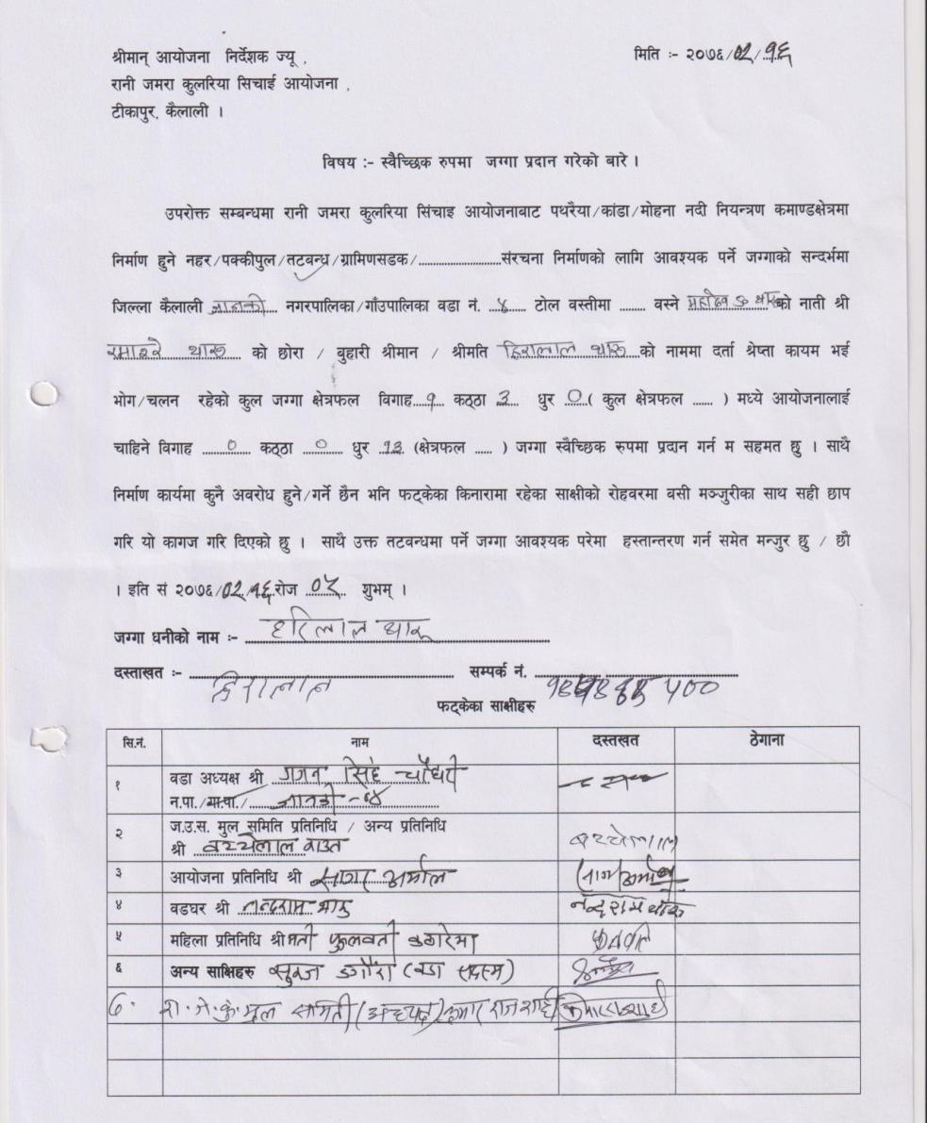

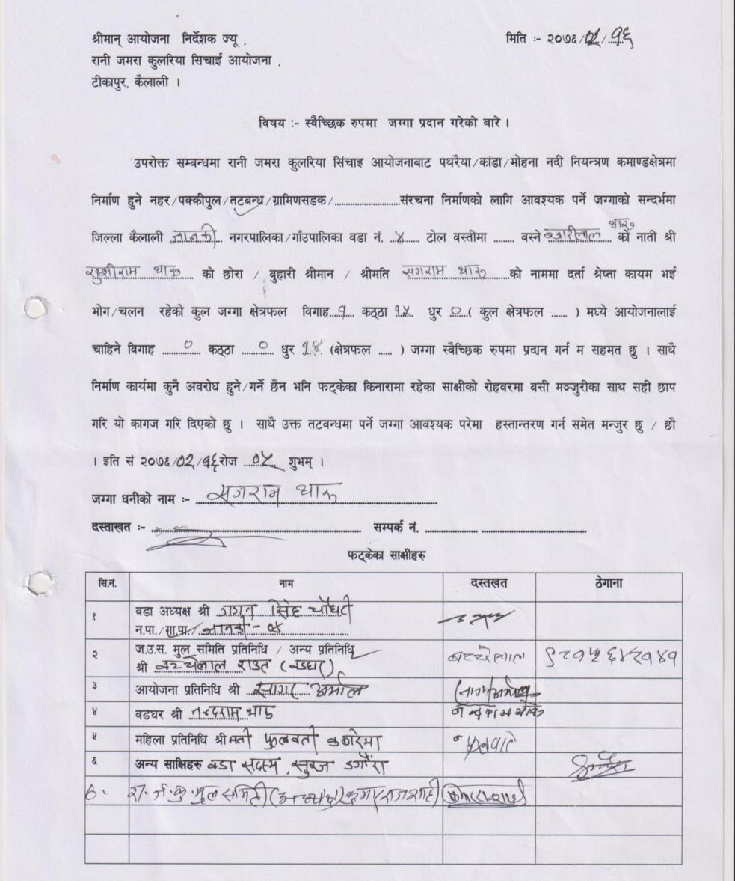
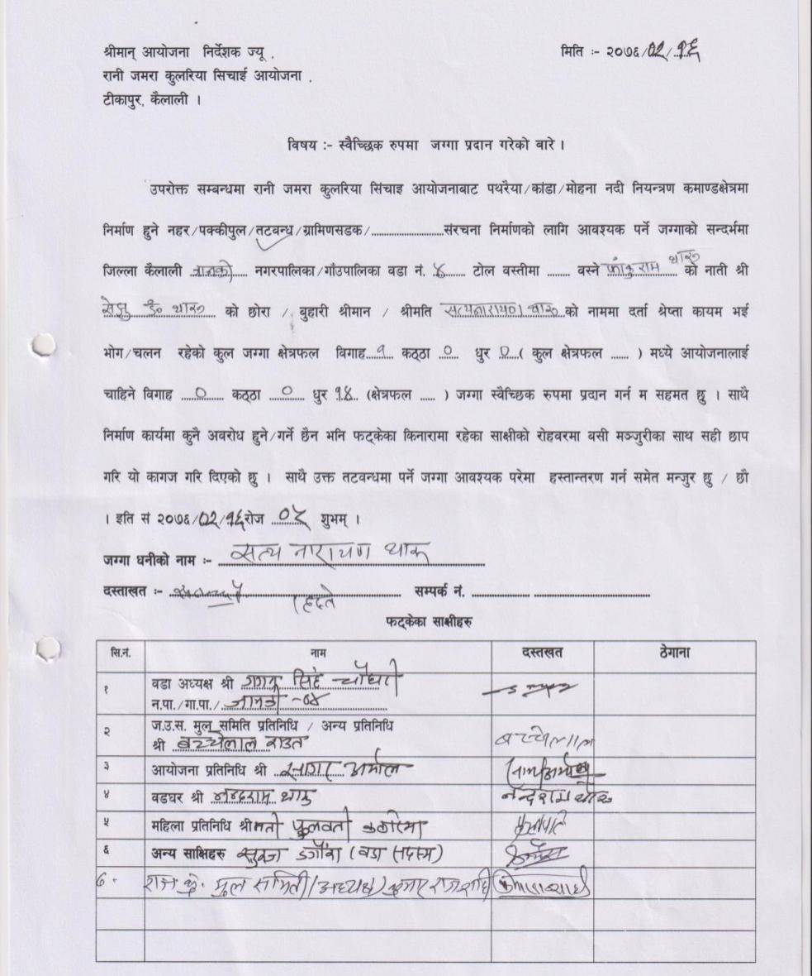

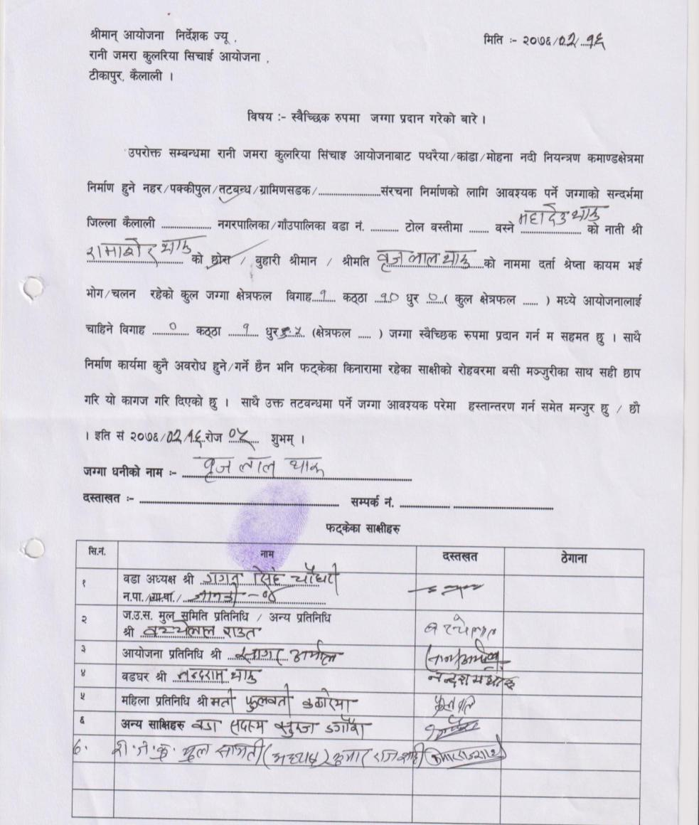
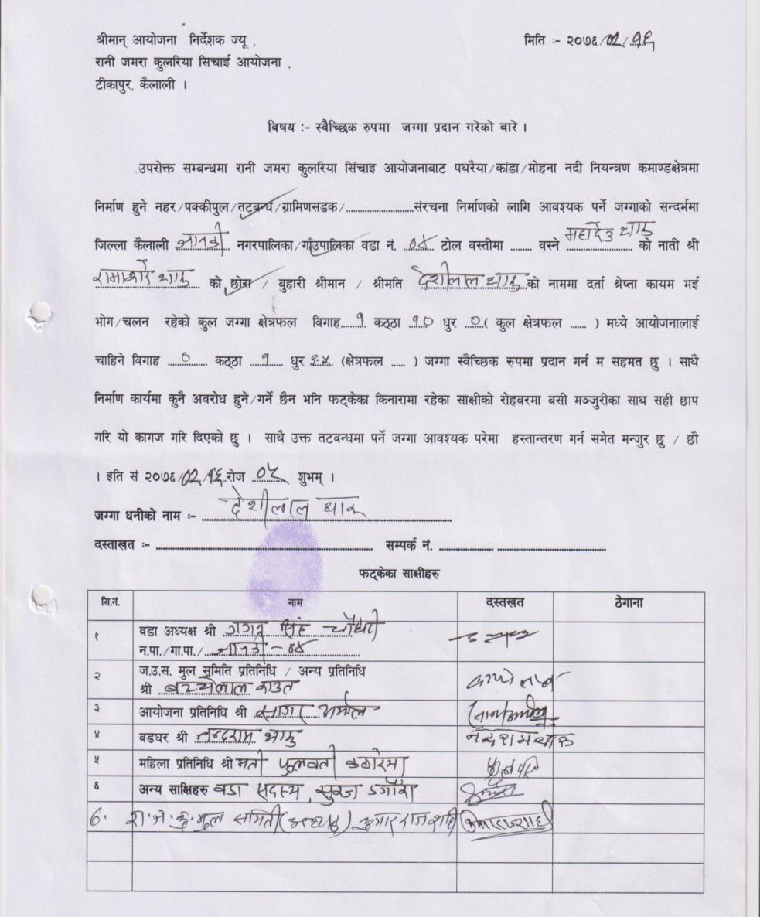

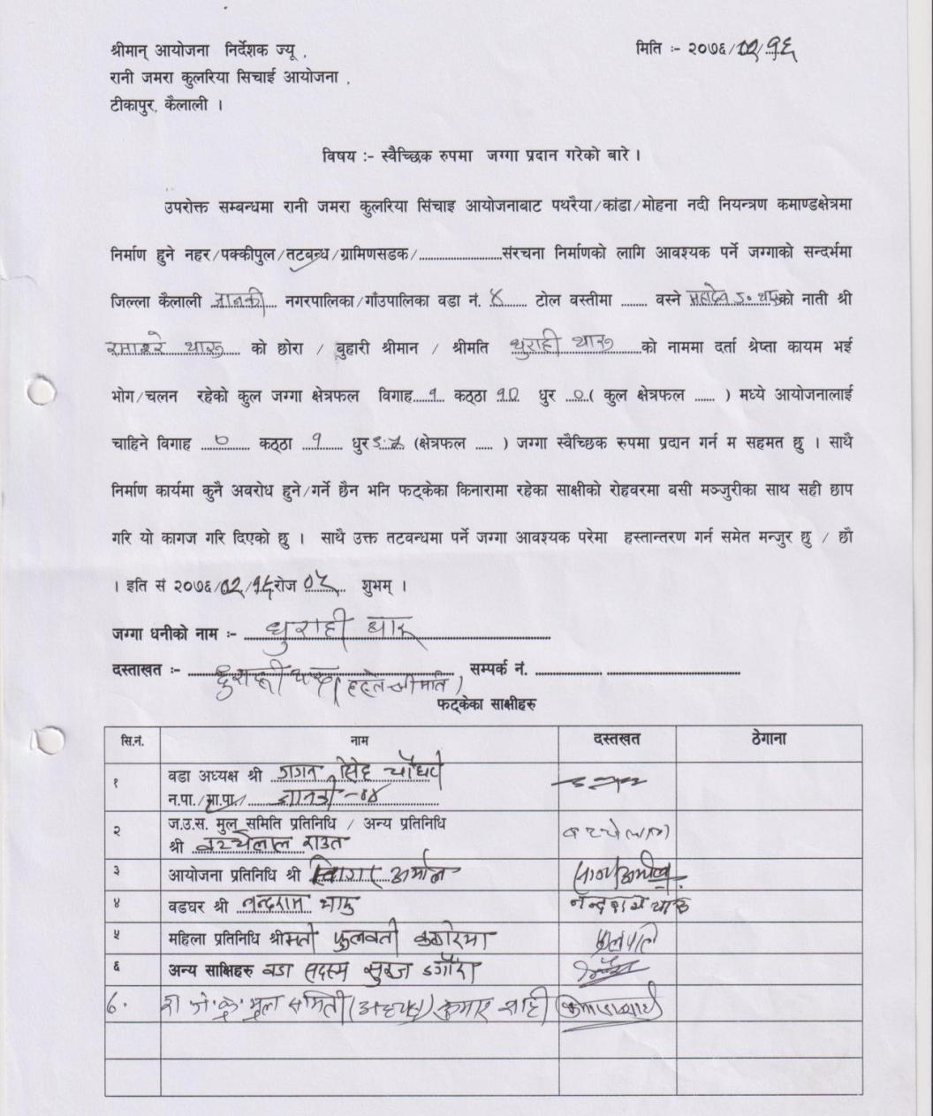
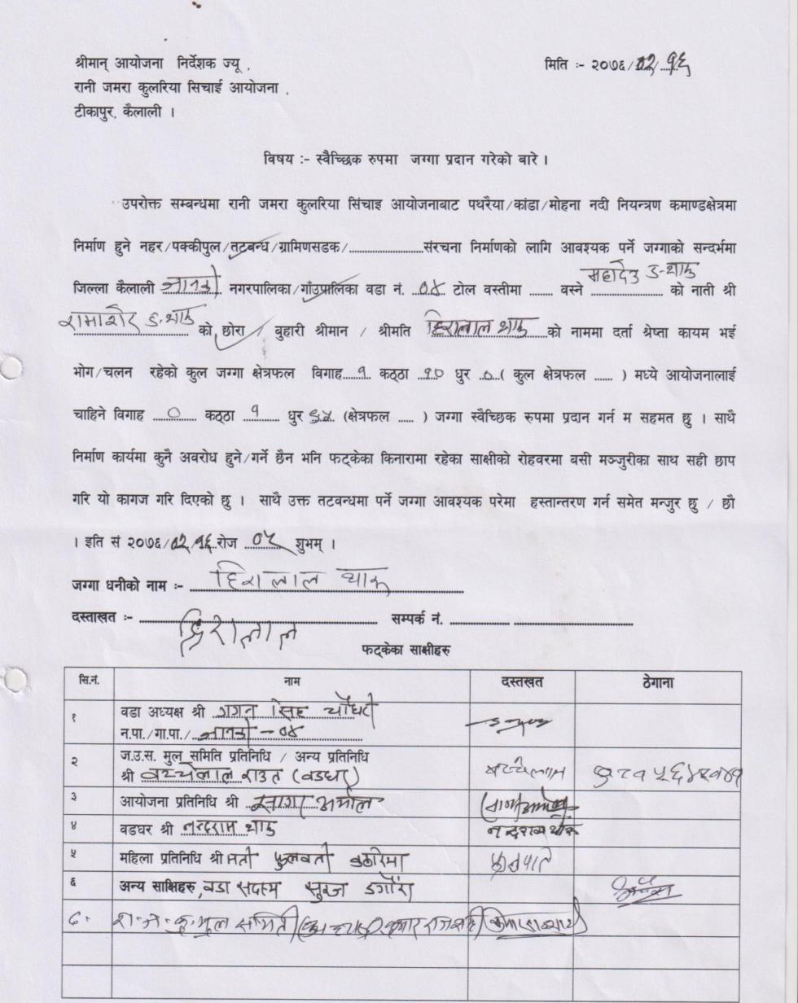

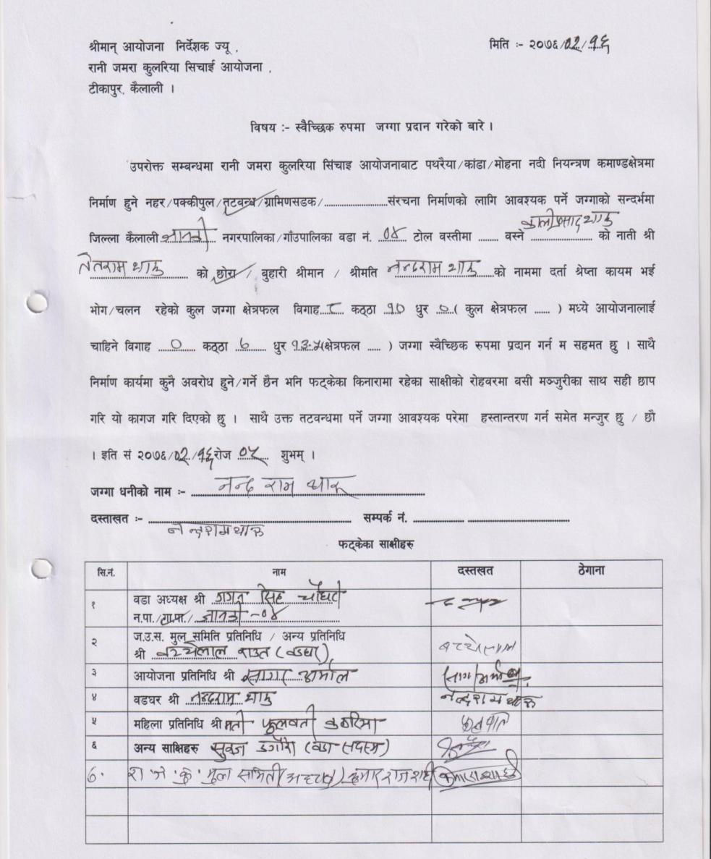
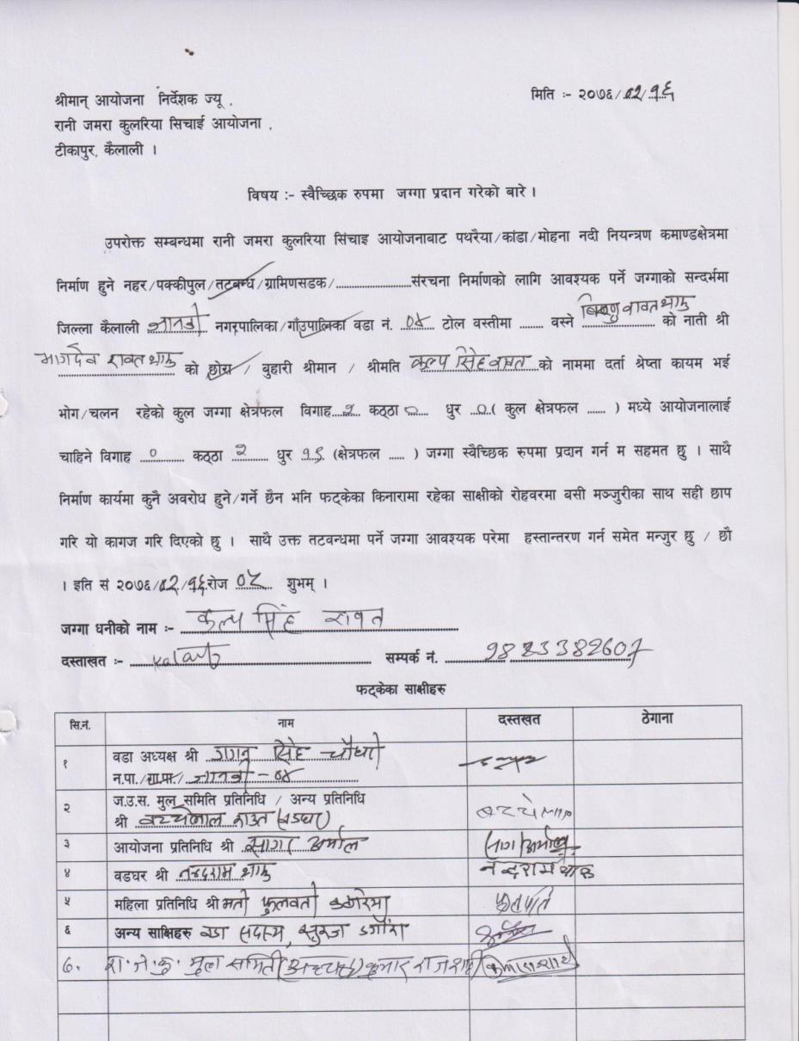

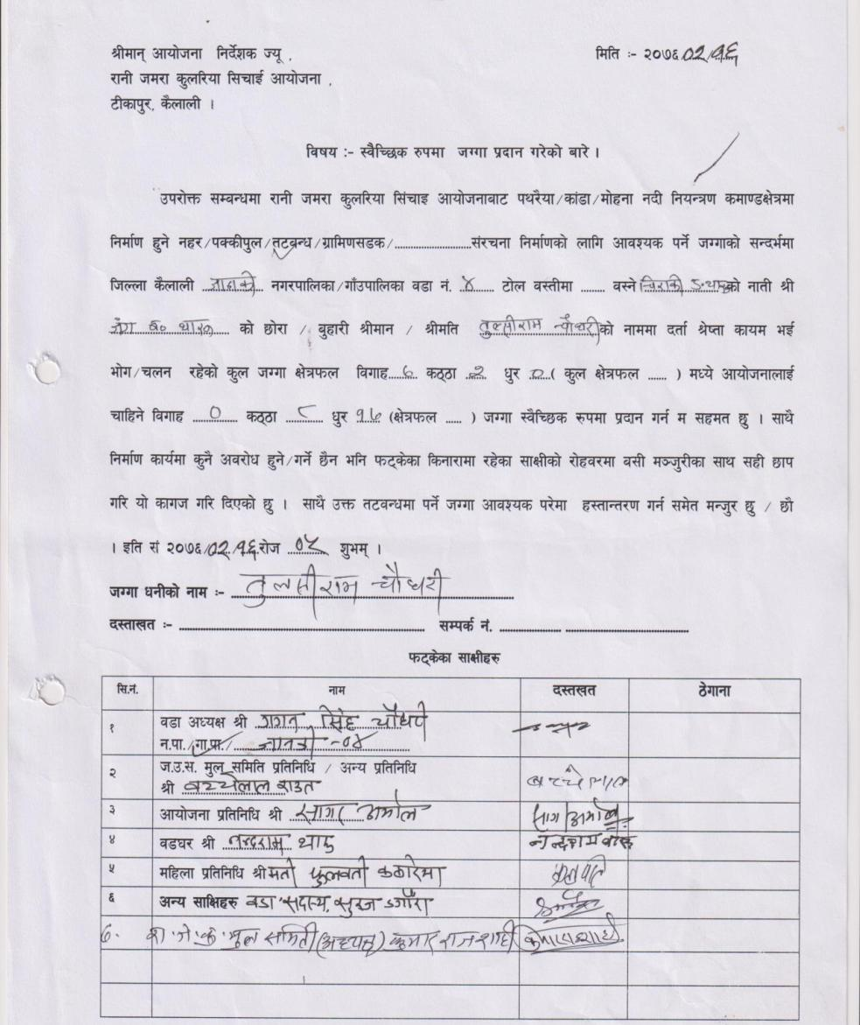
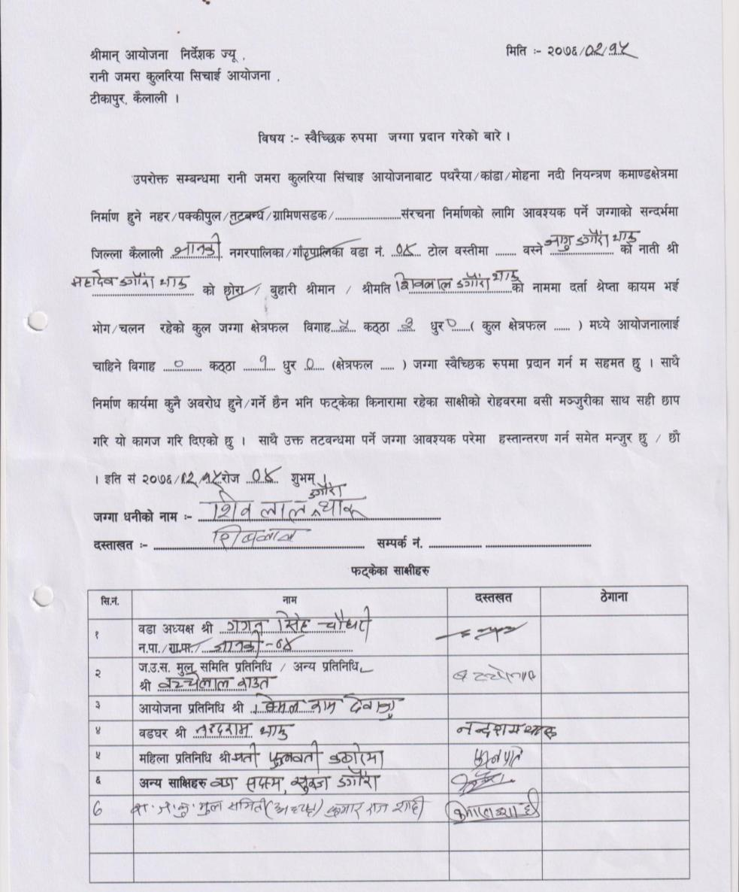

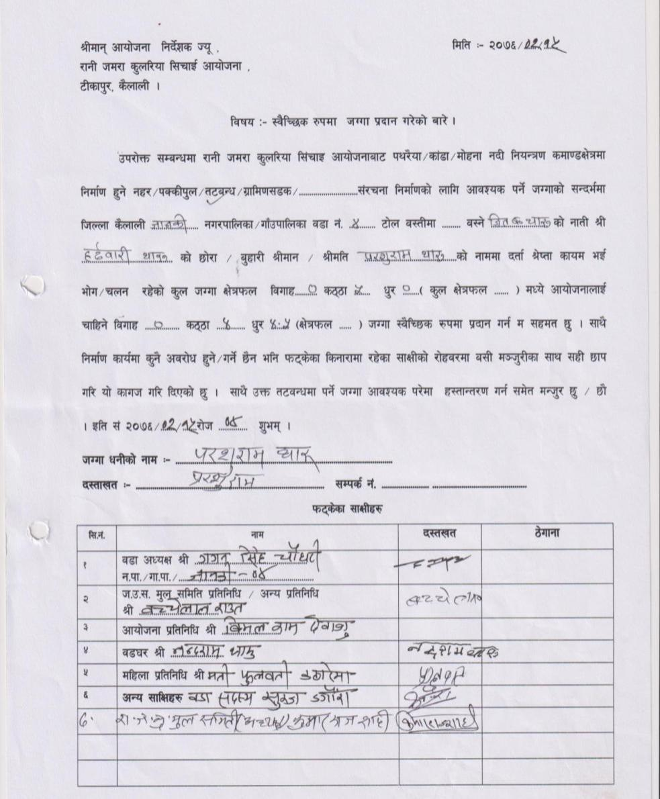
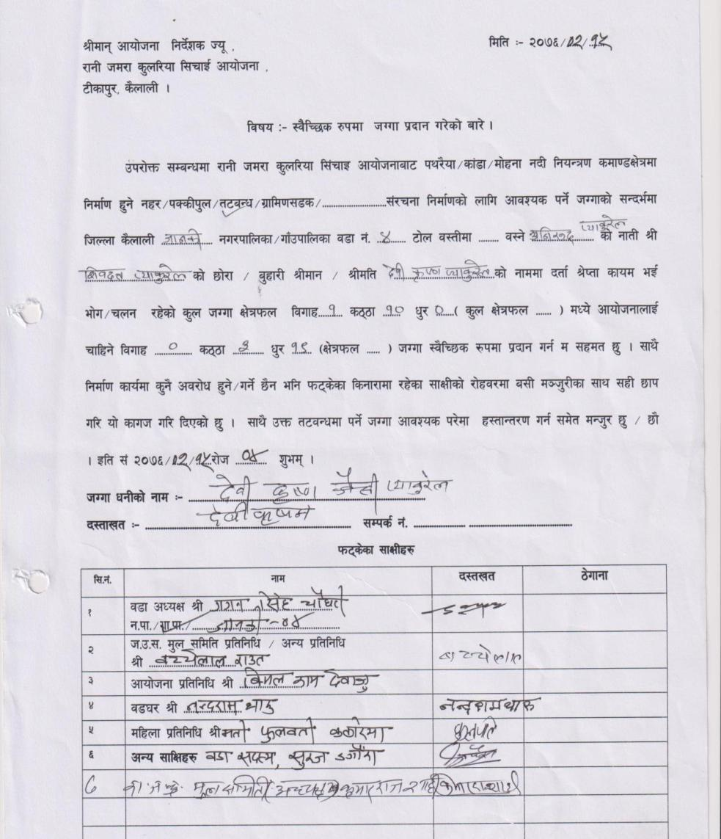

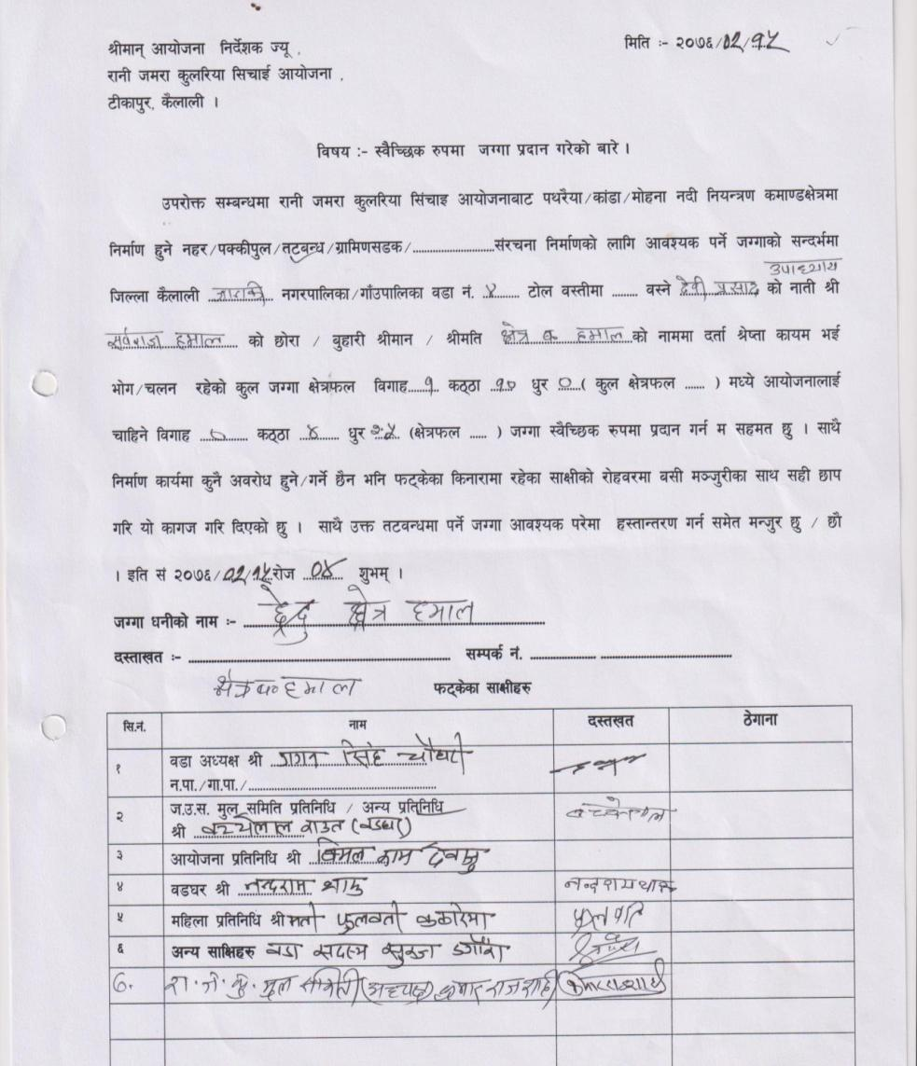
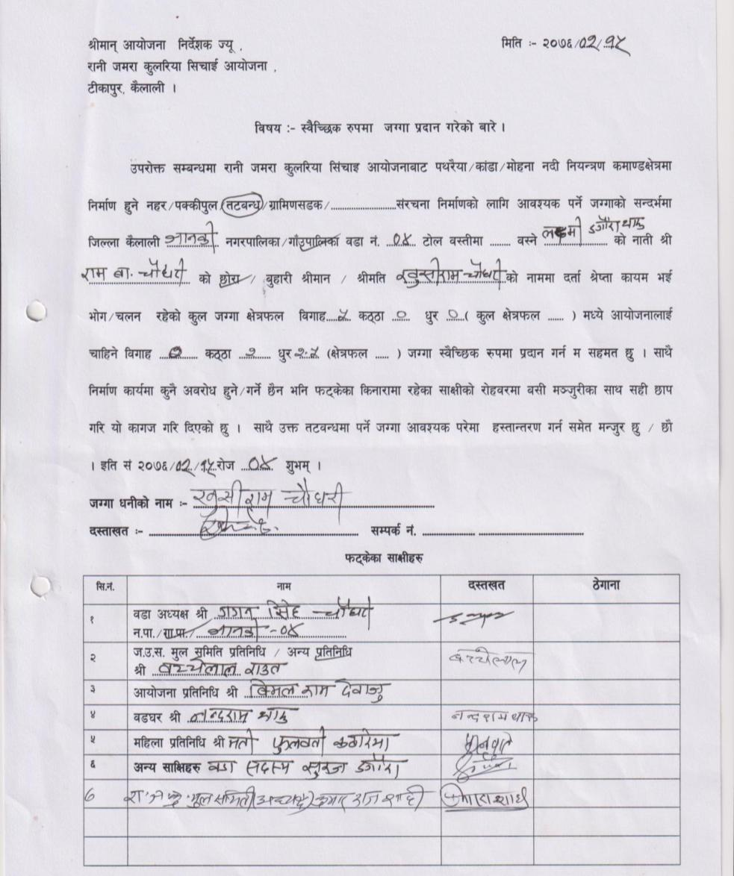

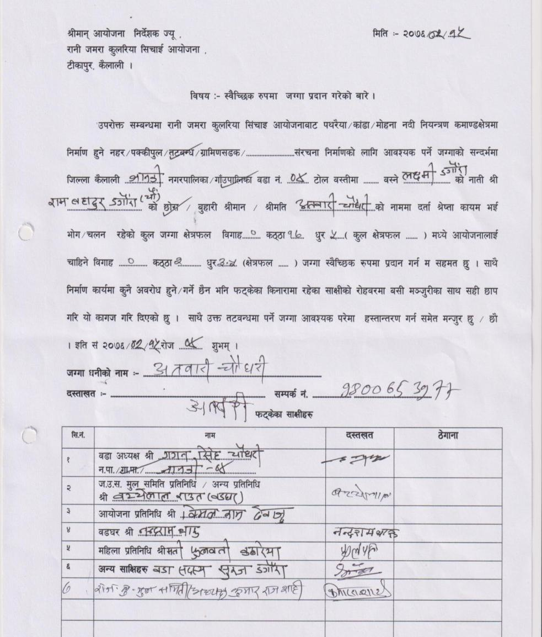
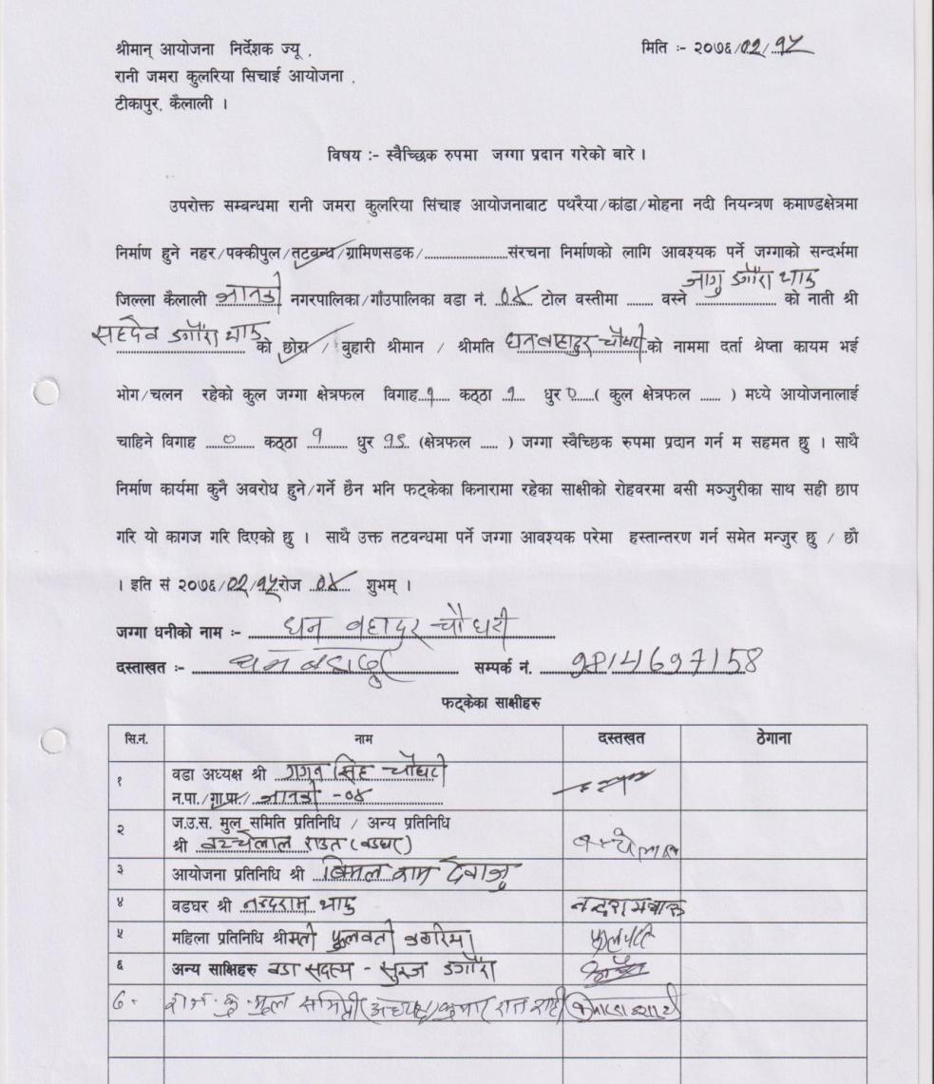

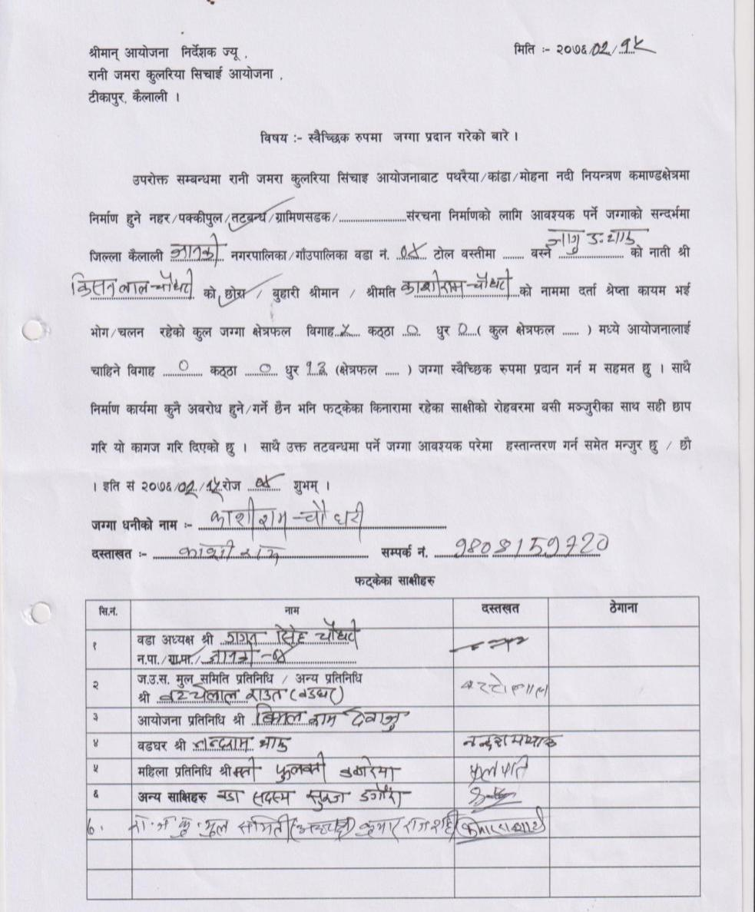
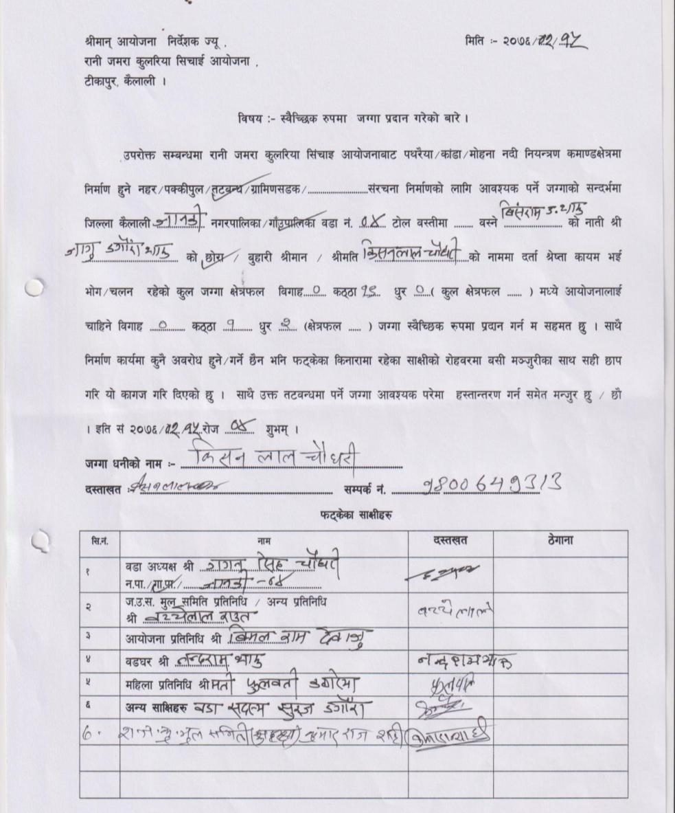

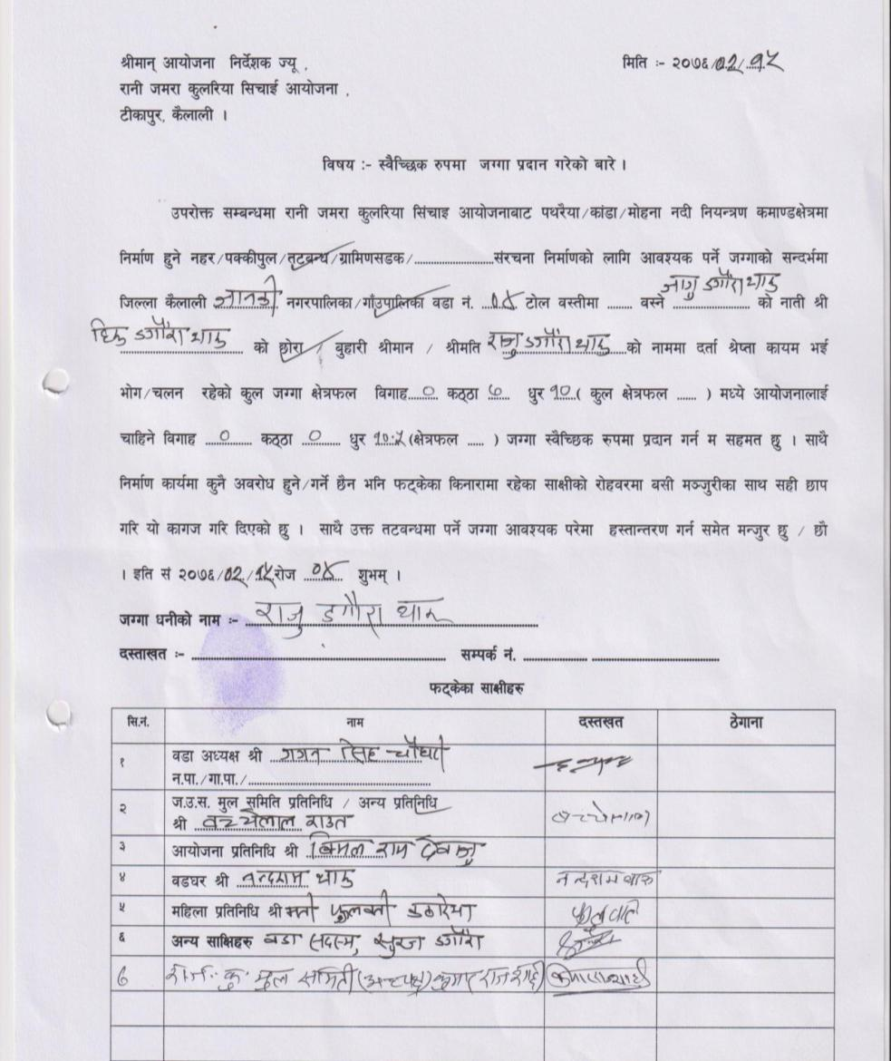
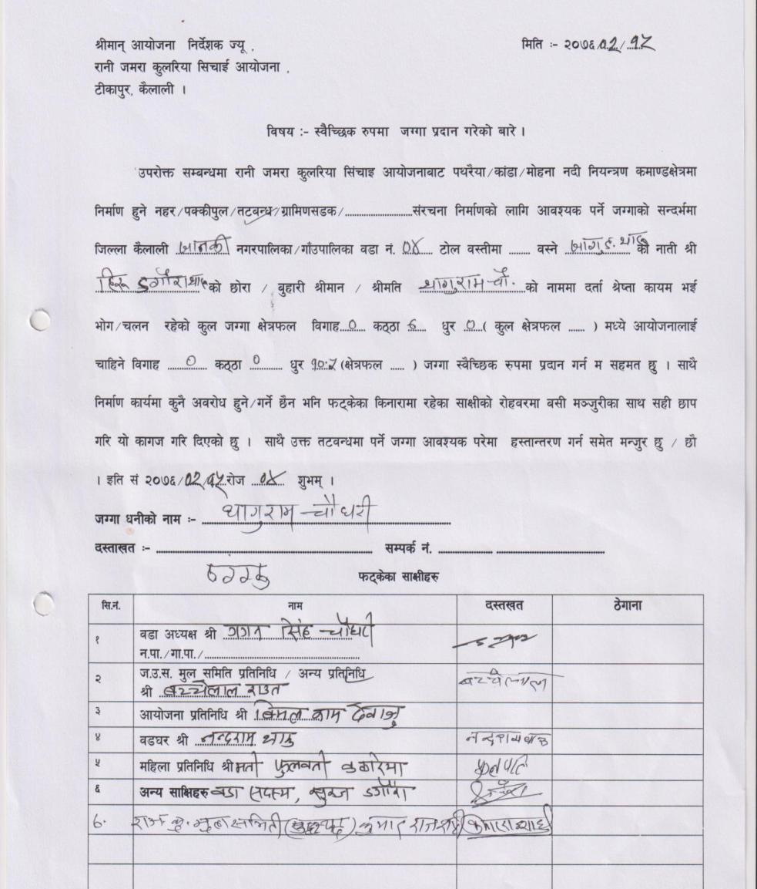

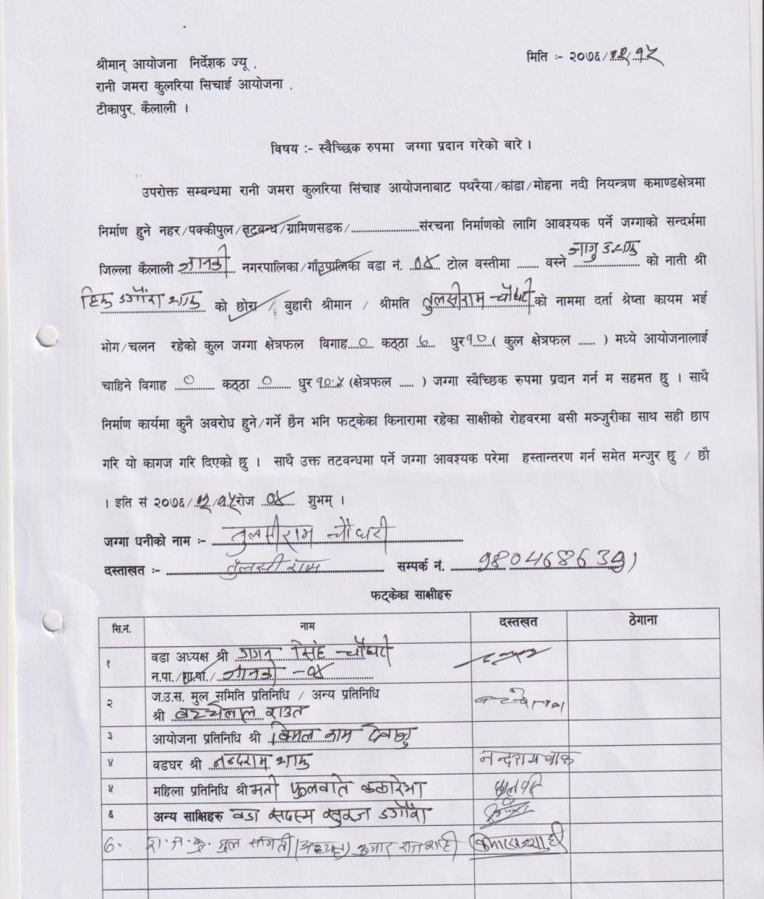
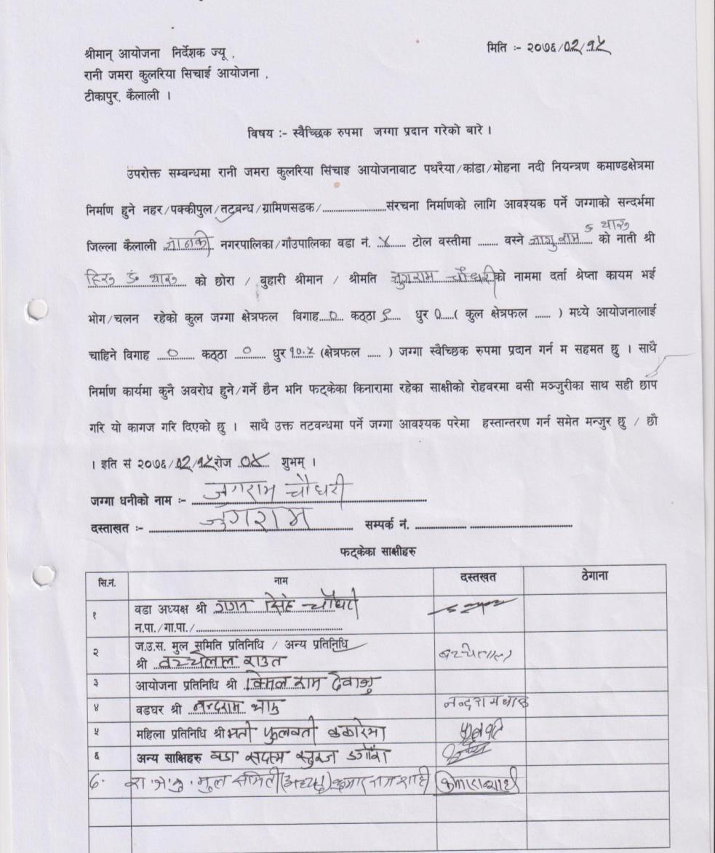

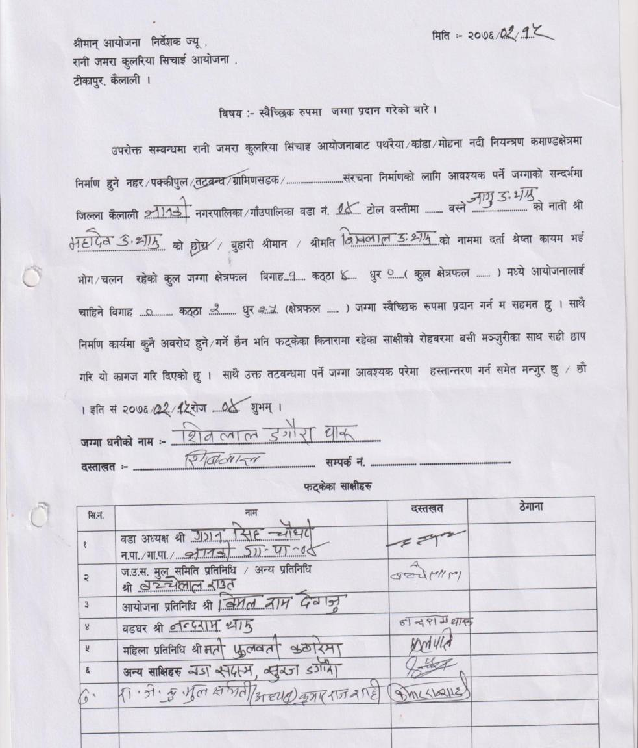
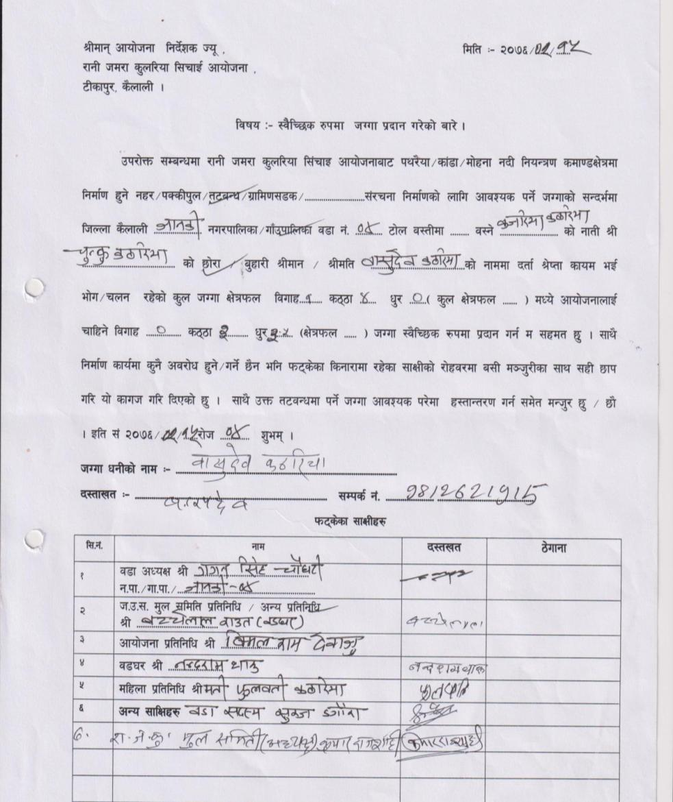

5: Janaki RM 7 (LB)
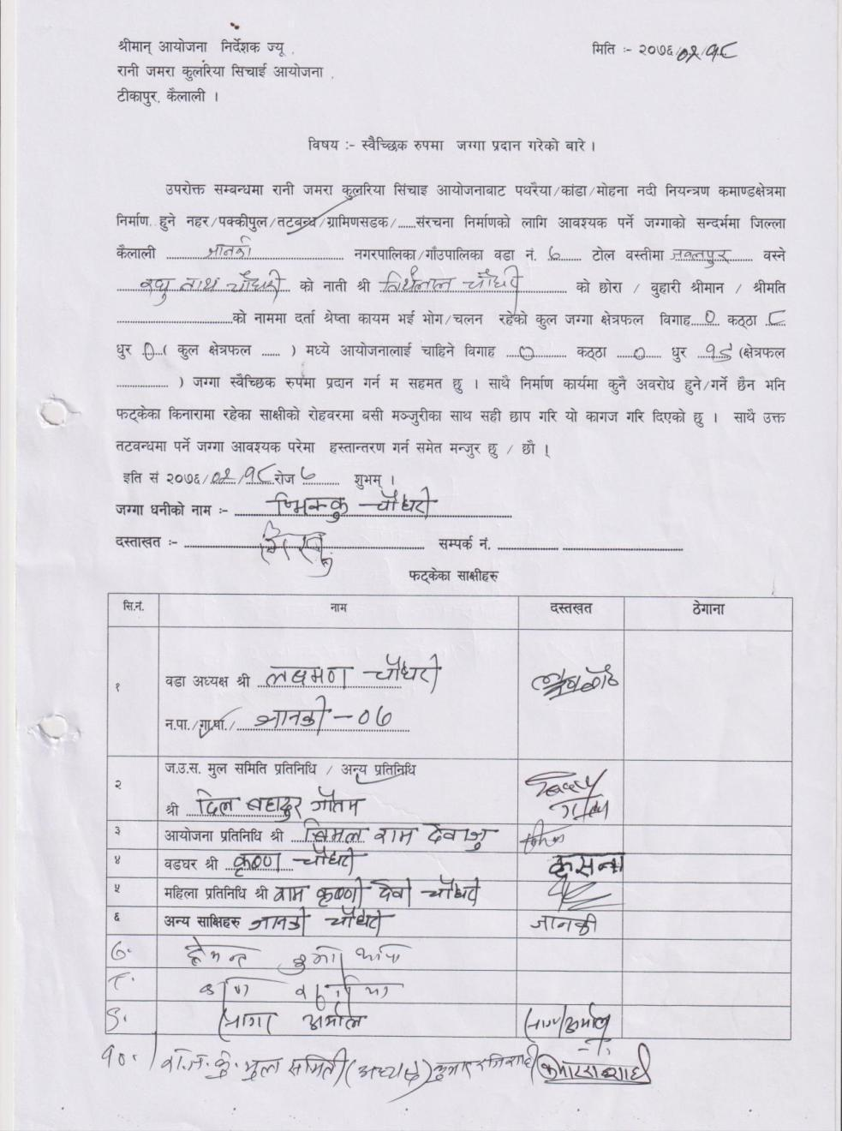
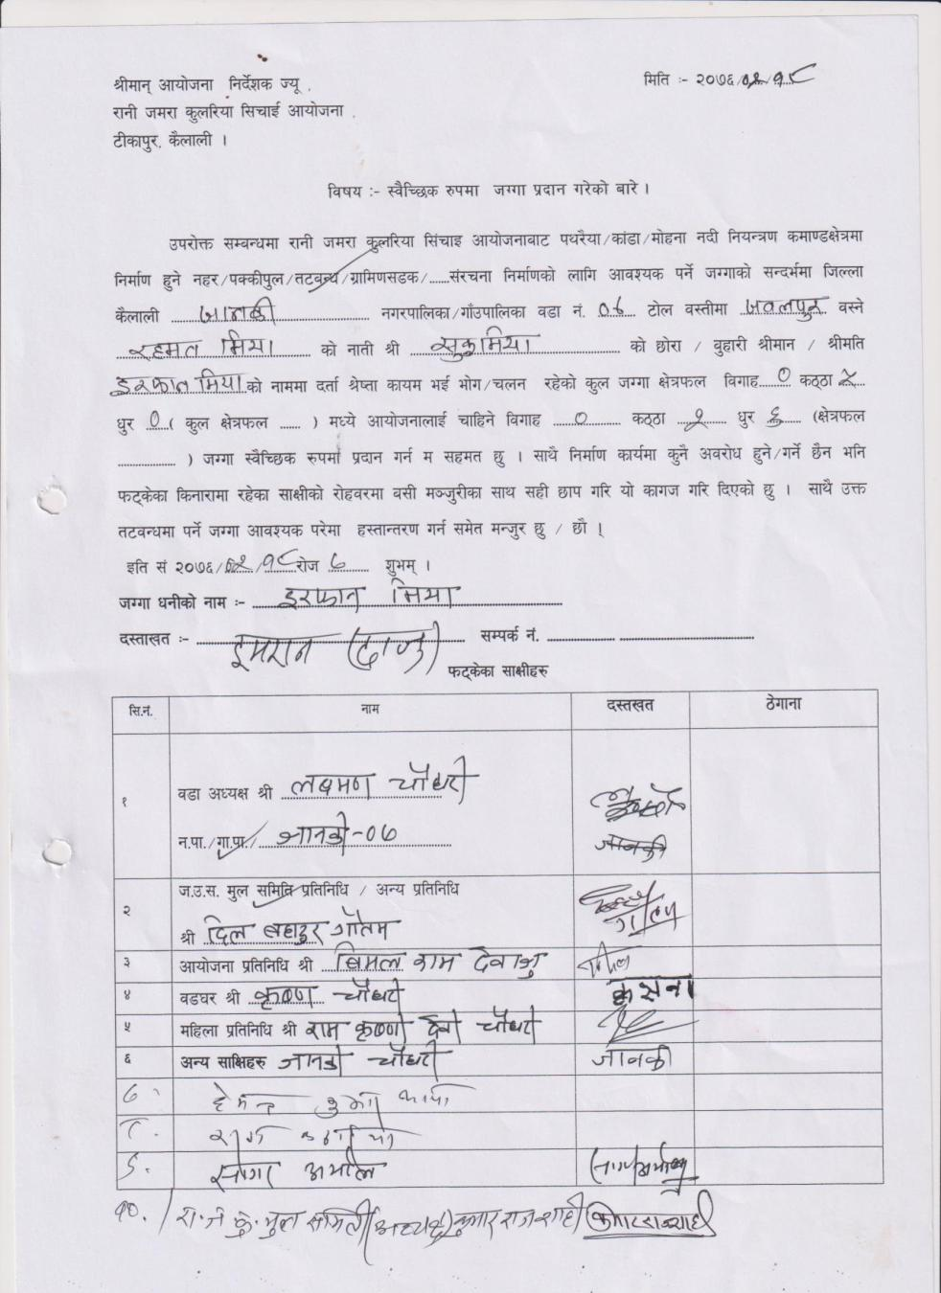

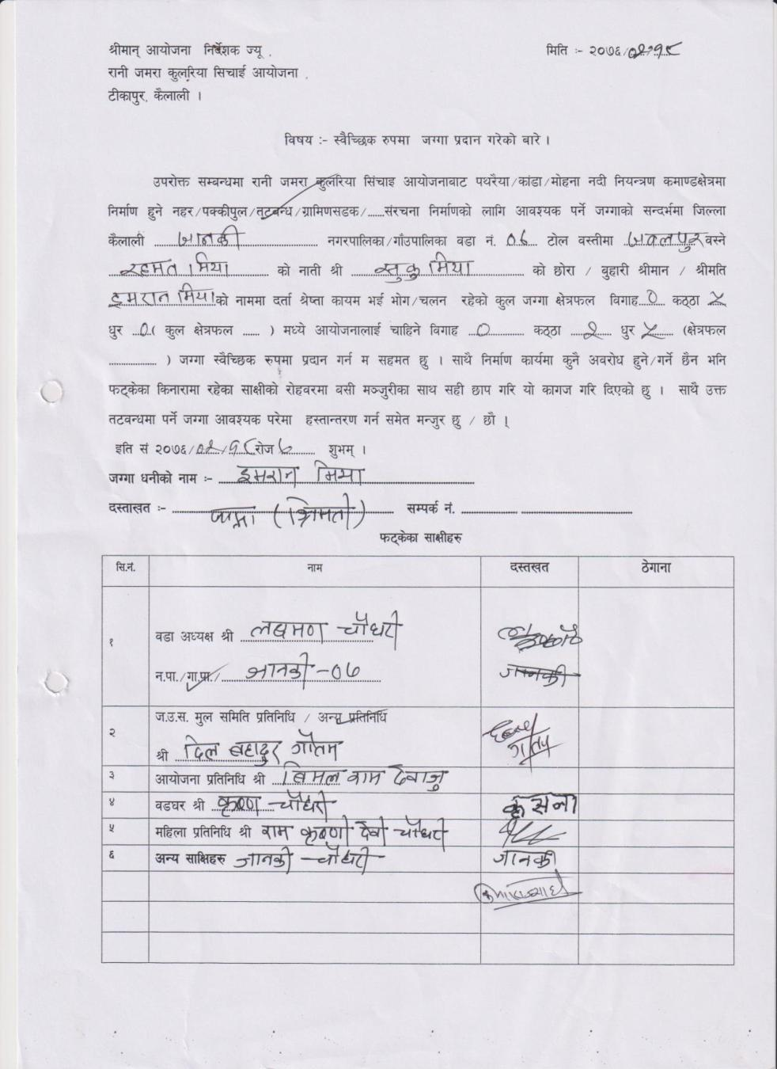
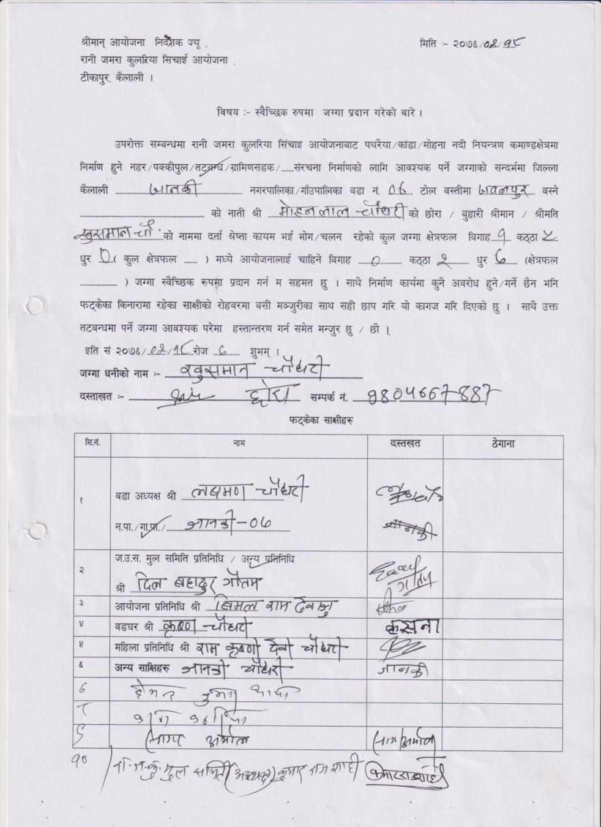

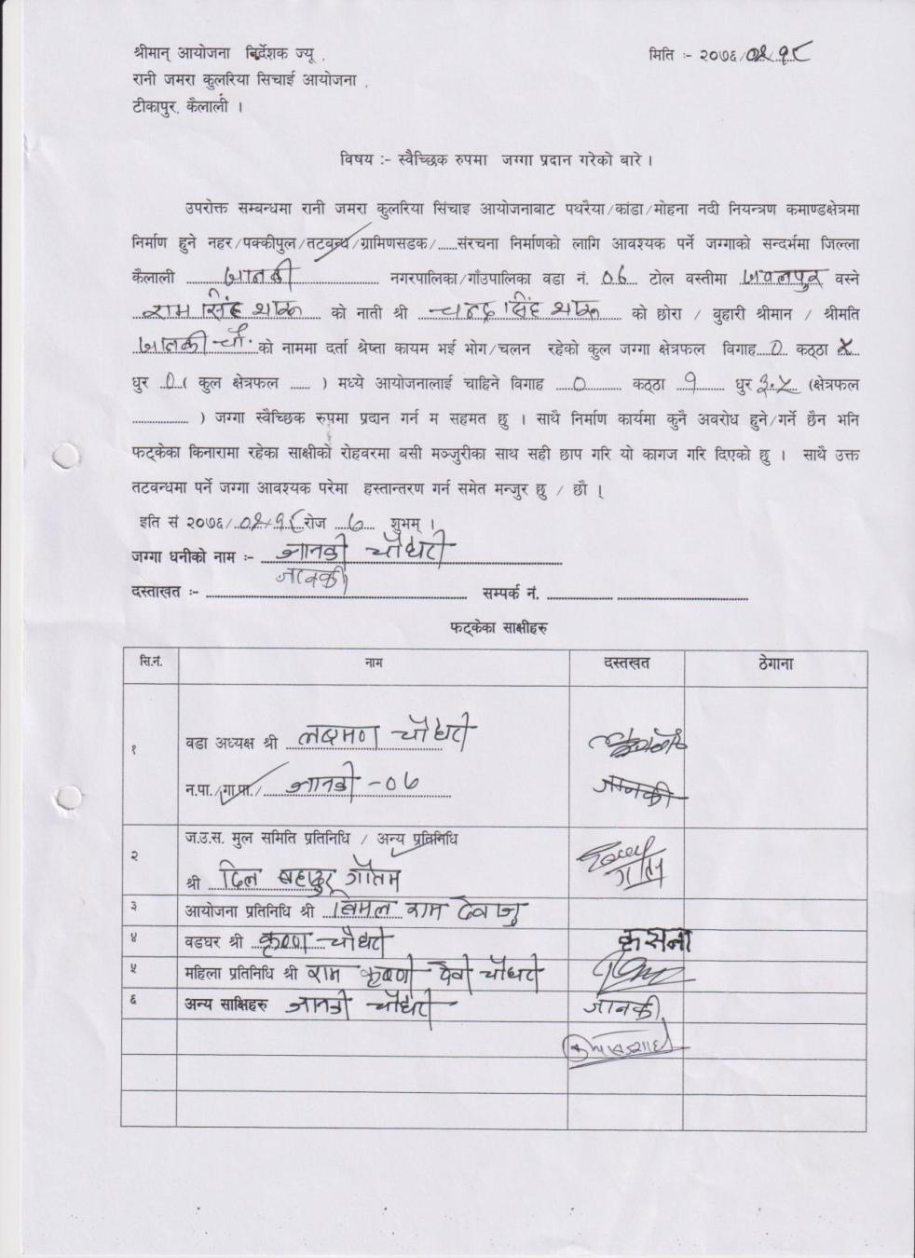
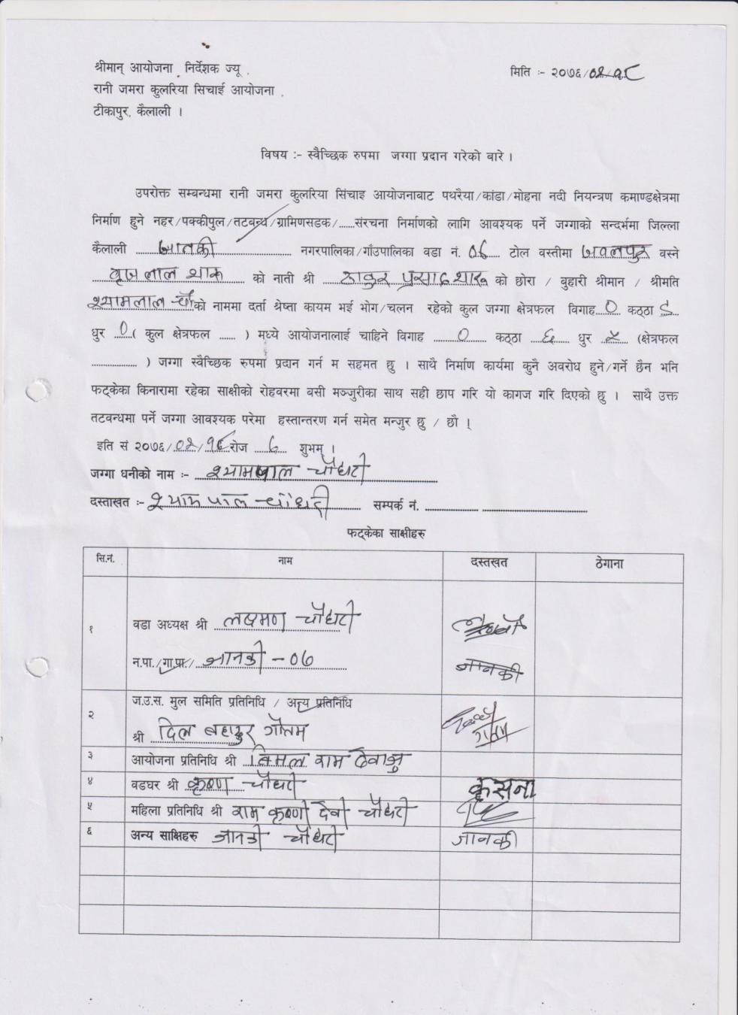

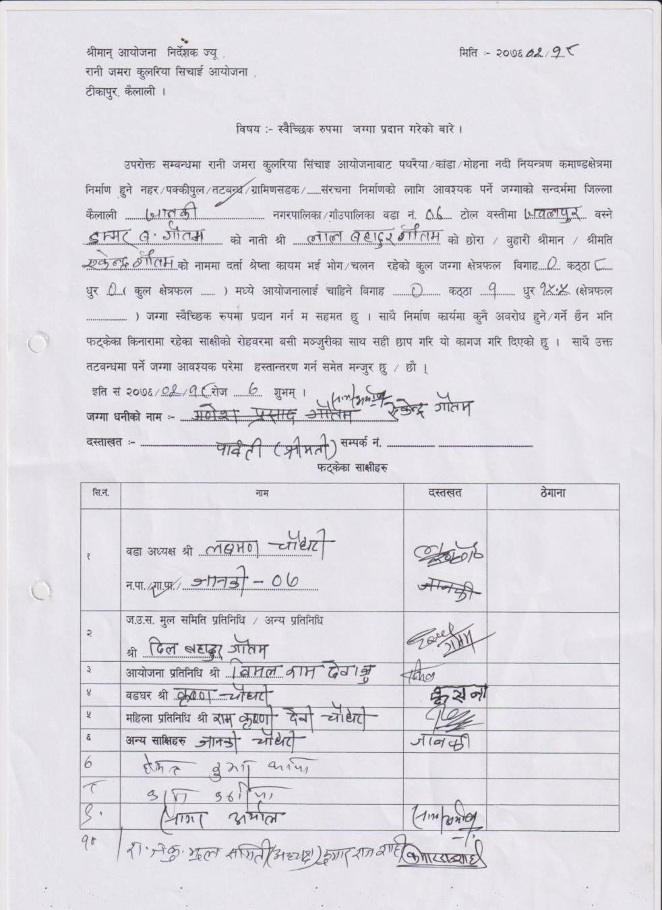
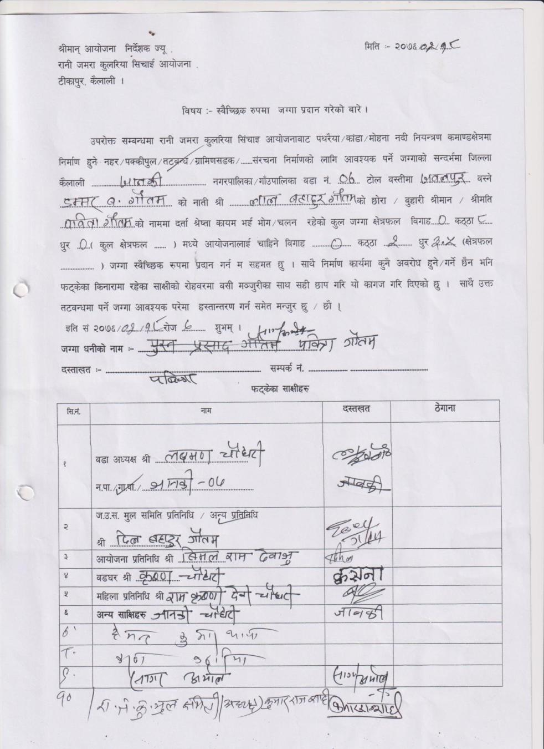

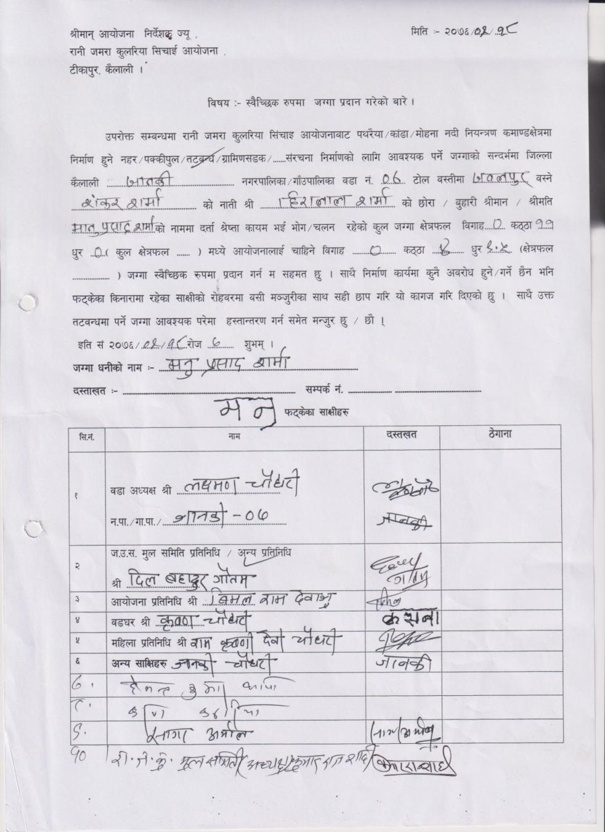
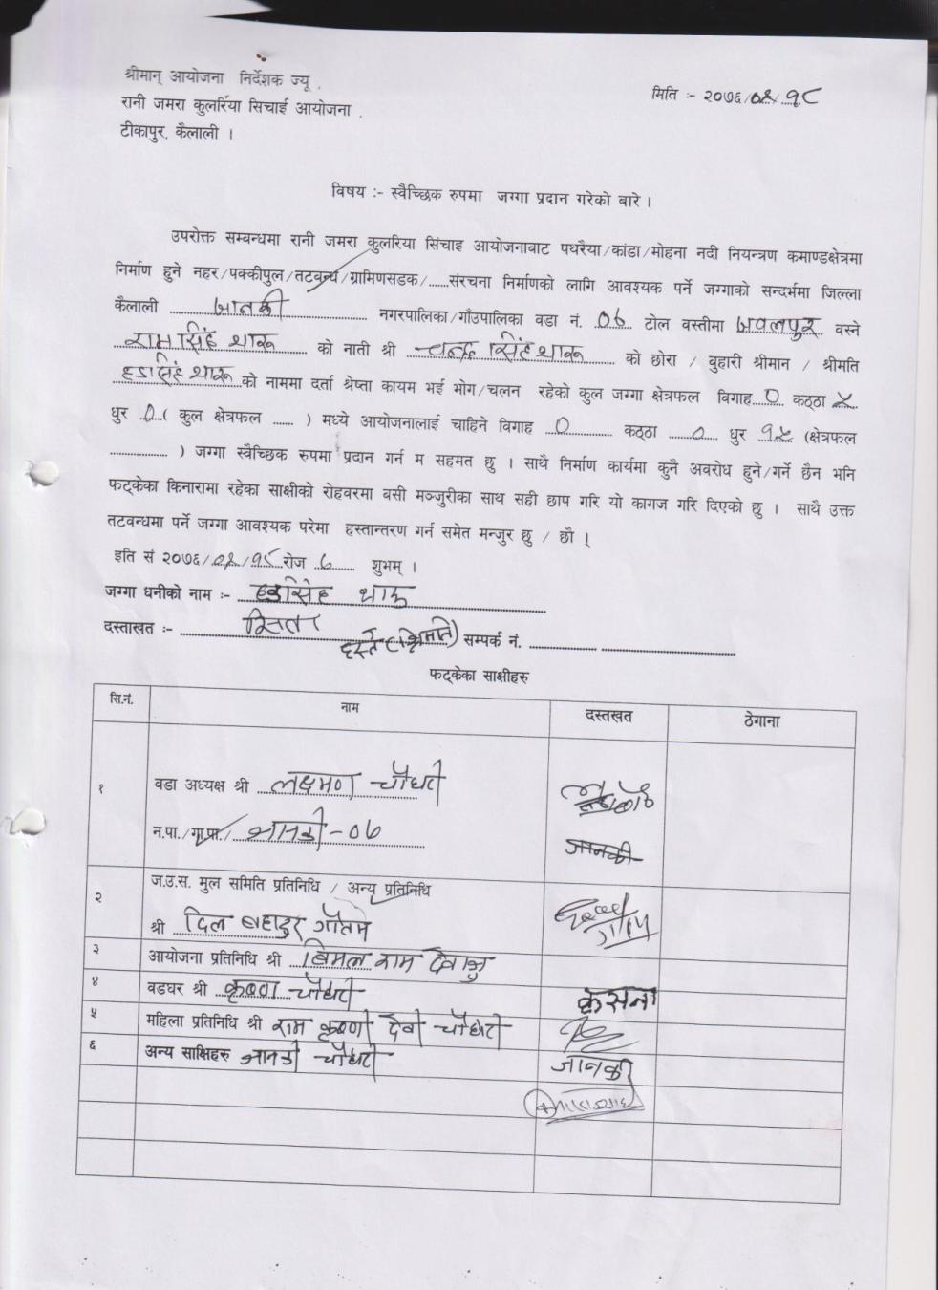

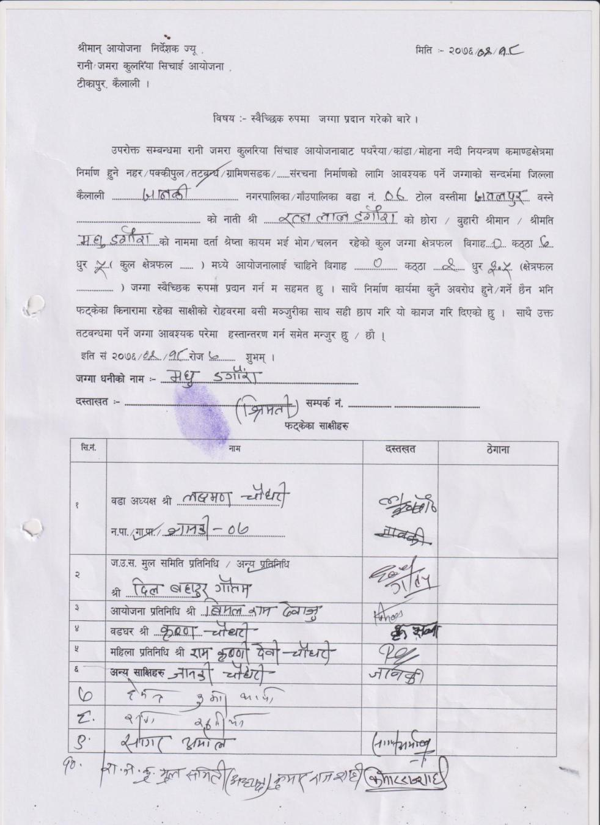
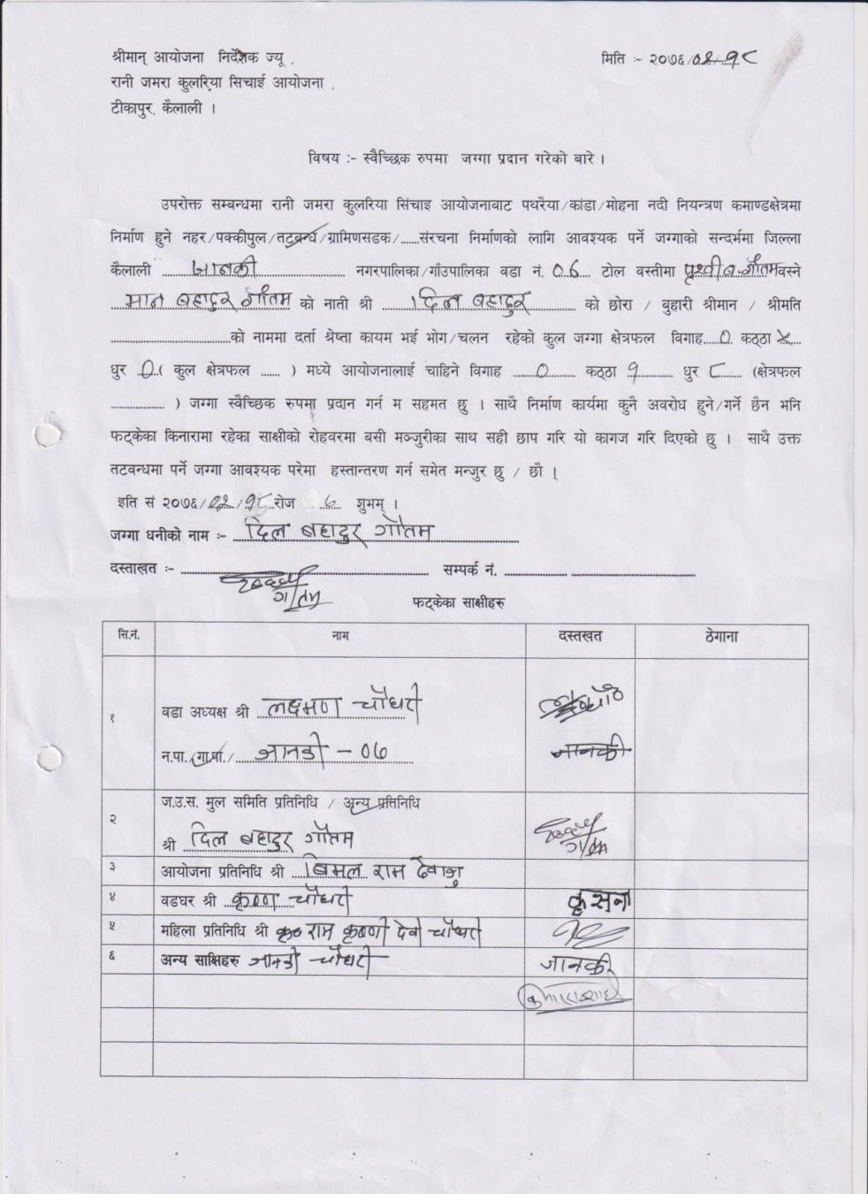

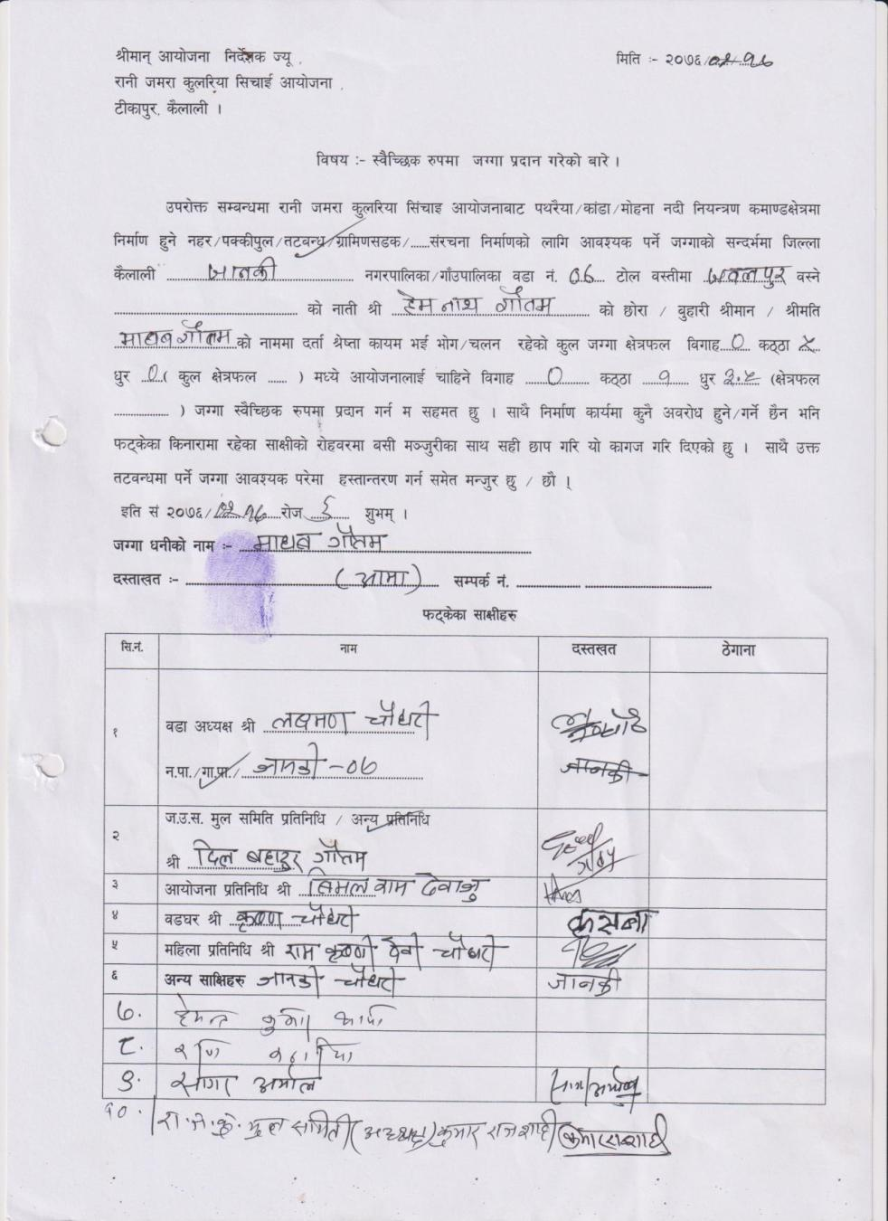
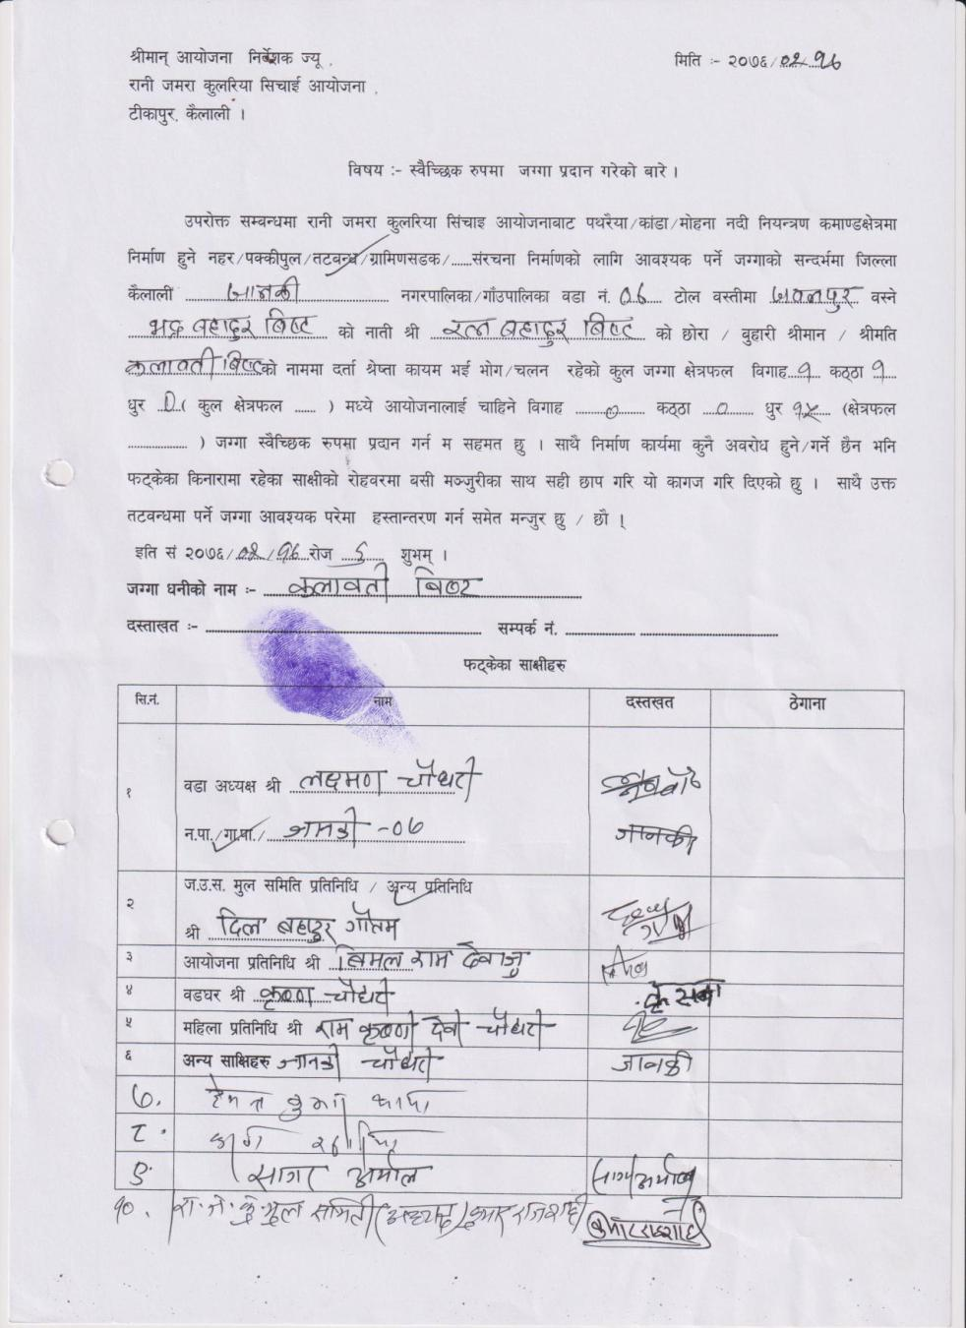

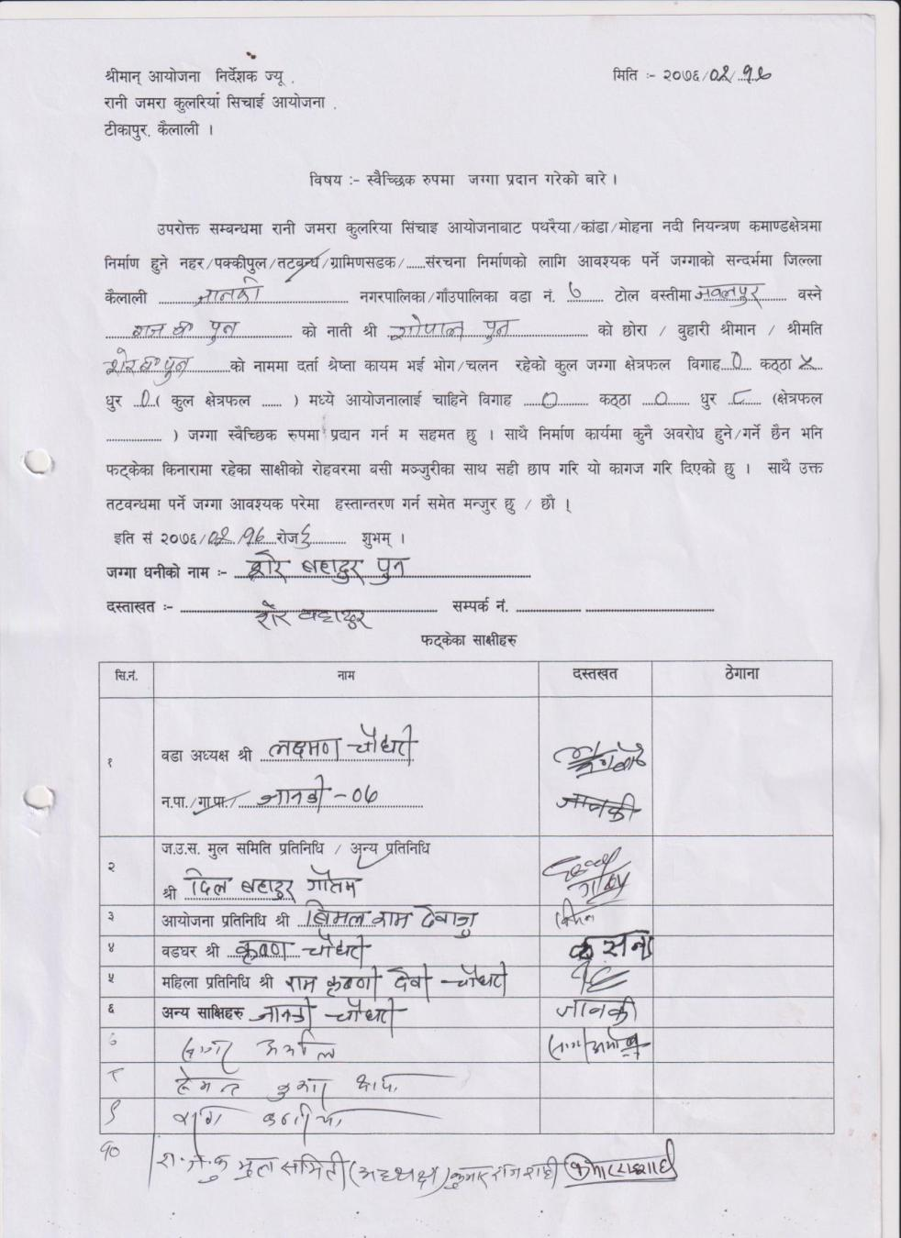
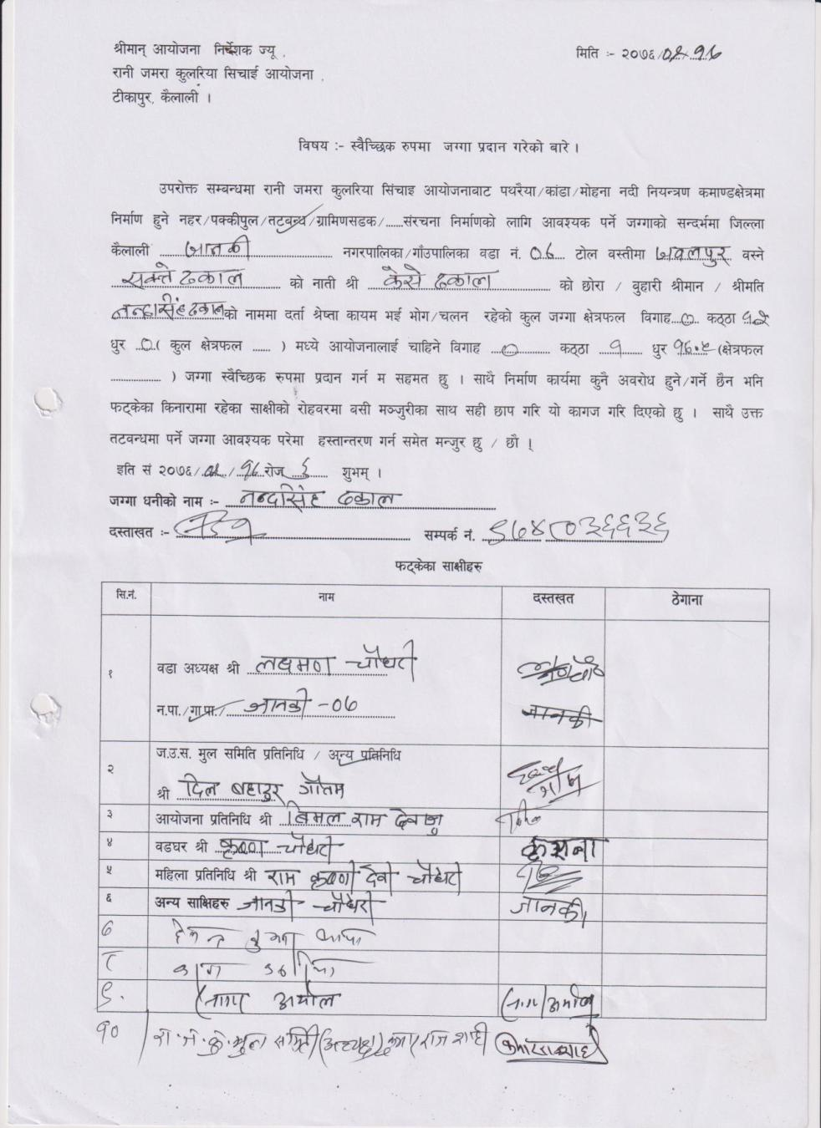

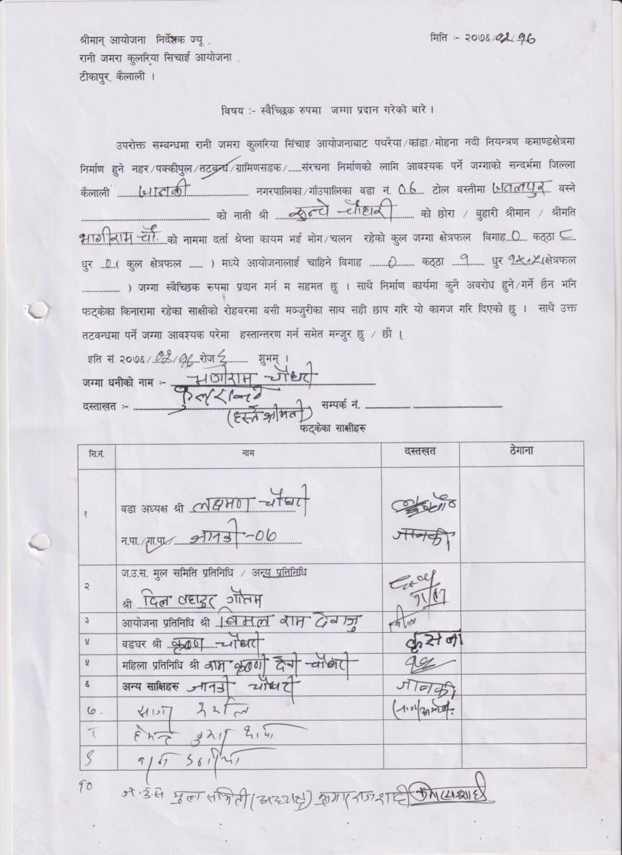
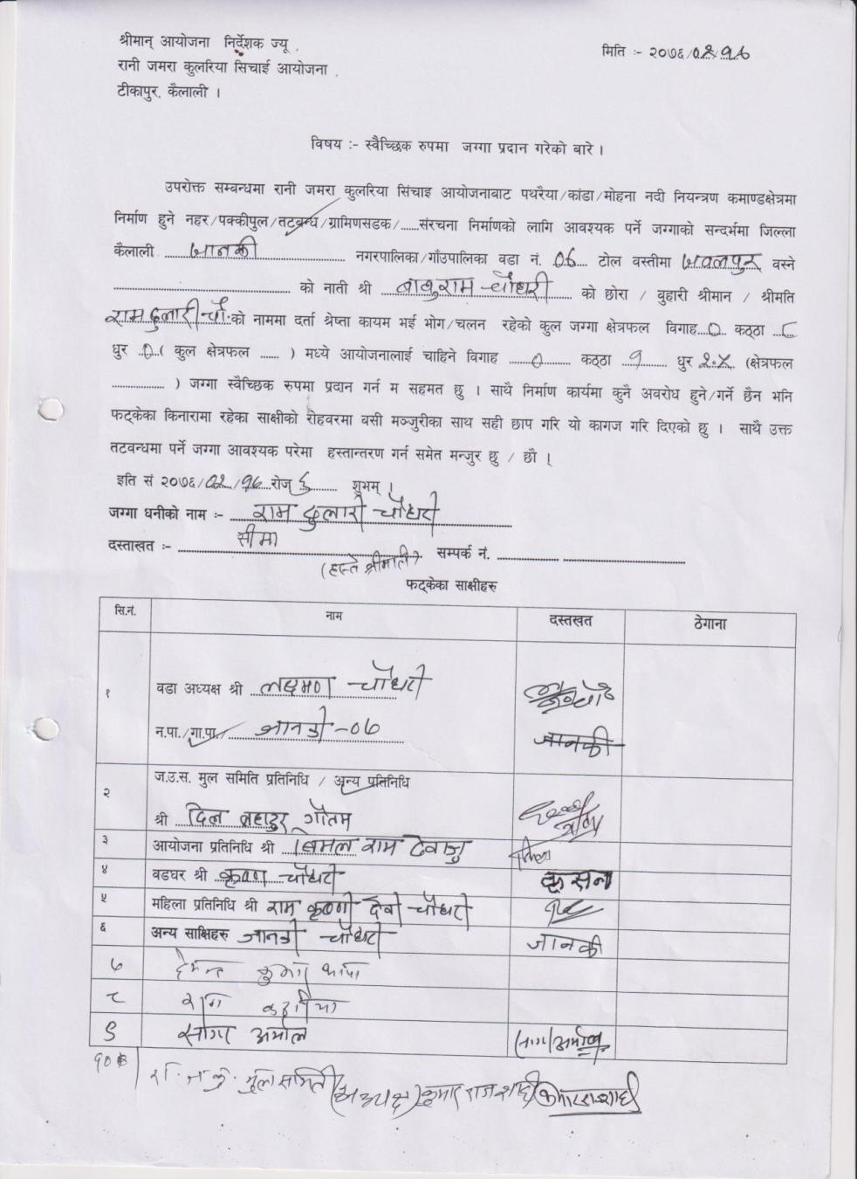

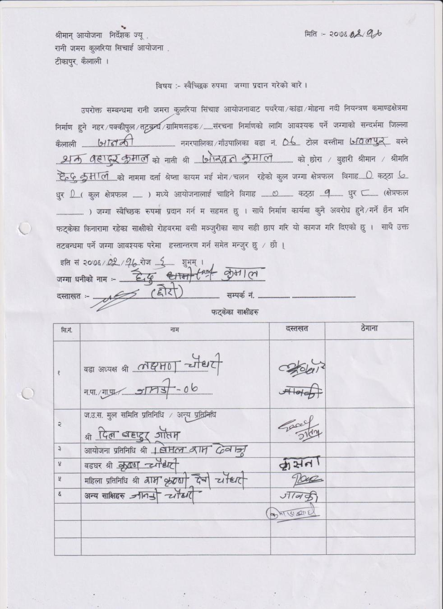
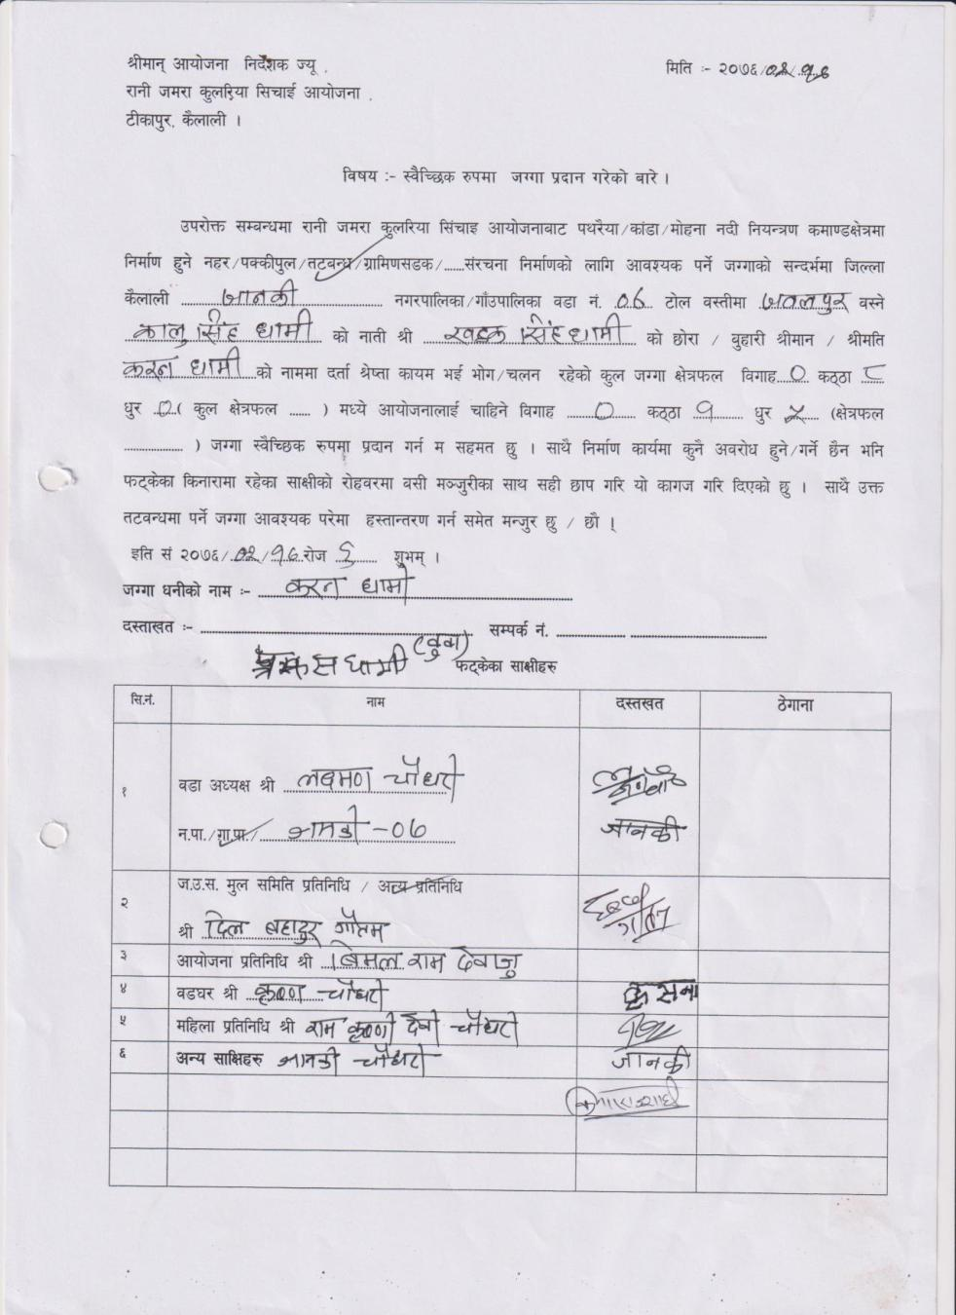

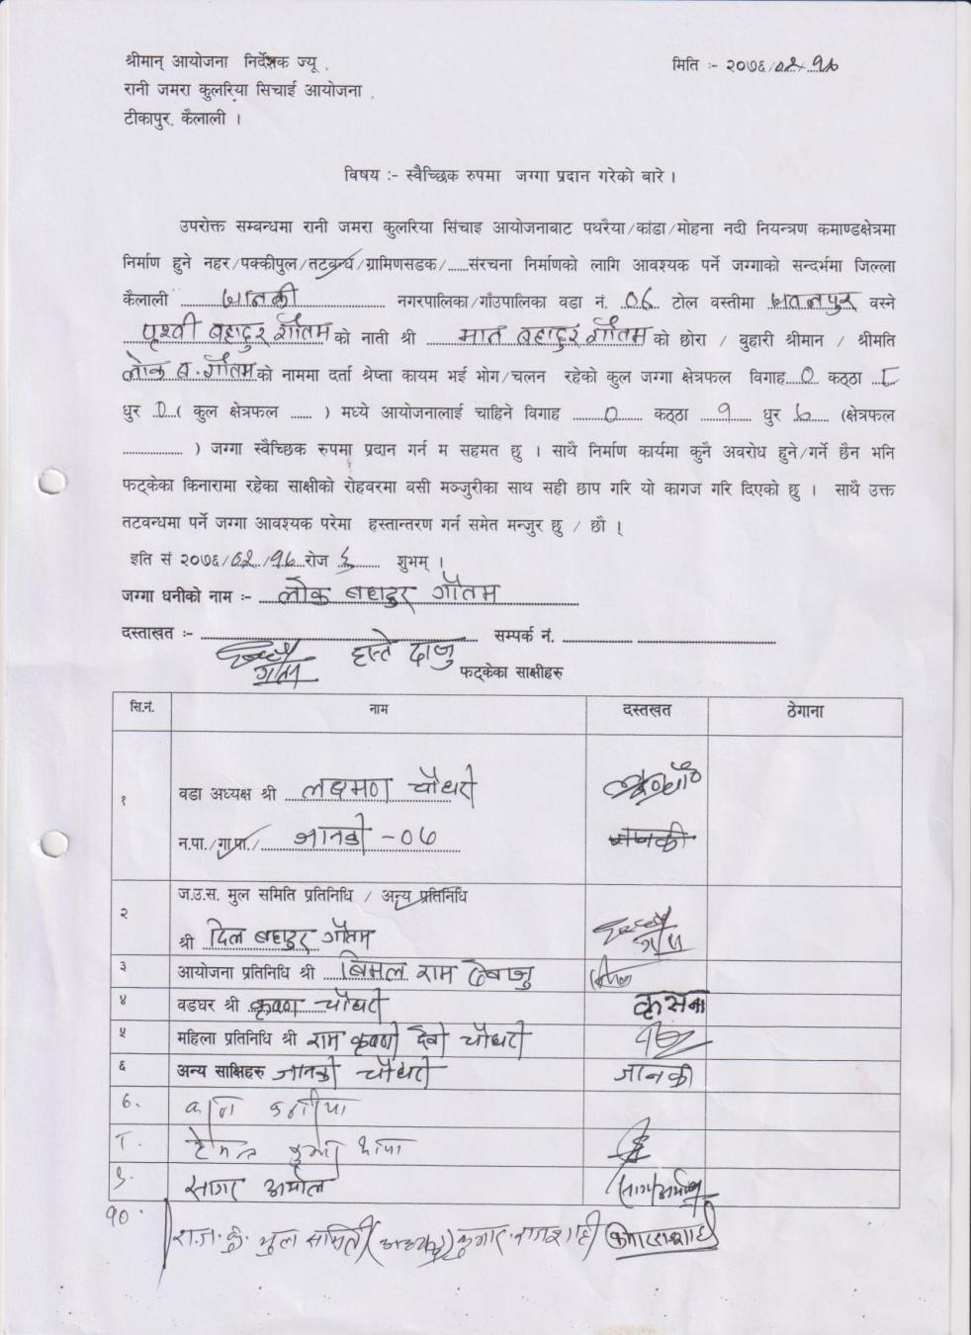
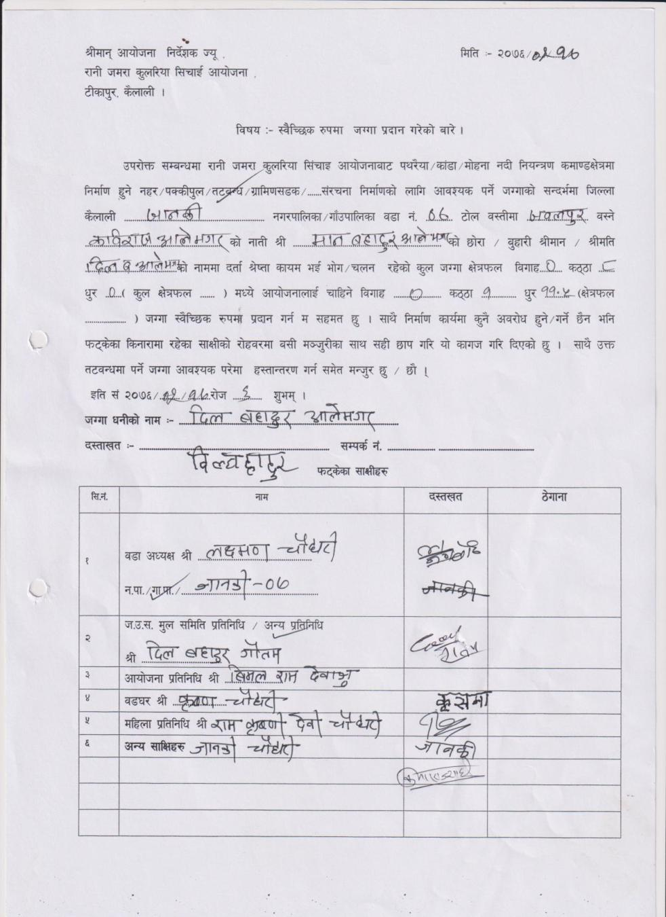

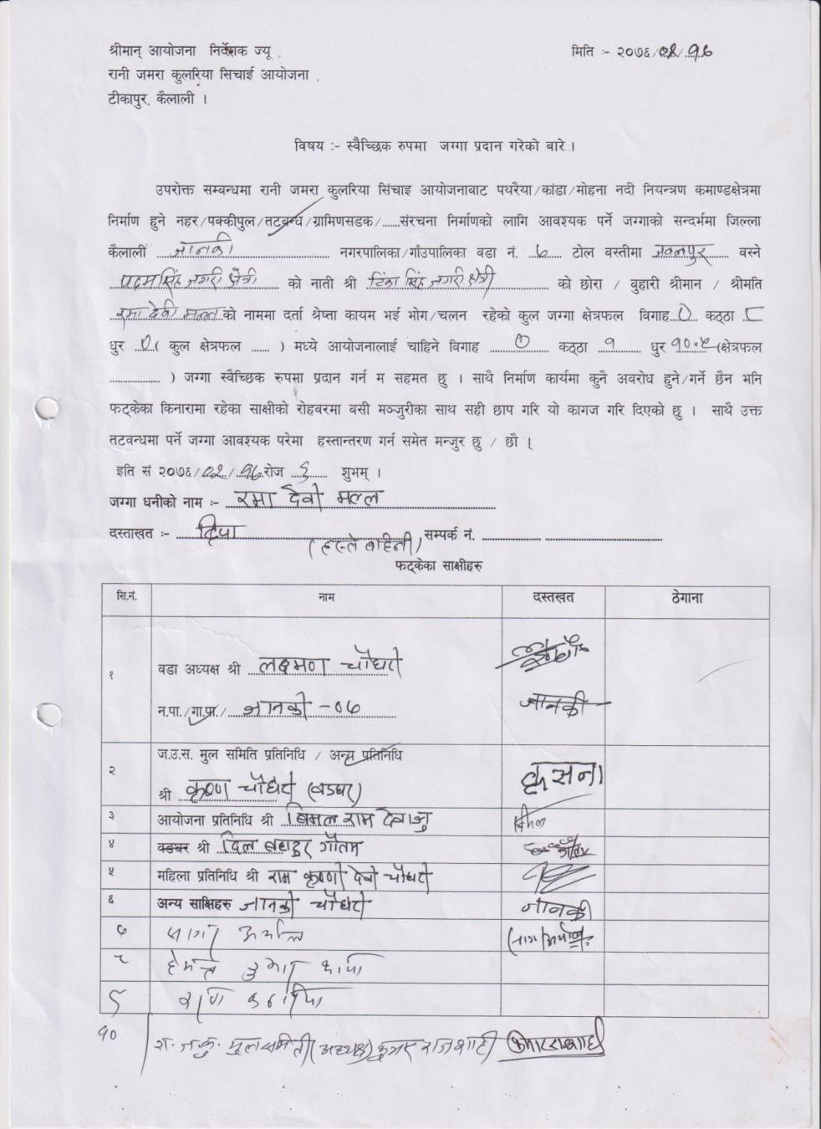
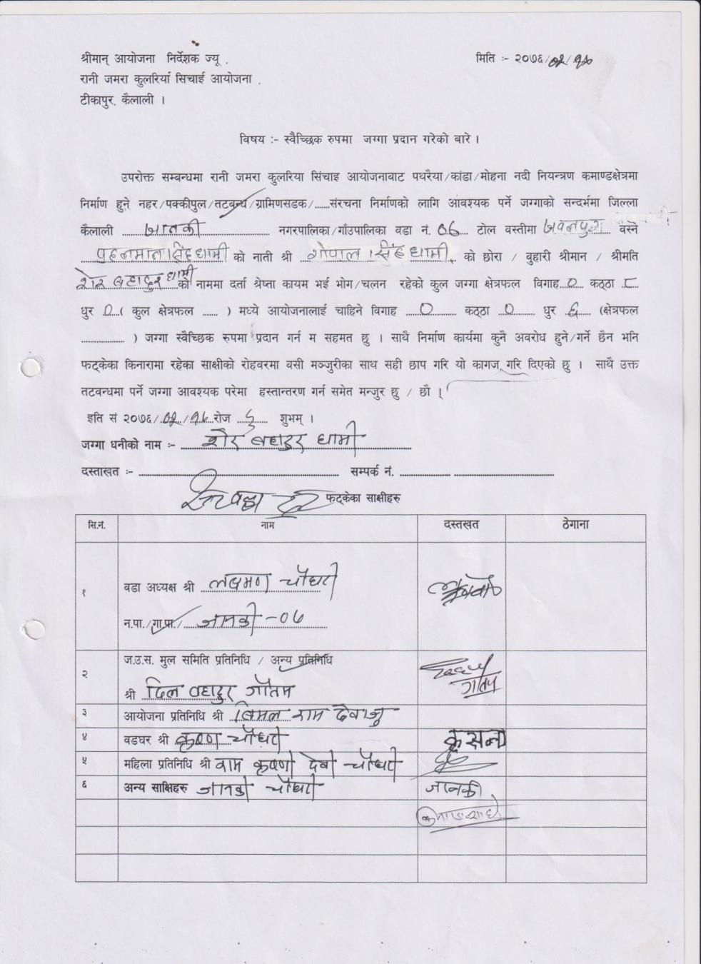

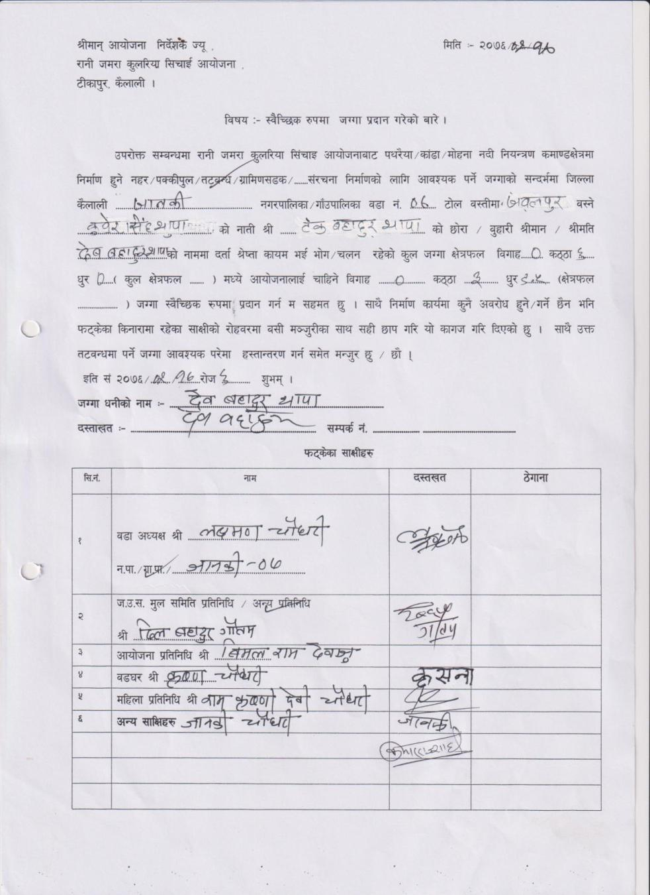
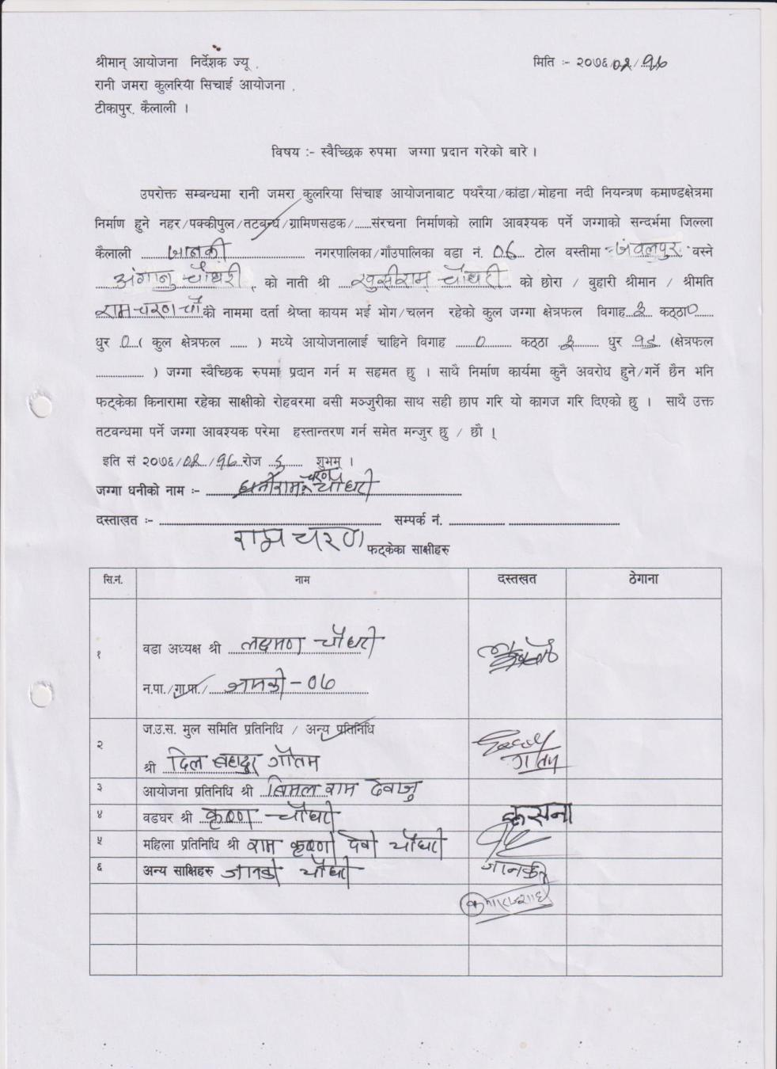

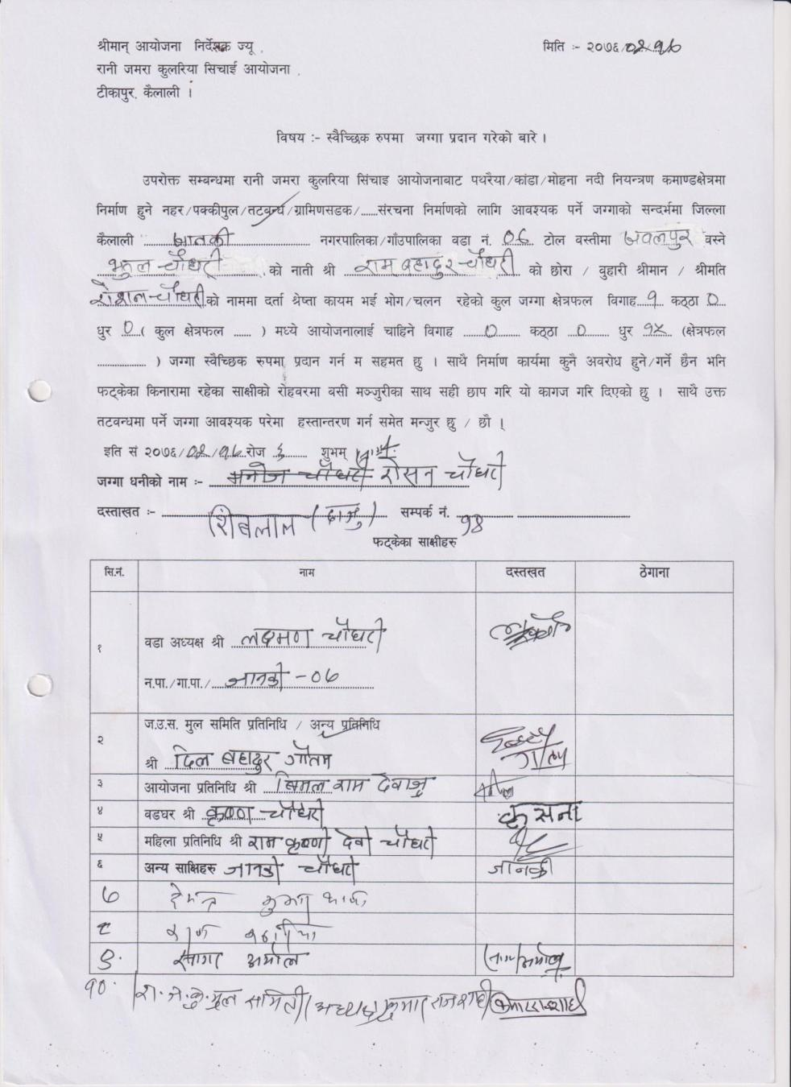
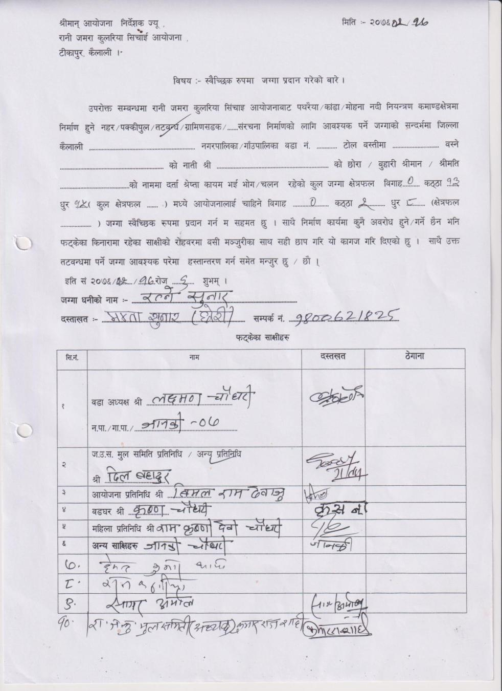

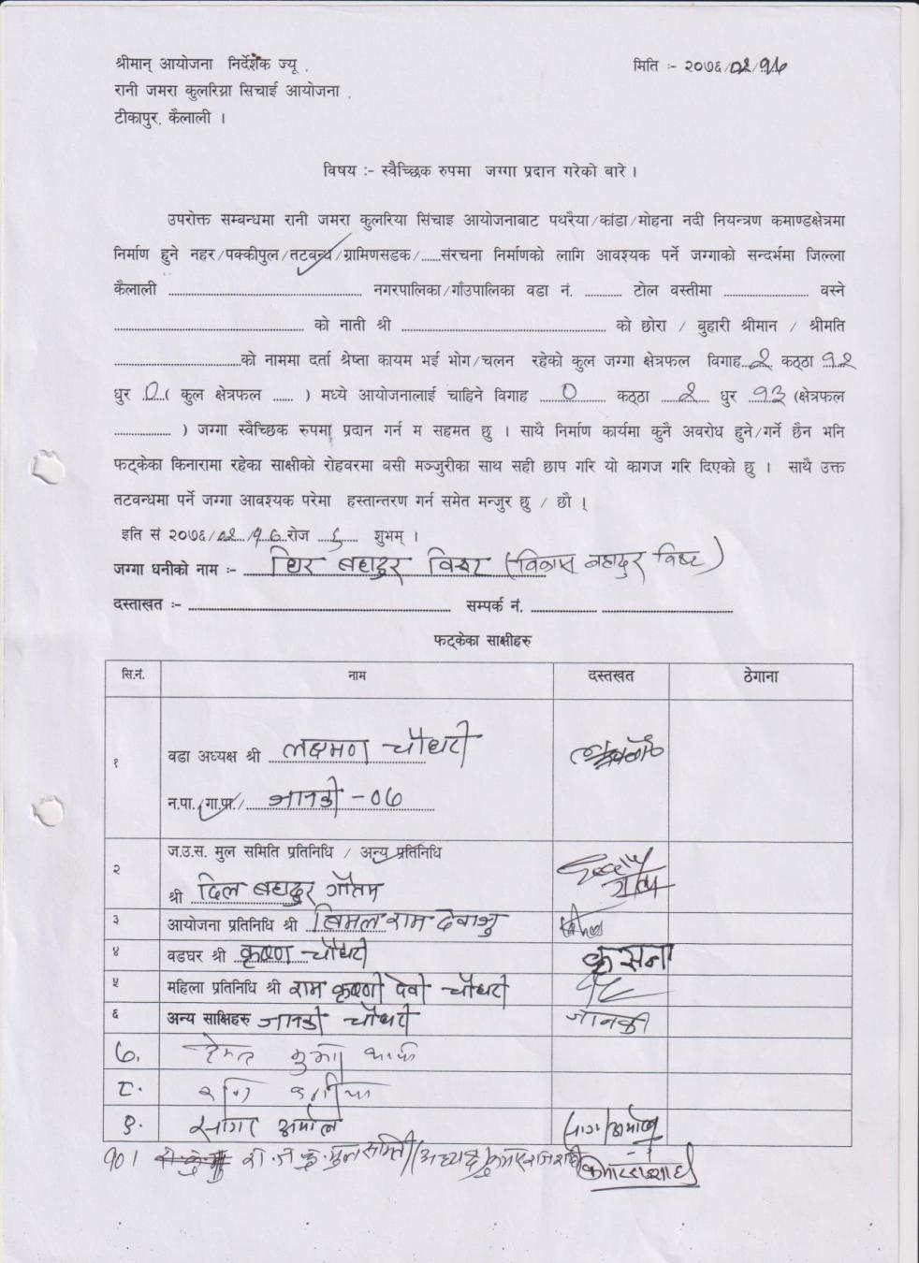
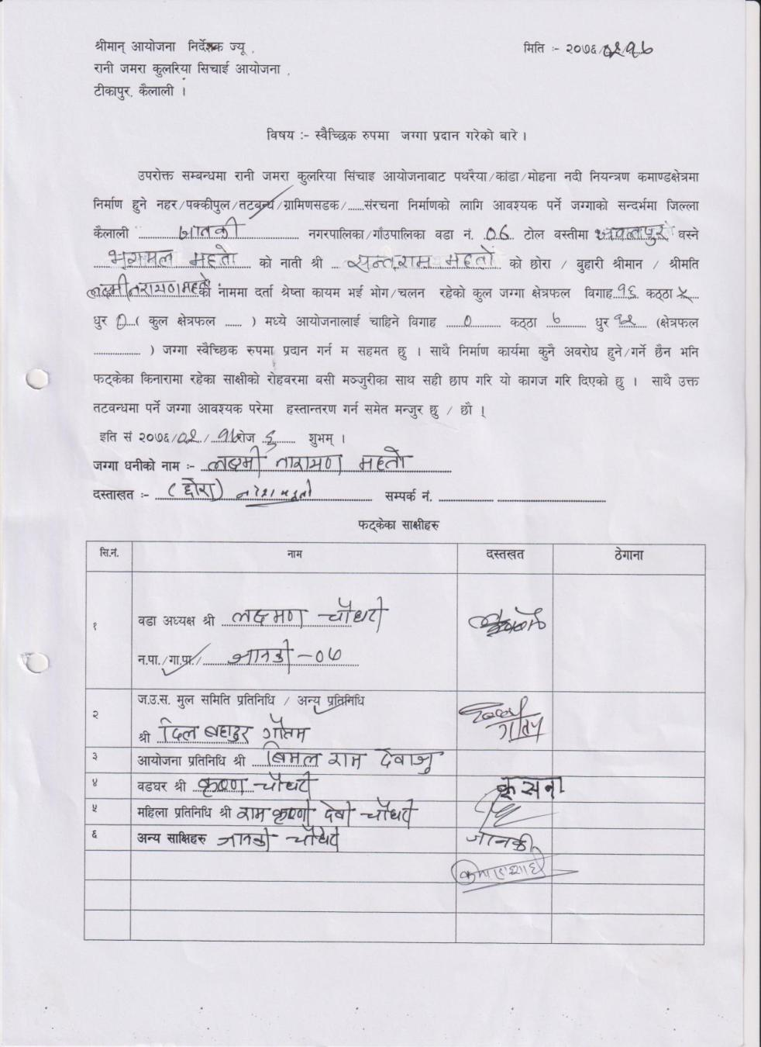

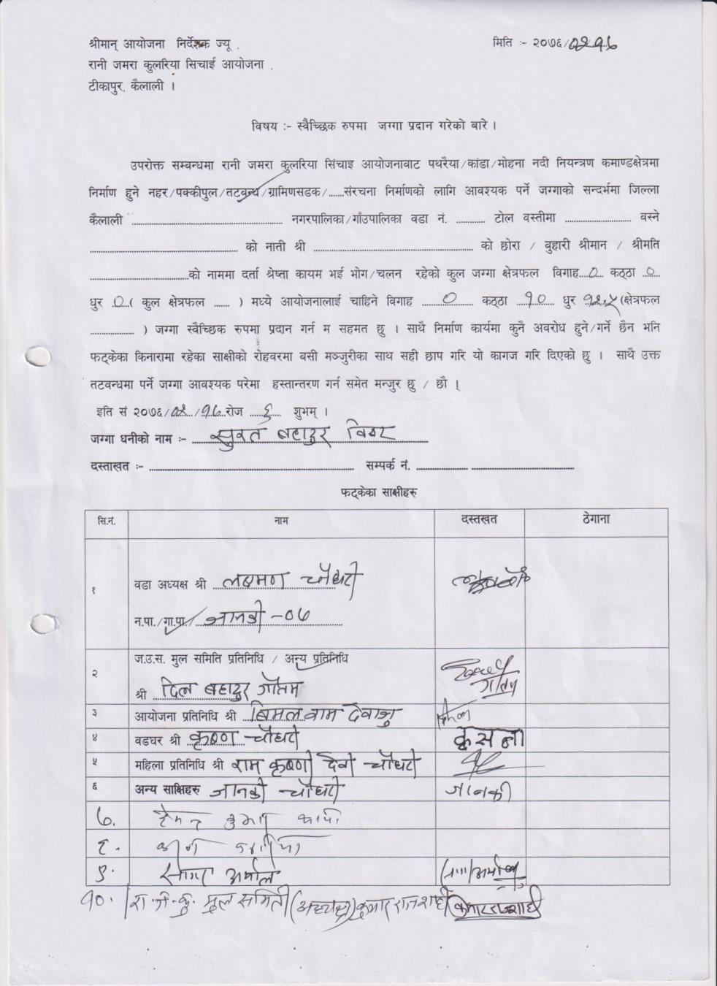
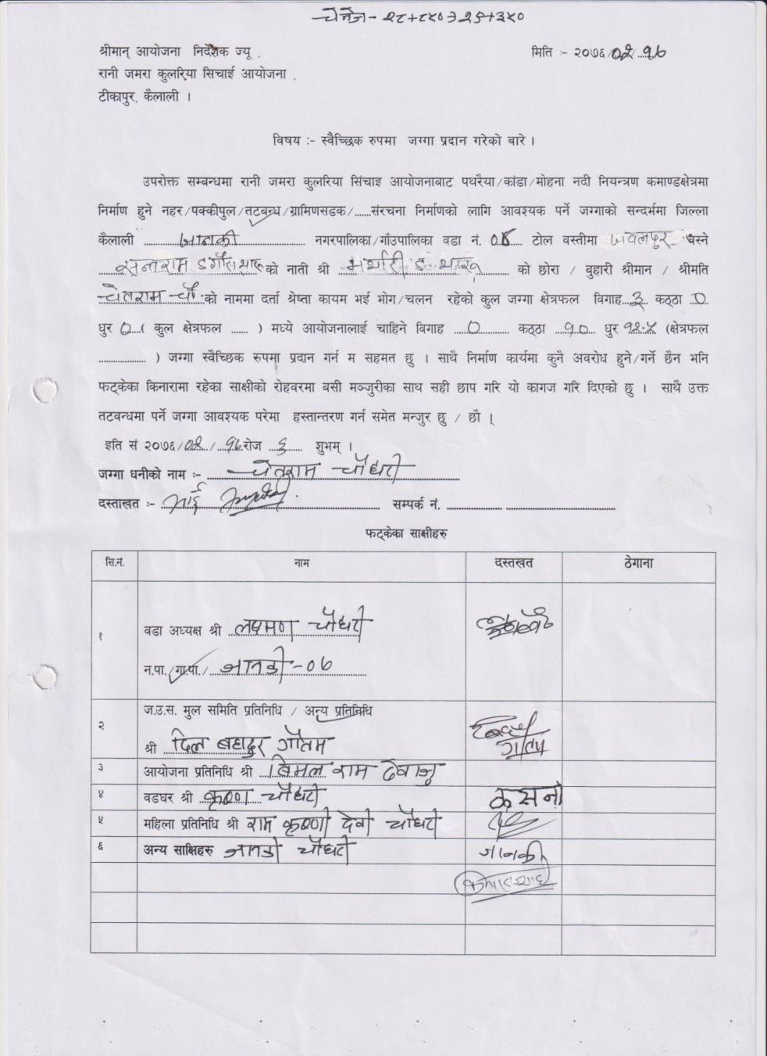

6: Tikapur Municipality 6 (LB)
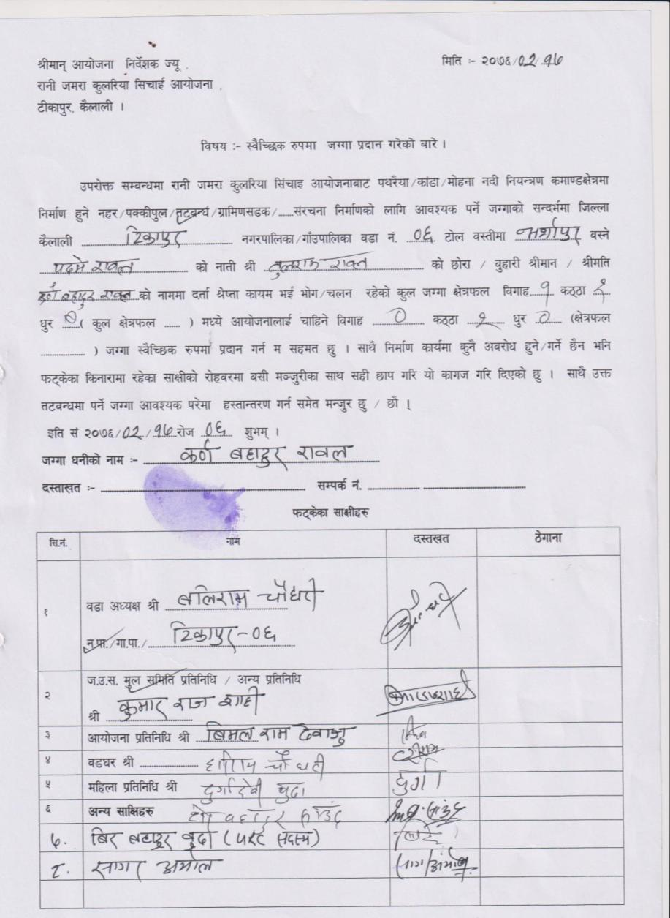
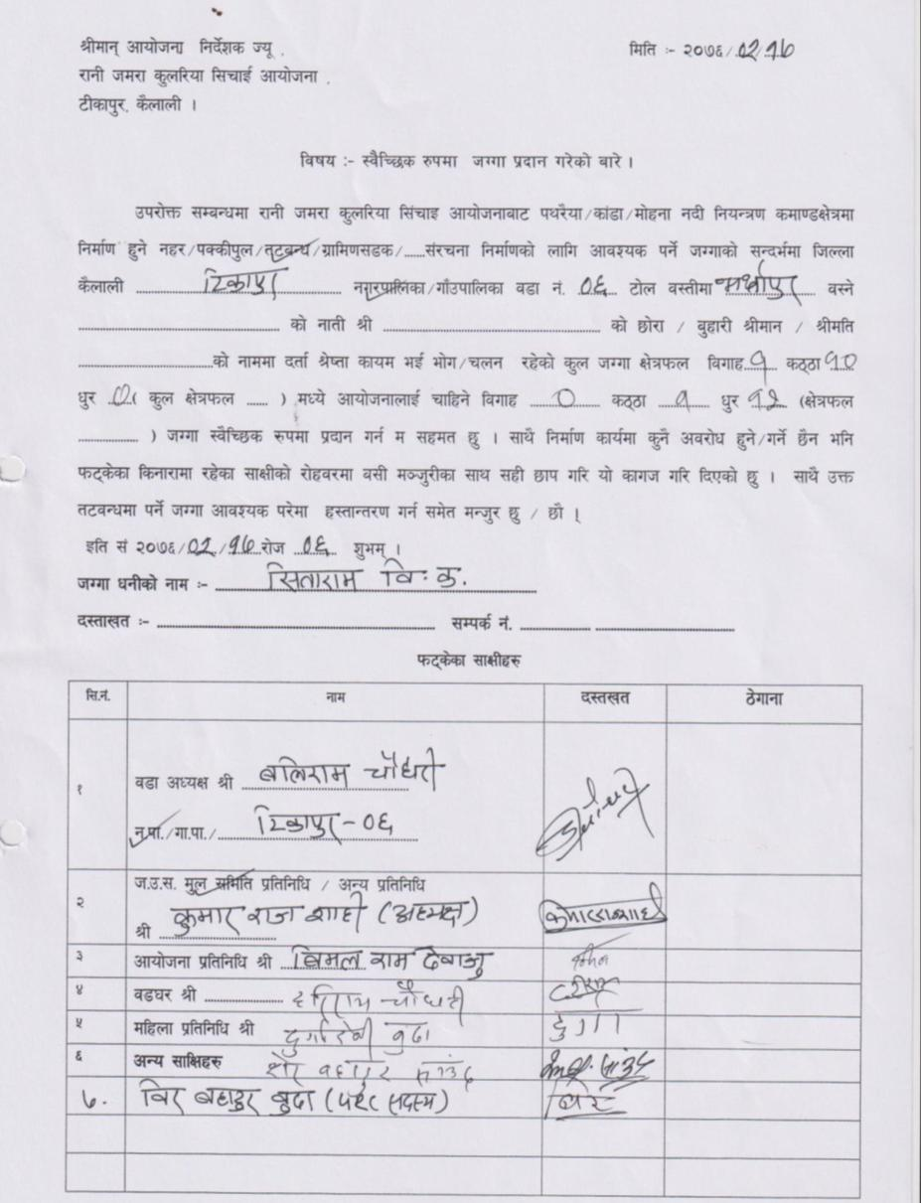

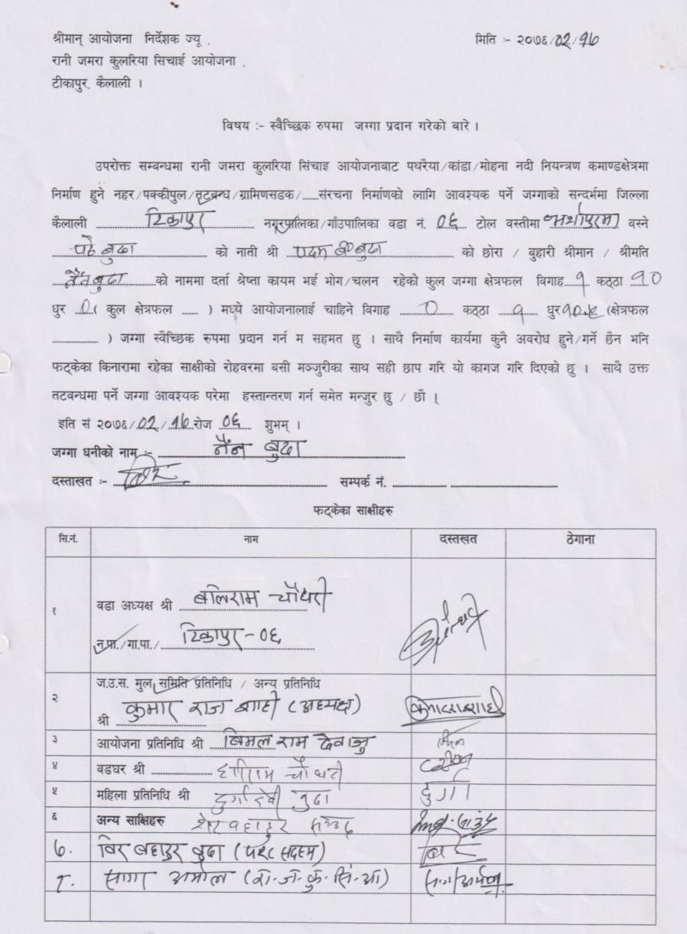
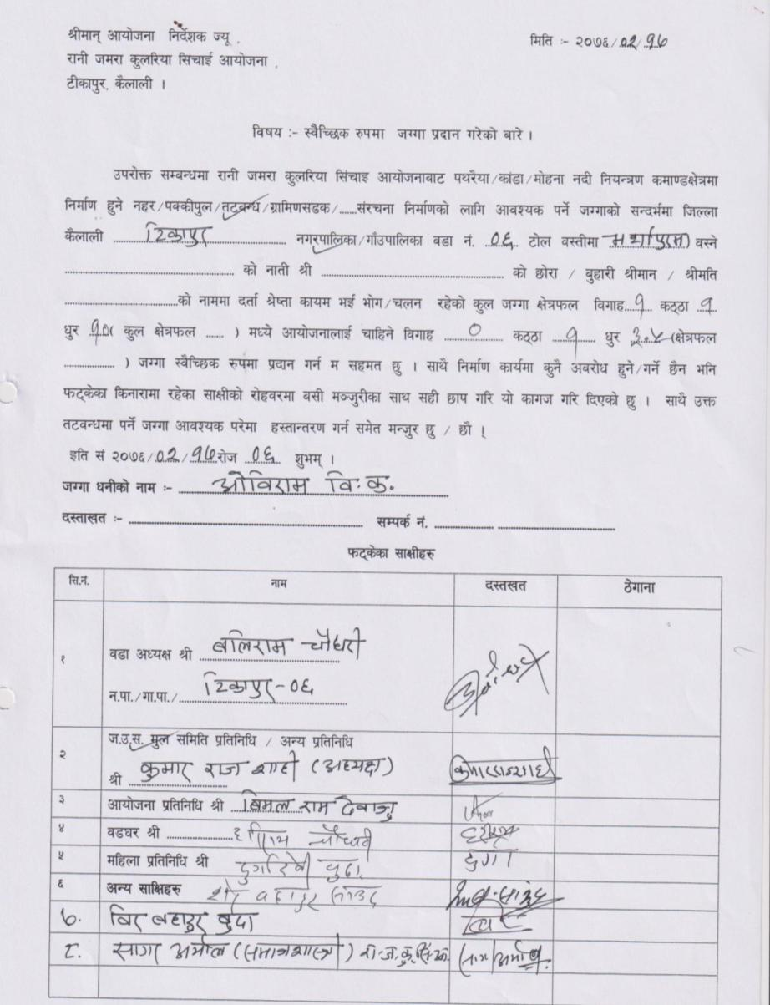

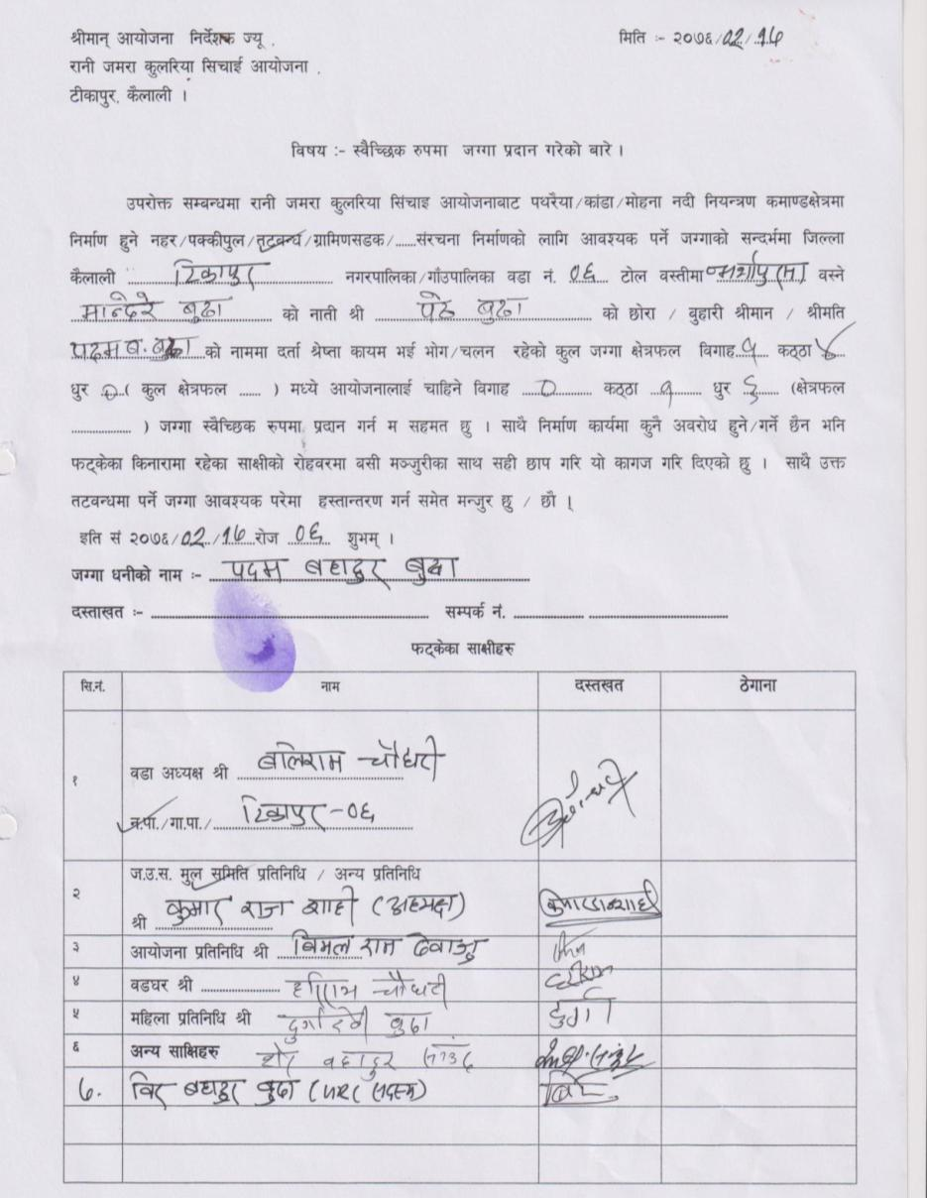
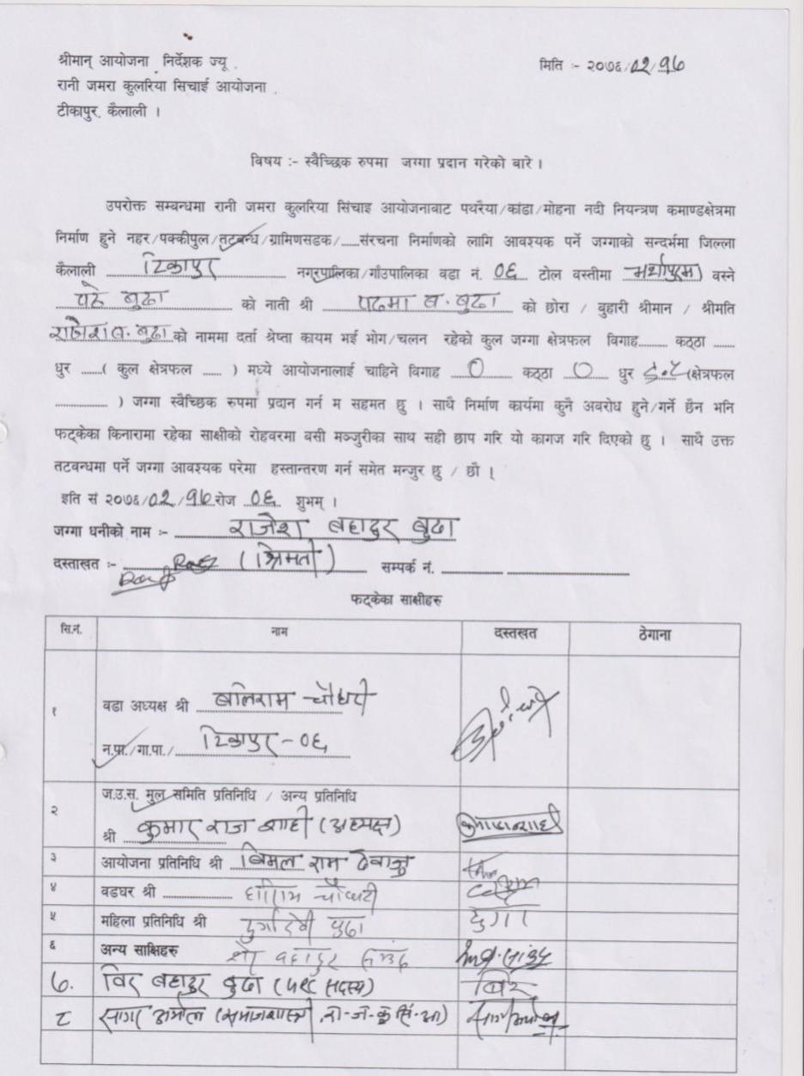

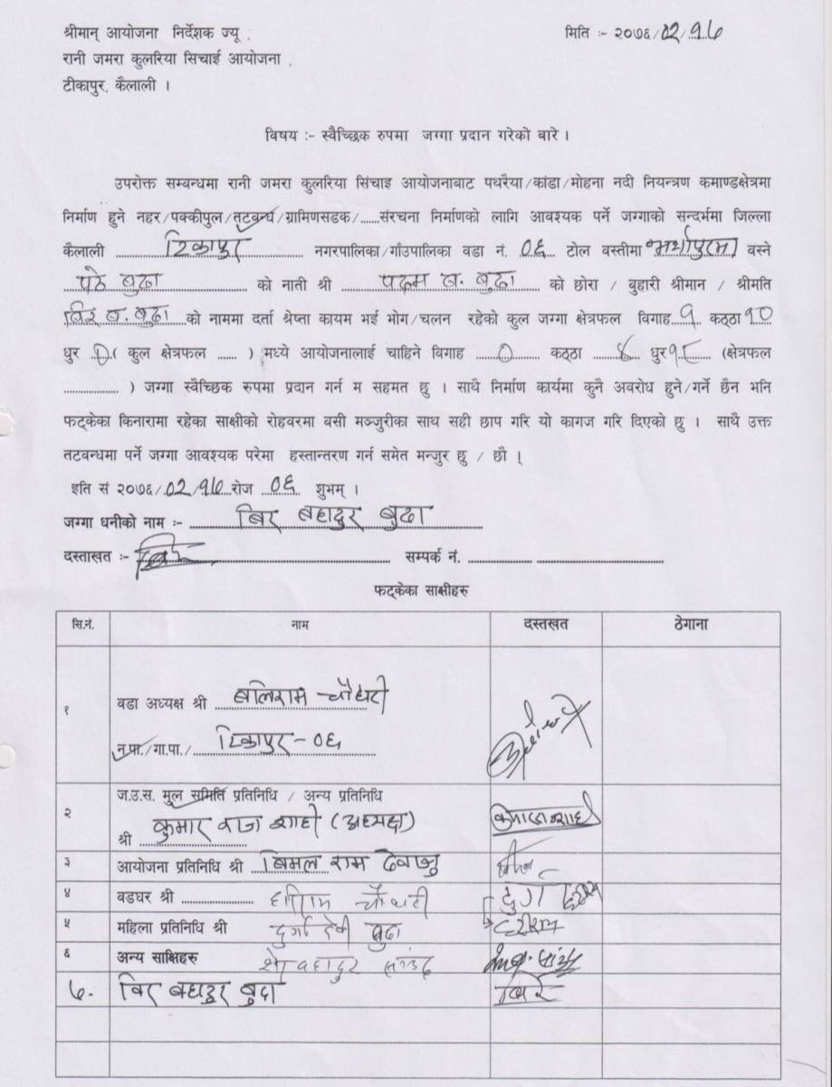
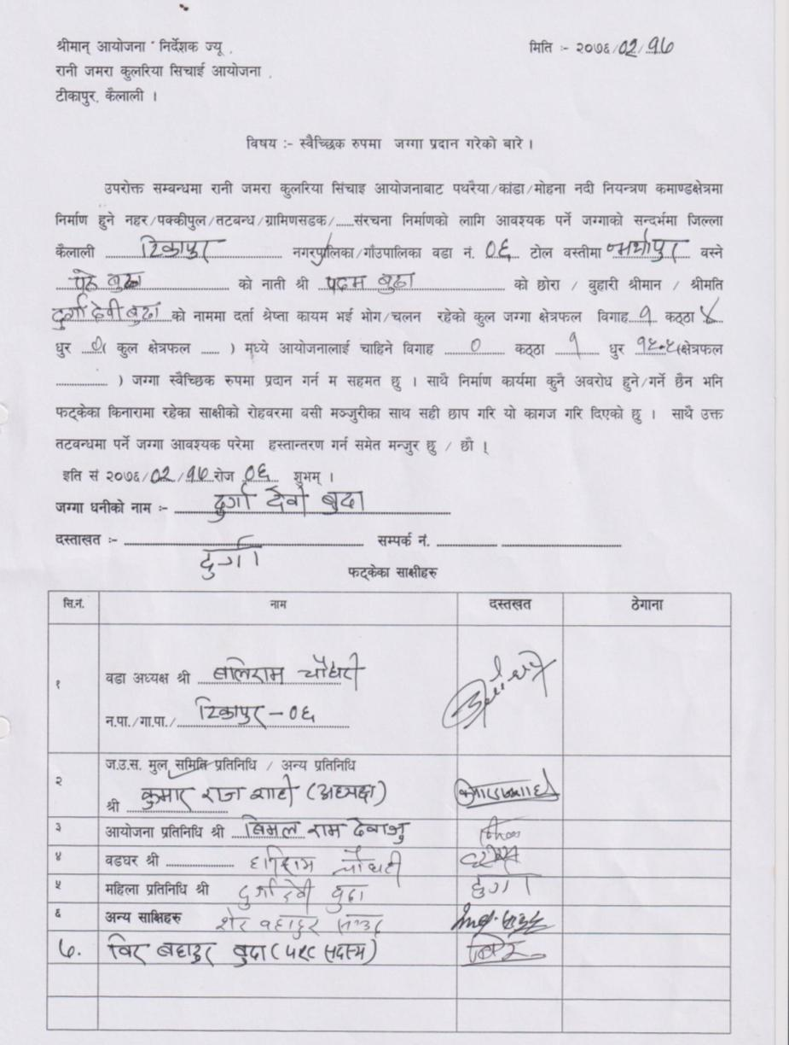

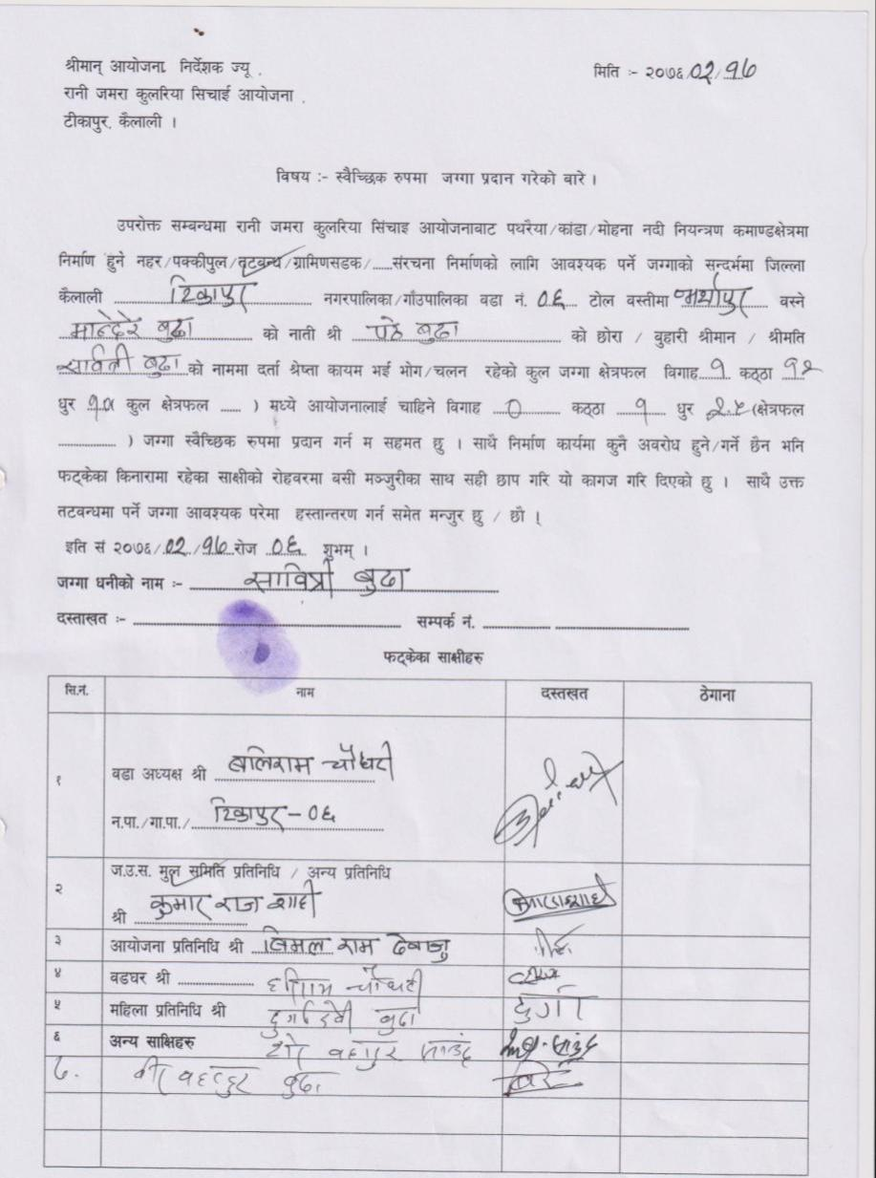
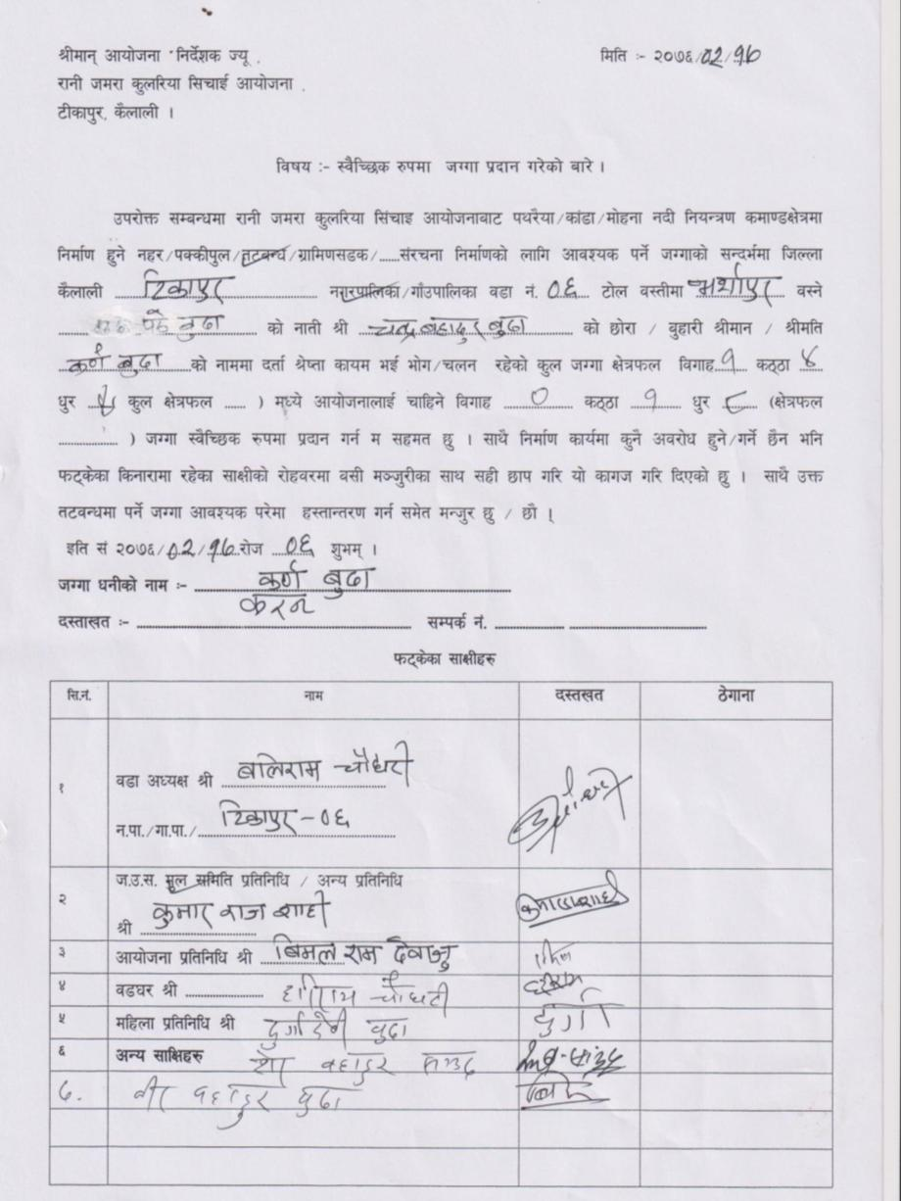

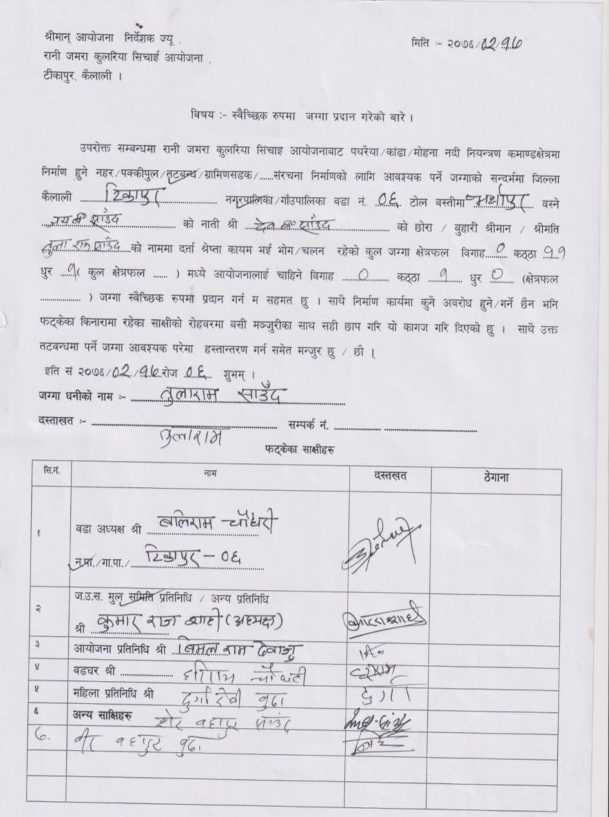
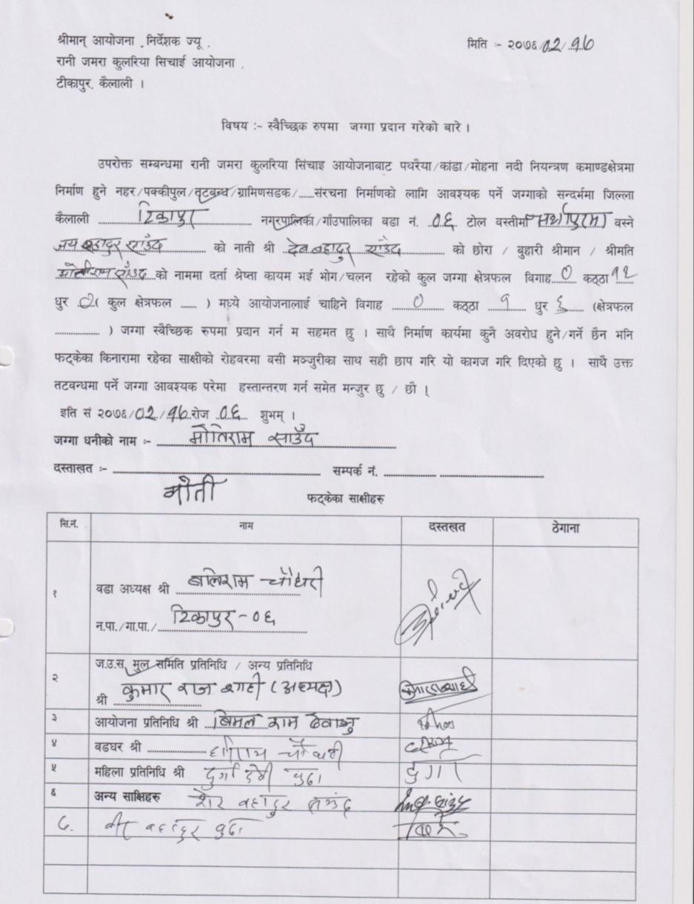

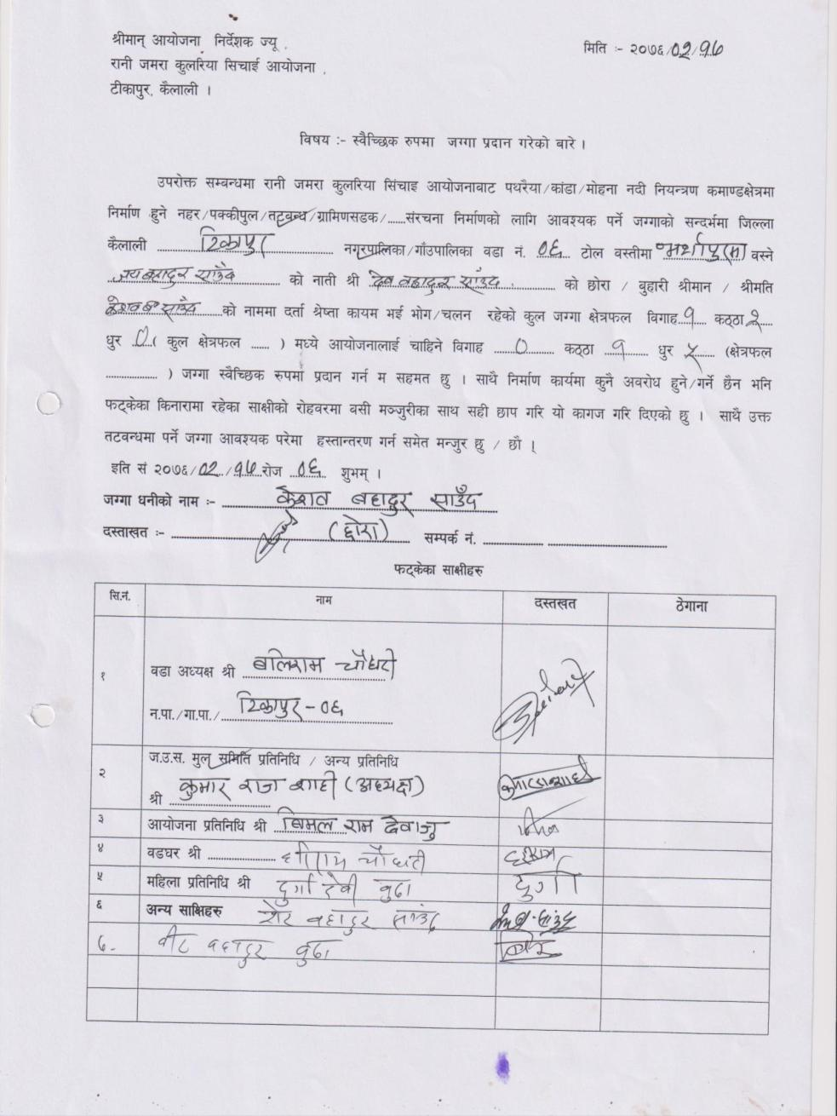
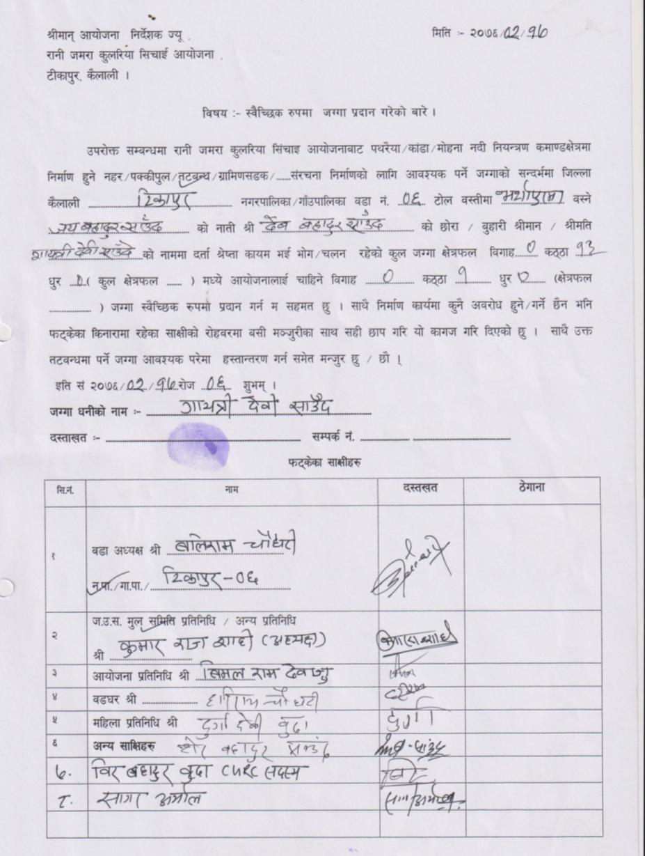

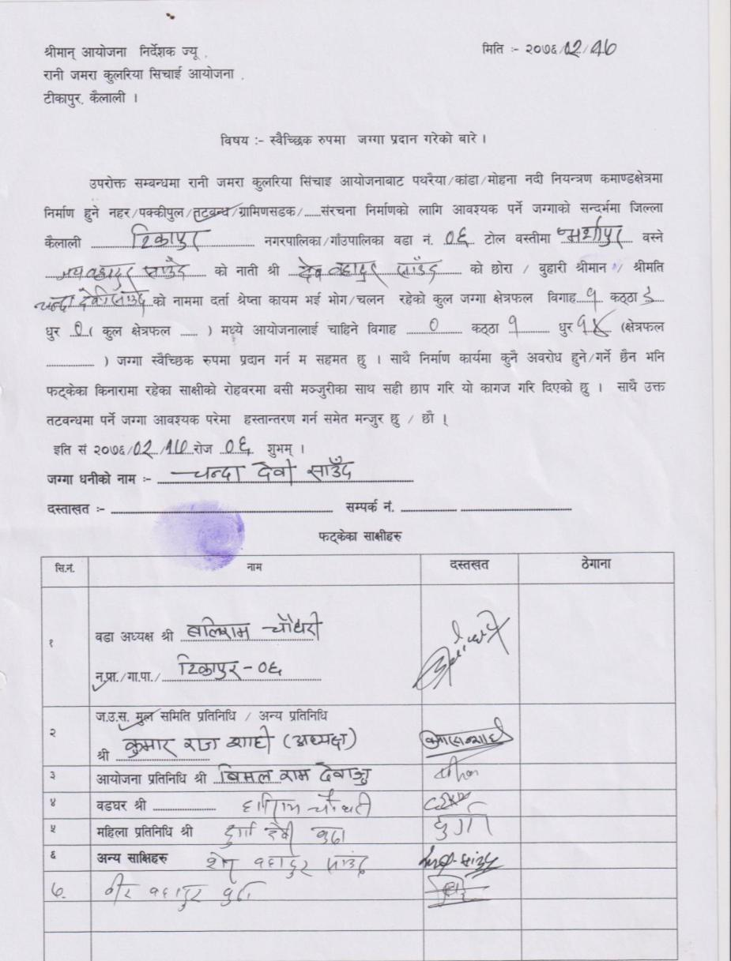
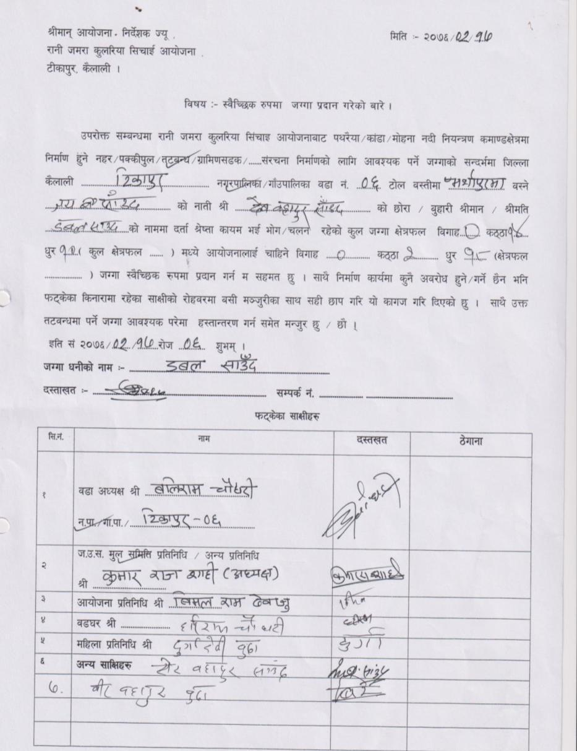

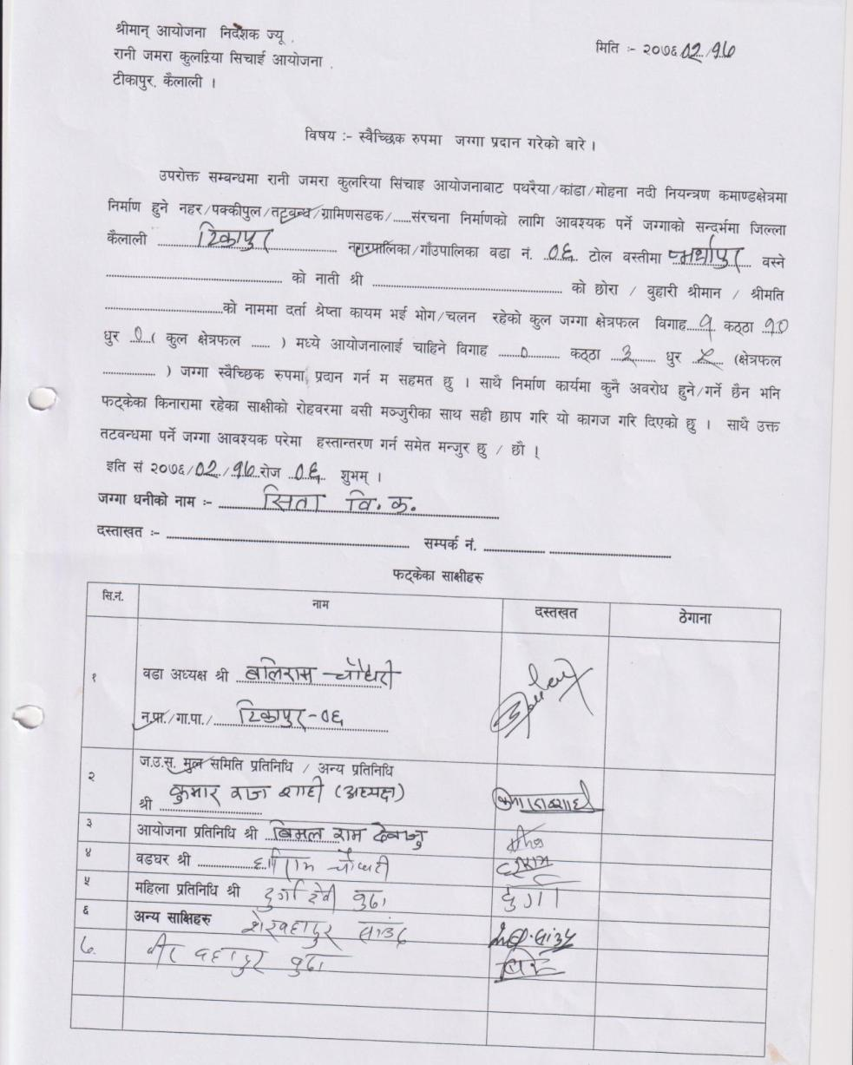
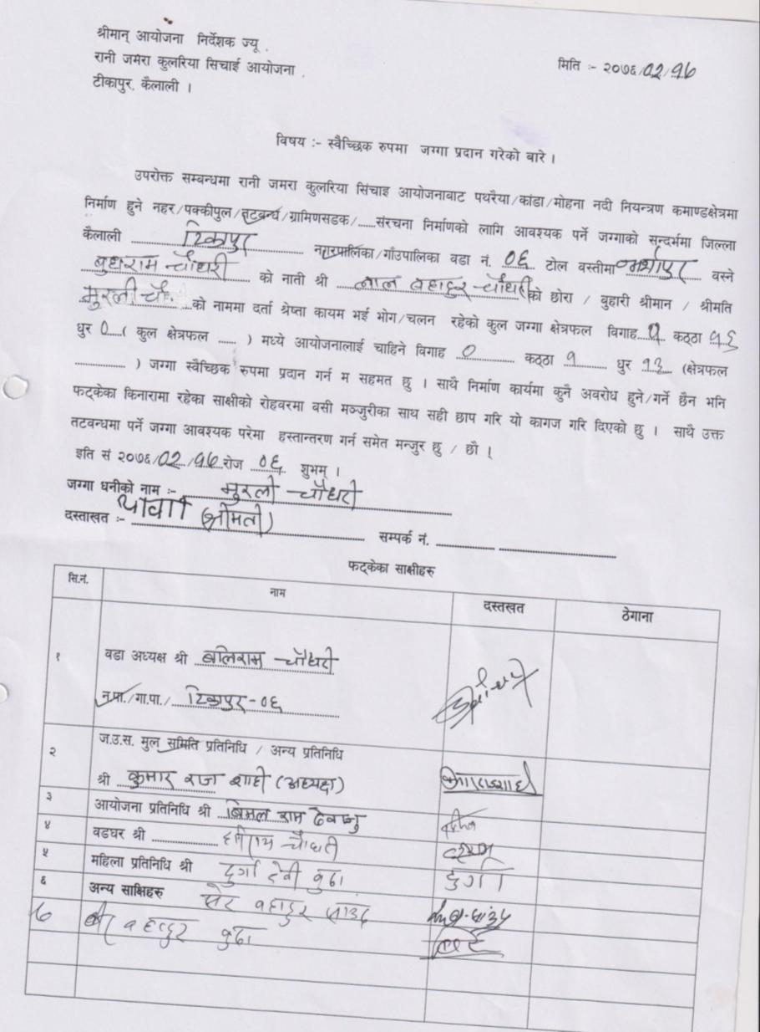

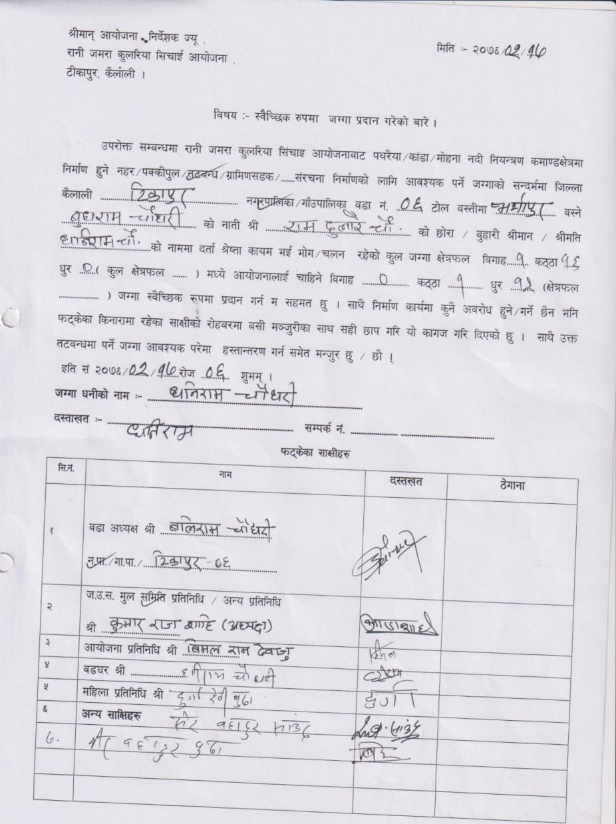
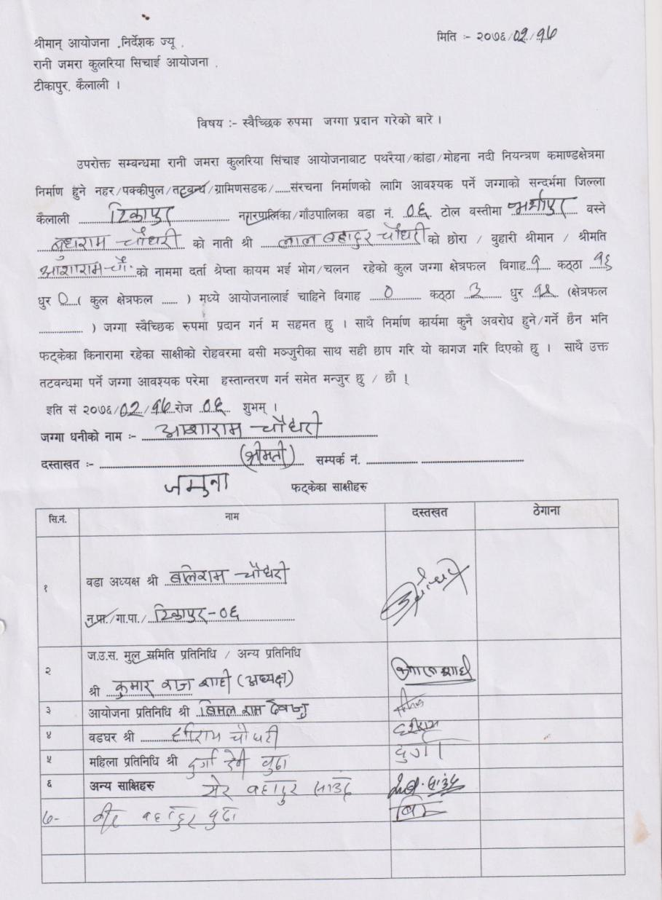

7: Joshipur RM 5 (RB)
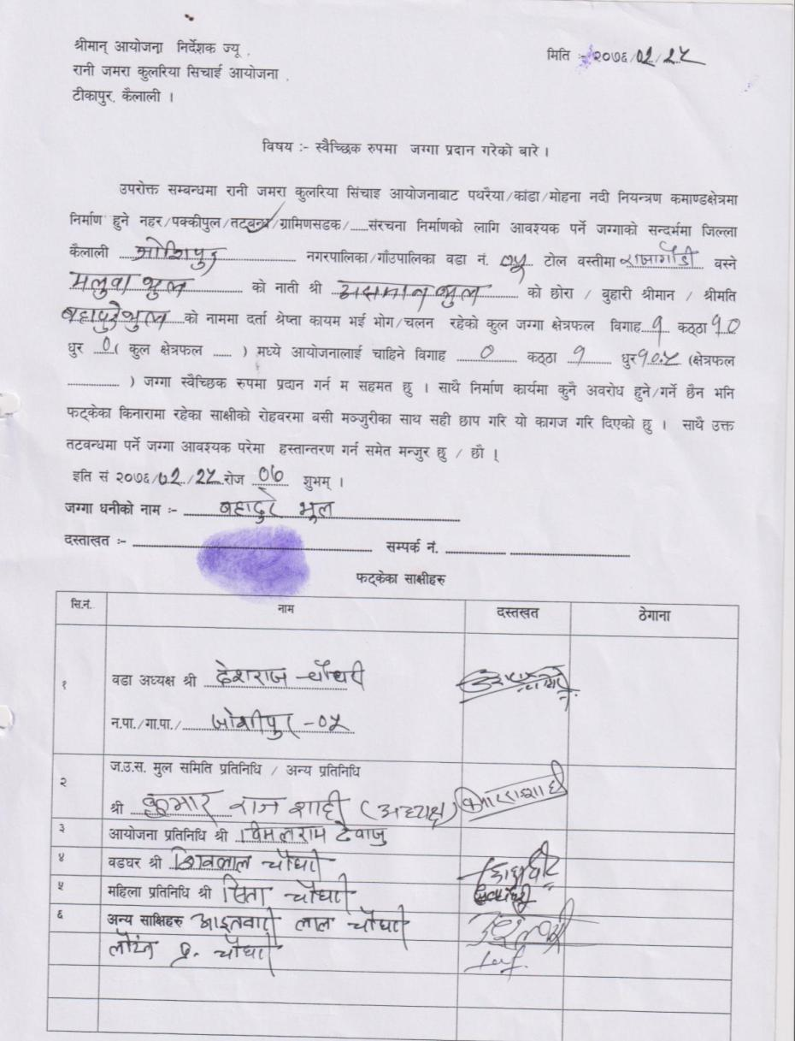
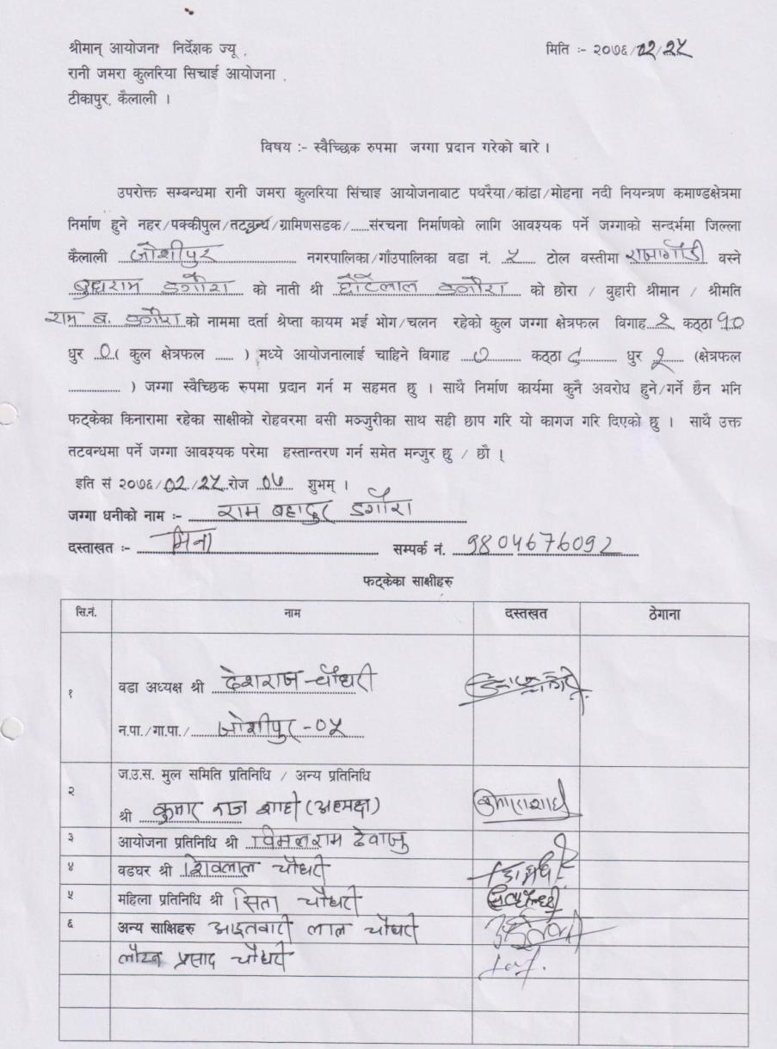

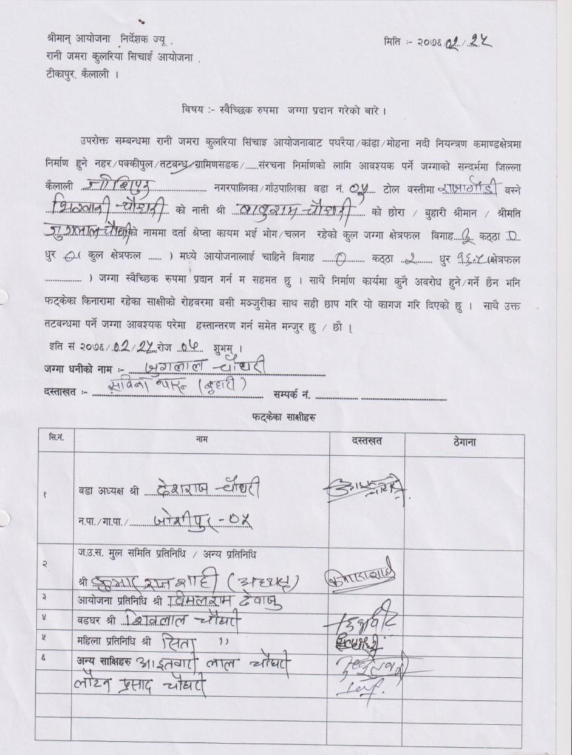
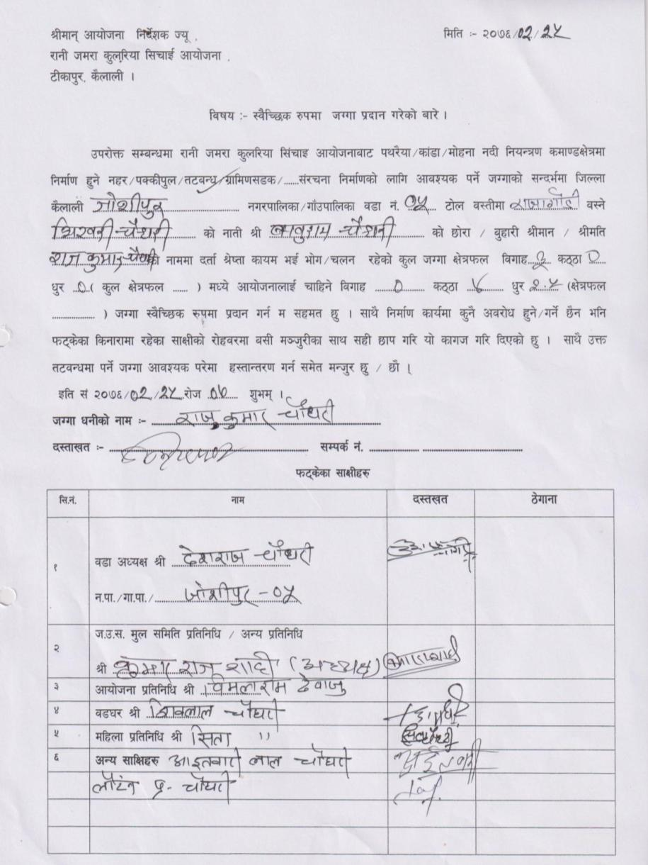

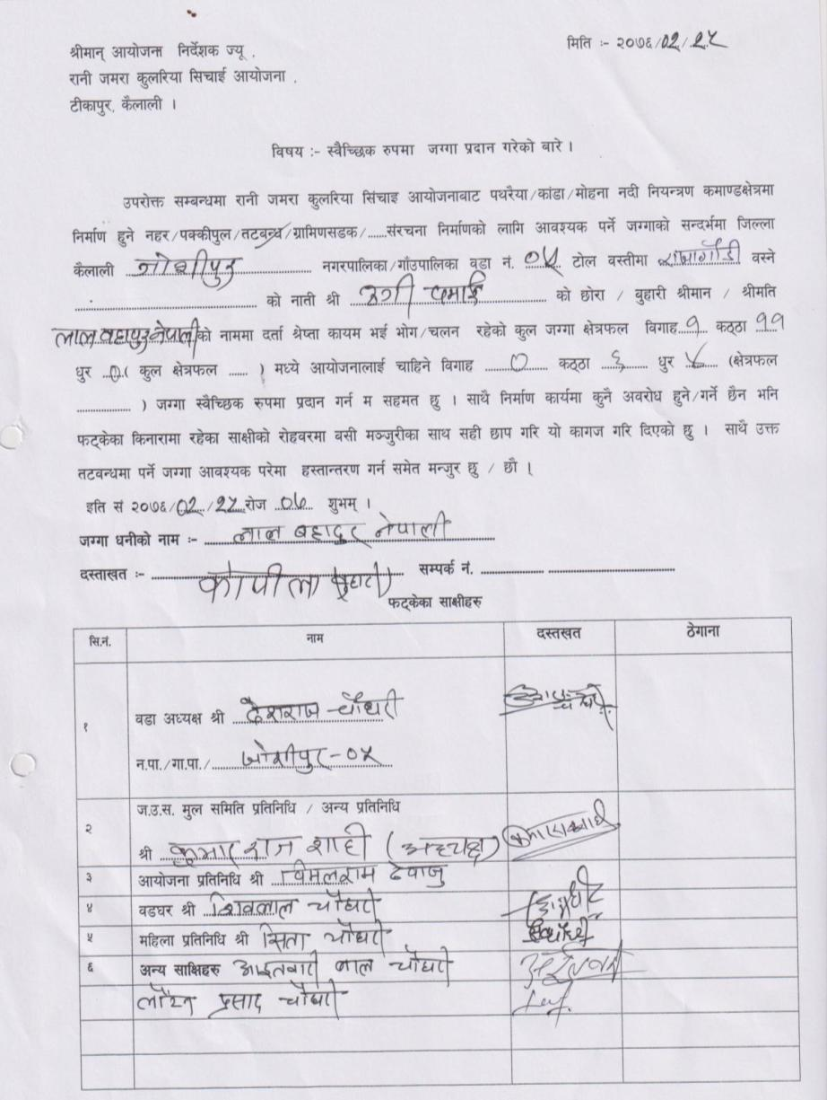
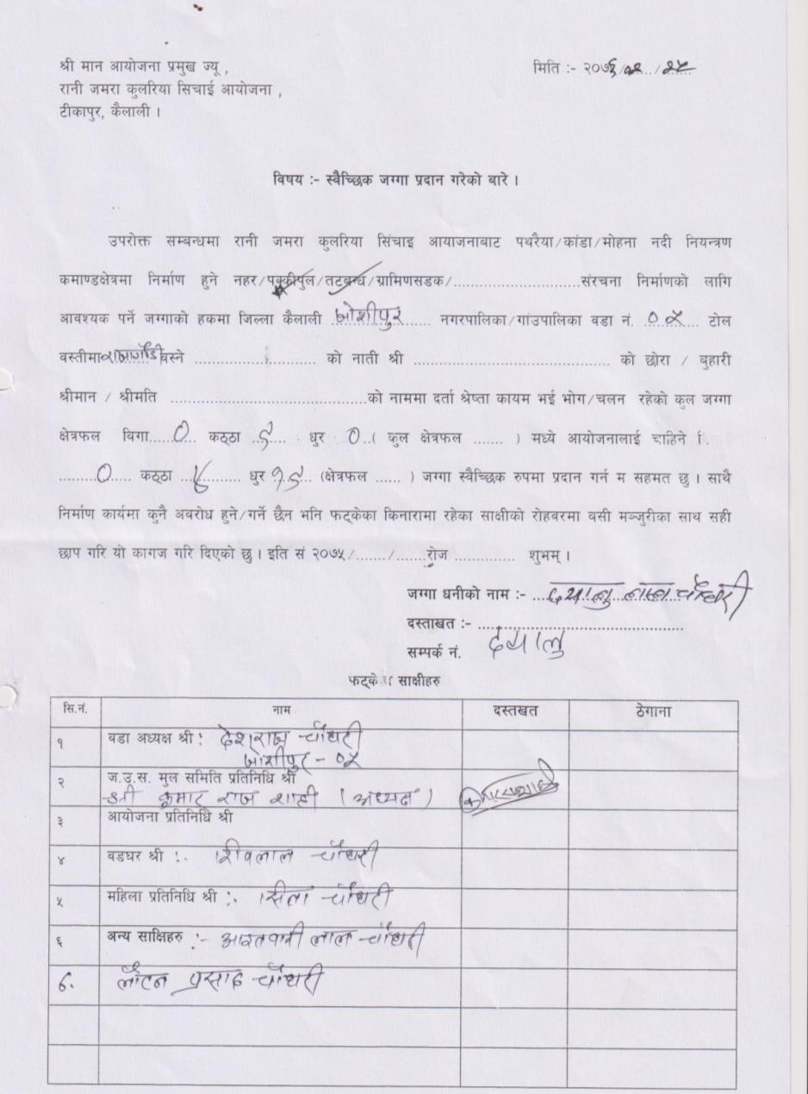

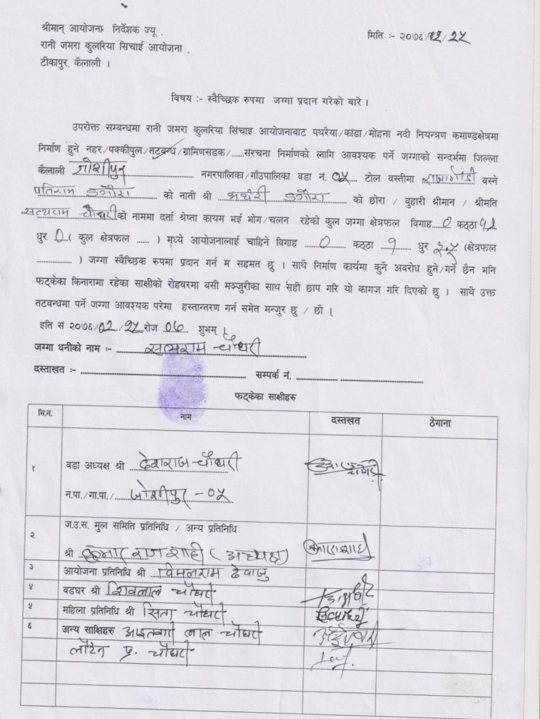
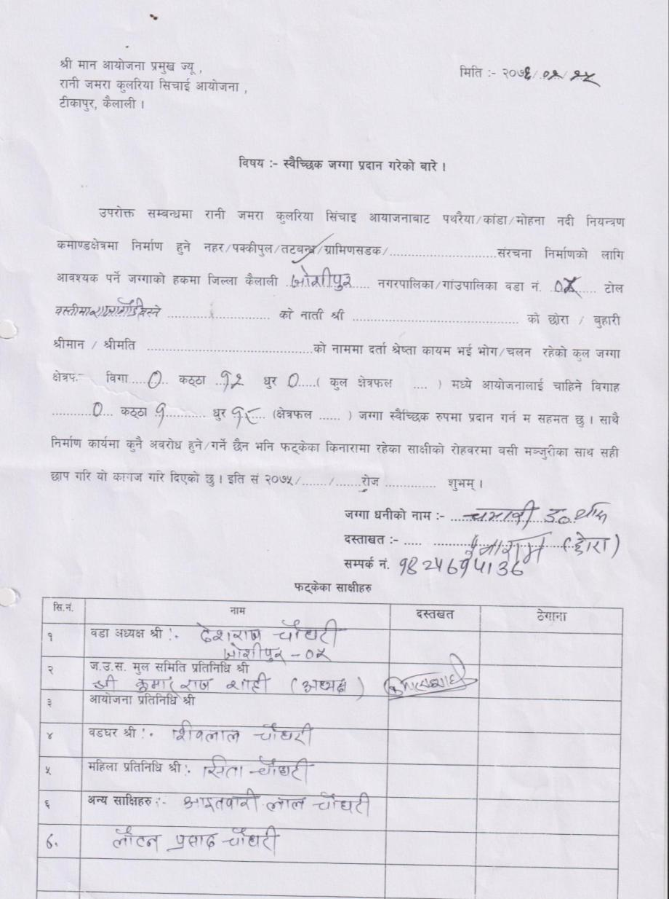

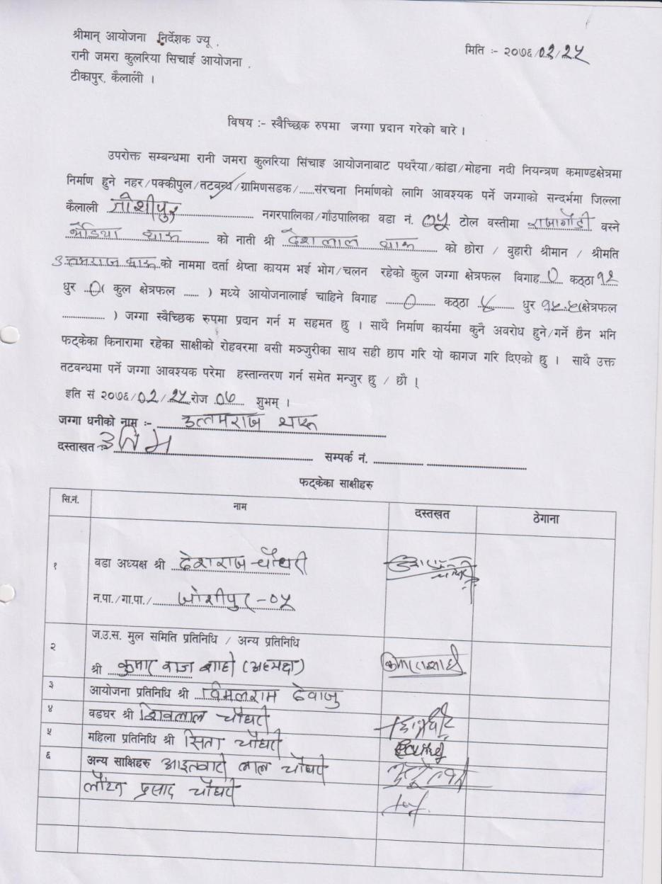
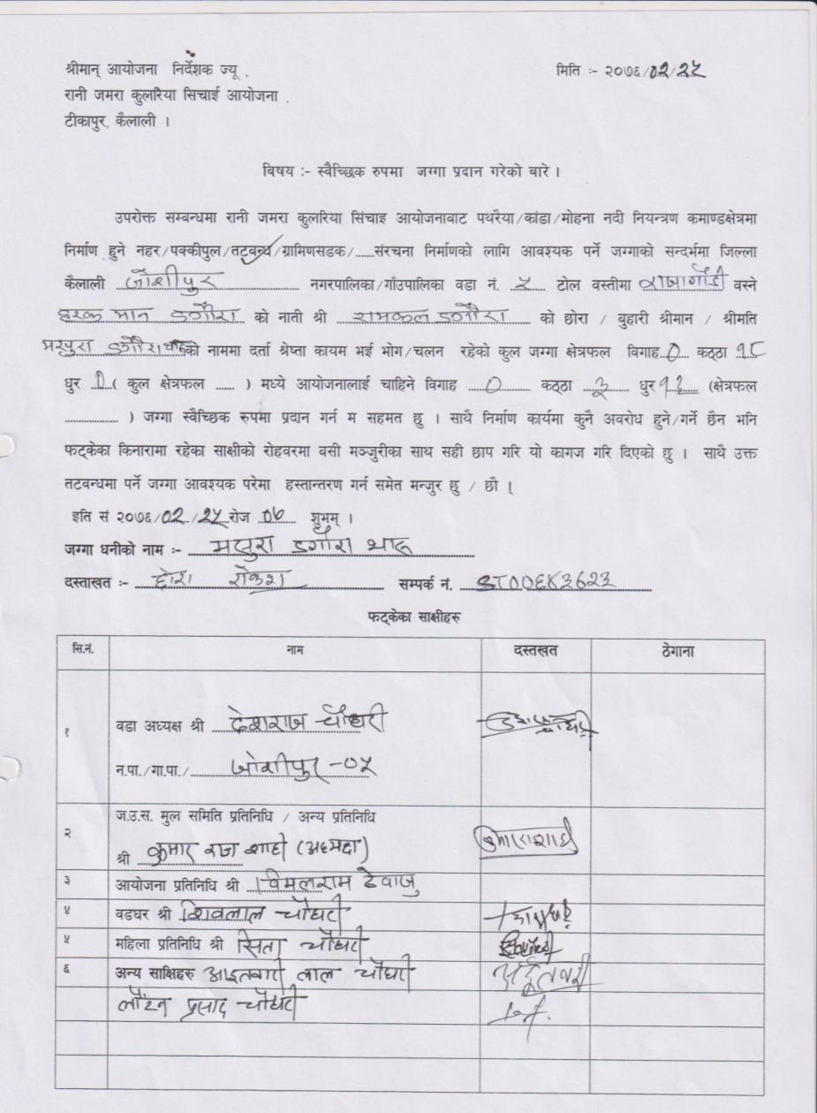

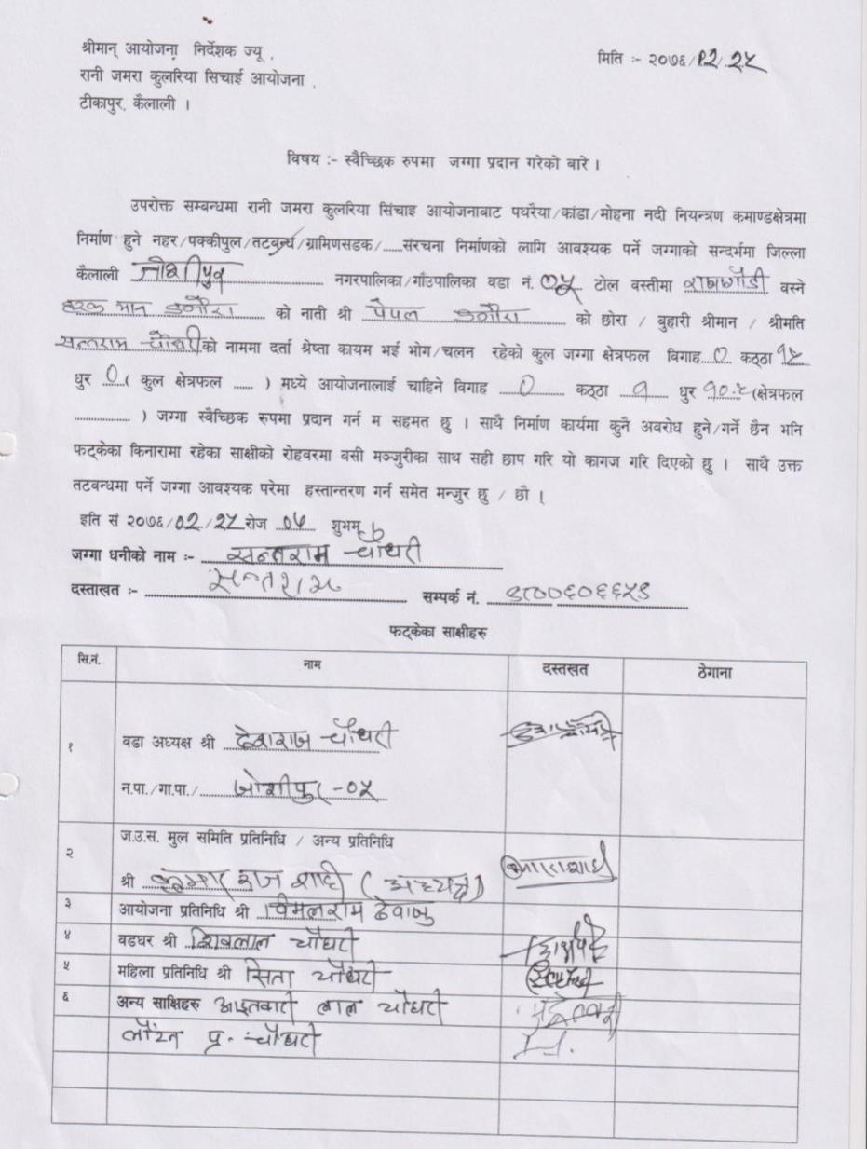
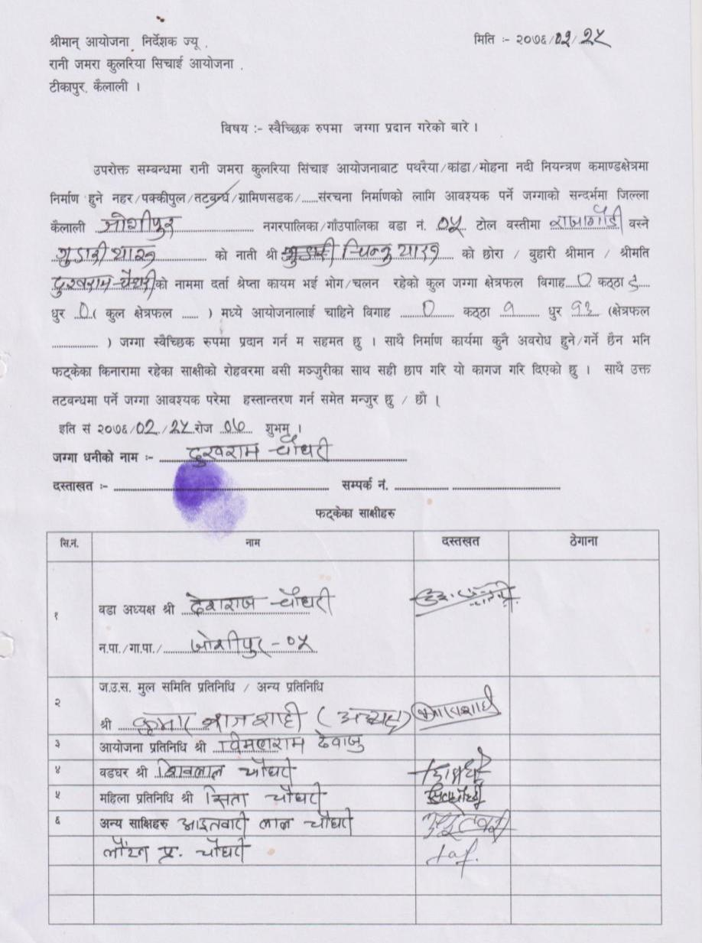

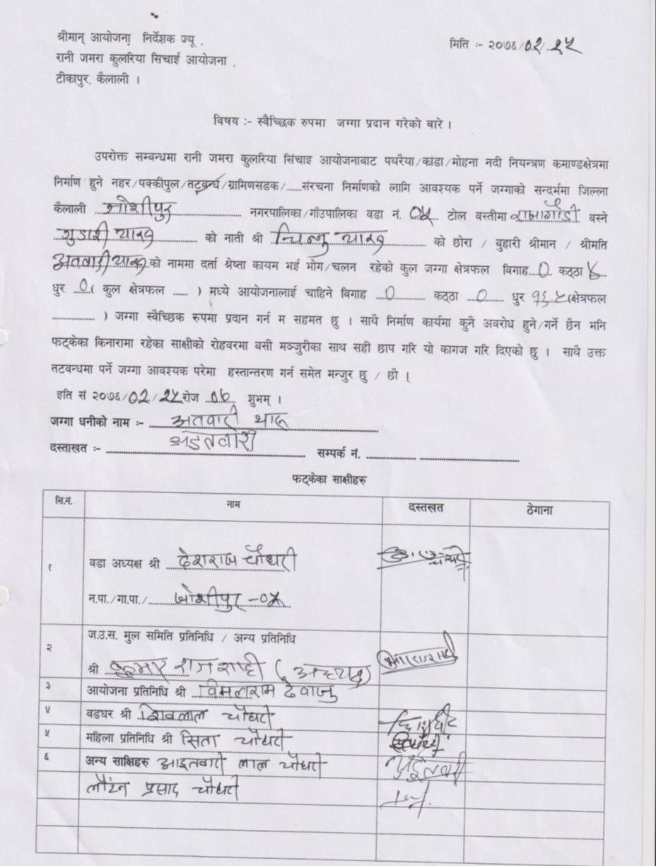
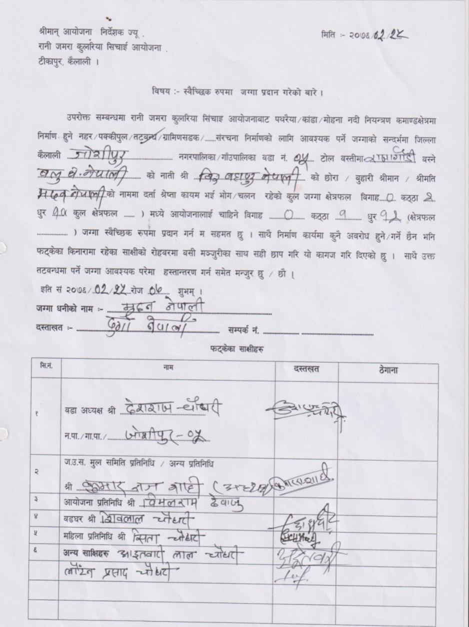

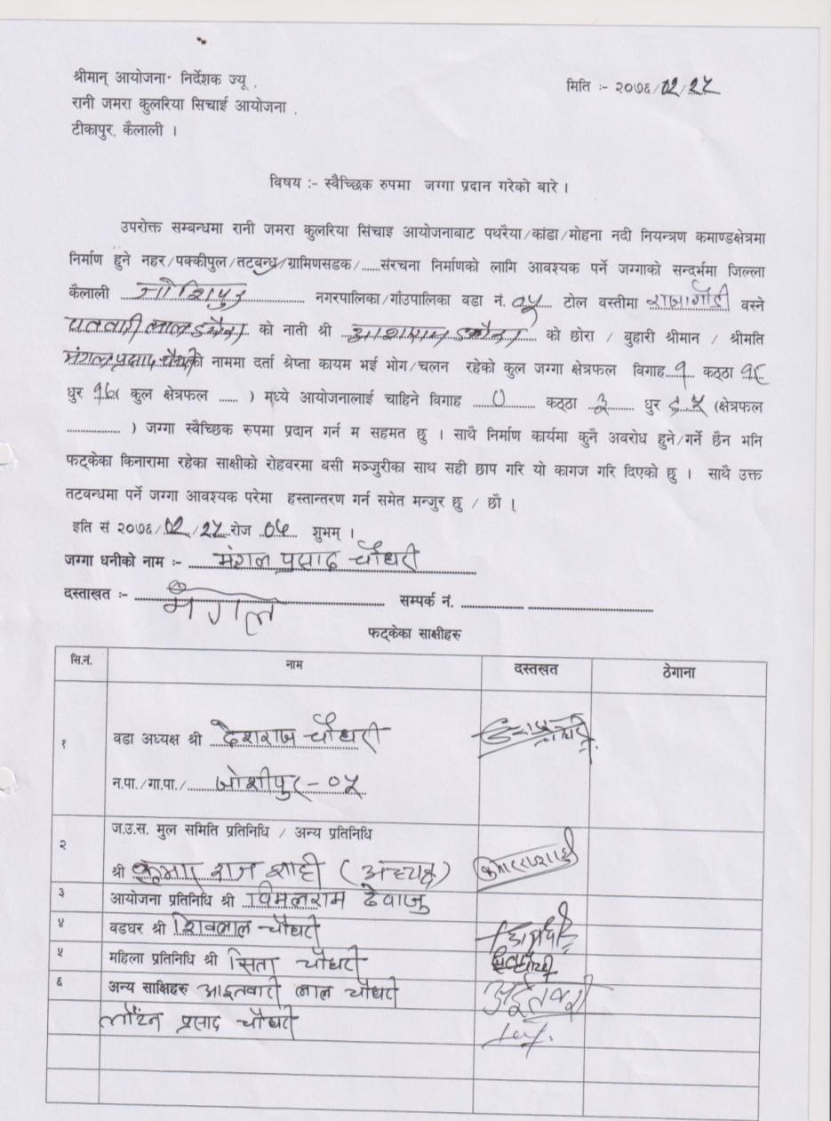
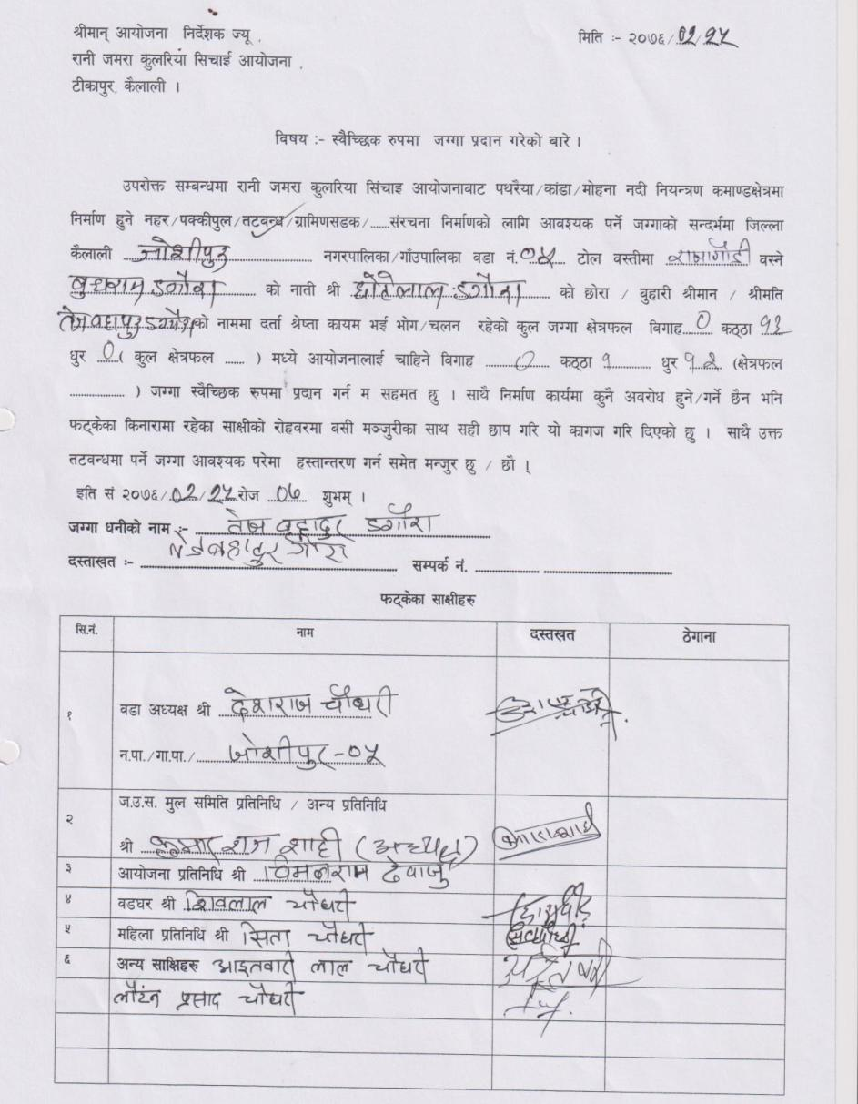

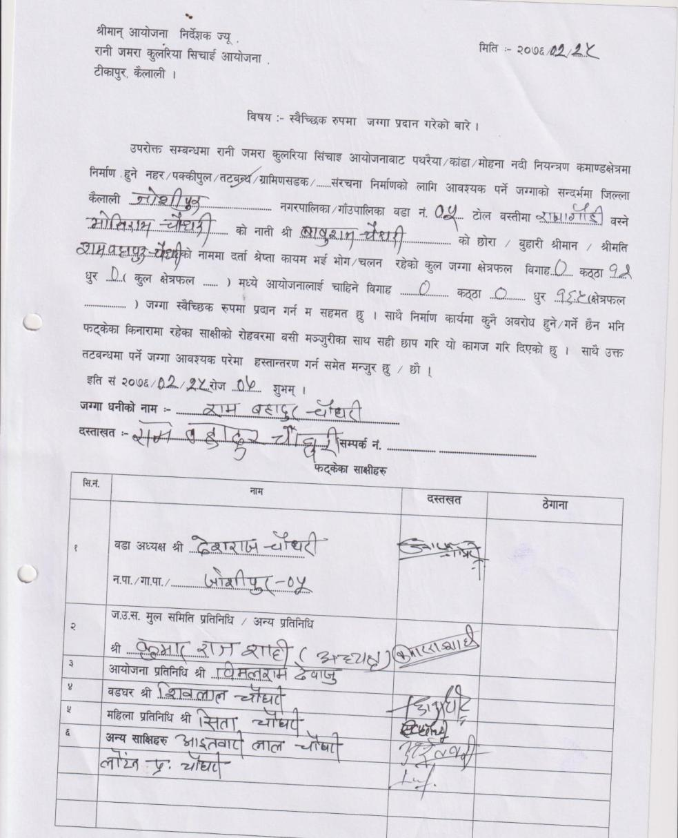
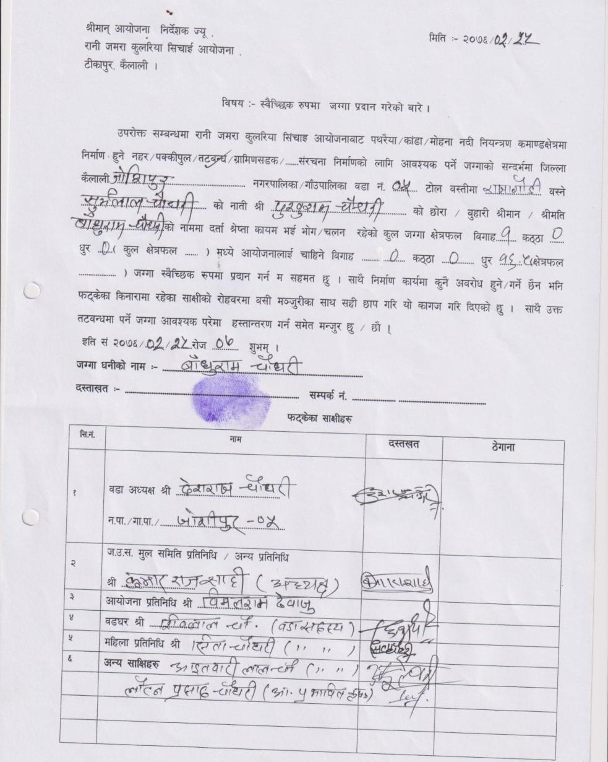

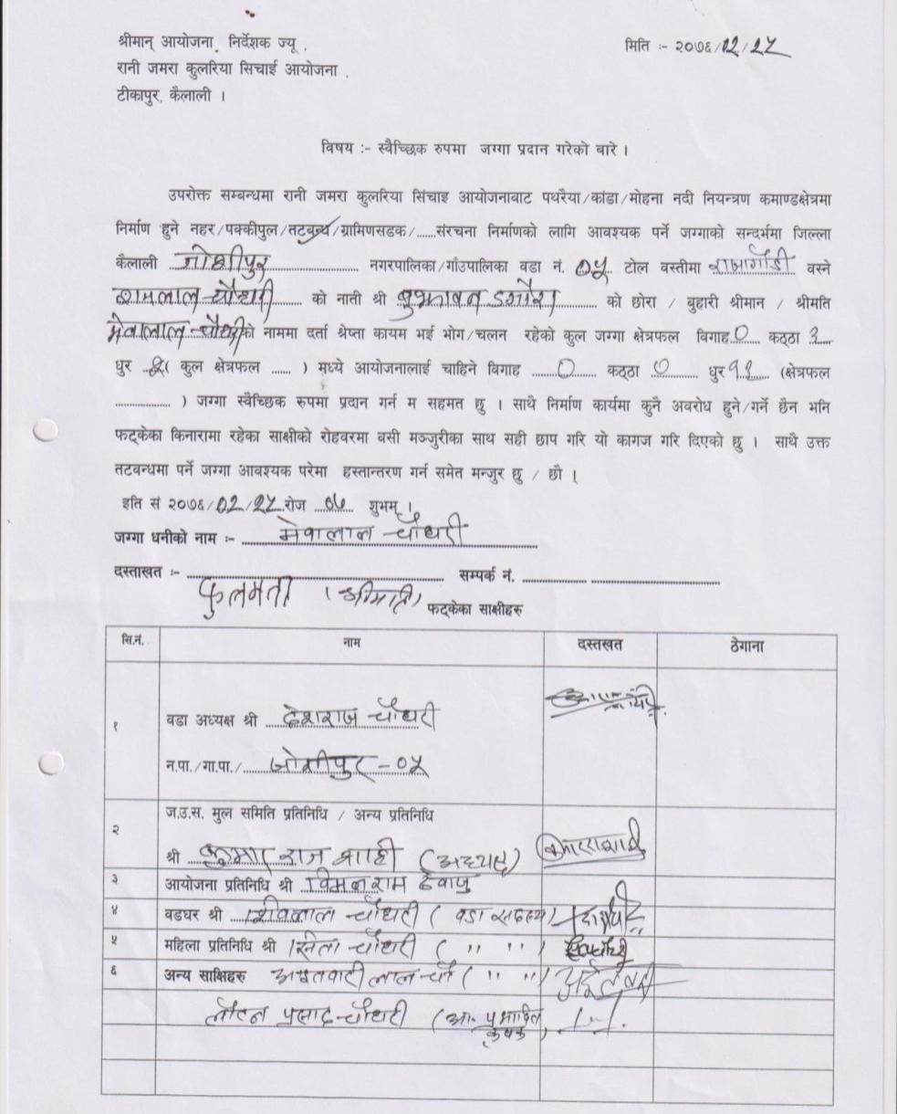
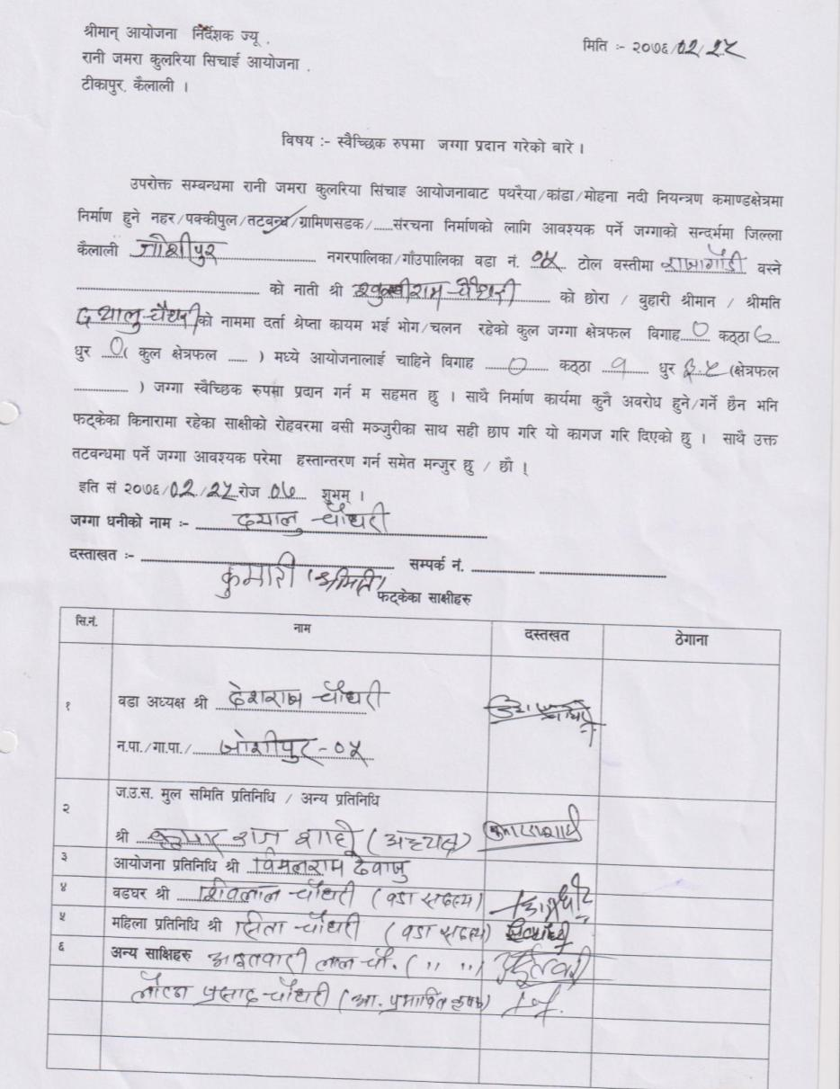

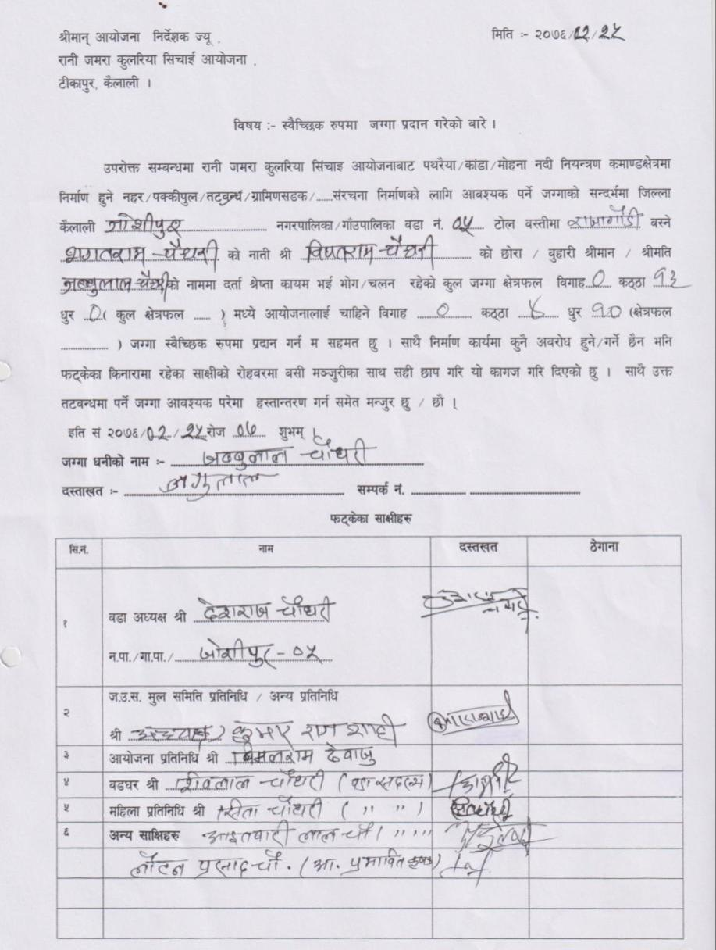
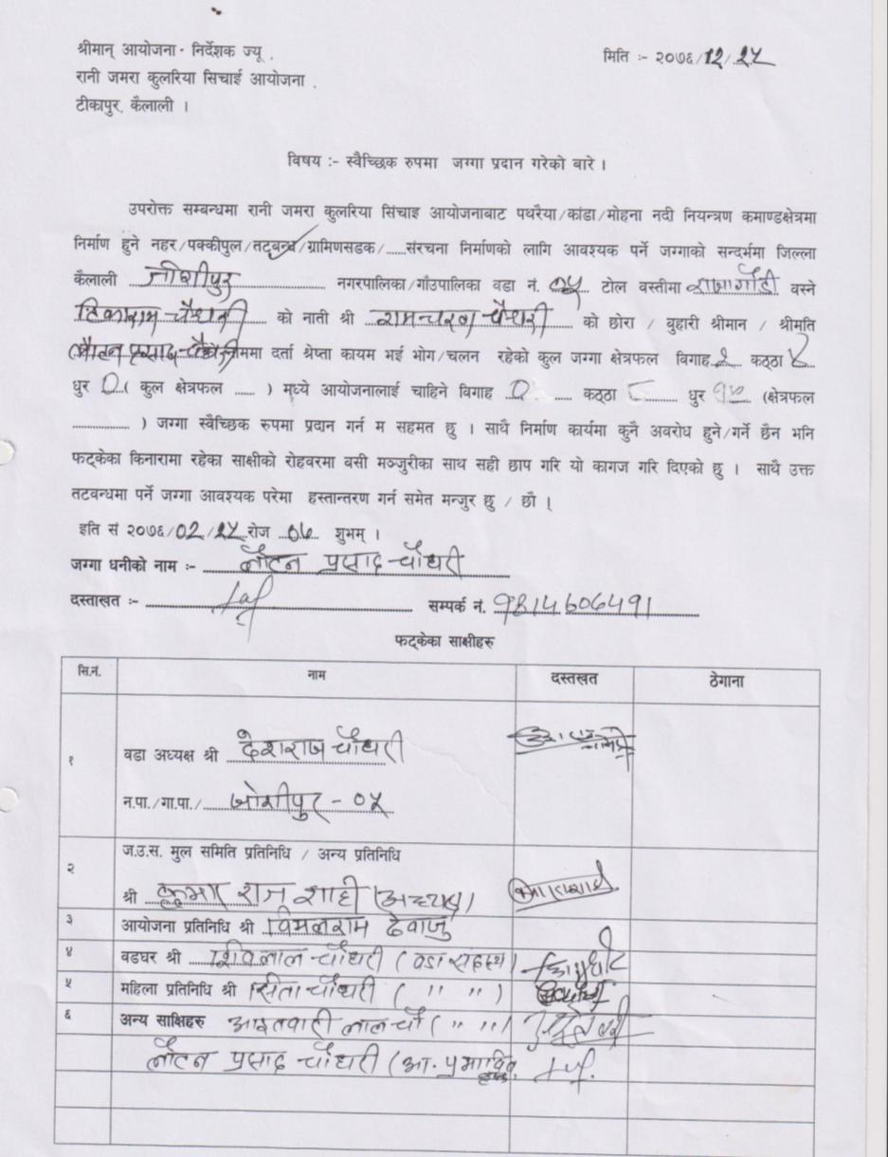

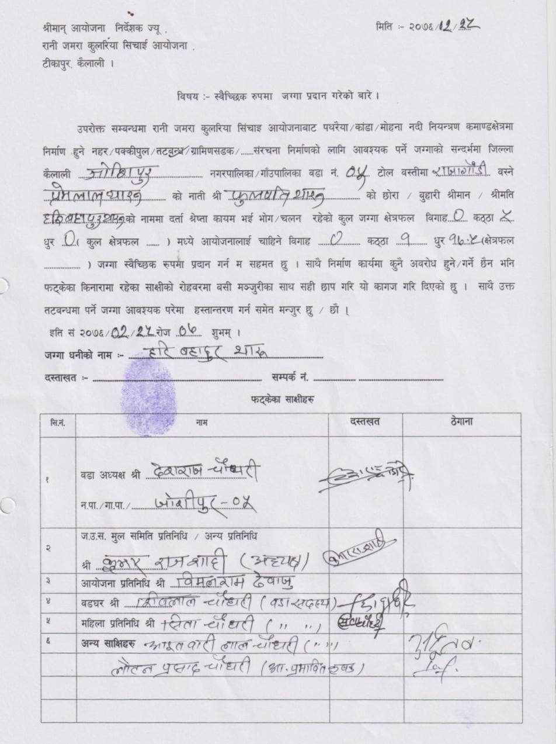
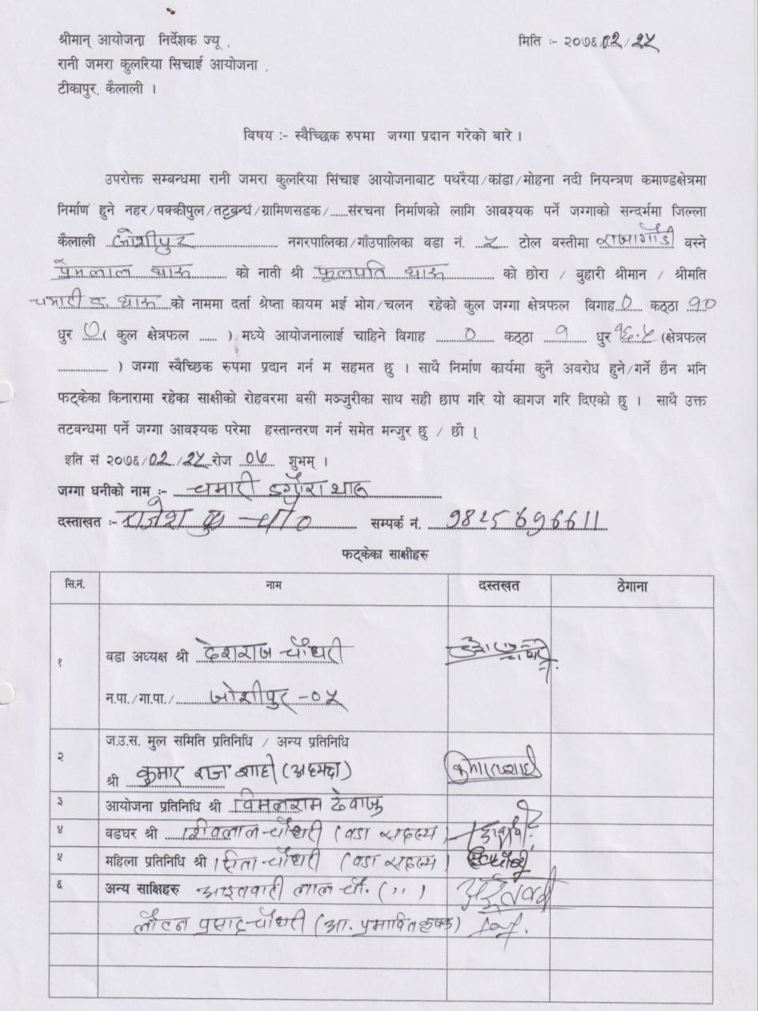

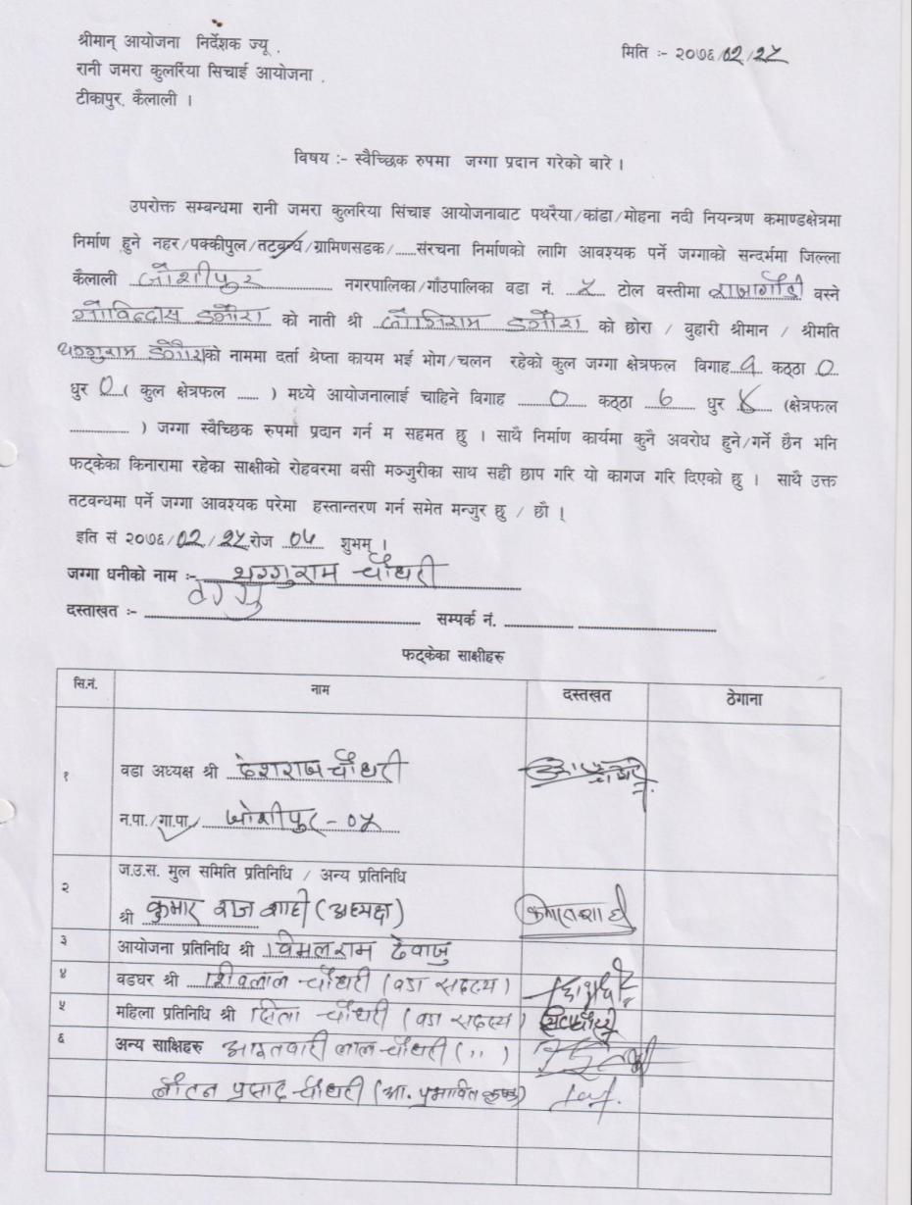
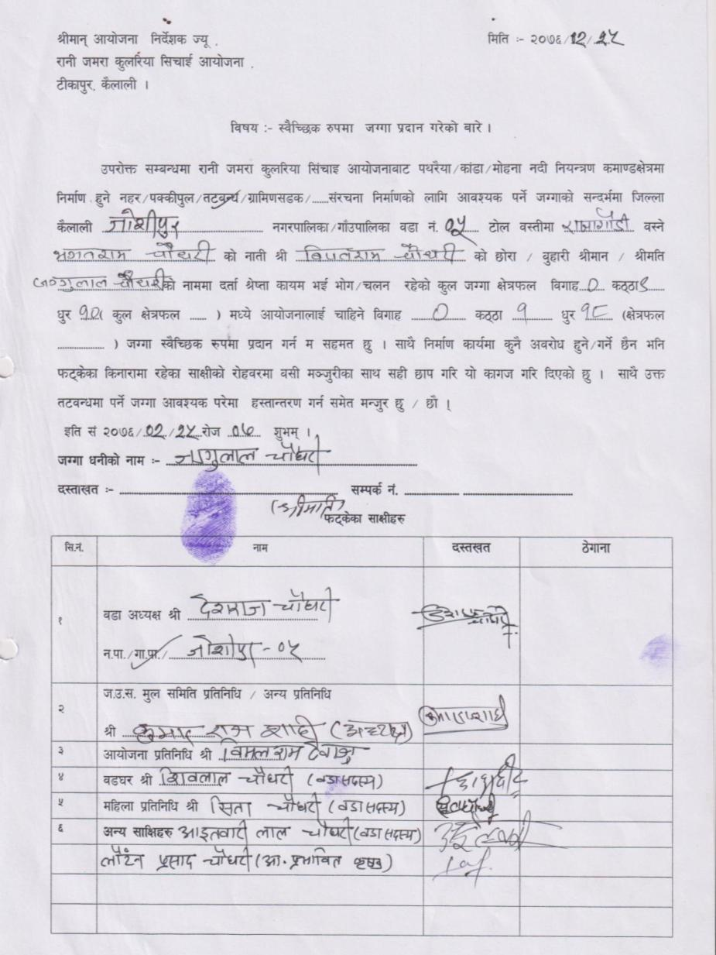

8: Joshipur RM 4 (RB)
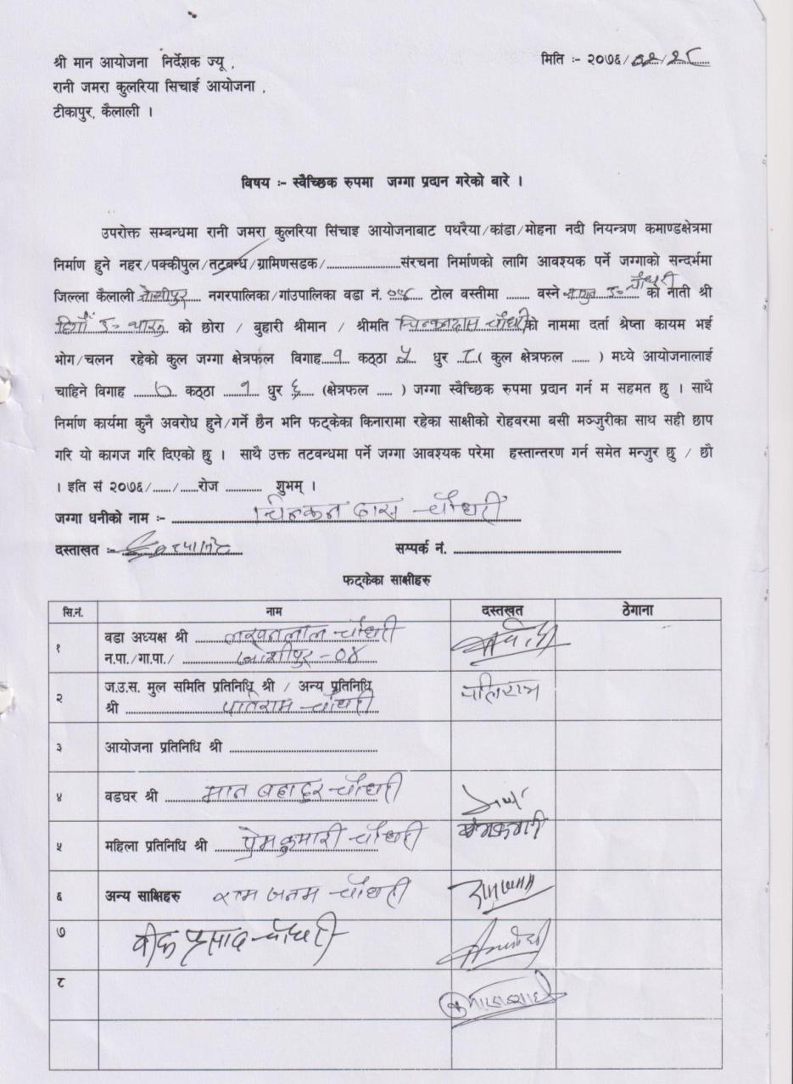
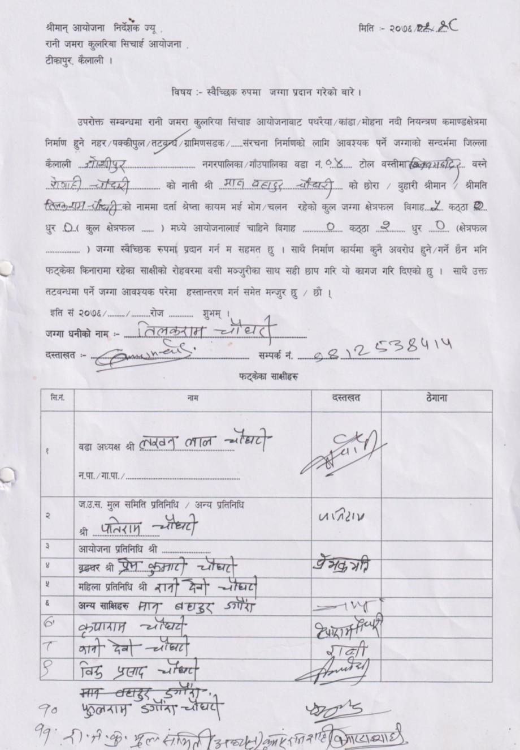

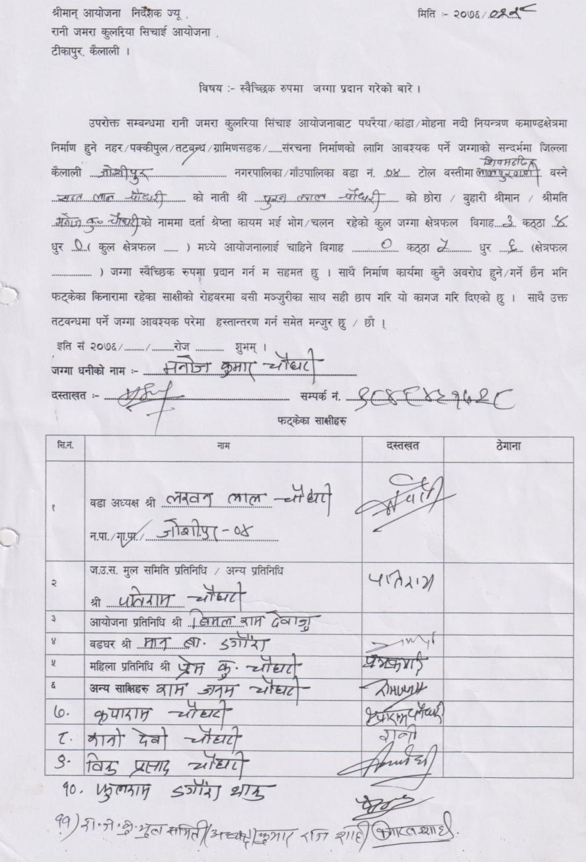
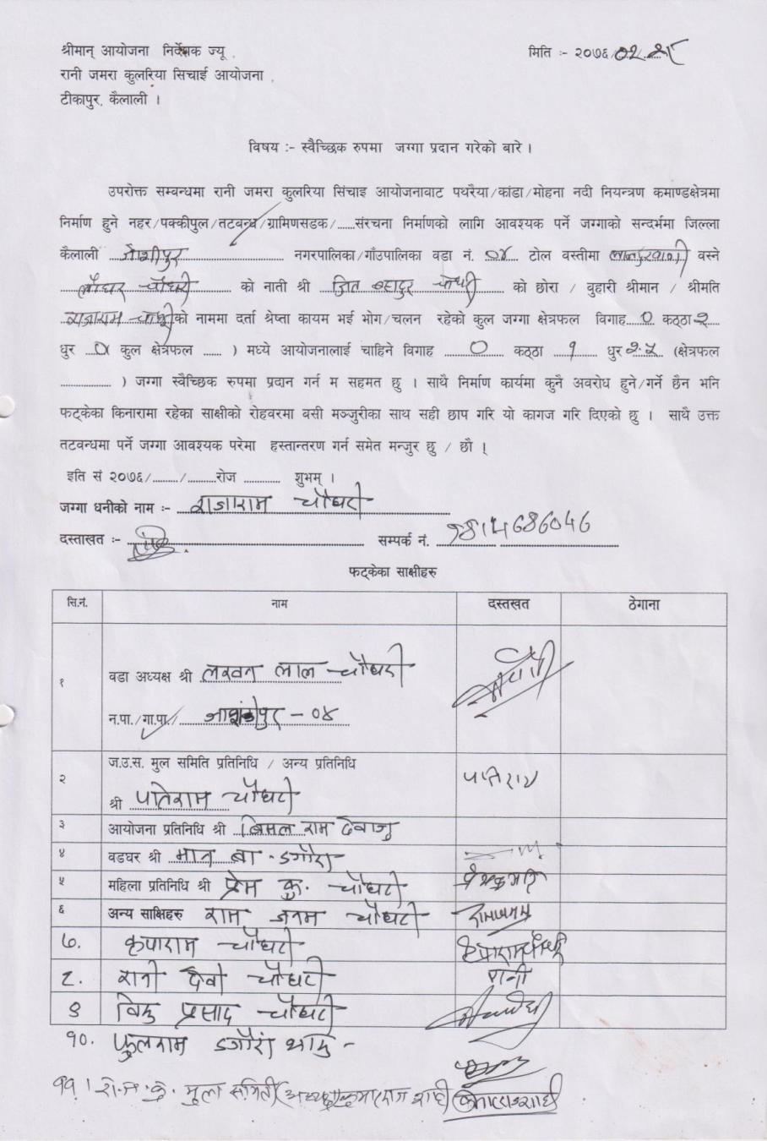

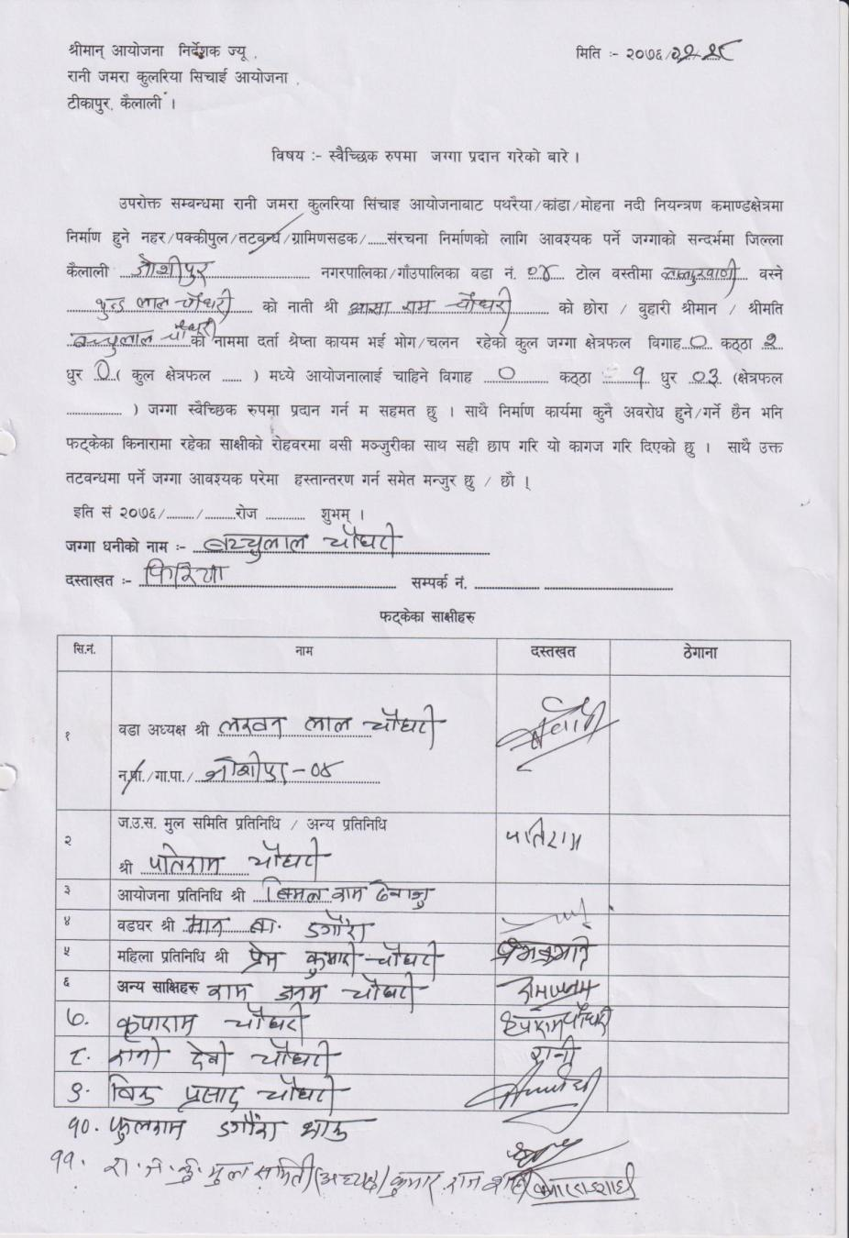
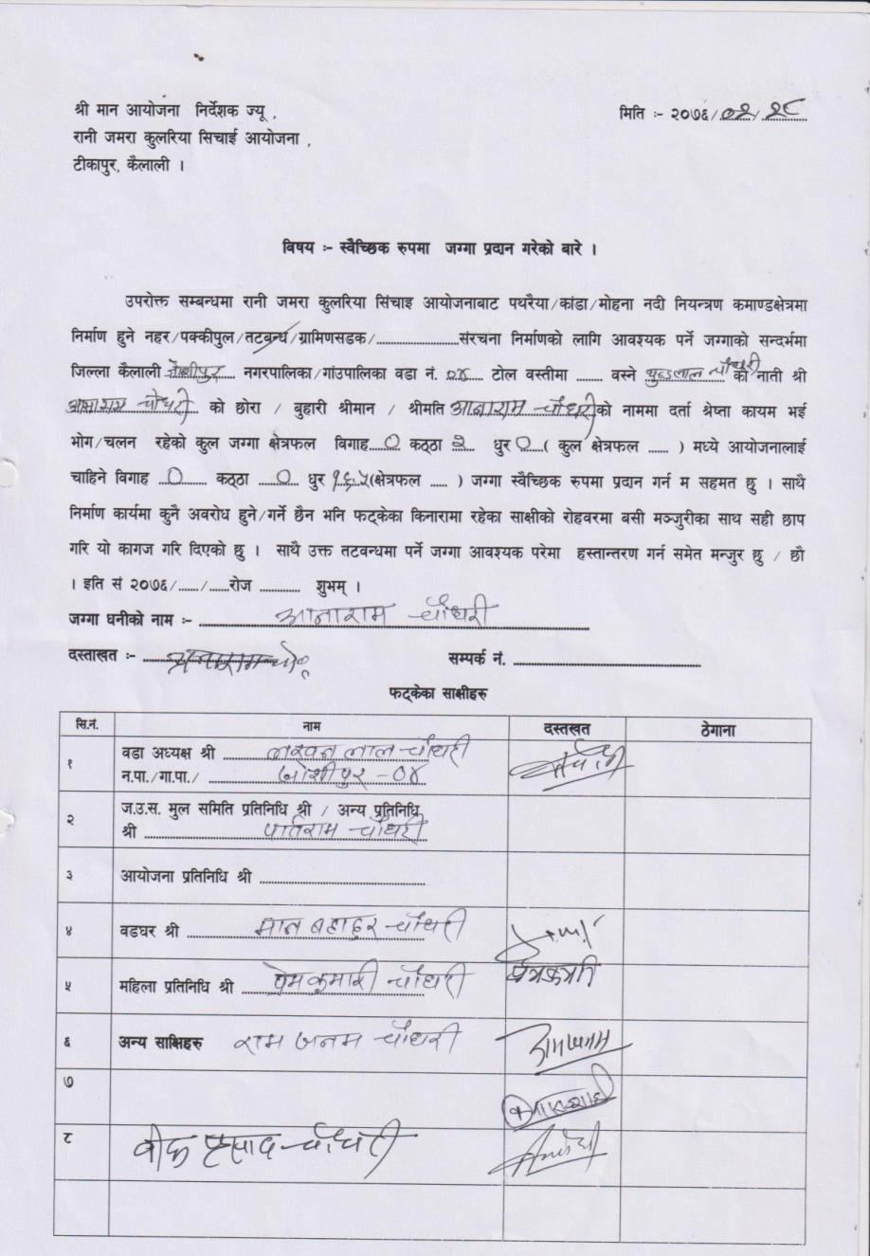

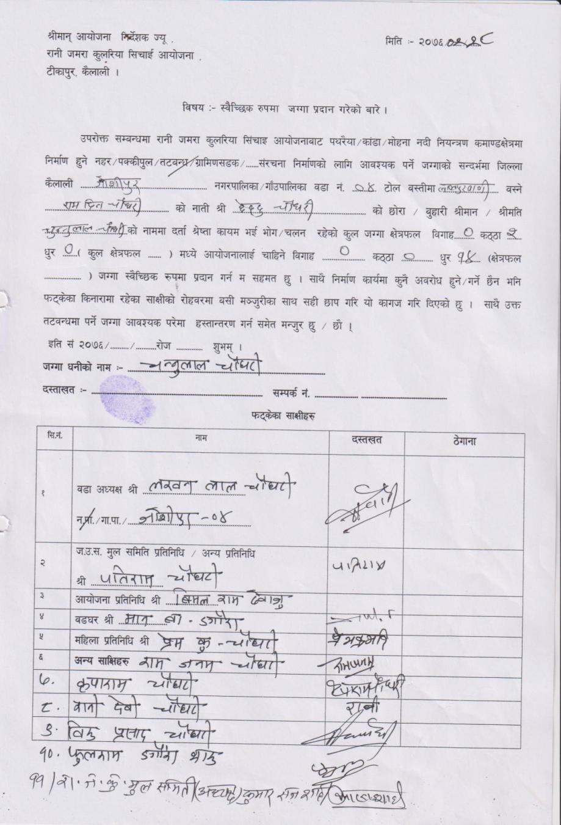
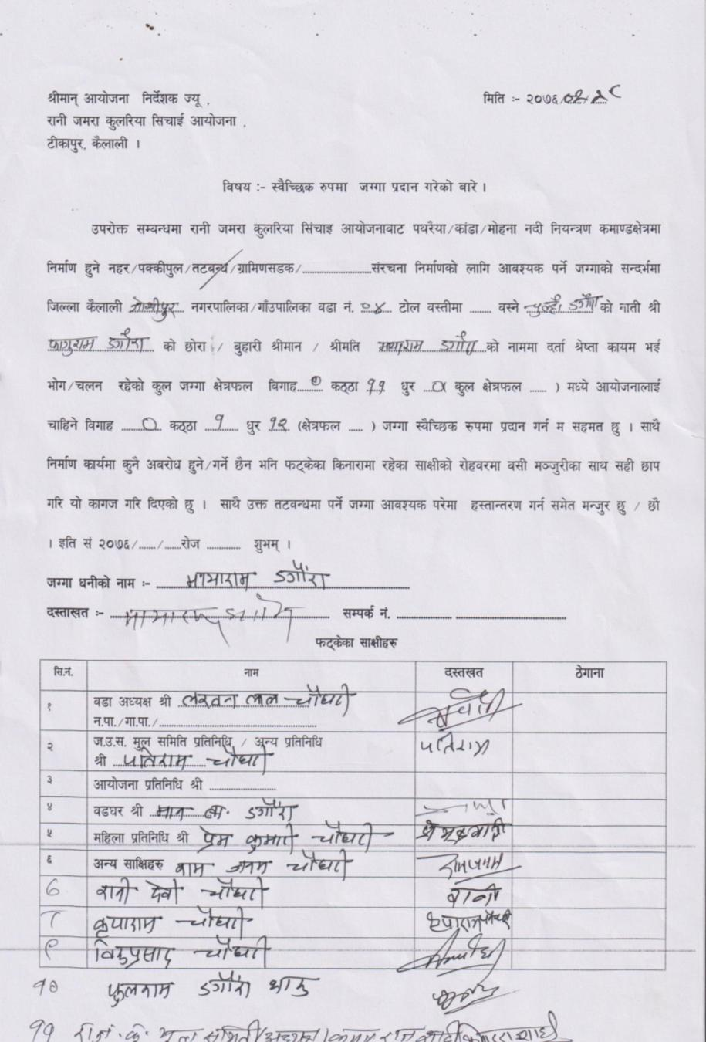

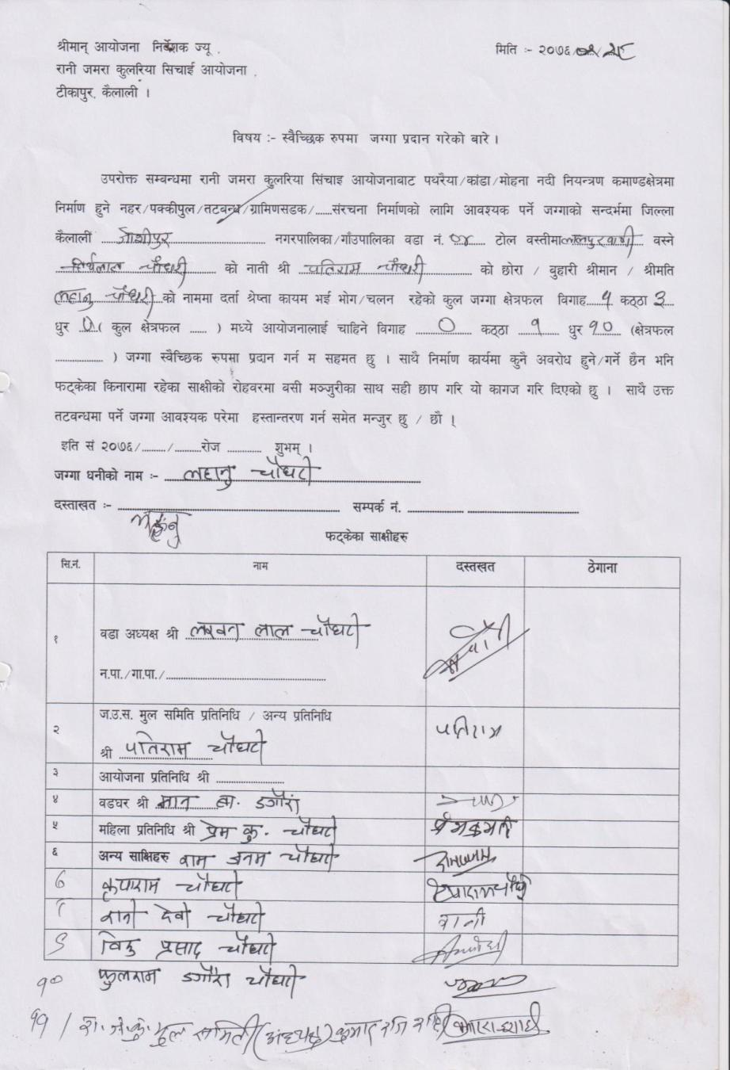
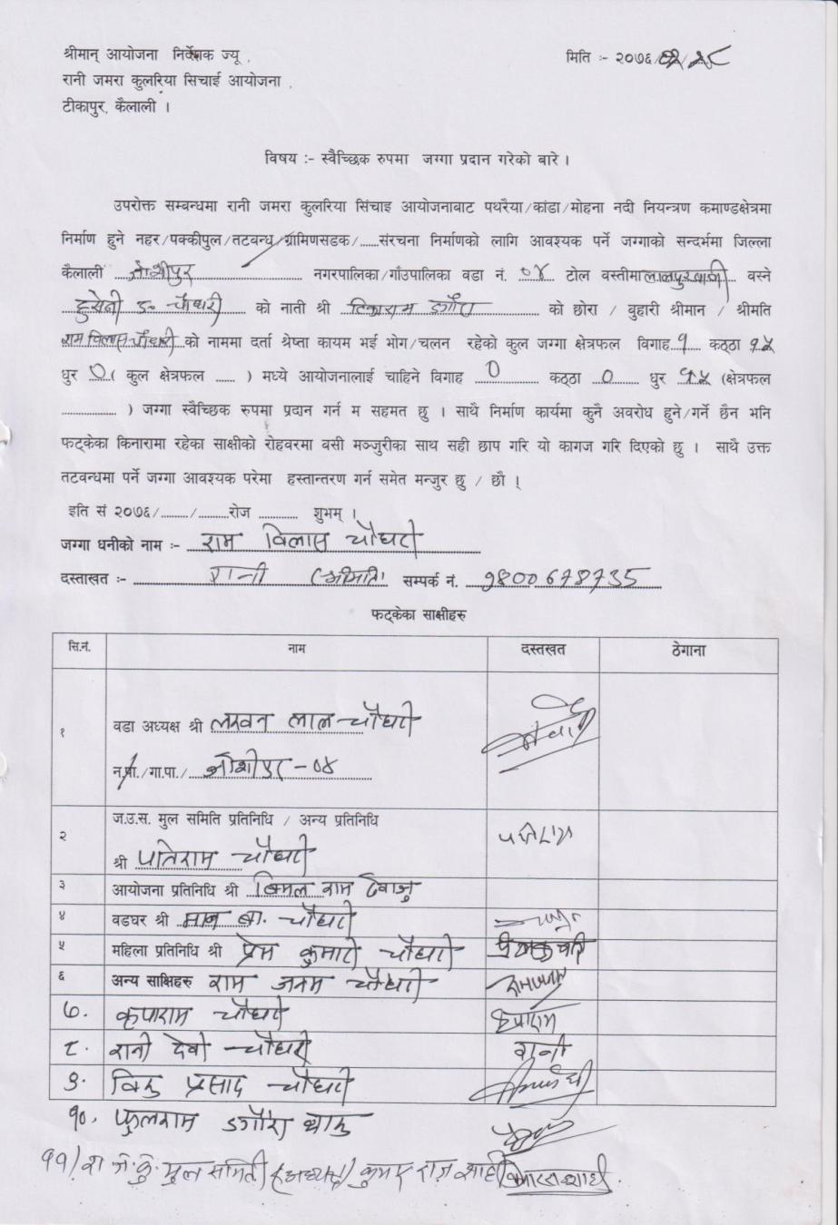

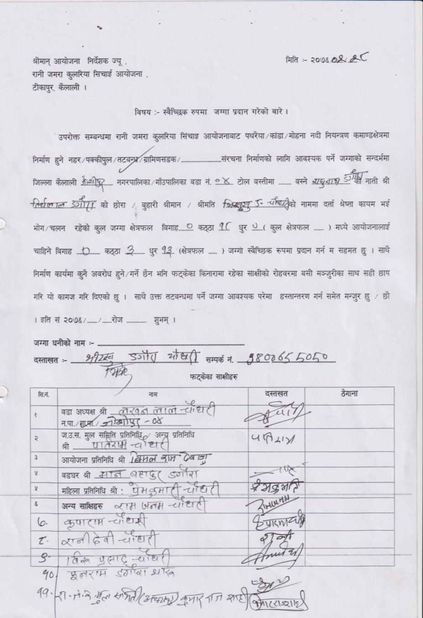
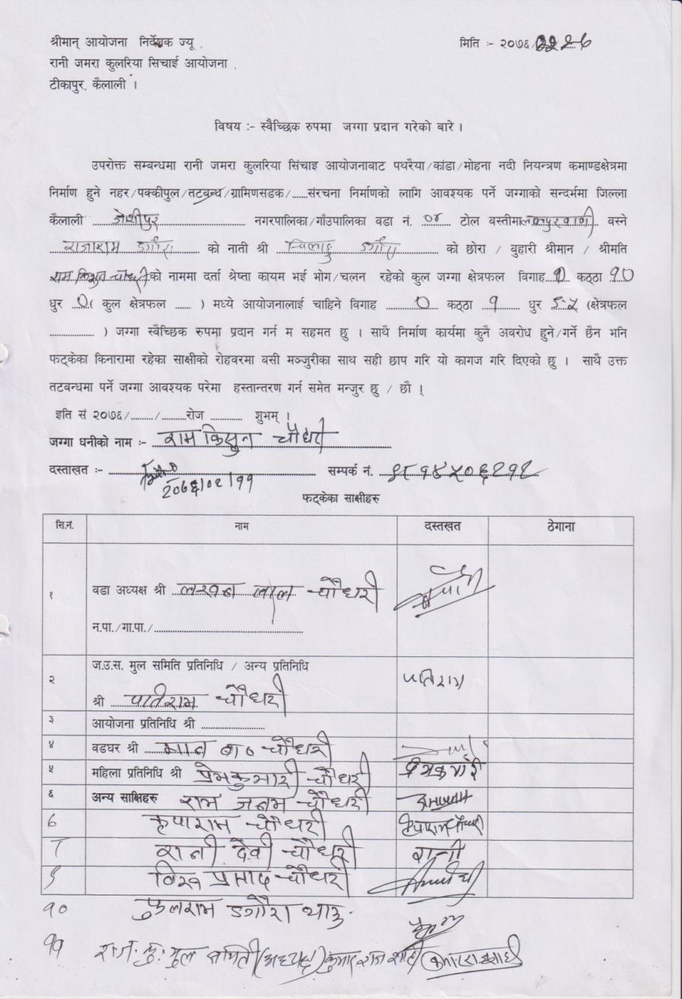

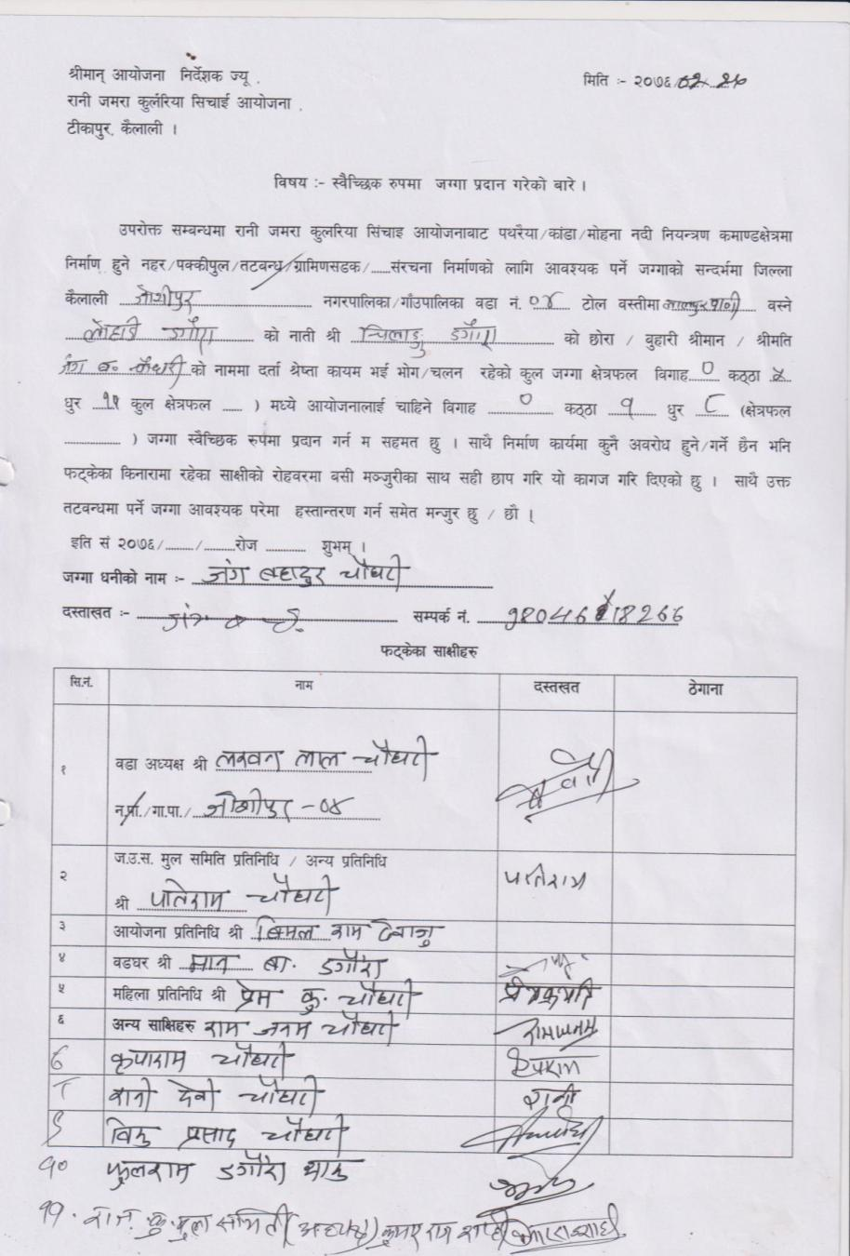
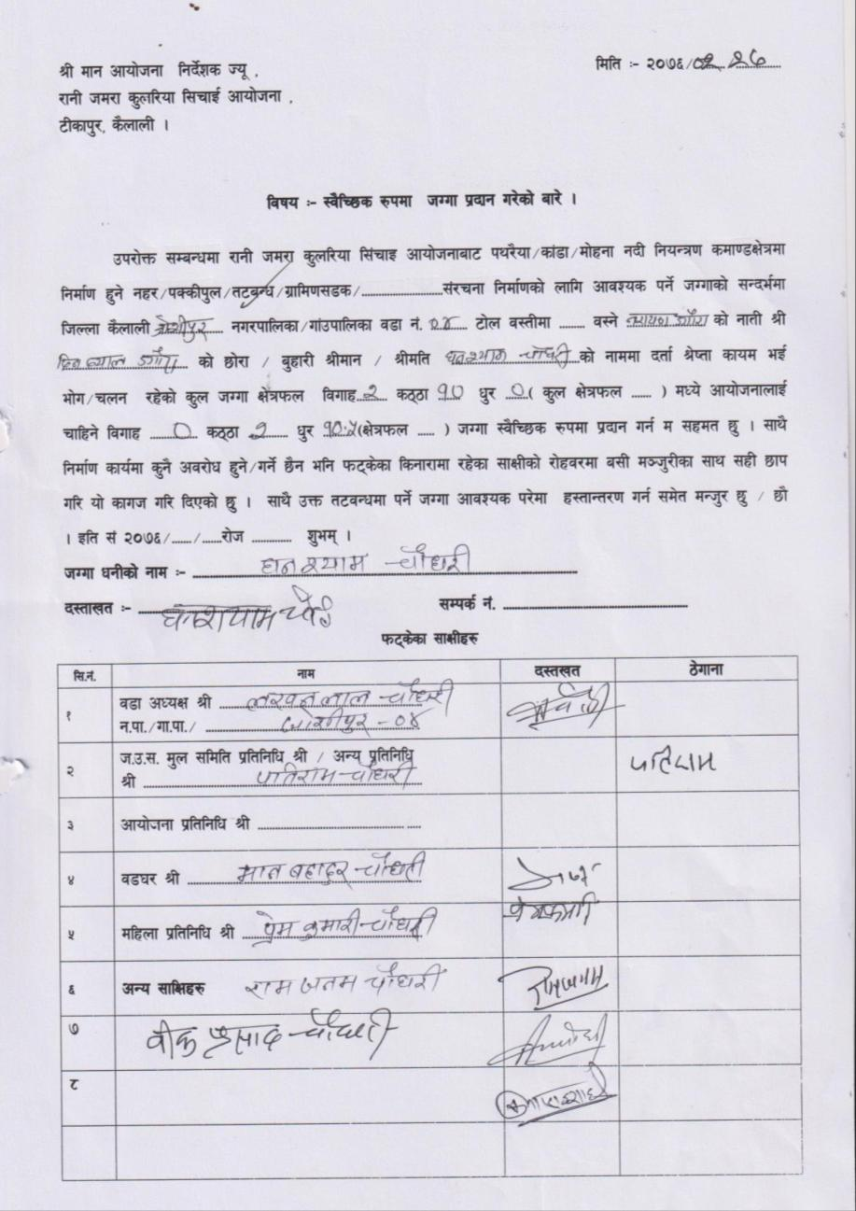

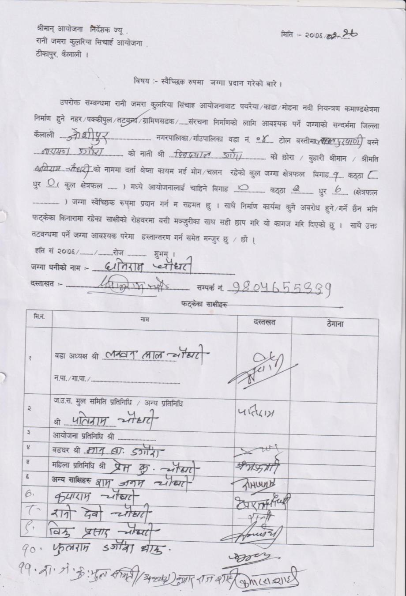
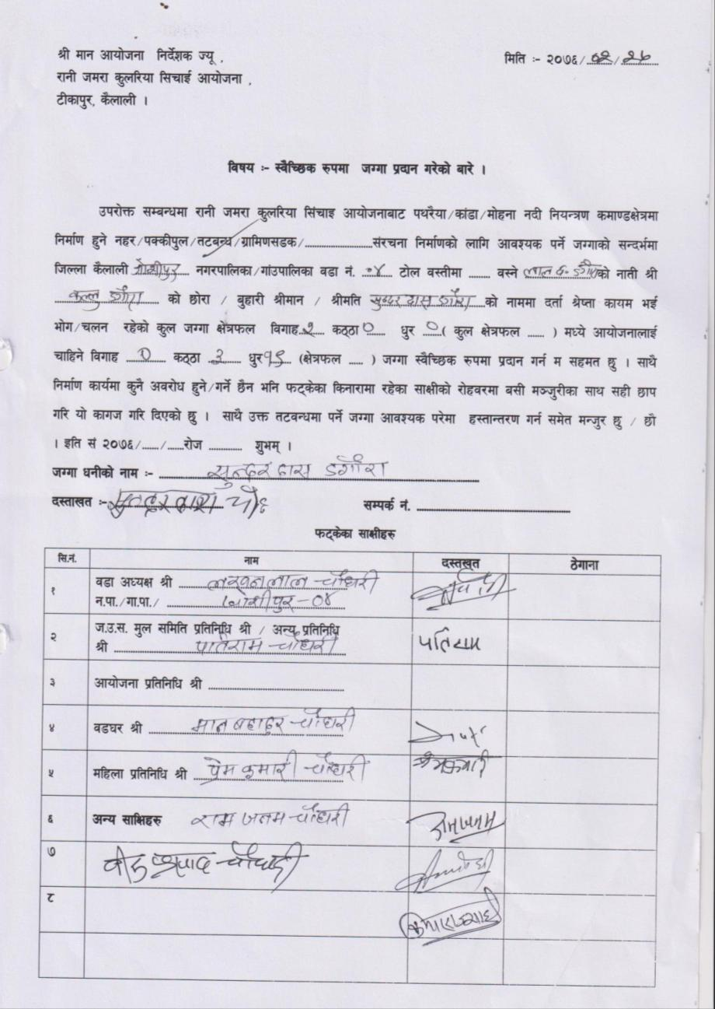

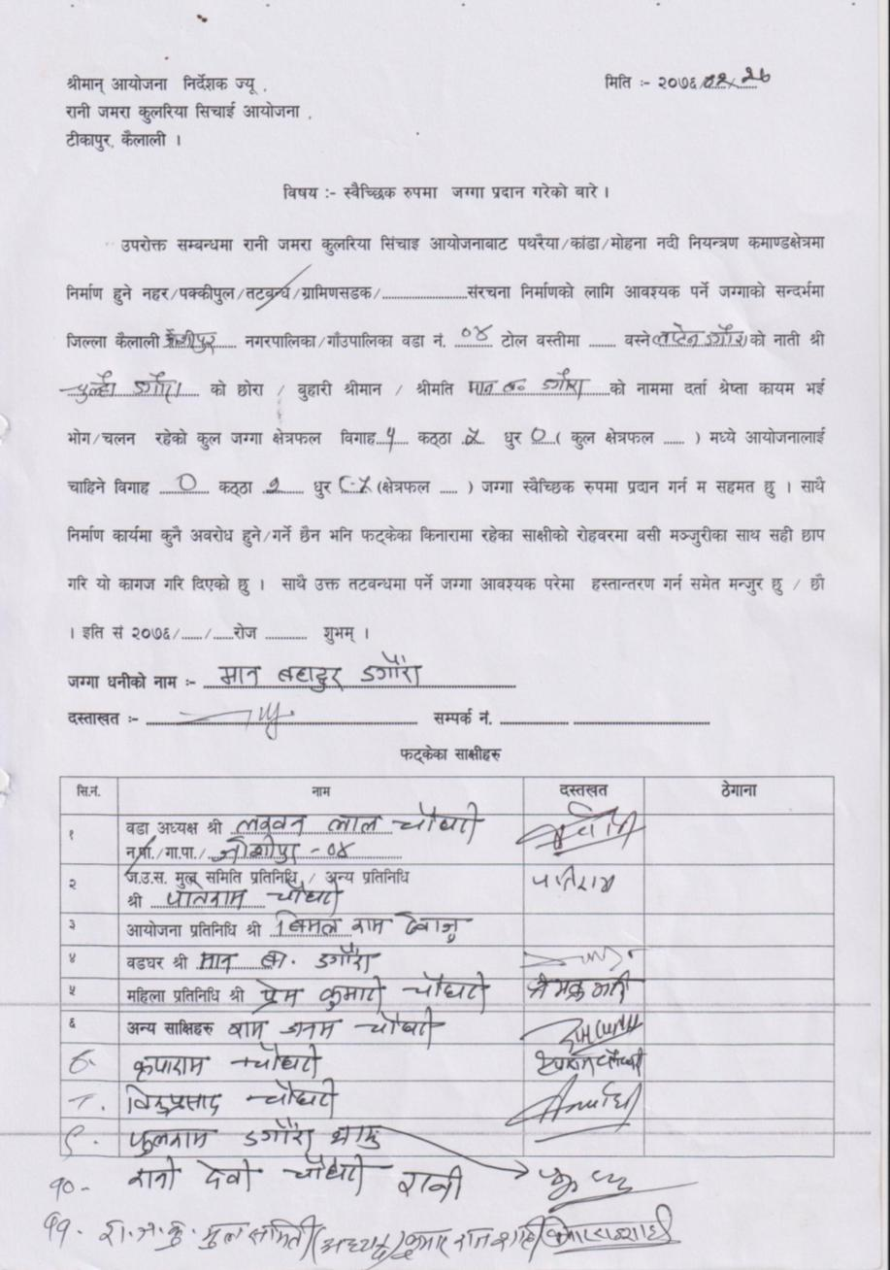
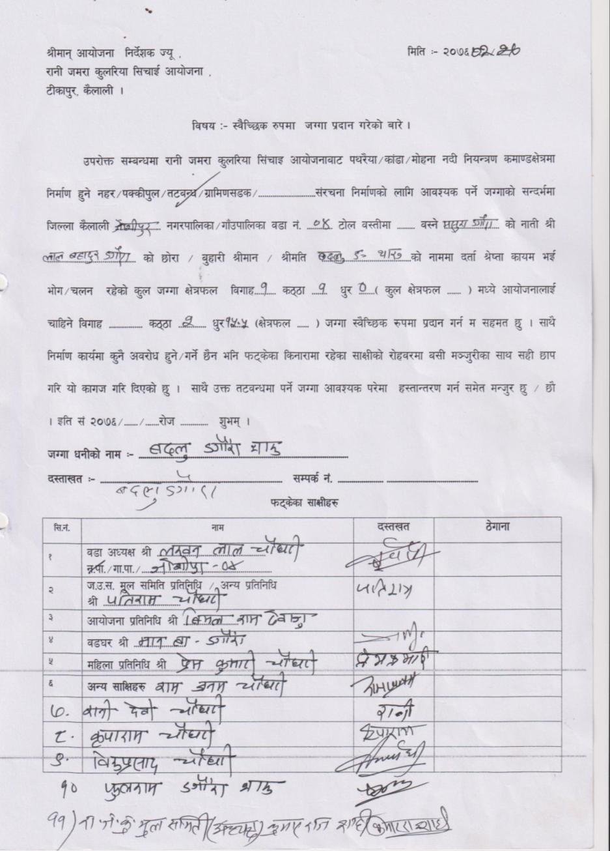

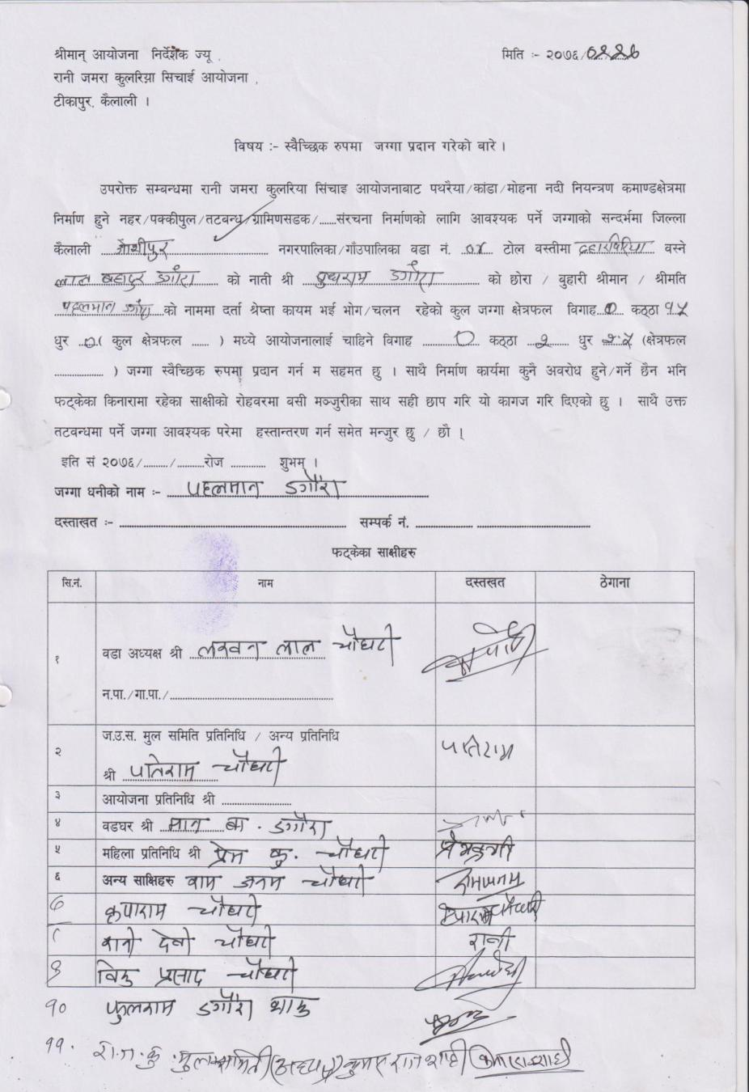
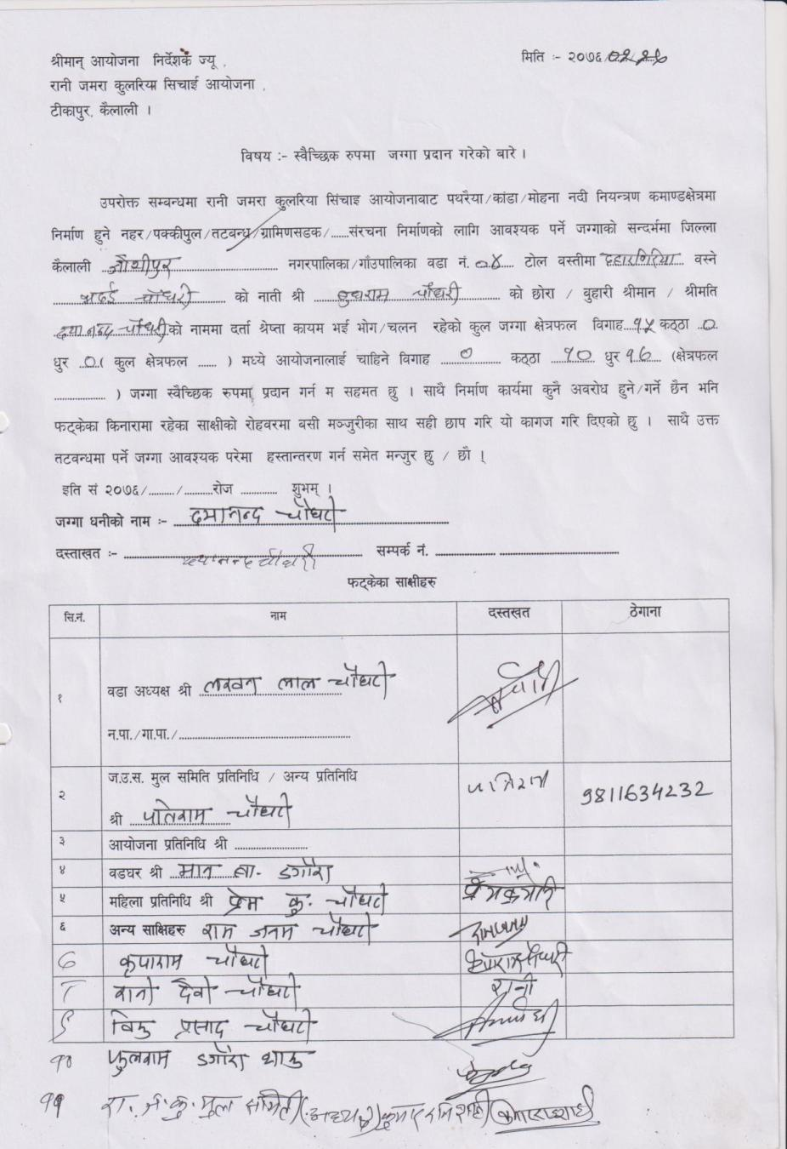

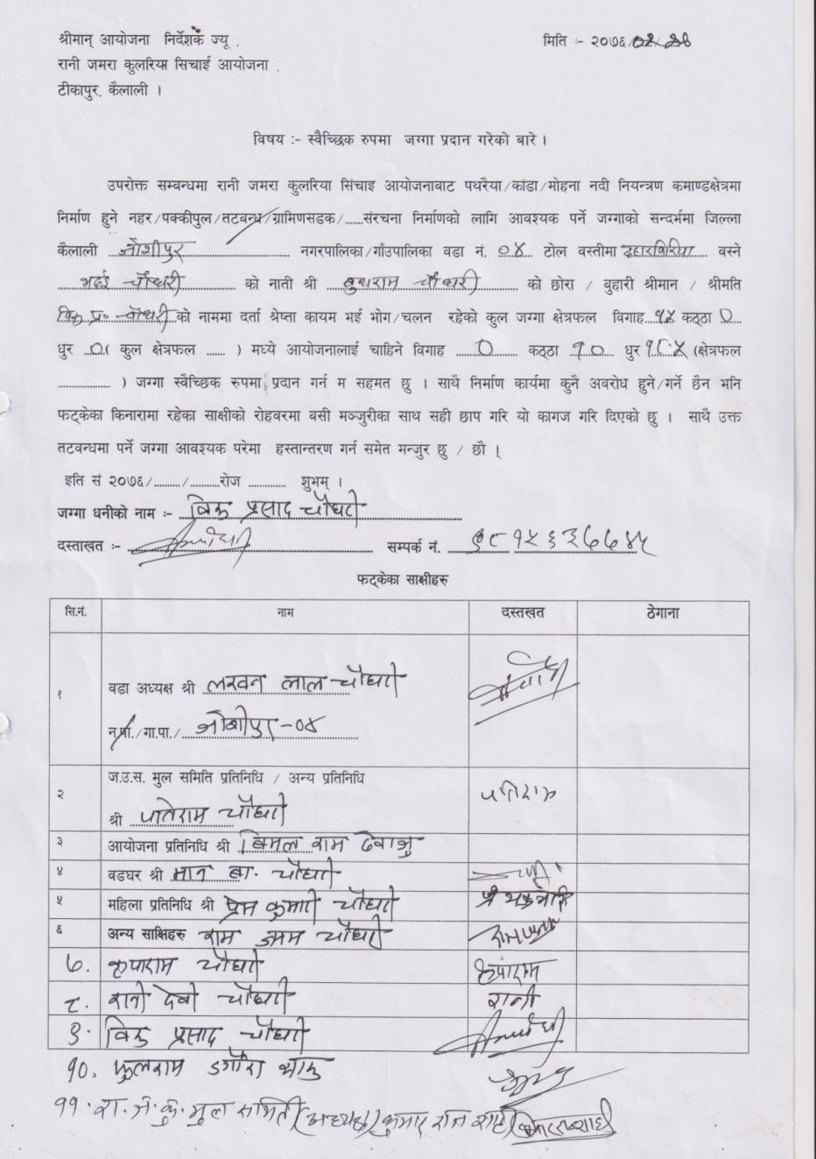
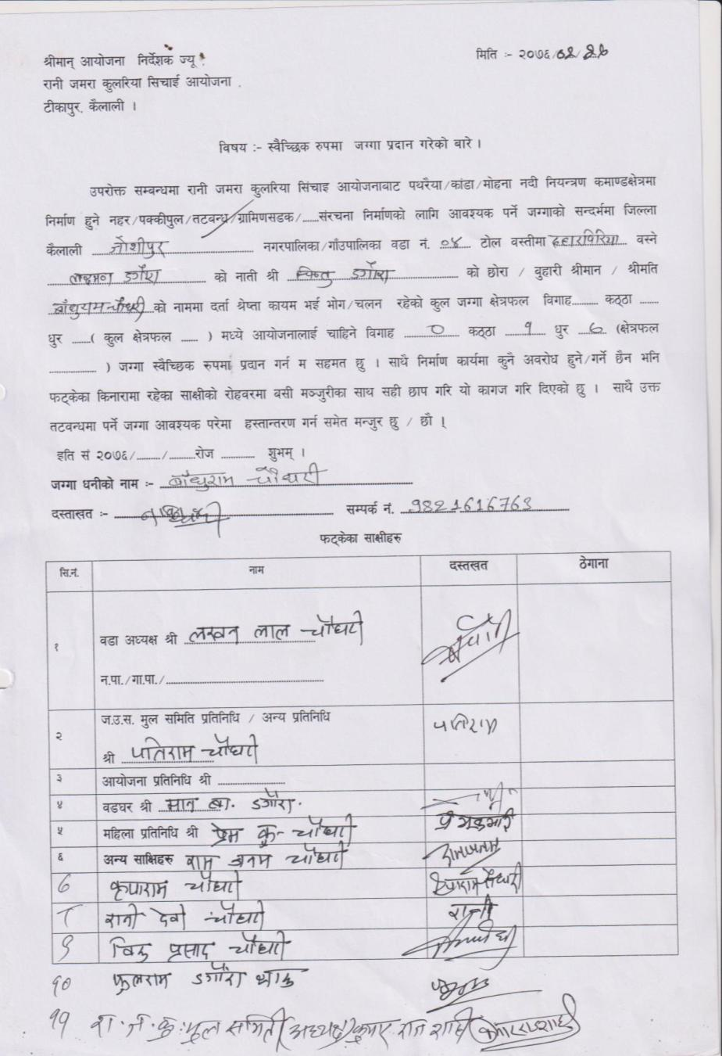

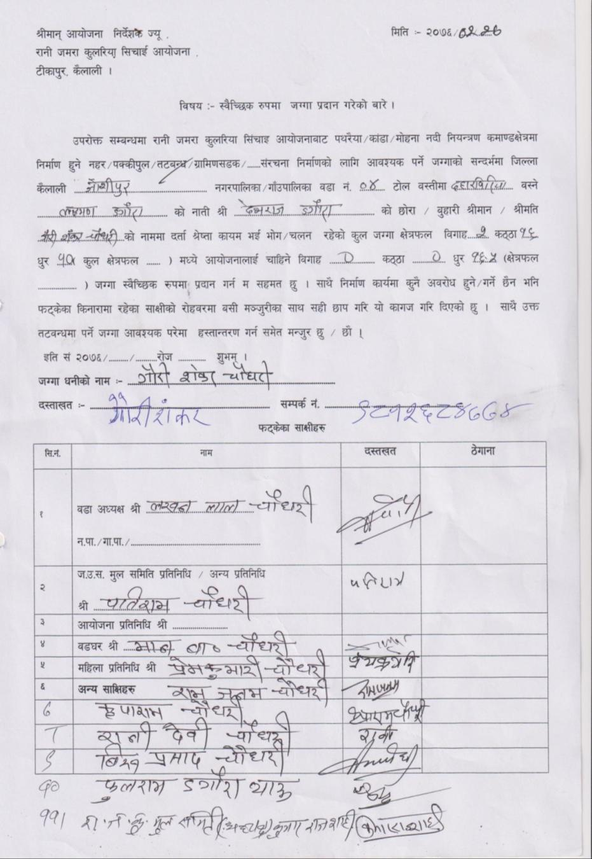
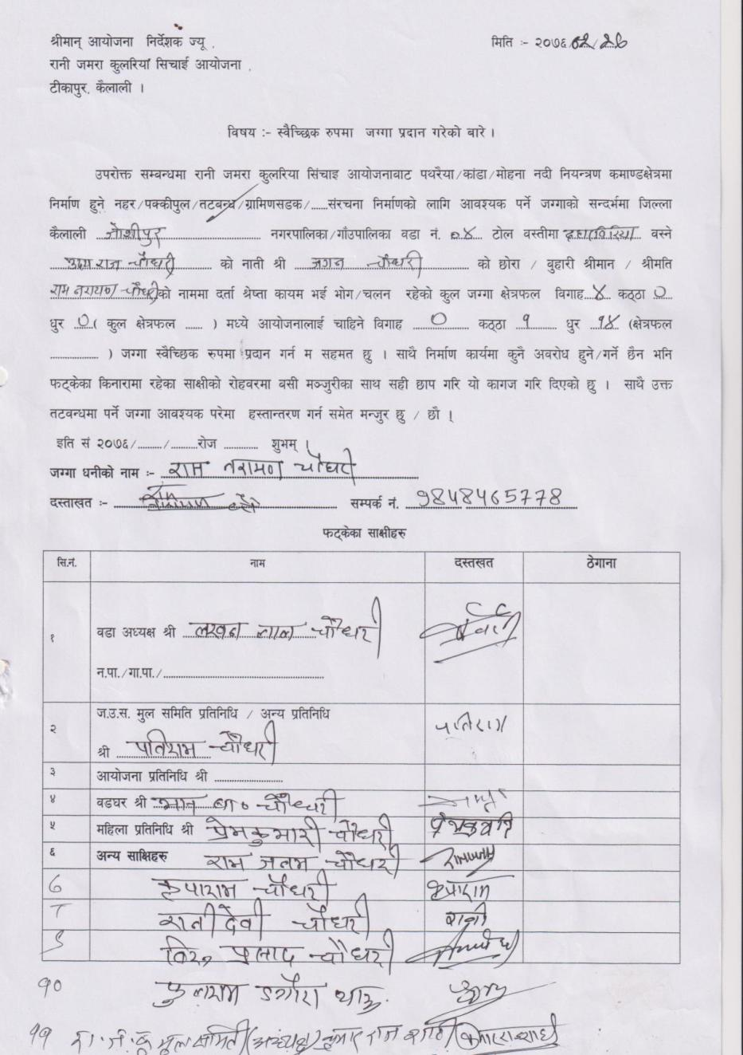

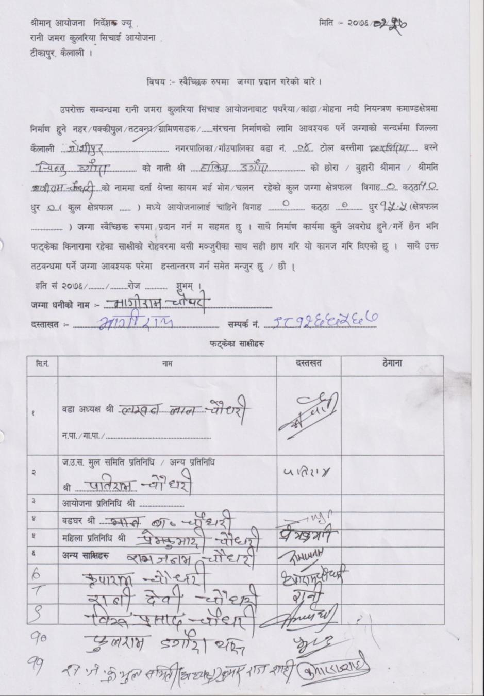
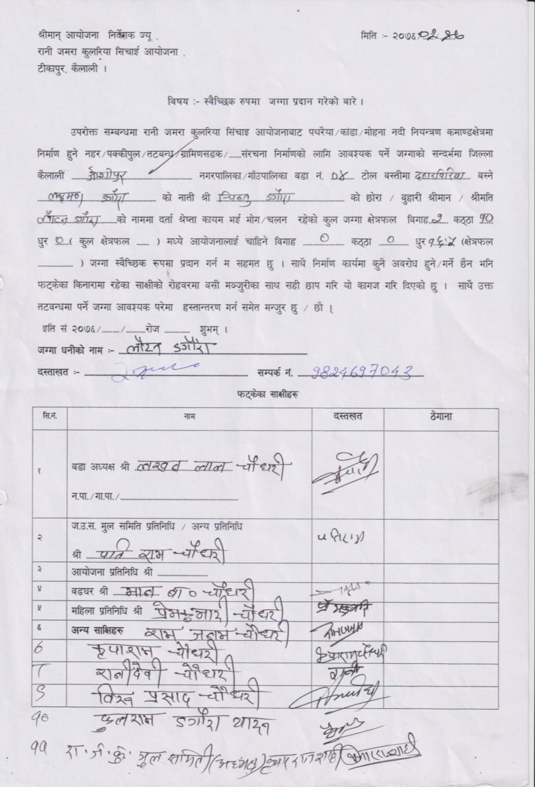

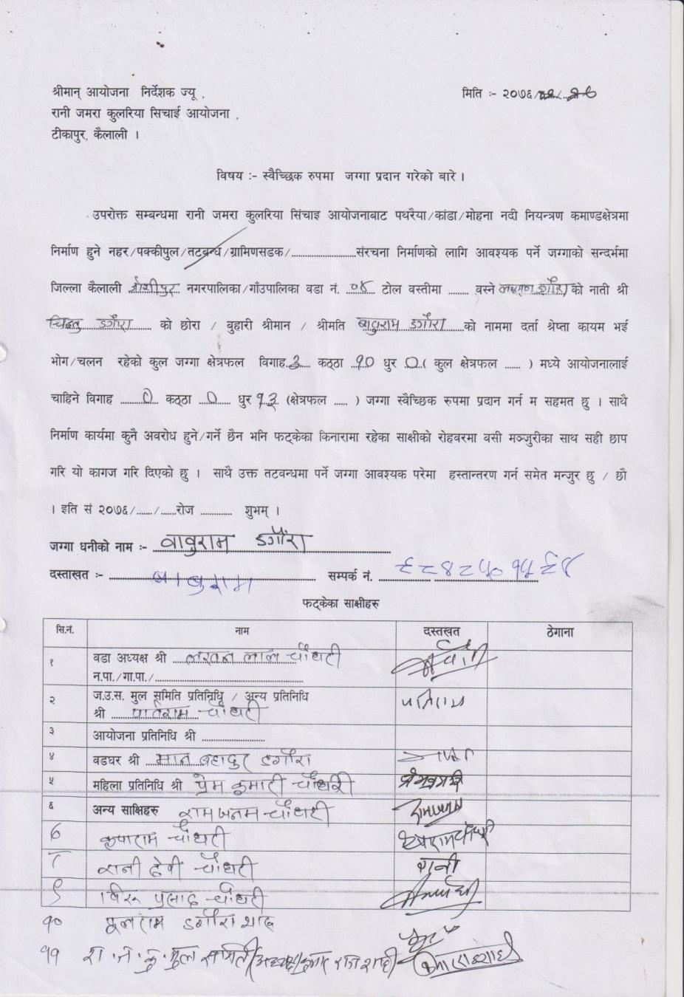
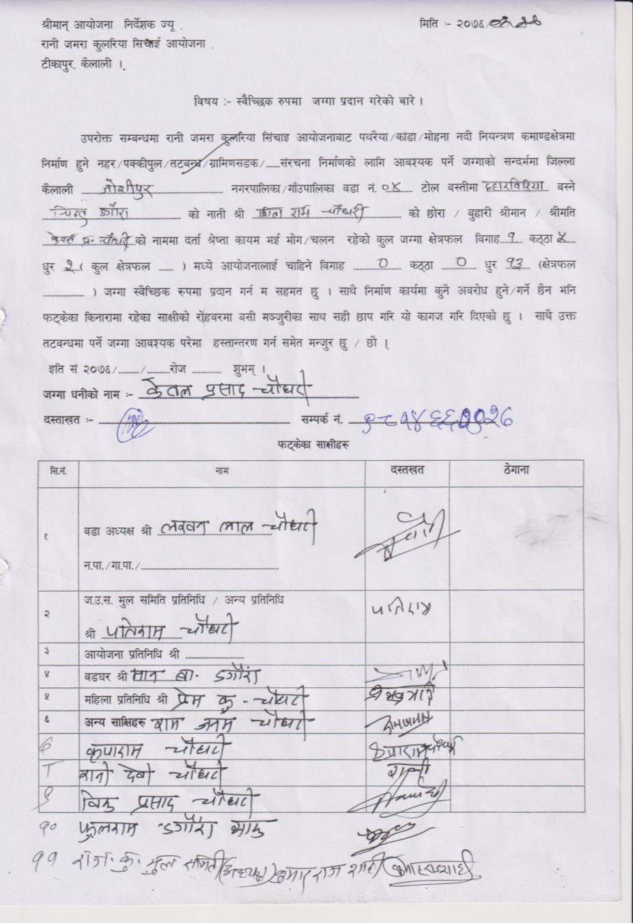

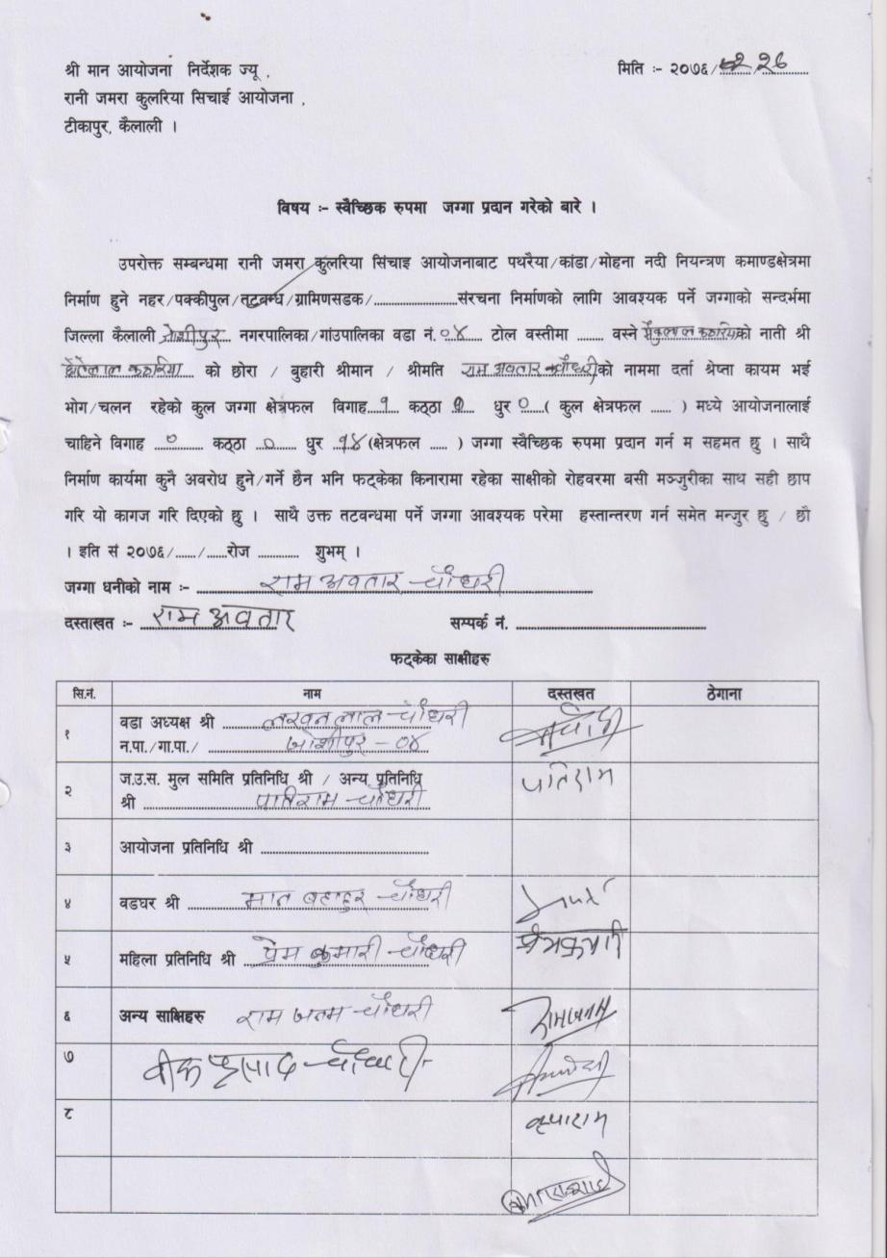
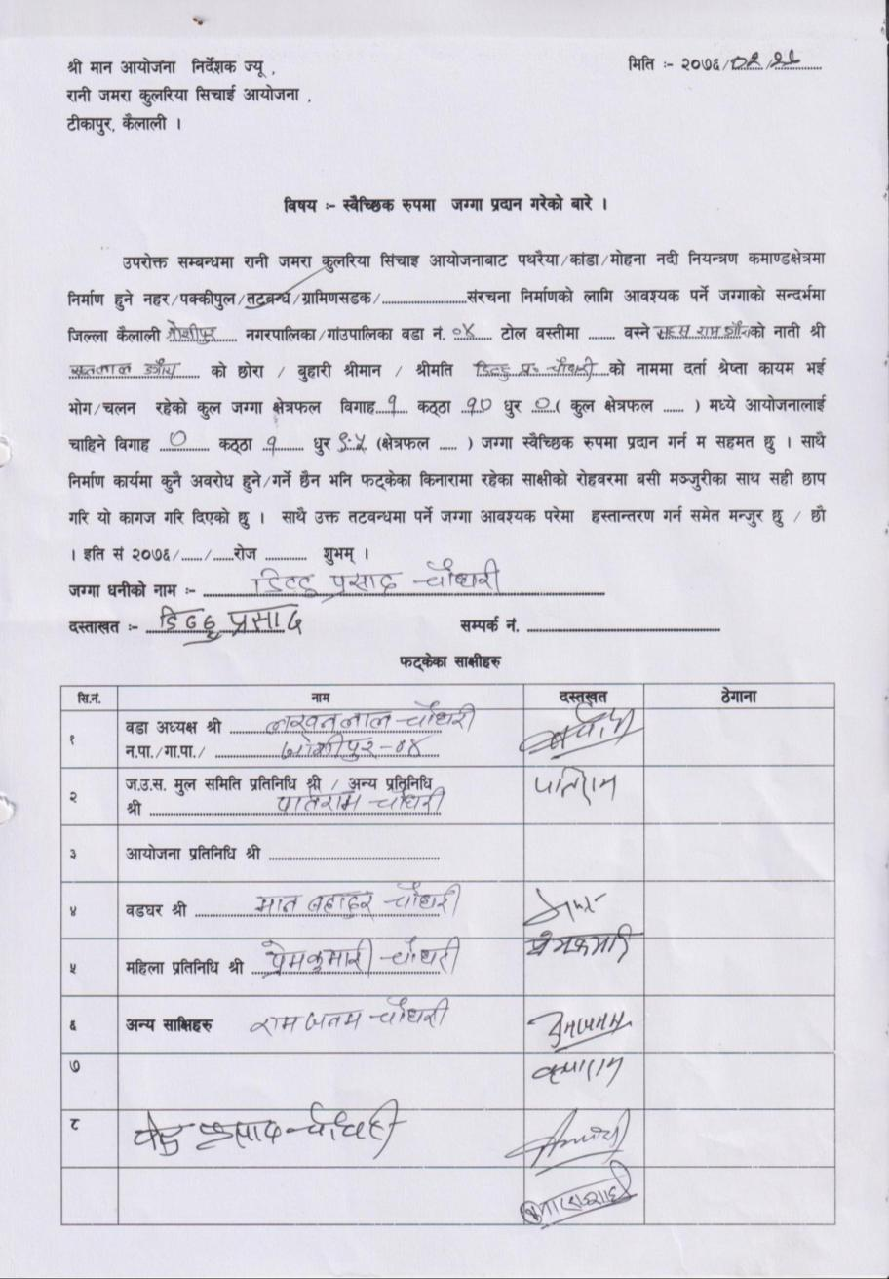

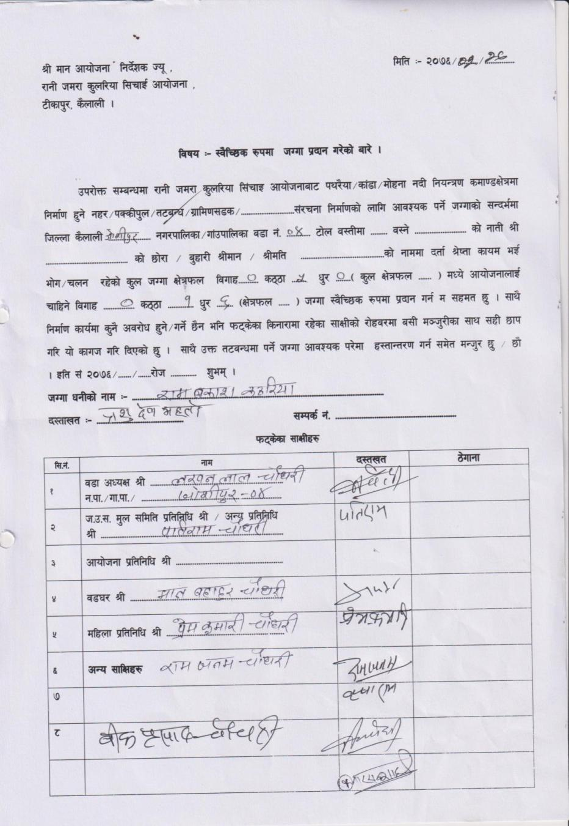
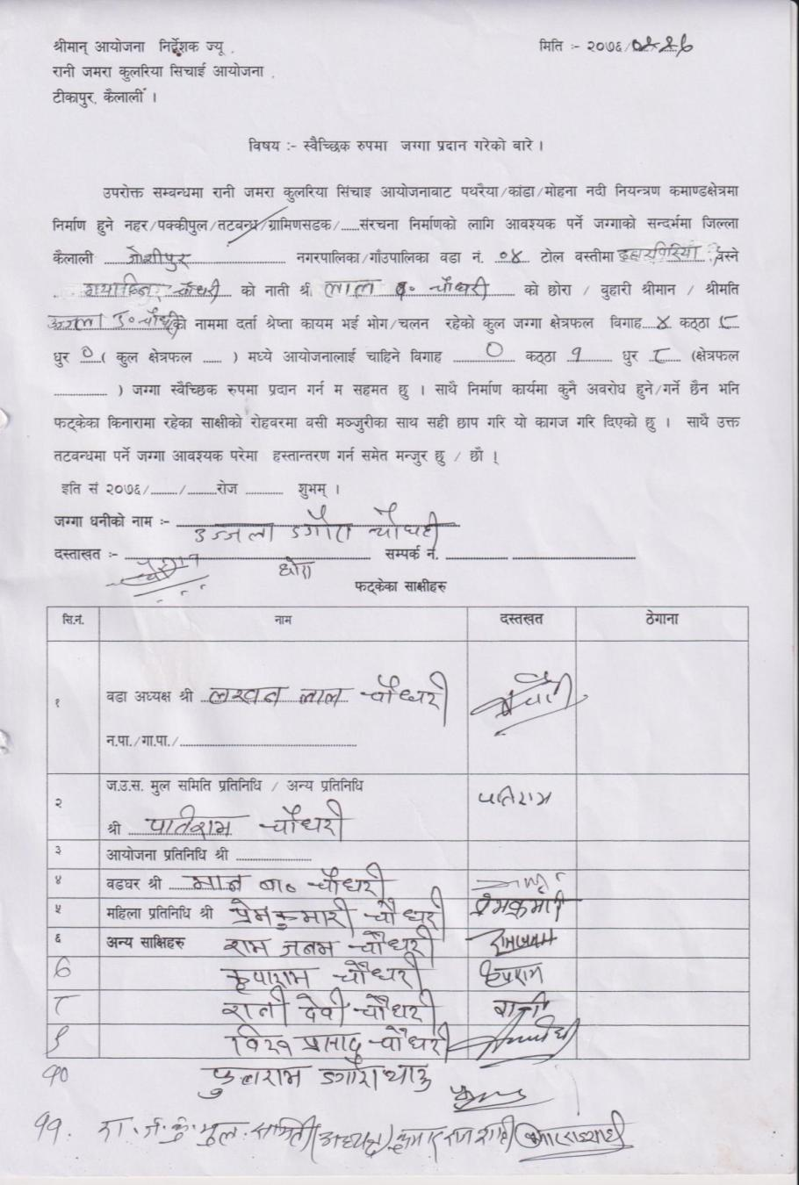

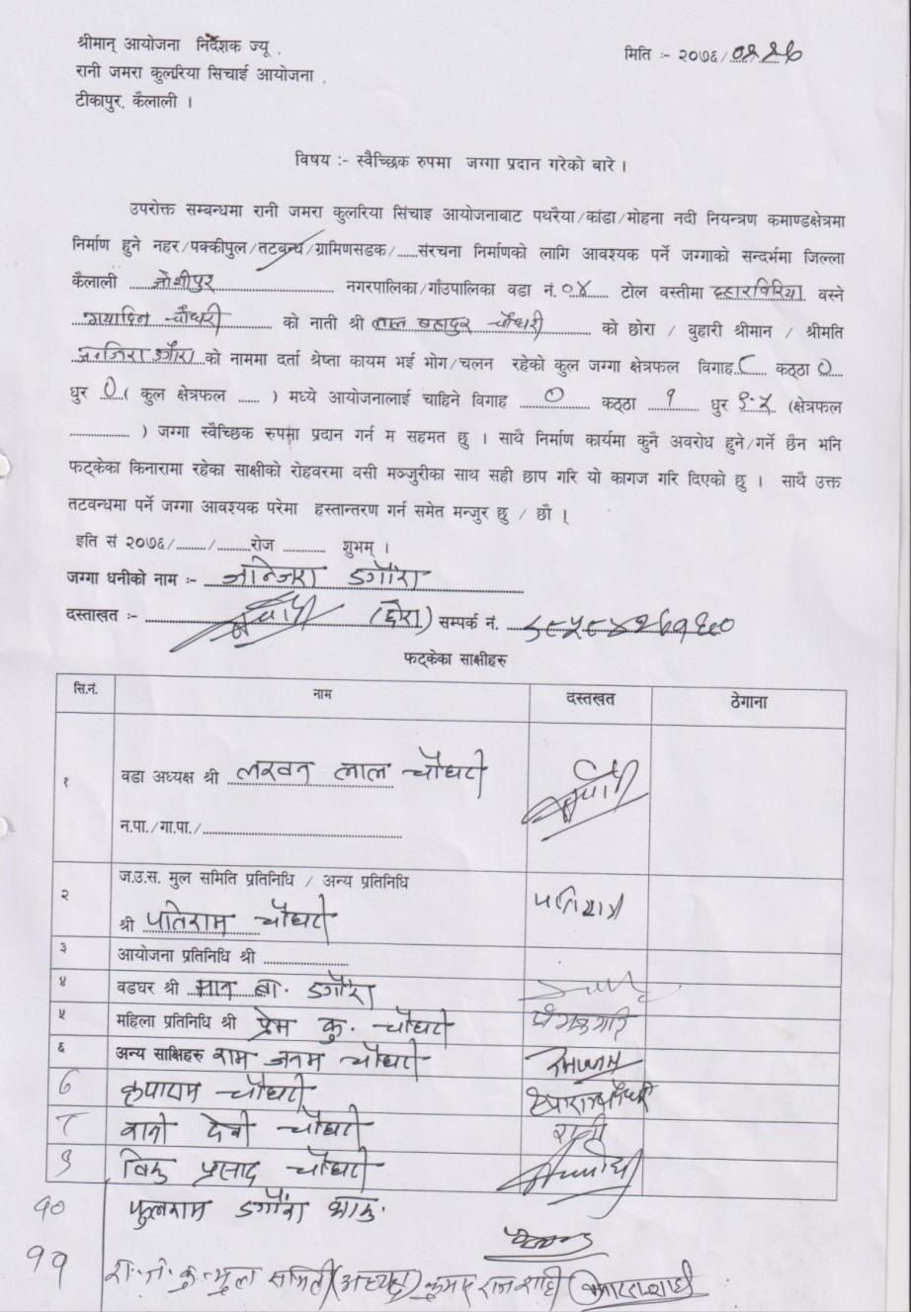
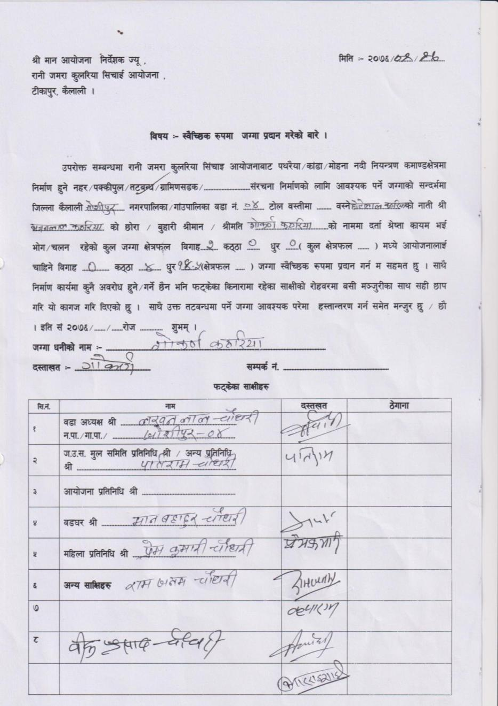

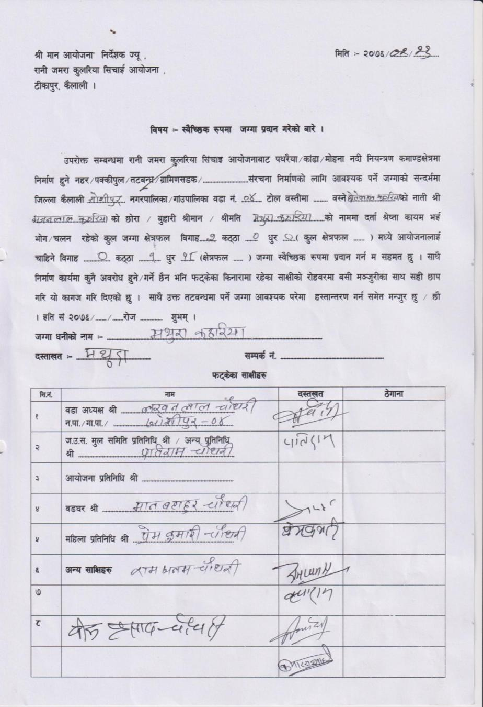
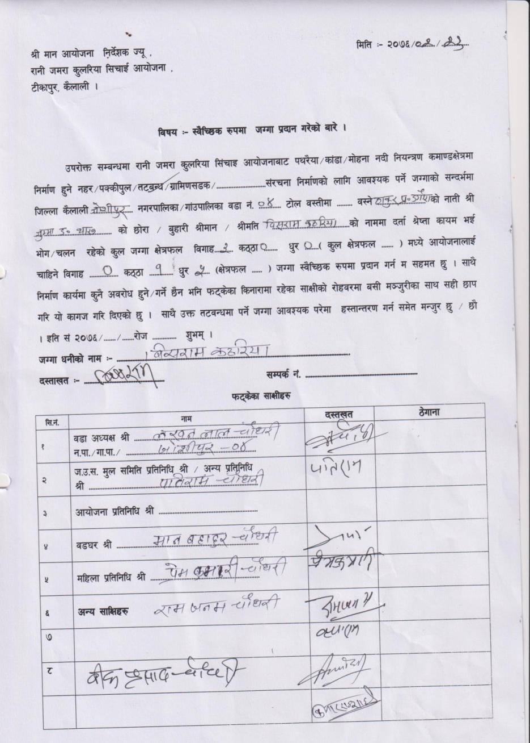

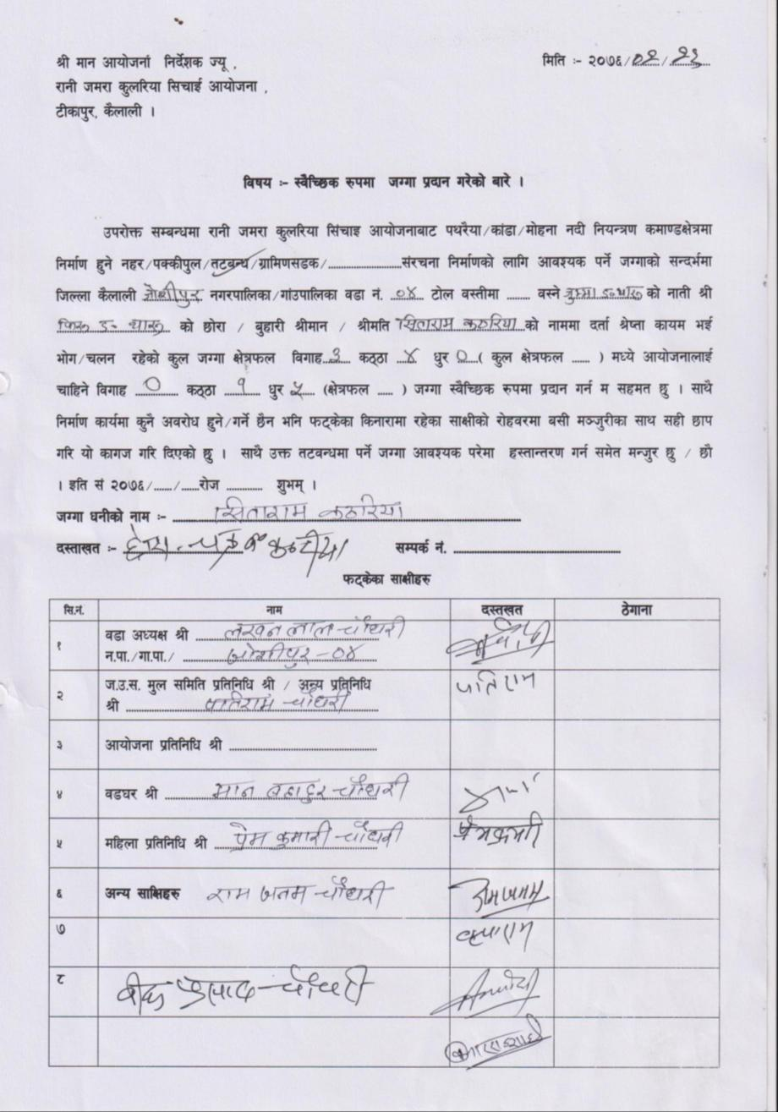
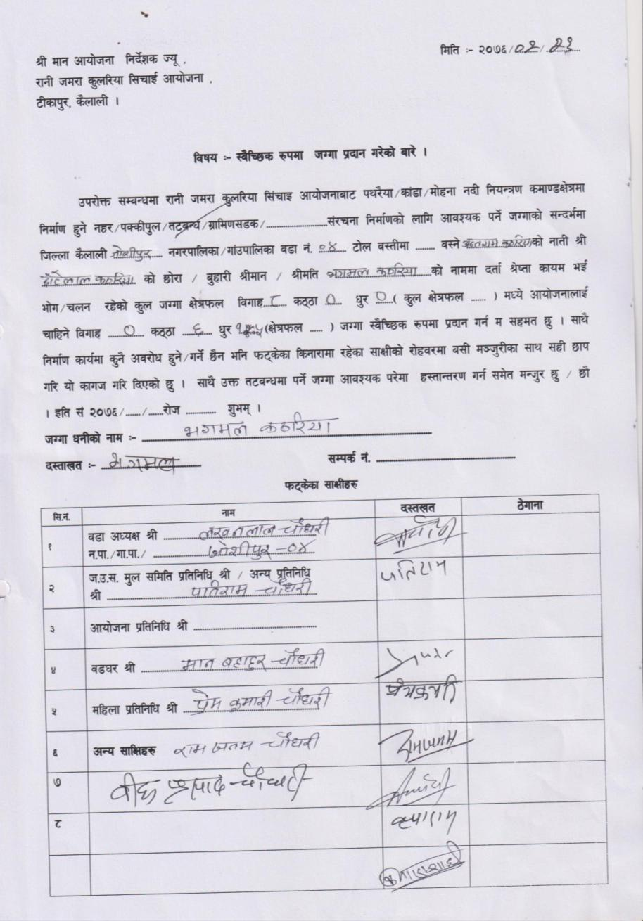

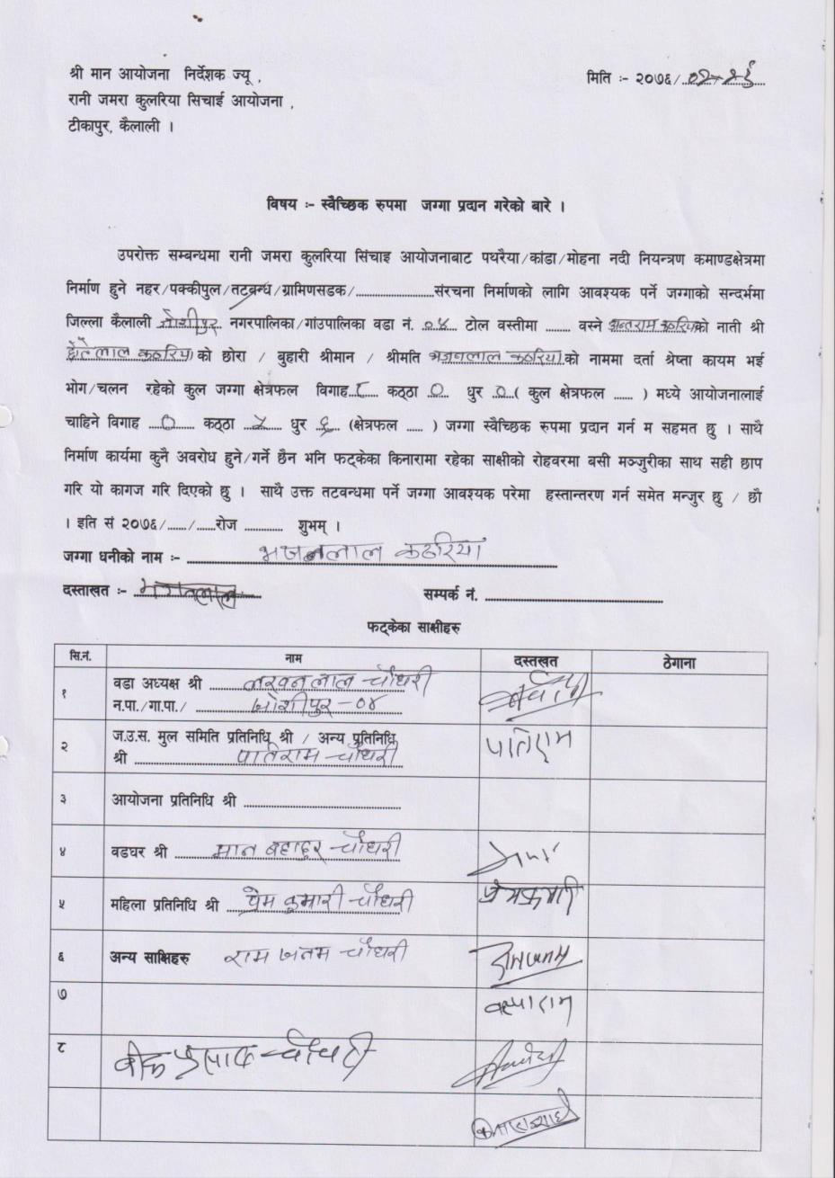
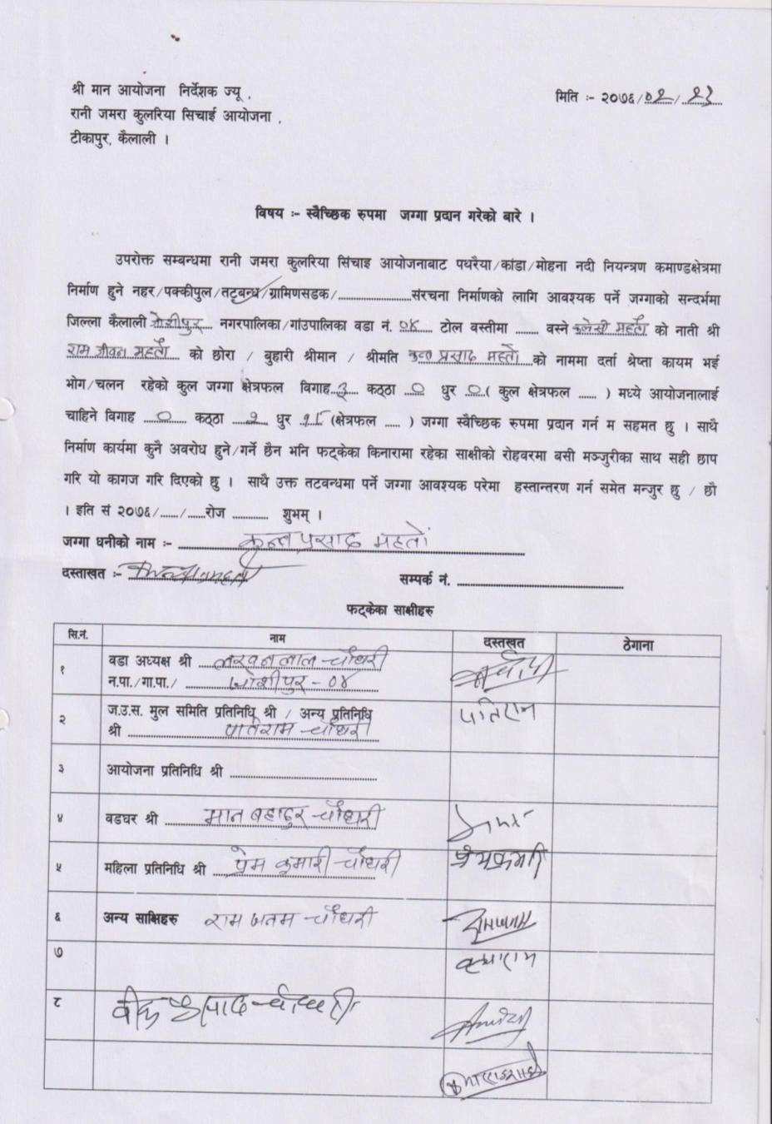

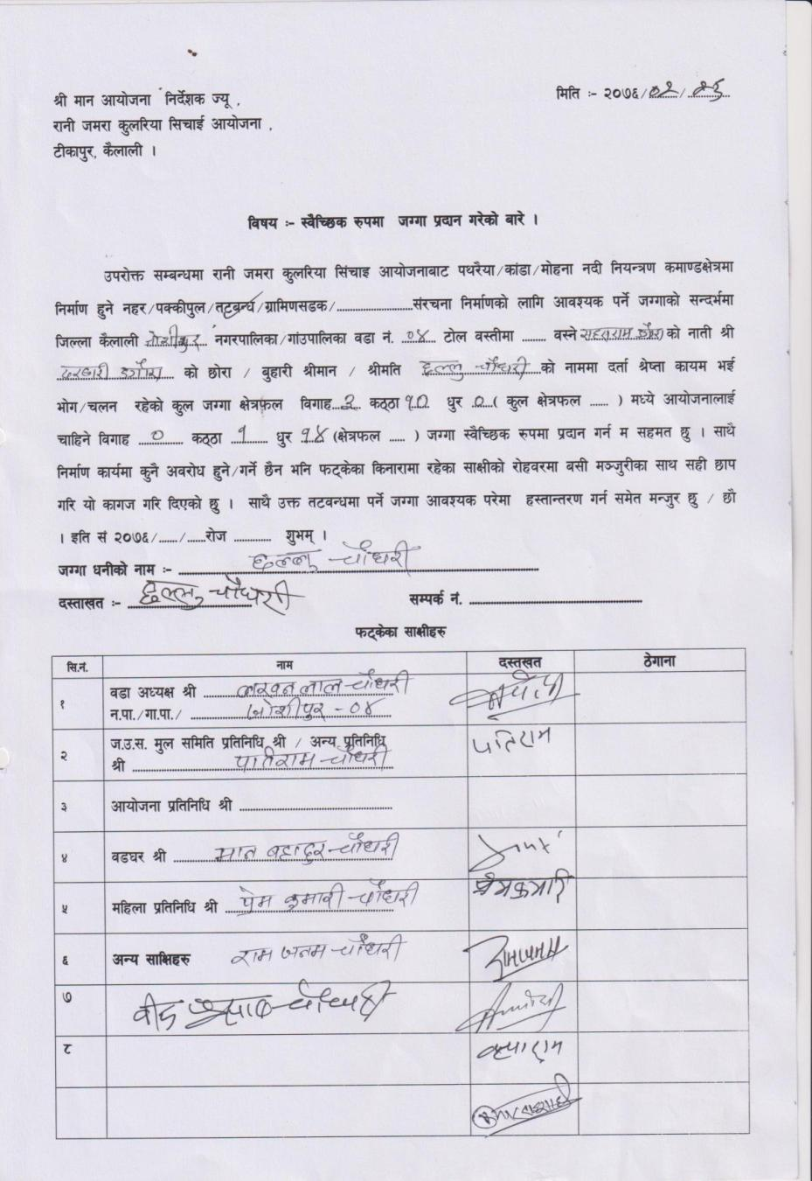
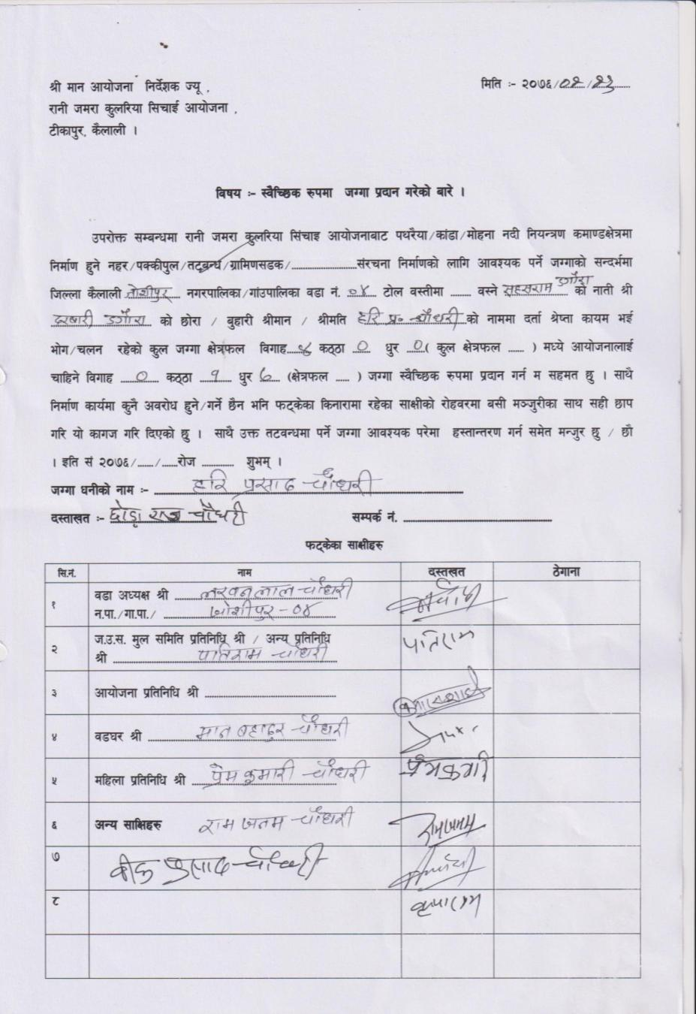

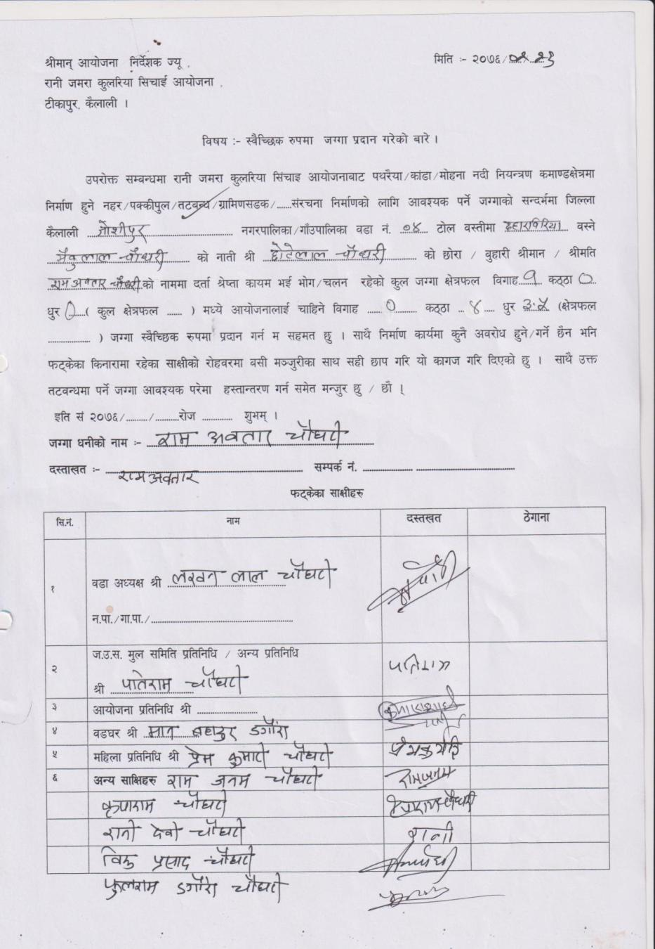
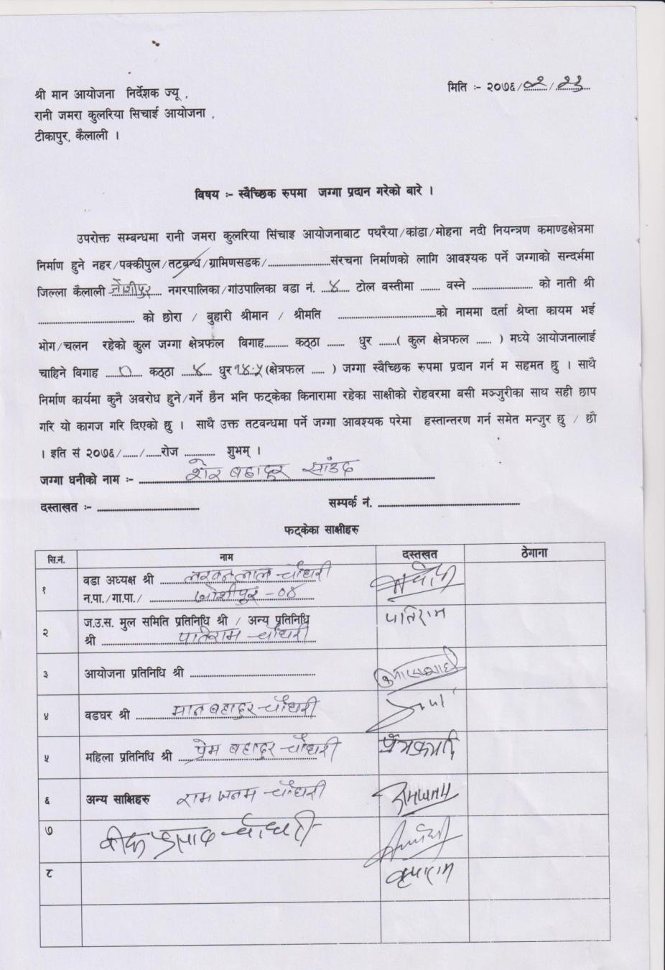

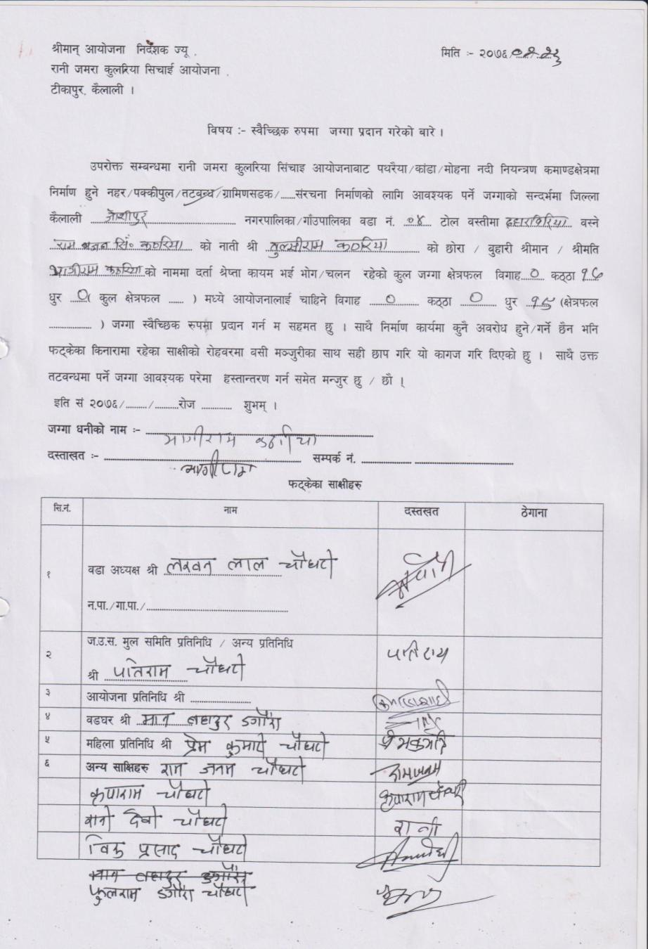
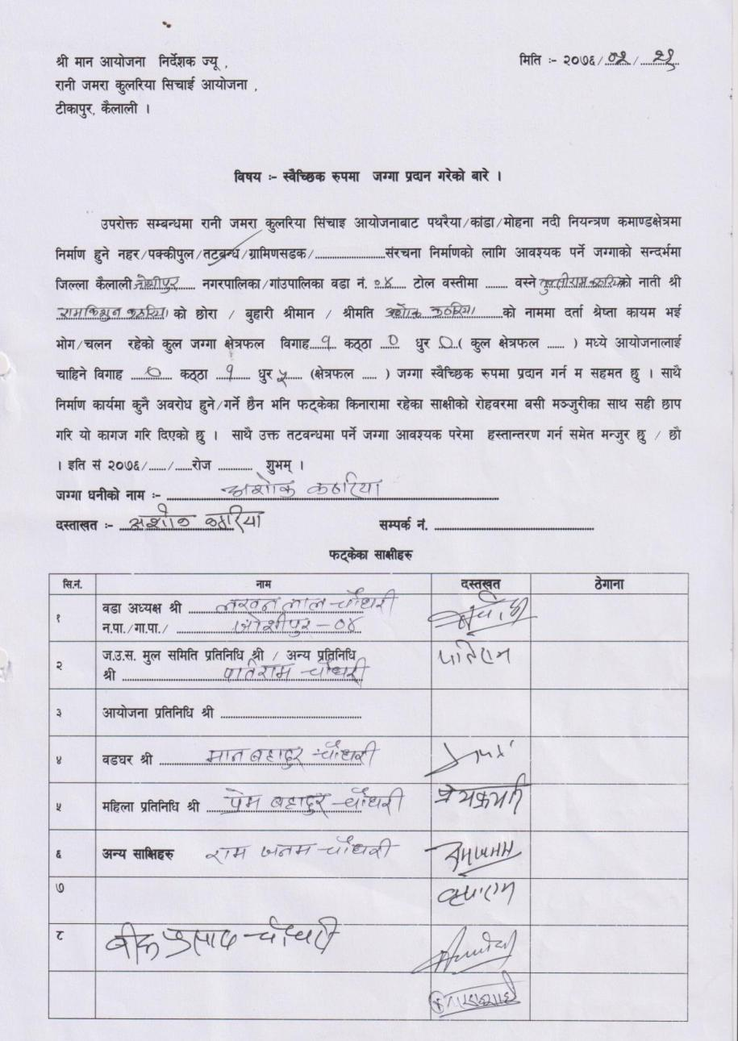

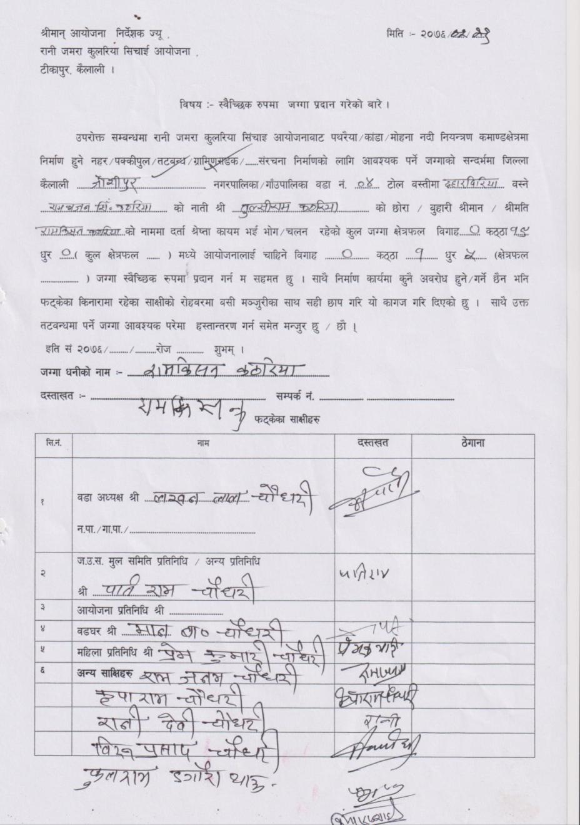
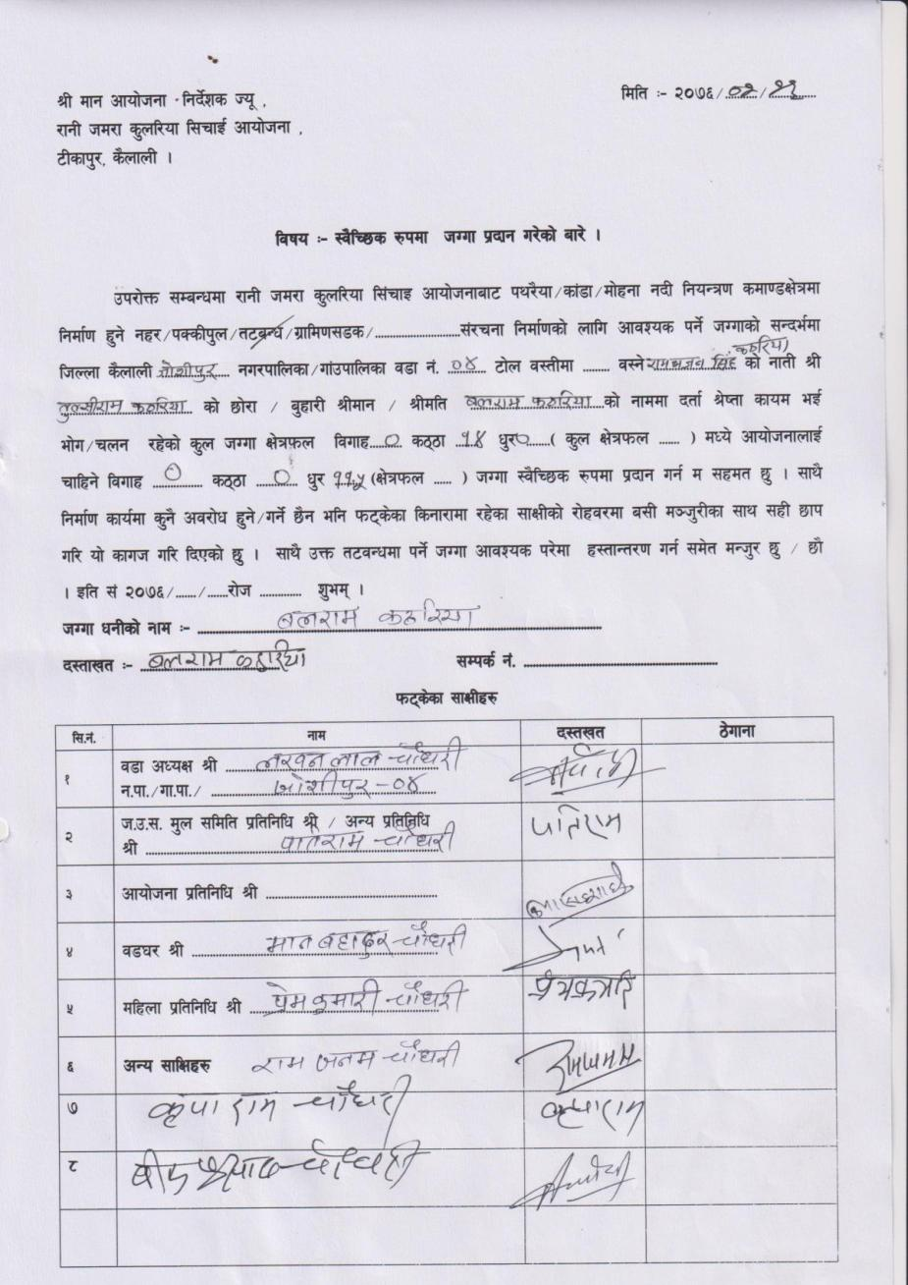

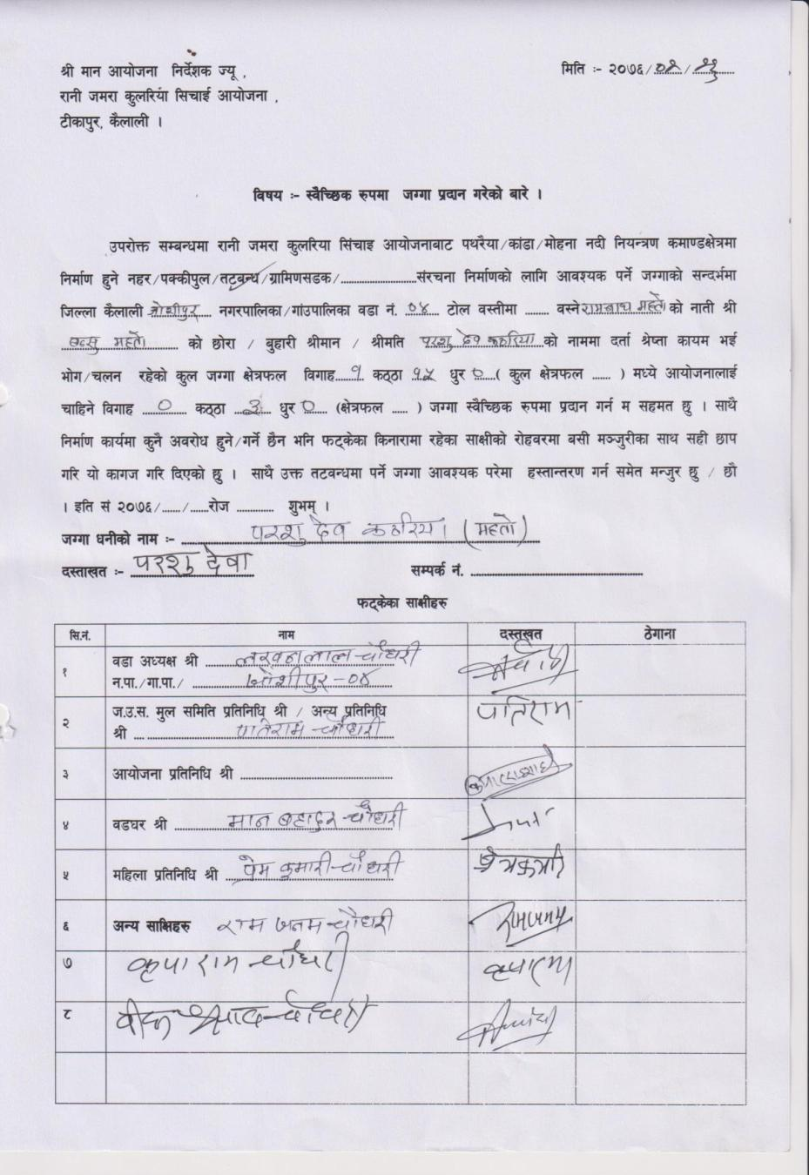
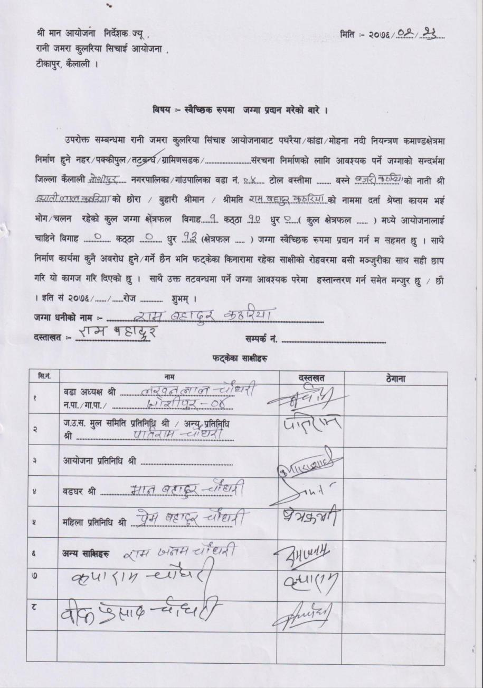

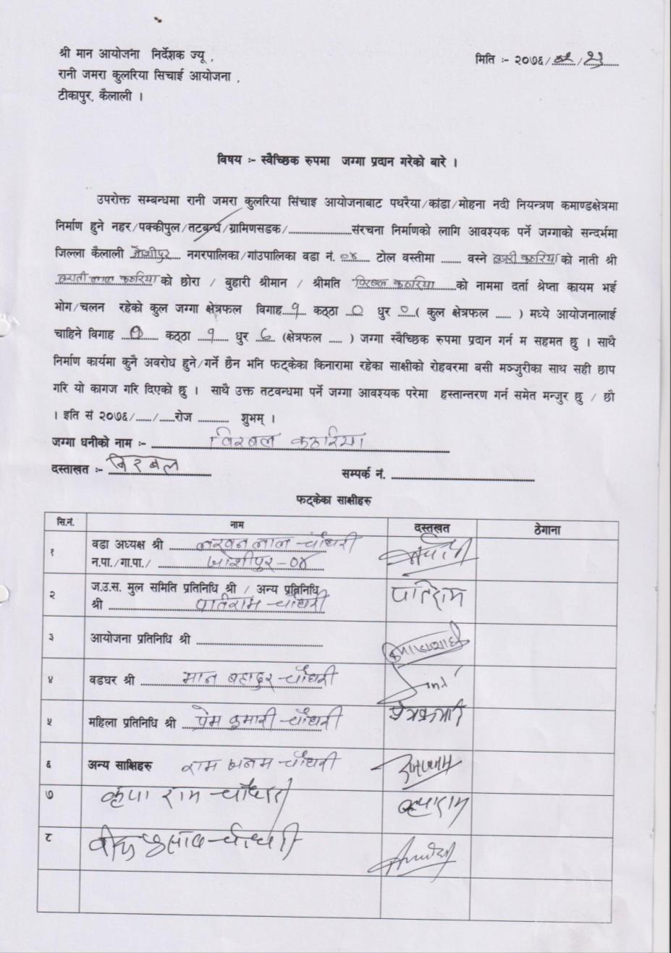
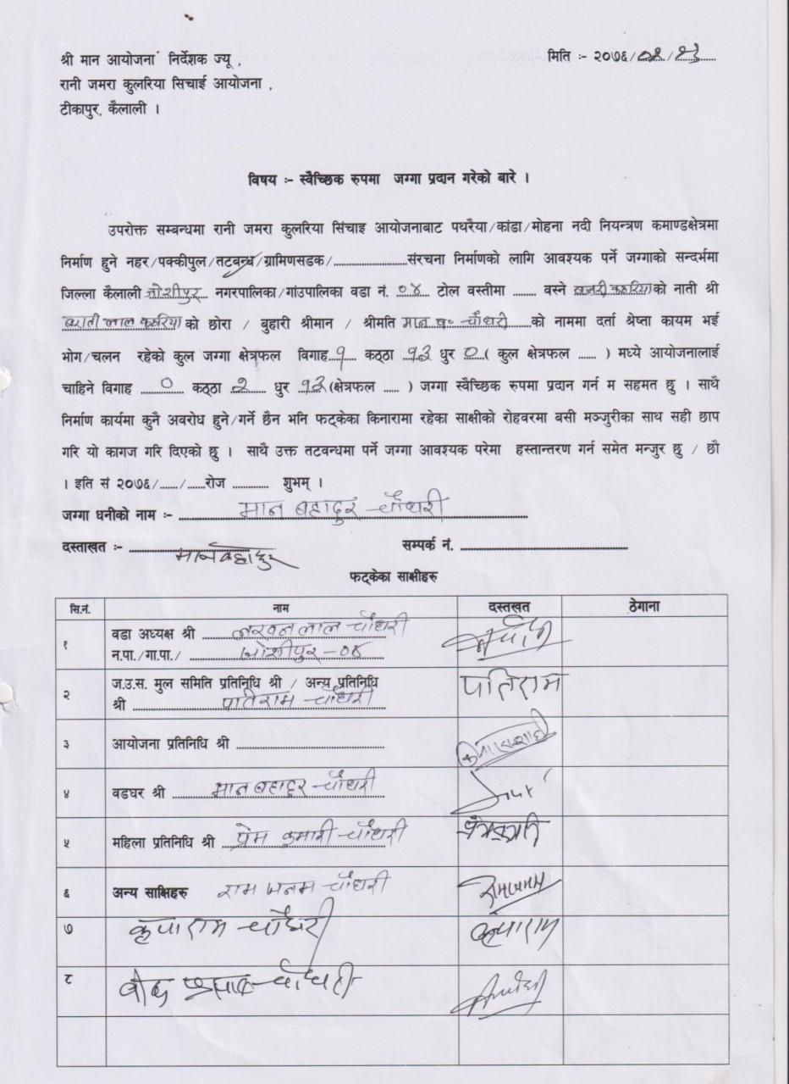

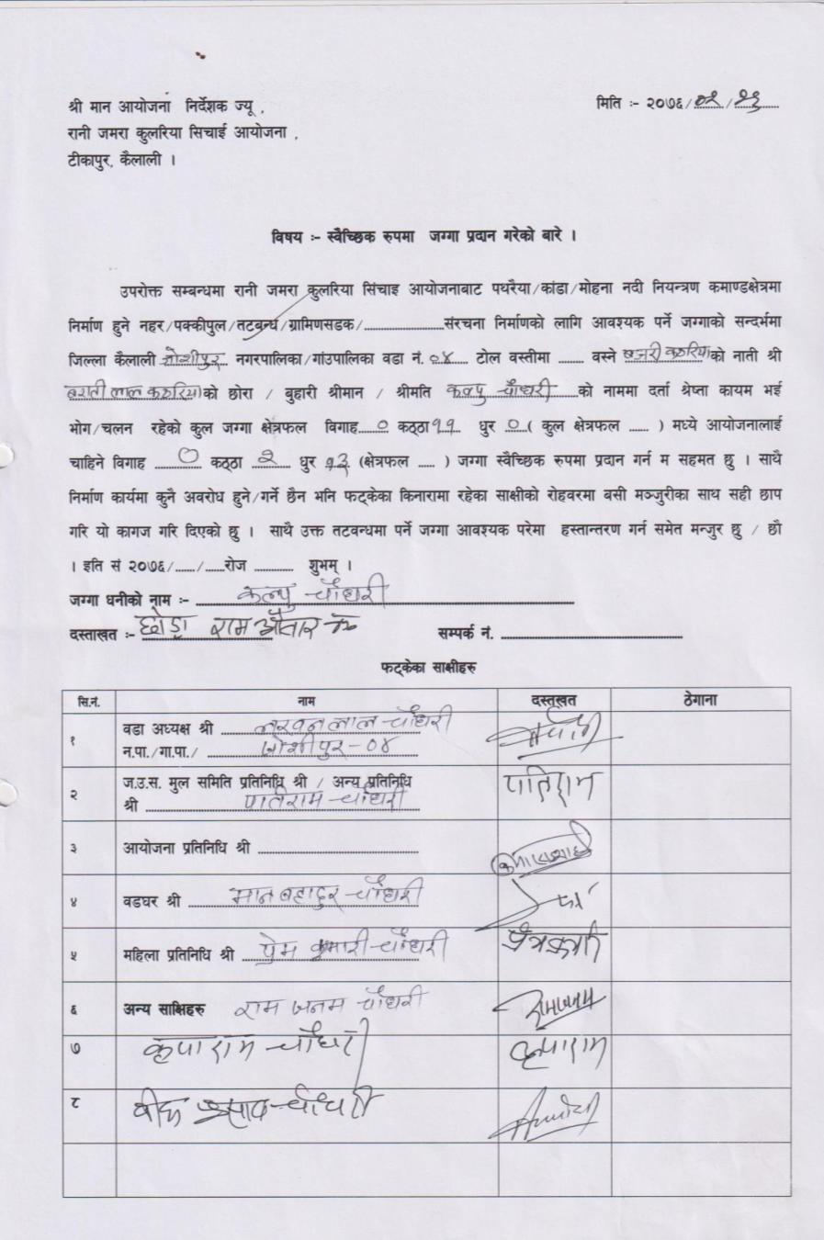
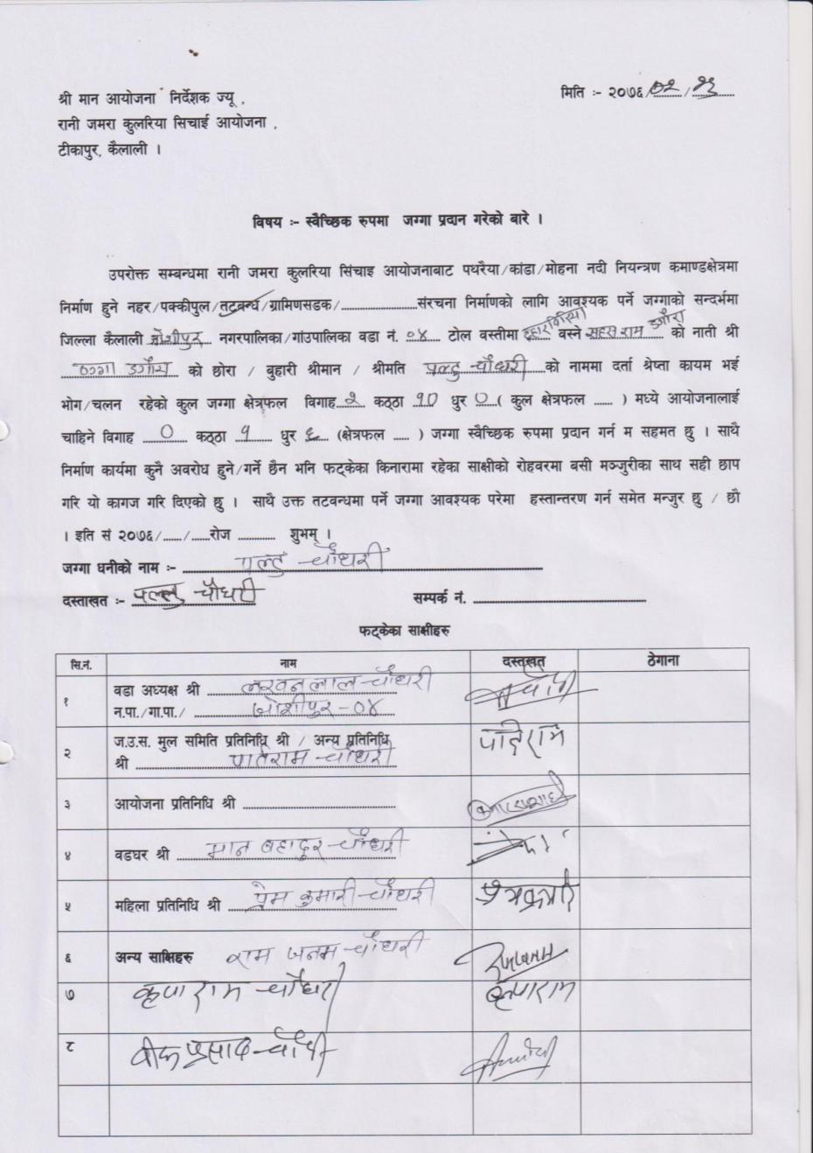

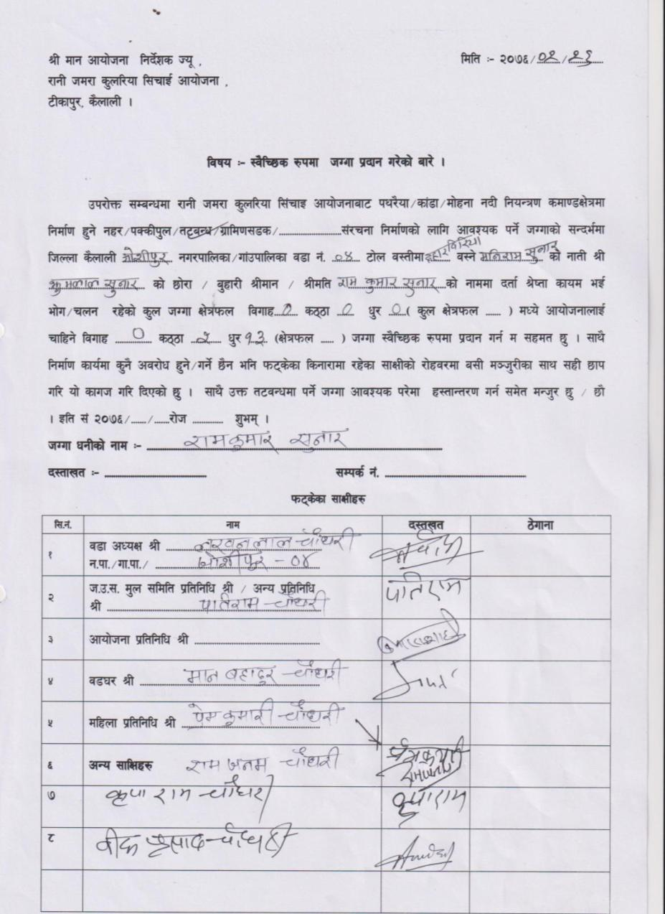
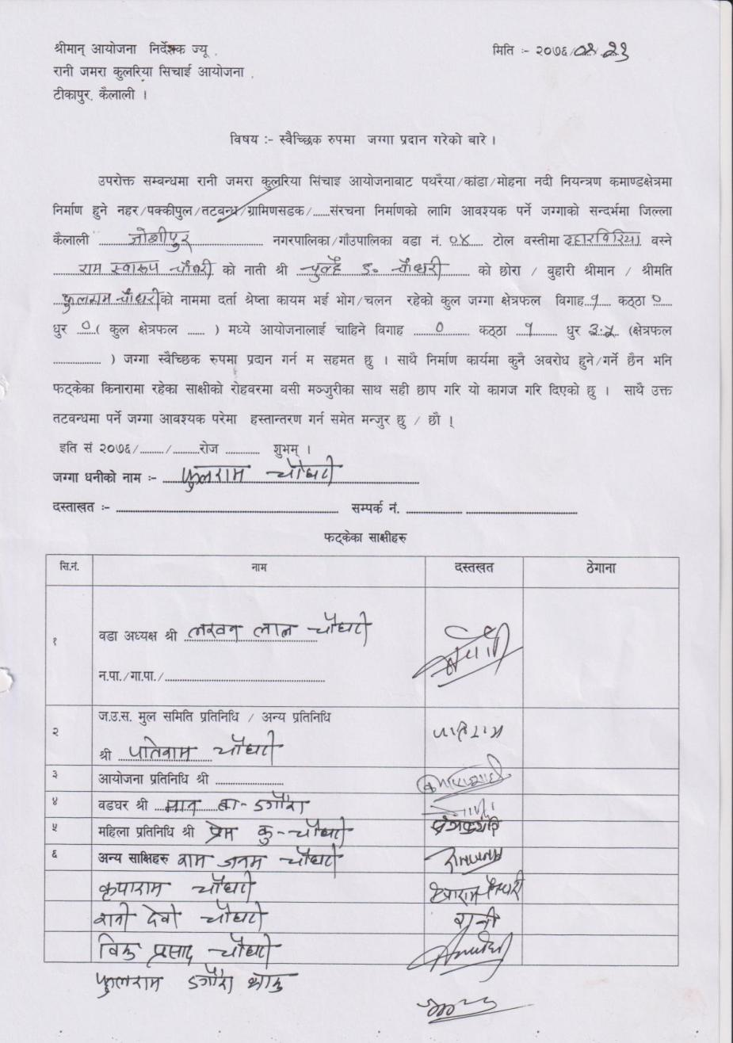

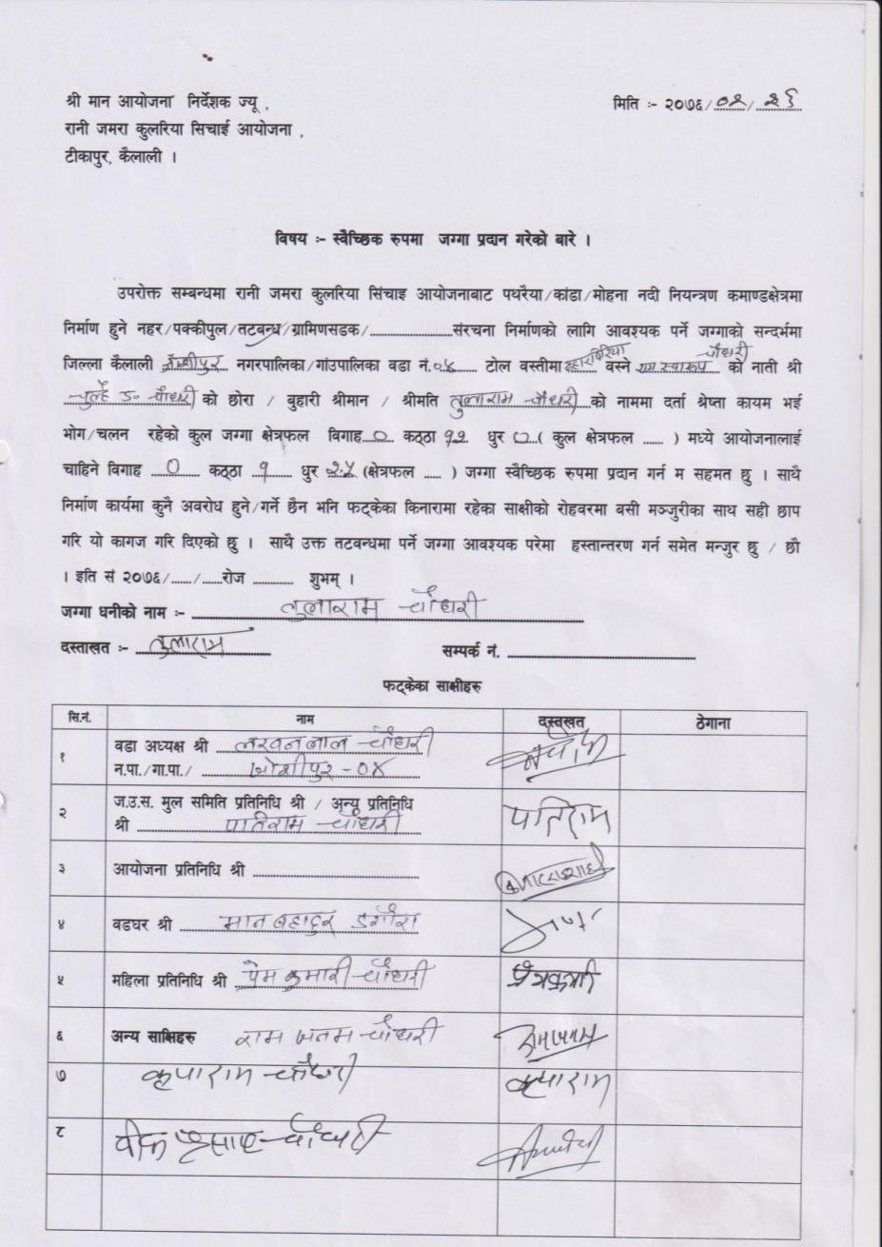
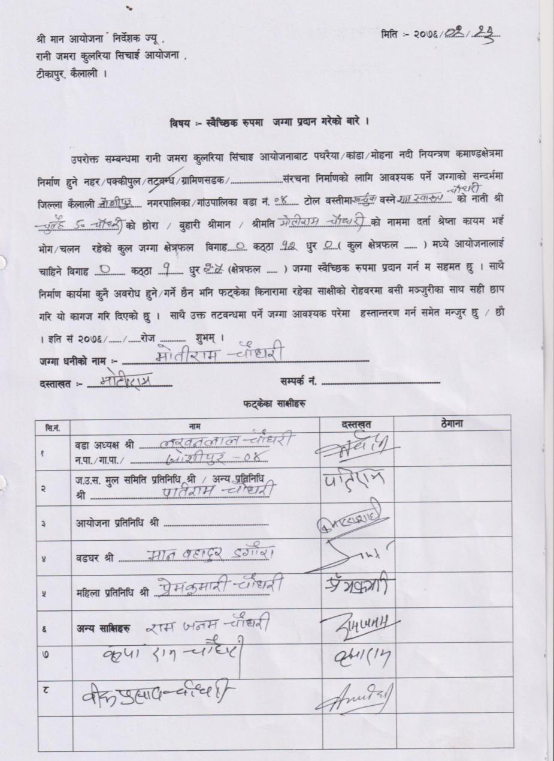

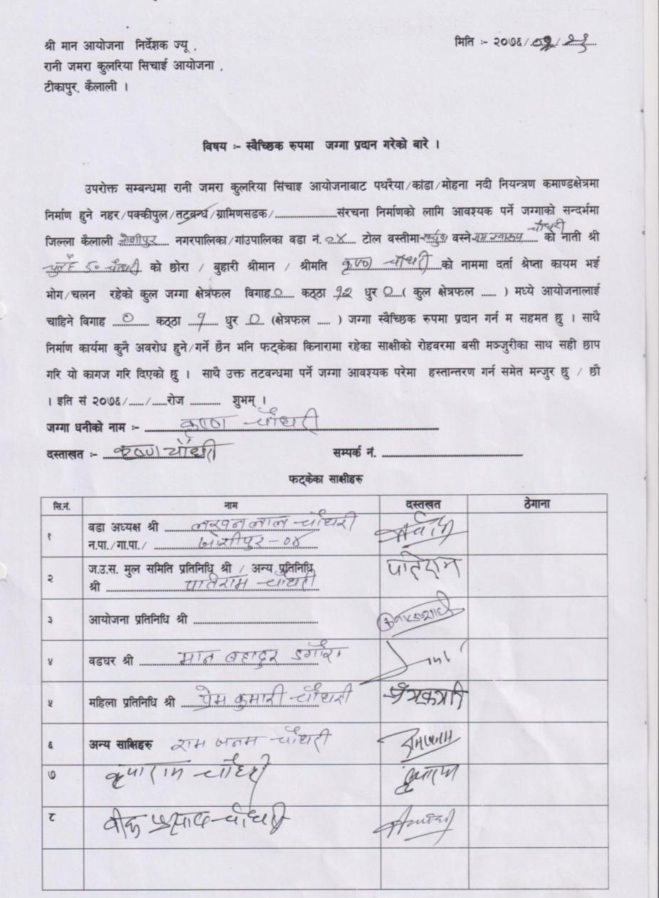
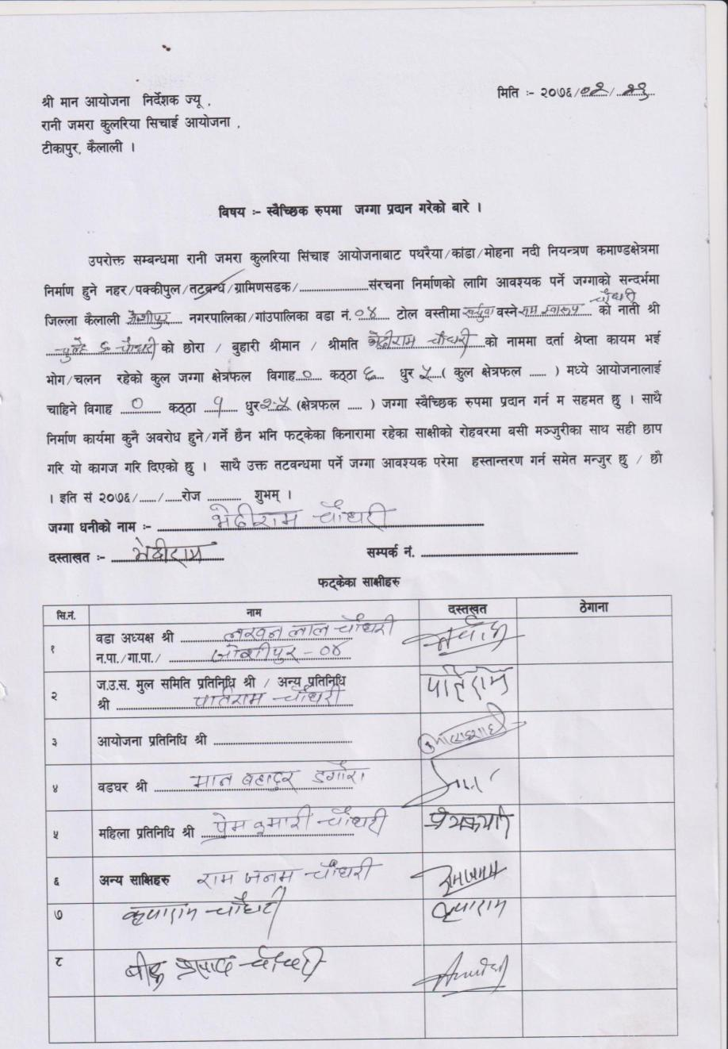

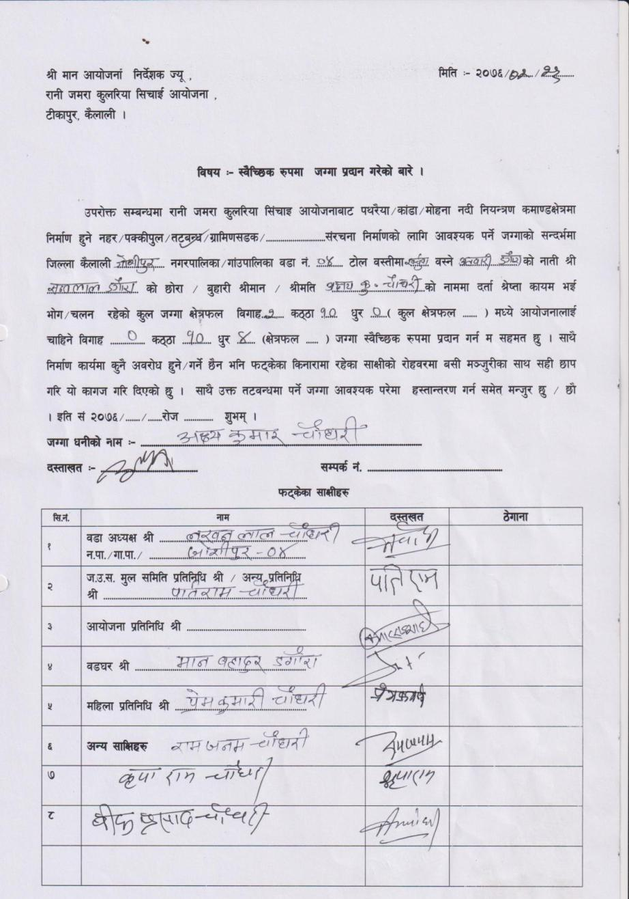
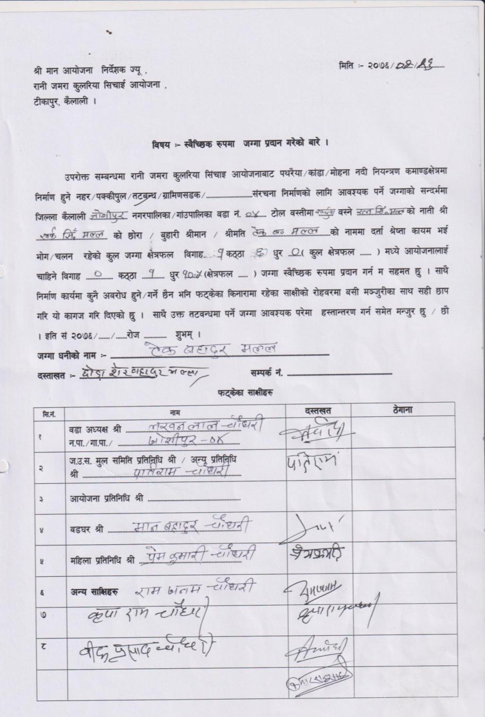

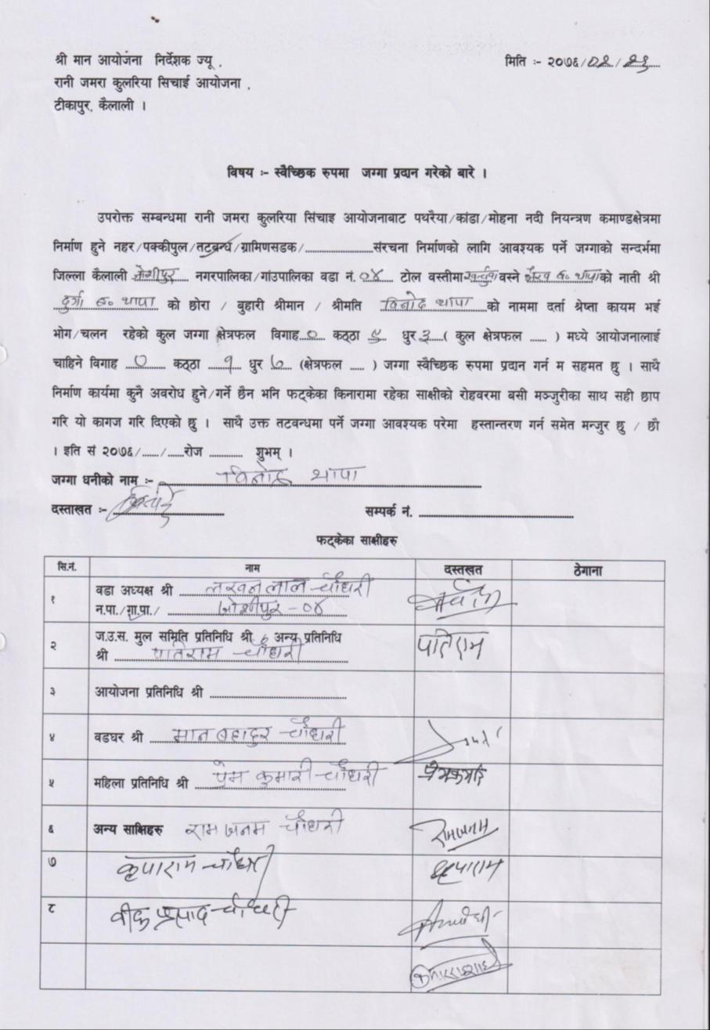
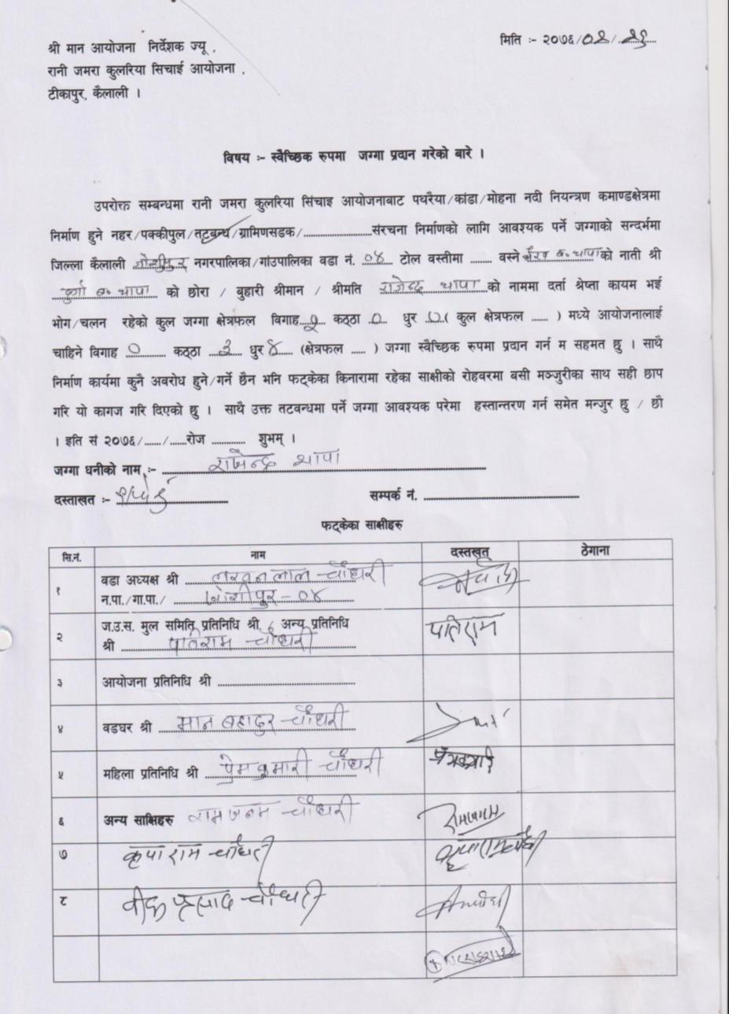

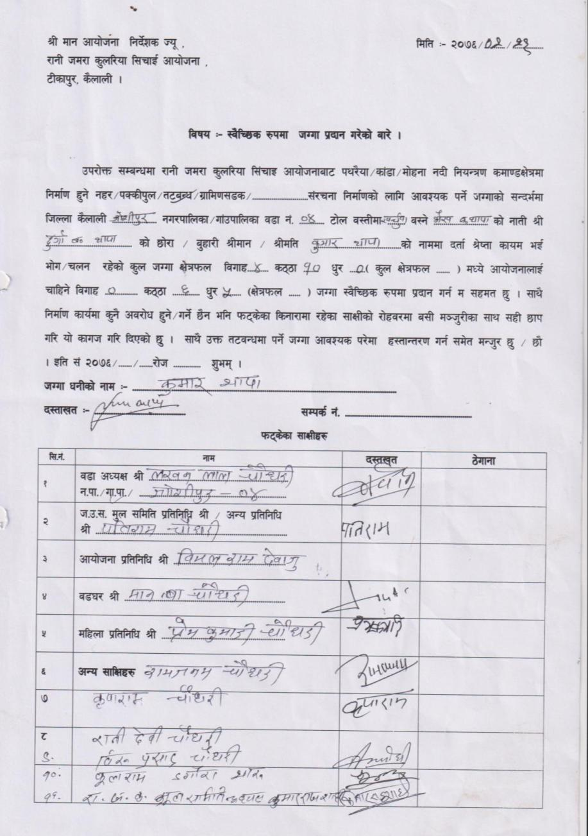
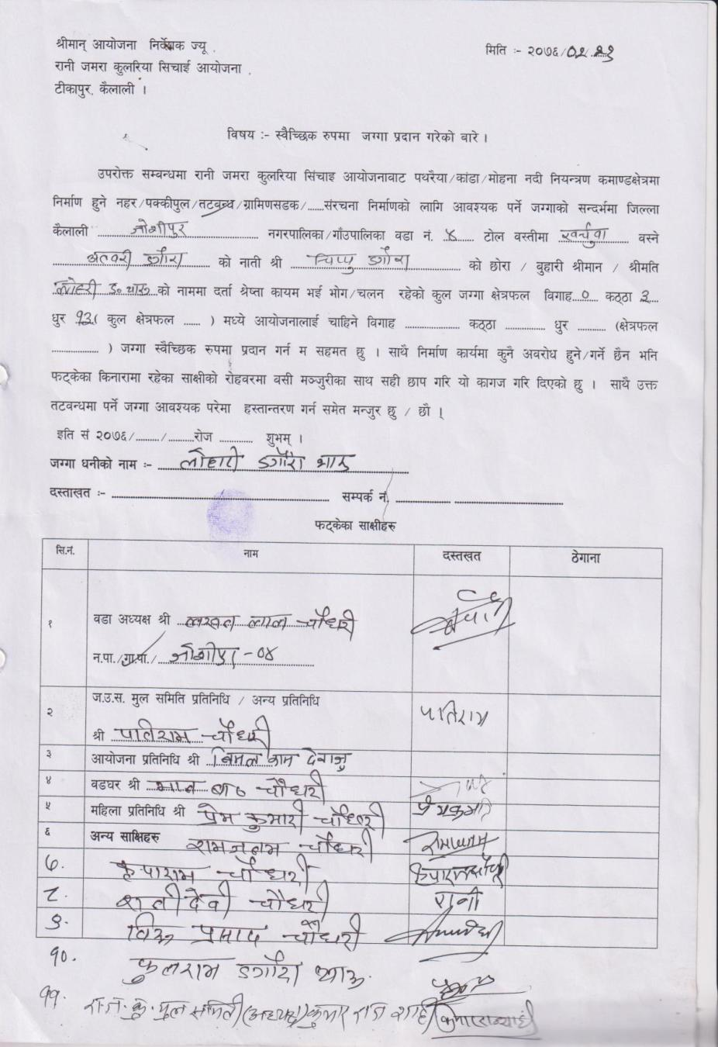

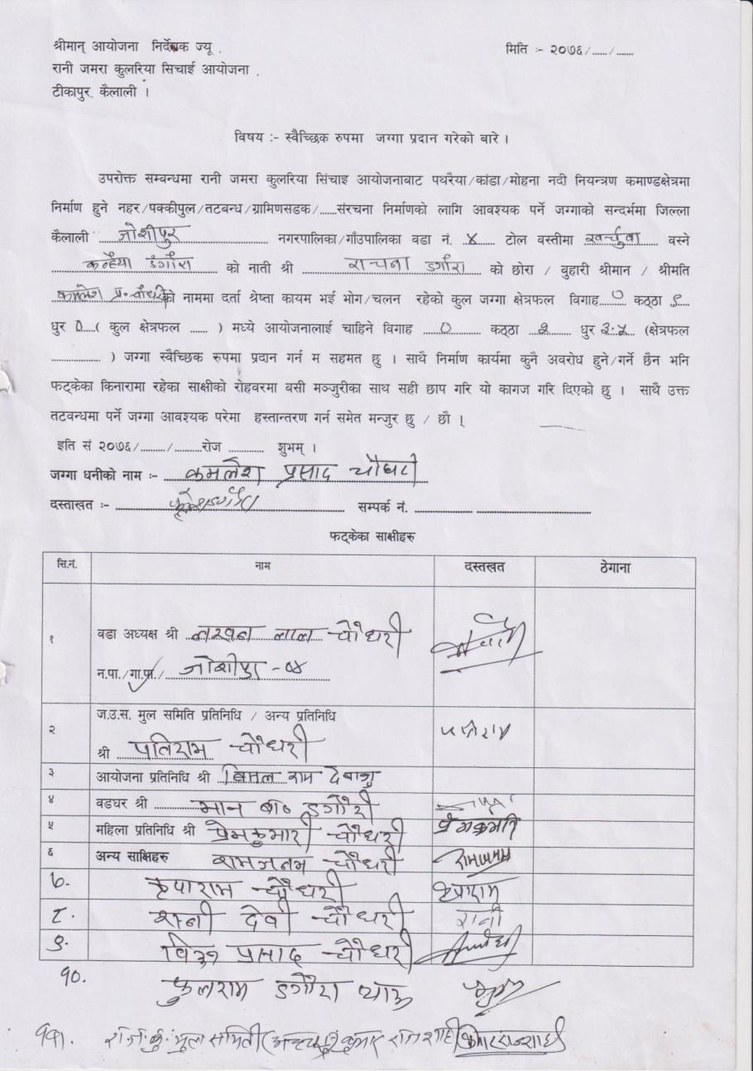

9: Bhajani RM 8 (RB)
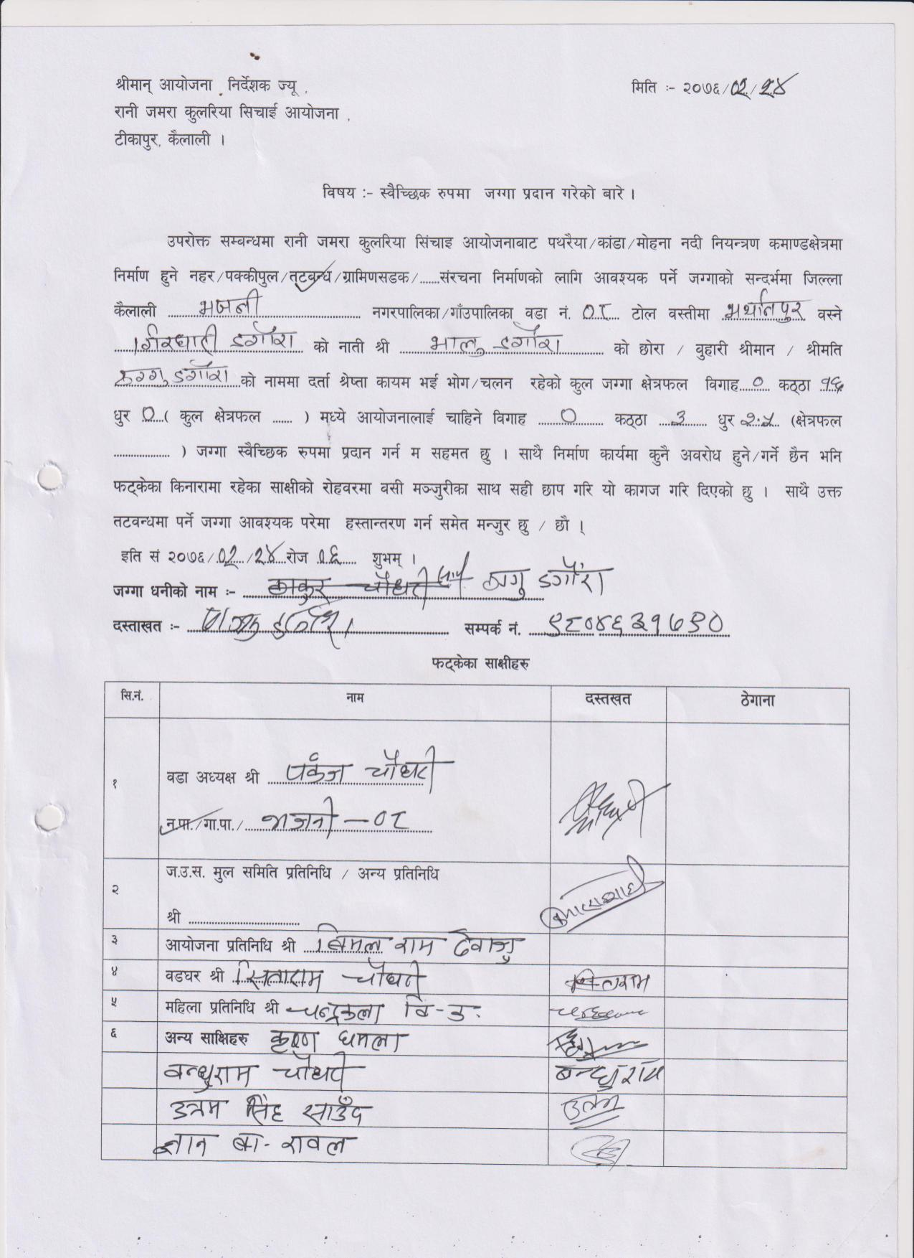
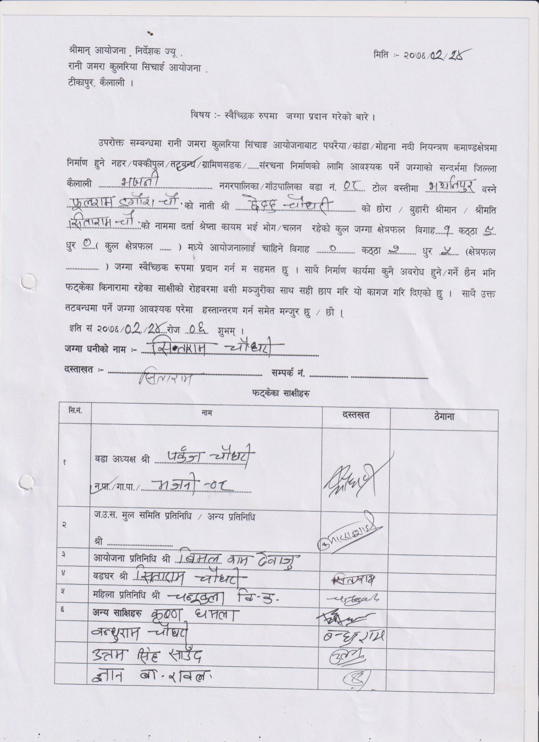

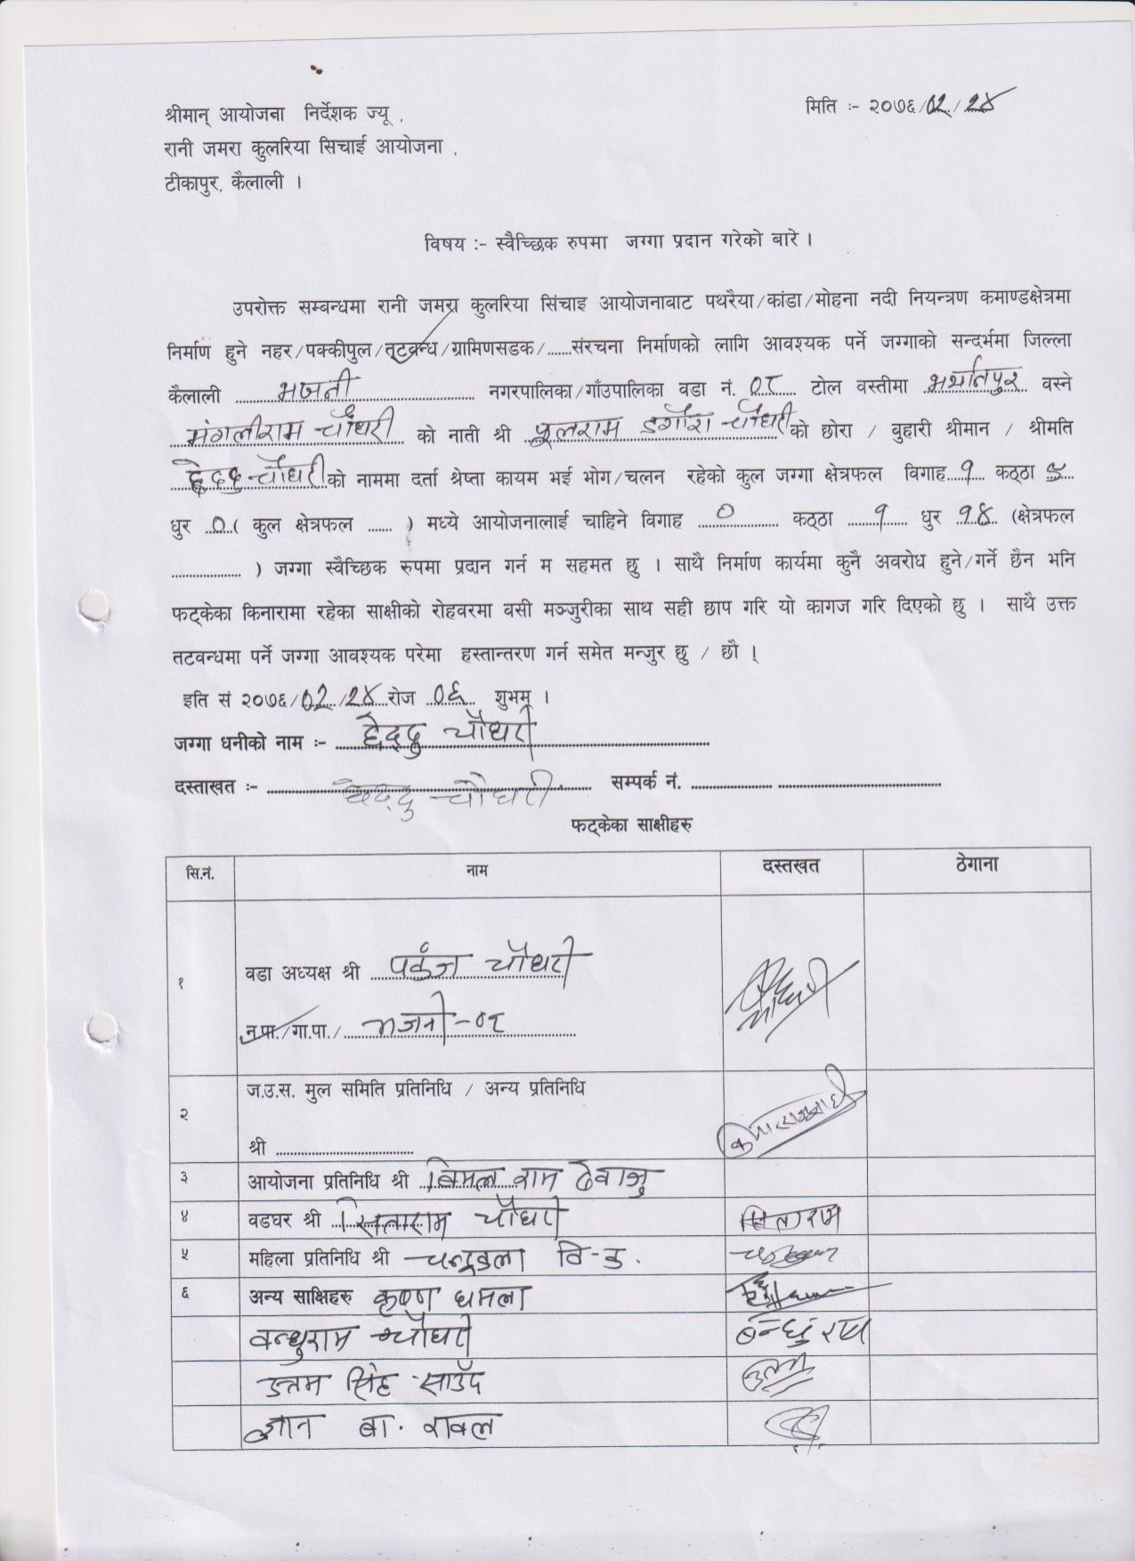
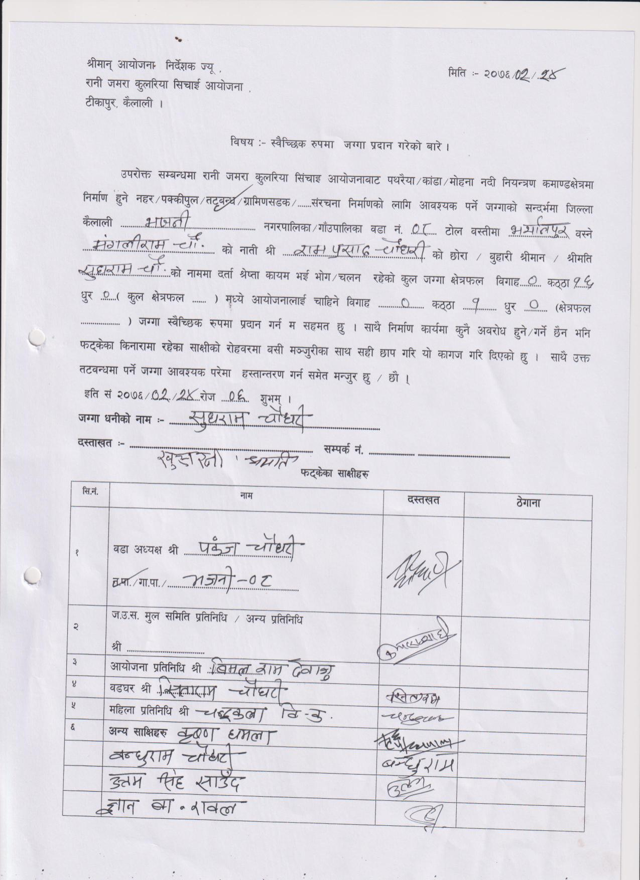

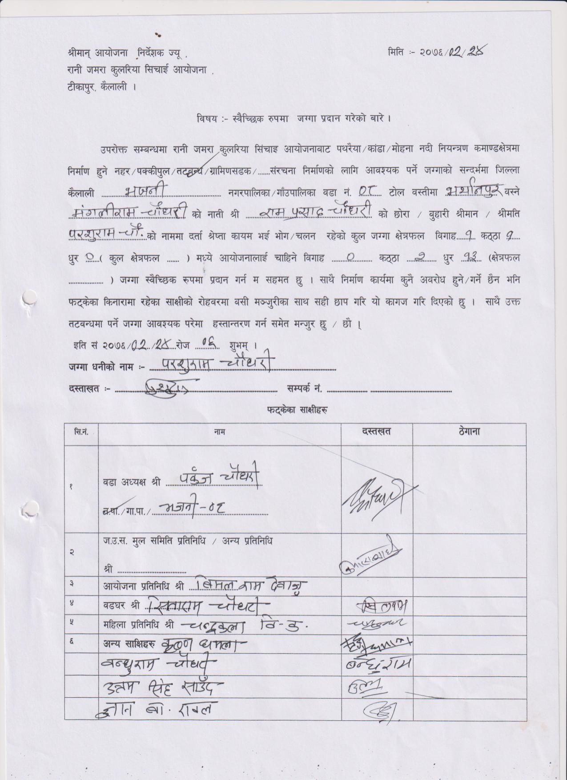
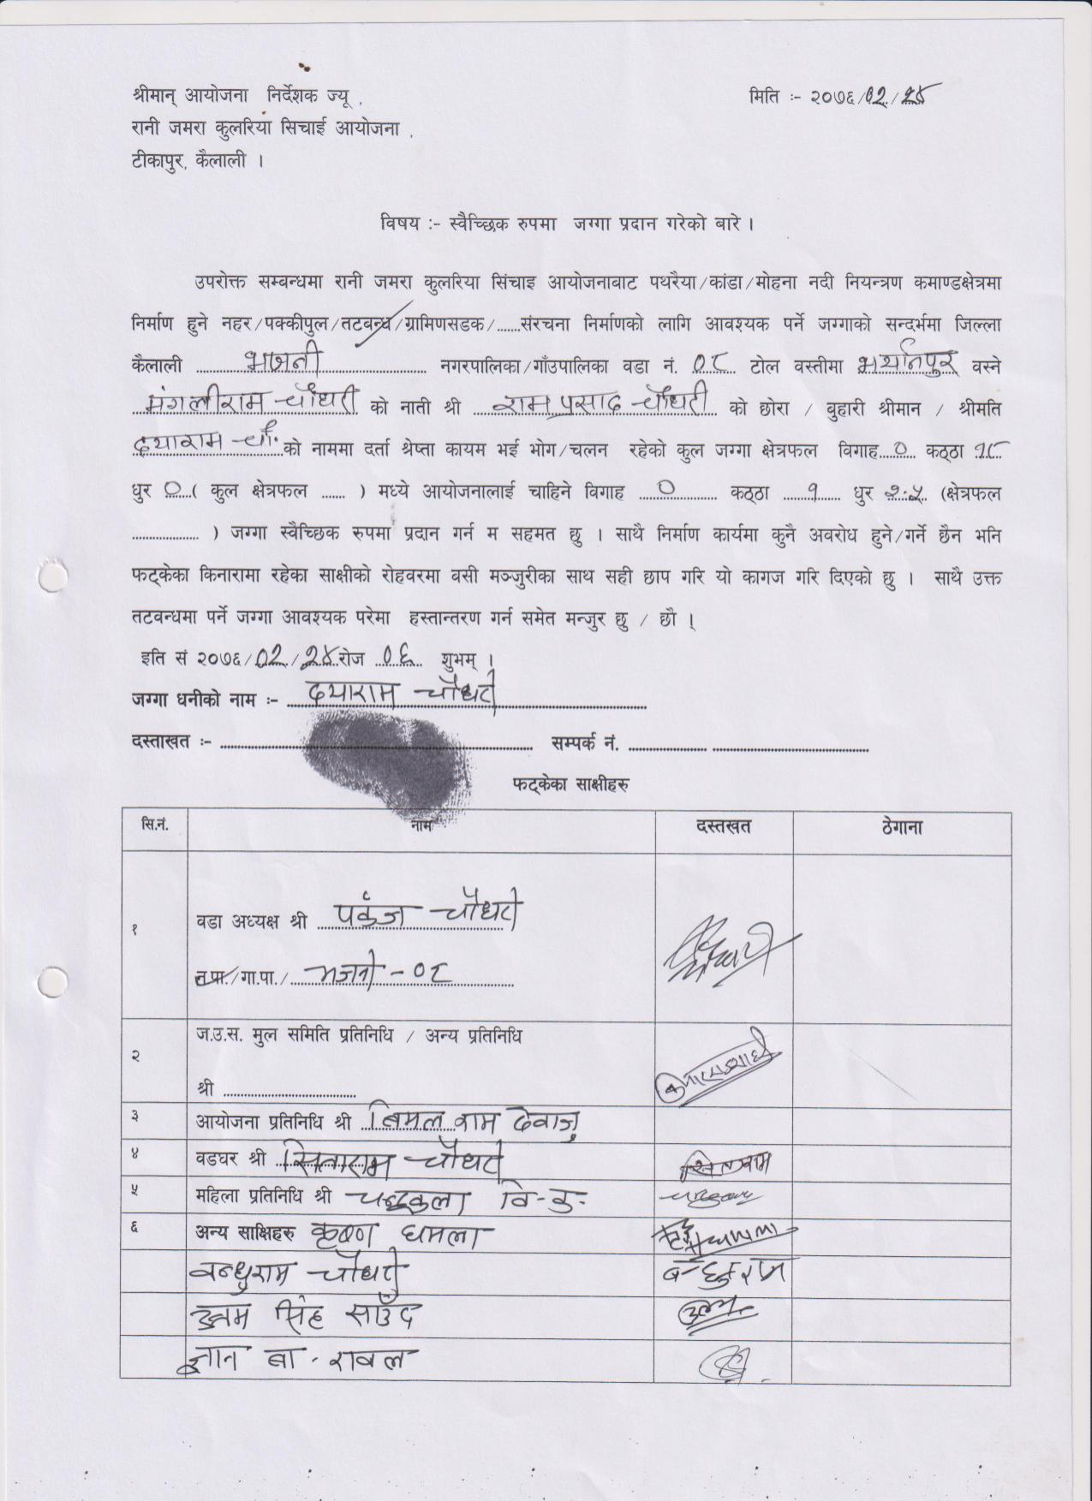

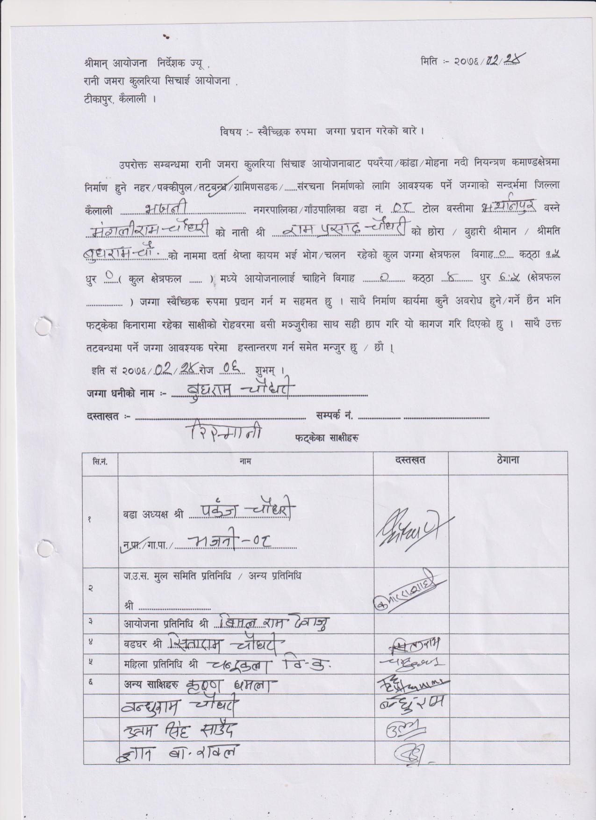
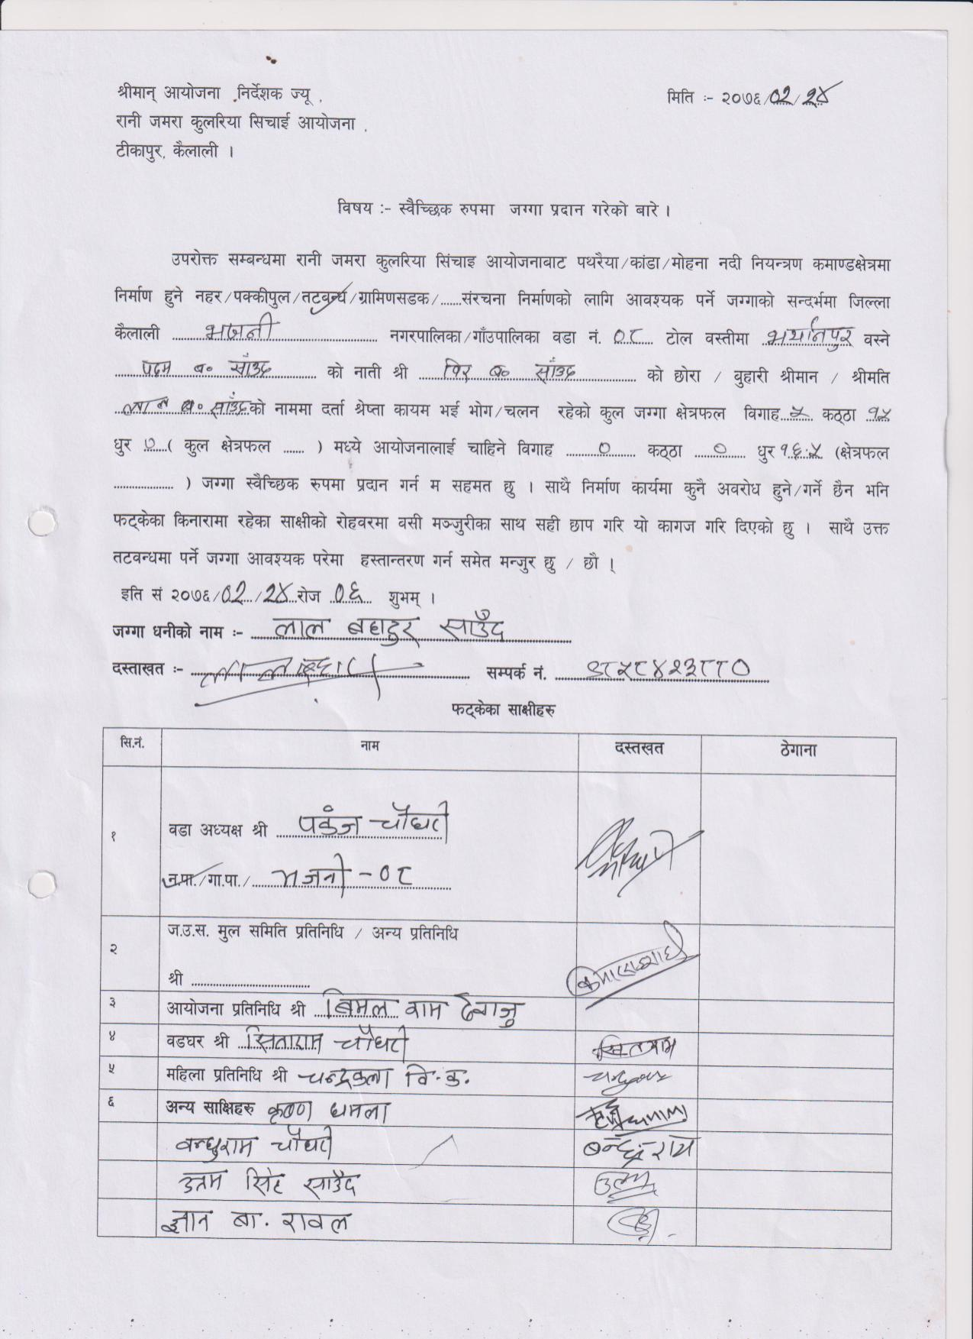

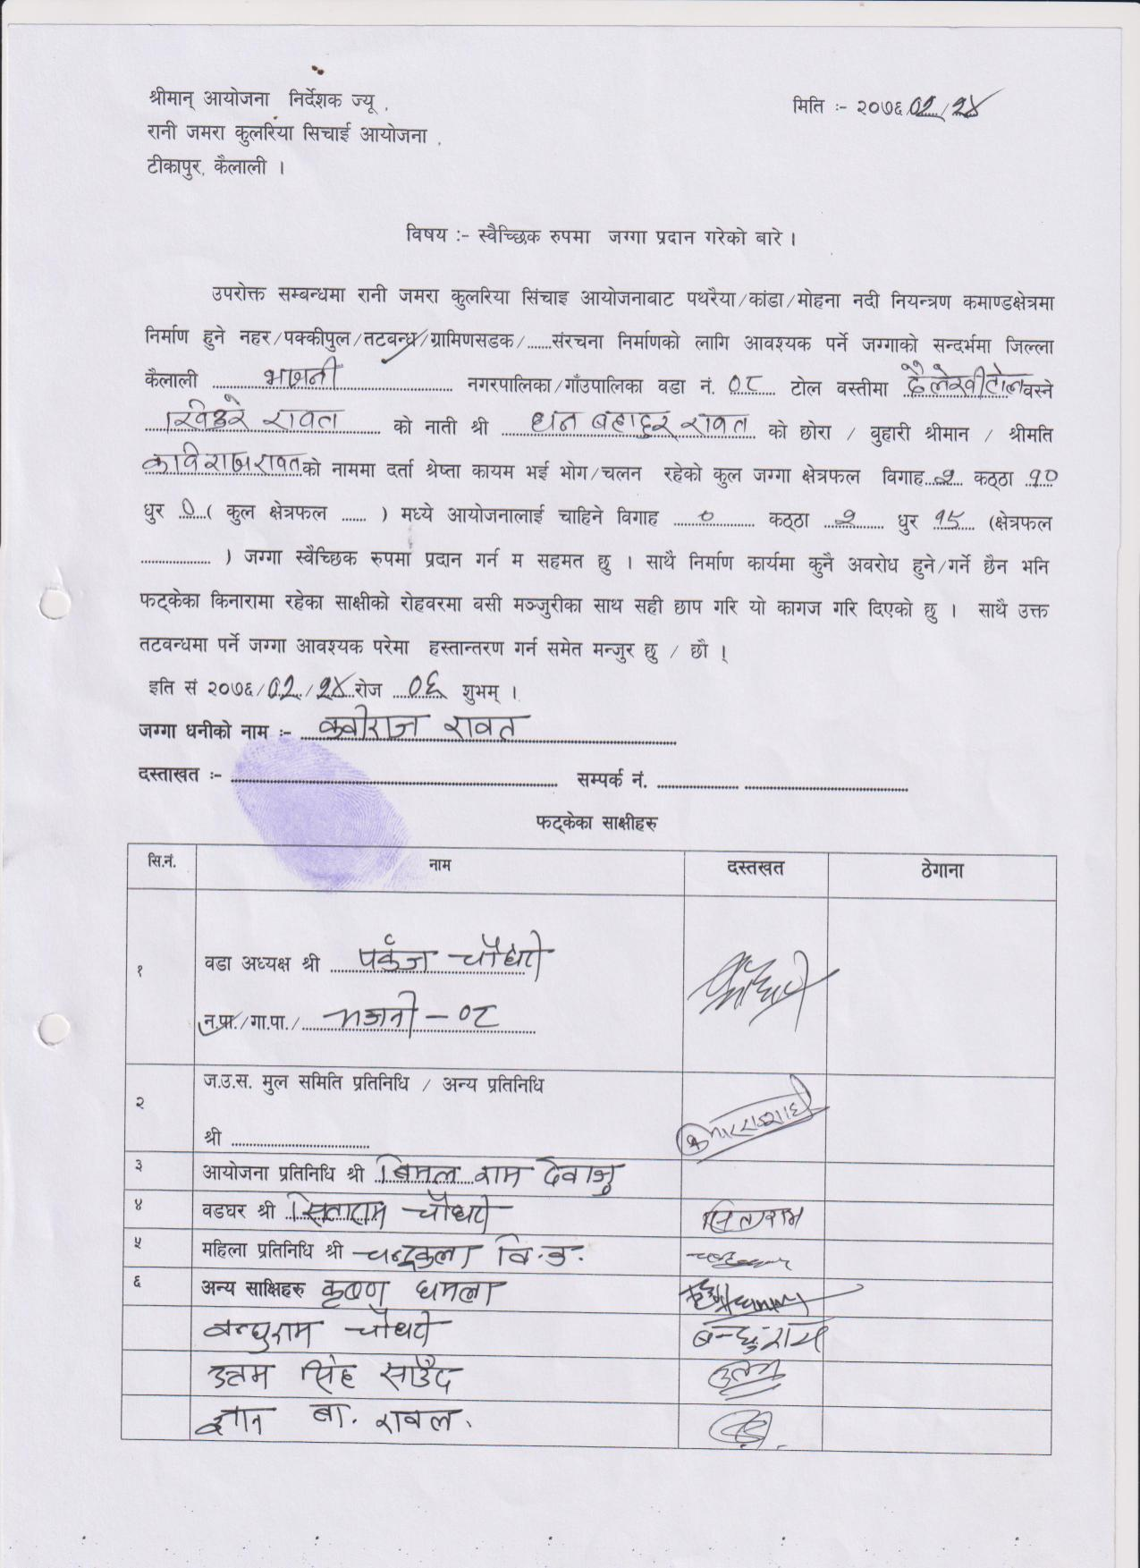
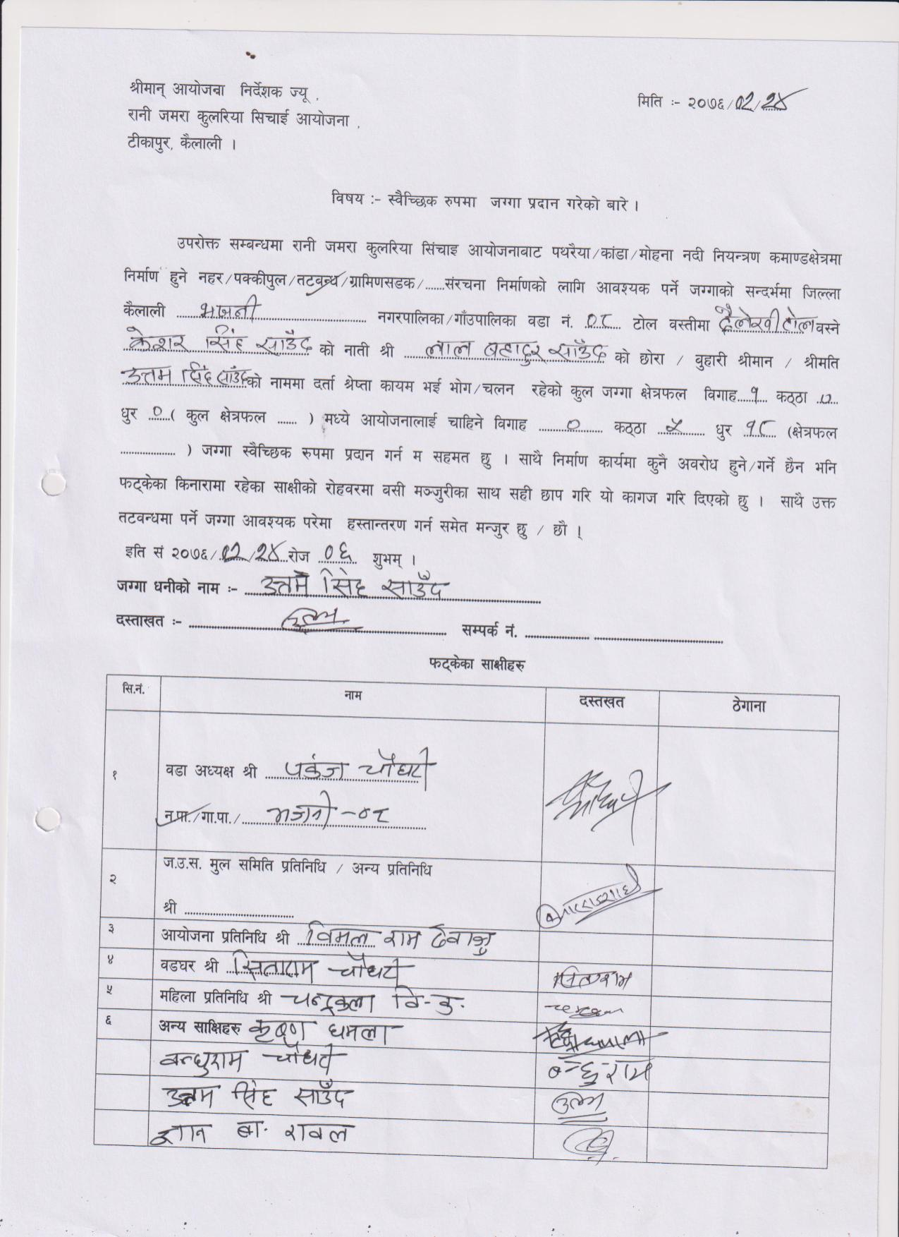

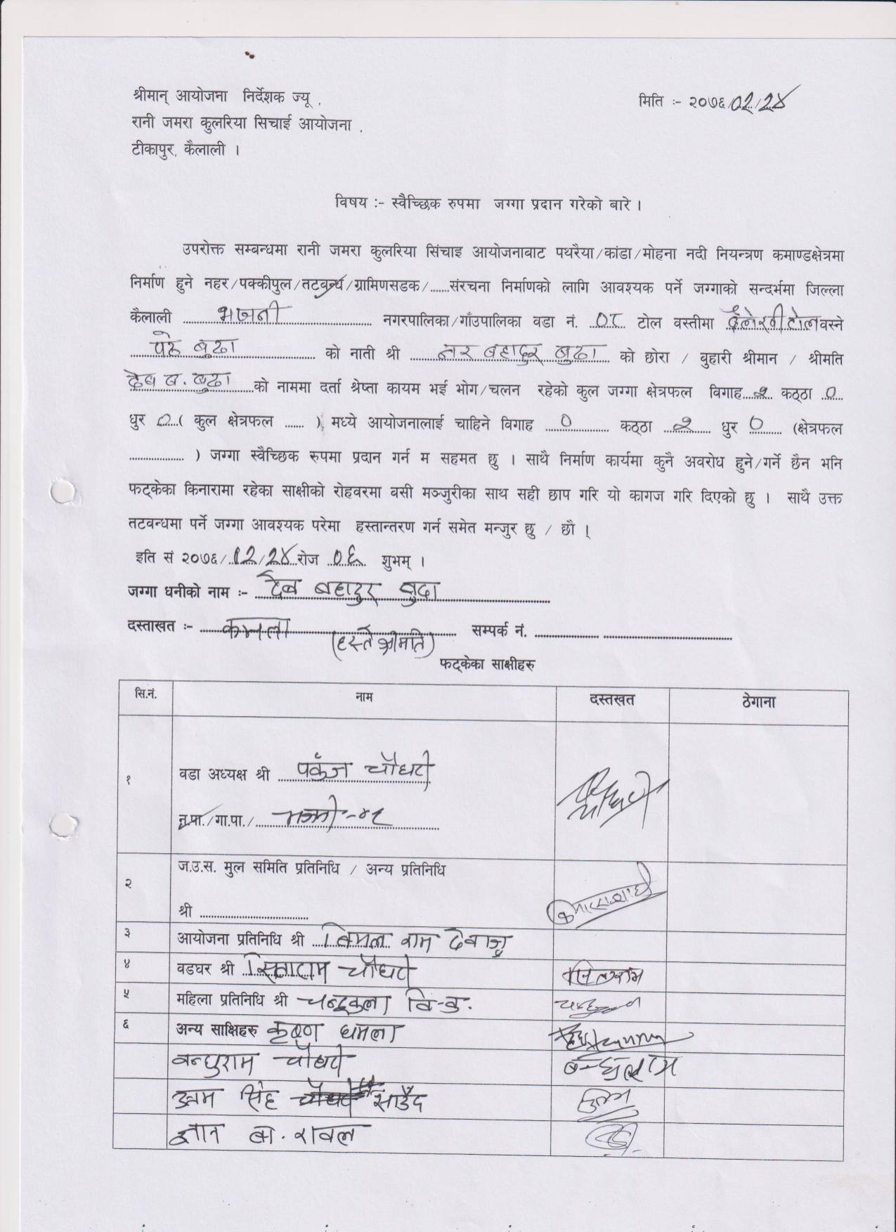
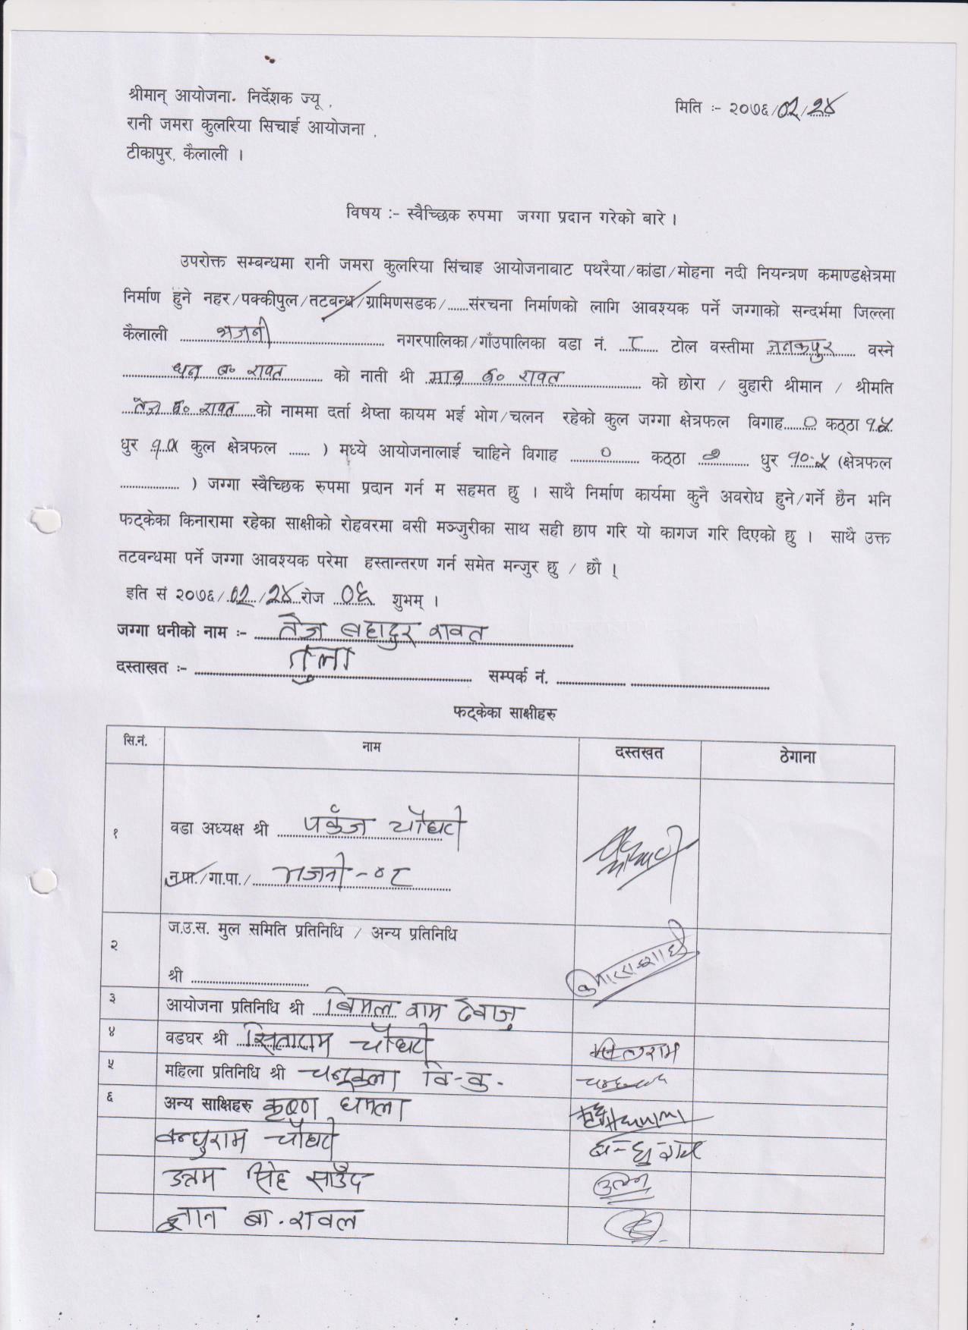

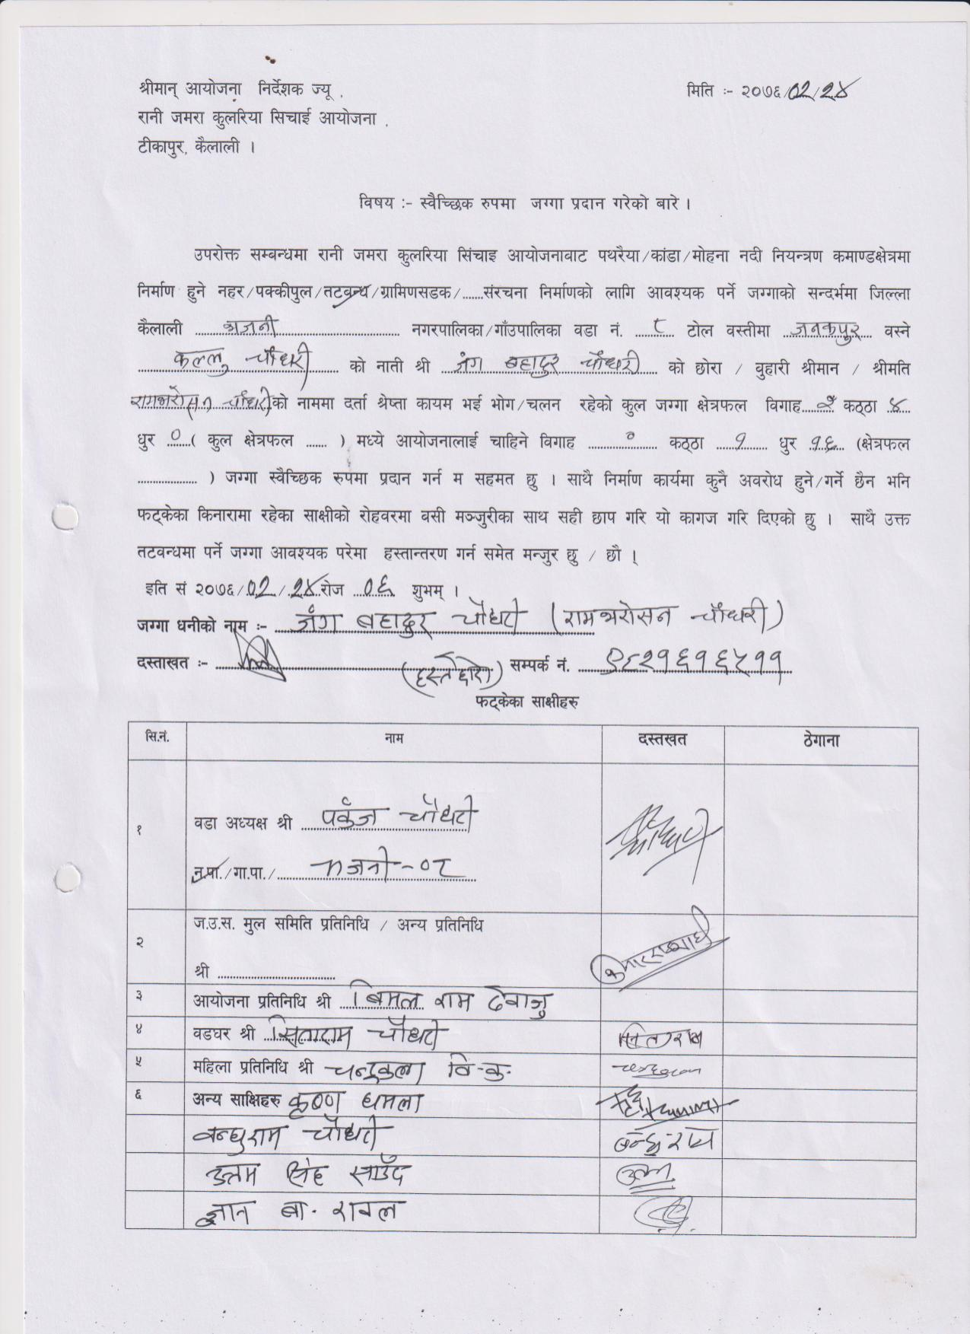
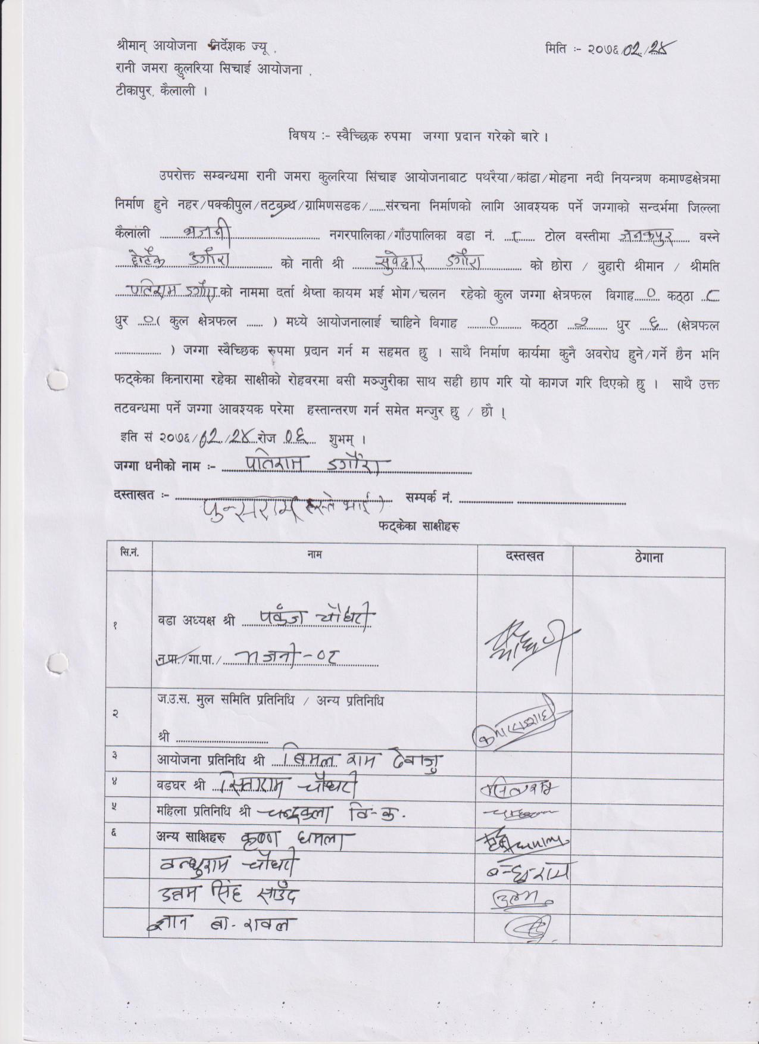

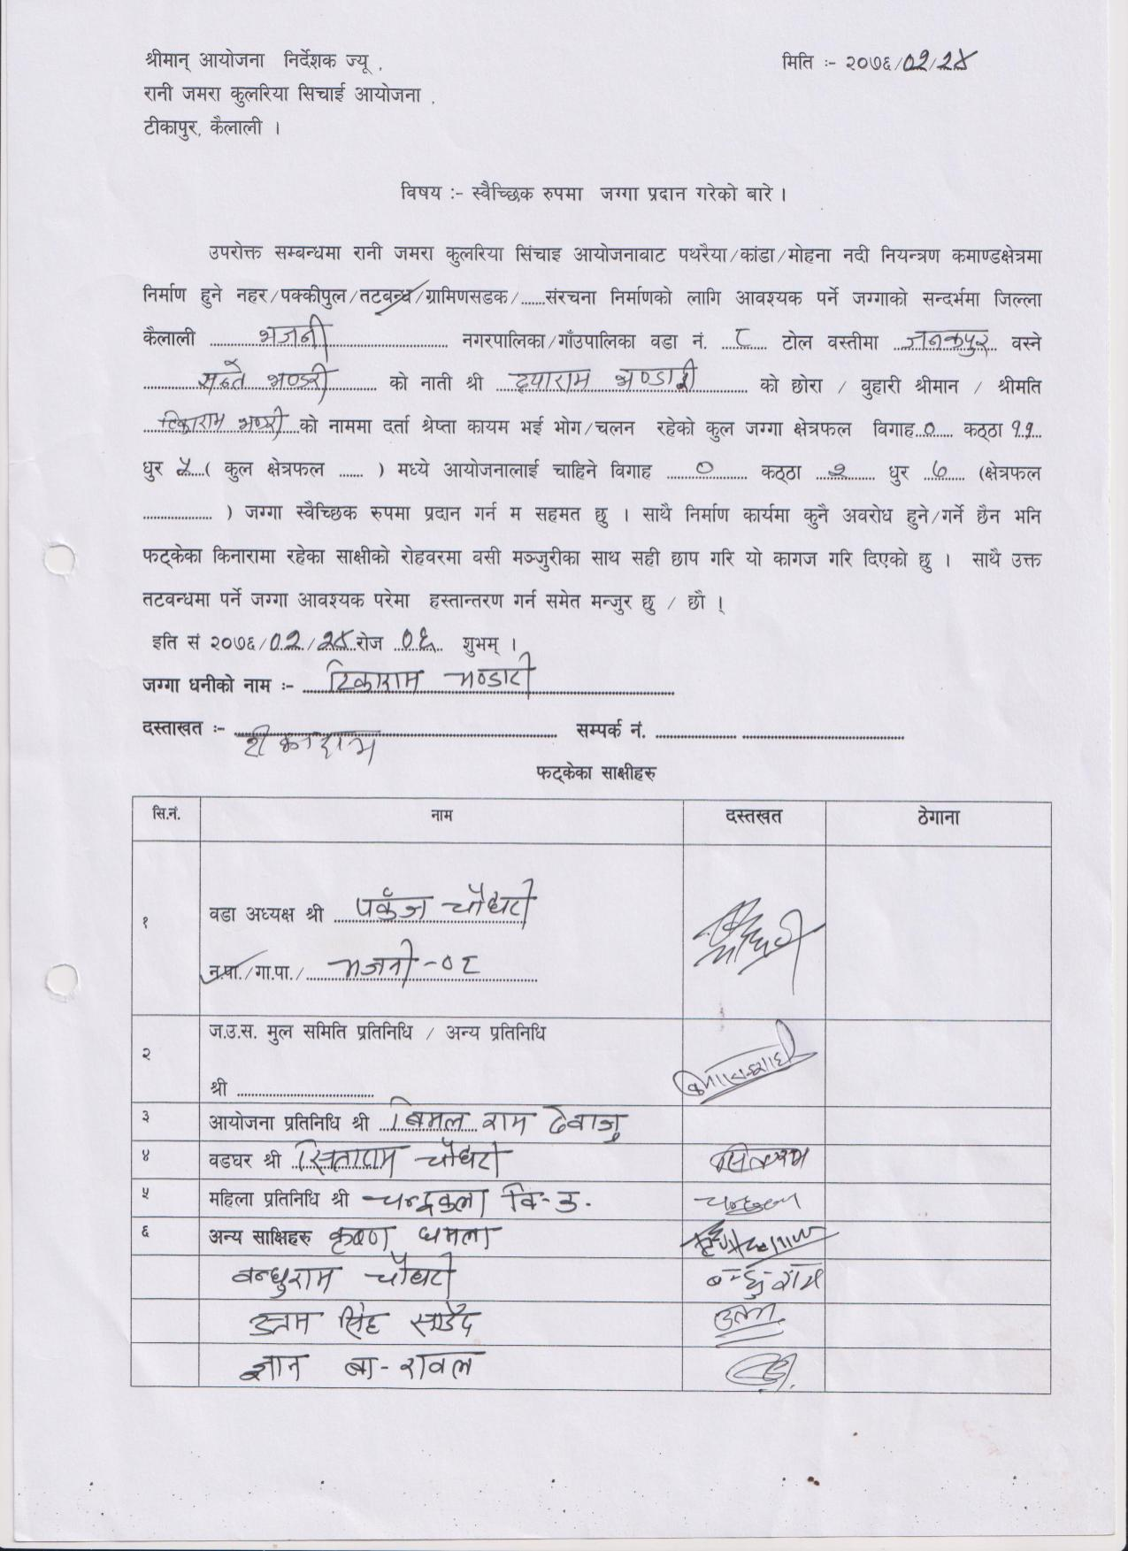
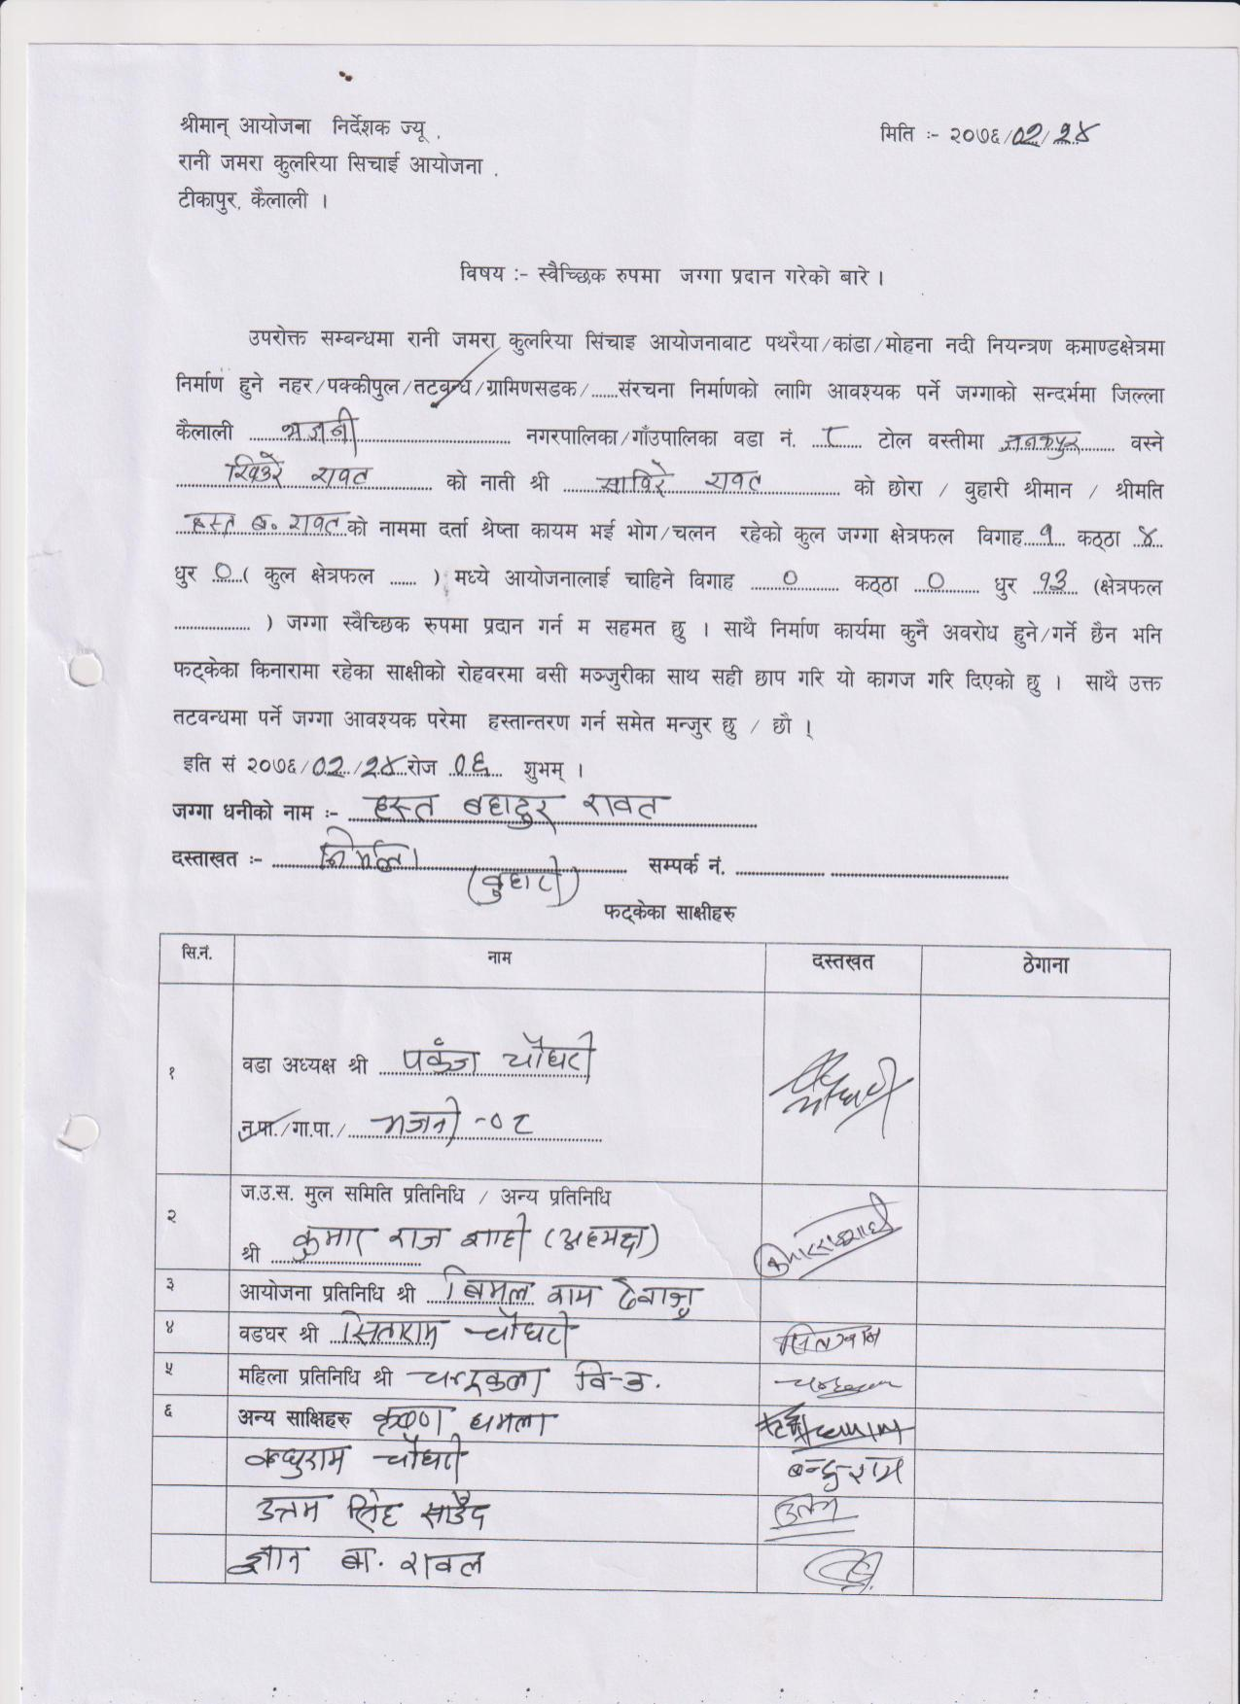

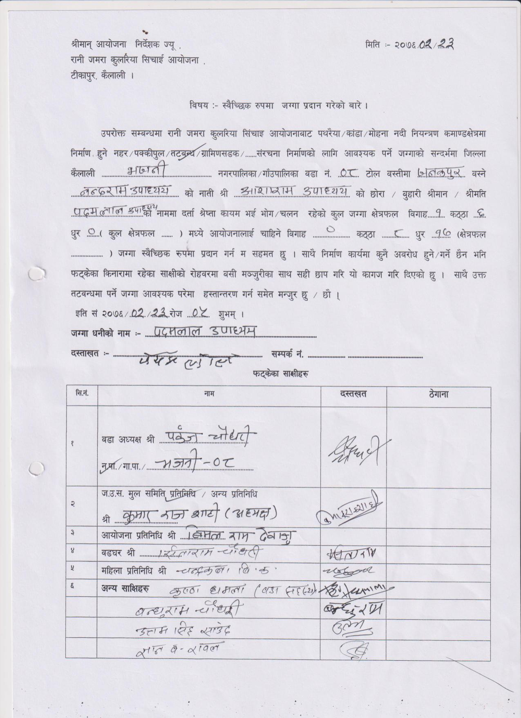
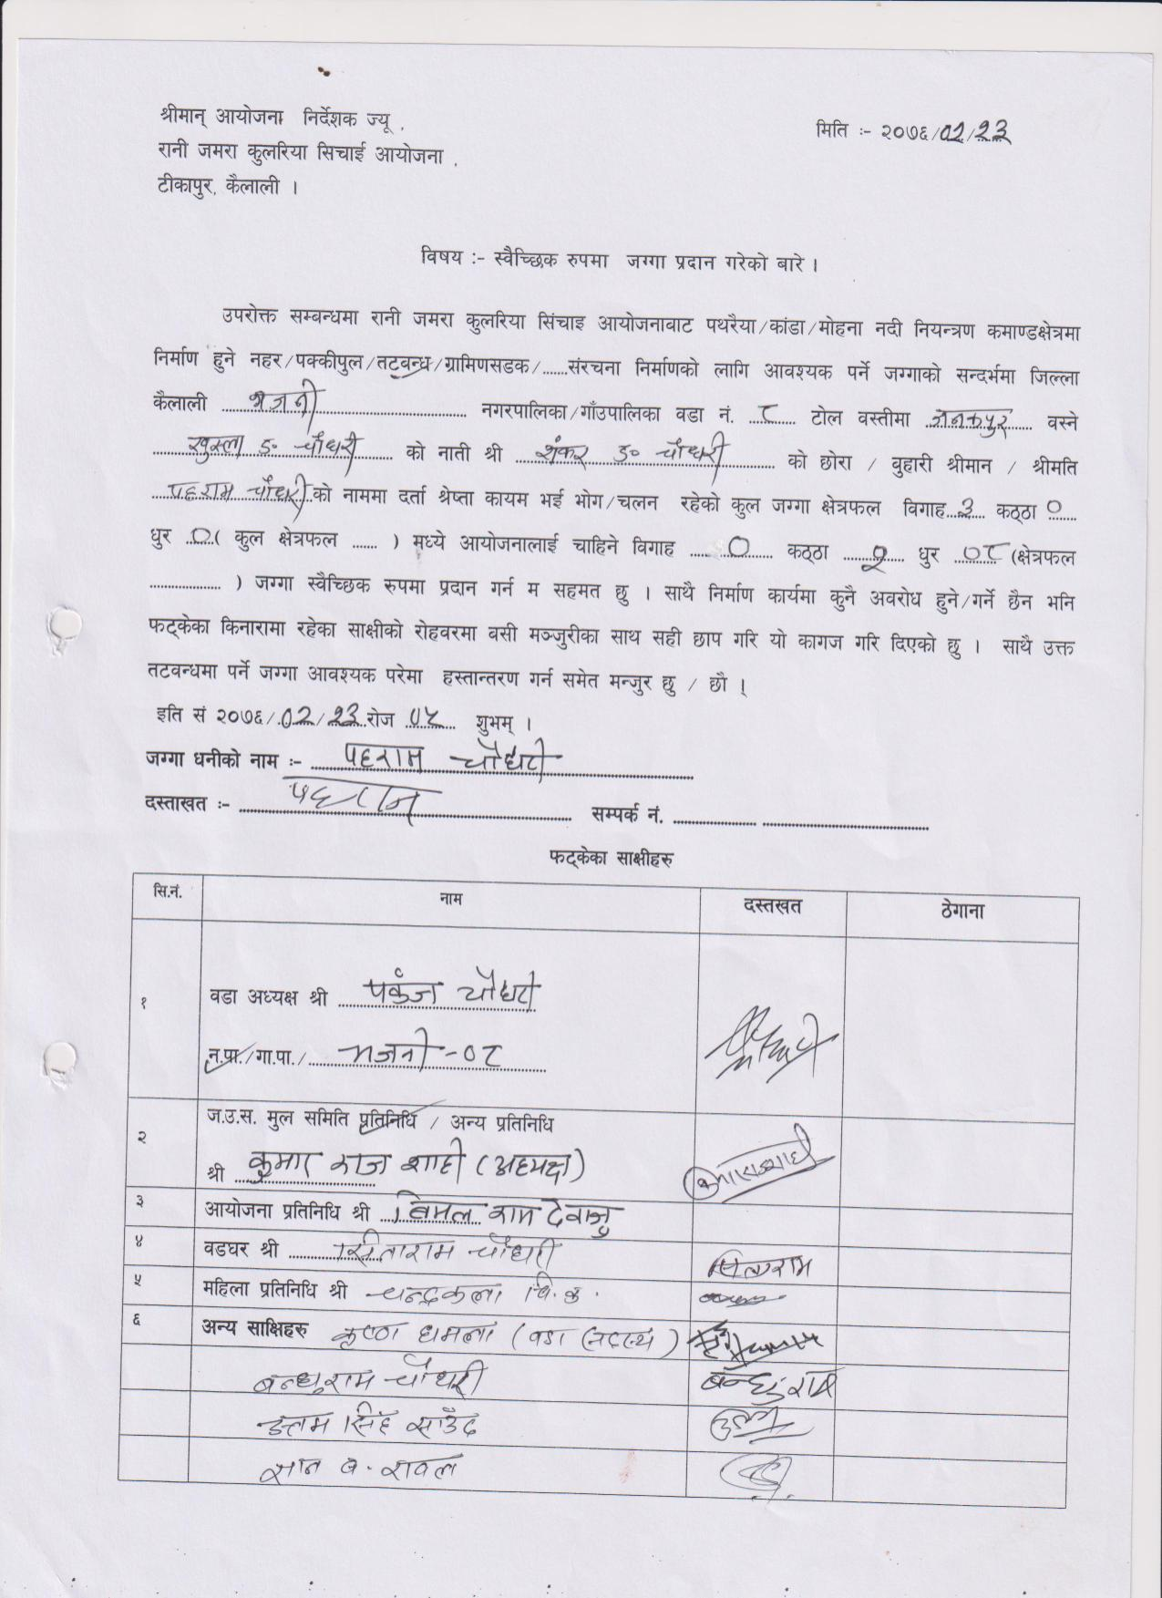

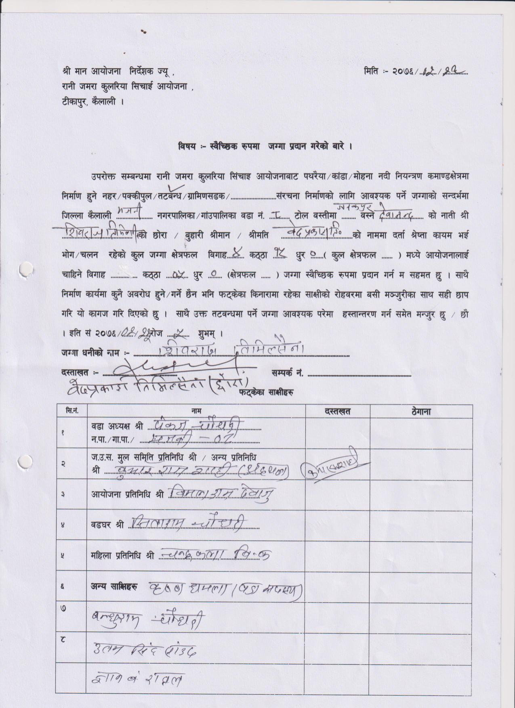
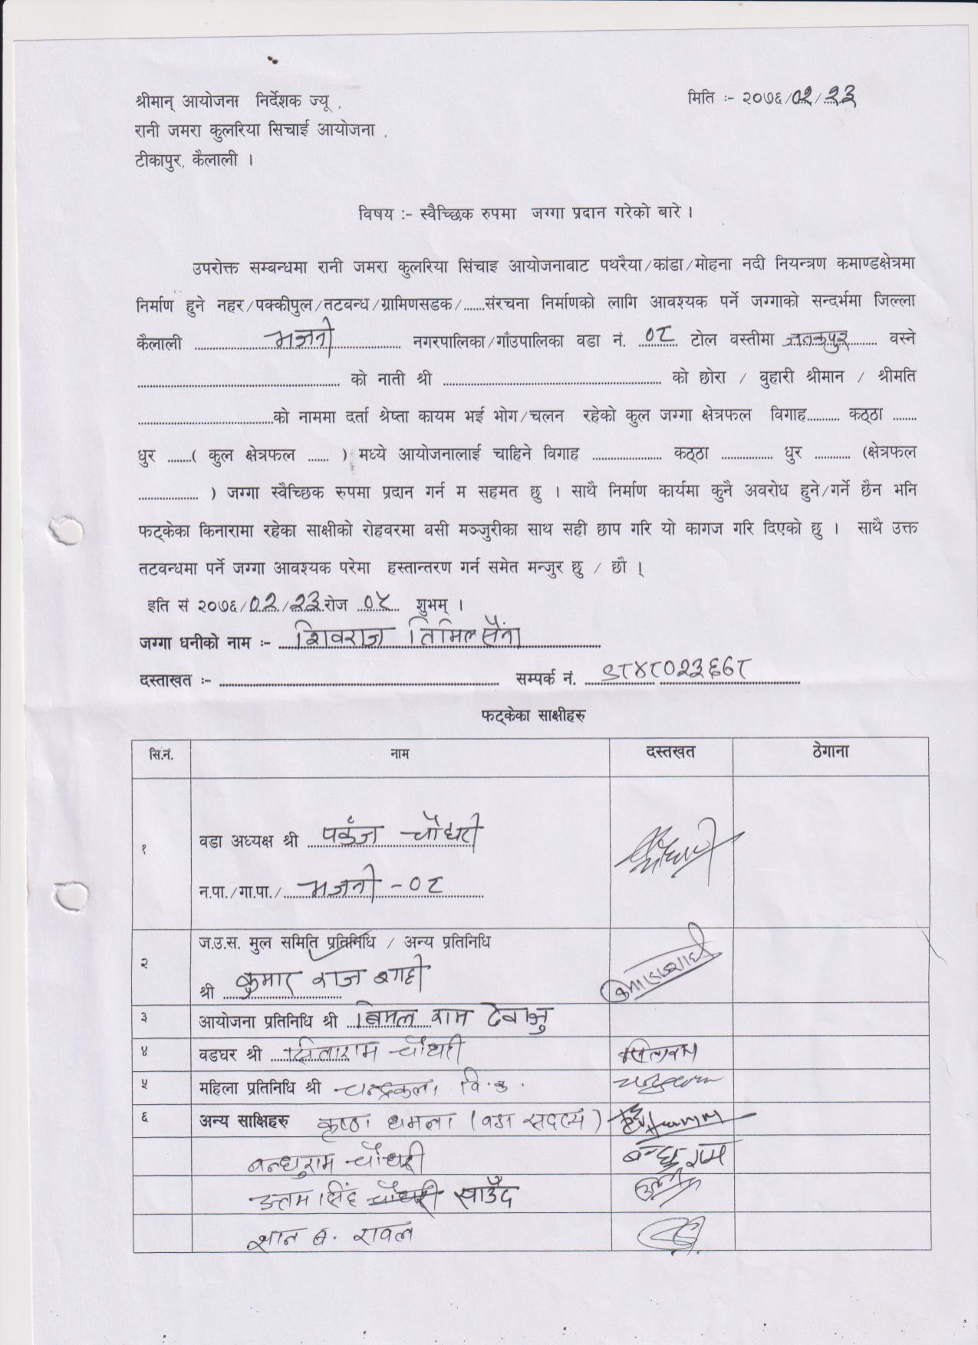

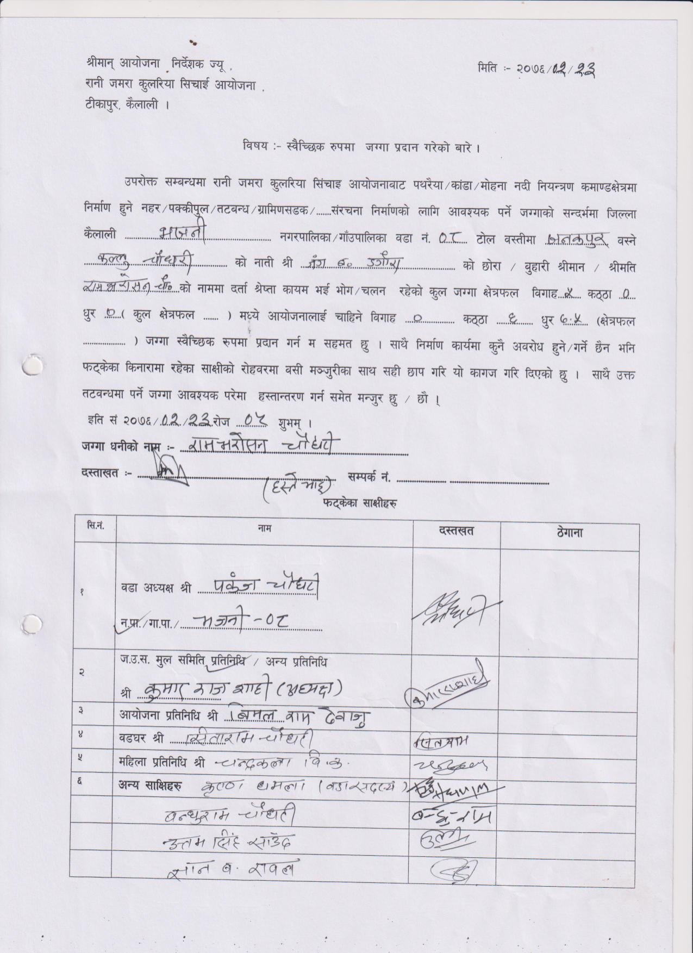
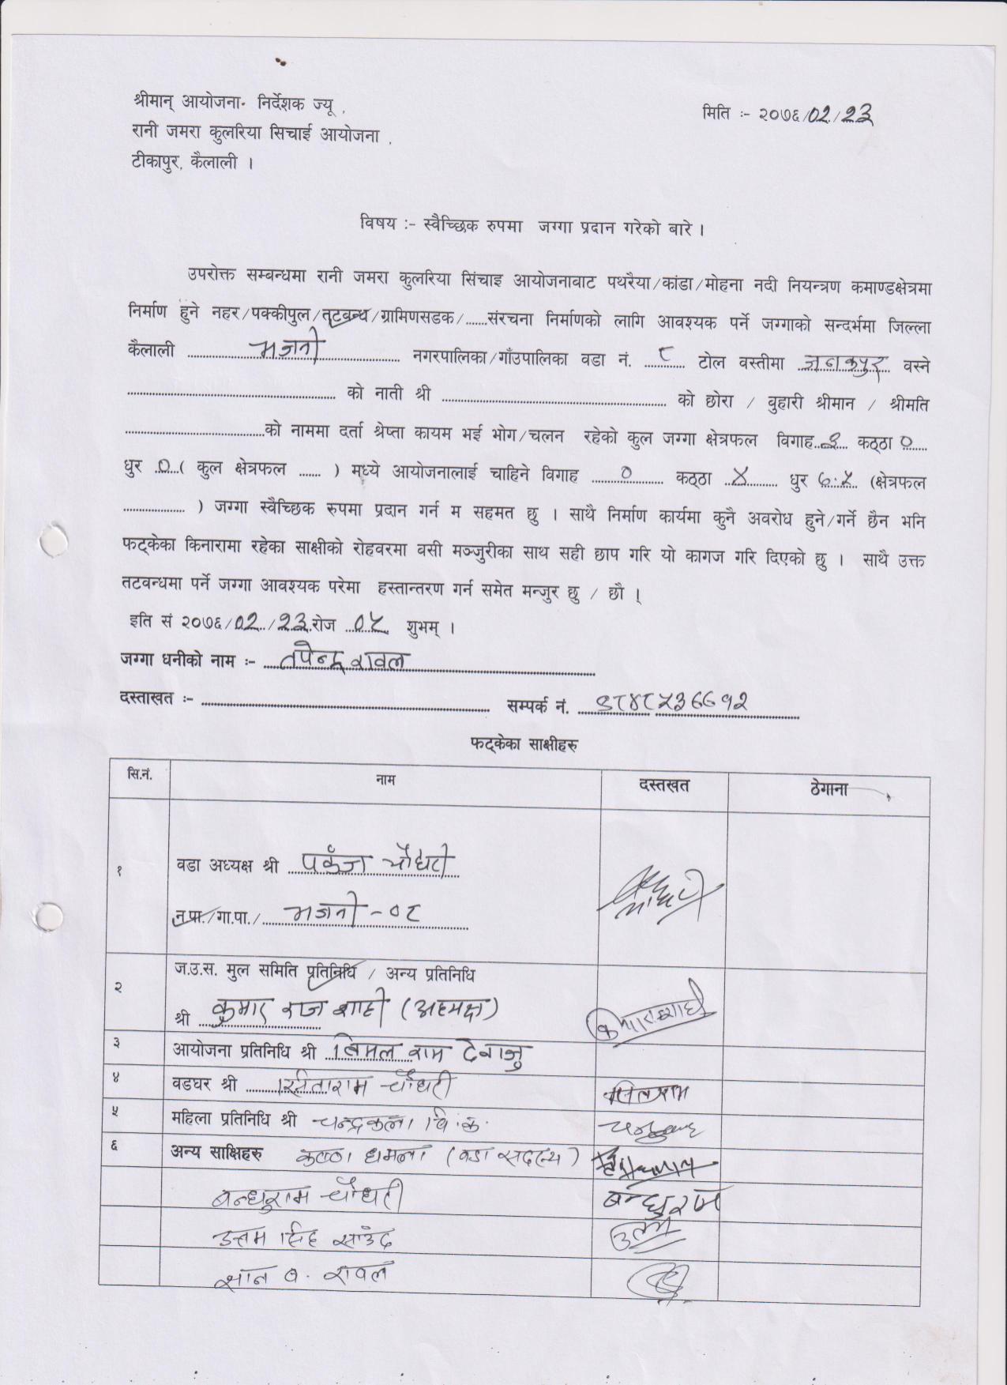

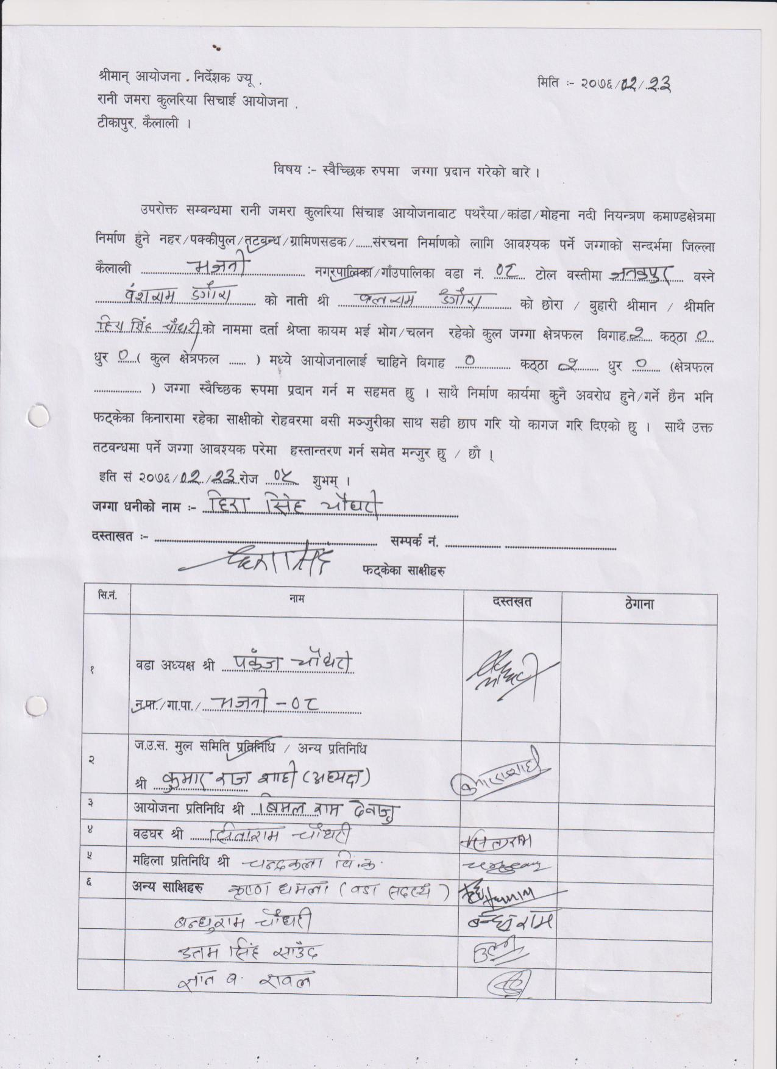
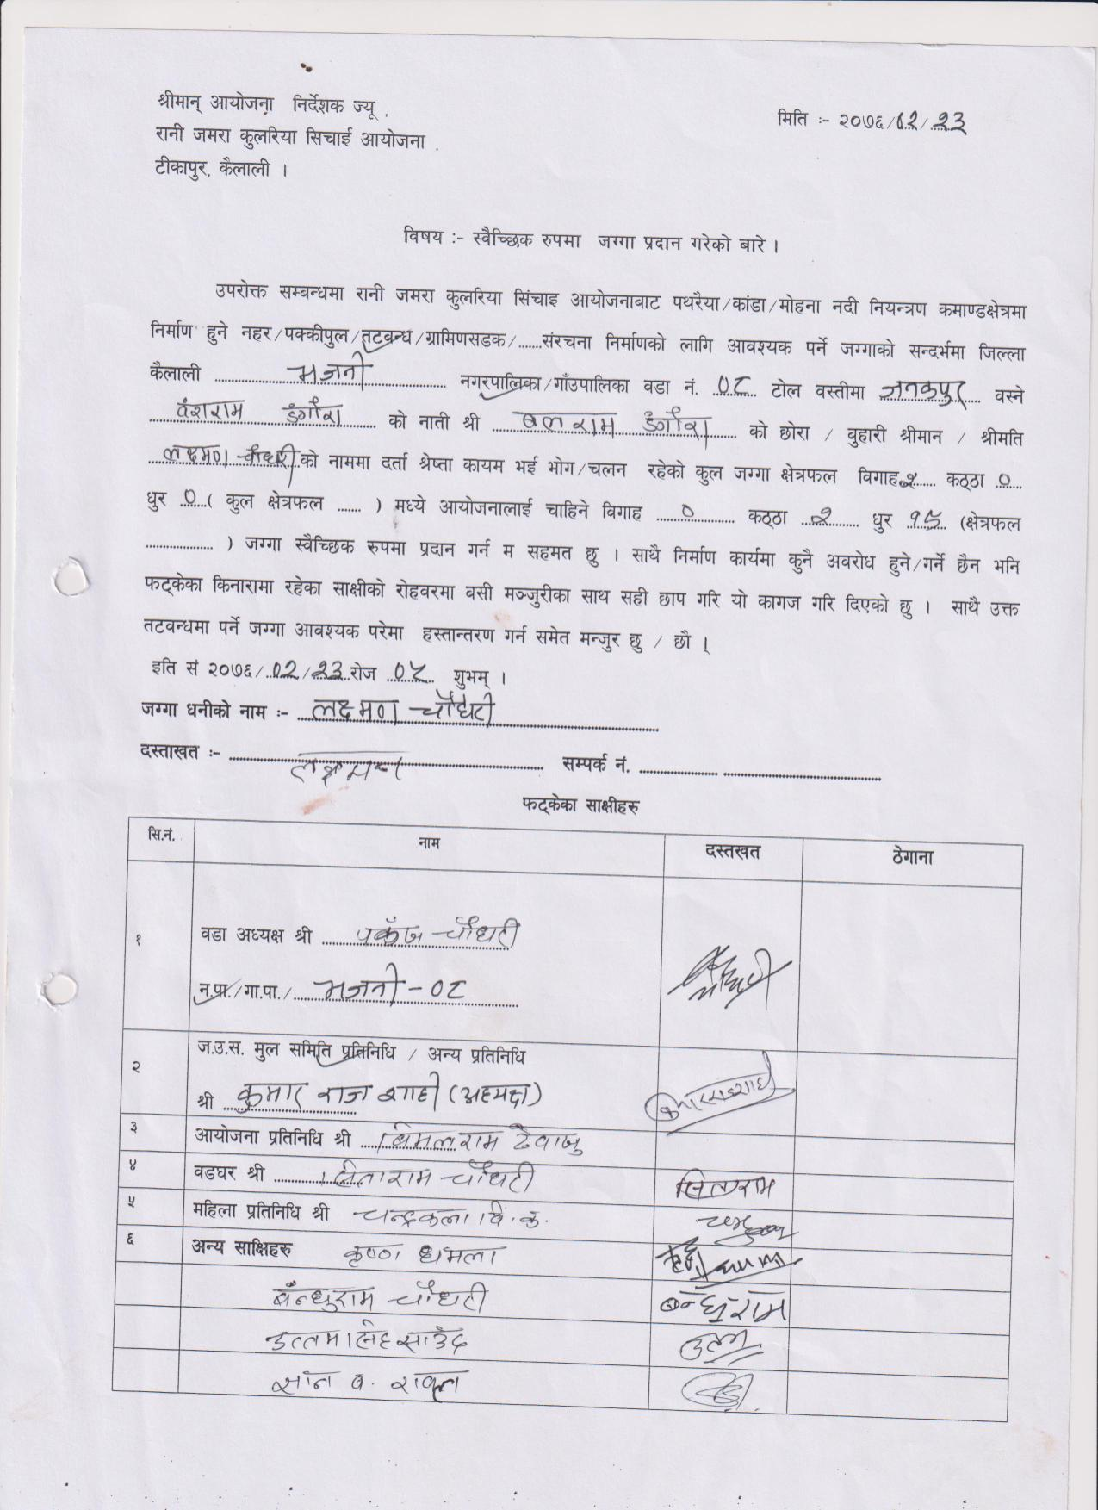

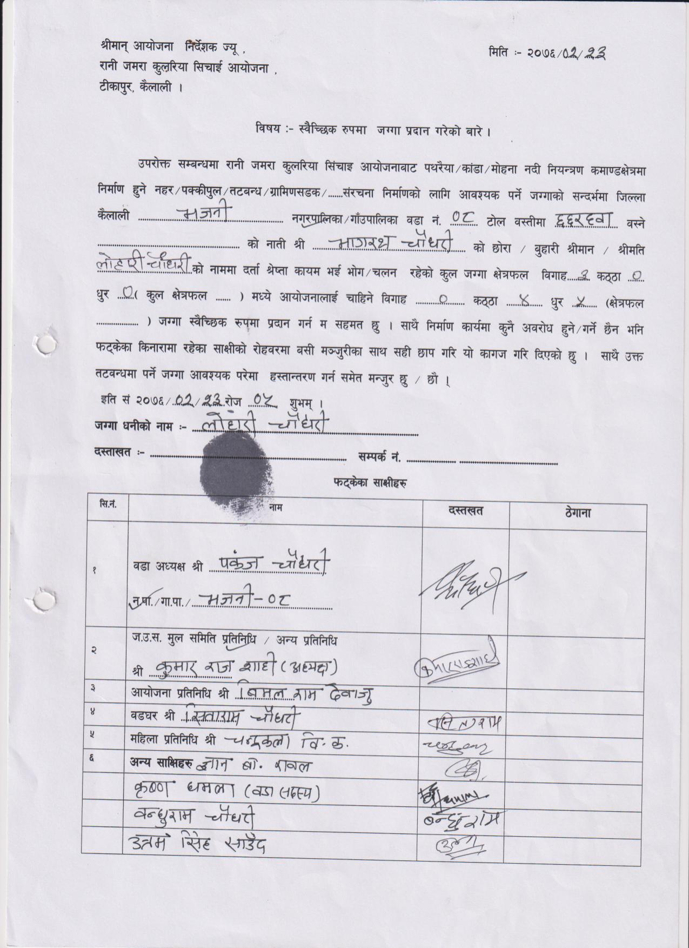

Annex 8: Demographic Infromation-Age Distribution and Literacy Rate

Figure 1: Age distribution and literacy rate-Lamki Chuwa Municipality 9 & 10

Figure 2: Age distribution and literacy rate-Janaki Rural Municipality 2, 4 &7

Figure 3: Age distribution and literacy rate-Joshipur Rural Municipality 4 & 5

Figure 4: Age distribution and literacy rate-Tikapur Municipality 6

Figure 5: Age distribution and literacy rate-Bhajani Rural Municipality 8

Annex 9: Google Maps and Photographs
CAP in Google Map 1: Lamki Chuwa Municipality Ward No. 10 & 9
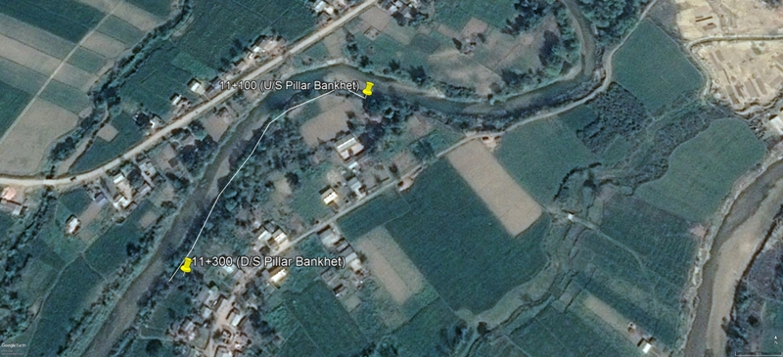

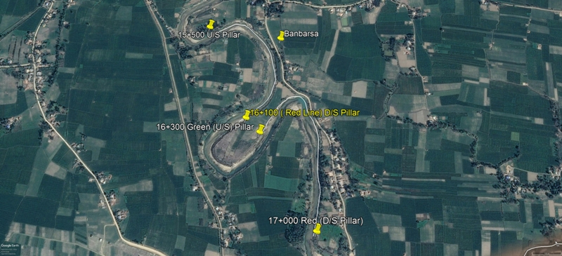

Google Map-Lamki Chuwa 9 and 10
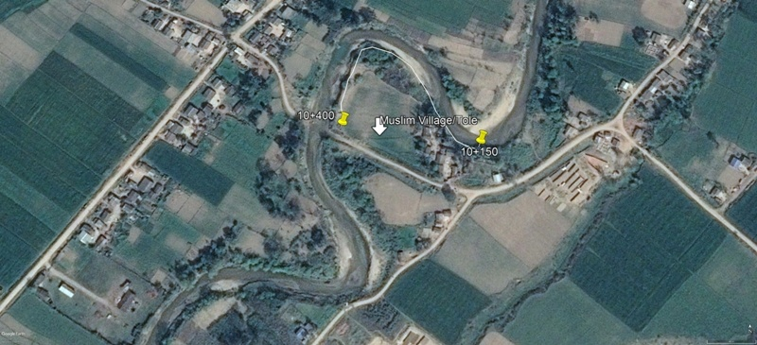

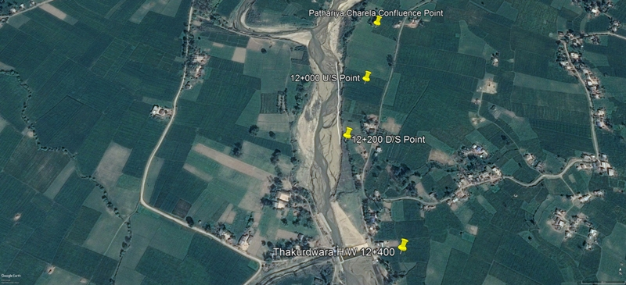

CAP in Google Map 2: Janaki Rural Municipality Ward No. 2, 4 & 7

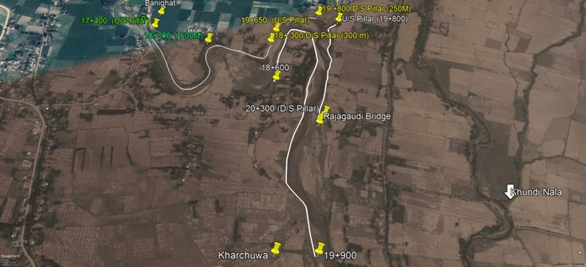

CAP in Google Map 3: Tikapur Municipality Ward No. 6
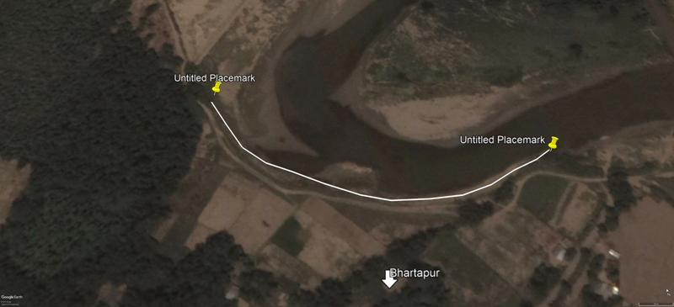

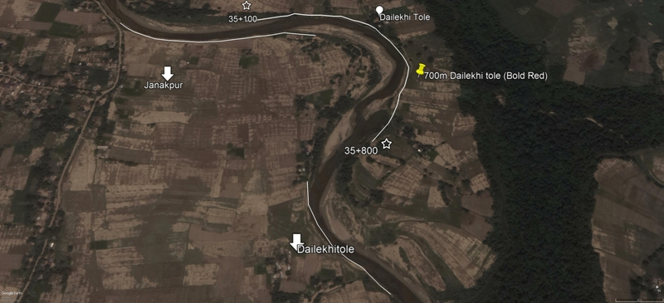

CAP in Google Map 4: Joshipur Rural Municipality Ward No. 5 & 4

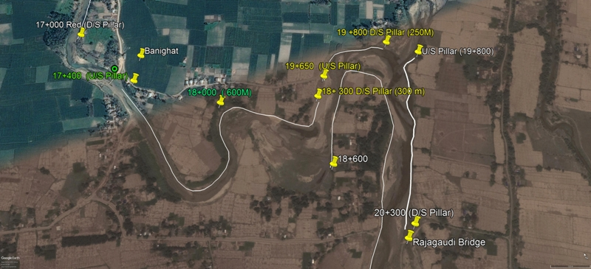

CAP in Google Map 5: Bhajani Rural Municipality Ward No. 8

Photographs 1:Lamki Chuwa Municipality
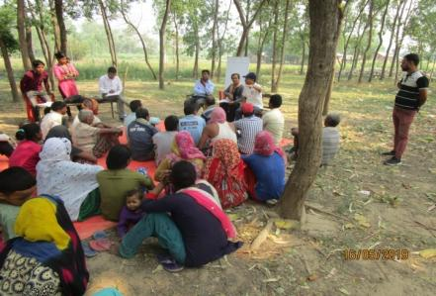
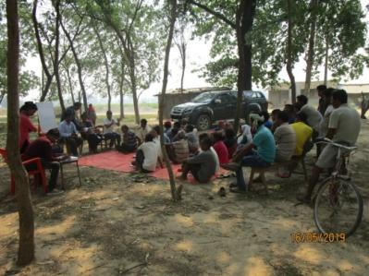

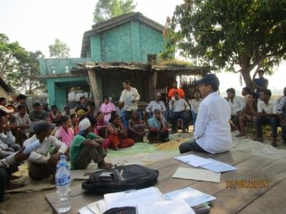
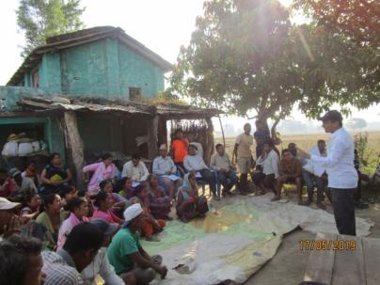

Photographs 2: Janaki Rural Municipality
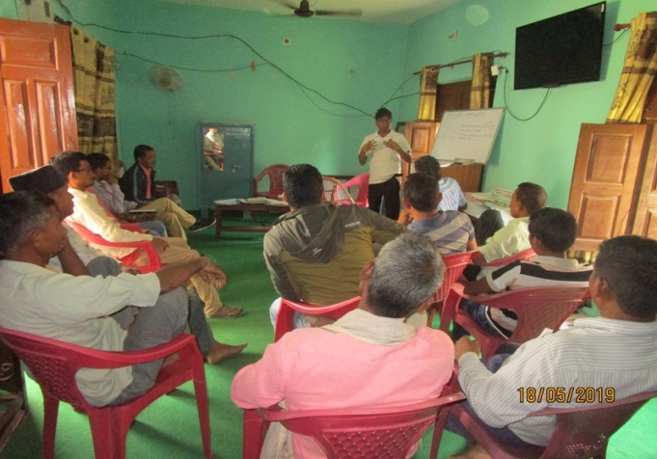

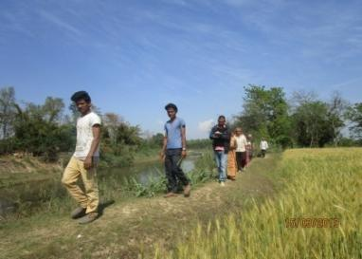
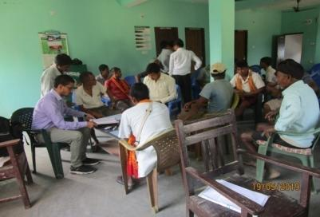

Photographs 3:Tikapur Municipality
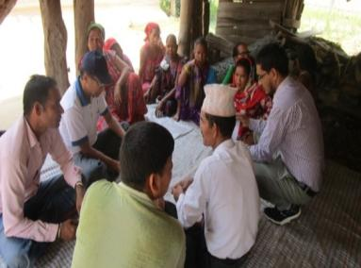
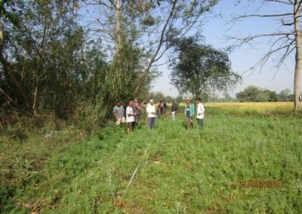

Photographs 4: Joshipur Rural Municipality
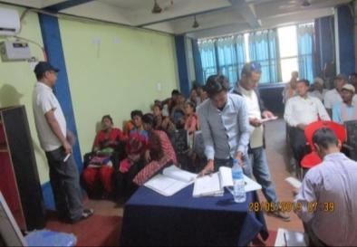
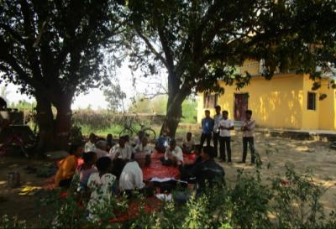

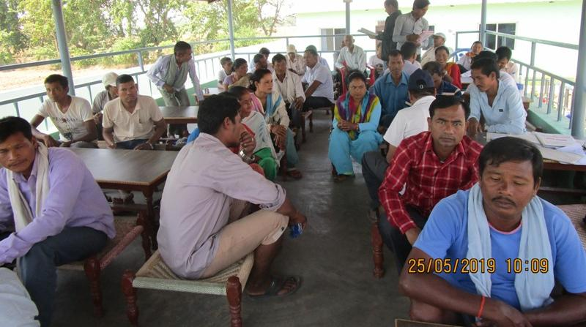

Photographs 5: Bhajani Rural Municipality
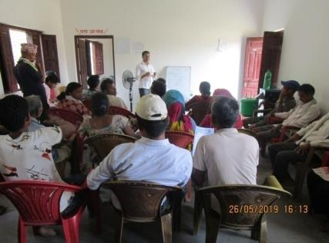
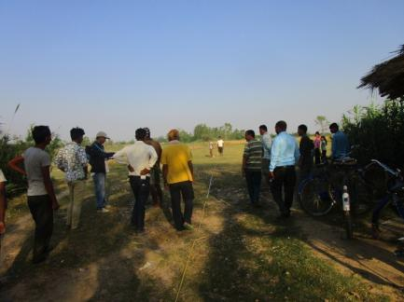

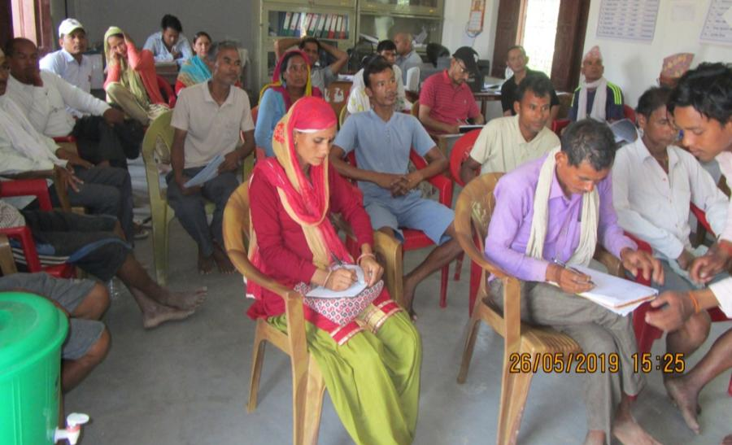

LB 24 has already existing embankment structure and hence needs only maintenance works for smooth functioning. Therefore, no any land donation forms are administered for the particular Bank.

